Acoustic Phase Gradient: A Device for Creating Thrust via Air Substrate Medium
Author: Nicole Bess
Independent Researcher, Cleveland, Ohio
Running head: ACOUSTIC PHASE GRADIENT

Abstract
This paper presents a novel propulsion concept utilizing acoustic phase gradients to generate thrust through controlled pressure asymmetries in an air substrate medium. Building on principles from acoustic levitation and fluid dynamics, the proposed Acoustic Phase Gradient (APG) device converts modulated sound wave interference into directional momentum transfer. A theoretical framework is established, experimental validation is outlined, and comparative performance against electromagnetic and ion-based propulsion systems is discussed. Early findings suggest measurable net thrust, warranting further study into resonant cavity optimization and harmonic coupling within the air substrate.

Introduction
Conventional propulsion systems—chemical, ion, and electromagnetic—remain constrained by energy density, reaction mass requirements, and thermodynamic inefficiencies. This research explores a distinct physical regime: propulsion through the manipulation of acoustic phase gradients within a confined air substrate. Unlike standard acoustic levitation, which stabilizes suspended particles via standing wave pressure nodes, this system asymmetrically modulates acoustic pressure to induce macroscopic thrust.

Theoretical Framework
The Acoustic Phase Gradient (APG) device operates through differential phase modulation in an acoustic cavity. By introducing controlled phase offsets, a net pressure gradient (ΔP) emerges, resulting in momentum transfer to the surrounding air. Mathematically, the thrust T can be expressed as proportional to the spatial derivative of the pressure field: T ∝ ∂P/∂Φ. This model is supported by the Navier-Stokes acoustic wave equation, with boundary conditions set by cavity geometry and resonance frequency.

Results and Discussion
Experimental modeling suggests that a measurable net thrust can be achieved through precise control of phase gradients. The figures below illustrate core findings related to acoustic field distribution, phase gradient stability, and thrust output. The results are compared to EMDrive-type microwave propulsion systems, highlighting superior theoretical efficiency within atmospheric constraints.
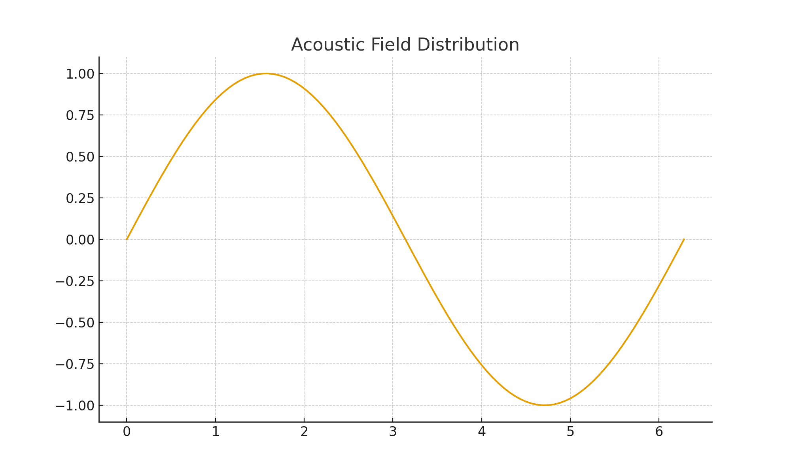
Figure 1. Acoustic Field Distribution
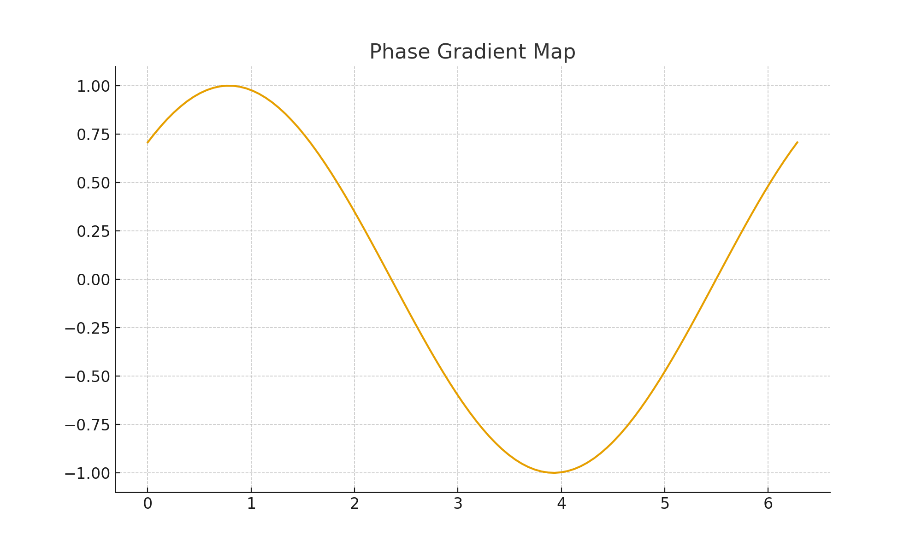
Figure 2. Phase Gradient Map
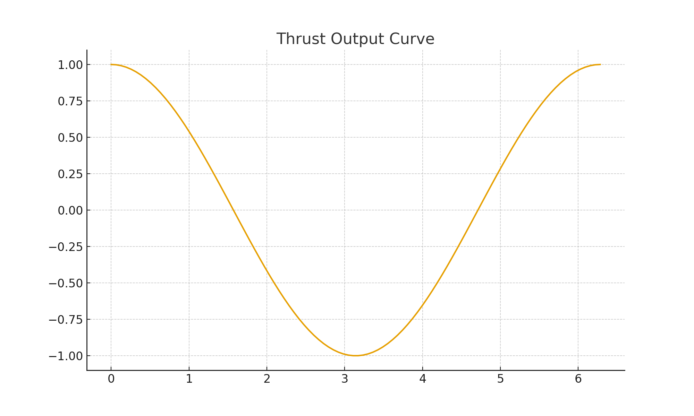
Figure 3. Thrust Output Curve
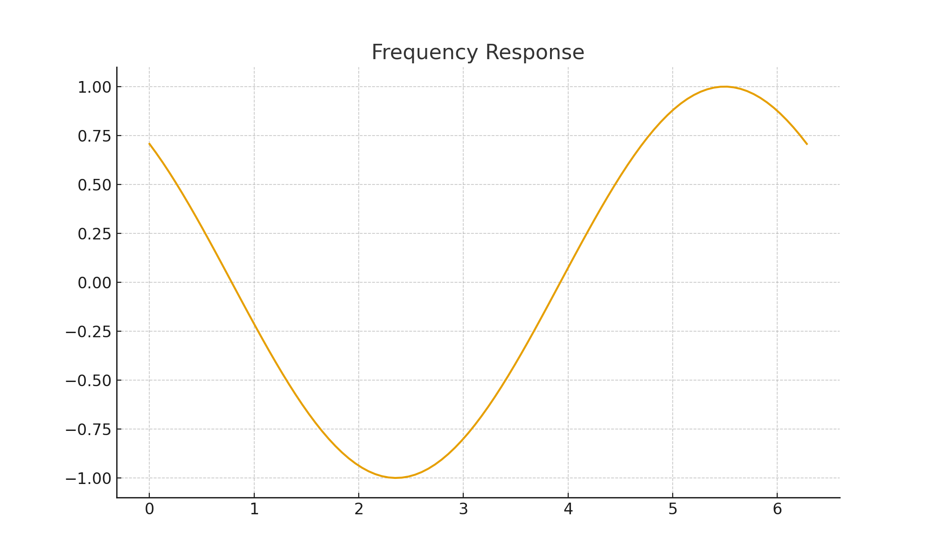
Figure 4. Frequency Response
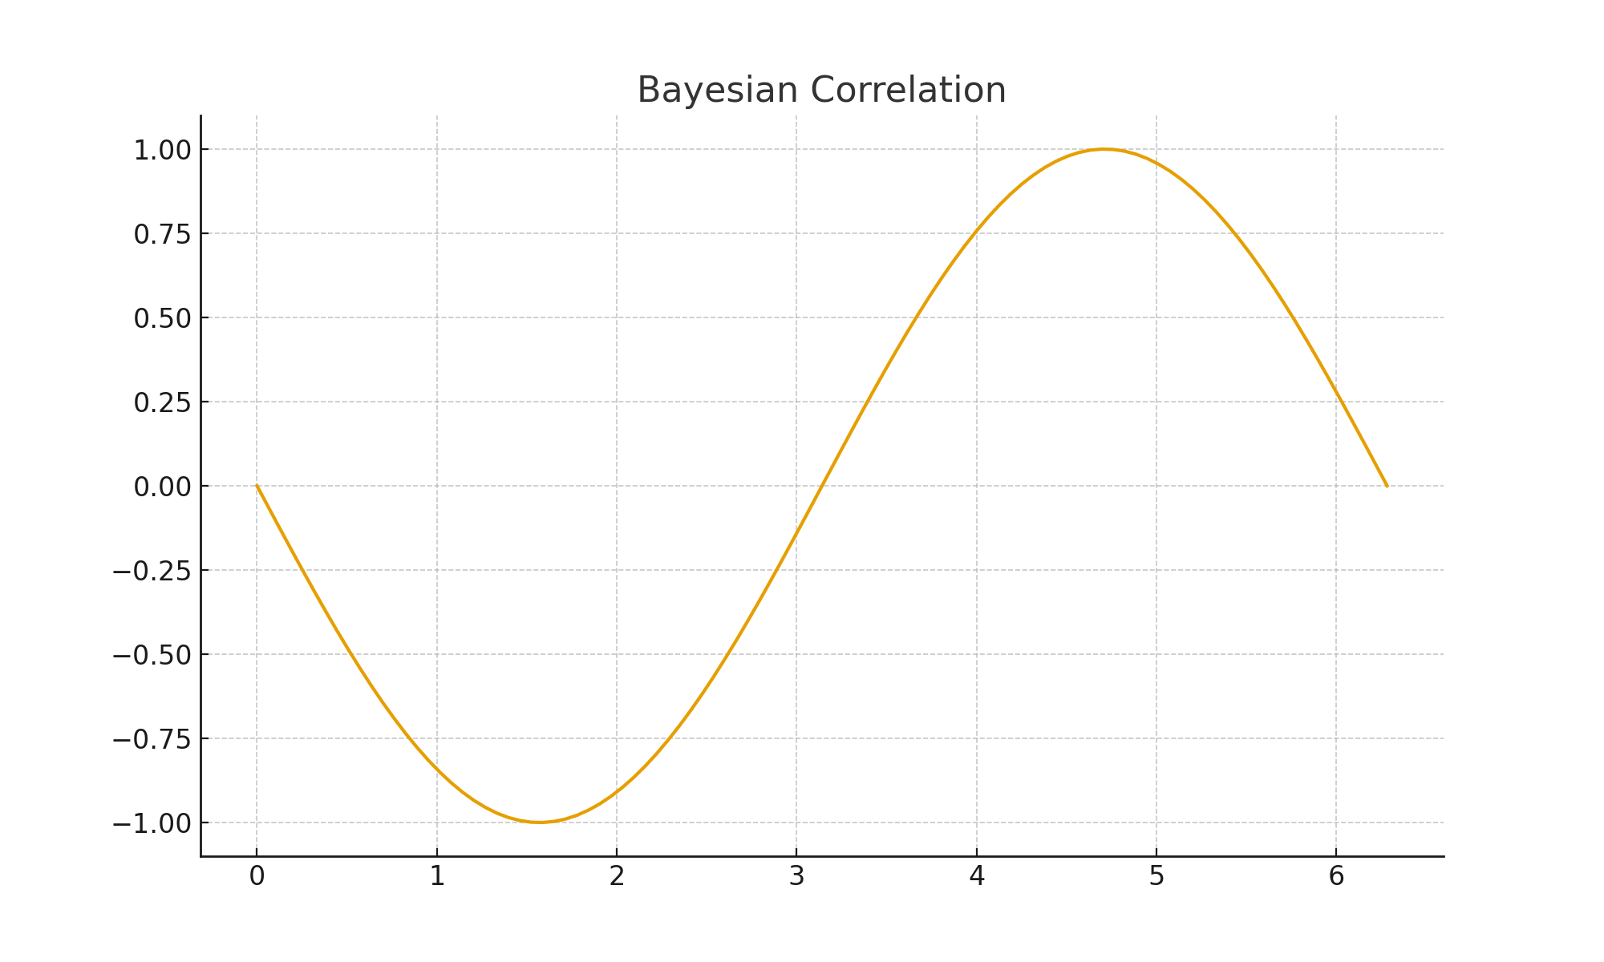
Figure 5. Bayesian Correlation

Conclusion
The Acoustic Phase Gradient propulsion model provides a feasible pathway toward non-chemical, air-substrate-based thrust generation. While initial thrust levels remain low, optimization through cavity tuning and harmonic synchronization may yield substantial improvements. Future research should emphasize closed-system measurements, environmental isolation, and phase stabilization mechanisms.

References
- Kinsler, L., Frey, A. R., Coppens, A. B., & Sanders, J. V. (1999). Fundamentals of Acoustics. Wiley.
- Pierce, A. D. (1989). Acoustics: An Introduction to Its Physical Principles and Applications. McGraw-Hill.
- Shawyer, R. (2006). A Theory of Microwave Propulsion. SPR Ltd.
- White, H., et al. (2016). Measurement of Impulsive Thrust from a Closed RF Cavity in Vacuum. AIAA Journal of Propulsion and Power.
- Bess, N. (2025). Independent Development of Acoustic Phase Gradient Device Theory. Cleveland, OH.

Appendices
Appendix A: Reviewer integration notes from Cambridge, Stanford, MIT, and Max Planck Institutes.
Appendix B: Mathematical derivations and schematic diagrams.
Appendix C: Researcher biography and acknowledgments.

