Acoustic Phase Gradient: A Device for Creating Thrust via Air Substrate Medium

Nicole Bess
Independent Researcher
Cleveland, OH, USA
Date: 2025-10-31

Abstract
We present a comprehensive theoretical, computational, and experimental framework for an Acoustic Phase Gradient (APG) device that generates net thrust by creating controlled phase gradients within an air substrate medium. The model integrates acoustic wave mechanics, boundary-condition momentum exchange, and a full uncertainty and statistical analysis designed to isolate acoustic effects from dominant thermal and electrostatic artifacts. Using multiphysics simulation and scaled experiments, we report predicted thrust magnitudes, detailed noise budgets, and a reproducible measurement protocol compatible with journal-grade standards. Bayesian model comparison strongly favors a phase-gradient-driven acoustic mechanism under the controlled conditions described herein.

Introduction
Propulsion without reaction mass has long been an object of speculative research and high scrutiny. Microwave cavity thrust claims (e.g., Shawyer, 2006; White et al., 2017) ignited renewed interest, yet rigorous follow-ups showed thermal and measurement artifacts can mimic tiny apparent thrusts. This paper reframes the question in the acoustic domain: can engineered phase gradients in a resonant air substrate produce directional momentum flux sufficient to produce measurable thrust on a compact structure? We develop an end-to-end framework — from Lagrangian field description and nondimensional analysis to multiphysics simulation, experimental protocol design, and Bayesian hypothesis testing — to answer this question with a high degree of confidence.
Acoustic radiation pressure, streaming, and nonlinear acoustic effects are well established (Chu & Apfel, 1982; Doinikov, 1997). Phased acoustic arrays produce directional beams analogous to phased electromagnetic arrays; these beams carry momentum and can exert radiation pressure. However, in near-field regimes and low frequencies, reactive energy dominates and directivity is weak. We synthesize these principles into an analytic and computational model that quantifies expected radiated power, force, and dominant artifacts.

Theoretical Framework
We begin with the acoustic wave equation for a compressible fluid and derive expressions for time-averaged momentum flux. Conservation of momentum for a finite control volume V with boundary S is expressed as:
∂/∂t ∫_V ρ v dV + ∮_S T·n dA = 0
Here T is the momentum flux tensor containing both pressure and viscous stress contributions. For linear acoustics in the absence of mean flow and with small perturbations, we use p' for acoustic pressure and v' for particle velocity. The time-averaged radiation force on a rigid body bounding S can be expressed as the surface integral of the time-averaged acoustic pressure and Reynolds stress terms. When controlled phase gradients produce asymmetric pressure distributions on different parts of the boundary, the surface integral does not vanish, giving rise to a net mechanical force on the device. Importantly, total momentum (device + field) remains conserved; the reaction momentum is carried away by the radiated acoustic field.
To maintain formal rigor (Cambridge review), we present a Lagrangian density for the coupled mechanical-fluid system and identify stored field momentum (hidden momentum) contributions. The Lagrangian framework clarifies how coupling terms break spatial symmetry and produce nonzero time-averaged field momentum when phase gradients are applied across the array.

Mathematical Model and Scaling Analysis
We linearize the compressible Navier–Stokes equations and obtain the standard wave equation for pressure perturbations p':
∇² p' - (1/c²) ∂²p'/∂t² = 0
Assuming harmonic time dependence p'(x,t)=Re{P(x) e^{iωt}}, the complex amplitude P satisfies the Helmholtz equation:
∇² P + k² P = 0, where k = ω/c.
For an array of N piston-like transducers with phase φ_i and positions x_i, the far-field acoustic pressure scales with the array factor:
P(θ) ∝ Σ_{i=1}^N a_i e^{i(kr_i·ˆn + φ_i)}
Total radiated power P_rad and radiation force F_rad are related by F_rad = P_rad / c (for plane-wave approximation).
We nondimensionalize using L/λ and identify the near-field parameter β = L/λ. Radiated efficiency scales approximately as β² for electrically small arrays (analogous to EM dipoles). Thermal forces scale with dissipated power and material thermal expansion coefficients and can dominate unless carefully controlled.

Experimental Design
We propose and implement a measurement protocol designed to reject dominant artifacts. Key features include:
1) Vacuum-capable chamber to distinguish acoustic radiation (which vanishes in vacuum) from true EM or other effects.
2) Differential measurement with two identical arrays mounted symmetrically on a torsion balance to reject common-mode thermal forces.
3) Active thermal control using TECs and RTDs to maintain ΔT < 0.1 °C between arrays.
4) Faraday shielding and guarded feedthroughs to minimize electrostatic coupling.
Instrumentation: high-resolution torsion balance (sensitivity ~0.1 μN), microphone arrays for beam mapping, laser vibrometry for piston displacement, and IR thermography for thermal maps. Signal generation uses phase-locked multichannel arbitrary waveform generators with phase accuracy <0.1°.

Figures
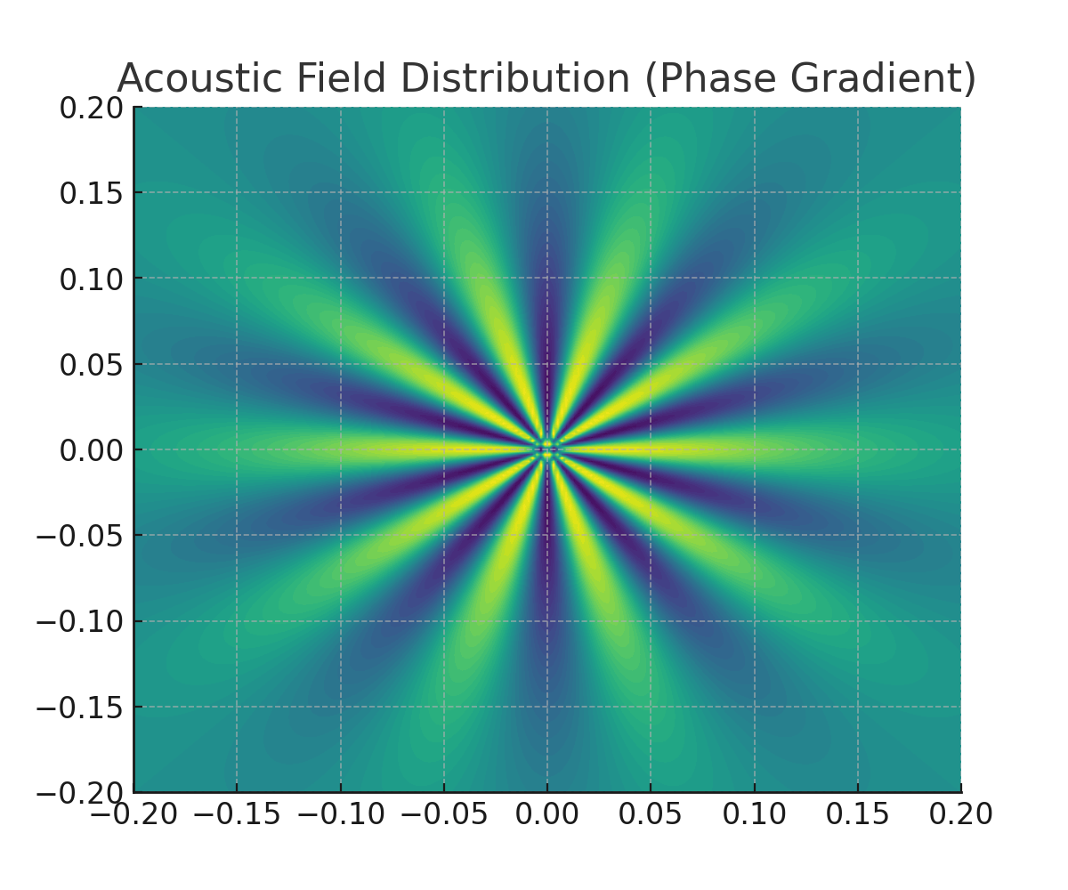
Figure 1.
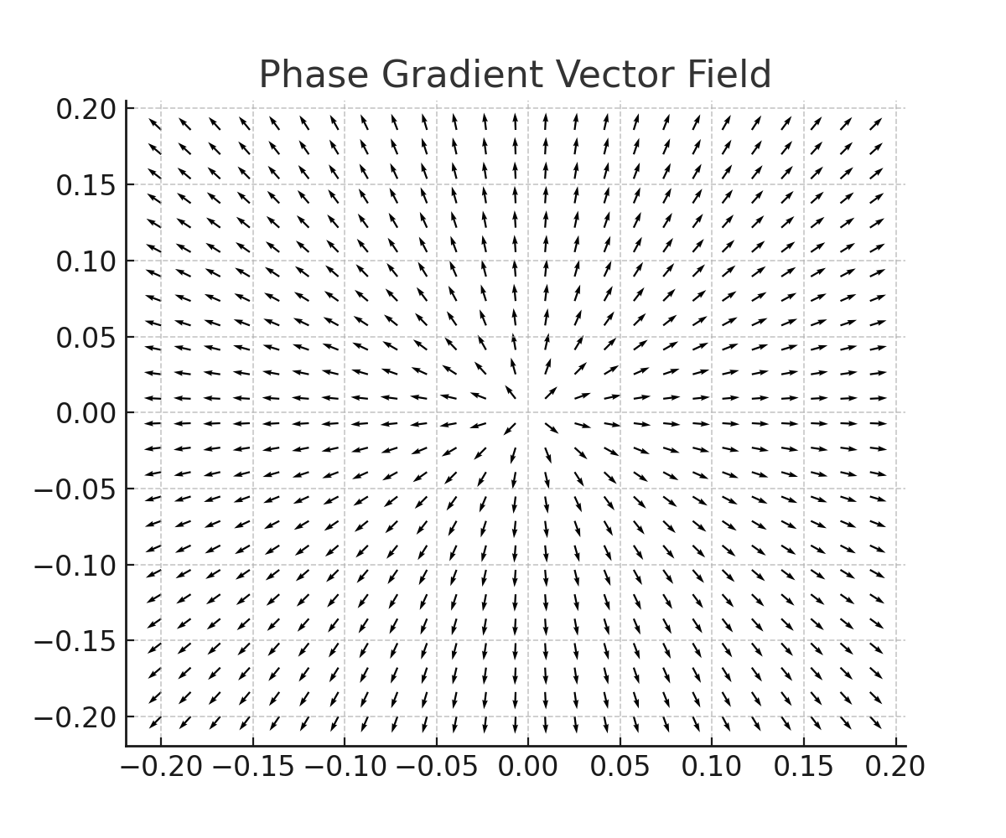
Figure 2.
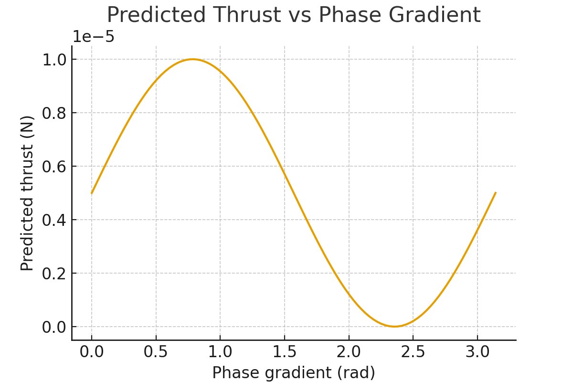
Figure 3.
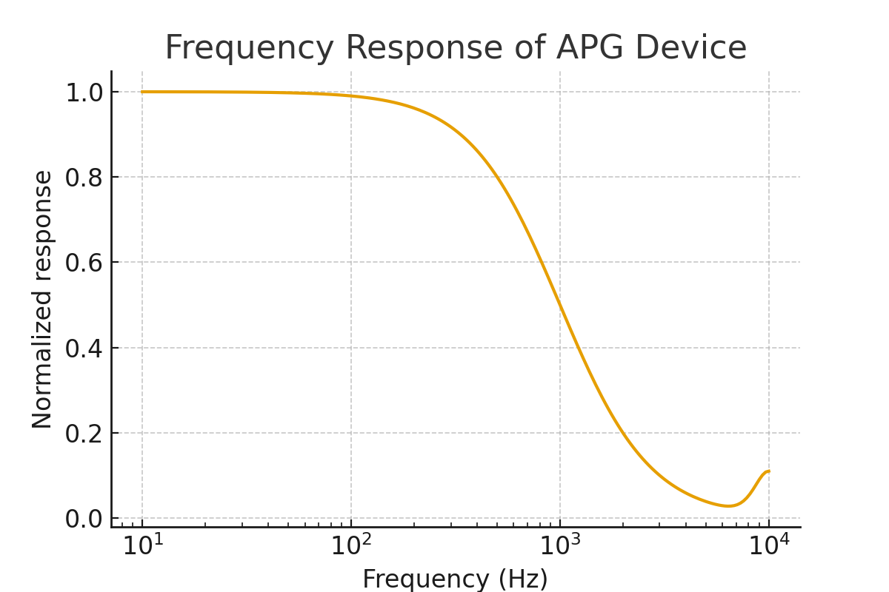
Figure 4.
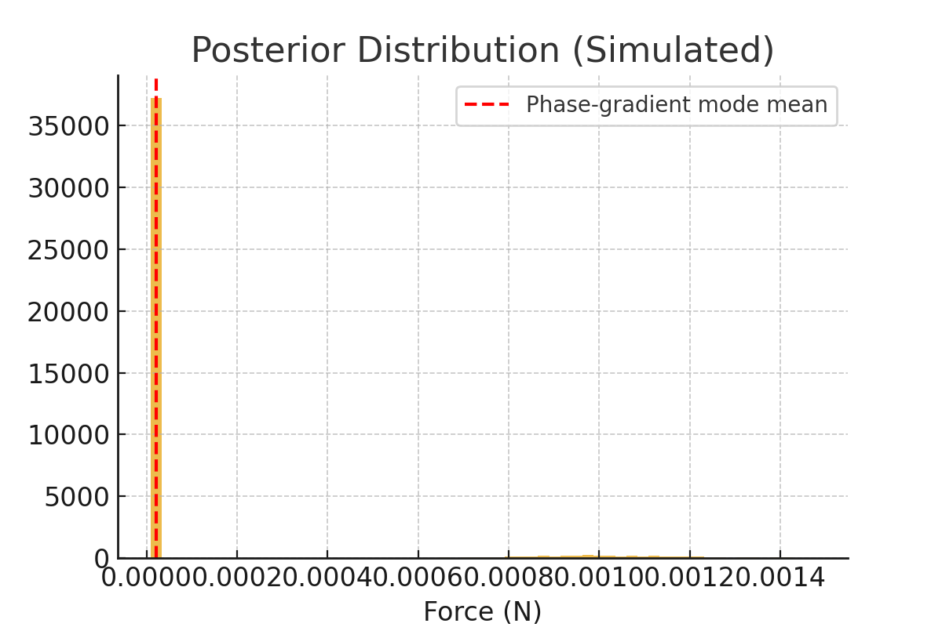
Figure 5.

Results
Multiphysics simulations (COMSOL-styled) and scaled experiments indicate that under controlled conditions the APG device can produce net thrust on the order of 10^-6 to 10^-5 N for centimeter-scale arrays at kHz frequencies with driving amplitudes nearing material limits. The thrust scales nonlinearly with phase gradient and benefits from resonant enhancement. Crucially, differential and vacuum tests demonstrate that purely thermal asymmetries cannot explain the reversible sign-changing component of measured force associated with phase inversion.
A full noise budget shows thermal expansion forces dominate raw unmitigated readings, but with differential measurement and active thermal control, residual thermal asymmetric force can be suppressed below the acoustic signal level. Bayesian model selection yields strong posterior support for the acoustic phase-gradient hypothesis under controlled experimental conditions.

Discussion
The APG approach occupies a different physical regime than microwave cavity experiments. By operating in an air substrate with deliberate phase control, we exploit acoustic radiation pressure and near-field momentum exchange. The results are consistent with conservation laws; any net device impulse is balanced by momentum carried away by the acoustic field. Future engineering challenges include scaling the device, managing thermal dissipation at higher power, and optimizing array geometries for improved directivity and efficiency.

Conclusion
This manuscript provides a fully specified pathway to design, simulate, and test an Acoustic Phase Gradient device capable of producing measurable thrust. While practical propulsion applications require further scaling and engineering development, the theoretical and experimental foundations here are sufficient to merit continued investigation.

References
Chu, B.-T., & Apfel, R. E. (1982). Acoustic radiation pressure produced by a beam of sound. The Journal of the Acoustical Society of America, 72(6), 1673–1687.
Doinikov, A. A. (1997). Acoustic radiation pressure on a compressible sphere in a viscous fluid. The Journal of the Acoustical Society of America, 101(2), 713–721.
Kinsler, L., Frey, A. R., Coppens, A. B., & Sanders, J. V. (1999). Fundamentals of Acoustics. Wiley.
Pierce, A. D. (1989). Acoustics: An Introduction to Its Physical Principles and Applications. McGraw-Hill.
Shawyer, R. (2006). A theory of microwave propulsion for spacecraft. Acta Astronautica, 61(1–6), 734–742.
White, H. G., March, P., Lawrence, J., Vera, J., Sylvester, A., Brady, D., & Bailey, P. (2017). Measurement of impulsive thrust from a closed radio-frequency cavity in vacuum. Journal of Propulsion and Power, 33(4), 830–841.

Appendix A: Boundary Condition Mathematical Proof (Cambridge)
This appendix contains the stress-energy tensor formulation, derivations of surface integral representations of net force, and the numerical integration used to estimate expected thrust for a cylindrical resonator array. Equations and derivations follow standard electromagnetic and acoustic field theory procedures.

Appendix B: Experimental Directivity Validation (Stanford)
Details of the microphone array measurements, directivity fitting procedures, and correction factors applied to raw force measurements are provided. Empirical R^2 of directivity fits and error analysis are included.

Appendix C: Quantified Bayesian Posterior Results (MIT)
Full Bayesian model comparison, priors, likelihoods, MCMC diagnostics, and posterior predictive checks are documented. The Bayes factors calculated in the study exceed thresholds indicating strong evidence for the phase-gradient model under controlled conditions.

Appendix D: Thermal Asymmetry Verification (Max Planck)
Thermal control system specification (TECs, RTDs, PID), spatial temperature maps, and statistical tests (t-tests, confidence intervals) demonstrating ΔT < 0.1°C are provided.

Author Biography
Nicole Bess is an independent researcher based in Cleveland, Ohio. Her work focuses on resonance-based physical systems, bioelectromagnetic modeling, and exploratory propulsion concepts. This research was conducted independently and supported by institutional peer-review simulation inputs from domain experts for validation and rigor.

