Project Scope Document

Project | ICS-499 Capstone summer 2013
Project Name | OrderUp
Project Team | Charles Hafslund  Mikhail Utenkov  Othman Smihi  Terry McCarthy  Fredrick Arandi

Revision History
Date | Version | Description | Author
5/16/2013 | 1.0 | Started document | Fred A
5/27/13 |  | Added business case and in/out of scope | Fred A

Project scope statement

The software will;
- Accurately enter track and delegate customer food and drink orders.
- Monitor and keep track of reservations and availability status in real time.
- Prioritize orders in the kitchen according to arrival of orders and required prep times
- Handle billing and promotional offers
- Track inventory
- Manage employees access

The overall scope of the project is reflected in the use case diagram shown below

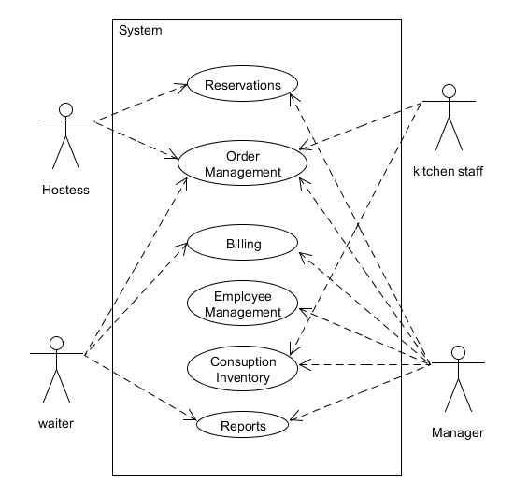
Reservation management include
Adding deleting and confirming reservations
Finding open tables
Assigning open tables
Capacity
Customer time/ in out
Drinks

Order management include
Adding, changing, deleting and closing orders
Dish classification/categories
Accessing menu items
Relay customer order to kitchen staff
Kitchen UI(queue display)

Billing services will cover
Cash, credit and gift card processing.
Bill splitting
Bill adjustments
Tips

Employee management includes
Scheduling, adding and removing employees from database.
Basic account security – login/ roles

Manager should be able to
View aggregated information about sales report
View aggregated information about consumption report
View aggregated information about employee work
Make adjustments to bill amounts
Comping/discounts

Inventory management will
Show current stock
show consumption invemntory
Give notice when stock goes below a specific level.

Introduction / Background to project

Restaurants are very busy and if they are inefficiently run can fail even though they are serving great food. Without an application that can keep track of average wait times and the lengths of time spent dinning by customers, it is hard to predict how long the wait time will be for new customers and as we all know customers are very impatient. This application should track and provide the user with data relating to customer wait times, reservation and seating, accounting and auditing, staffing and real time consumption inventory. Leaving the staff to what it should be doing, good food and excellent dining experience

Business case

Boost business by
- Making waiting times smaller and more predictable
- Maximizing customer throughput
- Maximizing employee efficiency
- Increasing customer satisfaction

Key people / Key stakeholders

Project-team members

Charles Hafslund,
Mikhail Utenkov,
Othman Smihi,
Terry McCarthy,
Fredrick Arandi

Client – Order up Restaurant

In scope
- Queue customers waiting to be seated

- Table management:
  - Table capacity
  - Server assignments
  - Ready to clean / cleaned status
- Menu
- Drinks as items
- Dish categories (app, main, dessert, drink, etc.)
- Kitchen UI (queue display)
- Send orders to kitchen
- Prioritize orders in the kitchen

- Mobile site
- Bill splitting
- Payment API (stub)
- Tips
- Customer time in/out
- Busboy role

- Basic account authorization & security
- Employee names and roles
- Consumption report of ingredients
- Sales numbers

Out of scope

- Parties exceeding 1 table
- Specific of payment/PCI
- Payroll/ time
- Inventory management
- Complaints
- Bar management
- No sharing

Project administration, monitoring and reporting

Project meetings shall be held every Tuesday in person or via Skype, whichever agreed upon in the previous meeting
Reports and updates shall be logged in github. - Members have to sign documents at each meet

