**GIS based Local Self Govt. portal - A new approach for sustainable development and Planning.**

1. *Jake J Jacob, 2. Govindaraj R, 3. Nizzi Soosan George and 4. Jismol S****)***

**Abstract**:

Local administrative bodies are always under the pressure to deliver the citizen services to the people in a timely, efficient and economical and transparent manner. The application of information technology has had a profound impact on the citizen service delivery. Various reforms of the government emphasis on adopting information technology practices in the planning and management of service delivery.

Lack of updated data is one of the biggest challenge faced by the local administrative bodies in India. Accurate and updated data pertains to the residential and commercial property data, socio-economic data, utilities, transportation networks, natural resources are basic need of various departments in the local administrative bodies for the better planning and delivery of services. The lack of this data can leads to the partial or total failure of project implementation as well as the service delivery.

Property Tax is one of the most important sources of income for any government. However, there are many forms of taxes, Property Tax is the single largest source of revenue for a local self-government body. Most governments depend on the revenue collection from property tax to finance their infrastructure and operations. Lack of these funds causes growth and progress to be delayed and reduces the economic potential of the city. By developing a GIS-based tax assessment and management system the government is able to: check the total tax collected for a defined area like a ward; compare this against what would be expected to be collected from the ward; re-plan tax amount based on changing urban development plan and new construction; and develop more detailed system focusing on new development areas to improve tax collection. For this purpose, we have been using an excellent system called Integrated Property Management System (IPMS) which is a web based application that enables online tax payment with spatial model for viewing, editing and identifying assets with its spatial location. Use of such systems have demonstrated an increase in tax revenue in towns in India by over 60% additional tax collection, better system of tax calculation and collection, and opportunity for private sector participation to work with government to increase efficiency in tax collection.

**Keywords**: Geographic Information System (GIS), Intelligent Property Management System (IPMS), Local Self Government (LSG)

**INTRODUCTION**

In many countries, there is a growing trend towards decentralization from national government to regional, sub-regional and municipal governments. This growing trend has resulted in an increased need for municipalities to obtain more precise and useful information for effective decision-making and the need to increase revenue collection to fund services. Many regional and municipal governments lack the tools needed to allow municipal governments to conduct urban planning activities and collect the necessary data to collect property and land taxes from residents. GIS technology provides a powerful tool to assist municipalities in transforming to a decentralized system ([Paul Lennox](https://www.geospatialworld.net/author/9j6jgbfygeospatialworl-wpengine-com/), 2012).

Municipal bodies in Kerala are expanding rapidly with new properties/infrastructures springing up. It is therefore necessary to assess all these new and existing built-up structures and maintain an effective database for easy collection of Property taxes. Through this paper, we are introducing a new way of property management system called IPMS which is a web based application which can store accurate information on tax payables and revenue collection which can be monitored visually.

Geographic Information Systems for Property Tax assessment can be used by local government authorities to maximize the government income and as the basis for other uses of geographic information (Kuldeep Pareta, 2017).Geographic information is collected from the field by surveyors who collect details of the residents, the data information which describes the property, and measure properties and their dimensions. The properties are positioned geographically using drone images. This paper introduces a new approach to revenue collection, by using systematic land information management to facilitate property tax collection. This approach is based on the pragmatic use of low cost GIS, field and drone survey and simplified assessment method.

The waves of the e-governance and Digital India are rising through the public administration across the country. One of the most important aspect of e-governance and Digital India is to bring the citizen closer to the government and thus making the citizen service delivery very effective. With the same vision Eraviperoor Grama panchayat proposing three concepts which involves the utilization of technology for the society. The concept are

1. **Panchayat –to-People**
2. **Spatial technology for better governance in property tax mapping**
3. **Public Grievance and Retrieval System**

**Concept of Panchayat –to-People**

Citizen are often required to visit multiple locations and departments to access the required government services and they may receive little or no information about the citizen services or service delivery standards. Hence enhancing the citizen access to the basic government service is one of the most important undertaking that a local administrative body can peruse. Though the individual departments in a local body been tasked with providing government service, consolidating the delivery into a single system can subsequently improve efficiency and service quality

* 1. **P-to-P Centers**

They are one stop integrated citizen service providing centers which makes all citizen services available at the different location within the administrative boundary thus eliminating the need for citizen to travel to the Panchayat office and interacting with various departments. These centers may be a viable answer to the growing impatience and urgency felt by people who are not willing to waste their time and energy by chasing various departments to get their work done.

* 1. **Major Objectives**
* To deliver all possible citizen service in a convenient and efficient manner
* To enable the Panchayat officials to focus on their core functions and responsibilities
* To bring transparency and effectiveness to the society needs
* Digital literary and digital skill development through the centers

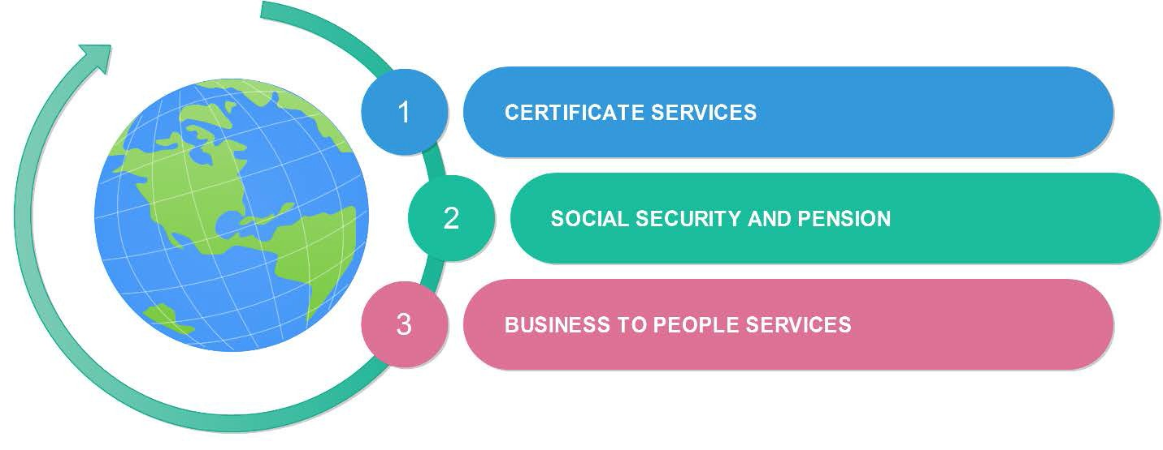

***Figure1: Major Objectives***

* 1. **Benefits**
     + One stop center for citizen service Delivery
     + Eliminate direct visit to Panchayat
     + Convenience of time as well as location
     + Transparent and simple
     + Cost Effective
  2. **Designing of P-to P Centers**

While all P-to-P center aim to integrate multiple services into a single location, they can be differentiated along four primary dimensions that need to be considered during the design stage. They are

* Defining the communication
* Defining the level of service
* Identifying the financial support
* Identifying the participating organizations

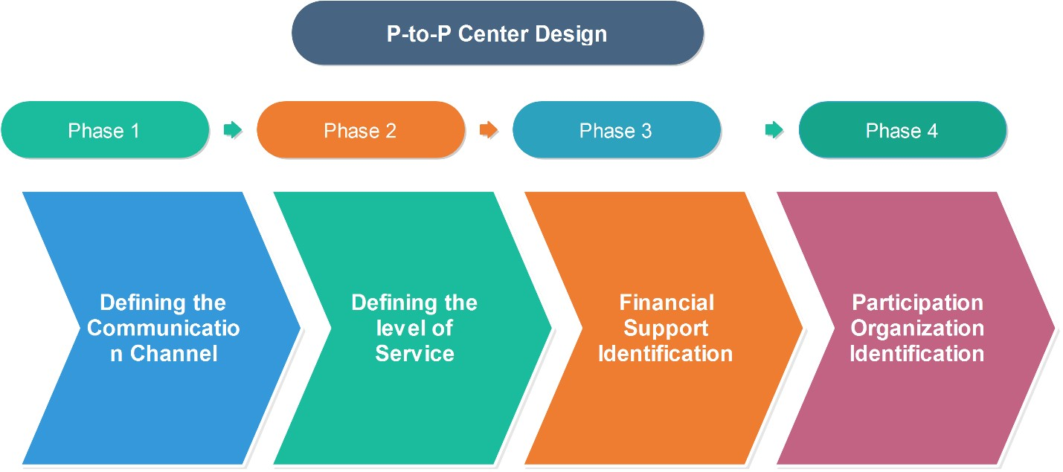

***Figure2: People to People Centre Design***

* 1. **Defining the communication Channel:**

There are three ways of communication is possible in P-to-P system. They are

* Panchayat – Remote center communication
* Remote center – Panchayat communication
* Remote center – Remote Center communication

Depending on the available connectivity and the level of services providing, the channel of communication can be defined

* 1. **Defining the level of service**

Various kinds of citizen service which may range from issuing of certificates to complicated transaction can be provided in the center. The level of service can be categorized into

* + - Information only
    - Limited transactions
    - Complex transactions
  1. **Identifying the financial support**

These P-to-P centers should be initiated in such a way that they will be capable of generating the sufficient revenues to meet their expenses.

* Charging a per transaction fee
* Establishing partnership with private sectors and charge for the delivery of their services
* Finding Government funds
  1. **Identification of participation organization**

Apart from the citizen service, any other service from various organizations can be provided through the remote center. Organizations like Kudumbashree, Anganvadies and other non- government organizations can be attached to these centers and their service also can be make available to the grass root level through these center.

* 1. **Implementation Phase**

The total implementation can be categorized in to the following stages

* Pre –Processing
* Infrastructure Development
* Training to the staff
* Launching
* Monitoring
* Future updation

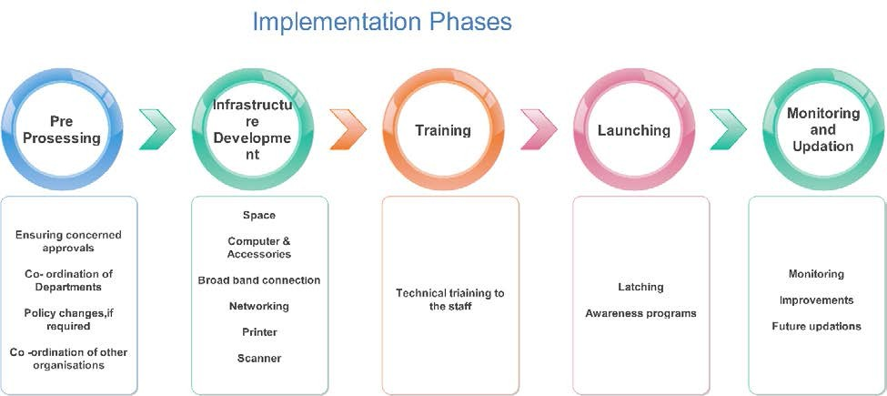

***Figure3: Implementation Phases***

1. **Spatial technology for better Governance** 
   1. **Need for GIS data Generation**

Local administrative bodies are always under the pressure to deliver the citizen services to the people in a timely, efficient and economical and transparent manner. The application of information technology a profound impact on the citizen service delivery. Various reforms of the government emphasis on adopting information technology practices in the planning and management of service delivery.

Lack of updated data is one of the biggest challenge faced by the local administrative bodies in India. Accurate and updated data pertains to the socio-economic factors, utilities, transportation networks, natural resources are basic need of various departments in the local administrative bodies for the better planning and delivery of services. The lack of this data can leads to the partial or total failure of project implementation as well as the service delivery.

Geographic Information System (GIS) id found to provide an integrated solution for all these changes. GIS got the capability of capturing any location based as well as attribute data and integrate it in single digital platform. This bring all data in s single umbrella system. These data can be stored centrally with in the local body so that it will be accessible for various departments depending on their requirements. Secure Web-based solutions will help further if the same data is to be accessed by the authorities situated at different locations across the local body

* Better quality and fast decision making process
* Reducing administrative expense and efficient e-governance
* Planning development activities
* Land use Planning
* Environmental Planning
  1. **Geographic Information System: Sources**

Generally the sources for GIS data generation can be categorized as

1. Remote sensing Data Sources
2. Survey Methods

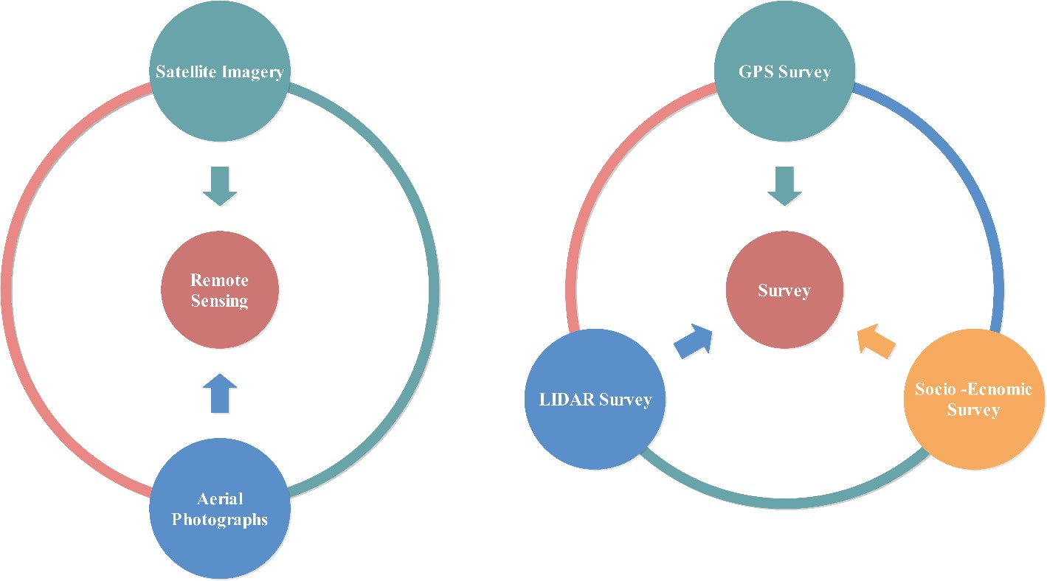

***Figure4: Geospatial System***

* 1. **GIS Data Bank Generation**

Geographic Information System (GIS) is capable of data capturing of various features and integrating it in to a single platform. GIS data generation for local administrative bodies focus on the below verticals

1. Physical Infrastructure
2. Social Infrastructure
3. Natural Resource

|  |  |  |
| --- | --- | --- |
| **Physical Infrastructure** | **Social Infrastructure** | **Natural features** |
| Transportation Network Water Supply  Power  Property(Residential & Commercial) Sewerage  Solid waste management | Education Health  Inclusive Planning | River  Natural drainages Land use Mapping |

***Table1: Data Bank Model***

* 1. **Base map Generation**

Base map is the basic GIS system which allows the user to view the important physical and administrative features in an area. Eg. A base map will contain important features like road, railway lines, landmarks, rivers and other important natural features. This is the basic and key factor for building a GIS based database for the area. The base map will include

* Panchayat Boundary
* Ward Boundary
* Transport Network ( Road & Rail)
* Natural Drainage
* Important landmarks
  1. **Geo enabled road database generation**

A database on road networks such as existing spatial distribution of roads and their possible links to the neighboring roads has been created and updated using Remote Sensing and GIS. It can facilitates unique visualization and querying of the roads with respect to different levels of administration units Mapping of Roads in the corporation help the administration to quickly identify and locate different roads in the corporation. The exact measurement of roads such as lengths, widths etc are also possible. This will be very helpful in transportation management. These road maps can play an important role in urban developmental activities. With the help of these roads it is possible to identify the locations for buildings, over bridges, bye-pass roads, footpaths etc.

* Road Name
* Length and breadth of road
* Carriage Width
* Category
* Surface type
  1. **Land use Mapping**

Land use is the major factor that drives the environmental equilibrium and ecological balance. In present proposal we prepare land use map from updated Satellite imagery and identify the change that happened over a time period. Land use mapping will helps in identifying the utilization of the land, this can be used for identifying the urbanization and future developmental area. By analyzing the change detection we can predict the percentage of land that is converted from one type to another. This can be used for identifying the conversion of forest and agricultural land for various developmental activities.

* 1. **Geo enabled survey and database generation of Property (Tax Mapping)**

Buildings and assets are key factors for the development and urbanization of an area and these are the major source of revenue for the government in form of building taxes. Due to various reasons government is not able to get the exact revenue from taxes as per the rules. GIS helps in property tax management by collecting the database pertaining to tax using GPS survey and satellite images will helps in identifying the physical geometry of the building, this can be verified and updated using satellite image. Once the database is collected by means of ground survey the updating can be done periodically using recent satellite image which will helps in identifying of modification or any new building.

Door to door survey using GPS devise will be conducted to collect the spatial and non-spatial data pertaining to each building within the given administrative boundary. Photographs for each building will be taken along with the house hold survey. Finally the data collected will be integrated in GIS platform to generate a database which will be compactable with the existing database.

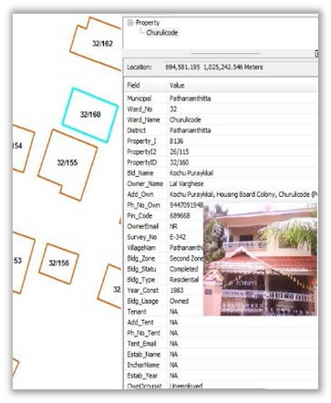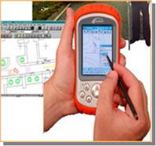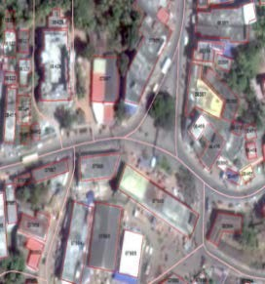

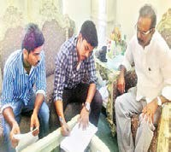

*Figure5: Geo enabled survey and database generation of Property*

* 1. **Web GIS Concept**
* It is enabled with spatial module for viewing, editing and identifying assets with its spatial location
* This system helps to get the geographic details of the location and users can view the details of assets with location and its attributes in a single click.
* The Customized Web Application will help staff and public users to get details of properties and their attributes.
* The centralized database can be updated from anywhere who has the administrator’s privileges with web access.
* The users can get answers to different queries regarding various attributes of each property based on their privileges
  1. **Features**
* **Search**

Upon entering a keyword, the system searches and returns properties related to the keyword. This function is restricted to administrator or higher-level users. Using this option buildings/roads can be searched using Building Name. Building ID, Road Name etc. The building/road that searched thus will be shown as highlighted.

* **Query Builder**

User can create customized queries based on attribute values and predicate logic. The system provides an interface for this and the result can be viewed on the map, restricted to administrator level.

* **Print/Export**

The system allows the users to print/export features on the map depending upon the level of authority. Once logged in, the property owners are able to print the area of the map relating to their property. The admin has rights to print/export any property that is displayed on the map. Users can decide on the necessary details that are to be displayed on the copy meant to be printed, such as scale, legend, title, description, layers to be displayed.

* **Custom Report Generation**

The IPMS system has an inbuilt report generation module. Any custom report can be generated in this module. Following are the major report that cab ne prepared

**3.0 SCOPE OF SERVICES**

The following are the scope of services in this present implementation of the IPMS portal

a) Citizen interface which provides limited access rights. Key features of citizen interface are:

* Building Search – by Owner Name, Property Number Old Or New and Survey Plot
* Administrative Boundary information- Ward, Village, Taluk and Muncipality
* Form Details - Owner information, property information and socio economic parameters on android platform based digital data collection tools.
* Part-print - Plot print with required layers and information
* Search – Predefined queries for data analysis

b) LSGD departmental interface, which consists various functionalities of different department

Users of web portal. The following departments in LSG are using the web application:

* Town planning
* Health
* Revenue
* Engineering

c) This interface allows for provisioning of the following services, benefitting both the organisation and the citizens:

* Web based GIS application for planning, management and governance in context of entire Functioning of the organization.
* Land Use Information System (LIS) which carry spatial as well as non-spatial details of Town - Planning Schemes, Development Plan, etc.
* Property Tax Mapping (i.e. Linking of Property attributes with Building footprints) & Integration of Building Permission approval system
* Incorporation of various physical features viz. Road Network, Railway, Water body, etc.
* Integration of existing applications developed by IKM like Sanchaya
* User-friendly Web based GIS application for various departments of LSGD.

**4.0 STUDY AREA**

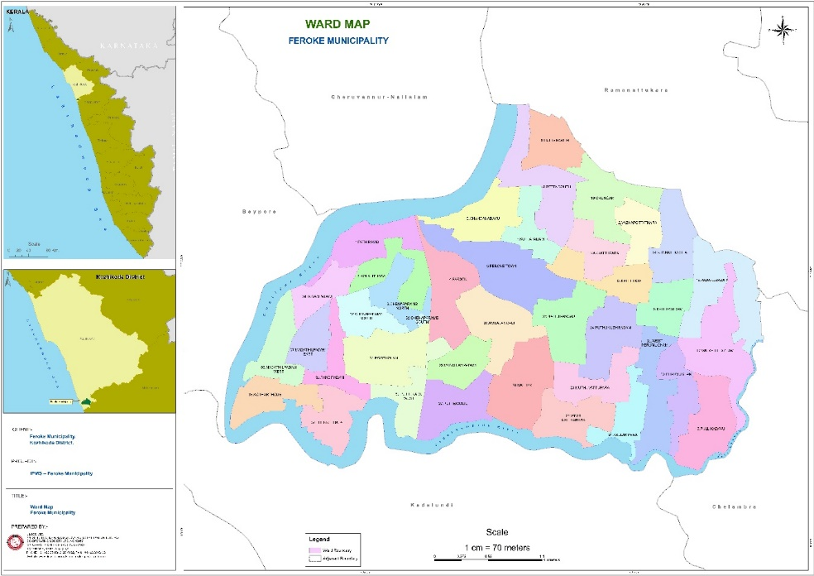The study area ,Feroke [Municipality](https://en.wikipedia.org/wiki/Municipality),  is a part of [Kozhikode metropolitan area](https://en.wikipedia.org/wiki/Kozhikode_Metropolitan_Area) under Kozhikode Development Authority (K.D.A) in the [Kozhikode district](https://en.wikipedia.org/wiki/Kozhikode_district) of the [Indian](https://en.wikipedia.org/wiki/India) [state](https://en.wikipedia.org/wiki/States_and_territories_of_India) of [Kerala](https://en.wikipedia.org/wiki/Kerala). The village was originally named Farookhabad by [Tippu Sultan](https://en.wikipedia.org/wiki/Tippu_Sultan" \o "Tippu Sultan). Later, the name was changed to Feroke by the British. It is assumed that Tipu Sulthan used Feroke as his capital in Malabar. Feroke is the prime place of the [tile](https://en.wikipedia.org/wiki/Tile) industry in Kerala. There are many tile factories in Feroke. Feroke is also well known for its wood and Timber industries. The area lies between 70049’53.12”E longitude and 11010’35.69”N latitude and covering a total area of 13.48 Sq.Km. Feroke municipality is bounded by the Northern and Western part,

***Figure1: Basemap- Feroke Municipality***

Ramanattukara municipality in the Eastern part and Vadakkumbad River in the Southern part. As of the 2001 India census, the literacy rate of Feroke city is 95.99% higher than state average of 94.00%. In Feroke, Male literacy is around 97.67% while female literacy rate is 94.42%.There are about 21824 properties in the Feroke Municipality in which 15400 of them are residential, 5156 commercial properties and 241 industries. Feroke is one of the prominent heritage spots in the Malabar region which is famous for its rich history.

**5.0 WORK FLOW METHODOLOGY**

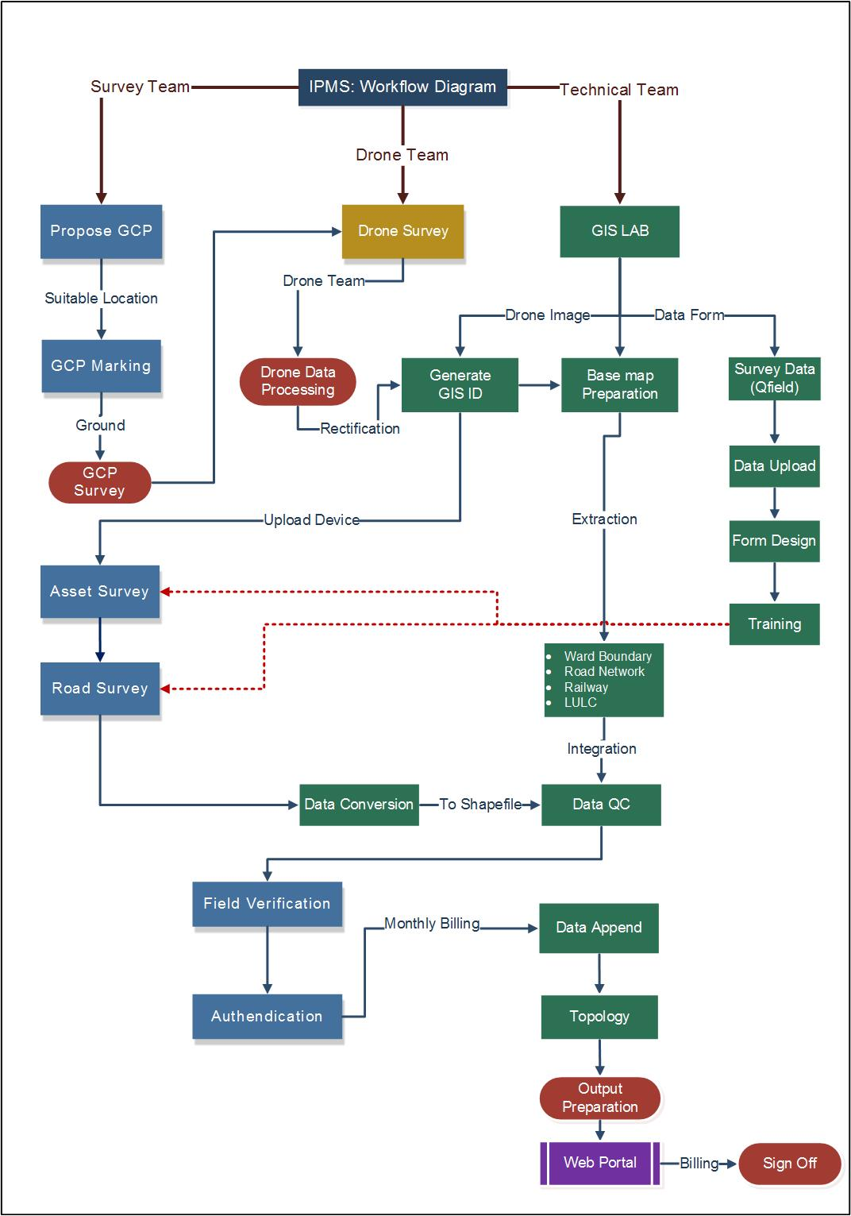

***Figure5: Work Flow- IPMS Project for Feroke Municipality***

**6.0 Technology Employed**

**Reverse Primary Server**

The IPMS application server is stationed behind a firewall to ensure security, Peculiarity about reverse proxy is that, it can provide access to a server behind a firewall. Reverse process can also be used to evenly distribute load among several back-end service or to provide cache for a slower back-end.

**Containers:**

The IPMS portal and web service can glide in this layer whose security is assured behind a firewall. Tomcat can be used for running website whereas instance contains can be used for running web service and portal. For multiple local bodies, individual geo servers are maintained for each local body wherein the data are stored using independent servers.

**Database:**

Postgres SQL database is employed to hold application and Geospatial data. In case of multiple local bodies, an individual database for each local body is maintained, where the data is kept in independent servers. As in previous cases, the database too can the kept in a separate server pertaining to budget and security constraints.

**Database backup server**

When heading towards storage of very important data, always a database backup server is essential. Hence, the database backup server is set in another machine which is placed in another physical location and a database backup script can be run on a daily basis.

**7.0 BENEFITS TO LSGD**

The GIS web application is being extensively used by the Town Planning Department, Revenue and Engineering Department.

**Centralised database of all departments:** The GIS application has created a central repository of all departments. All the departments of LSGD can now easily access the centralized GIS database through web GIS application. It facilitates the inter-department functionality easily because of centralized repository of data and its access. This GIS platform provides support for operational functions and decision making.

**Efficient planning tool for decision making:** The GIS portal can form as the basis for an informed decision making since the layers of information can be displayed for easy assimilation and understanding for faster decision making. Few examples of the layers so designed on direction from the Municipality officials is given below:-

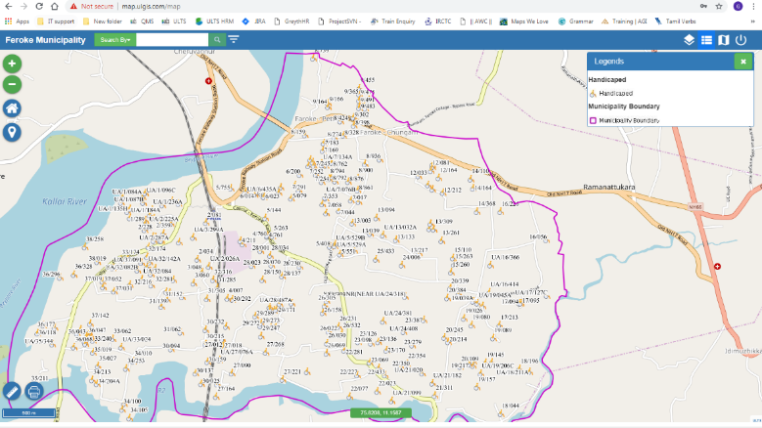 ***Figure6: Interface for displaying the location of Handicapped individuals in the Feroke Municipality***

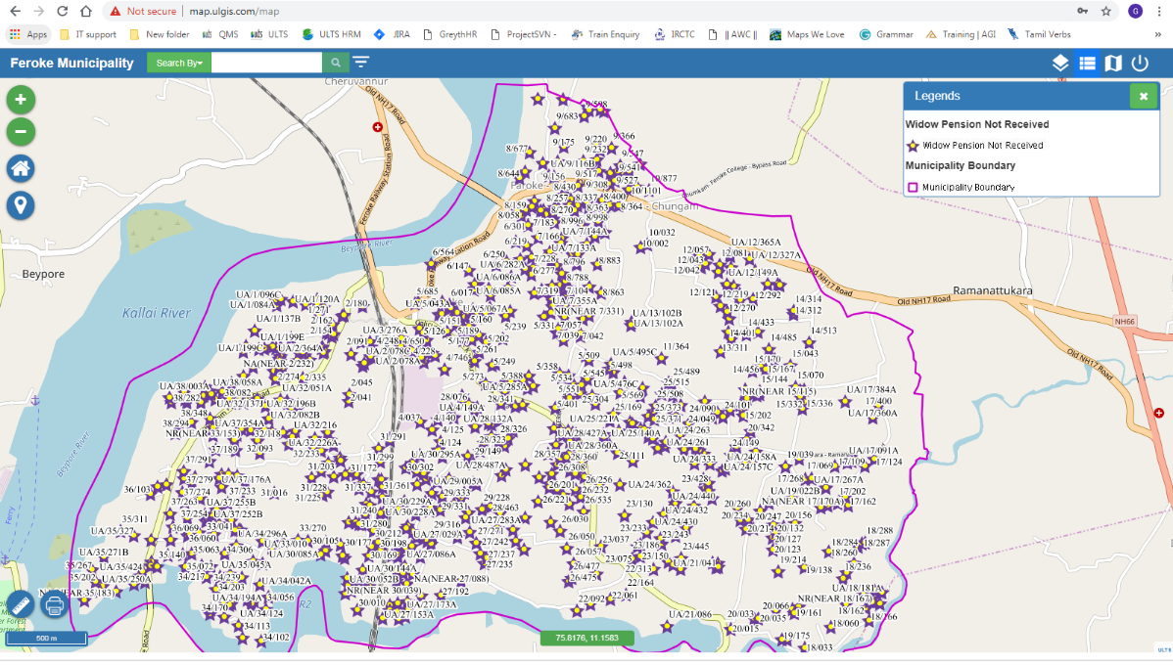

***Figure7: Snapshot of application interface for Widow Pension not received***

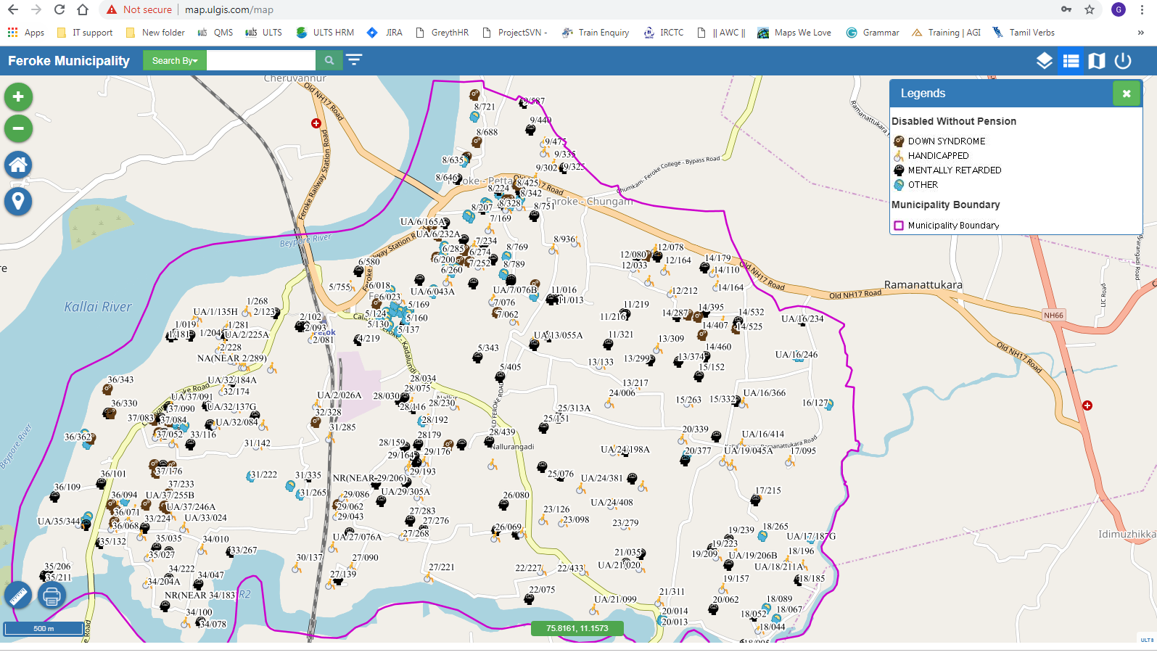

***Figure8: Snapshot of application interface for Disabled without pension***

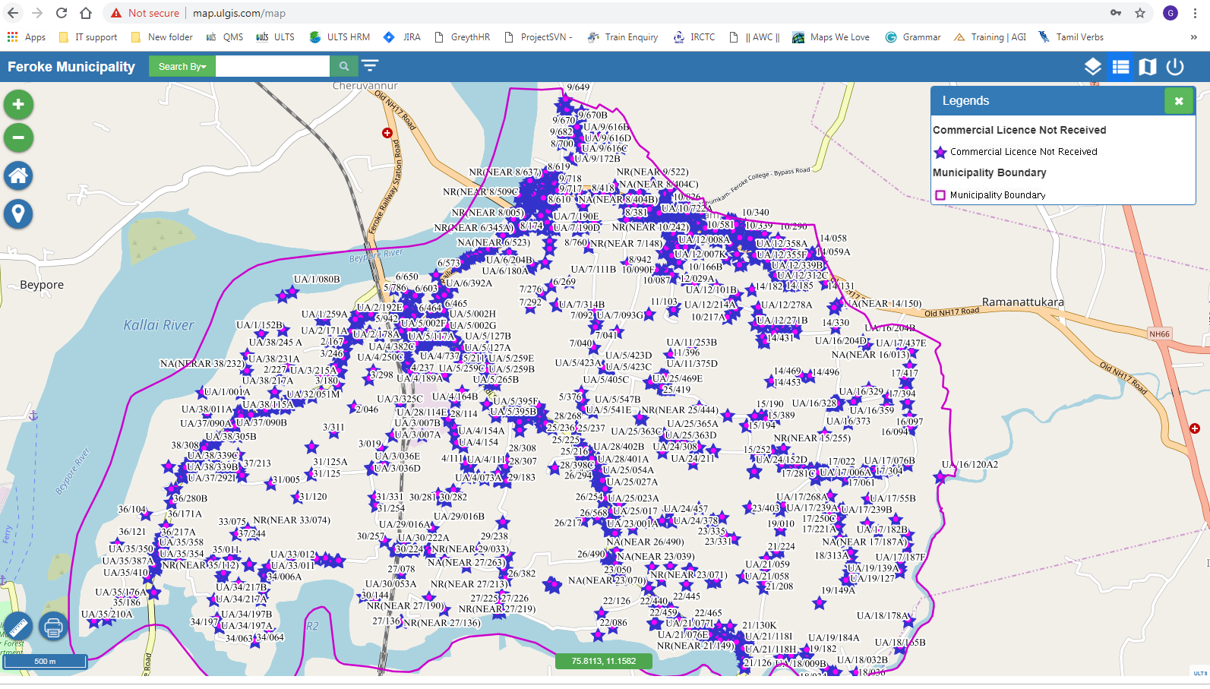

***Figure9: Snapshot of application interface for Commercial Licence Not received***

**Improved property tax collection:** The application has also facilitated improvement in revenue realisation as it allows for geographical representation of tax defaulters. The application is not exactly used for property tax collection but it can be used to assess which areas are not paying the property tax and due to this ‘automatically’ results can be increased because the visualisation of data can facilitate better assessment and action.

**Public Health benefits:** The web application has also been linked to the tracking of malaria cases using tablet based devices. This includes coverage of potential malaria cases, follow-up of positive cases, and identification of water logging/ mosquito breeding sites.

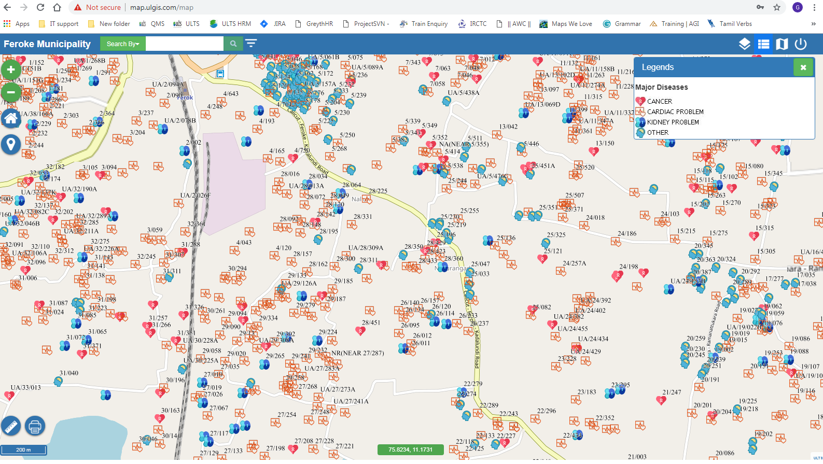

***Figure7: Snapshot of application interface for household wise disease details***

**8.0 BENEFITS TO CITIZENS**

All the departments of LSGD can now easily access the centralized GIS database through web GIS application. It facilitates the citizens to access the local body data like building plan permission details, building use certificate, etc.

Building plan approval like name of the builder, type of plan approved, legality of the building, no of dwelling units sanctioned, etc.

Citizens can print part plans through the application and do not have to visit the LSGD offices anymore for this purpose. They can also get authorized plot map information and building permission using internet which saves time and money.

**9.0 CHALLENGES**

The entire process of data collection, coordination with different departments and conducting the property survey was not without challenges.

* Data collection from, specifically the property tax data of 21824 household was an onerous job that needed to be completed within a month.
* Non co-operation of individual house holder to disclose the property information during survey.
* Data capturing for unoccupied houses.
* Repeated visits due to noncooperation or absence of property holders.
* The digitization and the linking of the tax data attributes with the building footprints, required special skill and huge manpower for such a large data.
* The property survey was an extensive process as individual houses had to be verified. Municipality had to make multiple iterations to their first methodology of property survey and used a new improved one then. Eventually, the field staff checked tenement certificates for all properties.
* The digitized maps were transferred to shape files for the use in GIS and the data as attributes were linked. Conversion of hard copy maps to digital form and integrating the large amount of associated data, both for utility networks as well as cadastral maps was a time-consuming process.
* Coordination of all departments and zones to procure attribute data for different modules was challenging. There was some difficulty for transfer to new platform due to ignorance of the GIS technology and its applicability in office management, but overall the consultants were of the view that municipal staff was quite supportive throughout the process.

**10.0 FUTURE PLANS**

LSGD is in the process of using drone image for the GIS platform and then a new mapping process will be undertaken so that new property and utility developments can be integrated on the application. An online self-assessment portal will also reduce the field visits that are presently required for data collation. The data can even be collated using voice bot applications for interactive help to the users. In a geospatial context, enterprise integration will be needed to move information from departmental systems to the central data repository, and eventually have new and larger systems which will alter stakeholder relationships and responsibilities.

**11.0 CONCLUSION**

The main benefit of Intelligent Property Management System designed by ULCCS is that, it helps to digitize the property data on a GIS platform enabling better scrutiny of the property tax collection and also in planning of welfare and developmental schemes in the specific local bodies. Use of such systems have demonstrated an increase in tax revenue in LSG by over 40% in terms of additional revenue. However the existing gaps in the existing LSG enterprise and the integrated GIS solution need to be further identified and documented. It could include public safety data, permitting data, work order data, or crowdsourcing information. Future opportunities exist to integrate those databases effectively be into the enterprise GIS initiative.

**REFERENCES**

1. Ofori, M. (1998), “Real property and land-based tax for development: Ghanaian perspective”, paper delivered at International Seminar on Property-based Taxation, Abuja, Nigeria.
2. Pareta, (2017), “Applications of GIS: Property Tax Mapping and Management System”, 17th Esri India User Conference 2017, Delhi.
3. Rees, W.E. (1990), “The ecology of sustainable development”, The Ecologist, Vol. 20 No. 1, pp. 18-23.
4. Samuel B Biitir, John K Assiamah. 2015. Mobilising sustainable local government revenue in Ghana: modelling property rates and business taxes. *Common wealth Journal of Local Governance*, ahead of print.
5. Visvalingam, M. 1989. Cartography, GIS & Maps in Perspective. Cartographic Journal. Vol. 26(1), pp. 26-32.
6. David A. Holdstock. 28 Sep 2016, 3 The Formula for Success from: Strategic GIS Planning and Management in Local Government CRC Press