Unix Domain Socket Test Port for TTCN-3 Toolset with TITAN, Function Specification

Contents
1 Introduction 2
1.1 Revision history 2
1.2 How to Read this Document 2
1.3 Scope 2
1.4 References 2
1.5 Abbreviations 2
1.6 Terminology 3
2 General 3
3 Function Specification 3
3.1 Implementation 3
3.1.1 Module structure 3
3.2 Configuration 4
3.3 Operation mode 4
3.4 Start Procedure 4
3.5 Sending/Receiving UD ASPs 4
3.5.1 UD ASP sent by the test port 4
3.5.2 UD ASP received by the test port 4
3.6 Logging 5
3.7 Error Handling 5
3.8 Closing Down 5
3.9 Limitations 5

Introduction

Revision history

Date | Rev | Characteristics | Prepared
2010-10-08 | PA1 | First draft version | EKRIPND
2013-09-06 | A | References updated | ESCHZOL

How to Read this Document
This is the Function Specification for the UD test port. The UD test port is developed for the TTCN-3 Toolset with TITAN. This document is intended to be read together with Product Revision Information [3] and the User’s Guide [4].

Scope
The purpose of this document is to specify the functionality of the UD test port. The document is primarily addressed to the end users of the product. Basic knowledge of TTCN-3 and TITAN TTCN-3 Test Executor is valuable when reading this document (see [1] and [2]).
This document is based on specifications of Unix Domain Socket Protocol.

References

ETSI ES 201 873-1 (2002)
The Testing and Test Control Notation version 3. Part 1: Core Language

1/198 17-CRL 113 200/3 Uen
User Guide for the TITAN TTCN-3 Test Executor

109 21-CNL 113 702-1 Uen
Unix Domain Socket Test Port for TTCN-3 Toolset with TITAN, Product Revision Information

198 17-CNL 113 702 Uen
Unix Domain Socket Test Port for TTCN-3 Toolset with TITAN, User Guide

Abbreviations
API Application Programming Interface
ASP Abstract Service Primitive
RTE Run-Time Environment
SUT System Under Test
TTCN-3 Testing and Test Control Notation version 3
UD Unix Domain

Terminology
-

General
The UD Test Port makes it possible to execute test suites towards a SUT. The test port offers UD primitives to the test suite and communicates with the SUT.
The communication between the UD test port and the TITAN RTE is done by using the API functions described in [2]. The UD protocol messages are then transferred by the UD test port to the SUT.
Figure 1. below shows the overview of the system:
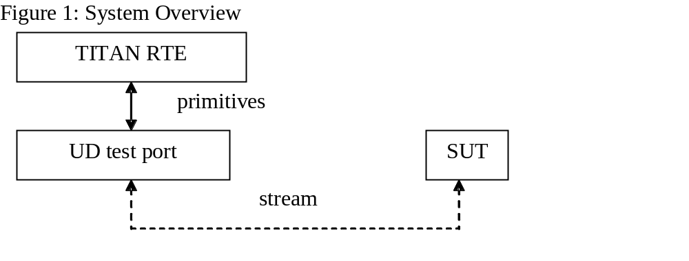

Function Specification

Implementation
The UD layer is implemented in UNIX kernel. The test port implements the communication between UNIX UD sockets and the TTCN-3 UD.

Module structure
The UD test port is implemented in the following TTCN-3 blocks:
- UD_Types.ttcn
- UD_PortType.ttcn
The file UD_Types.ttcn defines the UDP ASP. The port type is defined in UD_PortType.ttcn.
The C++ implementation of the test port is contained in the following files:
- UD_PT.hh
- UD_PT.cc

Configuration
-

Operation mode
Operation mode of the test port
- A UD interface provides the following port operations: create server socket, create client socket, close client/server socket, send and receive data. One test port can handle multiple UD sockets.

Start Procedure
The user has to make sure that the target system is up and running. When the executable test suite is started it initializes the UD socket. After the initialization is ready, the transmission of the ASPs can begin.

Sending/Receiving UD ASPs
When the communication between the UD test port and the target system is set up, the test port starts transferring the UD primitives towards the TITAN RTE and UD streams towards the SUT.

UD ASP sent by the test port
The UD test port is able to send the following UD:
- UD_send_data
- UD_close
- UD_connect
- UD_listen
- UD_shutdown

UD ASP received by the test port
The UD test port is able to receive the following type of UDP primitives:
- UD_send_data

Logging
The type of information that will be logged can be categorized into two groups. The first one consists of information that shows the flow of the internal execution of the test port, e.g. important events, which function that is currently executing etc. The second group deals with presenting valuable data, e.g. presenting the content of a PDU. The logging printouts will be directed to the RTE log file. The user is able to decide whether logging is to take place or not by setting appropriate configuration data, see [4].

Error Handling
Erroneous behaviour detected during runtime is shown on the console and directed into the RTE log file. The following two types of messages are handled:
- Errors: information about errors detected is provided. If an error occurs the execution of the test case will stop immediately and the socket will be closed.
- Warnings: information about warnings detected is provided. The execution continues after the warning is shown.

Closing Down
After the test port has executed all test cases it will stop automatically. It will close down the UD socket towards the SUT and terminate.
The execution of the test suite can be stopped at any time by pressing <Ctrl>-c. Before the executable terminates the socket is closed down.

Limitations
The operating system is Solaris 5.8.

