Unix Domain Socket Test Port for TTCN-3 Toolset with TITAN, User's Guide

Contents
1 Introduction 2
1.1 Revision history 2
1.2 About this Document 2
1.2.1 How to Read this Document 2
1.2.2 Prerequisite Knowledge 2
1.2.3 References 2
1.2.4 Abbreviations 2
1.2.5 Terminology 3
1.3 System Requirements 3
1.4 Fundamental Concepts 3
2 The Test Port 3
2.1 Overview 3
2.2 Installation 4
2.3 Operation modes 4
2.3.1 Advanced mode 4
2.4 Configuration 5
2.5 Start Procedure 5
2.5.1 TTCN-3 Test Executor 5
2.6 Sending UD ASPs 5
2.7 Receiving UD ASPs 6
2.8 Stop Procedure 6
2.8.1 TTCN-3 Test Executor 6
3 Examples 6
3.1 Error messages 6
3.2 Warning messages 7

Introduction

Revision history

Date | Rev | Characteristics | Prepared
2010-10-08 | PA1 | First draft version | EKRIPND
2013-09-06 | A | References updated | ESCHZOL

About this Document

How to Read this Document
This is the User’s Guide for the UD test port. The UD test port is developed for the TTCN-3 Toolset with TITAN. This document is intended to be read together with Product Revision Information [3] and Function Specification [4].

Prerequisite Knowledge
The knowledge of the TITAN TTCN-3 Test Executor [2] and the TTCN-3 language [1] is essential. Basic knowledge of the UD protocol is valuable when reading this document.

References

ETSI ES 201 873-1 (2002)
The Testing and Test Control Notation version 3. Part 1: Core Language

1/198 17-CRL 113 200/3 Uen
User Guide for the TITAN TTCN-3 Test Executor

109 21-CNL 113 702-1 Uen
Unix Domain Socket Test Port for TTCN-3 Toolset with TITAN, Product Revision Information

155 17-CNL 113 702 Uen
Unix Domain Socket Test Port for TTCN-3 Toolset with TITAN, Function Specification

Abbreviations
ASP Abstract Service Primitive
RTE Run-Time Environment
SUT System Under Test
TTCN-3 Testing and Test Control Notation version 3
UD Unix Domain

Terminology
-

System Requirements
In order to operate the UD test port the following system requirements must be satisfied:
- Platform: Solaris 5.8
- TITAN TTCN-3 Test Executor version R7A (1.7.pl0) or higher installed. For installation guide see [2]. Please note: This version of the test port is not compatible with TITAN releases earlier than R7A.
- The same C compiler gcc version installed which the TITAN was compiled with. See the Release Notes of TITAN.
For other known limitations please see the FS [4].

Fundamental Concepts
The test port establishes UD connection between the TTCN-3 test executor and the SUT. The test port transmits and receives UD protocol messages between the TITAN RTE and the SUT.

The Test Port

Overview
The UD test port offers UD primitives to the test suite in TTCN-3 format. The TTCN-3 definition of the ASPs can be found in a separate TTCN-3 module. This module should be imported into the test suite.
The test port transfers UD primitives towards the TITAN RTE and UD datagrams towards the SUT. The overview of the test system is shown on figure 1. below:
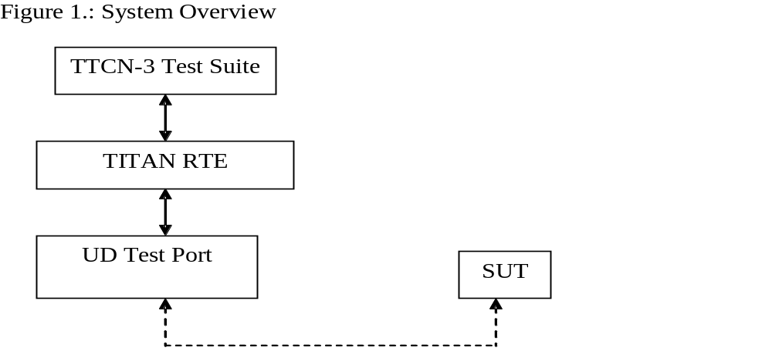

Installation
Since the UD test port is used as a part of the TTCN-3 test environment this requires TTCN-3 Test Executor to be installed before any operation of the UDP test port. For more details on the installation of TTCN-3 Test Executor see the relevant section of [2].
When building the executable test suite the libraries provided for the TTCN-3 Test Executor should also be linked into the executable. For more information see also [2].

Operation modes

Advanced mode

Description
In advanced mode the test port provides the following functionality:
- open client/server socket
- close client/server socket
- send and receive data
The port can handle several UD sockets.

ASP definition
- UD_send_data
- UD_close
- UD_connect
- UD_listen
- UD_shutdown

Configuration
-

Start Procedure

TTCN-3 Test Executor
Before the executable test suite can be run the TTCN-3 modules and C++ codes should be compiled and linked into an executable program. This process can be automated using the make utility. The way how the Makefile should be generated is described in [2]. Note that the C++ implementation files UD_PT.hh and UD_PT.cc of the test port should be included in the Makefile.
If the executable test suite is ready, run it giving the RTE configuration file as argument in your terminal:
Home> ExecutabletestSuite RTEConfigurationFile.cfg
For more information, see [2].

Sending UD ASPs

Open a new server socket
The opening of a new server socket is requested by the sending of the UD_listen message to the test port. The parameter path contains the path of the Unix Domain Socket.
The test port answers the listen request with the UD_listen_result.

Open a new client socket
The opening of a new client socket is requested by the sending of the UD_connect message to the test port. The parameter path contains the path of the Unix Domain Socket.
The test port answers the connect request with the UD_connect_result.
The server test port answers the connect request with the UD_connected.

Sending data
The data sending is requested with the UD_send_data message.
The data parameter contains the data to be transmitted.
The id specifies the socket used during data sending.

Close the server socket.
The close the server socket operation is requested by the UD_shutdown message.
The id identifies the socket to be closed.

Close the client socket.
The close the client socket operation is requested by the UD_close message.
The id identifies the socket to be closed.

Receiving UD ASPs

Receiving data
The data receiving is indicated via UD_send_data message.
The data parameter contains the data to be received.
The id specifies the socket used during data sending.

Stop Procedure

TTCN-3 Test Executor
The test port should stop automatically after it finished the execution of all test cases. It closes down the open UD sockets towards the SUT and terminates.
The execution of the test suite can be stopped at any time by pressing <Cntr>-c. It will shut down the socket and terminate.

Examples

Error messages
Cannot open socket
The socket system call fails.
User_map
Conn_list or conn_list_server is not Null
Send system call failed: <n> bytes was sent instead of <m>
The send system call fails.
Send system call failed: Write error
The send system call fails.

Warning messages
The following list shows the possible warning messages produced by the test port:
Cannot open socket
The socket system call fails.
Cannot bind port
The socket system call fails.
Error while listening
The socket system call fails

