Mobile Mediation Platform
Developer Guide
Summary

Object 3
Document goal 3
Overview 4
MMP Components 6
Entry point 6
Core components 7
Data Access Object 13
Logging component 24
Internationalization 28
Cache 31
Content Adaptation 36
File 40
Message 44
API 48
Net 53
Webpart 59
Modules 65
SMS 72
Filter 76
Annex 1: Environment 80
Build 80
Run 85
Object
Document goal
This document aims to describe the Mobile Mediation Platform (MMP). It gives information about functional and technical architecture of the server. This document should be used by technical teams to use and modify this application server for specific needs.

Overview

The Mobile Mediation Platform (MMP) is the Spring-based applicative server used to deploy and handle three kinds of modules:
- services (also known as bundles),
- libraries,
- mobile widgets.

MMP API can be accessed by installed services, and can also be enriched by features provided by these services.

Bundles and widgets must provide a specific configuration file called mmp-config.xml, which describes which methods should be exposed.

The diagram below shows MMP classes:
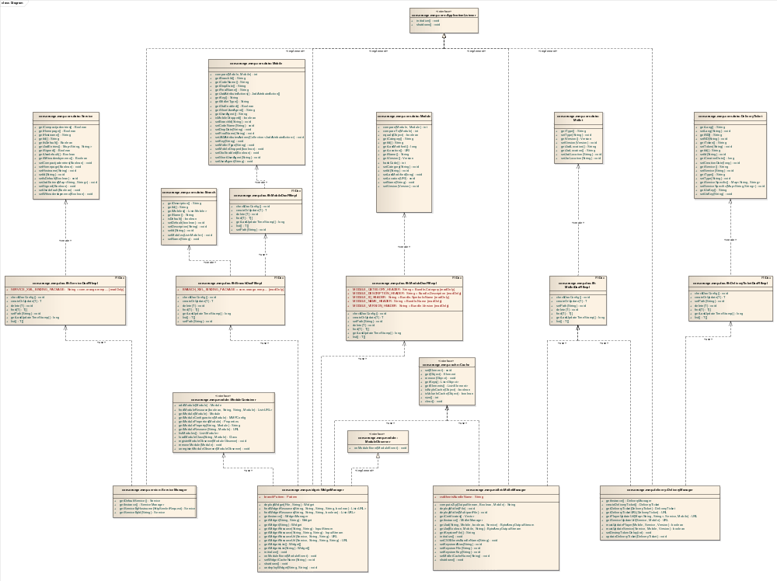
MMP class diagram

MMP is a Spring-based application, so it disposes of the concepts proposed by the Spring framework, especially inversion of control (IoC).

MMP entry point is the base.xml file. It lists the application components, which are each described in an XML file. Each of them is in charge of one MMP functional block. This implementation is described in the Entry point part.

The application core is built on components providing mobile solutions. These core components are detailed in the Core components part.

Data access in MMP is managed through a DAO design pattern, and data are all stored in a shared repository. These mechanisms are detailed in the Data Access Object part.

Other components are available, as a SMS broker, a logging component, cache implementation... They are all described in the rest of the document.

MMP Components

Entry point
The base.xml file is MMP main configuration file, and the application entry point, as defined in the web.xml file:
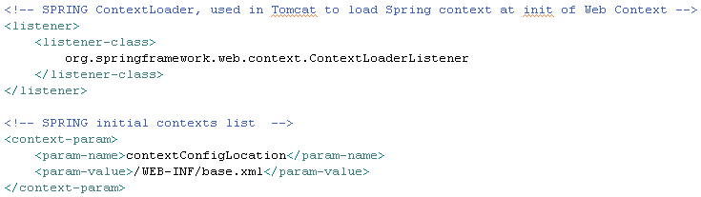
web.xml fragment

The Spring application context is linked to the J2EE web app context through the base.xml file: it lists Spring configuration files, and each of them defines a component injected in the application. These components can be used in the modules loaded in MMP.

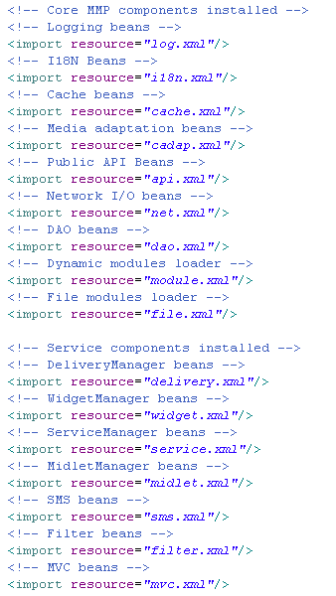
base.xml fragment

This set of files composes the application functional logic layer. Dependencies exist between these components. For example, if a component uses another, it must be placed below in the list.

The base.xml file also defines the main application controller, as shown below:
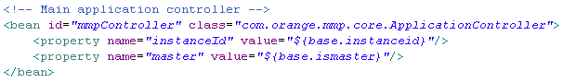
base.xml fragment

This component aims to control other components behavior, depending on application state.

Core components
The application core is described in four configuration files, which each defines a component providing solutions adapted to mobiles. The components are the following:
- MidletManager (described in midlet.xml), used to manage midlets,
- DeliveryManager (described in delivery.xml), which handles midlets delivery,
- ServiceManager (described in service.xml), used to configure and handle services localization,
- WidgetManager (described in widget.xml), used to manage the catalog of widgets provided by the platform.

All MMP components must implement the ApplicationListener interface, which provides the required initialize() and shutdown() methods.
They are all singletons, instanciated by Spring when the application starts.

ApplicationListener Interface
Connections
Connector | Source | Target
Realization  Source -> Destination | Public  DeliveryManager | Public  ApplicationListener
Realization  Source -> Destination | Public  FelixOSGiContainer | Public  ApplicationListener
Realization  Source -> Destination | Public  SocketConnectionManager | Public  ApplicationListener
Realization  Source -> Destination | Public  HttpConnectionManager | Public  ApplicationListener
Realization  Source -> Destination | Public  InternationalizationManager | Public  ApplicationListener
Realization  Source -> Destination | Public  EHCacheManager | Public  ApplicationListener
Realization  Source -> Destination | Public  WidgetManager | Public  ApplicationListener
Realization  Source -> Destination | Public  FlfDaoManager | Public  ApplicationListener
Realization  Source -> Destination | Public  Log4jLogManager | Public  ApplicationListener
Realization  Source -> Destination | Public  SMSFactory | Public  ApplicationListener
Realization  Source -> Destination | Public  MMPFilterDispatcher | Public  ApplicationListener
Realization  Source -> Destination | Public  MidletManager | Public  ApplicationListener
Realization  Source -> Destination | Public  ServiceManager | Public  ApplicationListener
Realization  Source -> Destination | Public  JMSMessageBroker | Public  ApplicationListener
Realization  Source -> Destination | Public  DefaultFileManager | Public  ApplicationListener
Realization  Source -> Destination | Public  DefaultInternationalizationManager | Public  ApplicationListener

Operations
Method | Notes | Parameters
initialize() void
Public
shutdown() void
Public

MidletManager Class
Connections
Connector | Source | Target | Notes
Dependency  Source -> Destination | Public  MidletManager | Public  MidletDaoFlfImpl
Dependency  Source -> Destination | Public  MidletManager | Public  Cache
Realization  Source -> Destination | Public  MidletManager | Public  ApplicationListener

Attributes
Attribute | Notes | Constraints and tags
cssSheetsBundleName String  Public |  | Default:
keystoreAlias String  Private |  | Default:
keystoreFile String  Private |  | Default:
keystoreKey String  Private |  | Default:
launcherPattern Pattern  Private  Static |  | Default:
MIDLET_LAST_MODIFICATION_DATE long  Private  Static Const |  | Default: 1220863782000L
midletCache Cache  Private |  | Default:
midletCacheName String  Private |  | Default:
midletManagerSingleton MidletManager  Private  Static |  | Default:

Operations
Method | Notes | Parameters
computeZip() String  Public |  | OutputStream [in] output  Boolean [in] signMidlet  Mobile [in] mobile
deployMidlet() void  Public |  | File [in] midletFile
deployMidlet() void  Public |  | MultipartFile [in] uploadedFile
getCertificates() Vector
Public
Static getInstance() MidletManager
Public
getJad() ByteArrayOutputStream  Public |  | Service [in] service  boolean [in] signMidlet  Mobile [in] mobile  String [in] ticketId
getJar() ByteArrayOutputStream  Public |  | Boolean [in] isMidletSigned  Mobile [in] mobile  String [in] appId
getKeystoreFile() String
Public
initialize() void
Public
setCSSSheetsBundleName() void  Public |  | String [in] cssSheetsBundleName
setKeystoreAlias() void  Public |  | String [in] keystoreAlias
setKeystoreFile() void  Public |  | String [in] keystoreFile
setKeystoreKey() void  Public |  | String [in] keystoreKey
setMidletCacheName() void  Public |  | String [in] midletCacheName
shutdown() void
Public

DeliveryManager Class
Connections
Connector | Source | Target | Notes
Realization  Source -> Destination | Public  DeliveryManager | Public  ApplicationListener
Dependency  Source -> Destination | Public  DeliveryManager | Public  DeliveryTicketDaoFlfImpl
Dependency  Source -> Destination | Public  DeliveryManager | Public  MidletDaoFlfImpl

Attributes
Attribute | Notes | Constraints and tags
deliveryManagerSingleton DeliveryManager  Private  Static |  | Default: null
destroyTokenDelay int  Private |  | Default: 60
isRunning boolean  Private |  | Default:

Operations
Method | Notes | Parameters
getDeliveryTicket() DeliveryTicket  Public |  | DeliveryTicket [in] deliveryTicket
createDeliveryTicket() DeliveryTicket
Public
getDeliveryTicketURL() URL  Public |  | DeliveryTicket [in] deliveryTicket
Static getInstance() DeliveryManager
Public
getPlayerUpdateUrl() URL  Public |  | Service [in] service  Mobile [in] mobile  Map<String, String> [in] serviceEntries
getServiceUpdateUrl() URL  Public |  | Service [in] service  Mobile [in] mobile
initialize() void
Public
mustUpdatePlayer() boolean  Public |  | Mobile [in] mobile  Service [in] service  Version [in] playerVersion
mustUpdateService() boolean  Public |  | Service [in] service  Mobile [in] mobile  Version [in] serviceVersion
setDestroyTokenDelay() void  Public |  | int [in] destroyTokenDelay
shutdown() void
Public

ServiceManager Class
Connections
Connector | Source | Target | Notes
Realization  Source -> Destination | Public  ServiceManager | Public  ApplicationListener
Dependency  Source -> Destination | Public  ServiceManager | Public  ServiceDaoFlfImpl

Attributes
Attribute | Notes | Constraints and tags
defaultService Service  Private |  | Default:
serviceManagerSingleton ServiceManager  Private  Static |  | Default:

Operations
Method | Notes | Parameters
getDefaultService() Service
Public
Static getInstance() ServiceManager
Public
getServiceByHostname() Service  Public |  | HttpServletRequest [in] request
getServiceById() Service  Public |  | String [in] id
initialize() void
Public
shutdown() void
Public

WidgetManager Class
Connections
Connector | Source | Target
Dependency  Source -> Destination | Public  WidgetManager | Public  BranchDaoFlfImpl
Dependency  Source -> Destination | Public  WidgetManager | Public  ModuleDaoFlfImpl
Realization  Source -> Destination | Public  WidgetManager | Public  ModuleObserver
Realization  Source -> Destination | Public  WidgetManager | Public  ApplicationListener
Dependency  Source -> Destination | Public  WidgetManager | Public  ModuleContainer
Dependency  Source -> Destination | Public  WidgetManager | Public  Cache

Attributes
Attribute | Notes | Constraints and tags
branchPattern Pattern  Public  Static |  | Default:
isRunning boolean  Private |  | Default:
widgetCacheName String  Private |  | Default:
widgetManagerSingleton WidgetManager  Private |  | Default:
widgetsCache Cache  Private |  | Default:

Operations
Method | Notes | Parameters
deployWidget() Widget  Public |  | File [in] widgetFile  String [in] branchId
findWidgetResources() List<URL>  Public |  | String [in] resourcePath  String [in] resourcePattern  String [in] widgetId  String [in] branchId  boolean [in] recurse
findWidgetResources() List<URL>  Public |  | String [in] resourcePath  String [in] resourcePattern  String [in] widgetId  boolean [in] recurse
Static getInstance() WidgetManager
Public
getWidget() Widget  Public |  | String [in] widgetId  String [in] branchId
getWidget() Widget  Public |  | String [in] widgetId
getWidgetResource() InputStream  Public |  | String [in] resourcePath  String [in] widgetId
getWidgetResource() InputStream  Public |  | String [in] resourcePath  String [in] widgetId  String [in] branchId
getWidgetResourceUrl() URL  Public |  | Service [in] currentService  String [in] resourcePath  String [in] widgetId
getWidgetResourceUrl() URL  Public |  | Service [in] currentService  String [in] resourcePath  String [in] widgetId  String [in] branchId
getWidgetsList() Widget[]
Public
getWidgetsList() Widget[]  Public |  | String [in] branchId
initialize() void
Public
onModuleEvent() void  Public |  | ModuleEvent [in] moduleEvent
setWidgetCacheName() void  Public |  | String [in] widgetCacheName
shutdown() void
Public
undeployWidget() void  Public |  | String [in] branchId  String [in] widgetId

Data Access Object
There is no database used on MMP. Resources are stored in a shared repository and retrieved using a file access. As there is no need to index data, this method is not time consuming and offers a simple way to install a new MMP instance.

However, all code relative to access of resources and data is based on DAO design pattern and can be reused/extended to support a database or add objects to shared repository.

Furthermore, Data Access Object on MMP is based on Factory Design Pattern: the DaoManagerFactory creates DaoManager objects. As seen above, there is only one implementation of DaoManager: FlfDaoManager, used for flat files. The FlfDaoManager lists all FlfDao objects.

All code dedicated to DAO can be found in:
com.orange.mmp.dao

To add a new resource to DAO:
- create a POJO class relative to your resource (ex : Mobile),
- implement the DAO using the current DAO implementation used on MMP.

As seen above, the default DAO implementation for file access is based on:
com.orange.mmp.dao.flf.FlfDao

Your implementation must extend this support class, and implement the Dao interface. The DAO implementation must be added to the list of DAO based on flat files, in dao.xml, and the folder relative to the resource to access must be defined. In the example below, the path values are replaced by those contained in the mmp.properties configuration file.
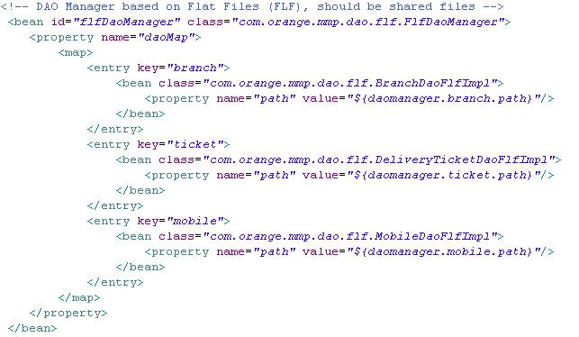
dao.xml fragment

To implement a DAO based on database access, it's then possible to use the existing support classes of Spring framework:
- org.springframework.orm.hibernate3.support.HibernateDaoSupport
- org.springframework.orm.jpa.support.JpaDaoSupport
- …

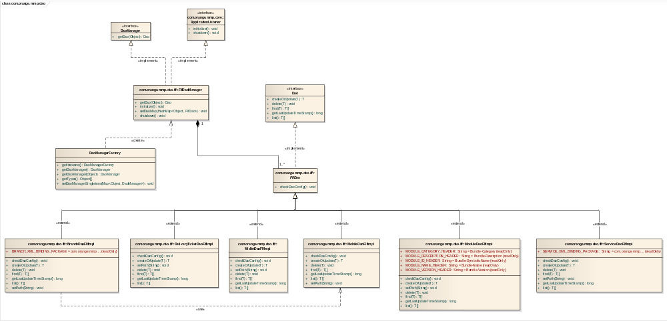
MMP DAO Class Diagram

DaoManagerFactory Class
Connections
Connector | Source | Target | Notes
Dependency  Source -> Destination | Public  DaoManagerFactory | Public  FlfDaoManager

Attributes
Attribute | Notes | Constraints and tags
daoManagerFactorySingleton DaoManagerFactory  Private |  | Default:
daoManagerSingletons Map<Object, DaoManager>  Private |  | Default:
defaultDaoManagerSingleton DaoManager  Private |  | Default

Operations
Method | Notes | Parameters
getDaoManager() DaoManager
Public
getDaoManager() DaoManager  Public |  | Object [in] type
getInstance() DaoManagerFactory
Public
getTypes() Object[]
Public
setDaoManagerSingletons() void  Public |  | Map<Object, DaoManager> [in] fileManagerSingletons

DaoManager Interface
Connections
Connector | Source | Target | Notes
Realization  Source -> Destination | Public  FlfDaoManager | Public  DaoManager

Operations
Method | Notes | Parameters
getDao() Dao  Public |  | Object [in] daoKey

Dao Interface
Connections
Connector | Source | Target | Notes
Realization  Source -> Destination | Public  FlfDao | Public  Dao

Operations
Method | Notes | Parameters
createOrUpdate() T  Public |  | T [in] entry
delete() void  Public |  | T [in] entry
find() T[]  Public |  | T [in] entry
getLastUpdateTimeStamp() long
Public
list() T[]
Public

FlfDaoManager Class
Connections
Connector | Source | Target | Notes
Dependency  Source -> Destination | Public  DaoManagerFactory | Public  FlfDaoManager
Realization  Source -> Destination | Public  FlfDaoManager | Public  DaoManager
Realization  Source -> Destination | Public  FlfDaoManager | Public  ApplicationListener
Aggregation  Source -> Destination | Public  FlfDao | Public  FlfDaoManager

Attributes
Attribute | Notes | Constraints and tags
daoMap HashMap<Object, FlfDao>  Private |  | Default:

Operations
Method | Notes | Parameters
getDao() Dao  Public |  | Object [in] daoKey
initialize() void
Public
setDaoMap() void  Public |  | HashMap<Object, FlfDao> [in] daoMap
shutdown() void
Public

FlfDao Class
Connections
Connector | Source | Target | Notes
Realization  Source -> Destination | Public  FlfDao | Public  Dao
Generalization  Source -> Destination | Public  BranchDaoFlfImpl | Public  FlfDao
Generalization  Source -> Destination | Public  DeliveryTicketDaoFlfImpl | Public  FlfDao
Generalization  Source -> Destination | Public  MidletDaoFlfImpl | Public  FlfDao
Generalization  Source -> Destination | Public  MobileDaoFlfImpl | Public  FlfDao
Generalization  Source -> Destination | Public  ModuleDaoFlfImpl | Public  FlfDao
Generalization  Source -> Destination | Public  ServiceDaoFlfImpl | Public  FlfDao
Aggregation  Source -> Destination | Public  FlfDao | Public  FlfDaoManager

Operations
Method | Notes | Parameters
checkDaoConfig() void
Public

BranchDaoFlfImpl Class
Connections
Connector | Source | Target | Notes
Dependency  Source -> Destination | Public  BranchDaoFlfImpl | Public  MobileDaoFlfImpl
Dependency  Source -> Destination | Public  WidgetManager | Public  BranchDaoFlfImpl
Dependency  Source -> Destination | Public  BranchDaoFlfImpl | Public  Branch
Generalization  Source -> Destination | Public  BranchDaoFlfImpl | Public  FlfDao

Attributes
Attribute | Notes | Constraints and tags
BRANCH_XML_BINDING_PACKAGE  Public  Static Const |  | Default: com.orange.mmp.bind.data.branch
lock Lock  Private |  | Default:
path  Private |  | Default:

Operations
Method | Notes | Parameters
checkDaoConfig() void
Public
createOrUpdate() T  Public |  | T [in] entry
delete() void  Public |  | T [in] entry
find() T[]  Public |  | T [in] entry
fromBranchPOJOToBranchXML() BranchCatalog.Branch  Private |  | Branch [in] branchPOJO
fromBranchXMLToBranchPOJO() Branch  Private |  | BranchCatalog.Branch [in] branchXML
getLastUpdateTimeStamp() long
Public
list() T[]
Public
loadBranchCatalog() BranchCatalog
Private
saveBranchCatalog() void  Private |  | BranchCatalog [in] branchCatalog
setPath() void  Public |  | String [in] path

DeliveryTicketDaoFlfImpl Class
Connections
Connector | Source | Target | Notes
Dependency  Source -> Destination | Public  DeliveryManager | Public  DeliveryTicketDaoFlfImpl
Generalization  Source -> Destination | Public  DeliveryTicketDaoFlfImpl | Public  FlfDao
Dependency  Source -> Destination | Public  DeliveryTicketDaoFlfImpl | Public  DeliveryTicket

Attributes
Attribute | Notes | Constraints and tags
JAD_PREFIX_ENTRY String  Private  Static Const |  | Default: Jad-Entry-
lock Lock  Private |  | Default:
ND_PARAMETER String  Private  Static Const |  | Default: ND
path String  Private |  | Default:
SERVICE_PARAMETER String  Private  Static Const |  | Default: Service
TMP_FILE_EXT String  Private  Static Const |  | Default: .tmp
TOKEN_PARAMETER String  Private  Static Const |  | Default: Token
UAKEY_PARAMETER String  Private  Static Const |  | Default: UA-Key

Operations
Method | Notes | Parameters
checkDaoConfig() void
Public
createOrUpdate() T  Public |  | T [in] entry
delete() void  Public |  | T [in] entry
find() T[]  Public |  | T [in] entry
getLastUpdateTimeStamp() long
Public
list() T[]
Public
setPath() void  Public |  | String [in] path

MidletDaoFlfImpl Class
Connections
Connector | Source | Target | Notes
Dependency  Source -> Destination | Public  DeliveryManager | Public  MidletDaoFlfImpl
Dependency  Source -> Destination | Public  MidletDaoFlfImpl | Public  Midlet
Dependency  Source -> Destination | Public  MidletManager | Public  MidletDaoFlfImpl
Generalization  Source -> Destination | Public  MidletDaoFlfImpl | Public  FlfDao

Attributes
Attribute | Notes | Constraints and tags
lock Lock  Private |  | Default:
path String  Private |  | Default:

Operations
Method | Notes | Parameters
checkDaoConfig() void
Public
createOrUpdate() T  Public |  | T [in] entry
delete() void  Public |  | T [in] entry
find() T[]  Public |  | T [in] entry
getLastUpdateTimeStamp() long
Public
list() T[]
Public
setPath() void  Public |  | String [in] path

MobileDaoFlfImpl Class
Connections
Connector | Source | Target | Notes
Dependency  Source -> Destination | Public  BranchDaoFlfImpl | Public  MobileDaoFlfImpl
Generalization  Source -> Destination | Public  MobileDaoFlfImpl | Public  FlfDao
Dependency  Source -> Destination | Public  MobileDaoFlfImpl | Public  Mobile

Attributes
Attribute | Notes | Constraints and tags
lock Lock  Private |  | Default
MOBILE_XML_BINDING_PACKAGE String  Private  Static Const |  | Default: com.orange.mmp.bind.data.mobile
path String  Private |  | Default:

Operations
Method | Notes | Parameters
checkDaoConfig() void
Public
createOrUpdate() T  Public |  | T [in] entry
delete() void  Public |  | T [in] entry
find() T[]  Public |  | T [in] entry
fromMobilePOJOToMobileXML() MobileCatalog.Mobile  Private |  | Mobile [in] mobilePOJO
fromMobileXMLToMobilePOJO() Mobile  Private |  | MobileCatalog.Mobile [in] mobileXML
getLastUpdateTimeStamp() long
Public
list() T[]
Public
loadMobileCatalog() MobileCatalog
Private
saveMobileCatalog() void  Private |  | MobileCatalog [in] mobileCatalog
setPath() void  Public |  | String [in] path

ModuleDaoFlfImpl Class
Connections
Connector | Source | Target | Notes
Dependency  Source -> Destination | Public  WidgetManager | Public  ModuleDaoFlfImpl
Dependency  Source -> Destination | Public  ModuleDaoFlfImpl | Public  Module
Generalization  Source -> Destination | Public  ModuleDaoFlfImpl | Public  FlfDao

Attributes
Attribute | Notes | Constraints and tags
lock Lock  Private |  | Default:
MODULE_CATEGORY_HEADER String  Public  Static Const |  | Default: Bundle-Category
MODULE_DESCRIPTION_HEADER String  Public  Static Const |  | Default: Bundle-Description
MODULE_ID_HEADER String  Public  Static Const |  | Default: Bundle-SymbolicName
MODULE_NAME_HEADER String  Public  Static Const |  | Default: Bundle-Name
MODULE_VERSION_HEADER String  Public  Static Const |  | Default: Bundle-Version
path String  Private |  | Default:

Operations
Method | Notes | Parameters
checkDaoConfig() void
Public
createOrUpdate() T  Public |  | T [in] entry
delete() void  Public |  | T [in] entry
find() T[]  Public |  | T [in] entry
getLastUpdateTimeStamp() long
Public
list() T[]
Public
setPath() void  Public |  | String [in] path

ServiceDaoFlfImpl Class
Connections
Connector | Source | Target | Notes
Dependency  Source -> Destination | Public  ServiceDaoFlfImpl | Public  Service
Generalization  Source -> Destination | Public  ServiceDaoFlfImpl | Public  FlfDao
Dependency  Source -> Destination | Public  ServiceManager | Public  ServiceDaoFlfImpl

Attributes
Attribute | Notes | Constraints and tags
filenameFormat MessageFormat  Private  Static Const |  | Default:
lock Lock  Private |  | Default:
path String  Private |  | Default:
SERVICE_XML_BINDING_PACKAGE String  Public  Static Const |  | Default: com.orange.mmp.bind.data.service

Operations
Method | Parameters
checkDaoConfig() void
Public
createOrUpdate() T  Public | T [in] entry
delete() void  Public | T [in] entry
find() T[]  Public | T [in] entry
fromServicePOJOToServiceXML() com.orange.mmp.bind.data.service.Service  Private | Service [in] servicePOJO
fromServiceXMLToServicePOJO() Service  Private | com.orange.mmp.bind.data.service.Service [in] serviceXML
getLastUpdateTimeStamp() long
Public
list() T[]
Public
setPath() void  Public | String [in] path

Logging component
The log.xml file defines the logging strategy of the application. It is based on Factory design pattern. The LogManagerFactory (which is a singleton) creates LogManager objects, and the Factory pattern allows the application to choose the appropriate implementation of LogManager to create.
Here, only one implementation is defined: the Log4jLogManager. In log.xml, it is a bean associated to the default keyword, and it will be used each time the LogManagerFactory is called.
The LogManagerFactory is exposed to the modules, so they can obtain a LogManager if needed. For this, the syntax is the following:
LogManagerFactory.getInstance().getLogManager(“default”);

If another LogManager implementation is created, it must be referenced as a bean in the log.xml file, and the bean added to the logManagerSingletons map. A LogManager implementation must implement the ApplicationListener interface, so it will dispose of the initialize() and shutdown() methods.

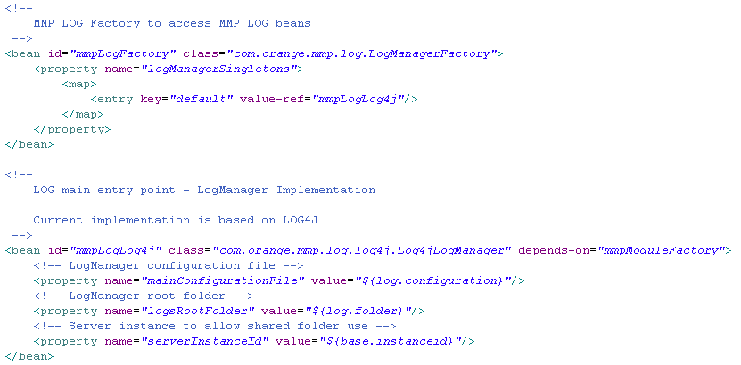
log.xml fragment

In Spring, the Inversion of Control (IoC) principle is implemented using the Dependency Injection design pattern. Thus, beans attributes can be initialized this way (see mainConfigurationFile, logsRootFolder and serverInstanceId in the file fragment above). For each bean property, the appropriate setter must be implemented in the class.
This principle is used throughout the application, for almost each component.

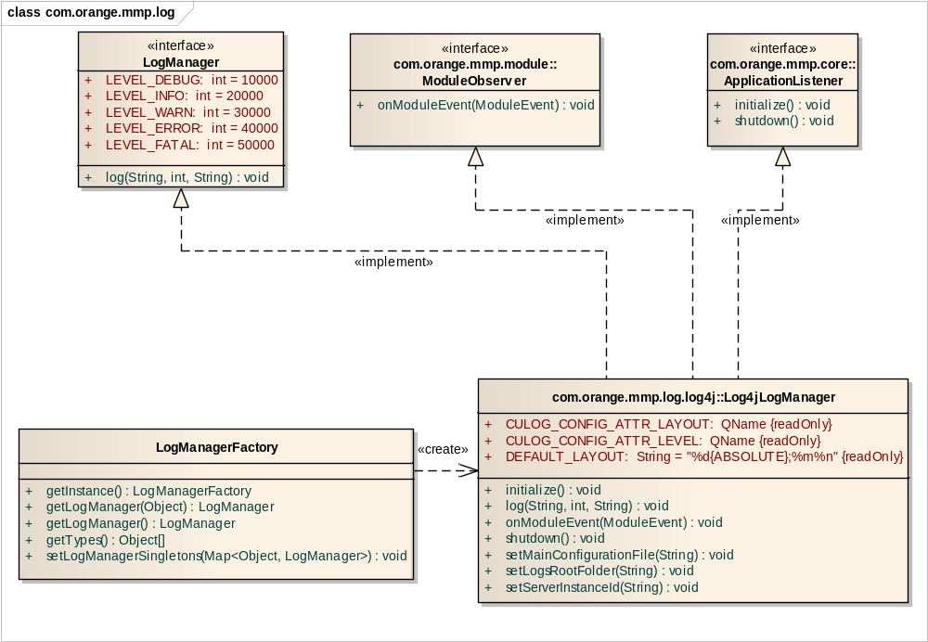
MMP Logging class diagram

LogManagerFactory Class
Connections
Connector | Source | Target | Notes
Dependency  Source -> Destination | Public  LogManagerFactory | Public  Log4jLogManager

Attributes
Attribute | Notes | Constraints and tags
defaultLogManagerSingleton LogManager  Private |  | Default:
logManagerFactorySingleton LogManagerFactory  Private  Static |  | Default:
logManagerSingletons Map<Object, LogManager>  Private |  | Default:

Operations
Method | Notes | Parameters
Static getInstance() LogManagerFactory
Public
getLogManager() LogManager  Public |  | Object [in] type
getLogManager() LogManager
Public
getTypes() Object[]
Public
setLogManagerSingletons() void  Public |  | Map<Object, LogManager> [in] logManagerSingletons

LogManager Interface
Connections
Connector | Source | Target | Notes
Realization  Source -> Destination | Public  Log4jLogManager | Public  LogManager

Attributes
Attribute | Notes | Constraints and tags
LEVEL_DEBUG int  Public  Static |  | Default: 10000
LEVEL_ERROR int  Public  Static |  | Default: 40000
LEVEL_FATAL int  Public  Static |  | Default: 50000
LEVEL_INFO int  Public  Static |  | Default: 20000
LEVEL_WARN int  Public  Static |  | Default: 30000

Operations
Method | Notes | Parameters
log() void  Public |  | String [in] message  int [in] level  String [in] key

Log4jLogManager Class
Connections
Connector | Source | Target | Notes
Realization  Source -> Destination | Public  Log4jLogManager | Public  LogManager
Realization  Source -> Destination | Public  Log4jLogManager | Public  ApplicationListener
Realization  Source -> Destination | Public  Log4jLogManager | Public  ModuleObserver
Dependency  Source -> Destination | Public  LogManagerFactory | Public  Log4jLogManager

Attributes
Attribute | Notes | Constraints and tags
CULOG_CONFIG_ATTR_LAYOUT QName  Public  Static Const |  | Default:
CULOG_CONFIG_ATTR_LEVEL QName  Public  Static Const |  | Default:
DEFAULT_LAYOUT String  Public  Static Const |  | Default:  "%d{ABSOLUTE};%m%n"
loggerCache HashMap<String, Logger>  Private |  | Default:
logsRootFolder String  Private |  | Default:
mainConfigurationFile String  Private |  | Default:
serverInstanceId String  Private |  | Default:

Operations
Method | Notes | Parameters
addModuleLogger() void  Protected |  | Module [in] module
initialize() void
Public
log() void  Public |  | String [in] message  int [in] level  String [in] key
onModuleEvent() void  Public |  | ModuleEvent [in] moduleEvent
removeModuleLogger() void  Protected |  | Module [in] module
setLogsRootFolder() void  Public |  | String [in] logsRootFolder
setMainConfigurationFile() void  Public |  | String [in] mainConfigurationFile
setServerInstanceId() void  Public |  | String [in] serverInstanceId
shutdown() void
Public

Internationalization
Internationalization in MMP is configured in the i18n.xml file. This file provides localization and data encoding.
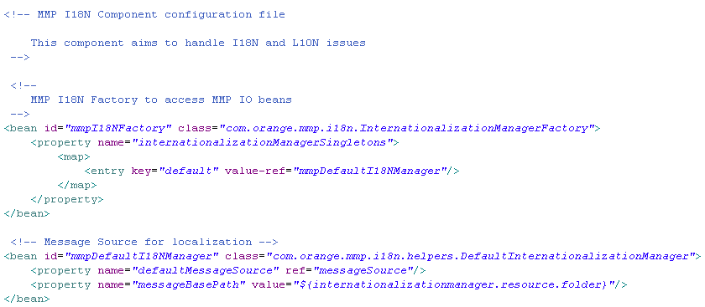
i18n.xml fragment

Internationalization is based on Factory design pattern. The InternationalizationManagerFactory creates InternationalizationManager objects, and the Factory pattern allows the application to choose the appropriate implementation of InternationalizationManager to create.
On MMP, internationalization has only one implementation: DefaultInternationalizationManager.

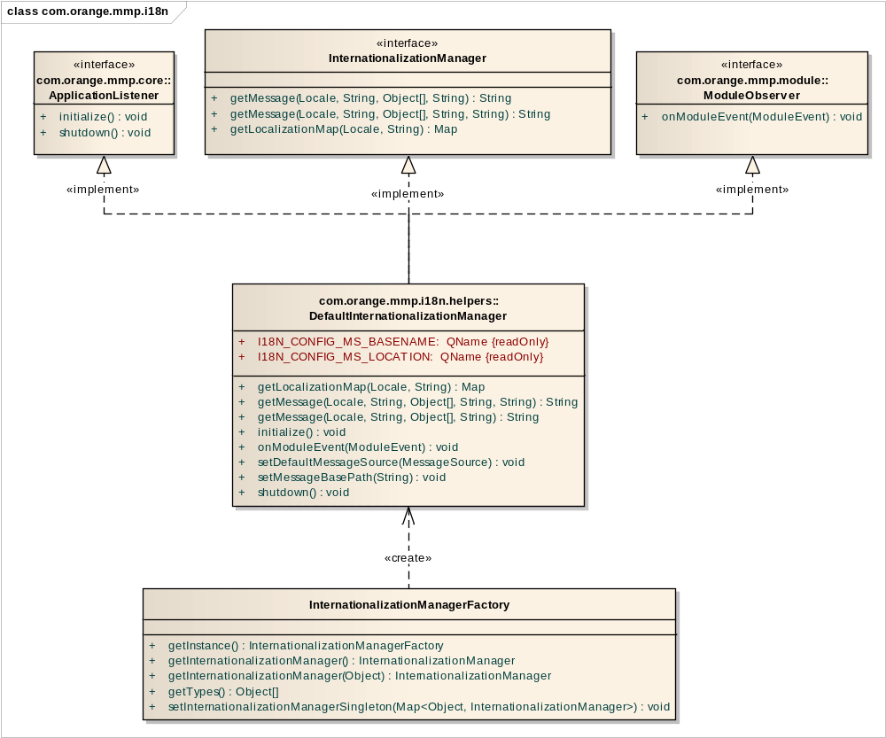
Internationalization class diagram

InternationalizationManagerFactory Class
Connections
Connector | Source | Target | Notes
Dependency  Source -> Destination | Public  InternationalizationManagerFactory | Public  DefaultInternationalizationManager

Attributes
Attribute | Notes | Constraints and tags
internationalizationManagerFactorySingleton InternationalizationManagerFactory  Private  Static |  | Default:
defaultInternationalizationManagerSingleton InternationalizationManager  Private |  | Default:
internationalizationManagerSingletons Map<Object, InternationalizationManager>  Private |  | Default:

Operations
Method | Notes | Parameters
Static getInstance() InternationalizationManagerFactory
Public
getInternationalizationManager() InternationalizationManager
Public
getInternationalizationManager() InternationalizationManager  Public |  | Object [in] type
getTypes() Object[]
Public
setInternationalizationManagerSingleton() void  Public |  | Map<Object, InternationalizationManager> [in] internationalizationManagerSingletons

InternationalizationManager Interface
Connections
Connector | Source | Target | Notes
Realization  Source -> Destination | Public  DefaultInternationalizationManager | Public  InternationalizationManager

Attributes
Attribute | Notes | Constraints and tags
internationalizationManagerSingleton InternationalizationManager  Private  Static |  | Default:
messageSource MessageSource  Private |  | Default:

Operations
Method | Notes | Parameters
getMessage() String  Public |  | Locale [in] locale  String [in] defaultMessage  Object[] [in] args  String [in] code
getMessage() String  Public |  | Locale [in] locale  String [in] defaultMessage  Object[] [in] args  String [in] code  String [in] messageSourceName
getLocalizationMap() Map  Public |  | Locale [in] locale  String [in] messageSource

DefaultInternationalizationManager Class
Connections
Connector | Source | Target | Notes
Dependency  Source -> Destination | Public  InternationalizationManagerFactory | Public  DefaultInternationalizationManager
Realization  Source -> Destination | Public  DefaultInternationalizationManager | Public  ApplicationListener
Realization  Source -> Destination | Public  DefaultInternationalizationManager | Public  InternationalizationManager
Realization  Source -> Destination | Public  DefaultInternationalizationManager | Public  ModuleObserver

Cache
MMP Cache component aims to handle caching features of the application. It provides a cache API using named cache, with basic cache policies. It is configured in the cache.xml file.

This component is based on Factory design pattern. Consequently, it provides a cache factory to access MMP cache beans: the CacheManagerFactory is used to obtain CacheManager objects. Only one CacheManager implementation is defined: EHCacheManager.

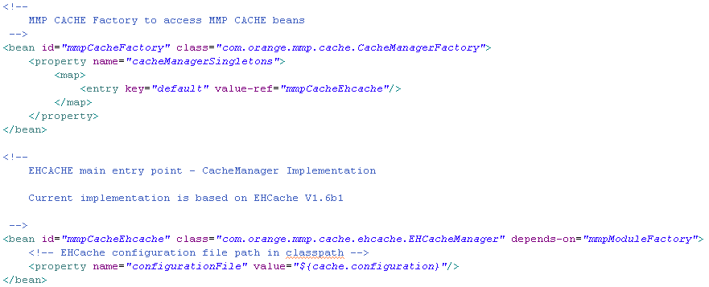
cache.xml fragment
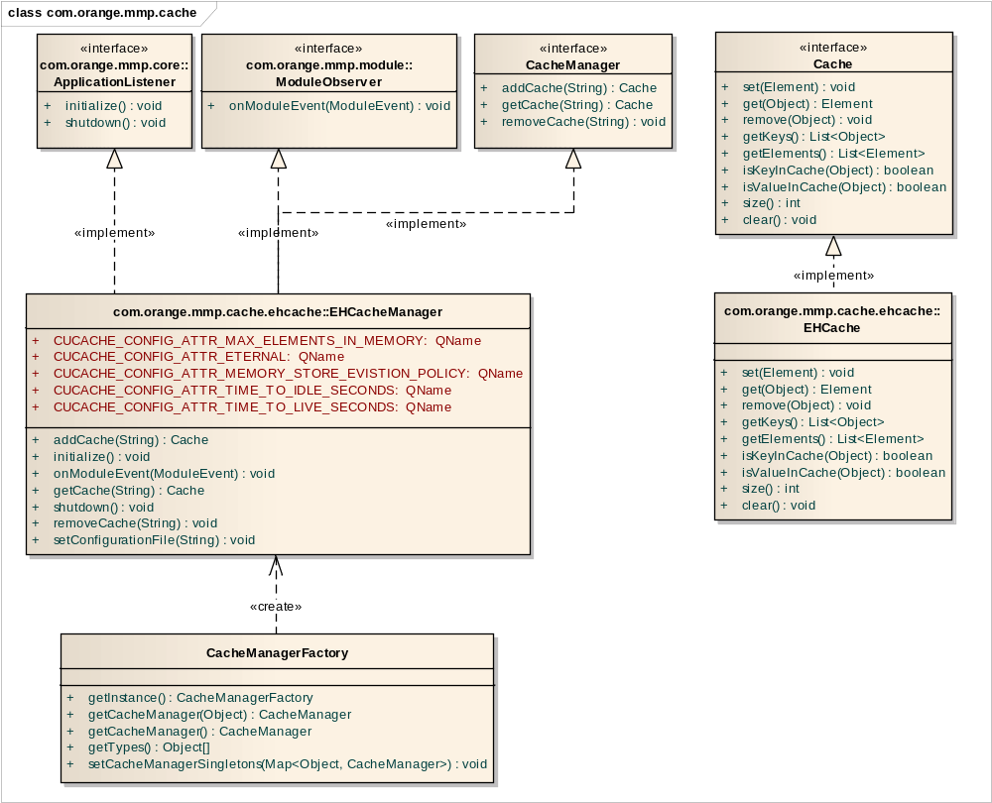
Cache class diagram

CacheManagerFactory Class
Connections
Connector | Source | Target | Notes
Dependency  Source -> Destination | Public  CacheManagerFactory | Public  EHCacheManager

Attributes
Attribute | Notes | Constraints and tags
cacheManagerFactorySingleton CacheManagerFactory  Private  Static |  | Default:
cacheManagerSingletons Map<Object, CacheManager>  Private |  | Default:
defaultCacheManagerSingleton CacheManager  Private |  | Default:

Operations
Method | Notes | Parameters
getCacheManager() CacheManager  Public |  | Object [in] type
getCacheManager() CacheManager
Public
Static getInstance() CacheManagerFactory
Public
getTypes() Object[]
Public
setCacheManagerSingletons() void  Public |  | Map<Object, CacheManager> [in] cacheManagerSingletons

Cache Interface
Connections
Connector | Source | Target | Notes
Realization  Source -> Destination | Public  EHCache | Public  Cache
Dependency  Source -> Destination | Public  MidletManager | Public  Cache
Dependency  Source -> Destination | Public  WidgetManager | Public  Cache

Operations
Method | Notes | Parameters
clear() void
Public
get() Element  Public |  | Object [in] key
getElements() List<Element>
Public
getKeys() List<Object>
Public
isKeyInCache() boolean  Public |  | Object [in] key
isValueInCache() boolean  Public |  | Object [in] value
remove() void  Public |  | Object [in] key
set() void  Public |  | Element [in] element
size() int
Public

CacheManager Interface
Connections
Connector | Source | Target | Notes
Realization  Source -> Destination | Public  EHCacheManager | Public  CacheManager

Operations
Method | Notes | Parameters
addCache() Cache  Public |  | String [in] cacheName
getCache() Cache  Public |  | String [in] cacheName
removeCache() void  Public |  | String [in] cacheName

EHCache Class
Connections
Connector | Source | Target | Notes
Realization  Source -> Destination | Public  EHCache | Public  Cache

Attributes
Attribute | Notes | Constraints and tags
ehCache net.sf.ehcache.Cache  Private |  | Default:

Operations
Method | Notes | Parameters
clear() void
Public
get() Element  Public |  | Object [in] key
getElements() List<Element>
Public
getKeys() List<Object>
Public
isKeyInCache() boolean  Public |  | Object [in] key
isValueInCache() boolean  Public |  | Object [in] value
remove() void  Public |  | Object [in] key
set() void  Public |  | Element [in] element
size() int
Public

EHCacheManager Class
Connections
Connector | Source | Target | Notes
Realization  Source -> Destination | Public  EHCacheManager | Public  ApplicationListener
Realization  Source -> Destination | Public  EHCacheManager | Public  CacheManager
Realization  Source -> Destination | Public  EHCacheManager | Public  ModuleObserver
Dependency  Source -> Destination | Public  CacheManagerFactory | Public  EHCacheManager

Attributes
Attribute | Notes | Constraints and tags
configurationFile String  Private |  | Default:
CUCACHE_CONFIG_ATTR_ETERNAL QName  Public  Static |  | Default:
CUCACHE_CONFIG_ATTR_MAX_ELEMENTS_IN_MEMORY QName  Public  Static |  | Default:
CUCACHE_CONFIG_ATTR_MEMORY_STORE_EVISTION_POLICY QName  Public  Static |  | Default:
CUCACHE_CONFIG_ATTR_TIME_TO_IDLE_SECONDS QName  Public  Static |  | Default:
CUCACHE_CONFIG_ATTR_TIME_TO_LIVE_SECONDS QName  Public  Static |  | Default:
ehcacheManager net.sf.ehcache.CacheManager  Private |  | Default:
moduleCachesCache Map<Module, net.sf.ehcache.Cache[]>  Private |  | Default:

Operations
Method | Notes | Parameters
addCache() Cache  Public |  | String [in] cacheName
addModuleCache() void  Protected |  | Module [in] module
getCache() Cache  Public |  | String [in] cacheName
initialize() void
Public
onModuleEvent() void  Public |  | ModuleEvent [in] moduleEvent
removeCache() void  Public |  | String [in] cacheName
removeModuleCache() void  Protected |  | Module [in] module
setConfigurationFile() void  Public |  | String [in] configurationFile
shutdown() void
Public

Content Adaptation
On MMP, content adaptation is configured in the cadap.xml file. It allows only images management, and is based on Factory design pattern. MediaAdapter has only one implementation, whatever the type of image, as defined in the mediaAdapterSingleton map. MediaAdapterFactory is responsible for creating MediaAdapter objects: JaiImageAdapter.

Other MediaAdapter implementations should allow other media management, video for instance.
For now, it supports the following image formats: gif, bmp, png and jpg.

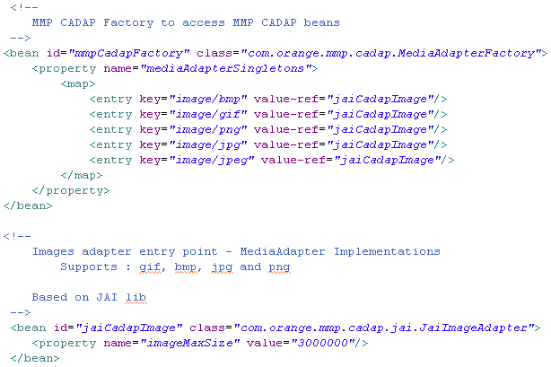
cadap.xml fragment
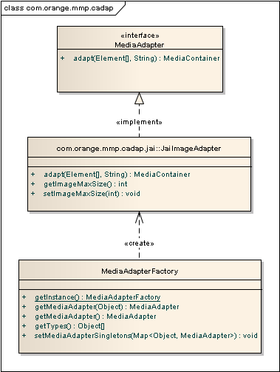
Content Adaptation class diagram

MediaAdapterFactory Class
Connections
Connector | Source | Target | Notes
Dependency  Source -> Destination | Public  MediaAdapterFactory | Public  JaiImageAdapter

Attributes
Attribute | Notes | Constraints and tags
defaultMediaAdapterSingleton MediaAdapter  Private |  | Default:
mediaAdapterFactorySingleton MediaAdapterFactory  Private  Static |  | Default:
mediaAdapterSingletons Map<Object, MediaAdapter>  Private |  | Default:

Operations
Method | Notes | Parameters
Static getInstance() MediaAdapterFactory
Public
getMediaAdapter() MediaAdapter  Public |  | Object [in] type
getMediaAdapter() MediaAdapter
Public
getTypes() Object[]
Public
setMediaAdapterSingletons() void  Public |  | Map<Object, MediaAdapter> [in] mediaAdapterSingletons

MediaAdapter Interface
Connections
Connector | Source | Target | Notes
Realization  Source -> Destination | Public  JaiImageAdapter | Public  MediaAdapter

Operations
Method | Notes | Parameters
adapt() MediaContainer  Public |  | Element[] [in] parameters  String [in] mediaLocation

JaiImageAdapter Class
Connections
Connector | Source | Target | Notes
Realization  Source -> Destination | Public  JaiImageAdapter | Public  MediaAdapter
Dependency  Source -> Destination | Public  MediaAdapterFactory | Public  JaiImageAdapter

Attributes
Attribute | Notes | Constraints and tags
imageMaxSize int  Private |  | Default:
inSupportedFormats List<String>  Private  Static |  | Default: null
outSupportedFormats List<String>  Private  Static |  | Default: null
PARAM_FORMAT_HASHCODE int  Private  Static |  | Default: -1268779017
PARAM_HEIGHT_HASHCODE int  Private  Static |  | Default: -1221029593
PARAM_WIDTH_HASHCODE int  Private  Static |  | Default: 113126854
PARAM_ZOOM_HASHCODE int  Private  Static |  | Default: 3744723
renderdingHints Map<RenderingHints.Key, Object>  Private  Static |  | Default: null

Operations
Method | Notes | Parameters
adapt() MediaContainer  Public |  | Element[] [in] parameters  String [in] mediaLocation
blurImage() BufferedImage  Private |  | BufferedImage [in] image
createCompatibleImage() BufferedImage  Private |  | BufferedImage [in] image
getImageLocationFromHTML() String  Private |  | InputStream [in] htmlIn  String [in] sourceLocation
getImageMaxSize() int
Public
resize() BufferedImage  Private |  | int [in] height  int [in] width  BufferedImage [in] buffIm
setImageMaxSize() void  Public |  | int [in] imageMaxSize

File
The MMP file component is defined in the file.xml file. It offers a file feature support for dynamic modules and services. It is based on a Factory pattern: the FileManagerFactory creates FileManager objects. The Factory pattern allows the application to choose the appropriate implementation of FileManager to create. Only one implementation is defined: the DefaultFileManager, based on standard java.io.

If another FileManager implementation is created, it must be referenced as a bean in the file.xml file, and the bean must be added to the fileManagerSingletons map.

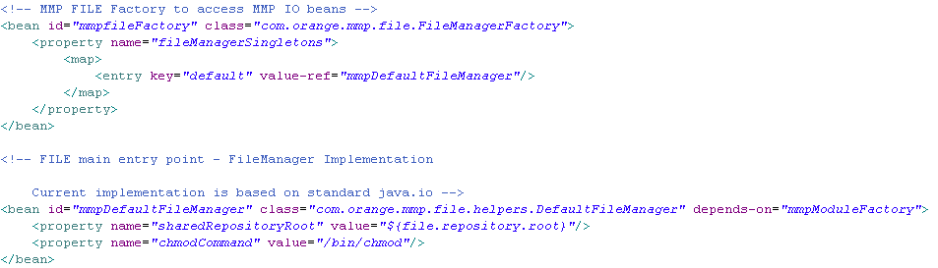
file.xml fragment

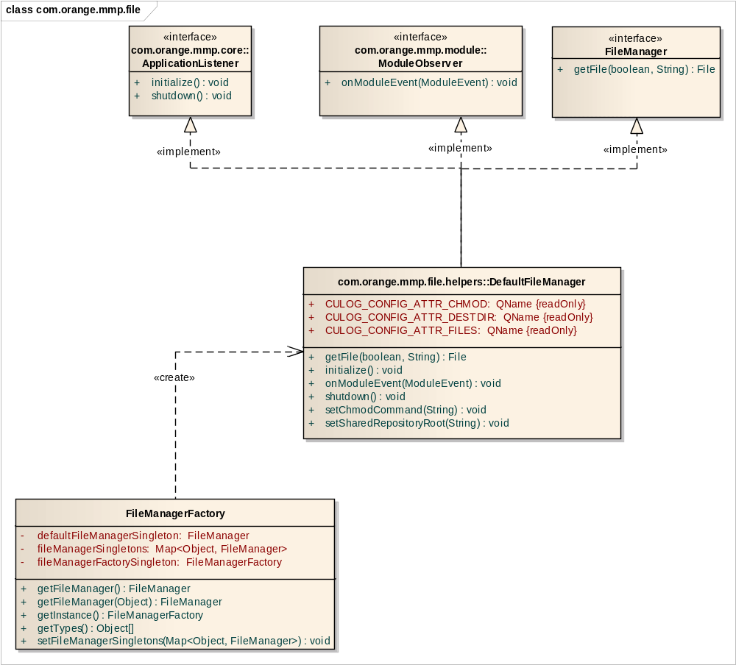
File class diagram

FileManagerFactory Class
Connections
Connector | Source | Target | Notes
Dependency  Source -> Destination | Public  FileManagerFactory | Public  DefaultFileManager

Attributes
Attribute | Notes | Constraints and tags
defaultFileManagerSingleton FileManager  Private |  | Default:
fileManagerSingletons Map<Object, FileManager>  Private |  | Default:
fileManagerFactorySingleton FileManagerFactory  Private  Static |  | Default:

Operations
Method | Notes | Parameters
getFileManager() FileManager
Public
getFileManager() FileManager  Public |  | Object [in] type
Static getInstance() FileManagerFactory
Public
getTypes() Object[]
Public
setFileManagerSingletons() void  Public |  | Map<Object, FileManager> [in] fileManagerSingletons

FileManager Interface
Connections
Connector | Source | Target | Notes
Realization  Source -> Destination | Public  DefaultFileManager | Public  FileManager

Operations
Method | Notes | Parameters
getFile() File  Public |  | boolean [in] create  String [in] filePath

DefaultFileManager Class
Connections
Connector | Source | Target | Notes
Realization  Source -> Destination | Public  DefaultFileManager | Public  ApplicationListener
Realization  Source -> Destination | Public  DefaultFileManager | Public  FileManager
Realization  Source -> Destination | Public  DefaultFileManager | Public  ModuleObserver
Dependency  Source -> Destination | Public  FileManagerFactory | Public  DefaultFileManager

Attributes
Attribute | Notes | Constraints and tags
CULOG_CONFIG_ATTR_CHMOD QName  Public  Static Const |  | Default:
CULOG_CONFIG_ATTR_DESTDIR QName  Public  Static Const |  | Default:
CULOG_CONFIG_ATTR_FILES QName  Public  Static Const |  | Default:
chmodCommand String  Private |  | Default:
filesetCache HashMap<String, File[]>  Private |  | Default:
sharedRepositoryRoot String  Private |  | Default:

Operations
Method | Notes | Parameters
getFile() File  Public |  | boolean [in] create  String [in] filePath
initialize() void
Public
onModuleEvent() void  Public |  | ModuleEvent [in] moduleEvent
shutdown() void
Public
addModuleFileset() void  Protected |  | Module [in] module
removeModuleFileset() void  Protected |  | Module [in] module
setChmodCommand() void  Public |  | String [in] chmodCommand
setSharedRepositoryRoot() void  Public |  | String [in] sharedRepositoryRoot

Message
MMP Message component is a message oriented broker. It allows sending and receiving messages. It is based on the Factory pattern, and provides a message factory to access MMP message beans. The MessageBrokerFactory creates MessageBroker objects. Only one MessageBroker implementation is defined: the JMSMessageBroker.
The message component is configured in the message.xml file. In order to add a new MessageBroker implementation, it has to be added in the messageBrokerSingletons map.
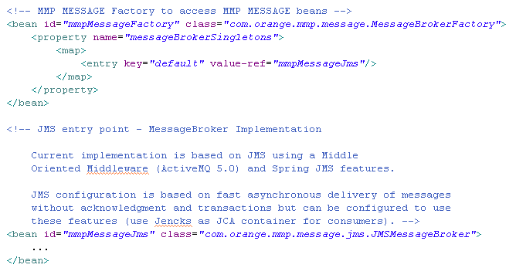
message.xml fragment

The message component offers horizontal scalability by exposing services across a service BUS which can be based on SOA/MOM features and introduces an abstraction layer to hide SOA implementation.

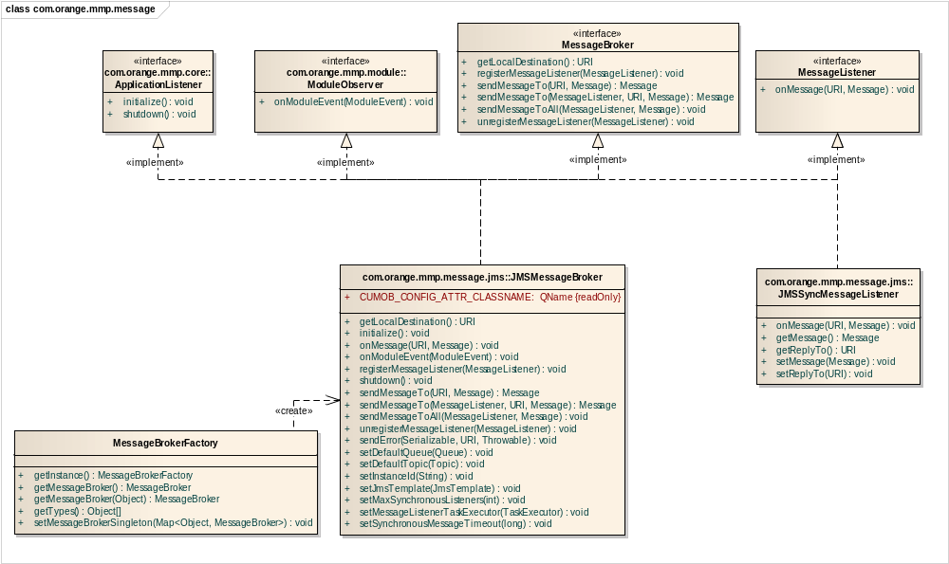
Message class diagram
MessageBrokerFactory Class
Connections
Connector | Source | Target | Notes
Dependency  Source -> Destination | Public  MessageBrokerFactory | Public  JMSMessageBroker

Attributes
Attribute | Notes | Constraints and tags
messageBrokerFactorySingleton MessageBrokerFactory  Private  Static |  | Default:
defaultMessageBrokerSingleton MessageBroker  Private |  | Default:
messageBrokerSingletons Map<Object, MessageBroker>  Private |  | Default:

Operations
Method | Notes | Parameters
Static getInstance() MessageBrokerFactory
Public
getMessageBroker() MessageBroker
Public
getMessageBroker() MessageBroker  Public |  | Object [in] type
getTypes() Object[]
Public
setMessageBrokerSingleton() void  Public |  | Map<Object, MessageBroker> [in] messageBrokerSingletons

MessageBroker Interface
Connections
Connector | Source | Target | Notes
Realization  Source -> Destination | Public  JMSMessageBroker | Public  MessageBroker

Operations
Method | Notes | Parameters
getLocalDestination() URI
Public
registerMessageListener() void  Public |  | MessageListener [in] messageListener
sendMessageTo() Message  Public |  | URI [in] destination  Message [in] message
sendMessageTo() Message  Public |  | MessageListener [in] callback  URI [in] destination  Message [in] message
sendMessageToAll() void  Public |  | MessageListener [in] callback  Message [in] message
unregisterMessageListener() void  Public |  | MessageListener [in] messageListener

JMSMessageBroker Class
Connections
Connector | Source | Target | Notes
Realization  Source -> Destination | Public  JMSMessageBroker | Public  ApplicationListener
Realization  Source -> Destination | Public  JMSMessageBroker | Public  MessageBroker
Realization  Source -> Destination | Public  JMSMessageBroker | Public  MessageListener
Realization  Source -> Destination | Public  JMSMessageBroker | Public  ModuleObserver
Dependency  Source -> Destination | Public  MessageBrokerFactory | Public  JMSMessageBroker

Attributes
Attribute | Notes | Constraints and tags
CUMOB_CONFIG_ATTR_CLASSNAME QName  Public  Static Const |  | Default:
defaultQueue Queue  Private |  | Default:
defaultTopic Topic  Private |  | Default:
instanceId String  Private |  | Default:
jmsTemplate JmsTemplate  Private |  | Default:
maxSynchronousListeners int  Private |  | Default:
messageListeners List<MessageListener>  Private |  | Default:
messageListenersMap Map<Serializable, MessageListener>  Private |  | Default:
messageListenerTaskExecutor TaskExecutor  Private |  | Default:
moduleListenersCache Map<Class, MessageListener>  Private |  | Default:
synchronousMessageTimeout long  Private |  | Default:
syncListenerPool BlockingQueue<JMSSyncMessageListener>  Private |  | Default:

Operations
Method | Notes | Parameters
getLocalDestination() URI
Public
initialize() void
Public
onMessage() void  Public |  | URI [in] replyTo  Message [in] message
onModuleEvent() void  Public |  | ModuleEvent [in] moduleEvent
registerMessageListener() void  Public |  | MessageListener [in] messageListener
shutdown() void
Public
sendMessageTo() Message  Public |  | URI [in] destination  Message [in] message
sendMessageTo() Message  Public |  | MessageListener [in] callback  URI [in] destination  Message [in] message
sendMessageToAll() void  Public |  | MessageListener [in] callback  Message [in] message
unregisterMessageListener() void  Public |  | MessageListener [in] messageListener
addModuleListener() void  Protected |  | Module [in] module
removeModuleListener() void  Protected |  | Module [in] module
sendError() void  Public |  | Serializable [in] sourceId  URI [in] destination  Throwable [in] e
setDefaultQueue() void  Public |  | Queue [in] defaultQueue
setDefaultTopic() void  Public |  | Topic [in] defaultTopic
setInstanceId() void  Public |  | String [in] instanceId
setJmsTemplate() void  Public |  | JmsTemplate [in] jmsTemplate
setMaxSynchronousListeners() void  Public |  | int [in] maxSynchronousListeners
setMessageListenerTaskExecutor() void  Public |  | TaskExecutor [in] messageListenerTaskExecutor
setSynchronousMessageTimeout() void  Public |  | long [in] synchronousMessageTimeout

API
The MMP API component is defined in the api.xml file. Its aim is to handle dynamic services exposure. There are two types of webservices in MMP:
- REST, used for tickets creation for instance,
- JSON (nested hashtables format), for the mobile APIs.

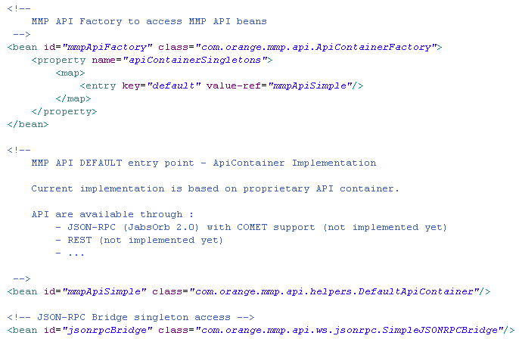
api.xml fragment

The API component is based on Factory design pattern: the ApiContainerFactory provides ApiContainer implementations. Only one implementation of ApiContainer is available: DefaultApiContainer. ApiContainer objects dispose of a list of ApiObserver, which receive notifications of services events and are able to add and remove services.
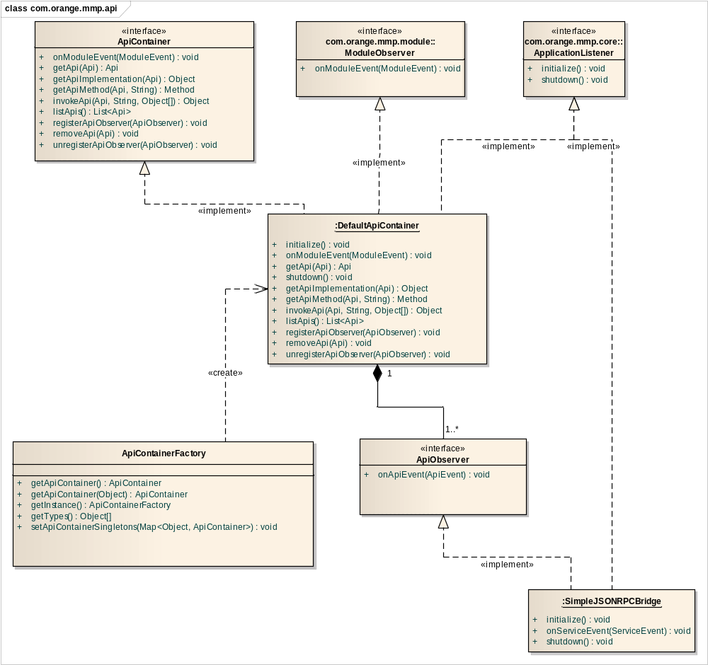
API Component class diagram

ApiContainerFactory Class
Connections
Connector | Source | Target | Notes
Dependency  Source -> Destination | Public  ApiContainerFactory | Public  DefaultApiContainer

Attributes
Attribute | Notes | Constraints and tags
defaultApiContainerSingleton ApiContainer  Private |  | Default:
apiContainerFactorySingleton ApiContainerFactory  Private  Static |  | Default:
apiContainerSingletons Map<Object, ApiContainer>  Private |  | Default:

Operations
Method | Parameters
getApiContainer() ApiContainer
Public
getApiContainer() ApiContainer  Public | Object [in] type
Static getInstance() ApiContainerFactory
Public
getTypes() Object[]
Public
setApiContainerSingletons() void  Public | Map<Object, ApiContainer> [in] apiContainerSingletons

ApiContainer Interface
Connections
Connector | Source | Target | Notes
Realization  Source -> Destination | Public  DefaultApiContainer | Public  ApiContainer

Operations
Method | Notes | Parameters
addApi() Api  Public |  | Api [in] api  Object [in] serviceImpl
getApi() Api  Public |  | Api [in] api
getApiImplementation() Object  Public |  | Api [in] api
getApiMethod() Method  Public |  | Api [in] api  String [in] methodName
invokeApi() Object  Public |  | Api [in] api  String [in] methodName  Object[] [in] params
listApis() List<Api>
Public
onModuleEvent() void  Public |  | ModuleEvent [in] moduleEvent
registerApiObserver() void  Public |  | ApiObserver [in] apiObserver
removeApi() void  Public |  | Api [in] api
unregisterApiObserver() void  Public |  | ApiObserver [in] apiObserver

ApiObserver Interface
Connections
Connector | Source | Target | Notes
Aggregation  Source -> Destination | Public  ApiObserver | Public  DefaultApiContainer
Realization  Source -> Destination | Public  SimpleJSONRPCBridge | Public  ApiObserver

Operations
Method | Notes | Parameters
onApiEvent() void  Public |  | ApiEvent [in] apiEvent

DefaultApiContainer Class
Attributes
Attribute | Notes | Constraints and tags
apiCache Map<Api, Element>  Private |  | Default:
apiObservers List<ApiObserver> |  | Default:
CUAPI_CONFIG_ATTR_CLASSNAME QName  Public  Static |  | Default:
CUAPI_CONFIG_ATTR_IS_PRIVATE QName  Public  Static |  | Default:
CUAPI_CONFIG_ATTR_IS_PUBLIC QName  Public  Static |  | Default:
CUAPI_CONFIG_ATTR_IS_PUBLISHED QName  Public  Static |  | Default:
CUAPI_CONFIG_ATTR_IS_SHARED QName  Public  Static |  | Default:

Operations
Method | Notes | Parameters
addModuleApi() void  Protected |  | Module [in] module
removeModuleApi() void  Protected |  | Module [in] module

SimpleJSONRPCBridge Class
Attributes
Attribute | Notes | Constraints and tags
privateGlobalBridge JSONRPCBridge  Private  Static |  | Default:
publicGlobalBridge JSONRPCBridge  Private  Static |  | Default:

Operations
Method | Notes | Parameters
call() JSONRPCResult  Public |  | JSONObject [in] jsonReq  Object[] [in] context
Static getGlobalBridge() JSONRPCBridge
Public
Static getPrivateGlobalBridge() JSONRPCBridge
Public
Static getPublicGlobalBridge() JSONRPCBridge
Public

Net
The MMP Net Component is configured in the net.xml file. Based on the Factory design pattern, it provides ConnectionManager for different protocols. The ConnectionManagerFactory can create these ConnectionManager:
- HttpConnectionManager: a ConnectionManager implementation for HTTP/HTTPS entry point,
- SocketConnectionManager: a ConnectionManager implementation for Socket entry point.

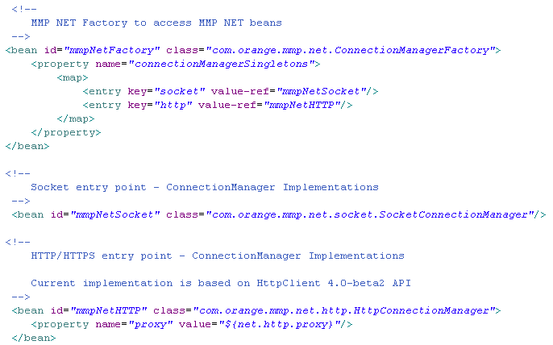
net.xml fragment
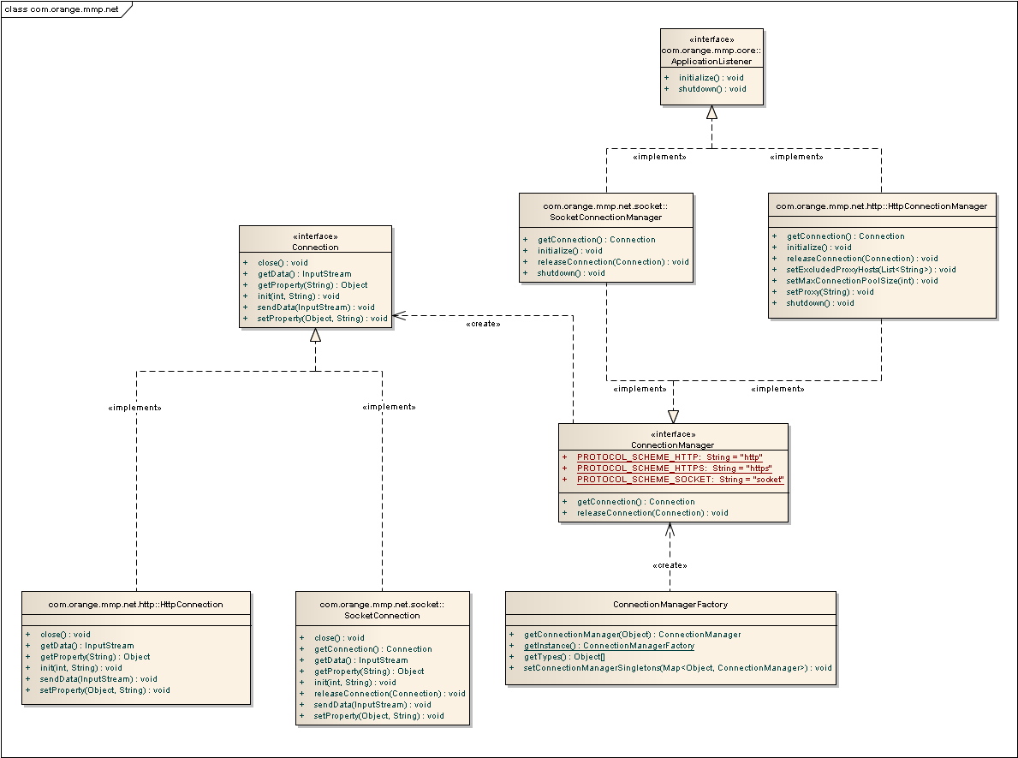
Net Component class diagram

ConnectionManagerFactory Class
Connections
Connector | Source | Target | Notes
Dependency  Source -> Destination | Public  ConnectionManagerFactory | Public  ConnectionManager

Attributes
Attribute | Notes | Constraints and tags
connectionManagerFactorySingleton ConnectionManagerFactory  Private  Static |  | Default:
connectionManagerSingletons Map<Object, ConnectionManager>  Private |  | Default:

Operations
Method | Notes | Parameters
getConnectionManager() ConnectionManager  Public |  | Object [in] type
Static getInstance() ConnectionManagerFactory
Public
getTypes() Object[]
Public
setConnectionManagerSingletons() void  Public |  | Map<Object, ConnectionManager> [in] connectionManagerSingletons

Connection Interface
Connections
Connector | Source | Target | Notes
Realization  Source -> Destination | Public  HttpConnection | Public  Connection
Realization  Source -> Destination | Public  SocketConnection | Public  Connection
Dependency  Source -> Destination | Public  ConnectionManager | Public  Connection

Operations
Method | Notes | Parameters
close() void
Public
getData() InputStream
Public
getProperty() Object  Public |  | String [in] name
init() void  Public |  | int [in] timeout  String [in] endPoint
sendData() void  Public |  | InputStream [in] dataStream
setProperty() void  Public |  | Object [in] value  String [in] name

ConnectionManager Interface
Connections
Connector | Source | Target | Notes
Realization  Source -> Destination | Public  HttpConnectionManager | Public  ConnectionManager
Realization  Source -> Destination | Public  SocketConnectionManager | Public  ConnectionManager
Dependency  Source -> Destination | Public  ConnectionManagerFactory | Public  ConnectionManager
Dependency  Source -> Destination | Public  ConnectionManager | Public  Connection

Attributes
Attribute | Notes | Constraints and tags
PROTOCOL_SCHEME_HTTP String  Public  Static |  | Default: "http"
PROTOCOL_SCHEME_HTTPS String  Public  Static |  | Default: "https"
PROTOCOL_SCHEME_SOCKET String  Public  Static |  | Default: "socket"

Operations
Method | Notes | Parameters
getConnection() Connection
Public
releaseConnection() void  Public |  | Connection [in] connection

HttpConnection Class
Connections
Connector | Source | Target | Notes
Realization  Source -> Destination | Public  HttpConnection | Public  Connection

Attributes
Attribute | Notes | Constraints and tags
currentStatusCode int  Private |  | Default: -1
endPointUrl URL  Private |  | Default: null
httpClient DefaultHttpClient  Private |  | Default:
httpConnectionProperties Map  Private |  | Default: null
httpResponse HttpResponse  Private |  | Default: null
inDataStream InputStream  Private |  | Default: null
preemptiveAuthInterceptor HttpRequestInterceptor  Private  Static |  | Default:
DEFAULT_TIMEOUT int  Private  Static Const |  | Default: 60000

Operations
Method | Notes | Parameters
close() void
Public
doExecute() void  Protected |  | InputStream [in] dataStream
getData() InputStream
Public
getProperty() Object  Public |  | String [in] name
init() void  Public |  | int [in] timeout  String [in] endPoint
sendData() void  Public |  | InputStream [in] dataStream
setProperty() void  Public |  | Object [in] value  String [in] name

HttpConnectionManager Class
Connections
Connector | Source | Target | Notes
Realization  Source -> Destination | Public  HttpConnectionManager | Public  ConnectionManager
Realization  Source -> Destination | Public  HttpConnectionManager | Public  ApplicationListener

Attributes
Attribute | Notes | Constraints and tags
supportedSchemes SchemeRegistry  Private |  | Default: null
DEFAULT_HTTP_PORT int  Private  Static |  | Default: 80
DEFAULT_HTTPS_PORT int  Private  Static |  | Default: 443
PROXY_DEFAULT_PORT int  Private  Static |  | Default: 8080
proxyHost String  Private |  | Default:
proxyPort int  Private |  | Default:

Operations
Method | Notes | Parameters
getConnection() Connection
Public
initialize() void
Public
releaseConnection() void  Public |  | Connection [in] connection
setProxy() void  Public |  | String [in] proxy
shutdown() void
Public

SocketConnection Class
Connections
Connector | Source | Target | Notes
Realization  Source -> Destination | Public  SocketConnection | Public  Connection

Operations
Method | Notes | Parameters
close() void
Public
getConnection() Connection
Public
getData() InputStream
Public
getProperty() Object  Public |  | String [in] name
init() void  Public |  | int [in] timeout  String [in] endPoint
releaseConnection() void  Public |  | Connection [in] connection
sendData() void  Public |  | InputStream [in] dataStream
setProperty() void  Public |  | Object [in] value  String [in] name

SocketConnectionManager Class
Connections
Connector | Source | Target | Notes
Realization  Source -> Destination | Public  SocketConnectionManager | Public  ApplicationListener
Realization  Source -> Destination | Public  SocketConnectionManager | Public  ConnectionManager

Operations
Method | Notes | Parameters
getConnection() Connection
Public
initialize() void
Public
releaseConnection() void  Public |  | Connection [in] connection
shutdown() void
Public

Webpart
The MMP platform provides a Web Part component, which is configured in the webpart.xml file. It allows each bundle to provide a default web page.

The bean property contentTypeByExtension defines a map associating extensions and MIME types.
The FreeMarker engine is used to generate files from templates and associated values files (for instance in an internationalization purpose). The property extentionWithTemplateSupport sets a list of files extensions supporting the use of these templates.

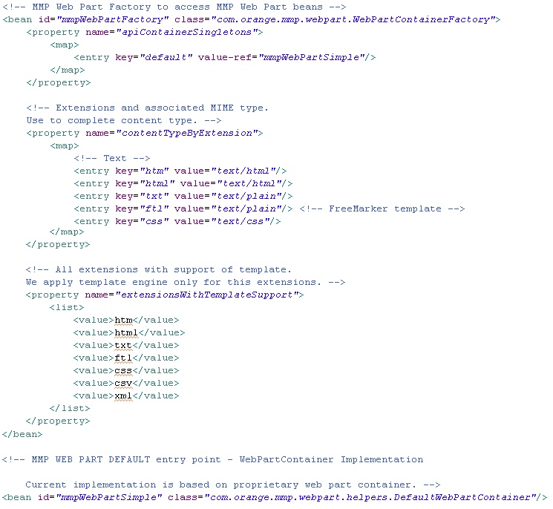
webpart.xml fragment

The Web Part component is based on the Factory pattern. The WebPartContainerFactory creates WebPartContainer objects. Only one WebPartContainer implementation is defined: the DefaultWebPartContainer.

The BundleWebAccessPoint class should be extended in bundles which require a web access point.
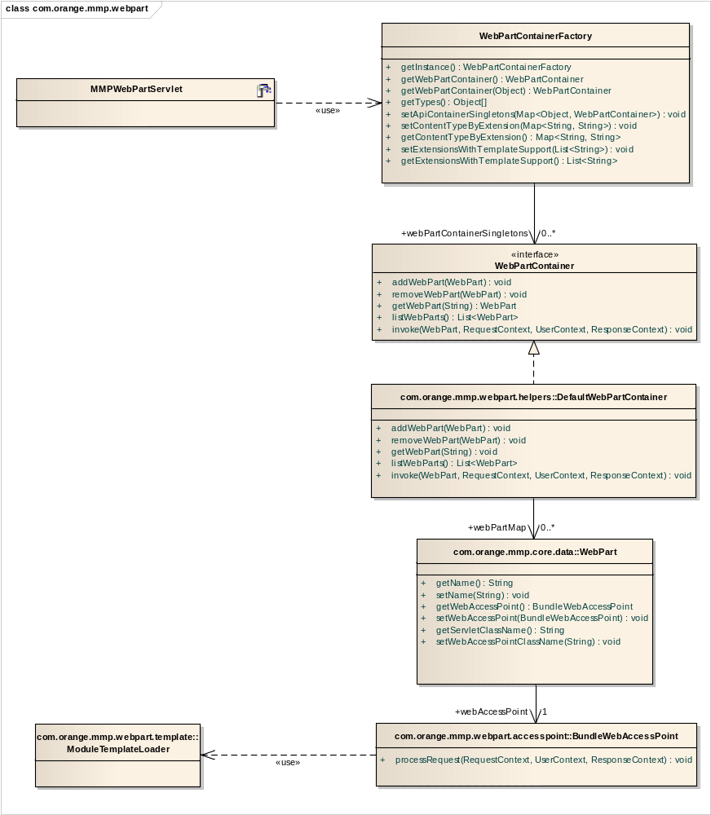
Web Part component class diagram

The following diagram shows the Web Part component mechanism:
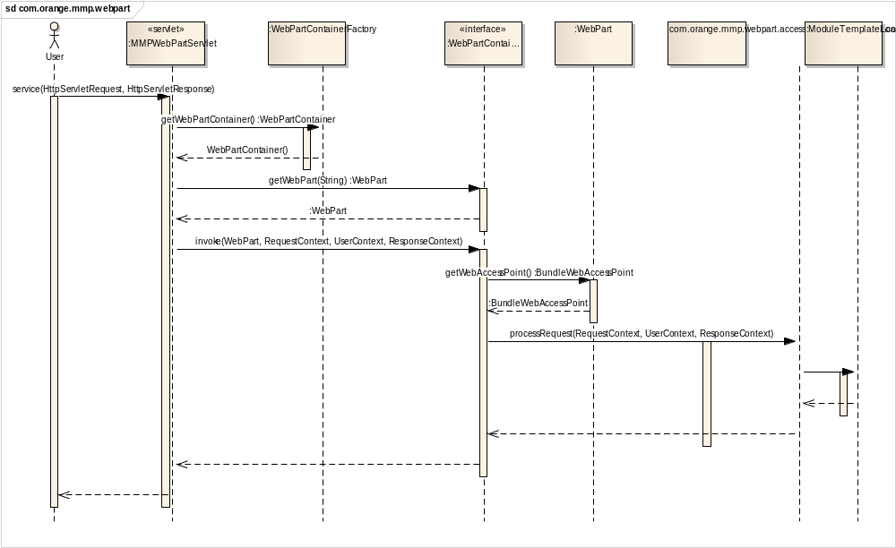
Web Part Component sequence diagram

WebPartContainerFactory Class
Connections
Connector | Source | Target | Notes
Association  Source -> Destination | Public  WebPartContainerFactory | Public webPartContainerSingletons  WebPartContainer
Dependency  Source -> Destination | Public  MMPWebPartServlet | Public  WebPartContainerFactory

Attributes
Attribute | Notes | Constraints and tags
webPartContainerSingletons Map<Object, WebPartContainer>  Private | Map of registered container by type | Default:

Operations
Method | Notes | Parameters
Static getInstance() WebPartContainerFactory  Public | Get the instance of factory (Singleton design pattern).
getWebPartContainer() WebPartContainer  Public | Get the default WebPartContainer.
getWebPartContainer() WebPartContainer  Public | Get an instance of WebPartContainer based on the type | Object [in] type
getTypes() Object[]  Public | Get the supported types to obtain WebPartContainer.
setApiContainerSingletons() void  Public | Define WebPartContainer singletons by type (use to initialize factory via Spring). | Map<Object, WebPartContainer> [in] webPartContainerSingletons
setContentTypeByExtension() void  Public | Define return content type (use to initialize factory via Spring). | Map<String, String> [in] contentTypeByExtension
getContentTypeByExtension() Map<String, String>  Public | Get the map of content types by extension
setExtensionsWithTemplateSupport() void  Public | Define the list of extension with template support (initialized by Spring) | List<String> [in] extensionsWithTemplateSupport
getExtensionsWithTemplateSupport() List<String>  Public | Get the list of extensions with template support.

WebPartContainer Interface
Connections
Connector | Source | Target
Association  Source -> Destination | Public  WebPartContainerFactory | Public webPartContainerSingletons  WebPartContainer
Realization  Source -> Destination | Public  DefaultWebPartContainer | Public  WebPartContainer

Operations
Method | Notes | Parameters
addWebPart() void  Public | Add a web part. | WebPart [in] webPart
removeWebPart() void  Public | Remove a web part. | WebPart [in] webPart
getWebPart() WebPart  Public | Get the web part for a service (web part name). | String [in] service
listWebParts() List<WebPart>  Public | Get the list of web parts.
invoke() void  Public | Use a web part to execute a user request (transfert the request to the web part access point). | WebPart [in] webPart  RequestContext [in] requestContext  UserContext [in] userContext  ResponseContext [in] responseContext

DefaultWebPartContainer Class
Connections
Connector | Source | Target | Notes
Association  Source -> Destination | Public  DefaultWebPartContainer | Public webPartMap  WebPart
Realization  Source -> Destination | Public  DefaultWebPartContainer | Public  WebPartContainer

Attributes
Attribute | Notes | Constraints and tags
webPartMap Map<String, WebPart>  Private | Map of web parts by name | Default:

Operations
Method | Notes | Parameters
addWebPart() void  Public | Add a web part. | WebPart [in] webPart
removeWebPart() void  Public | Remove a web part. | WebPart [in] webPart
getWebPart() void  Public | Get the web part for a service (web part name). | String [in] service
listWebParts() List<WebPart>  Public | Get the list of web parts.
invoke() void  Public | Use a web part to execute a user request (transfert the request to the web part access point). | WebPart [in] webPart  RequestContext [in] requestContext  UserContext [in] userContext  ResponseContext [in] responseContext

WebPart Class
Connections
Connector | Source | Target | Notes
Association  Source -> Destination | Public  WebPart | Public webAccessPoint  BundleWebAccessPoint
Association  Source -> Destination | Public  DefaultWebPartContainer | Public webPartMap  WebPart

Attributes
Attribute | Notes | Constraints and tags
name String  Private | Web part name. | Default:
webAccessPoint BundleWebAccessPoint  Private | Web part entry class. | Default:
accessPointClassName String  Private | Class name of BundleWebAccessPoint implementation (use if the BundleWebAccessPoint is redefined in the OSGi bundle). | Default:

Operations
Method | Notes | Parameters
getName() String
Public
setName() void  Public |  | String [in] name
getWebAccessPoint() BundleWebAccessPoint
Public
setWebAccessPoint() void  Public |  | BundleWebAccessPoint [in] webAccessPoint
getServletClassName() String
Public
setWebAccessPointClassName() void  Public |  | String [in] accessPointClassName

BundleWebAccessPoint Class
Connections
Connector | Source | Target | Notes
Association  Source -> Destination | Public  WebPart | Public webAccessPoint  BundleWebAccessPoint
Dependency  Source -> Destination | Public  BundleWebAccessPoint | Public  ModuleTemplateLoader | ModuleTemplateLoader is used by access point to load resources in bundle.
Sequence processRequest(RequestContext, UserContext, ResponseContext)  Source -> Destination | Public  <anonymous> | Public  BundleWebAccessPoint
Sequence  Source -> Destination | Public  BundleWebAccessPoint | Public  <anonymous>
Sequence  Source -> Destination | Public  <anonymous> | Public  BundleWebAccessPoint
Sequence  Source -> Destination | Public  BundleWebAccessPoint | Public  <anonymous>

Operations
Method | Notes | Parameters
processRequest() void  Public | Process an user request | RequestContext [in] requestContext  UserContext [in] userContext  ResponseContext [in] responseContext

Modules
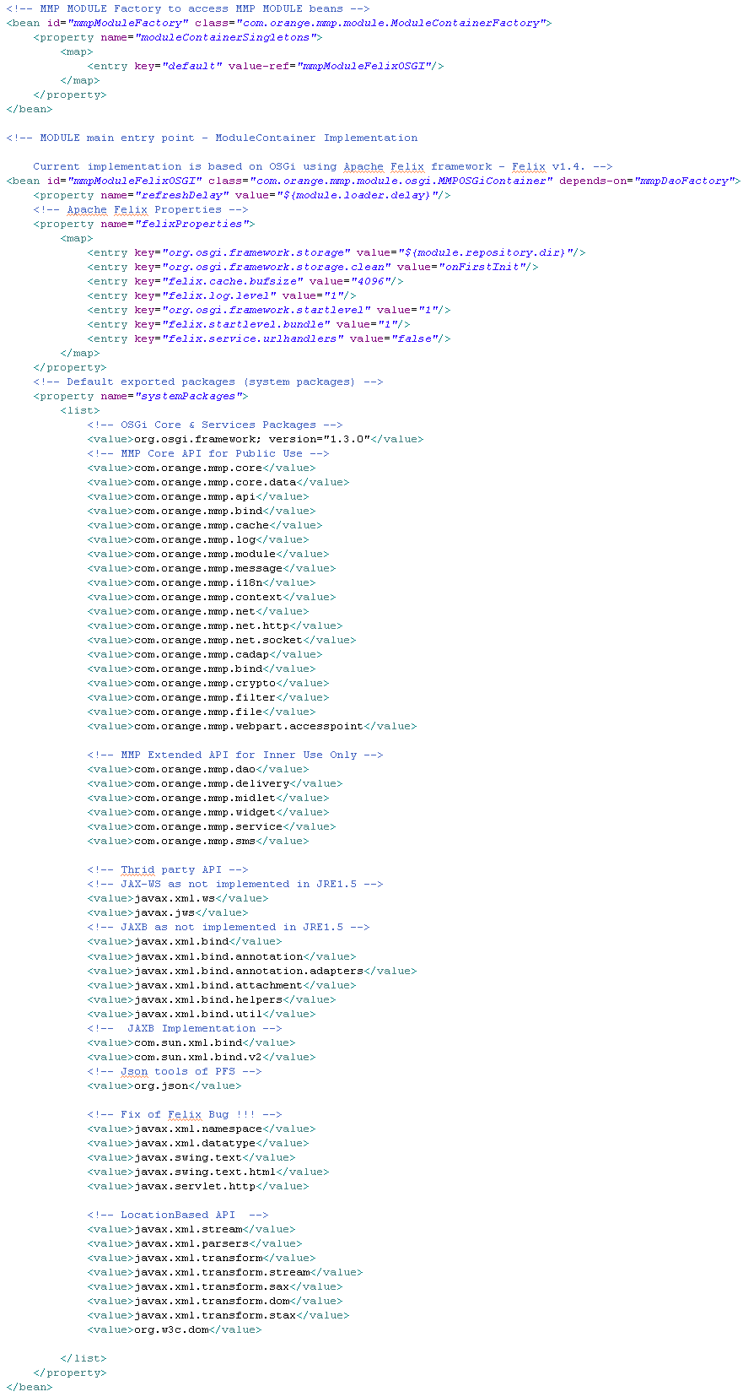
The MMP Module Component is configured in the module.xml file (see fragment above). It aims to handle dynamic modules framework for MMP by providing modules resources access, modules dynamic class loading…

The ModuleContainer is a dynamic module container; its implementation is MMPOSGiContainer, a module container based on OSGi using the Apache Felix Framework. ModuleContainer are obtained from ModuleContainerFactory, according to the Factory design pattern on which the MMP Module Component is based.
The mmpModuleFelixOSGI bean lists the packages that will be exposed to modules by the ModuleContainer.

The ModuleObserver aims to handle modules events throughout the application.

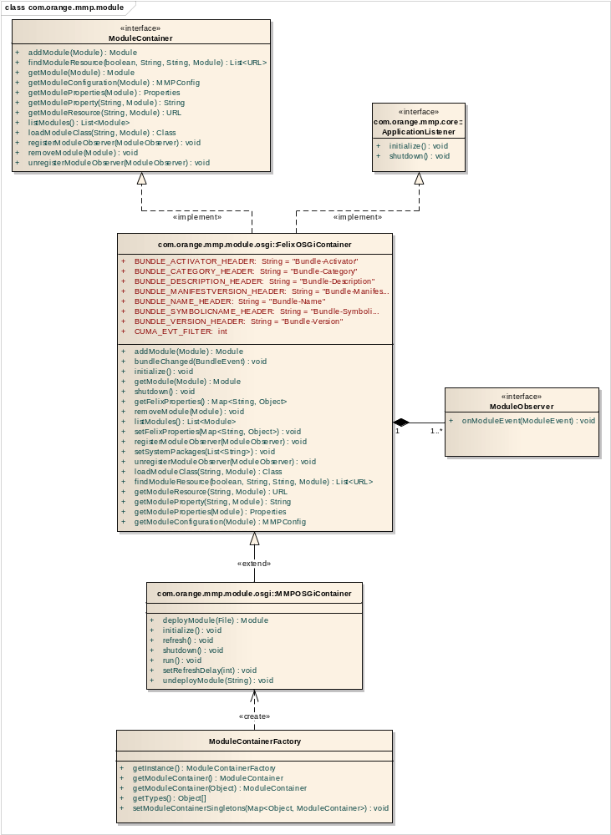
Module Component class diagram

ModuleContainerFactory Class
Connections
Connector | Source | Target | Notes
Dependency  Source -> Destination | Public  ModuleContainerFactory | Public  MMPOSGiContainer

Attributes
Attribute | Notes | Constraints and tags
defaultModuleContainerSingleton ModuleContainer  Private |  | Default:
moduleContainerFactorySingleton ModuleContainerFactory  Private  Static |  | Default:
moduleContainerSingletons Map<Object, ModuleContainer>  Private |  | Default:

Operations
Method | Notes | Parameters
Static getInstance() ModuleContainerFactory
Public
getModuleContainer() ModuleContainer
Public
getModuleContainer() ModuleContainer  Public |  | Object [in] type
getTypes() Object[]
Public
setModuleContainerSingletons() void  Public |  | Map<Object, ModuleContainer> [in] moduleContainerSingletons

ModuleContainer Interface
Connections
Connector | Source | Target | Notes
Realization  Source -> Destination | Public  FelixOSGiContainer | Public  ModuleContainer
Dependency  Source -> Destination | Public  WidgetManager | Public  ModuleContainer

Operations
Method | Notes | Parameters
addModule() Module  Public |  | Module [in] module
findModuleResource() List<URL>  Public |  | boolean [in] recurse  String [in] filePattern  String [in] path  Module [in] module
getModule() Module  Public |  | Module [in] module
getModuleConfiguration() MMPConfig  Public |  | Module [in] module
getModuleProperties() Properties  Public |  | Module [in] module
getModuleProperty() String  Public |  | String [in] propertyName  Module [in] module
getModuleResource() URL  Public |  | String [in] resourcePath  Module [in] module
listModules() List<Module>
Public
loadModuleClass() Class  Public |  | String [in] className  Module [in] module
registerModuleObserver() void  Public |  | ModuleObserver [in] moduleObserver
removeModule() void  Public |  | Module [in] module
unregisterModuleObserver() void  Public |  | ModuleObserver [in] moduleObserver

FelixOSGIContainer Class
Connections
Connector | Source | Target | Notes
Realization  Source -> Destination | Public  FelixOSGiContainer | Public  ApplicationListener
Realization  Source -> Destination | Public  FelixOSGiContainer | Public  ModuleContainer
Generalization  Source -> Destination | Public  MMPOSGiContainer | Public  FelixOSGiContainer
Aggregation  Source -> Destination | Public  ModuleObserver | Public  FelixOSGiContainer

Attributes
Attribute | Notes | Constraints and tags
BUNDLE_ACTIVATOR_HEADER String  Public  Static |  | Default: "Bundle-Activator"
BUNDLE_CATEGORY_HEADER String  Public  Static |  | Default: "Bundle-Category"
BUNDLE_DESCRIPTION_HEADER String  Public  Static |  | Default: "Bundle-Description"
BUNDLE_MANIFESTVERSION_HEADER String  Public  Static |  | Default: "Bundle-ManifestVersion"
BUNDLE_NAME_HEADER String  Public  Static |  | Default: "Bundle-Name"
BUNDLE_SYMBOLICNAME_HEADER String  Public  Static |  | Default: "Bundle-SymbolicName"
BUNDLE_VERSION_HEADER String  Public  Static |  | Default: "Bundle-Version"
CUMA_EVT_FILTER int  Public  Static |  | Default:
felixFramework Felix  Private |  | Default:
felixProperties Map<String,Object>  Private |  | Default:
hostActivator HostActivator  Private |  | Default:
lock Lock  Private |  | Default:
moduleObservers List<ModuleObserver>  Private |  | Default:
modulesCache Map<Module, Element>  Private |  | Default:
modulesConfigurationCache Map<Module, MMPConfig>  Private |  | Default:
systemPackages List<String>  Private |  | Default:

Operations
Method | Notes | Parameters
addModule() Module  Public |  | Module [in] module
bundleChanged() void  Public |  | BundleEvent [in] bundleEvent
bundleToModule() Module  Protected |  | Bundle [in] bundle
findModuleResource() List<URL>  Public |  | boolean [in] recurse  String [in] filePattern  String [in] path  Module [in] module
getFelixProperties() Map<String, Object>
Public
getModule() Module  Public |  | Module [in] module
getModuleConfiguration() MMPConfig  Public |  | Module [in] module
getModuleProperties() Properties  Public |  | Module [in] module
getModuleProperty() String  Public |  | String [in] propertyName  Module [in] module
getModuleResource() URL  Public |  | String [in] resourcePath  Module [in] module
initialize() void
Public
listModules() List<Module>
Public
loadModuleClass() Class  Public |  | String [in] className  Module [in] module
registerModuleObserver() void  Public |  | ModuleObserver [in] moduleObserver
removeModule() void  Public |  | Module [in] module
setFelixProperties() void  Public |  | Map<String, Object> [in] felixProperties
setSystemPackages() void  Public |  | List<String> [in] systemPackages
shutdown() void
Public
unregisterModuleObserver() void  Public |  | ModuleObserver [in] moduleObserver

MMPOSGIContainer Class
Connections
Connector | Source | Target | Notes
Generalization  Source -> Destination | Public  MMPOSGiContainer | Public  FelixOSGiContainer
Dependency  Source -> Destination | Public  ModuleContainerFactory | Public  MMPOSGiContainer

Attributes
Attribute | Notes | Constraints and tags
FAIL_MAX_COUNT int  Private  Static Const |  | Default: 20
isRunning boolean  Private |  | Default:
lastUpdate long  Private |  | Default: 0
lock Lock  Private |  | Default: new ReentrantLock()
refreshDelay int  Private |  | Default:
RESTART_MAX_COUNT int  Private  Static |  | Default: 20
runningModules Module[]  Private |  | Default:

Operations
Method | Notes | Parameters
deployModule() Module  Public |  | File [in] moduleFile
initialize() void
Public
refresh() void
Public
run() void
Public
setRefreshDelay() void  Public |  | int [in] refreshDelay
shutdown() void
Public
undeployModule() void  Public |  | String [in] moduleId

SMS
The MMP SMS Component is configured in the sms.xml file. An ISMSHandler object, implemented by XMSHubHandler, provides a method to send SMS, and is able to return a list of the countries supported by the handler. Other handlers could be implemented, as the SMS Component is based on Factory design pattern.

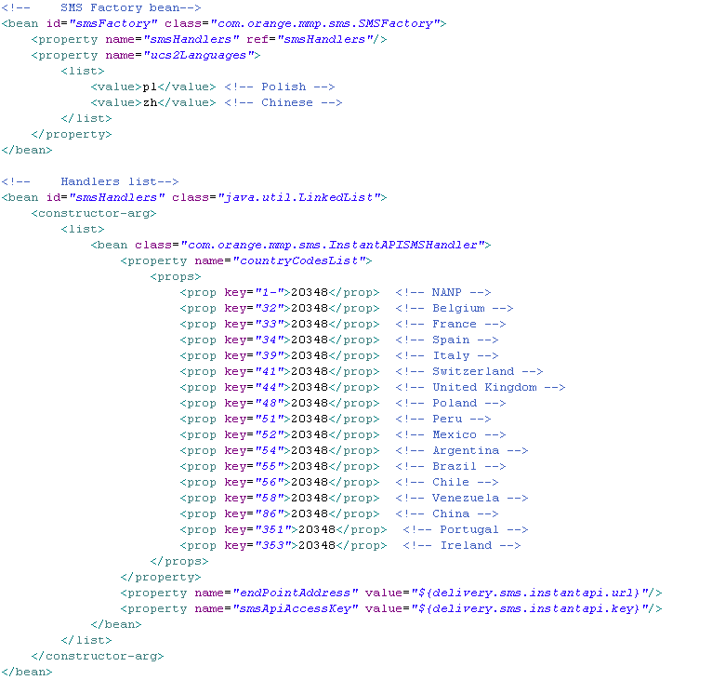
sms.xml fragment

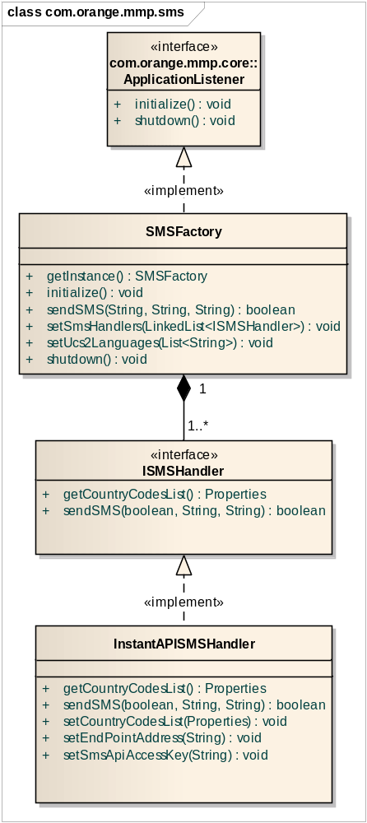
SMS Component class diagram

SMSFactory Class
Connections
Connector | Source | Target | Notes
Realization  Source -> Destination | Public  SMSFactory | Public  ApplicationListener
Aggregation  Source -> Destination | Public  ISMSHandler | Public  SMSFactory

Attributes
Attribute | Notes | Constraints and tags
smsFactorySingleton SMSFactory  Private  Static |  | Default:
smsHandlers List<ISMSHandler>  Private |  | Default:
ucs2Languages List<String>  Private |  | Default:

Operations
Method | Notes | Parameters
findHandler() ISMSHandler  Private |  | String [in] _phoneNumber
formatND() String  Private |  | String [in] _ND
Static getInstance() SMSFactory
Public
initialize() void
Public
sendSMS() boolean  Public |  | String [in] lang  String [in] text  String [in] ND
setSmsHandlers() void  Public |  | LinkedList<ISMSHandler> [in] smsHandlers
setUcs2Languages() void  Public |  | List<String> [in] ucs2Languages
shutdown() void
Public

ISMSHandler Class
Connections
Connector | Source | Target | Notes
Realization  Source -> Destination | Public  InstantAPISMSHandler | Public  ISMSHandler
Aggregation  Source -> Destination | Public  ISMSHandler | Public  SMSFactory

Operations
Method | Notes | Parameters
getCountryCodesList() Properties
Public
sendSMS() boolean  Public |  | boolean [in] useUCS2Support  String [in] text  String [in] ND

InstantAPISMSHandler Class
Connections
Connector | Source | Target | Notes
Realization  Source -> Destination | Public  InstantAPISMSHandler | Public  ISMSHandler

Attributes
Attribute | Notes | Constraints and tags
countryCodesList Properties  Private |  | Default: null
endPointAddress String  Private |  | Default: null
smsApiAccessKey String  Private |  | Default: null

Operations
Method | Notes | Parameters
getCountryCodesList() Properties
Public
sendSMS() boolean  Public |  | boolean [in] useUCS2Support  String [in] text  String [in] ND
setCountryCodesList() void  Public |  | Properties [in] countryCodesList
setEndPointAddress() void  Public |  | String [in] endPointAddress
setSmsApiAccessKey() void  Public |  | String [in] smsApiAccessKey

ISMSHandler Interface
Connections
Connector | Source | Target | Notes
Realization  Source -> Destination | Public  InstantAPISMSHandler | Public  ISMSHandler
Aggregation  Source -> Destination | Public  ISMSHandler | Public  SMSFactory

Operations
Method | Notes | Parameters
getCountryCodesList() Properties
Public
sendSMS() boolean  Public |  | boolean [in] useUCS2Support  String [in] text  String [in] ND

Filter
The MMP Filter Component is configured in the filter.xml file. It offers an extension of servlets filters features. In MMP, filters are handled by MMPFilterDispatcher. The only implementation of MMPFilter is MMPFilterWrapper, which is a simple MMPFilter wrapping an MMPFilter and simple configuration.
There are two specializations of MMPFilterDispatcher:
- MMPPrivateAPIFilter, used for private MMP API,
- MMPPublicAPIFilter, used for public MMP API.

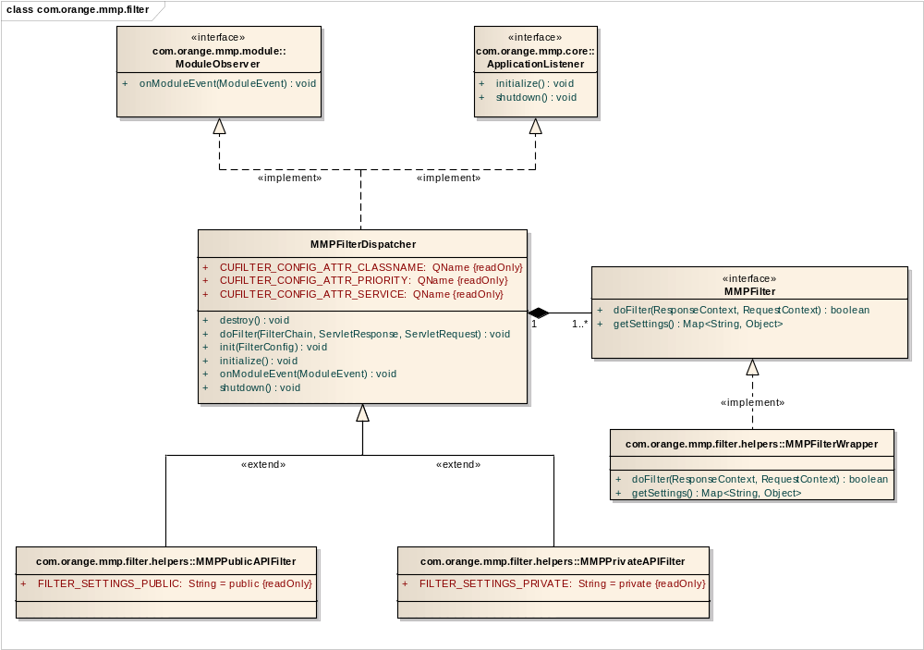
Filter Component diagram class

MMPFilterDispatcher Class
Connections
Connector | Source | Target | Notes
Generalization  Source -> Destination | Public  MMPPublicAPIFilter | Public  MMPFilterDispatcher
Generalization  Source -> Destination | Public  MMPPrivateAPIFilter | Public  MMPFilterDispatcher
Realization  Source -> Destination | Public  MMPFilterDispatcher | Public  ApplicationListener
Realization  Source -> Destination | Public  MMPFilterDispatcher | Public  ModuleObserver
Aggregation  Source -> Destination | Public  MMPFilter | Public  MMPFilterDispatcher

Attributes
Attribute | Notes | Constraints and tags
CUFILTER_CONFIG_ATTR_CLASSNAME QName  Public  Static Const |  | Default:
CUFILTER_CONFIG_ATTR_PRIORITY QName  Public  Static Const |  | Default:
CUFILTER_CONFIG_ATTR_SERVICE QName  Public  Static Const |  | Default:
filters Map<Service, List<Element>>  Private |  | Default:
lock Lock  Private |  | Default:

Operations
Method | Notes | Parameters
addFilter() void  Protected |  | String [in] name  MMPFilter [in] filter
addModuleFilter() void  Protected |  | Module [in] module
destroy() void
Public
doFilter() void  Public |  | FilterChain [in] filterChain  ServletResponse [in] servletResponse  ServletRequest [in] servletRequest
init() void  Public |  | FilterConfig [in] filterConfig
initialize() void
Public
onModuleEvent() void  Public |  | ModuleEvent [in] moduleEvent
removeFilter() void  Protected |  | String [in] name  MMPFilter [in] filter
removeModuleFilter() void  Protected |  | Module [in] module
shutdown() void
Public
supportFilter() boolean  Protected |  | MMPFilter [in] filter

MMPFilter Interface
Connections
Connector | Source | Target | Notes
Realization  Source -> Destination | Public  MMPFilterWrapper | Public  MMPFilter
Aggregation  Source -> Destination | Public  MMPFilter | Public  MMPFilterDispatcher

Operations
Method | Notes | Parameters
doFilter() boolean  Public |  | ResponseContext [in] response  RequestContext [in] request
getSettings() Map<String, Object>
Public

MMPFilterWrapper Class
Connections
Connector | Source | Target | Notes
Realization  Source -> Destination | Public  MMPFilterWrapper | Public  MMPFilter

Attributes
Attribute | Notes | Constraints and tags
innerFilter MMPFilter  Private |  | Default:
settings Map<String, Object>  Private |  | Default:

Operations
Method | Notes | Parameters
doFilter() boolean  Public |  | ResponseContext [in] response  RequestContext [in] request
getSettings() Map<String, Object>
Public

MMPPrivateAPIFilter Class
Connections
Connector | Source | Target | Notes
Generalization  Source -> Destination | Public  MMPPrivateAPIFilter | Public  MMPFilterDispatcher

Attributes
Attribute | Notes | Constraints and tags
FILTER_SETTINGS_PRIVATE String  Public  Static Const |  | Default: private

Operations
Method | Notes | Parameters
supportFilter() boolean  Protected |  | MMPFilter [in] filter

MMPPublicAPIFilter Class
Connections
Connector | Source | Target | Notes
Generalization  Source -> Destination | Public  MMPPublicAPIFilter | Public  MMPFilterDispatcher

Attributes
Attribute | Notes | Constraints and tags
FILTER_SETTINGS_PUBLIC String  Public  Static Const |  | Default: public

Operations
Method | Notes | Parameters
supportFilter() boolean  Protected |  | MMPFilter [in] filter

Annex 1: Environment

Build
MMP has been developed on Eclipse 3.4 IDE and is packaged as an Eclipse Web project. The following plug-in are needed to support all MMP features:
- Web Standard Tools - Version: 3.0.0 or later
- Spring IDE - Version: 2.0.0 or later (using Spring Framework 2.0.3)
- Eclipse AspectJ Development Tools - Version: 1.4.2 or later (using AspectJ v1.6.5)
- JAXB-Workshop - Version 1.1.0 or later (https://jaxb-workshop.dev.java.net/)

Once opened in an Eclipse J2EE perspective, the MMP project should look as follows:

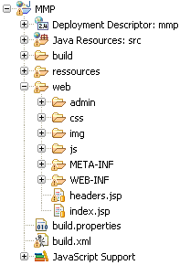

Here is a detailed description of each folder:

- Deployment Descriptor : MMP
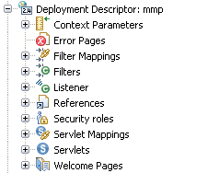

It's the J2EE Web Application descriptor (web.xml) used to add resources and components to MMP.

- Java Resources : src
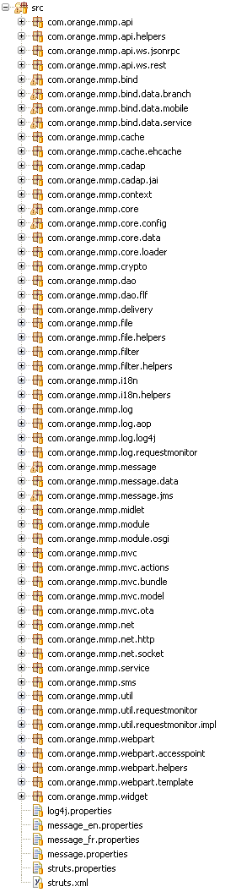

MMP Java sources and libraries:
- com.orange.mmp.api: API management
- com.orange.mmp.api.ws.jsonrpc: RPC Web service exposure (JSON-RPC)
- com.orange.mmp.api.ws.rest: REST Web service exposure
- com.orange.mmp.bind: JAXB tools classes (REST Client)
- com.orange.mmp.bind.data: XSD source files (for development only) and generated classes
- com.orange.mmp.cache: cache management
- com.orange.mmp.cadap: content adaptation package
- com.orange.mmp.context: context accessors for modules
- com.orange.mmp.core: core package (constants and main components)
- com.orange.mmp.core.config: XSD source file and generated classes for mmp-config.xml file (configuration file exposing modules features)
- com.orange.mmp.core.data: POJO (Widget, Midlet...)
- com.orange.mmp.dao: DAO support
- com.orange.mmp.dao.flf: DAO Flat Files implementation
- com.orange.mmp.file: files management
- com.orange.mmp.filter: HTTP servlet filter (MMPFilter for versioning)
- com.orange.mmp.i18n: internationalization management
- com.orange.mmp.log: logging package
- com.orange.mmp.log.aop: AOP package (aspects implementation used for statistics)
- com.orange.mmp.midlet: midlets management package
- com.orange.mmp.module: Modules management, OSGI framework and implementation
- com.orange.mmp.mvc.actions: Struts2 classes (admin GUI)
- com.orange.mmp.mvc.bundle: Spring MVC servlet controller used for downloading M4M
- com.orange.mmp.mvc.model: model class when not available
- com.orange.mmp.mvc.ota: Spring MVC servlet controller used for PFM delivery and update
- com.orange.mmp.net: connection management package
- com.orange.mmp.sms: SMS support for OTA installation
- com.orange.mmp.webpart: web part management
- com.orange.mmp.webpart.accesspoint: package containing bundle access point for a web part
- com.orange.mmp.webpart.template: package containing module template loader for a web part
- com.orange.mmp.widget: Dedicated class exposed to widgets

Inner resources:
- log4j.properties: base LOG4J configuration, do not modify, use log4j-mmp.properties
- message_xx.properties: localization resources
- struts.properties: Struts2 configuration
- struts.xml: Struts2 actions definition

- Resources
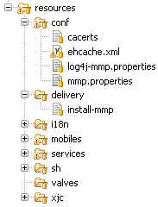

Any configuration parameter must be set in mmp.properties and not in other files directly. The main Spring descriptor base.xml should point on it to retrieve values:

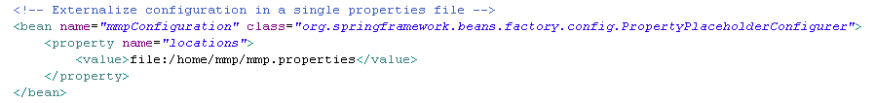

The conf folder contains other resources used by the application; their paths are referenced in mmp.properties:
- cacerts is the file owning the keystore for midlet signing (defined as midletmanager.sign.keystore.file)
- ehcache.xml contains the configuration for cache module (cache.configuration)
- log4j-mmp.properties contains log configuration (log.configuration)

Installation script is located in the delivery folder.

The i18n folder contains localized messages for OTA installation and SMS.

The supported mobiles list is located in the mobiles folder, in the mobile-catalog.xml file. The branches list is located in the same folder, in the branch-catalog.xml file.

The services folder contains one XML file for each service deployed on the platform. These files provide services configuration.

Both mobiles and services folders own files shared between each instance on MMP (using shared folder). The administration server modifies these properties using DAO and other instances update their inner cache according to the new content of these files.

The sh folder contains statistics aggregation scripts.

The valves folder contains Tomcat valves used by the application server.

The xjc folder contains JAXB libraries.

- web
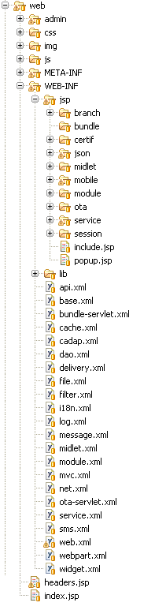

These are the Web resources of MMP:
- admin – css – img – js folders: web resources available at ROOT path
- WEB-INF/jsp: Struts2 pages for administration interface
- WEB-INF/jsp/ota: Spring MVC dynamic pages used for OTA installation
- WEB-INF/lib: webapp libraries

Run
MMP can be hosted directly on a Tomcat 5.5 server project of Eclipse which must be installed by the way to import J2EE servlet libraries.

The main application is a simple Web application which can be packaged as WAR file and deployed in the webapps directory of a Tomcat server (or any J2EE server).

Configuration files are available in resources/conf directory of delivered MMP. These files must be copied in a directory with Tomcat user's rights and the main Spring IoC descriptor must be configured to point on mmp.properties file.

A shared repository (can be local for testing purpose) must be defined too with Tomcat user's rights. Each subdirectory must be configured in mmp.properties to point on this folder.

There are two other directories to create; they are defined in mmp.properties:
- Log root folder: log.folder,
- OSGI cache: module.repository.dir.

