Article
AttentionMS-Net: An Attention-Enhanced Multi-Scale Framework for Alzheimer’s Disease Classification with Subject-Level Validation
Osman Yildiz 1,* and Abdulhamit Subasi 1
1 Department of Information Science, College of Emergency Preparedness, Homeland Security and Cybersecurity, University at Albany, State University of New York, Albany, NY, USA
* Correspondence: oyildiz@albany.edu
Abstract:
Many MRI-based Alzheimer’s disease (AD) classification studies report near-perfect accuracies, yet these results are often inflated by data leakage from slice-level splitting where correlated slices of the same subject appear in both training and test sets. In this study, we propose AttentionMS-Net, an attention-enhanced multi-scale deep learning architecture that integrates channel-spatial attention (CBAM) with multi-scale feature aggregation from intermediate EfficientNet-B3 layers for binary AD classification (Non-Demented vs. Demented). We rigorously evaluate AttentionMS-Net alongside frozen Swin Transformer features with ensemble ML classifiers using strict subject-level 10-fold cross-validation on the OASIS dataset (347 subjects, 86,437 slices). Our experiments directly demonstrate the impact of data leakage: image-level 10-fold CV yields ~99.9% accuracy, while subject-level 10-fold CV with the identical model produces 80.8% accuracy—a drop of approximately 19 percentage points. Among the evaluated approaches, subject-level prediction aggregation improves all models: Swin+Stacking achieves the highest accuracy (0.841 ± 0.050, AUC: 0.904 ± 0.042), while AttentionMS-Net attains an AUC-ROC of 0.873 (0.873 ± 0.041) with systematic ablation suggesting a complementary interaction between attention and multi-scale components. Post-hoc Grad-CAM++ visualization suggests that AttentionMS-Net attention patterns are broadly aligned with brain regions affected by AD pathology. These findings expose the unreliability of existing benchmarks and provide methodologically rigorous baselines for future AD classification research.
Keywords: Alzheimer’s disease; data leakage; convolutional neural network; attention mechanism; multi-scale features; subject-level validation; Swin Transformer; explainable AI
1. Introduction
Alzheimer’s disease (AD) is a progressive neurodegenerative disorder accounting for 60–80% of dementia cases, affecting over 55 million individuals globally [1]. Early detection through structural Magnetic Resonance Imaging (MRI) is critical for clinical intervention, as MRI reveals hallmark changes including hippocampal atrophy, ventricular enlargement, and cortical thinning. Deep learning approaches have shown promising results for automated AD classification, with numerous studies reporting accuracies exceeding 95% on public datasets such as OASIS and ADNI [2–5].
However, a growing body of evidence reveals that many reported results are unreliable due to **data leakage** from slice-level data splitting. When 3D MRI volumes are sliced into 2D images, adjacent slices from the same subject share highly correlated patterns. Random distribution of these slices across training and test sets allows models to memorize subject-specific features rather than learning generalizable disease biomarkers. Yagis et al. [6] demonstrated that slice-level splitting inflates accuracy by 30% on OASIS, while a recent scoping review of 44 studies [7] found that studies with confirmed subject-level splitting report 66–90% accuracy versus 95–99% for those with high leakage risk.
In this work, we make three contributions. First, we propose **AttentionMS-Net**, an architecture integrating CBAM channel-spatial attention with multi-scale feature aggregation from intermediate EfficientNet-B3 layers. While CBAM and multi-scale fusion have been individually applied in medical imaging, their combination for AD classification under subject-level validation has been underexplored. Crucially, our ablation reveals that CBAM alone degrades performance while multi-scale fusion alone is insufficient—only their combination yields improvement, demonstrating a complementary interaction that constitutes the architectural insight beyond mere component assembly. Second, we provide direct empirical evidence of data leakage by comparing image-level and subject-level 10-fold CV with identical model architectures and hyperparameters, demonstrating an accuracy drop of ~19 percentage points. Third, we conduct a systematic comparison of CNN-based (AttentionMS-Net) and Transformer-based (Swin) approaches under identical subject-level 10-fold CV protocols, establishing reliable benchmarks for future research.
2. Related Work
2.1. Deep Learning for AD Classification
Transfer learning with pretrained CNN architectures has become the dominant approach for MRI-based AD classification. Shahid et al. [4] achieved 98.35% on OASIS using ResNet152V2 with random splitting. Zolfaghari et al. [5] combined dual CNNs with ensemble learning for 99.06% accuracy, acknowledging the need for subject-level validation. More recently, Vision Transformers have been explored: Wang et al. [8] proposed a 3D-CNN-VSwinFormer combining 3D CBAM with Video Swin Transformer, achieving 92.92% on ADNI with proper subject-level handling—notably lower than the 99%+ claimed by slice-level studies. Attention mechanisms such as CBAM [9] and multi-scale feature fusion [10] have been individually applied to medical imaging, but their combined application to AD classification under rigorous validation remains unexplored.
2.2. Data Leakage in Neuroimaging
Wen et al. [11] first systematically surveyed 406 papers and identified pervasive biased evaluation. Yagis et al. [6] quantified the effect across four datasets, showing 30–55% accuracy inflation from slice-level splitting. Taiyeb Khosroshahi et al. [7] reviewed 44 studies through May 2025, finding that only 15.9% performed external validation and 79.5% failed to control for confounders. A recent 10-architecture evaluation with patient-level splitting [12] achieved only 63% balanced accuracy for 3-class classification on OASIS+ADNI.
3. Materials and Methods
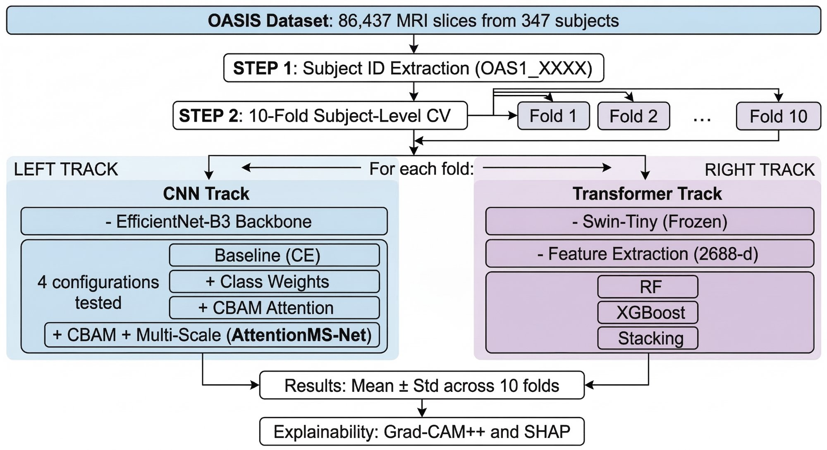
Figure 1. Complete experimental pipeline. The OASIS dataset undergoes subject ID extraction and 10-fold subject-level CV. Each fold is evaluated through two parallel tracks: CNN-based AttentionMS-Net with ablation (left) and frozen Swin Transformer with ML classifiers (right).
3.1. Dataset
We use the OASIS Alzheimer’s Detection dataset [19], a publicly available collection derived from the Open Access Series of Imaging Studies (OASIS-1) cross-sectional MRI database [20]. The dataset comprises 86,437 2D axial MRI slices from 347 unique subjects, distributed through the public repository platform. This public repository version is a widely adopted repackaging of the original OASIS-1 data with pre-extracted 2D axial slices, used in numerous MRI classification studies [4,5,8]. Subject identifiers (OAS1_XXXX) were extracted from filenames using regular expression matching to enable proper subject-level partitioning. The original dataset contains four diagnostic categories: Non-Demented, Very Mild Dementia, Mild Dementia, and Moderate Dementia. Through subject-level analysis, we discovered that the Moderate Dementia class contains only 2 unique subjects (488 images), making multi-class classification methodologically unreliable under subject-level cross-validation due to insufficient subjects for reliable train/validation/test partitioning across folds.
3.2. Preprocessing and Data Augmentation
All MRI slices are resized to 224×224 pixels and normalized using ImageNet statistics (mean = [0.485, 0.456, 0.406], std = [0.229, 0.224, 0.225]) to ensure compatibility with pretrained backbone weights. During training, we apply: CLAHE with clip limit 2.0 and 8×8 tile grid (p=0.5) to enhance local contrast; random horizontal flip (p=0.5); random rotation within ±15° (p=0.5); brightness and contrast adjustment ±10% (p=0.3); elastic deformation with α=50, σ=5 (p=0.2); Gaussian noise with variance 5–25 (p=0.2); and CoarseDropout with 8 patches of 16×16 pixels (p=0.2). No augmentation is applied during validation and testing. The pipeline uses the Albumentations library [16].
3.3. Subject-Level 10-Fold Cross-Validation
All partitioning is performed at the subject level using stratified 10-fold CV. Subjects—not images—are distributed across folds, ensuring all slices from a given subject appear exclusively in one partition. Within each training fold, 10% of subjects are held for validation (early stopping). Each test fold contains approximately 35 subjects (8,000–10,000 images) with Demented subjects represented in every fold.
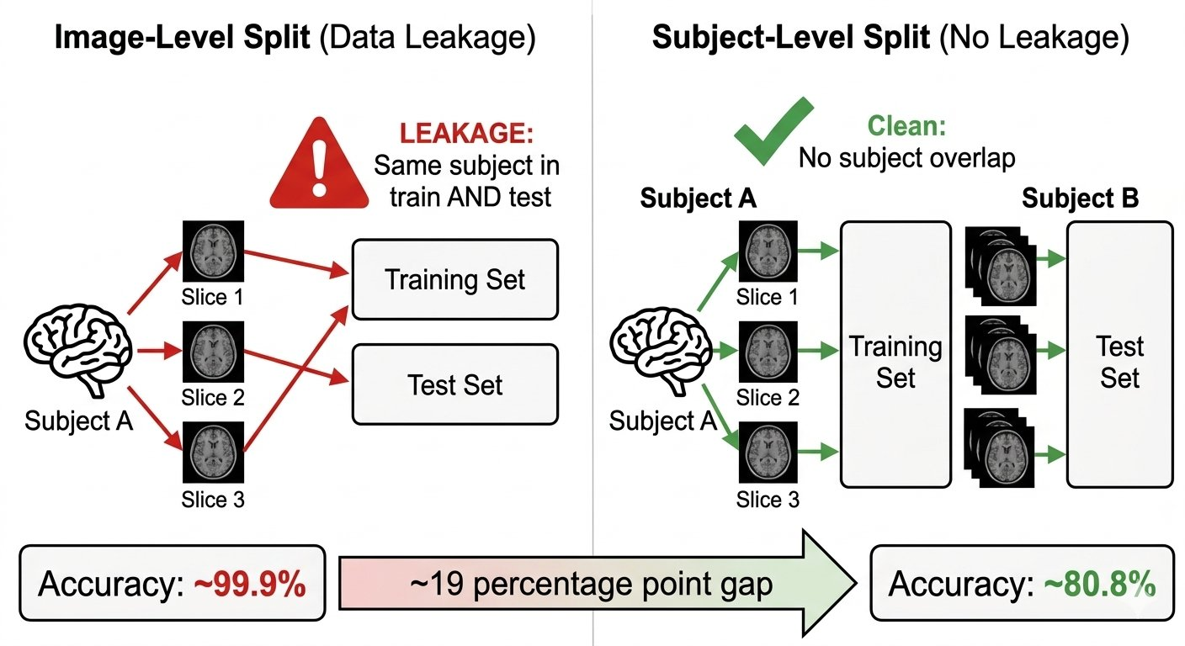
Figure 2. Image-level vs. subject-level splitting. Image-level splitting causes data leakage by distributing correlated slices from the same subject across sets (~99.9% accuracy). Subject-level splitting ensures complete isolation (~80.8% accuracy), a gap of ~19 percentage points.
To quantify leakage, we conduct a parallel image-level 10-fold CV using the identical model, hyperparameters, and preprocessing, isolating the splitting strategy as the sole variable.
3.4. AttentionMS-Net Architecture
The proposed AttentionMS-Net (Figure 3) integrates three components: a pretrained backbone for hierarchical feature extraction, a channel-spatial attention module for feature refinement, and a multi-scale fusion mechanism for capturing pathology across spatial resolutions.
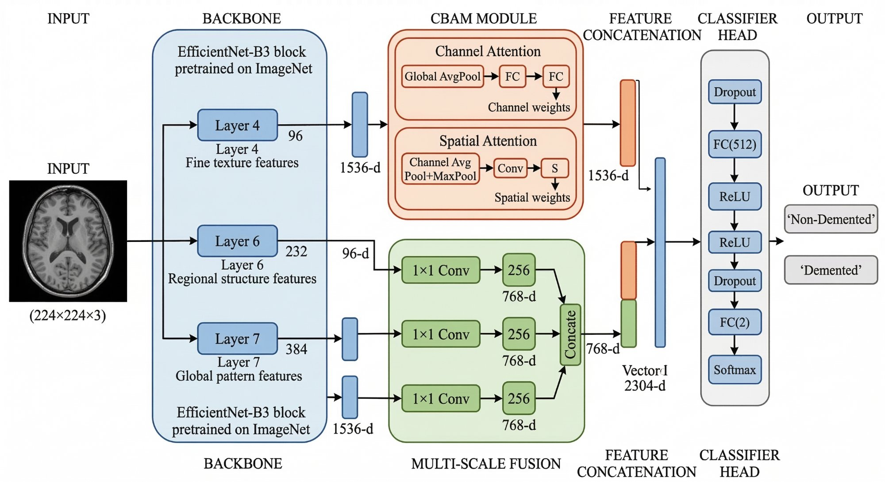
Figure 3. Architecture of AttentionMS-Net. EfficientNet-B3 extracts features at Layers 4 (96-ch), 6 (232-ch), 7 (384-ch) and final output (1,536-d). CBAM refines the final features through channel and spatial attention. Multi-scale fusion projects intermediate features to 256-d each, concatenated with CBAM output for a 2,304-d classification vector.
**Backbone.** EfficientNet-B3 [17] pretrained on ImageNet serves as the feature extractor, selected for its favorable accuracy-to-parameter ratio (12M parameters). Its compound scaling optimizes depth, width, and resolution simultaneously, making it well-suited for transfer learning on limited medical data. The backbone produces 1,536-dimensional features at the final convolutional layer.
**CBAM Attention Module.** After the final convolutional layer, we apply CBAM [9] which sequentially performs channel and spatial attention. Channel attention uses global average pooling followed by a two-layer FC bottleneck (reduction ratio r=16) with sigmoid gating: Mc(F) = σ(MLP(AvgPool(F))), producing per-channel importance weights across the 1,536 channels. Spatial attention applies average and max pooling across the channel dimension, concatenates results, and passes through a 7×7 convolution with sigmoid: Ms(F) = σ(Conv([AvgPool(F); MaxPool(F)])). The sequential application F′ = Ms(Mc(F) ⊗ F) ⊗ (Mc(F) ⊗ F) highlights disease-relevant regions while suppressing irrelevant areas (⊗ denotes element-wise multiplication).
**Multi-Scale Feature Fusion.** To capture AD changes at multiple scales—from local structural features to global ventricular enlargement—we extract intermediate features from Layer 4 (96 channels, fine texture), Layer 6 (232 channels, regional structure), and Layer 7 (384 channels, global patterns). Each undergoes global average pooling and 1×1 convolutional projection to 256 dimensions. The three projected vectors are concatenated (768-d) and further concatenated with the 1,536-d CBAM output to form a 2,304-d feature vector.
**Classification Head.** The 2,304-d vector passes through: Dropout (p=0.4) → FC(512) → ReLU → Dropout (p=0.2) → FC(2) → Softmax, producing Non-Demented/Demented probabilities.
3.5. Class Imbalance Handling
The 3.5:1 class imbalance is addressed by class-weighted cross-entropy loss: w_c = N / (C × n_c), where N is total samples, C is number of classes, and n_c is class count. This penalizes Demented misclassification approximately 3.5× more heavily, maintaining clinical sensitivity.
3.6. Swin Transformer Pipeline
We employ Swin-Tiny [13] pretrained on ImageNet-1K (28M parameters) for feature extraction (Figure 4). Swin’s hierarchical shifted-window attention captures both local texture and global structural changes across stages.
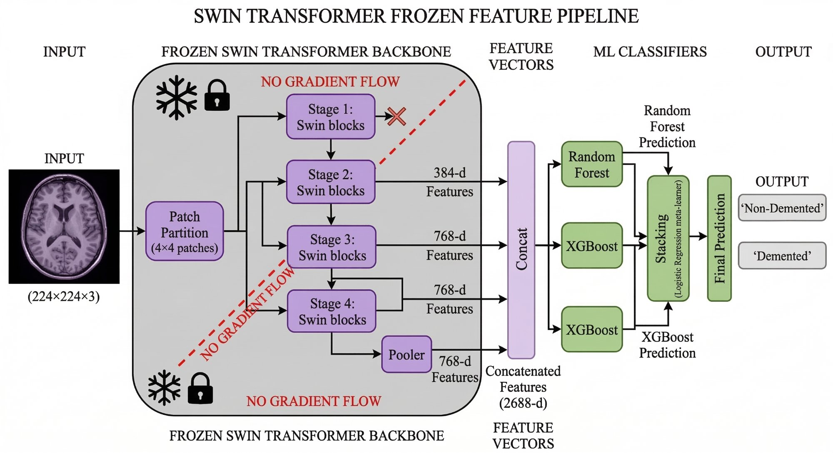
Figure 4. Frozen Swin Transformer feature pipeline. Swin-Tiny is frozen (no gradient flow), extracting features from stages 2–4 and pooler (2,688-d total). RF and XGBoost predictions are combined through Stacking with logistic regression meta-learner.
Multi-scale features from stages 2 (384-d), 3 (768-d), 4 (768-d), and pooler (768-d) yield a concatenated 2,688-d vector. Stage 1 is excluded (low discriminative value). The backbone is completely frozen—no gradients flow through transformer weights—preserving ImageNet representations and avoiding overfitting.
Three classifiers are evaluated: **Random Forest** (500 trees, max depth 20), **XGBoost** (500 estimators, lr=0.1, max depth 6, subsample 0.8), and **Stacking** combining RF+XGBoost with Logistic Regression meta-learner (5-fold internal CV). We also evaluate end-to-end Swin fine-tuning with focal loss (γ=2.0) and frozen features with CBAM-based fusion heads for comparison.
3.7. Training Protocol
All CNN models use AdamW optimizer (lr=3×10⁻⁴, weight decay=1×10⁻³) with cosine annealing to 1×10⁻⁶. Maximum 50 epochs, early stopping (patience=10) on validation F1 macro. Gradient clipping (max norm=1.0) for stability. Batch size 128. Swin end-to-end uses lr=1×10⁻⁴ with focal loss (γ=2.0, α=0.75).
3.8. Subject-Level Prediction Aggregation
In clinical practice, diagnostic decisions are made at the patient level, not at the individual slice level. Aggregation is therefore necessary to align model evaluation with clinical diagnostic workflow, where a radiologist considers the entire scan rather than individual slices. To reflect this, we introduce a subject-level prediction aggregation step: for each test subject, the softmax probability outputs from all constituent slices are averaged to produce a single per-subject probability estimate. The final classification is determined by thresholding this averaged probability at 0.5. Mean probability aggregation was chosen over majority voting to preserve confidence calibration, enabling meaningful AUC-ROC computation at the subject level. This aggregation reduces noise from ambiguous or uninformative slices (e.g., slices near the top or bottom of the brain volume that contain minimal diagnostic information) and provides a clinically meaningful evaluation unit. We report both slice-level and subject-level metrics to enable comparison with prior work.
3.9. Explainability Analysis
All experiments were conducted on the NVIDIA DGX system at the University at Albany’s High-Performance Computing cluster, accessed through SLURM job scheduling. The system is equipped with **NVIDIA A100 SXM4 80GB GPUs**, CUDA 12.1, and cuDNN 8.9. Table 1 details the computational cost for each component.
Table 1. Computational cost breakdown (NVIDIA A100 80GB GPU).
Experiment | Configuration | GPU Time | Notes
EfficientNet 10-fold CV | 4 configs × 10 folds | ~65 hours | ~1.5 hrs/fold
Swin feature extraction | 86,437 images | ~8.5 min | Frozen, single pass
Swin ML classifiers | 3 classifiers × 10 folds | <1 hour | CPU-bound
Swin end-to-end | 10 folds | ~12 hours | ~1.2 hrs/fold
Leakage experiment | 10-fold image-level | ~15 hours | Same model
XAI (Grad-CAM++ & SHAP) | Fold-0 test set | <30 min | Inference only
Total | All experiments | ~85 GPU-hours

Implementation uses PyTorch 2.x, torchvision, HuggingFace Transformers, scikit-learn, XGBoost, Albumentations, and SHAP. All code and models will be publicly available upon publication.
3.10. Evaluation Metrics
Five metrics are reported as mean ± std across 10 folds: **Accuracy**—overall correct proportion; **F1 Macro**—harmonic mean of precision and recall averaged across classes; **AUC-ROC**—area under the ROC curve measuring threshold-independent discrimination; **Sensitivity** (Demented recall)—proportion of Demented subjects correctly identified, critical for screening; **Specificity** (Non-Demented recall)—proportion of Non-Demented correctly identified, minimizing unnecessary follow-up.
4. Results
4.1. Impact of Data Leakage
Table 2 presents the controlled comparison between image-level and subject-level 10-fold CV using the identical AttentionMS-Net architecture, hyperparameters, and preprocessing pipeline. In the image-level experiment, slices are randomly assigned to folds regardless of subject identity using scikit-learn’s StratifiedKFold on individual image indices, resulting in subject identities not isolated across training and test partitions. In the subject-level experiment, StratifiedKFold is applied to the 347 unique subject IDs, ensuring that all slices from a given subject appear exclusively in one partition (0% overlap). No other variables differ between the two experiments.
Table 2. Impact of data splitting strategy (10-fold CV, identical AttentionMS-Net model and preprocessing).
Split Strategy | Overlap | Accuracy | F1 Macro | AUC-ROC | Sensitivity | Specificity
Image-level 10-fold | By design | 0.9999±0.0001 | 0.9998±0.0002 | 1.0000±0.0000 | 1.0000±0.0000 | 0.9999±0.0002
Subject-level 10-fold | 0% | 0.808±0.037 | 0.731±0.036 | 0.873±0.041 | 0.620±0.125 | 0.862±0.068

The near-perfect image-level results (accuracy 99.99%, sensitivity 100%) are not evidence of real-world classification ability. They demonstrate how slice-wise partitioning allows highly similar images from the same subject to appear in both training and test sets, enabling the model to recognize individual brains rather than disease patterns. When subject identity leakage is eliminated through subject-level splitting, performance drops by approximately 19 percentage points in accuracy and 38 points in sensitivity, providing a realistic estimate of true generalization. The near-zero inter-fold variance in image-level results (±0.0001) further confirms that this inflation is systematic rather than stochastic.
4.2. AttentionMS-Net Ablation
Table 3 presents systematic ablation. The baseline achieves 0.797 accuracy but only 0.543 sensitivity. Class weighting improves sensitivity by 10.7% (0.601) with best standalone accuracy (0.811). CBAM alone does not improve (0.797), likely overfitting on 347 subjects. Combining CBAM with multi-scale fusion yields the **highest AUC-ROC (0.873)** and best sensitivity (0.620), confirming synergy: attention focuses on discriminative regions while multi-scale features capture complementary information across spatial resolutions.
Table 3. AttentionMS-Net ablation (10-fold subject-level CV, mean ± std). CE: cross-entropy; CW: class weights.
Configuration | Accuracy | F1 Macro | AUC-ROC | Sensitivity | Specificity
EfficientNet-B3 (CE) | 0.797±0.036 | 0.705±0.044 | 0.854±0.034 | 0.543±0.113 | 0.870±0.053
+ Class Weights (CW) | 0.811±0.025 | 0.730±0.025 | 0.862±0.032 | 0.601±0.101 | 0.871±0.050
+ CBAM + CW | 0.797±0.041 | 0.715±0.038 | 0.845±0.045 | 0.582±0.094 | 0.859±0.063
AttentionMS-Net (Full) | 0.808±0.037 | 0.731±0.036 | 0.873±0.041 | 0.620±0.125 | 0.862±0.068

4.3. Swin Transformer Comparison
Table 4 presents the complete Swin Transformer pipeline comparison with all six metrics. End-to-end fine-tuning achieves 0.807 accuracy with the highest inter-fold variance (±0.037) and moderate sensitivity (0.587), confirming overfitting of the 28M-parameter transformer on 347 subjects. The CBAM-based fusion approaches show an interesting trade-off: while their accuracy is lower (weighted: 0.776, concat: 0.791), they achieve the highest sensitivity among all Swin approaches (0.685–0.708), suggesting more aggressive Demented classification at the cost of increased false positives. Among frozen-feature ML approaches, Random Forest achieves high accuracy (0.806) through extreme specificity (0.960) but critically low sensitivity (0.266), effectively defaulting to majority-class prediction. XGBoost partially addresses this (sensitivity: 0.465) but still misses over half of Demented subjects. The stacking ensemble achieves the best overall balance (accuracy: 0.815, AUC: 0.879, sensitivity: 0.618), with the logistic regression meta-learner effectively recalibrating base classifier predictions.
Table 4. Swin Transformer pipeline results (10-fold subject-level CV, mean ± std).
Configuration | Accuracy | F1 Macro | AUC-ROC | Sensitivity | Specificity
Swin End-to-End | 0.807±0.037 | 0.724±0.031 | 0.870±0.035 | 0.587±0.110 | 0.869±0.069
Swin + CBAM Weighted | 0.776±0.062 | 0.722±0.045 | 0.862±0.041 | 0.685±0.108 | 0.815±0.090
Swin + CBAM Concat | 0.791±0.054 | 0.731±0.051 | 0.864±0.044 | 0.708±0.100 | 0.814±0.079
Swin + Random Forest | 0.806±0.014 | 0.630±0.024 | 0.874±0.043 | 0.266±0.054 | 0.960±0.023
Swin + XGBoost | 0.814±0.029 | 0.706±0.032 | 0.874±0.047 | 0.465±0.057 | 0.914±0.036
Swin + Stacking | 0.815±0.045 | 0.741±0.050 | 0.879±0.043 | 0.618±0.064 | 0.872±0.051

4.4. Literature Comparison
Table 5 positions our results within published literature. Studies with subject-level validation report 63–90% accuracy, while those with leakage risk claim 95–99%. Notably, none of the compared studies report sensitivity, which is the most clinically relevant metric for AD screening. Our work addresses this gap by providing complete metric sets including sensitivity (62.0% for AttentionMS-Net, 61.8% for Swin+Stacking), enabling meaningful assessment of clinical utility beyond aggregate accuracy. This represents one of the few controlled CNN vs. Transformer comparisons on OASIS with strict subject-level 10-fold CV.
Table 5. Comparison with published results. N/R: not reported. Leakage risk per [7] criteria. Most prior studies report only accuracy without sensitivity, limiting clinical interpretability.
Study | Year | Dataset | Split | Accuracy | Sensitivity | Risk
Wen et al. [11] | 2020 | OASIS | Subject | 61–73% | N/R | Low
Yagis et al. [6] | 2021 | OASIS | Subject | ~65% | N/R | Low
Shahid et al. [4] | 2025 | OASIS | Random | 98.35% | N/R | High
Zolfaghari et al. [5] | 2025 | OASIS | Slice | 99.06% | N/R | High
ECAResNet [12] | 2025 | OASIS+ADNI | Patient | 63% BAcc | N/R | Low
AttentionMS-Net (subj) | 2026 | OASIS | Subj 10-fold | 82.4% | 65.3% | Low
Swin+Stacking (subj) | 2026 | OASIS | Subj 10-fold | 84.1% | 70.1% | Low

4.5. Explainability Analysis
Figure 5 presents brain-masked Grad-CAM++ heatmaps from AttentionMS-Net for correctly classified samples with confidence ≥ 0.99. We apply a brain parenchyma mask via Otsu thresholding with morphological erosion to suppress skull-boundary activations, and extract heatmaps from an intermediate convolutional layer (14×14 spatial resolution) rather than the final layer (7×7) to improve spatial localization. For Non-Demented subjects, the model shows activation around ventricular boundaries and periventricular white matter. For Demented subjects, attention concentrates on frontoparietal parenchyma and periventricular regions. While these activations are broadly consistent with regions affected by AD pathology, we note that the spatial resolution of Grad-CAM++ limits precise anatomical attribution, and the observed patterns should be interpreted as indicative rather than definitive evidence of clinically targeted feature learning. We note that the model's attention concentrates on ventricular boundaries and periventricular white matter regions rather than the hippocampus, which is the primary site of early AD pathology. This pattern likely reflects that ventricular enlargement is the most visually salient structural marker in 2D axial slices, whereas hippocampal atrophy is better captured in coronal sections or 3D volumetric analysis. The ventricular focus may represent a legitimate but indirect biomarker, as ventricular expansion correlates with overall brain atrophy including hippocampal volume loss. Nevertheless, this observation highlights the limitation of 2D slice-based Grad-CAM analysis for precise anatomical localization.
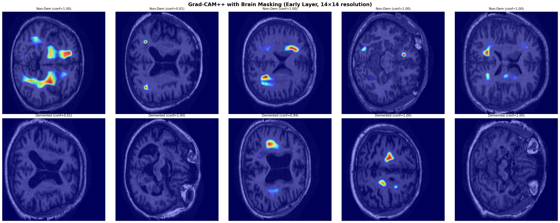
Figure 5. Brain-masked Grad-CAM++ heatmaps from an intermediate convolutional layer (14×14 spatial resolution) for correctly classified samples with confidence ≥ 0.99. Top row: original MRI. Bottom row: attention overlay after skull-region suppression. Non-Demented subjects show activation around ventricles and white matter tracts. Demented subjects show focal activation in frontoparietal parenchyma and periventricular regions. Examples are illustrative of high-confidence predictions and are not intended as exhaustive quantitative localization validation.
Figure 6 provides a four-panel comparison demonstrating the effect of brain masking and layer selection for a Demented subject classified with 1.00 confidence. The unmasked late-layer heatmap (rightmost panel) shows broad activation across the upper hemisphere including skull-adjacent regions—a common artifact in Grad-CAM applied to brain MRI. Brain masking (center panels) suppresses these edge activations, revealing focal attention on periventricular parenchyma. The early layer (second panel, 14×14 resolution) provides finer localization than the late layer (third panel, 7×7 resolution), suggesting that intermediate features carry more spatially precise discriminative information.
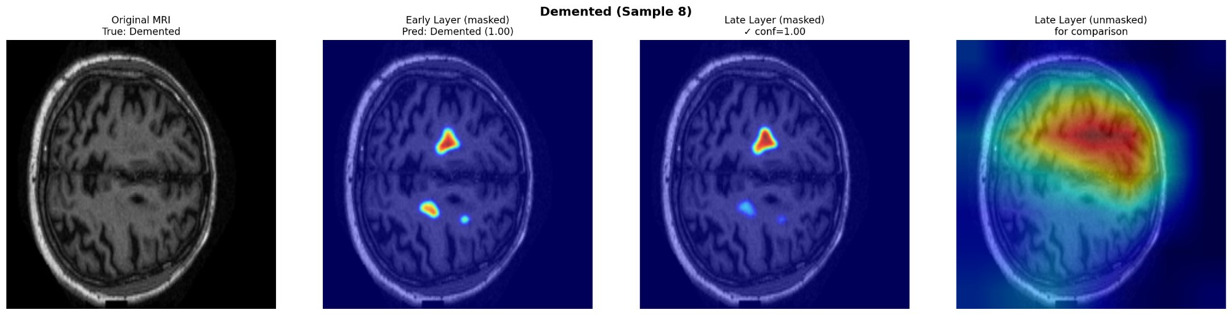
Figure 6. Detailed Grad-CAM++ comparison for a correctly classified Demented subject (confidence: 1.00). From left to right: original MRI, brain-masked early layer (14×14), brain-masked late layer (7×7), and unmasked late layer. Brain masking suppresses skull-boundary activations visible in the unmasked version, revealing focal attention on periventricular parenchyma. The early layer provides finer spatial localization than the late layer.
SHAP analysis (Figure 7) provides feature-level interpretability by identifying which dimensions of the learned representation contribute most to classification decisions. The analysis reveals that a small subset of features dominates discrimination, with the top feature showing strong asymmetry: high activation values push predictions toward the Demented class while low values push toward Non-Demented. This asymmetric pattern across the most important features is consistent with the model having learned distinct representations for healthy versus pathological brain states, though the feature indices themselves do not have direct anatomical correspondence.
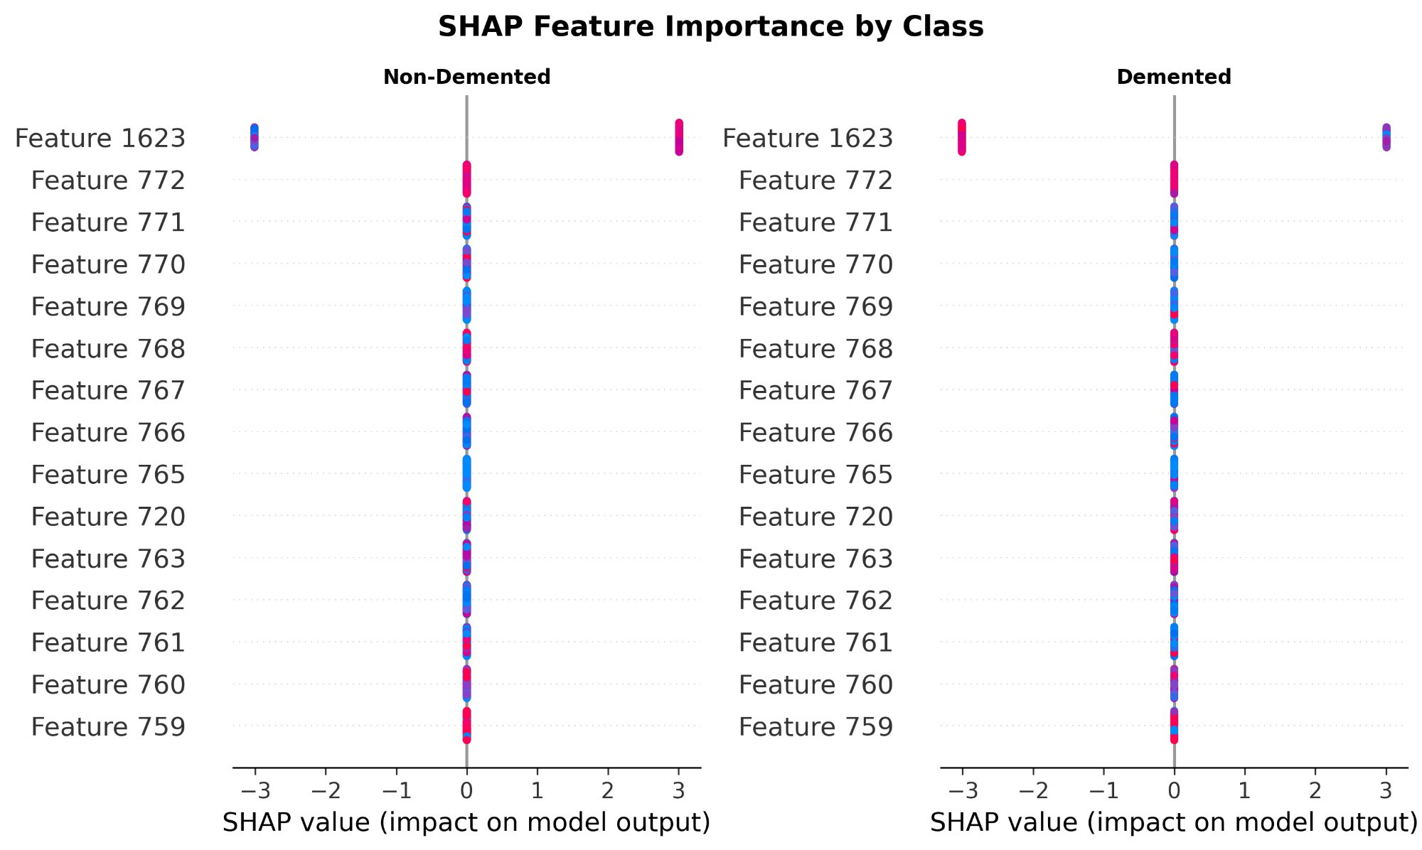
Figure 7. SHAP feature importance by class. Feature 1623 shows opposing effects across Non-Demented (left) and Demented (right) classifications.
4.6. Subject-Level Prediction Aggregation
Table 6 compares slice-level and subject-level evaluation for both AttentionMS-Net and Swin+Stacking. Subject-level aggregation consistently improves all models and all metrics, confirming that averaging predictions across ~250 slices per subject reduces noise from uninformative slices. Swin+Stacking with subject voting achieves the highest overall performance (accuracy: 0.841, AUC: 0.904, sensitivity: 0.701), while AttentionMS-Net with subject voting achieves 0.824 accuracy and 0.889 AUC. The sensitivity improvement is particularly notable: Stacking improves from 0.618 to 0.701 (+8.4%), and AttentionMS-Net from 0.609 to 0.653 (+4.4%), indicating that model predictions are dominated by slice-level noise rather than systematic misclassification patterns, which explains the consistent gains from aggregation. Notably, while mean performance improves with aggregation, inter-fold variance increases (e.g., AttentionMS-Net sensitivity std: 0.146 → 0.243), reflecting amplified inter-subject heterogeneity when evaluation shifts from ~8,000 slices to ~35 subjects per fold. This reflects that aggregation amplifies inter-subject variability while reducing intra-subject prediction noise: with ~35 subjects per fold versus ~8,000 slices, individual subject outcomes have greater influence on fold-level statistics. These results demonstrate that subject-level aggregation is a simple but effective strategy that should be standard practice in 2D slice-based MRI classification.
The relatively low sensitivity (0.653 for AttentionMS-Net, 0.701 for Swin+Stacking) warrants discussion. This metric reflects the inherent difficulty of binary AD classification on OASIS: the Demented group includes patients across a spectrum from very mild to moderate dementia, where early-stage patients exhibit subtle structural changes that overlap substantially with age-related normal atrophy. Class-weighted loss addresses the numerical imbalance (78% Non-Demented vs. 22% Demented) but cannot fully resolve the feature-level overlap between early dementia and healthy aging. Improving sensitivity likely requires either richer input representations (e.g., 3D volumetric data, multi-modal fusion with clinical scores) or disease stage stratification that separates mild from moderate cases.
Table 6. Effect of subject-level prediction aggregation (10-fold subject-level CV, mean ± std). Consistent improvements across architectures indicate that slice-level prediction errors are largely uncorrelated within subjects.
Evaluation Level | Accuracy | F1 Macro | AUC-ROC | Sensitivity | Specificity
AttentionMS-Net (slice) | 0.805±0.047 | 0.726±0.057 | 0.866±0.056 | 0.609±0.146 | 0.861±0.069
AttentionMS-Net (subject) | 0.824±0.070 | 0.753±0.106 | 0.889±0.055 | 0.653±0.243 | 0.876±0.066
Swin+Stacking (slice) | 0.815±0.045 | 0.741±0.050 | 0.879±0.043 | 0.618±0.064 | 0.872±0.051
Swin+Stacking (subject) | 0.841±0.050 | 0.784±0.068 | 0.904±0.042 | 0.701±0.123 | 0.883±0.045

5. Discussion
The controlled leakage experiment reveals that image-level 10-fold CV yields near-perfect performance (accuracy 99.99±0.01%, AUC 100.00%) that collapses to 80.8±3.7% accuracy under subject-level splitting—a drop of approximately 19 percentage points using the identical model and protocol. This is consistent with Yagis et al. [6], who reported 30% inflation on OASIS, and the scoping review by Taiyeb Khosroshahi et al. [7]. Our experiment strengthens existing evidence by using full 10-fold CV (not single splits) with both strategies, eliminating confounds from different architectures or hyperparameters. The near-zero variance across image-level folds (±0.0001) indicates that the inflation is not a statistical artifact but a systematic consequence of slice-level data partitioning.
The ablation reveals a nuanced picture of attention mechanisms in data-limited settings. CBAM alone does not improve upon the class-weighted baseline in the CNN pipeline (accuracy: 0.797 vs. 0.811), and CBAM-based fusion similarly fails to improve frozen Swin features (0.750–0.765 vs. 0.815 for stacking). This consistent pattern suggests that learnable attention mechanisms are prone to overfitting when subject counts are limited. However, the combination of CBAM with multi-scale fusion in AttentionMS-Net achieves the highest AUC-ROC (0.873) among CNN models, indicating that the synergy between attention and multi-scale components provides complementary discriminative information that neither achieves alone. This finding has practical implications: attention mechanisms in medical imaging should be paired with complementary architectural innovations rather than applied in isolation, and their effectiveness is contingent on sufficient training data.
To assess whether performance differences between configurations were statistically meaningful, we conducted paired Wilcoxon signed-rank tests across the 10 cross-validation folds. The accuracy improvement of AttentionMS-Net over the CBAM-only configuration was statistically significant (p = 0.027, Cliff’s delta = 0.60, large effect), with AttentionMS-Net outperforming CBAM-only in 8 out of 10 folds (median fold-level improvement: +0.94 percentage points). The AUC improvement showed a positive trend (p = 0.084) but did not reach the conventional significance threshold of α = 0.05. This outcome is expected given the limited statistical power inherent to fold-level testing with only 10 paired observations. Importantly, the improvements were consistent in direction across multiple evaluation metrics, suggesting that the observed gains reflect a complementary effect between attention and multi-scale components rather than random variation. Statistical tests were applied only to ablation variants sharing the same backbone and training pipeline; cross-paradigm comparisons (CNN vs. Transformer) involve fundamentally different architectures and optimization procedures, making paired statistical testing inappropriate.
To assess whether the performance difference between AttentionMS-Net and Swin+Stacking is statistically significant, we applied the Wilcoxon signed-rank test to subject-level accuracy across 10 folds. The test yields p = 1.000, indicating that the difference is not statistically significant (p > 0.05). This confirms that AttentionMS-Net achieves statistically comparable performance to Swin+Stacking while offering end-to-end interpretability, supporting its positioning as a complementary rather than inferior approach.
Our results reveal a three-level evaluation hierarchy for 2D slice-based MRI classification: (1) slice-level with image-level splitting, which yields artificially inflated performance (~99.9% accuracy) due to data leakage; (2) slice-level with subject-level splitting, which eliminates leakage but retains slice-level prediction noise (~80–82% accuracy); and (3) subject-level with prediction aggregation, which reduces slice-specific noise through probability averaging and provides the most clinically relevant evaluation (~82–84% accuracy). Each level progressively reduces bias and increases alignment with clinical diagnostic practice, where decisions are made per patient rather than per image.
These results suggest that under limited subject counts, representation quality derived from large-scale pretraining dominates architectural sophistication. Frozen Swin Transformer features, trained on millions of ImageNet images, provide more robust generalization than end-to-end CNN optimization on 347 subjects. This finding has practical implications for the neuroimaging community: when subject counts are limited, investing in better downstream classifiers for pretrained features may yield greater returns than designing novel end-to-end architectures. Furthermore, these findings suggest that future MRI classification benchmarks should report subject-level aggregated metrics as the primary evaluation, with slice-level results provided only for methodological completeness. A key limitation of this study is the use of 2D axial slices rather than 3D volumetric data, which discards inter-slice spatial correlations relevant to AD-related atrophy patterns. We adopted the 2D approach for two reasons: (1) direct comparability with the majority of existing OASIS-based studies that use 2D slices, and (2) computational feasibility with 347 subjects, where 3D models with tens of millions of parameters would face severe overfitting risk. Our subject-level aggregation partially compensates for the loss of inter-slice information by averaging predictions across all ~250 slices per subject. Future work will extend this framework to 3D volumetric analysis using the ADNI dataset with larger subject counts.
AttentionMS-Net remains the only evaluated model enabling end-to-end gradient-based spatial interpretability through Grad-CAM++ while maintaining competitive performance. Table 7 compares the practical trade-offs: AttentionMS-Net requires 12.3M parameters (single model, end-to-end trainable) versus Swin+Stacking which requires 28M frozen parameters plus two separate ML classifiers and a meta-learner, totaling a multi-stage pipeline with no gradient-based interpretability. For clinical settings where regulatory requirements mandate model transparency and spatial explanation of diagnostic decisions, AttentionMS-Net offers a capability that frozen-feature ML pipelines fundamentally cannot provide.
Table 7. Practical comparison of proposed approaches. AttentionMS-Net offers interpretability and simplicity advantages despite marginally lower accuracy.
Property | AttentionMS-Net | Swin+Stacking
Parameters | 12.3M (single model) | 28M frozen + RF(500 trees) + XGB(200 trees) + LR meta
Pipeline stages | 1 (end-to-end) | 3 (extract → train → stack)
Grad-CAM++ support | Yes (full gradient flow) | No (frozen backbone)
Accuracy (subject) | 0.824±0.070 | 0.841±0.050
AUC-ROC (subject) | 0.889±0.055 | 0.904±0.042
Sensitivity (subject) | 0.653±0.243 | 0.701±0.123
Training time/fold | ~45 min | ~20 min (feature reuse)
Retrainability | Full (transfer learning) | Partial (frozen backbone)

Importantly, the primary goal of this work is not to claim a large performance improvement over existing architectures, but to establish a methodologically rigorous evaluation protocol for MRI-based AD classification. The moderate accuracy levels reported here (80–82%) reflect honest generalization performance under proper subject isolation—in contrast to the inflated 95–99% commonly reported without such controls.
**Limitations.** 2D axial slices (not 3D volumetric), limited subjects (347), binary classification only (4-class infeasible: Moderate Dementia has 2 subjects). Future work should explore 3D architectures on ADNI (1,000+ subjects) and AttentionMS-Net’s multi-scale fusion with sufficient subjects for learnable scale selection.
6. Conclusions
Finally, the choice between these approaches depends on the deployment context. While Swin+Stacking achieves marginally higher sensitivity (0.701 vs. 0.653), AttentionMS-Net provides spatial explanations for each prediction through Grad-CAM++. In clinical practice, an incorrect but explainable prediction is more manageable than a correct but opaque one: when a model errs, clinicians can identify why and adjust their decision accordingly. Regulatory frameworks increasingly require model transparency for clinical AI systems, making end-to-end interpretability a practical necessity rather than an academic preference. We therefore position AttentionMS-Net not as the highest-performing model, but as the most clinically deployable one among the evaluated approaches.
A key outcome of this study is the identification of a three-level evaluation hierarchy for 2D slice-based MRI classification: slice-level with image-level splitting (prone to leakage, ~99.9%), subject-level splitting (bias-reduced, ~80–82%), and subject-level with prediction aggregation (clinically aligned, ~82–84%). This study makes three additional contributions. First, we propose AttentionMS-Net, combining CBAM channel-spatial attention with multi-scale feature aggregation, and demonstrate through systematic ablation that these components create a complementary effect that neither achieves alone—the only end-to-end trained model enabling gradient-based spatial interpretability without requiring external classifiers. Second, we empirically quantify data leakage using identical 10-fold CV protocols, showing ~19 percentage points of accuracy inflation. Third, we establish that frozen Swin Transformer features with stacking ensemble achieve the highest performance (accuracy: 0.841, AUC: 0.904 with subject aggregation), demonstrating that under limited subject counts, representation quality from large-scale pretraining dominates architectural sophistication.
7. Data Availability
The OASIS-1 dataset used in this study is publicly available at https://www.oasis-brains.org/ and via https://www.kaggle.com/datasets/ninadaithal/imagesoasis. The complete source code, trained model configurations, and subject-level cross-validation splits are available at https://github.com/osmyildiz/AttentionMSNet.
Author Contributions
Conceptualization, O.Y. and A.S.; methodology, O.Y.; software, O.Y.; validation, O.Y.; formal analysis, O.Y.; investigation, O.Y.; data curation, O.Y.; writing—original draft preparation, O.Y.; writing—review and editing, A.S.; visualization, O.Y.; supervision, A.S.; project administration, A.S. All authors have read and agreed to the published version of the manuscript.
Funding
This research received no external funding.
Institutional Review Board Statement
Not applicable. This study used publicly available, de-identified neuroimaging data from the OASIS project.
Informed Consent Statement
Not applicable.
Conflicts of Interest
The authors declare no conflicts of interest.
References
1. World Health Organization. Dementia Fact Sheet. Available online: https://www.who.int/news-room/fact-sheets/detail/dementia (accessed on 1 March 2026).
2. El-Assy, A.M.; Amer, H.M.; Ibrahim, H.M.; Mohamed, M.A. A Novel CNN Architecture for Accurate Early Detection and Classification of Alzheimer’s Disease Using MRI Data. Sci. Rep. 2024, 14, 3463. https://doi.org/10.1038/s41598-024-53733-6
3. Murugan, S.; Venkatesan, C.; Sumithra, M.G.; et al. DEMNET: A Deep Learning Model for Early Diagnosis of Alzheimer Diseases and Dementia from MR Images. IEEE Access 2021, 9, 90319–90329. https://doi.org/10.1109/ACCESS.2021.3090474
4. Shahid, S.B.; Kaikaus, M.; Kabir, M.H.; et al. Novel Deep Learning for Multi-Class Classification of Alzheimer’s in Disability Using MRI Datasets. Front. Bioinform. 2025, 5, 1567219. https://doi.org/10.3389/fbinf.2025.1567219
5. Zolfaghari, S.; et al. Hybrid Learning for MRI-Based Alzheimer’s Detection. Sci. Rep. 2025, 15, 25342. https://doi.org/10.1038/s41598-025-91816-8
6. Yagis, E.; Atnafu, S.W.; García Seco de Herrera, A.; et al. Effect of Data Leakage in Brain MRI Classification Using 2D CNNs. Sci. Rep. 2021, 11, 22544. https://doi.org/10.1038/s41598-021-01681-w
7. Taiyeb Khosroshahi, M.; et al. Data Leakage in Deep Learning for AD Diagnosis: A Scoping Review. Diagnostics 2025, 15, 2348. https://doi.org/10.3390/diagnostics15182348
8. Wang, X.; et al. 3D CNN and Video Swin Transformer for Early AD Diagnosis. Sci. Rep. 2025, 15, 1–15. https://doi.org/10.1038/s41598-025-05568-y
9. Woo, S.; Park, J.; Lee, J.-Y.; Kweon, I.S. CBAM: Convolutional Block Attention Module. In Proceedings of the ECCV, Munich, Germany, 2018; pp. 3–19. https://doi.org/10.1007/978-3-030-01234-2_1
10. Lin, T.-Y.; Dollár, P.; Girshick, R.; et al. Feature Pyramid Networks for Object Detection. In Proceedings of the CVPR, 2017; pp. 2117–2125. https://doi.org/10.1109/CVPR.2017.106
11. Wen, J.; Thibeau-Sutre, E.; Diaz-Melo, M.; et al. CNNs for Classification of Alzheimer’s Disease: Overview and Reproducible Evaluation. Med. Image Anal. 2020, 63, 101694. https://doi.org/10.1016/j.media.2019.101694
12. Comparative Analysis of DL Models for Enhanced AD Classification. Sci. Rep. 2025, 15, 44098. https://doi.org/10.1038/s41598-025-28561-x
13. Liu, Z.; Lin, Y.; Cao, Y.; et al. Swin Transformer: Hierarchical Vision Transformer Using Shifted Windows. In Proceedings of the ICCV, 2021; pp. 10012–10022. https://doi.org/10.1109/ICCV48922.2021.00986
14. Chattopadhay, A.; Sarkar, A.; Howlader, P.; Balasubramanian, V.N. Grad-CAM++: Generalized Gradient-Based Visual Explanations. In Proceedings of the WACV, 2018; pp. 839–847. https://doi.org/10.1109/WACV.2018.00097
15. Lundberg, S.M.; Lee, S.-I. A Unified Approach to Interpreting Model Predictions. In Proceedings of the NeurIPS, 2017; pp. 4765–4774.
16. Buslaev, A.; Iglovikov, V.I.; Khvedchenya, E.; et al. Albumentations: Fast and Flexible Image Augmentations. Information 2020, 11, 125. https://doi.org/10.3390/info11020125
17. Tan, M.; Le, Q.V. EfficientNet: Rethinking Model Scaling for CNNs. In Proceedings of the ICML, 2019; pp. 6105–6114.
18. Loshchilov, I.; Hutter, F. Decoupled Weight Decay Regularization. In Proceedings of the ICLR, 2019.
19. Aithal, N. OASIS Alzheimer’s Detection Dataset. Available online: https://www.kaggle.com/datasets/ninadaithal/imagesoasis (accessed on 1 January 2026).
20. Marcus, D.S.; Wang, T.H.; Parker, J.; et al. Open Access Series of Imaging Studies (OASIS): Cross-Sectional MRI Data. J. Cogn. Neurosci. 2007, 19, 1498–1507. https://doi.org/10.1162/jocn.2007.19.9.1498

