**Digital Signal Processing Laboratory Experiment 1**

**Analog Periodic and Analog Aperiodic Signal**

**1. Source Code**

amplitude = 2;

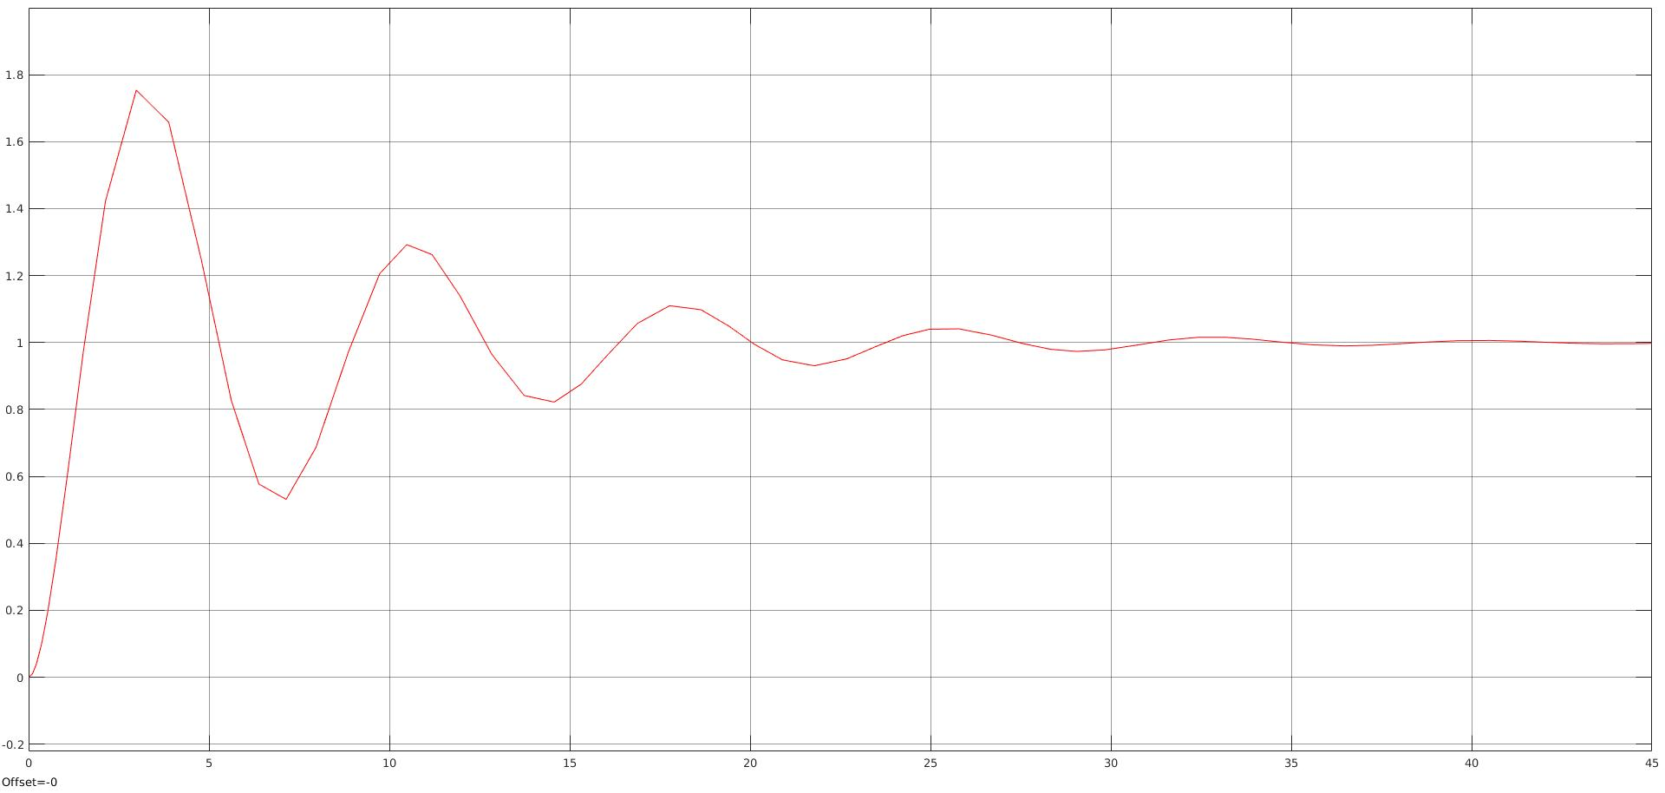

[u,t] = gensig('sine',5,30,0.1);

subplot(2,1,1)

plot(t, amplitude*u);

axis([0 30 -1.5*amplitude 1.5*amplitude]);

xlabel('Time (sec)');

ylabel('Amplitude');

title('Sine Periodic Wave');

subplot(2,1,2)

[v1,t] = gensig('sine',4,30,0.1);

[v2,t] = gensig('sine',2,30,0.1);

[v3,t] = gensig('sine',6,30,0.1);

plot(t, u+v3+v2+v1);

axis([0 30 -5 5]);

xlabel('Time (sec)');

ylabel('Amplitude');

title('Sine Aperiodic Wave');

**2. Observation**

