**Digital Signal Processing Laboratory Experiment 2**

**Generate Digital Signal**

**1. Source Code – Periodic Digital Signal**

amplitude = 2;

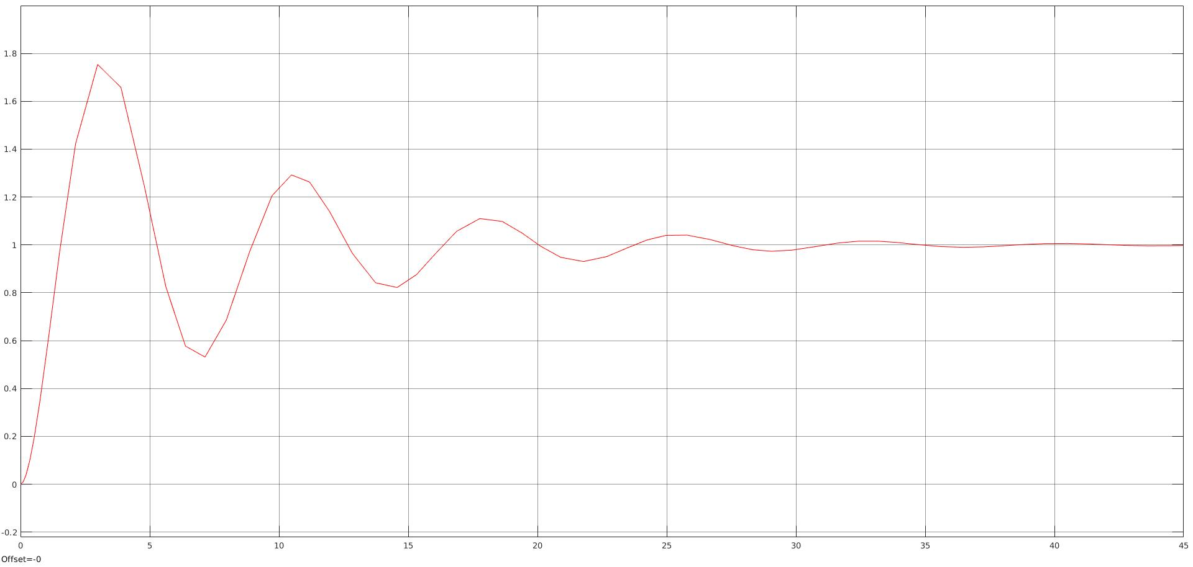

[u,t] = gensig('square',5,30,0.1);

plot(t, amplitude*u);

axis([0 30 -1.5*amplitude 1.5*amplitude]);

xlabel('Time (sec)');

ylabel('Amplitude');

title('Square Periodic Wave')

**2. Observation**

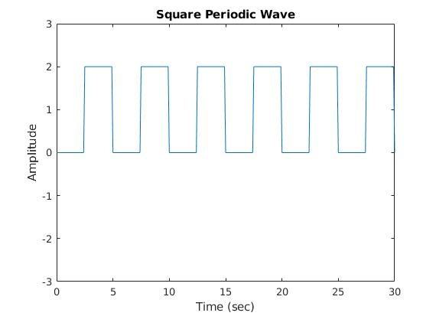

**3. Source Code – Aperiodic Digital Signal**

amplitude = 2;

[u,t] = gensig('square',5,30,0.1);

subplot(2,1,1)

plot(t, amplitude*u,'LineWidth', 2 );

axis([0 30 -1.5*amplitude 1.5*amplitude]);

xlabel('Time (sec)');

ylabel('Amplitude');

title('Square Periodic Wave');

subplot(2,1,2);

[v1,t] = gensig('square',4,30,0.1);

[v2,t] = gensig('square',2,30,0.1);

[v3,t] = gensig('Square',6,30,0.1);

plot(t, u+v3+v2+v1, 'LineWidth', 2);

axis([0 30 -5 5]);

xlabel('Time (sec)');

ylabel('Amplitude');

title('Square Wave with harmonics');

**4. Observation**

