**Digital Signal Processing Laboratory Experiment 3**

**Generate analog signal with noise**

**1. Source Code**

% generate raw sine signal

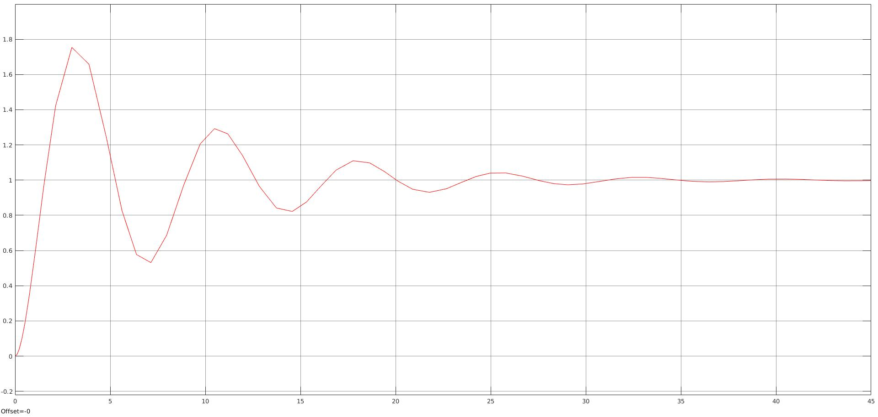

[x,t] = gensig('sine',5,30,0.1);

% add Gaussian white noise using awgn()

y = awgn(x,0.01,'measured');

% Plot the signals

plot(t,[x y],'LineWidth',1.5)

legend('Original Signal','Signal with AWGN')

xlabel('Time (sec)');

ylabel('Amplitude');

**2. Observation**

