**Digital Signal Processing Laboratory Experiment 4**

**Fast Fourier transform of a given Signal**

**1. Source Code**

clc;

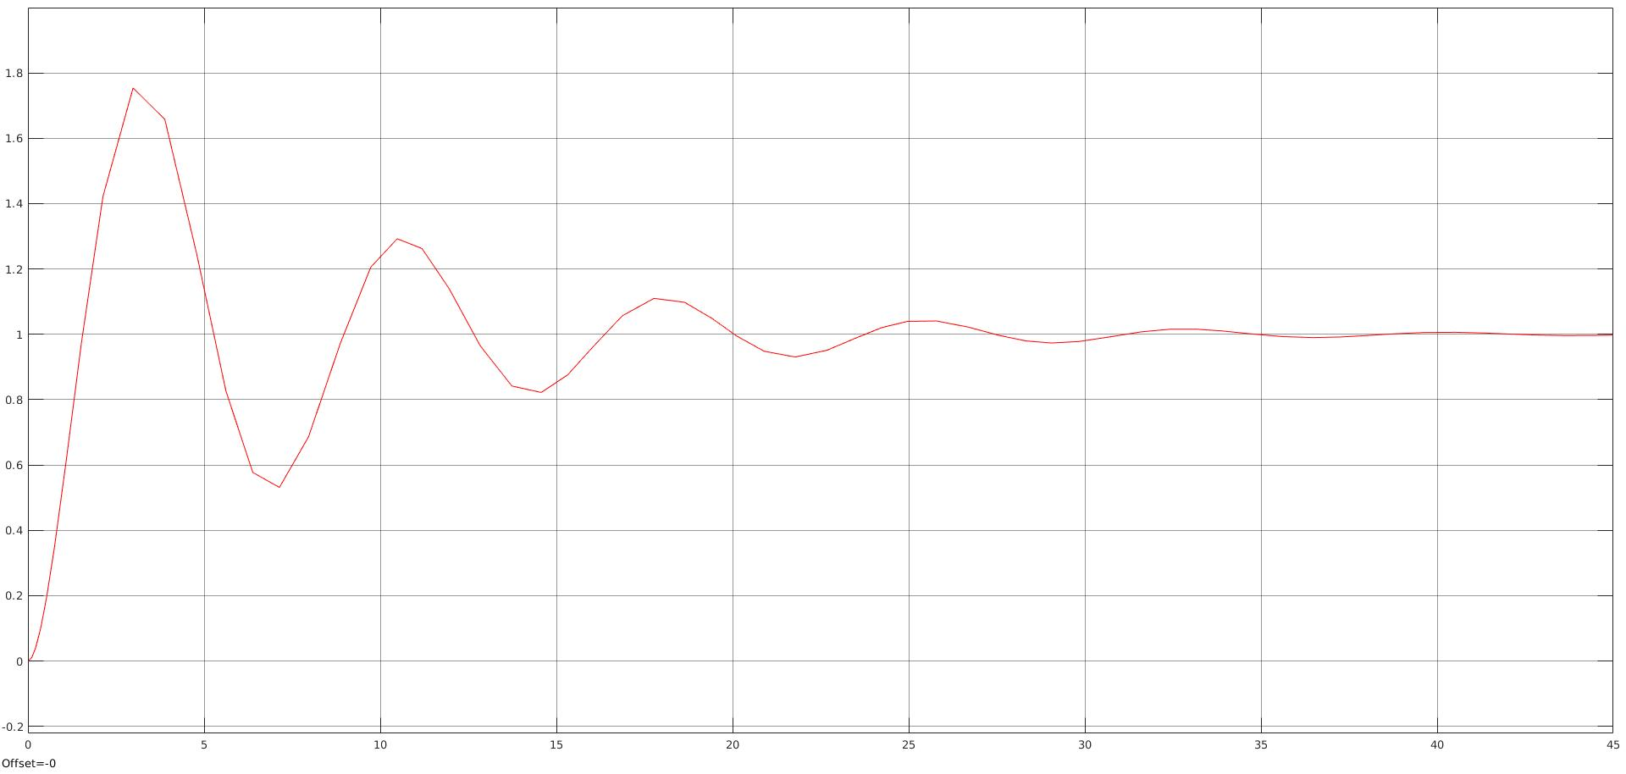

clear all;

fs = 1000;

ts = 1/fs;

t = 0:ts:2-ts;

y = 10 * sin(2*pi*200*t) + 5 * sin(2*pi*400*t) + 12 * sin(2*pi*300*t);

N = 2^nextpow2(fs);

% fast fourier transform functions

yy = fft(y,N);

yyy = fftshift (yy);

f = fs * (-N/2: N/2 -1)/N ;

% Plot graphs

subplot(2,1,1);

plot(t,y)

xlabel('Frequency (hz)');

ylabel('Time domain signal');

subplot(2,1,2);

plot(f, (2 * abs(yyy/N)));

title('Frequency spectrum of given signal');

xlabel('Frequency (hz)');

ylabel('Amplitude (volt)');

**2. Observation**

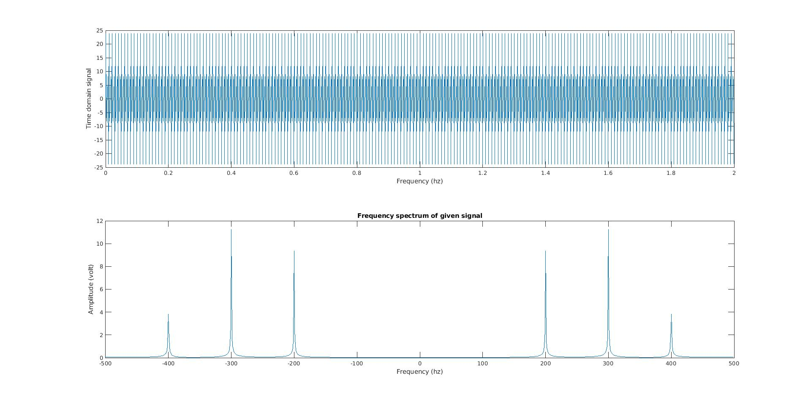

**Digital Signal Processing Laboratory Experiment 5**

**Design an IIR filter**

**1. Source Code**

clc;



clear all;

fs = 100e3;

f = 5e3;

ts = 1/fs;

t = 0:ts: 5e-3-ts

X = 5 * sin (2* pi* f * t);

Z = awgn(X,1);

% plot the output - sinusoidal signal

plot(t,X);

title('Sinusoidal signal');

% Plot 2 - signal with noise

plot(1,Z);

title('Signal with noise');

nfft = length(Z)

nfft2 = 2^nestpow2(nfft);

% fast fourier transformation

Fy = fft(Z, nfft2);

Fy = Fy(1:nfft2/2);

xfft = fs * (0:nfft2/2 - 1)/nfft2;

% plot3

plot(xfft, abs( Fy/max(Fy));

0:40;

wc = 2* pi * f/fs;

[b,a] = butter(0, wc, 'low');

x_f_iir = filter(b,a,Z);

figure;

plot(t,x_f_iir);

title('Filtered Sinusoidal Wave');

**Digital Signal Processing Laboratory Experiment 6**

**Implement low pass filter**

**1. Source Code**

Fs = 100;

T = 1/Fs;

t = 0:T:1-T;

% generate signal

s = sin(2 * pi * 10 * t);

% generate noise

noise = 0.5 * randn(size(t));

% input signal with random noise

x = s + noise;

plot(x)

shg

plot(x)

% low pass filter

d = designfilt('lowpassfir','FilterOrder',5,'CutOffFrequency',11,'SampleRate',Fs);

% output - filtered waveform

y = filter(d,x)

plot(y)

plot(X), hold on; plot(y)