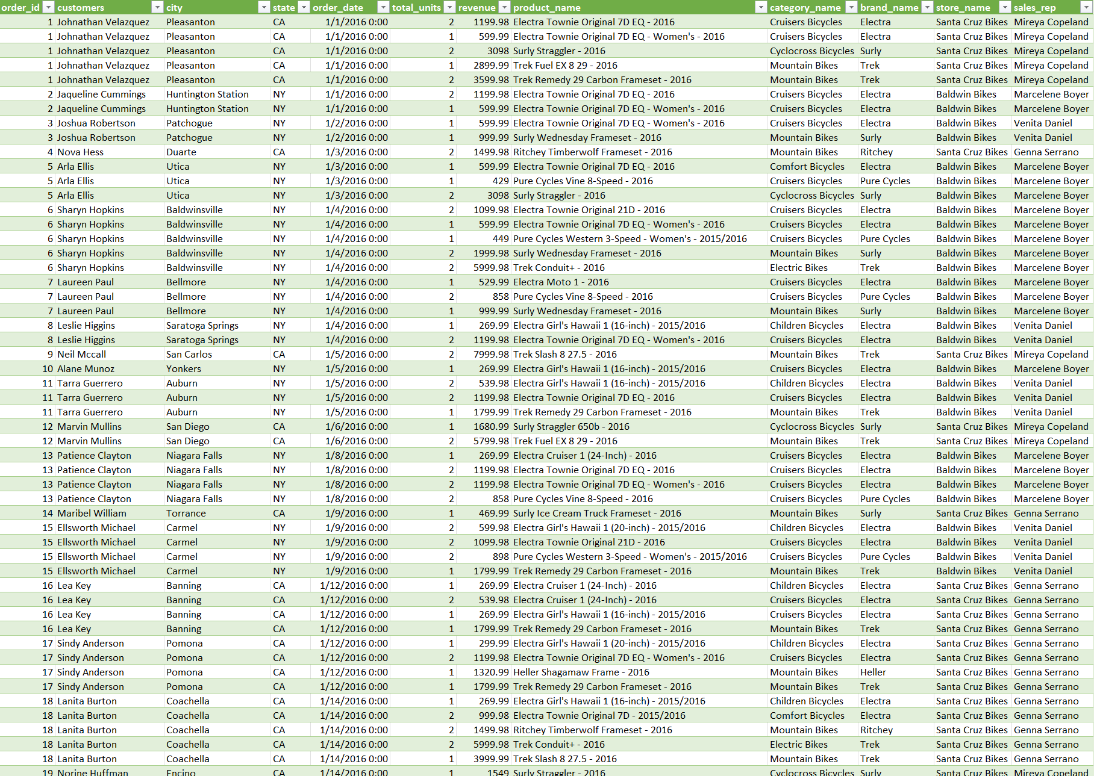

* Dataset imported from Microsoft SQL Server to Microsoft Excel.

* Multiple pivot tables created to compare revenue with various independent variables.

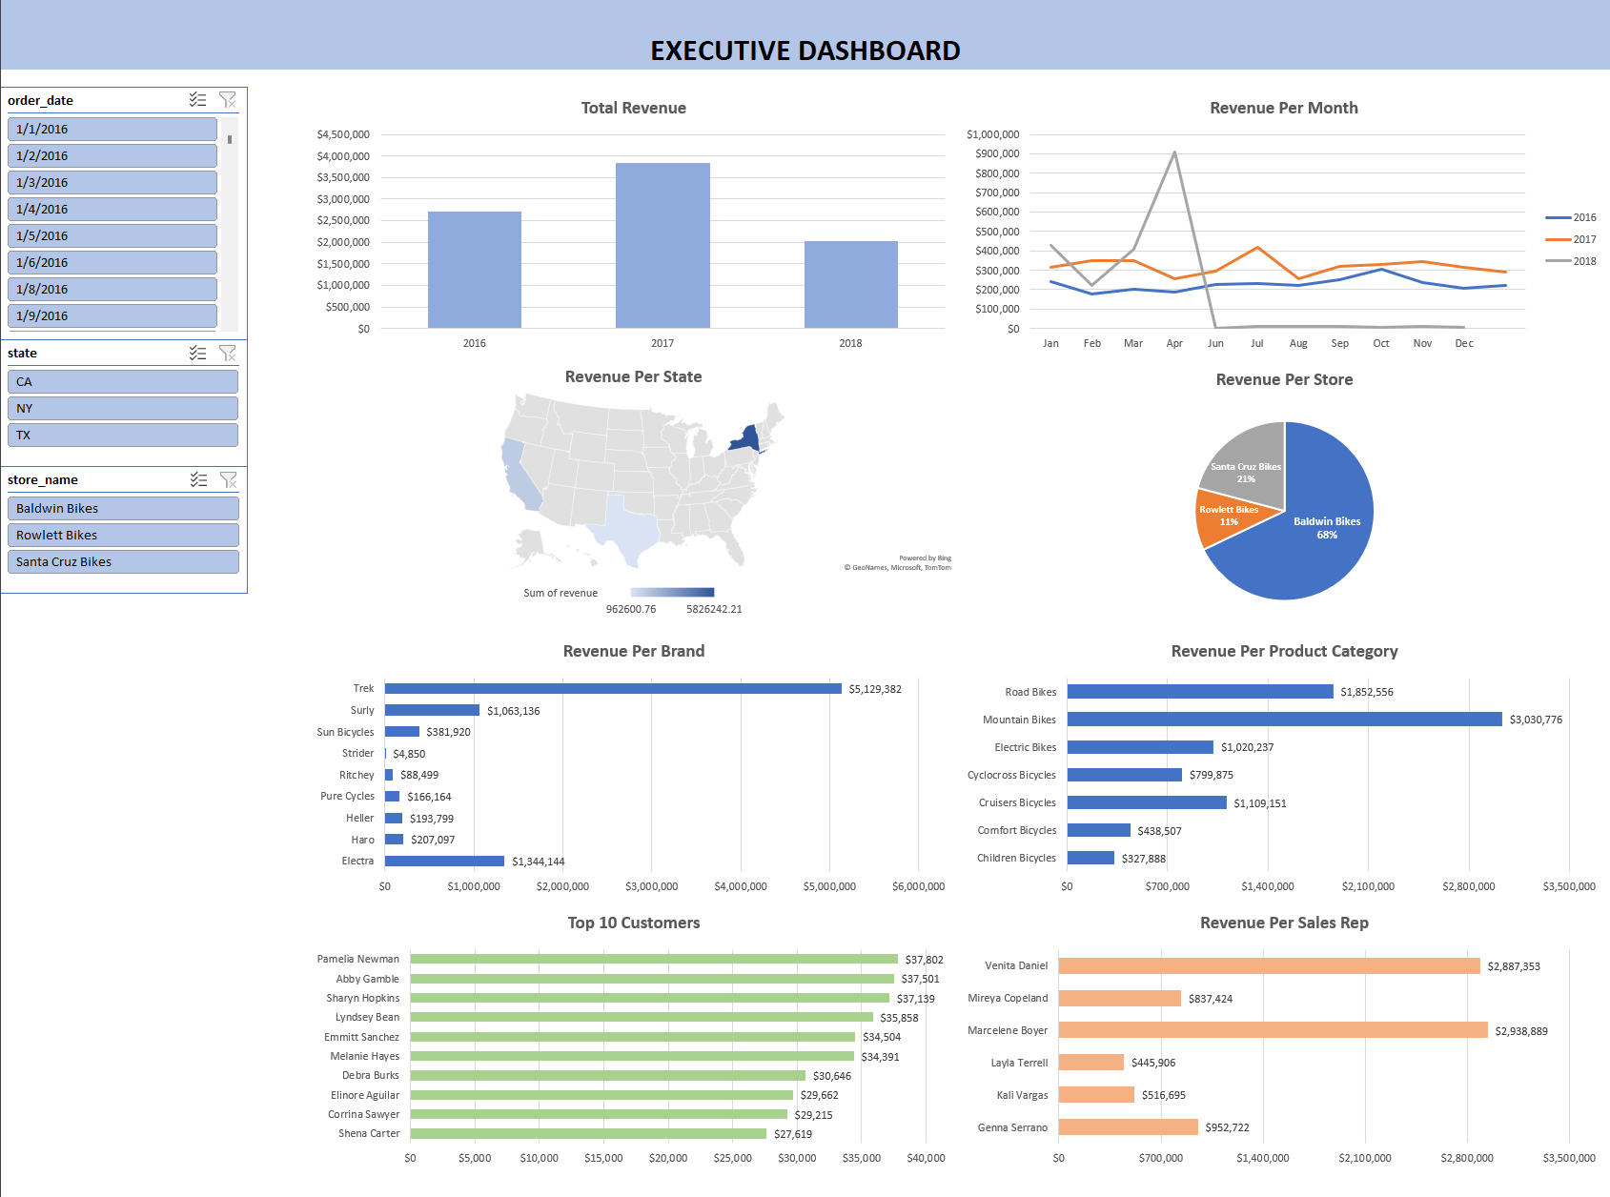

* Interactive dashboard that contains data from multiple pivot tables.