example

Sample Document with Mermaid Diagrams

Introduction

This is a sample markdown document that demonstrates the conversion of Mermaid diagrams to Google Docs.

System Architecture

Our application follows a typical three-tier architecture:

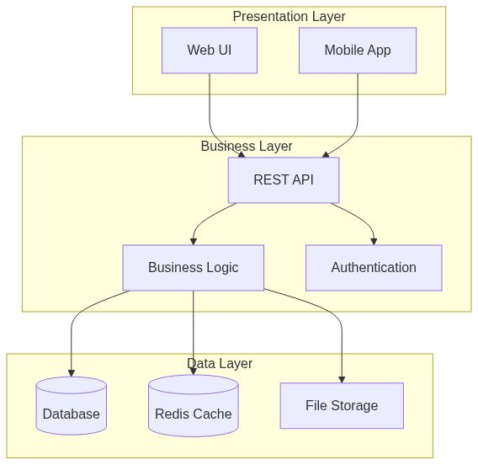

User Flow

Here's how a typical user interaction works:

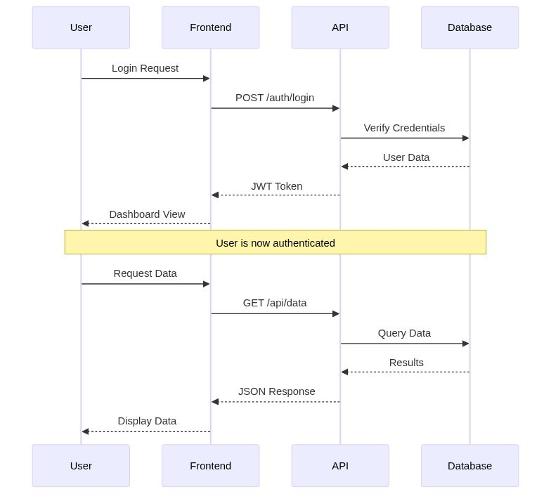

Development Process

Our development workflow:

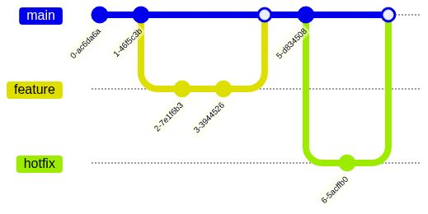

State Machine Example

User account states:

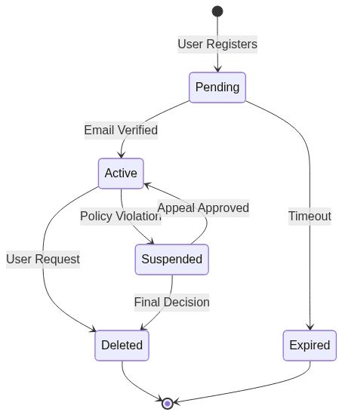

Code Examples

Python Example

def fibonacci(n):
"""Generate Fibonacci sequence up to n terms."""
if n <= 0:
return []
elif n == 1:
return [0]
elif n == 2:
return [0, 1]
fib_sequence = [0, 1]
for i in range(2, n):
fib_sequence.append(fib_sequence[-1] + fib_sequence[-2])
return fib_sequence
# Example usage
print(fibonacci(10))

JavaScript Example

// Async function to fetch user data
async function fetchUserData(userId) {
try {
const response = await fetch(`/api/users/${userId}`);
if (!response.ok) {
throw new Error(`HTTP error! status: ${response.status}`);
}
const data = await response.json();
return data;
} catch (error) {
console.error('Error fetching user data:', error);
return null;
}
}

Project Timeline

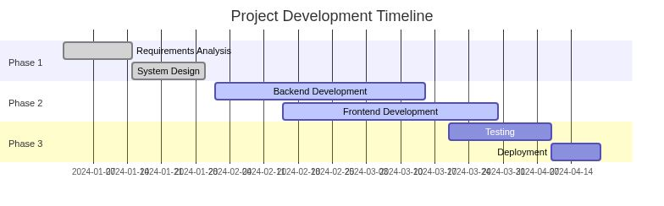

Pie Chart Example

Distribution of development time:

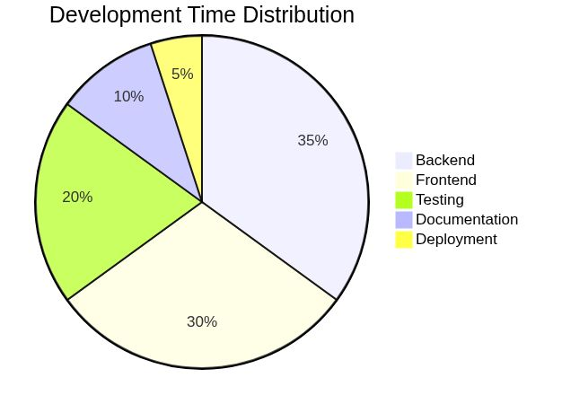

Conclusion

This document demonstrates various types of Mermaid diagrams that can be converted to Google Docs format with embedded images.

Features Demonstrated

- Flowcharts and graphs
- Sequence diagrams
- Git graphs
- State diagrams
- Gantt charts
- Pie charts
- Code blocks with syntax highlighting
- Regular markdown formatting

All these elements will be properly converted to Google Docs format.

