**Project Prospectus**

Title: Assessment of the impacts of the BP oil spill in the Gulf of Mexico on water quality

Notice: Dr. Bryan Runck

Author: Diego Osorio

Date: 9/28/2022

**Project Repository:** https://github.com/osori050/GIS5571_project

**Google Drive Link:**

**Time Spent:** 6 h

**Abstract**

In 2010, an explosion occurred in the Deepwater Horizon semi-submersible mobile offshore drilling unit leading to an oil spill of roughly 210 million gals into the Gulf of Mexico. NOAA measured physicochemical parameters in water then and projected the oil plume's trajectory. That data will be analyzed together to assess the impact of the said catastrophe on water quality over the Louisiana continental shelf. Those parameters are expected to have abrupt changes due to the pollutant input.

**Problem Statement**

In 2010, the Deepwater Horizon semi-submersible mobile offshore drilling unit suffered an explosion that killed 11 workers, injured 17 others, and spill around 210 million US gal (780000 m3) of oil into the ocean over 87 days. This catastrophe caused the biggest oil leak in history and severely impacted the quality of water in the Gulf of Mexico (Deepwater Horizon oil spill, 2022; Deepwater Horizon explosion, 2022). Thus, this project aims to assess the impact of the BP oil spill in the Gulf of Mexico on the water by analyzing physicochemical parameters such as oxygen, conductivity, and SPM (Suspended particulate matter), among others, measured at that time. Figure 1 shows roughly the area affected by the spill, and Figure 2 shows the locations where the physicochemical parameters were measured.

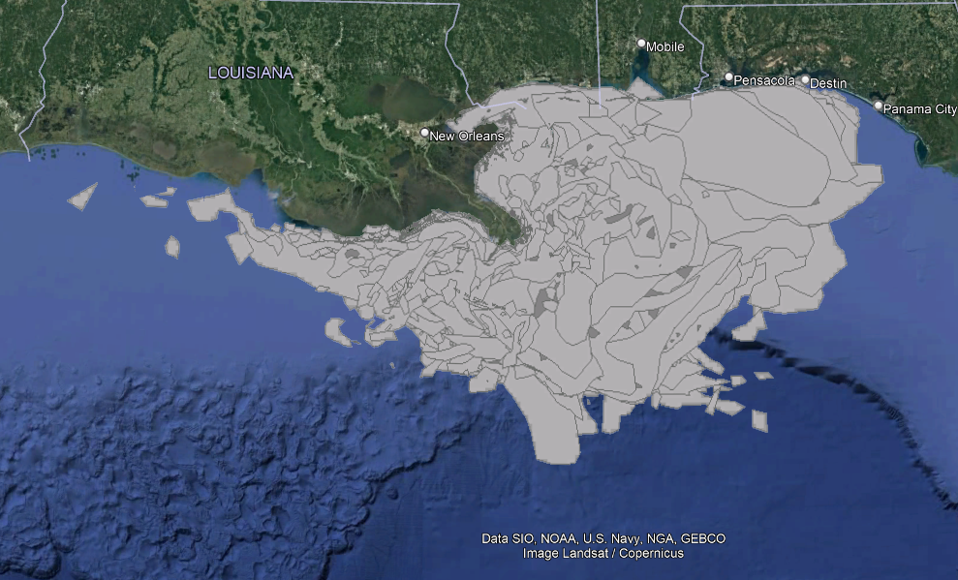

Figure 1. Oil spill plume (ESRI, n.d.)

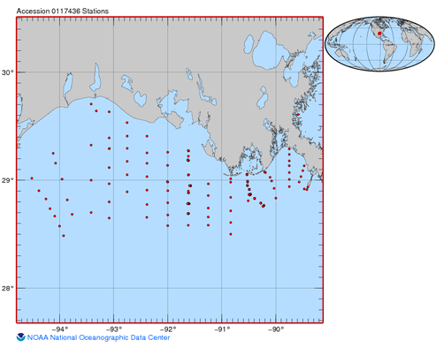

Figure 2. Station locations (NOAA, 2021)

Table 1. Requirements for the oil impact on water quality

|  |  |  |  |  |  |  |
| --- | --- | --- | --- | --- | --- | --- |
| **#** | **Requirement** | **Defined As** | **(Spatial) Data** | **Attribute Data** | **Dataset** | **Preparation** |
| 1 | Area affected by the oil spill | Projection of the trajectory of the spill plume | Polygon geometry | Dates and area | [NOAA](https://gisdata.mn.gov/dataset/trans-roads-mndot-tis) Data |  |
| 2 | Physicochemical parameters | Raw input dataset | Tables | Physicochemical parameters | NOAA Data | Transformation into GIS layers |

**Input Data**

First, ESRI has created a layer on ArcGIS Online that shows the daily projection of the oil spill plume in the Gulf of Mexico from May 2 to August 5 of 2010 based on NOAA data acquisition. The full extent is from -85.7202 to -93.4310 latitude, and from 27.2551 to 30.4219 longitude (datum WGS 1984). Additionally, there is a collection of physical, chemical, and biological data in the Gulf of Mexico from February 2 to October 28 of 2010 by NOAA available on data.gov. This data is recorded in a Microsoft Access database and .txt files.

Table 2. Input data for oil spill analysis

|  |  |  |  |
| --- | --- | --- | --- |
| **#** | **Title** | **Purpose in Analysis** | **Link to Source** |
| 1 | NOAA_Gulf_Oil_Spill | Analysis of the extension of the oil spill plum in the Gulf of Mexico over time | http://maps1.arcgisonline.com/arcgis/rest/services/NOAA_Gulf_Oil_Spill/MapServer |
| 2 | Physical, chemical, and biological data collected in the Gulf of Mexico from 02 Feb 2010 to 28 Oct 2010 (NCEI Accession 0117436) | Assessment of physicochemical parameters | https://catalog.data.gov/dataset/physical-chemical-and-biological-data-collected-in-the-gulf-of-mexico-from-02-feb-2010-to-28-oc |

**Methods**

First, the physicochemical data must be converted into GIS data to overlay the information with the oil spill plume. Then, spatial interpolations will be performed to assess and estimate water quality all over the Louisiana continental shelf at different times and see the correlation with the oil spill. Finally, time-series maps will show the water physicochemical parameter behavior during the oil spill. Figure 3 illustrates roughly the methodology of this project.

Figure 3. Flow chart of Assessment of the impacts of the BP oil spill in the Gulf of Mexico on water quality

**Results**

It is expected to see some parameters changing abruptly over time because of the oil spill plume expansion. Likewise, the further stations from the spill are expected to have recorded the spill impacts days later than the closer ones. In this section, time series maps will show the changes over time in the physicochemical parameters in the seawater of the Louisiana continental shelf.

**Results Verification**

The results will be compared to other NOAA datasets or similar ones publicly available. Moreover, exact interpolators will be used; therefore, the equations are expected to predict the values identical to the measurements.

**Discussion and Conclusion**

As the physicochemical parameters are expected to change considerably, the magnitude of the change will be compared to standards of water quality, such as those of the EPA, to draw conclusions about the impact of the oil spill. Moreover, in this section, I will talk about the methods (such as packages, functions, etc.) that helped me get the results as well as those that did not and why. I will explain the new tools and knowledge acquired and how that can be applied to other problems.

**References**

*Deepwater Horizon explosion*. (2022, August 26). Retrieved from Wikipedia: https://en.wikipedia.org/wiki/Deepwater_Horizon_explosion

*Deepwater Horizon oil spill*. (2022, September 20). Retrieved from Wikipedia: https://en.wikipedia.org/wiki/Deepwater_Horizon_oil_spill

ESRI. (n.d.). *NOAA_Gulf_Oil_Spill (MapServer).* Retrieved from ArcGIS REST Services Directory: http://maps1.arcgisonline.com/arcgis/rest/services/NOAA_Gulf_Oil_Spill/MapServer

NOAA. (2021). *Physical, chemical, and biological data collected in the Gulf of Mexico from 02 Feb 2010 to 28 Oct 2010 (NCEI Accession 0117436).* Retrieved from DATA.GOV: https://catalog.data.gov/dataset/physical-chemical-and-biological-data-collected-in-the-gulf-of-mexico-from-02-feb-2010-to-28-oc

**Self-score**

|  |  |  |  |
| --- | --- | --- | --- |
| **Category** | **Description** | **Points Possible** | **Score** |
| **Structural Elements** | All elements of a lab report are included **(2 points each)**:  Title, Notice: Dr. Bryan Runck, Author, Project Repository, Date, Abstract, Problem Statement, Input Data w/ tables, Methods w/ Data, Flow Diagrams, Results, Results Verification, Discussion and Conclusion, References in common format, Self-score | 28 | 28 |
| **Clarity of Content** | Each element above is executed at a professional level so that someone can understand the goal, data, methods, results, and their validity and implications in a 5 minute reading at a cursory-level, and in a 30 minute meeting at a deep level **(12 points)**. There is a clear connection from data to results to discussion and conclusion **(12 points)**. | 24 | 24 |
| **Reproducibility** | Results are completely reproducible by someone with basic GIS training. There is no ambiguity in data flow or rationale for data operations. Every step is documented and justified. | 28 | 28 |
| **Verification** | Results are correct in that they have been verified in comparison to some standard. The standard is clearly stated **(10 points)**, the method of comparison is clearly stated **(5 points)**, and the result of verification is clearly stated **(5 points)**. | 20 | 20 |
|  |  | 100 | 100 |