Heterogeneous accretion, composition and core-mantle differentiation of the Earth

Supplementary Data

Table S1. Bulk oxygen-free starting composition based on solar system (CI chondritic) abundances with refractory element enrichment.

Si | wt% | 10.68
Mg | wt% | 9.61
Fe | wt% | 18.43
Al | wt% | 1.04*
Ca | wt% | 1.14*
Ni | wt% | 1.077
Co | wt% | 0.0505
Nb | ppb | 300*
Ta | ppb | 17.3*
V | ppm | 60.3#
W | ppb | 110*
Cr | ppm | 2646

With the exception of refractory elements, concentrations are taken directly from Table 4 of Palme and O’Neill (2003). Because oxygen is not included and listed concentrations are based on analyses of CI chondrites with a high volatile content, the wt% values do not sum to 100% and are presented to show only relative abundances. The concentrations are identical for all embryos.
* Concentrations of refractory elements are enhanced by 22% relative to CI

# Concentration of V is enhanced by 11% relative to CI

S1. Element partitioning

S1.1. Parameterization of distribution coefficients.

As described in the main text (Eqs. 1 and 2), pressure-temperature extrapolations of partitioning data are performed for most elements using the relationship:
log₁₀ K_{D} = a + b/T + c P/T (S1)
where P is pressure in GPa and T is absolute temperature. Values of the constants a, b and c, and their uncertainties and sources are listed below in Table S2. Note that studies such as Mann et al. (2009) also included appropriate literature data when fitting Eq. S1.

Table S2. Regression coefficients in Eq. S1 that describe log K_{D}
 | n |  | a | σ |  | b | σ |  | c | σ
Ni¹ | 2⁺ |  | 0.41 | 0.28 |  | 3745 | 471 |  | -272 | 32
Ni² | 2⁺ |  | 1.06 | 0.40 |  | 1553 | 921 |  | -98 | 8
Co¹ | 2⁺ |  | 0.38 | 0.24 |  | 1501 | 401 |  | -17 | 31
Co² | 2⁺ |  | 0.13 | 0.38 |  | 2057 | 823 |  | -57 | 9
W³ | 4.4⁺ |  | -0.35 | 0.46 |  | 1209 | 1005 |  | -114 | 13
Ta⁴ | 5⁺ |  | 0.84 | 0.09 |  | -13806 |  |  | -105 | 15
Nb⁴ | 5⁺ |  | 2.66 | 0.11 |  | -14032 |  |  | -199 | 16
V⁴ | 3⁺ |  | -0.48 | 0.38 |  | -5063 | 894 |  | 0
Cr⁴ | 2⁺ |  | -0.17 | 0.13 |  | -2730 | 312 |  | 0
Si⁴ | 4⁺ |  | 2.98 | 0.02 |  | -15934 |  |  | ⁵

Errors are standard deviations determined from least square fits; in cases where a standard deviation is not listed, the parameter b was fixed to a value derived from published free energy data (Wade and Wood, 2005; Mann et al., 2009).
Sources of data:
1: P<5 GPa; 2: P>5 GPa; parameters used for Ni and Co are obtained from fits to molar ratios of Kegler et al. (2008);
3: P>5 GPa with a based on nbo/t = 2.5: Cottrell et al. (2009. 2010);
4: Mann et al. (2009).
5. Si data were fit by log K_{D} = a - b/T + (c₁P + c₂P² + c₃P³)/T with c₁ = -155±25, c₂ = 2.26±84, and c₃ = -0.011±0.007 (see Section S1.3 below).

S1.2. Compositional dependence of partitioning

Some metal/silicate partition coefficients depend strongly on silicate melt composition whereas others show little or no such dependence. The relevant parameter is the activity of the oxide component in the silicate melt. The activities of FeO, CoO and NiO, for example, depend only very weakly on melt composition (Holzheid et al., 1997). In calculating K_{D,} partition coefficients are normalized to FeO and the NiO/FeO and CoO/FeO ratios are independent of melt composition (O`Neill and Eggins, 2002). Other partition coefficients can depend strongly on melt composition. In such cases, we have used data obtained using peridotite liquid (e.g. Mann et al., 2009) or, in the case of W, we used the melt composition relationship of Cottrell et al. (2009).

S1.3. Silicon partitioning

In order to constrain the partitioning of Si over a wide pressure range, data on the Si content of liquid Fe-metal in equilibrium with (Mg,Fe)SiO₃-perovskite from 25 to 97 GPa and 2500-3150 K (Takafuji et al., 2005) were employed in the regression, in addition to data on liquid silicate-liquid metal partitioning obtained up to 25 GPa by Mann et al. (2009).
Experimental data indicate that the metal-silicate K_{D}(Si) estimated from metal-perovskite partitioning is very close to that involving silicate melt (Trønnes and Frost, 2002). Further details are reported by Mann et al. (2009). The combined data sets used for determining log K_{D} for Si suggest that the pressure dependence is not linear and the following empirical equation was fit to the data (Table S2; see also Mann et al., 2009):
log K_{D}(Si) = a - b/T + (c₁ P + c₂ P² + c₃ P³)/T . (S2)

S1.4. Partitioning of oxygen between metal, magnesiowüstite and silicates

As described in the main text, the oxygen content of the bulk composition controls the oxygen fugacity. Oxygen partitioning is also critical for estimating the oxygen content of the Earth’s core. The thermodynamic treatment of oxygen partitioning between metal and silicate is derived from experimental data, obtained up to 70 GPa and 3500 K, on the partitioning of oxygen between (i) liquid metal and magnesiowüstite, (ii) metal and silicate melt and (iii) the partitioning of FeO between magnesiowüstite and silicate melt (Asahara et al. 2007; Frost et al., 2010). The thermodynamic basis for the model considers the equilibrium between the FeO components in liquid metal and magnesiowüstite with the condition at equilibrium:
mu_metal_FeO = mu_mg-wustite_FeO (S3)
where mu_metal_FeO is the chemical potential of FeO in phase m. These chemical potentials are related to the mole fractions of FeO in each phase, e.g. x_metal_FeO, through the equations:
u_metal_FeO = u_std_metal_FeO,p,t + RTlnX_metal_FeO + RTln(gamma_metal_FeO (S4)
and
u_mg-wustite_FeO = u_std_mg-wustite_FeO,p,t + RTlnX_mg-wustite_FeO + RTln(gamma_metal_FeO (S5)
where mu_standard_FeO, p,t is the standard state chemical potential, R is the gas constant and 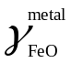is, for example, the activity coefficient of FeO in the metallic phase. The standard state chemical potentials of FeO in liquid Fe and magnesiowüstite were determined using thermodynamic data extracted from the melting curve of FeO (Frost et al., 2010). The non-ideal mixing terms for FeO and Fe in the metallic liquid and magnesiowüstite are described using asymmetric Margules equations and are taken from fits to experimental data as described by Frost et al. (2010).
The partitioning of FeO between silicate liquid and liquid Fe-alloy is determined from the partitioning of FeO between magnesiowüstite and liquid Fe alloy using an empirical relation of Rubie et al. (2004) that was determined from the data of Trønnes (2000), Trønnes and Frost (2002) and Ito et al. (2004):

X_mg-wustite_FeO = 1.148*x_sil_feO + 1.319*(x_sil_FeO)^2 (S6)
where 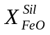is the mole fraction of FeO in the silicate liquid. This expression shows no dependence on P and T based on data obtained over a 20 GPa pressure range.

S2. Solution of the mass balance to determine the compositions of co-existing silicate and metal liquids

Consider the equilibration reaction (occurring, for example, due to a change in P and/or T), where (2) represents the equilibrated compositions:

Silicate-Liquid(1) + Metal-Liquid(1) → Silicate-Liquid(2) + Metal-Liquid(2).

For a model chondritic system, this reaction can be expanded to:

[(FeO) _{x} (NiO) _{y} (SiO₂)_{z} (Mg_{u} Al_{m} Ca_{n})O] + [Fe_{a} Ni_{b} O_{c} Si_{d}]
→ [(FeO) _{x'} (NiO) _{y'} (SiO₂)_{z'} (Mg_{u} Al_{m} Ca_{n} )O] + [Fe_{a'} Ni_{b'} O_{c'} Si_{d'}]

In this reaction:
Fixed coefficients: x, y, z, a, b, c, d (defined by starting compositions)
Constant coefficients: u, m, n (defined by bulk composition)
Unknown coefficients: x', y', z', a', b', c', d' (require 7 independent equations to solve).

Four of the required seven equations are provided by the following mass balance equations:

Mass balancing for: Fe: x + a = x' + a' (S7)
Ni y + b = y' + b' (S8)
O x + y + 2z + c = x' + y' + 2z' + c' (S9)
Si z + d = z' + d' (S10)

The three other equations are the K_{D} expressions for partitioning of O, Ni and Si. Because the expression for O is expressed in terms of partitioning between magnesiowüstite (Mw) and liquid Fe (Asahara et al., 2007; Frost et al., 2010), we use Eq. S6 to relate x_mg_wustite_FeO and x_sil_FeO (mole fractions of FeO in Mw and silicate liquid respectively), where
X_sil_FeO = x’/x’+y’+z’+(u+m+n)
.

For oxygen partitioning, K_O_D = [(X_met_Fe * X_met_O)/(X_mg_wustite_FeO)]
Where
X_met_O = c’/a’+b’+c’+d’ and X_met_Fe = a’/a’+b’+c’+d’
and substituting these gives
K_O_D = [(a’*c’)/(X_mg_wustite_FeO*(a’+b’+c’+d’))]. (S11)

For Ni partitioning:

K_Ni_D = [(X_met_Ni * X_met_Fe)/( X_sil_Ni * X_met_Fe)]

so that
K_Ni_D = x’*b’/y’*a’ (S12)

where K_Ni_D is determined from a fit to the data of Kegler et al. (2008).

For Si partitioning:
K_Si_D = ((d’/(a’+b’+c’+d’)*(x’/x’+y’+z’+u+m+n)^2))/((z’/x’+y’+z’+u+m+n)*(a’/a’+b’+c’+d’)^2)

Thus,
K_Si_D = x’^2*d’*(a’+b’+c’+d’)/a’^2*z’*(x’+y’+z’+u+m+n). (S13)

where 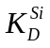is from Mann et al. (2009) as described in section S1.3.

From Eqs. (S7) to (S10)

a' = (x + a - x') (S14a)
b' = (y + b - y') (S14b)
c' = (x + y + 2z + c - x' - y' – 2z') (S14c)
d' = (z + d - z' ) (S14d)

From Eq. (S12):

K_Ni_D = x’*b’/y’*a’
so that

y’ = x’*b’/a’*K_Ni_D =( x’(y+b-y’))/(x+a-x’)*K_Ni_D

which simplifies to
y’ = (x’*(y+b))/((x+a-x’)*K_Ni_D + x’) (S15)

Using Eqs. (S14c,d) to eliminate c' and d' from Eq. (S13):

K_Si_D = x’^2*(z+d-z’)*[a’+b’+(x+y+2z+c-x’-y’-2z’)+(z+d-z’)]/a’^2*z’*(x’+y’+z’+u+m+n).

so that

K_Si_D = x’^2*(z+d-z’)*[a’+b’+x+y+3z+c-x’-y’-3z’+d]/a’^2*z’*(x’+y’+z’+u+m+n). (S16)

Eq. (S16) can be written as a quadratic equation with z' as the unknown, as follows:

For simplification, let
α = z + d
γ = a' + b' + x + y + 3z + c - x' - y' + d
σ = x' + y' + u +m + n

Substituting these into Eq. (S16) gives
K_Si_D = x’^2 *(α−z’)( γ-3z’)/a’^2*z’*(σ+z’)

which simplifies to
K_Si_D = x’^2 *(α∗γ−γ∗z’ −3αz’+3*z’^2)/(a’^2*z’*σ+a’2*z’^2)

and further to
αγx’^2-γx’^2z’-3αx’^2z’+3x’^2z’2 = a’2z’σK_Si_D+a’^2z’^2K_Si_D
thus leading to the quadratic equation:

[ 3x’2-a’^2K_Si_D]*z’2 – [γx’^2 + 3αx’^2+a’2σK_Si_D]*z’+αγx^2=0 (S17)

The procedure for solving for the 7 unknowns is as follows:
- Guess an initial value of x'
- Determine y' from Eq. (S15)
- Obtain a' and b' from Eq. (S14a,b)
- Using Eq. (S17), determine z'
- Determine c' and d' from Eq. (S14c,d)
- Obtain x_mg_wustite_FeO from Eq. (S6)
- Substitute determined values into Eq. (S11) and compare the resulting value of K_O_D with that determined from the model of Frost et al. (2010). Depending on the difference between the two values, adjust the value of x' and return to step 2, repeating the calculation (steps 2-7) iteratively until K_O_D obtained using Eq. (S11) converges with that determined from the model of Frost et al. (2010). Note that K_O_D has to be recalculated from the model of Frost et al. (2010) at each iteration.

S3. Single-stage core formation

Traditionally, metal-silicate partitioning data for siderophile elements have been used to determine pressure-temperature conditions at which compositions of equilibrated metal and silicate correspond to those of the Earth’s core and mantle respectively. These conditions have then been considered to represent those at the base of the magma ocean (e.g. Li and Agee, 1996; Righter et al., 1997; Gessmann and Rubie, 2000; Chabot et al., 2005; Righter, 2010). In addition to chemical difficulties discussed by Wade and Wood (2005), there are several problems with such a model: (a) The Earth’s lower mantle, i.e. below the base of the magma ocean, implicitly does not experience any metal-silicate segregation (except possibly for that induced by descending metal diapirs). (b) The timescale for a deep magma ocean to chemically equilibrate with a segregated metal layer (as is implicitly required in single stage models) is two to three orders of magnitude greater than the timescale of magma ocean crystallization (Rubie et al., 2003). (c) The single-stage model cannot be reconciled with current models of how the Earth accreted (e.g. O’Brien et al., 2006). Based on the last point, it has been proposed that derived P-T conditions actually represent the cumulative or averaged effects of a relatively complex differentiation history.

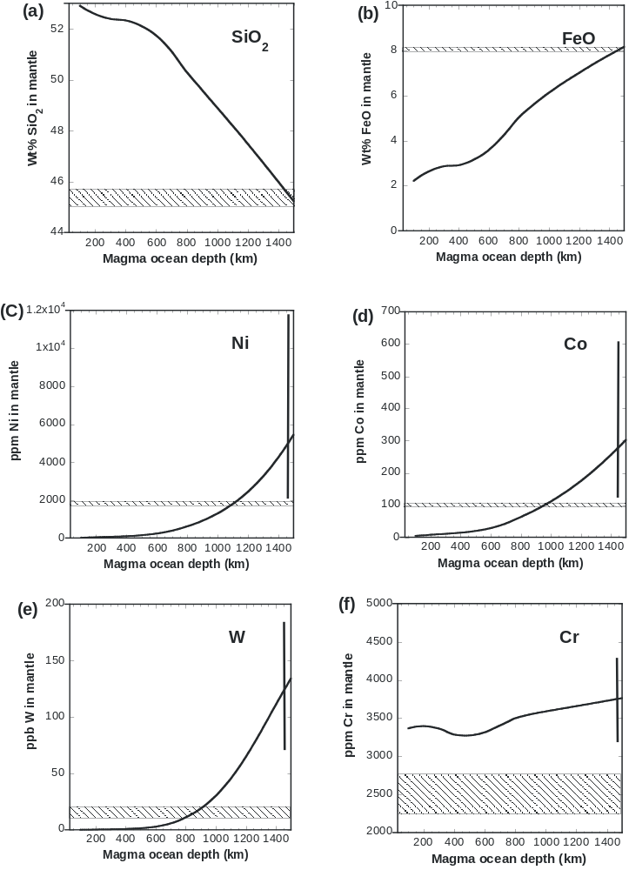
Fig. S1. Results of a single stage core formation model showing calculated mantle composition as a function of magma ocean depth. Actual mantle composition is indicated by the shaded bars. The error bars show the concentration uncertainties for a 1500 km deep magma ocean based on the propagation of uncertainties in log K_{D}.

Here we attempt to model single-stage core formation using the mass balance/element partitioning approach presented in the main text. We assume the same bulk composition (CI non-volatile element ratios but with 22% enhancement of refractory elements) and calculate equilibrated metal and silicate compositions at P-T conditions that lie along the peridotite liquidus (see main text). In addition to pressure (depth), the only variable parameter is the oxygen content of the bulk composition, which determines the oxygen fugacity and is defined by the fraction of Fe present as metal (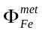) together with the initial Si content of the metal (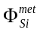). We use the FeO and SiO₂ concentrations of the primitive upper mantle as the primary constraints and determine the resulting siderophile element concentrations in the peridotitic magma
With a reduced (low oxygen content) bulk composition (= 0.999; = 0.01) and a magma ocean depth of 1500 km, the equilibrated magma ocean contains 45.2 wt% SiO₂ and 8.2 wt% FeO (Fig. S1) – i.e. values that are close to estimated PUM abundances (Table 2 in the main text). Within error, values for V and Nb are reasonable. However, under these conditions, the concentrations of the siderophile elements Ni, Co, W and Cr are much too high (Fig. S1c-f) and the Ta concentration is too low. By increasing log K_{D}(Si) by 1σ, reasonable fits for SiO₂, FeO, Ni and Co can be obtained within their propagated uncertainties, but W and Cr and Nb/Ta remain too high (even taking uncertainties into account). The high siderophile element concentrations in the mantle are largely the consequence of the fixed oxygen fugacity value being too high (~IW-1.9).
If the bulk composition is varied by changing the bulk oxygen content, SiO₂ and FeO concentrations cannot be matched simultaneously for any magma ocean depth. At lower bulk oxygen contents (higher 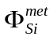), the FeO concentration corresponding to 45-46 wt% SiO₂ becomes too low, and at higher bulk oxygen contents (lower 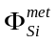), it becomes too high.
In conclusion, as discussed by Wade and Wood (2005), satisfactory fits for single stage core formation models are difficult, if not impossible, to find.

S4. Least squares fitting
Minima derived in the least squares minimization are well defined, as shown in Fig. S2.
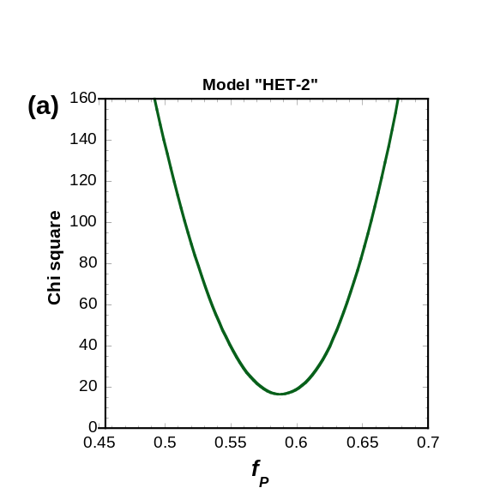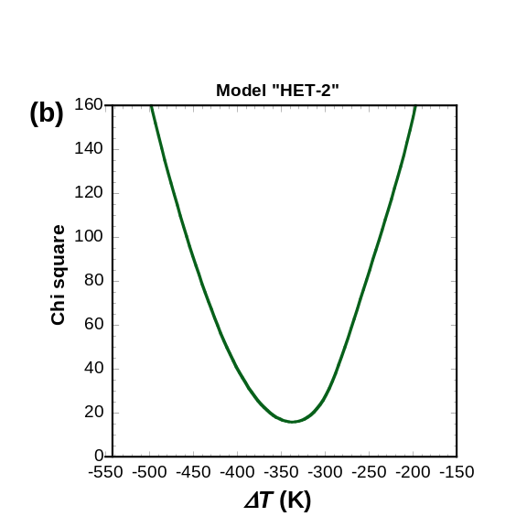
Fig. S2. Variation of χ² with f_{P} (a) and ΔT (b) in model HET-2, with values of all other parameters held constant. In both cases, the minimum is well defined.

S5. Correlations between fit parameters
Unique values of most refined parameters could not be determined because some parameters are strongly correlated (such as 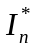 and λ in Eq. 4 in the main text). The ranges of parameter values obtained in fits which gave χ² < 17 are as follows:
Proportionality factor that gives effective equilibration pressure as a function of core-mantle boundary pressure (Eq. 3, main text):
f_{P} 0.54 to 0.87
Fraction of Fe initially present as metal in composition (1):
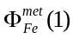 0.999*
Fraction of Fe initially present as metal in composition (2):
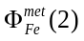 0.55 to 0.72
Fraction of Si initially dissolved in metal in composition (1):
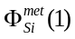 0.17 to 0.21*
Fraction of Si initially dissolved in metal in composition (2):
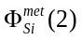 0.0
Impact number at which composition changes
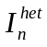 20 to 22
Disequilibrium parameters in Eq. (4) (main text):
λ 0.37 to 0.87
14 to 20
Deviation of effective equilibration temperature from peridotite liquidus temperature at P_{e}:
ΔT -574 to -304 K (±270 K)
* Note that 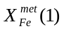 can be reduced to lower values if the value of 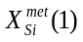 is increased, without changing the results.
Despite the ranges of parameter values, the results in terms of fitting the terrestrial primitive mantle composition are similar.
Table S3a. Evolution of impactor and terrestrial MANTLE COMPOSITIONS in heterogeneous accretion model HET-2
Differentiated impactor set: 1 (Initial fraction of Fe as metal: 0.999; Initial fraction of Si in metal: 0.19)
IMP# M/Me Pe Te fO2 SiO2 FeO MgO Al2O3 CaO Ni Co Nb Ta V W Cr Nb/Ta
GPa K ΔIW wt% wt% wt% wt% wt% ppm ppm ppb ppb ppm ppb ppm
1:1 0.01 1.0 2033 -4.43 48.44 0.58 41.69 5.12 4.16 2.02 0.98 57.93 35.53 61.75 0.0033 1636 1.63
1:2 0.02 2.6 2112 -4.25 48.35 0.71 41.66 5.11 4.16 4.59 1.31 72.05 35.93 64.28 0.0066 1728 2.01
1:3 0.03 4.1 2177 -4.12 48.26 0.83 41.64 5.11 4.16 9.16 1.64 85.97 36.24 65.99 0.0113 1794 2.37
1:4 0.04 5.4 2226 -4.04 48.20 0.91 41.62 5.11 4.15 12.69 2.42 98.40 36.48 67.06 0.0166 1837 2.70
1:5 0.05 6.6 2264 -3.98 48.15 0.97 41.61 5.11 4.15 15.55 2.86 109.9 36.67 67.73 0.0224 1866 3.00
1:6 0.06 7.7 2297 -3.94 48.12 1.02 41.61 5.11 4.15 18.44 3.27 120.8 36.82 68.11 0.0285 1885 3.28
Differentiated impactor set: 2 (Initial fraction of Fe as metal: 0.62; Initial fraction of Si in metal: 0.00)
IMP# M/Me Pe Te fO2 SiO2 FeO MgO Al2O3 CaO Ni Co Nb Ta V W Cr Nb/Ta
GPa K ΔIW wt% wt% wt% wt% wt% ppm ppm ppb ppb ppm ppb ppm
2:1 0.01 1.0 2033 -1.45 44.69 17.17 31.18 3.83 3.11 93.02 43.20 588.7 33.89 117.4 7.647 4920 17.37
2:2 0.02 2.6 2112 -1.45 44.72 17.11 31.20 3.83 3.11 169.4 46.61 588.9 33.91 117.4 9.506 4906 17.37
2:3 0.03 4.1 2177 -1.45 44.74 17.04 31.22 3.83 3.12 285.3 49.52 589.2 33.93 117.4 11.46 4894 17.36
2:4 0.04 5.4 2226 -1.46 44.77 16.99 31.24 3.84 3.12 355.7 62.64 589.4 33.95 117.4 13.30 4883 17.36
2:5 0.05 6.6 2264 -1.46 44.79 16.94 31.26 3.84 3.12 404.6 69.30 589.7 33.97 117.4 15.08 4874 17.36
2:6 0.06 7.7 2297 -1.46 44.81 16.89 31.27 3.84 3.12 452.4 74.74 589.9 33.99 117.4 16.83 4866 17.36
2:7 0.07 8.8 2324 -1.46 44.83 16.85 31.29 3.84 3.12 500.7 79.74 590.2 34.00 117.4 18.58 4859 17.36
2:8 0.08 9.8 2347 -1.46 44.85 16.81 31.30 3.84 3.12 550.0 84.51 590.4 34.02 117.4 20.35 4853 17.36
2:9 0.09 10.8 2367 -1.46 44.86 16.77 31.31 3.84 3.13 600.5 89.13 590.7 34.03 117.4 22.13 4847 17.36
Earth accretion:
I_{n} IMP# M/Me Pe Te fO2 SiO2 FeO MgO Al2O3 CaO Ni Co Nb Ta V W Cr Nb/Ta ξ
GPa K ΔIW wt% wt% wt% wt% wt% ppm ppm ppb ppb ppm ppb ppm
1 1:1 0.11 12.7 2004 -5.09 48.61 0.30 41.79 5.13 4.17 7.29 0.93 152.2 36.85 53.54 0.0027 1451 4.13 1.00
2 1:1 0.12 13.6 2016 -5.25 48.66 0.23 41.80 5.13 4.17 7.00 0.85 131.8 35.78 41.22 0.0021 1138 3.68 1.00
3 1:1 0.13 14.5 2027 -5.27 48.67 0.23 41.80 5.13 4.17 7.67 0.90 123.5 34.89 33.61 0.0023 964.6 3.54 1.00
4 1:1 0.14 15.4 2036 -5.27 48.67 0.23 41.80 5.13 4.17 8.45 0.96 122.3 34.17 28.87 0.0026 866.4 3.58 1.00
5 1:1 0.15 16.2 2069 -5.18 48.66 0.25 41.79 5.13 4.17 10.36 1.15 126.5 33.69 26.58 0.0036 829.3 3.75 1.00
6 1:2 0.17 17.1 2097 -5.09 48.64 0.28 41.78 5.13 4.17 12.51 1.36 138.6 33.13 25.07 0.0049 818.7 4.18 1.00
7 1:2 0.19 18.8 2147 -4.96 48.62 0.32 41.77 5.13 4.17 17.26 1.79 157.0 32.95 25.15 0.0083 841.8 4.76 1.00
8 1:2 0.21 20.5 2192 -4.85 48.59 0.36 41.75 5.13 4.17 23.18 2.30 178.3 32.99 25.86 0.0131 876.0 5.40 1.00
9 1:2 0.23 22.2 2240 -4.73 48.55 0.41 41.74 5.12 4.17 31.10 2.97 201.0 33.16 26.97 0.0211 918.4 6.06 1.00
10 1:2 0.25 23.8 2297 -4.59 48.50 0.49 41.72 5.12 4.16 42.64 3.94 224.5 33.43 28.54 0.0358 972.7 6.72 1.00
11 1:3 0.28 25.5 2359 -4.42 48.43 0.59 41.70 5.12 4.16 59.04 5.30 258.1 33.93 31.18 0.0628 1058 7.61 1.00
12 1:3 0.31 28.0 2459 -4.18 48.30 0.77 41.66 5.11 4.16 93.89 8.12 290.9 34.47 34.45 0.1416 1164 8.44 1.00
13 1:3 0.34 30.4 2537 -4.00 48.17 0.93 41.62 5.11 4.15 137.5 11.36 322.0 35.02 37.68 0.2697 1267 9.20 1.00
14 1:3 0.37 32.9 2609 -3.85 48.04 1.10 41.58 5.10 4.15 193.8 15.27 350.8 35.54 40.76 0.4789 1365 9.87 1.00
15 1:4 0.41 35.4 2675 -3.70 47.88 1.29 41.54 5.10 4.15 268.7 20.21 385.2 36.18 44.49 0.8218 1480 10.65 1.00
16 1:4 0.45 38.7 2758 -3.55 47.69 1.52 41.49 5.09 4.14 390.6 27.49 415.5 36.75 47.94 1.527 1588 11.30 1.00
17 1:5 0.50 42.1 2834 -3.40 47.47 1.78 41.45 5.09 4.14 560.7 37.03 448.2 37.39 51.86 2.749 1710 11.99 1.00
18 1:5 0.55 46.3 2922 -3.24 47.20 2.08 41.39 5.08 4.13 822.0 50.19 476.0 37.93 55.46 5.120 1823 12.55 1.00
19 1:6 0.61 50.6 3004 -3.12 46.98 2.32 41.34 5.08 4.13 1097 62.41 478.6 38.20 58.23 8.196 1900 12.53 0.60
20 1:6 0.67 55.9 3095 -3.00 46.82 2.50 41.30 5.07 4.12 1344 72.20 466.9 38.26 60.03 11.37 1943 12.20 0.36
21 2:7 0.74 61.2 3179 -2.60 46.42 4.40 40.04 4.92 4.00 1667 90.80 481.3 37.70 66.55 16.65 2274 12.77 0.21
22 2:7 0.81 67.6 3270 -2.35 46.18 5.80 39.08 4.80 3.90 1788 99.86 492.9 37.29 71.86 19.40 2541 13.22 0.13
23 2:8 0.89 74.2 3355 -2.15 46.00 7.02 38.23 4.69 3.82 1810 104.7 503.6 36.93 76.76 21.08 2788 13.64 0.08
24 2:9 0.98 81.9 3446 -1.98 45.85 8.10 37.47 4.60 3.74 1774 107.1 513.2 36.61 81.18 22.15 3010 14.02 0.05
IMP# - identification number of impacting body; M/Me – mass as fraction of Earth’s current mass
Table S3b. Evolution of impactor and terrestrial CORE COMPOSITIONS in model HET-2
Differentiated impactor set: 1 (Initial fraction of Fe as metal: 0.999; Initial fraction of Si in metal: 0.19)
IMP# M/Me Pe Te fO2 Fe Ni Co Si O Nb Ta V W Cr Core Mass
GPa K ΔIW wt% wt% wt% wt% wt% ppb ppb ppm ppb ppm %
1:1 0.01 1.0 2033 -4.43 85.25 5.03 0.24 9.44 0.04 1304 17.47 171.2 514.4 9436 35.9
1:2 0.02 2.6 2112 -4.25 85.17 5.03 0.24 9.51 0.05 1280 16.73 166.8 515.0 9280 35.9
1:3 0.03 4.1 2177 -4.12 85.10 5.04 0.24 9.57 0.06 1256 16.16 163.9 515.5 9170 35.8
1:4 0.04 5.4 2226 -4.04 85.04 5.04 0.24 9.61 0.07 1235 15.72 162.0 515.9 9097 35.8
1:5 0.05 6.6 2264 -3.98 85.00 5.04 0.24 9.64 0.08 1215 15.37 160.9 516.1 9048 35.8
1:6 0.06 7.7 2296 -3.94 84.96 5.04 0.24 9.67 0.09 1196 15.08 160.2 516.3 9017 35.8
Differentiated impactor set: 2 (Initial fraction of Fe as metal: 0.62; Initial fraction of Si in metal: 0.00)
IMP# M/Me Pe Te fO2 Fe Ni Co Si O Nb Ta V W Cr Core Mass
GPa K ΔIW wt% wt% wt% wt% wt% ppb ppb ppm ppb ppm %
2:1 0.01 1.0 2033 -1.45 90.88 8.34 0.38 0.01 0.39 3.424 0.0043 2.273 831.2 1030 20.0
2:2 0.02 2.6 2112 -1.45 90.87 8.30 0.37 0.01 0.44 3.937 0.0054 2.549 821.7 1094 20.1
2:3 0.03 4.1 2177 -1.46 90.85 8.26 0.37 0.02 0.50 4.360 0.0066 2.815 811.9 1151 20.1
2:4 0.04 5.4 2226 -1.46 90.84 8.22 0.37 0.02 0.55 4.673 0.0076 3.055 802.8 1201 20.2
2:5 0.05 6.6 2264 -1.46 90.82 8.18 0.36 0.02 0.60 4.896 0.0085 3.273 794.1 1244 20.2
2:6 0.06 7.7 2296 -1.46 90.81 8.15 0.36 0.03 0.65 5.045 0.0094 3.472 785.7 1283 20.2
2:7 0.07 8.8 2324 -1.46 90.81 8.12 0.36 0.03 0.69 5.134 0.0101 3.656 777.4 1318 20.3
2:8 0.08 9.8 2347 -1.46 90.80 8.08 0.36 0.03 0.73 5.175 0.0108 3.826 769.3 1349 20.3
2:9 0.09 10.8 2367 -1.46 90.80 8.05 0.35 0.03 0.76 5.176 0.0113 3.984 761.1 1378 20.3
Earth accretion:
I_{n} IMP# M/Me Pe Te fO2 Fe Ni Co Si O Nb Ta V W Cr Core Mass
GPa K ΔIW wt% wt% wt% wt% wt% ppb ppb ppm ppb ppm %
1 1:1 0.11 12.7 2004 -5.09 83.63 4.91 0.23 9.17 0.10 1109 14.90 181.7 502.3 9540 36.5
2 1:1 0.12 13.6 2016 -5.25 83.67 4.91 0.23 9.14 0.09 1144 16.77 203.0 502.0 10081 36.5
3 1:1 0.13 14.5 2027 -5.27 83.68 4.91 0.23 9.13 0.08 1159 18.32 216.3 502.0 10382 36.5
4 1:1 0.14 15.4 2036 -5.27 83.69 4.91 0.23 9.13 0.08 1161 19.56 224.5 502.1 10554 36.5
5 1:1 0.15 16.2 2069 -5.18 83.69 4.91 0.23 9.14 0.07 1154 20.40 228.6 502.3 10622 36.5
6 1:2 0.17 17.1 2097 -5.09 83.69 4.91 0.23 9.14 0.07 1133 21.36 231.3 502.5 10644 36.5
7 1:2 0.19 18.8 2147 -4.96 83.68 4.91 0.23 9.16 0.06 1102 21.67 231.3 502.7 10609 36.5
8 1:2 0.21 20.5 2192 -4.85 83.66 4.91 0.23 9.18 0.06 1065 21.61 230.1 503.0 10554 36.5
9 1:2 0.23 22.2 2240 -4.73 83.64 4.91 0.23 9.20 0.06 1026 21.30 228.3 503.3 10486 36.4
10 1:2 0.25 23.8 2297 -4.59 83.61 4.92 0.23 9.23 0.06 985.6 20.81 225.7 503.6 10399 36.4
11 1:3 0.28 25.5 2359 -4.42 83.56 4.92 0.23 9.28 0.06 927.7 19.93 221.3 504.1 10259 36.4
12 1:3 0.31 28.0 2459 -4.18 83.46 4.92 0.23 9.36 0.06 871.3 18.95 215.9 504.9 10090 36.3
13 1:3 0.34 30.4 2537 -4.00 83.37 4.92 0.23 9.44 0.07 817.5 17.97 210.5 505.5 9924 36.2
14 1:3 0.37 32.9 2609 -3.85 83.27 4.92 0.23 9.53 0.09 767.6 17.02 205.4 505.9 9765 36.2
15 1:4 0.41 35.4 2675 -3.70 83.14 4.92 0.23 9.64 0.11 707.5 15.86 199.1 506.2 9575 36.1
16 1:4 0.45 38.7 2758 -3.55 82.99 4.90 0.23 9.77 0.14 654.5 14.80 193.3 505.9 9400 36.1
17 1:5 0.50 42.1 2834 -3.40 82.80 4.88 0.23 9.93 0.19 596.8 13.63 186.6 504.8 9200 36.0
18 1:5 0.55 46.3 2922 -3.24 82.58 4.85 0.23 10.13 0.25 547.4 12.61 180.5 501.8 9015 35.9
19 1:6 0.61 50.6 3004 -3.12 82.42 4.81 0.22 10.28 0.30 543.0 12.08 175.8 497.3 8892 35.8
20 1:6 0.67 55.9 3095 -3.00 82.32 4.77 0.22 10.40 0.33 564.2 11.91 172.8 492.5 8829 35.8
21 2:7 0.74 61.2 3179 -2.60 82.66 4.89 0.23 9.89 0.37 531.6 11.22 163.6 501.4 8431 34.2
22 2:7 0.81 67.6 3270 -2.35 82.99 5.02 0.23 9.39 0.40 501.9 10.59 154.9 511.5 8051 32.9
23 2:8 0.89 74.2 3355 -2.15 83.35 5.17 0.24 8.85 0.44 471.5 9.946 145.8 523.1 7654 31.7
24 2:9 0.98 81.9 3446 -1.98 83.70 5.32 0.24 8.30 0.48 441.3 9.303 136.8 535.3 7255 30.7
References
Asahara, Y., Frost, D.J., Rubie, D.C., 2007. Partitioning of FeO between magnesiowüstite and liquid iron at high pressures and temperatures: Implications for the composition of the Earth’s outer core. Earth Planet. Sci. Lett. 257, 435–449.
Chabot, N.L., Draper, D.S., Agee, C.B., 2005. Conditions of core formation in the Earth: Constraints from nickel and cobalt partitioning. Geochim. Cosmochim. Acta 69, 2141-2151.
Cottrell, E., Walter, M.J., Walker, D., 2009. Metal-silicate partitioning of tungsten at high pressure and temperature: Implications for equilibrium core formation in Earth. Earth Planet. Sci. Lett. 281, 275-287.
Cottrell, E., Walter, M.J., Walker, D., 2010. Erratum to “Metal-silicate partitioning of tungsten at high pressure and temperature: Implications for equilibrium core formation in Earth” [Earth Planet. Sci. Lett. 281 (2009) 275-287]. Earth Planet. Sci. Lett. 289, 631-634.
Frost, D.J., Asahara, Y., Rubie, D.C., Miyajima, N., Dubrovinsky, L.S., Holzapfel, C., Ohtani, E., Miyahara, M., Sakai, T., 2010. The partitioning of oxygen between the Earth’s mantle and core. J. Geophys. Res. 115, B02202, doi:10.1029/2009JB006302.
Gessmann, C.K., Rubie, D.C., 2000. The origin of the depletions of V, Cr and Mn in the mantles of the Earth and Moon. Earth Planet. Sci. Lett. 184, 95-107.
Holzheid, A., Palme, H., Chakraborty, S., 1997. The activities of NiO, CoO and FeO in silicate melts. Chem. Geol. 139, 21-38.
Ito, E., Kubo, A., Katsura, T., Walter, M.J., 2004. Melting experiments of mantle materials under lower mantle conditions with implications for magma ocean differentiation. Phys. Earth Planet. Inter., 143-144, 397-406.
Kegler, P., Holzheid, A., Frost, D.J., Rubie, D.C., Dohmen, R., Palme, H., 2008. New Ni and Co metal-silicate partitioning data and their relevance for an early terrestrial magma ocean. Earth Planet. Sci. Lett. 268, 28-40.
Li, J., Agee, C.B., 1996. Geochemistry of core-mantle differentiation at high pressure. Nature 381, 686-689.
Mann, U., Frost, D.J., Rubie, D.C., 2009. Evidence for high-pressure core-mantle differentiation from the metal-silicate partitioning of lithophile and weakly siderophile elements. Geochim. Cosmochim. Acta 73, 7360-7386, doi: 10.1016/j.gca.2009.08.006.
O'Brien, D.P., Morbidelli, A., Levison, H.F., 2006. Terrestrial planet formation with strong dynamical friction. Icarus 184, 39-58.
O’Neill, H.St.C., Eggins, S.M., 2002. The effect of melt composition on trace element partitioning: an experimental investigation of the activity coefficients of FeO, NiO, CoO, MoO₂ and MoO₃ in silicate melts. Chem. Geol. 186, 151-181.
Palme, H., O’Neill, H.St.C., 2003. Cosmochemical estimates of mantle composition, in: Carlson, R.W. (Ed.), Treatise on Geochemistry, Volume 2-The Mantle and Core. Elsevier-Pergamon, Oxford, pp. 1-38.
Righter, K, 2010. Conditions of core formation in the early Earth: Single stage or heterogeneous accretion? 41st Lunar and Planetary Science Conference, Abstract #2301.
Righter, K., Drake, M.J., Yaxley, G., 1997. Prediction of siderophile element metal/silicate partition coefficients to 20 GPa and 2800°C: the effects of pressure, temperature, oxygen fugacity, and silicate and metallic melt compositions. Phys. Earth Planet. Int. 100, 115-134.
Rubie, D.C. Melosh, H.J., Reid, J.E., Liebske, C., Righter, K., 2003. Mechanisms of metal-silicate equilibration in the terrestrial magma ocean. Earth Planet. Sci. Lett. 205, 239-255.
Rubie, D.C., Gessmann, C.K., Frost, D.J., 2004. Partitioning of oxygen during core formation on the Earth and Mars. Nature 429, 58-61.
Takafuji, N., Hirose, K., Mitome, M., Bando, Y., 2005. Solubilities of O and Si in liquid iron in equilibrium with (Mg,Fe)SiO₃ perovskite and the light elements in the core. Geophys. Res. Lett. 32, L06313, doi:10.1029/2005GL022773.
Trønnes, R.G., 2000. Melting relations and major element partitioning in an oxidized bulk Earth model composition at 15-26 GPa. Lithos 53, 233-245.
Trønnes, R.G., Frost, D.J., 2002. Peridotite melting and mineral-melt partitioning of major and minor elements. Earth Planet. Sci. Lett. 197, 117-131.
Wade, J., Wood, B.J., 2005. Core formation and the oxidation state of the Earth. Earth Planet. Sci. Lett. 236, 78-95.

Silicate |  | Reduced | Oxidized
SiO2 | wt.% | 48.84 | 44.51
MgO | wt.% | 41.79 | 31.05
FeO | wt.% | 0.06 | 17.52
Al2O3 | wt.% | 5.13 | 3.81
CaO | wt.% | 4.17 | 3.1
Ni | ppm | 28 | 21
Co | ppm | 1.3 | 1
Nb | ppb | 79 | 59
Ta | ppb | 4.5 | 3.4
V | ppm | 16 | 12
W | ppb | 29 | 21
Cr | ppm | 694 | 516
Metal
Fe | wt.% | 85.59 | 91.04
Ni | wt.% | 5 | 8.56
Co | wt.% | 0.23 | 0.4
O | wt.% | 0 | 0
Si | wt.% | 9.17 | 0
Nb | ppb | 1260 | 2158
Ta | ppb | 72 | 124
V | ppm | 252 | 432
W | ppb | 461 | 789
Cr | wt.% | 1.1 | 1.9
Metalb | wt.% | 36.1 | 19.7
Trace elements are partitioned arbitrarily prior to the initial equilibration event.
a These compositions (prior to the initial equilibration) are based on the chondritic
concentrations listed in Table S1 (supplementary data). The fraction of total Fe in metal
(Φfe met) is 0.999 in (1) and 0.62 in (2) and the corresponding fractions of total Si in metal
(Φsi met) are 0.18 in (1) and 0.00 i

The molar compositions of coexisting chemically-equilibrated sili-
cate and metal liquids are expressed as:

[(FeO) _{x} (NiO) _{y} (SiO₂)_{z} (Mg_{u} Al_{m} Ca_{n})O] + [Fe_{a} Ni_{b} O_{c} Si_{d}]

silicate liquid metal liquid
The coefficients u, m and n, for Mg, Al and Ca respectively, are
constants because these elements do not dissolve into liquid Fe and
the oxygen content of the silicate liquid is fixed by charge balance. The
values of the seven unknown coefficients x’, y’, z’, a’, b’, c’ and d’ are
determined from seven constraints by simultaneously solving four
mass balance equations (for Fe, Ni, Si and O respectively — based on
the bulk composition), two equations that describe the metal–silicate
partitioning of Ni and Si, and the oxygen distribution coefficient
derived from the model of Frost et al. (2010). The simultaneous
equations are highly non-linear and are solved iteratively, as
described in the supplementary data (Section S2). The low concen-
trations of Co, V, W, Nb, Ta and Cr have a negligible effect on the mass
balance and their concentrations in core and mantle are determined
from partition coefficients alone. In addition to the elements listed
above, the Earth's core is considered to contain ~1.7 wt.% S based on
the high cosmochemical volatility of S and the low abundances of
volatiles in the Earth (Dreibus and Palme, 1996; McDonough, 2003).
The effect of ~ 2 wt.% S on the metal–silicate partitioning of the
elements under consideration is insignificant (Li and Agee, 2001;
Mann et al., 2009; Righter, 2003) and S is not included in the mass
balance; however, 2 wt.% S is added when calculating final core
compositions. The carbon content of the core has been estimated to be
~ 0.2 wt.% (McDonough, 2003) and is not considered her

