**Comparisons of Linear Prediction of Stock Market Averages**

Owen Sowatzke

Georgia Institute of Technology

School of Electrical and Computer Engineering

ECE 4271

Spring 2021

**Introduction**

The goal of this extra credit project was to design and evaluate linear predictors using MATLAB. Specifically, this project examined linear predictors in applications involving stock market prediction. This document details the different experiments performed and then makes conclusions based on the results of each experiment.

**Part (i)**

The first experiment performed involved using the first ten years (520 weeks) of data to predict the 2018 stock market data. This involved optimizing the number of linear predictor coefficients and then comparing the predicted 2018 stock market with the actual 2018 stock market data.

First, to determine the number of linear predictor coefficients, linear predictor coefficients, a, were determined for p=1:10. Then, the total squared error was calculated for each p value using E = e’*e, wheree = x+X*a. The total squared prediction error is plotted vs the number of linear predictor coefficients (p). This result is shown in Figure 1.

Figure 1 – Plot of the Total Squared Prediction Error vs the Number of Linear Predictor Coefficients (p).

Typically, the value of p is chosen at a knee point, the point after which total squared prediction stops drastically decreasing for each increase in p. However, examining the plot, a clear knee point cannot be found. Therefore, p is chosen to minimize the total squared prediction error. For our training dataset, this implies p = 10.

When optimizing our choice of p, we used the training data set. However, in order to see how our predictor actually performs, we must use the 2018 data set. In order to make a prediction, we use the filter command to generate stock market predictions using a weighted sum of previous values. In Figure 2, the predicted 2018 market data is plotted on the same plot as the actual 2018 stock market data.

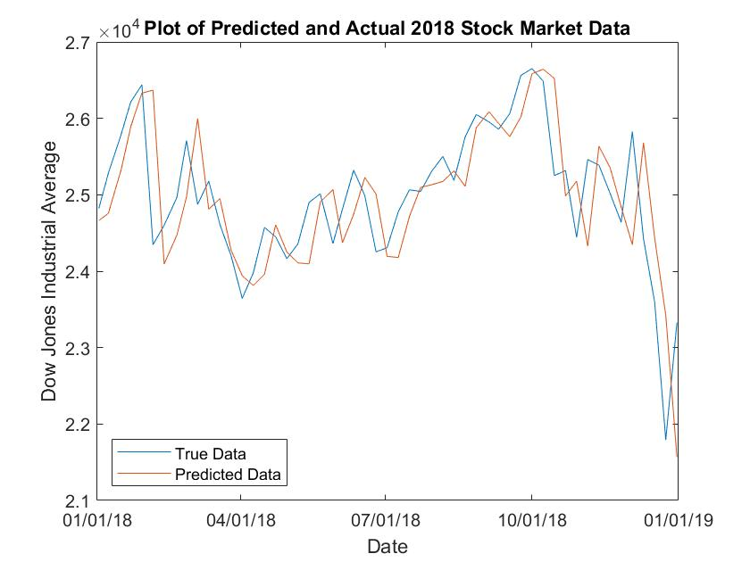

Figure 2 - Plot of the Predicted and Actual Stock Market Data when the Predictor is Designed Using the First 520 weeks of Stock Market Data.

Another metric of prediction performance is the squared error of the predicted data. We determine this metric using the following formula: . Using this formula, we find that the squared error of the predicted data is .

**Part (ii)**

In this part, we design our linear predictor using the 2006-2007 stock market as training data. Then, we use this predictor to predict the 2018 stock market data. Using p=10 as derived in part (i), we determine the predictor coefficients. After our predictor coefficients have been determined, we repeat the analysis of part (i). First, in Figure 3, the predicted 2018 market data is plotted on the same plot as the actual 2018 stock market data.

Figure 3 - Plot of the Predicted and Actual Stock Market Data when the Predictor is Designed Using the 2006-2007 Stock Market Data.

Next using the formula in part (i), we also compute the predicted squared error of the new predictor. Repeating the same analysis, we find that the predicted squared error is .

**Part (iii)**

In this part, we design two linear predictors with 10 linear predictor coefficients (p=10). The first predicted uses the data from July – December 2017 as training data, and the second predictor uses the data from January – June 2018 as training data. Each predictor is then used to predict the next 6 months of data. Specifically, the first predictor predicts data from January – June 2018 and the second predictor predicts data from July – December 2018. By concatenating the results of each predictor, we can obtain the entire predicted 2018 dataset. Then, using this data, we can repeat the analysis performed on the predicted datasets. First, in Figure 4, the predicted 2018 market data is plotted on the same plot as the actual 2018 stock market data.

Figure 4 – Plot of the Predicted and Actual Stock Market Data when Two Predictors Trained with the Past 6 Months of Data are Used to Make Predictions.

Next using the formula in part (i), we also compute the predicted squared error of the new predictor. Repeating the same analysis, we find that the predicted squared error is .

**Part (iv)**

Analyzing the results of each predictor, we find that there are two primary factors that drive the differences in the results of each predictor.