Installation Guide for OsParking jar files and the Parking Lot Database

Contents

- Installing JRE
- Installing OsParking jar files
- MySQL - Installing and Starting
- Creating MySQL database instance ‘parkinglot’
- Creating MySQL user ‘gate_1’
- Creating OsParking database instance ‘parkinglot’ tables
- Creating ‘parkinglot’ table dummy data
- How to run OsParking in simulation mode
- Developer contact point

Creation date of this document : 2016. Oct. 3(Mon)

Open Source Parking, Inc.

- Installing JRE
  - Installation Steps
    - Visit https://www.java.com/en/ and click the red button shown below
Free Java Download
    - from the page that pops up click next button
Agree and Start Free Download
    - Execute the file downloaded (file name: “jre-8u161-windows-x64.exe” or something similar to that)
    - On the “Security warning” window click left button and agree with their policy
(after a progress bar appearance, the JRE will be installed)
- After installing JRE
  - Create a window environment variable “JAVA_HOME” with the value of Java JRE installation folder path (e.g :
C:\Program Files\Java\jre1.8.0_101” or something similar to it.)
  - Open a DOS terminal and make sure that Java installed successfully
DOS:\> java -version // you just type the blue letters
(in case of a successful installation of JRE, DOS will respond with the following message or similar to that one -
java version “1.8.0_101”
……
II. Installing OsParking jar files
- Download compressed installation file
  - Visit https://github.com/osparking/OsParking_jar
  - Click Clone or download between two buttons, choose right one -
Download ZIP
  - File name you will have : OsParking_jar-master.zip
- Unzip the file that you downloaded into the folder you choose for example
C:\OsParking\OsParking_jar-master\
// from now on, I’ll call this folder as “jar folder”

III. Installing and starting MySQL
- Download Installation File
  - Visit https://dev.mysql.com/downloads/mysql/5.6.html#downloads
  - Near bottom of the page you would find two buttons similar to
Download
-- choose the one that suits your computer CPU bit count (either 32 or 64)
  - Unzip the downloaded file into the below folder
C:\Program Files\MySQL\MySQL Server 5.6
// or similar folder name that you can remember
// under the above folder you should have these subfolders
bin, data, docs, include, …
- Register MySQL service
  - Open DOS window as the “Administrator”
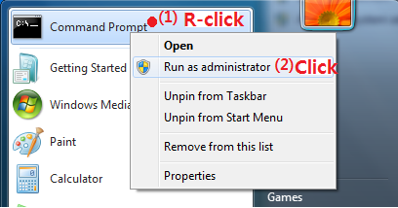
  - Use below command to MySQL server service
// you just type the blue letters
C:\> “C:\Program Files\MySQL\MySQL Server 5.6\bin\mysqld” -install
// DOS will respond with below message
Service successfully installed.
- Append below bin folder full path string at the end of environment variable ‘path’
C:\Program Files\MySQL\MySQL Server 5.6\bin
- In the DOS window that you opened as the “Administrator” privilege, use “net” command to start MySQL service immediately (without rebooting the system) - if you accidentally execute the command you will encounder “System error 5 has occurred.”
// you just type the blue letters
C:\> net start mysql
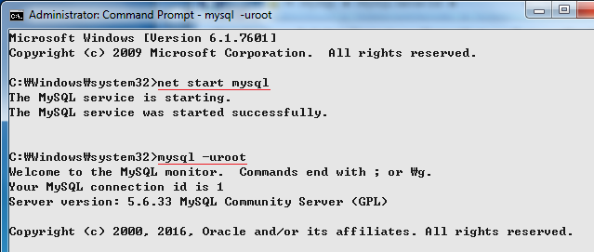
* Possible error : if you have 1067 error for the above “net” command, copy “my-default.ini” file from the MySQL installation folder and make a my.ini file in the same folder. After that, define these three words by uncommenting and changing their value as shown below.
basedir = C:\Program Files\MySQL\MySQL Server 5.6
datadir = C:\Program Files\MySQL\MySQL Server 5.6\data
port = 3306
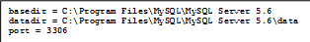
IV. Creating MySQL database instance ‘parkinglot’
- (as you added bin folder of MySQL folder to the ‘path’ environment variable), when you open DOS window use below command to login as “root” to get mysql prompt.
C:\> mysql -uroot
- Create ‘parkinglot’ database instance by this “create” command and make sure the database is in good shape.
mysql> create database parkinglot;
mysql> show databases;
→ including ‘parkinglot’ 5 database instances will be listed
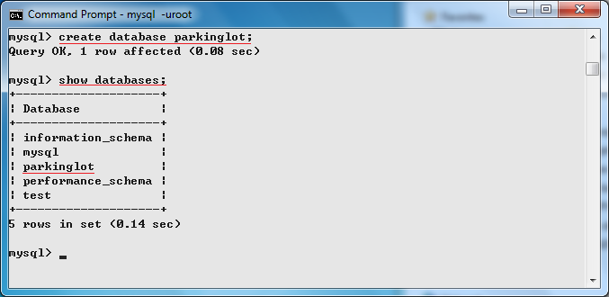

V. Creating MySQL user ‘gate_1’
- Use below command to create a user ‘gate_1’
// it is a case-insensitive command
mysql> GRANT SELECT, INSERT, UPDATE, DELETE, CREATE, DROP
-> ON parkinglot.*
-> TO ‘gate_1’@’localhost’
-> IDENTIFIED BY ‘1234’;
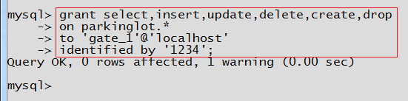

- (optionally) make sure user ‘gate_1’ is created well
C:\> mysql -ugate_1 -p
// enter the password ‘1234’ that you entered above -- without single quotes.
VI. Creating OsParking database instance ‘parkinglot’ tables

- Download database backup file to insall
  - Visit https://github.com/osparking/OsParking_DB, click Clone or download, between two buttons that expend, choose right one -
Download ZIP
  - File you will have : OsParking_DB-master.zip
- Unzip the zip file, in the folder you will find restore_parkinglot.bat, execute the bat file by double clicking it.
  - At the password entry prompt,
(as there should be no password set) just press ENTER, // see figure below
  - In case O/S refuses to run *.bat file for the security reason, open a DOS window(see figure below again), navigate to the directory where the bat file is, use the bat file name as the command, then you could create ParkingLot database tables.

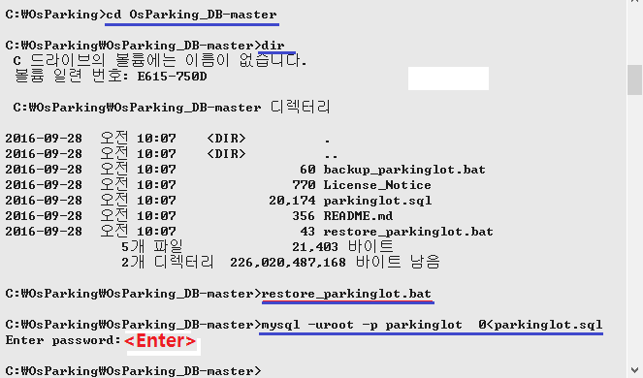

- After you login as a root to the MySQL (using DOS command “mysql -uroot -p”), (see figure below) at the mysql> prompt enter “use parkinglot” command to select current database. Then, use “show tables” command to check if all the parkinglot database 14 tables are created well.

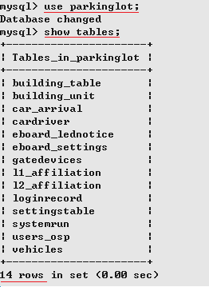

VII. Creating ‘parkinglot’ table dummy data
- OsParking data management program
  - in the jar folder (defined in chapter II), run “ManageData.bat – shortcut” by double clicking the file
  - Create dummy data for each tables in the order shown below figure.

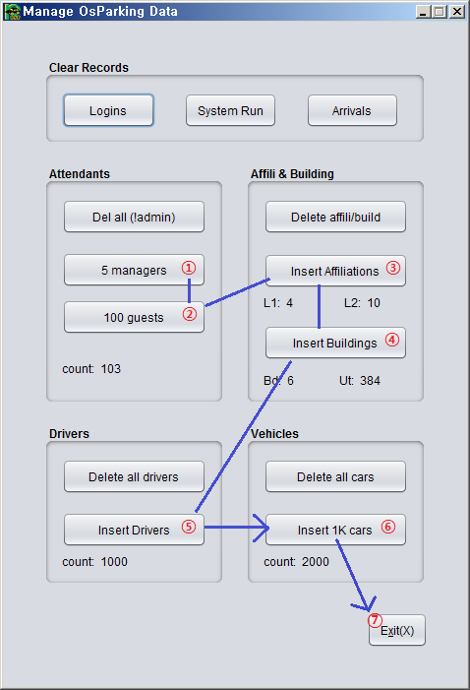

VIII. How to run OsParking in simulation mode
// System simulation is performed using the shortcut icons in the jar folder(chapter II)

- Starting server
  - Use either one of 3 shortcuts for your taste
    - OsParking.bat – shortcut // basic
License notice window ⇒ Login window //id, pw : see next section (b)
    - OsParking-debug.bat – shortcut // debugging mode
⇒ Login window
    - OsParking-random.bat – shortcut // debugging and (automatic)random processing for the visiting cars
⇒ Login window
  - After OsParking server started, even when no user logs in server runs anyway. (You may close login window without logging in.) When you wish to login to check the internal function of OsParking, use -
    - user ID : admin, manager or guest
    - password : 1234
- Running Gate Bar (simulator)
  - Choose one of two shortcut icons
    - GateBar.bat - shortcut // basic
License notice window will appear
    - GateBar-debug.bat – shortcut // for system debugging
  - (optionally) use error checkbox to insert random artificial (packet transmission) errors
- Running Electrical Board (simulator)
  - Choose one of two shortcut icons
    - E_Board.bat - shortcut // basic
    - E_Board-debug.bat – shortcut // for debugging
  - (optionally) use error checkbox to insert random artificial (packet transmission) errors

- Running Camera (simulator)
  - Choose one of two shortcut icons again
    - Camera.bat shortcut // basic
    - Camera-debug.bat shortcut // for debugging
  - (optionally) use error checkbox to insert random artificial (packet transmission) errors
- Simulation Result Analysis
  - Camera simulator sends car image with license plate every 2 to 20 seconds. On the reception of those images, electrical board and gate bar simulators operates accordingly which means successful installation of the whole OsParking system.
  - In case the number of gate is one and the camera type is configured to the (car) entry button, as camera simulator is not being employed, the above explaination(‘a’) doesn’t apply. Right after OsParking server runs, being green color of the camera LED means that the car entry button is usable. In fact, the entry button generates car entry images by itself (without camera simulator).

IX. OsParking developer Contact Point
- Email : jbpark03@gmail.com (name: Park, JongBum, Job title : Programmer)
- Company homepage : http://www.osparking.com/index.php

