SOYBEAN YIELD AND CLIMATE VARIABILITY
Illinois County Panel
1980 to 2025

A county × year panel testing how growing-season heat and moisture relate to soybean yield, with Champaign County as the focal unit.
Observations | 4,459 | County × year, 1980–2025
Counties | 102 | 91 in the balanced panel
Two-way FE R² | 0.668 | County and year fixed effects
ML skill vs baseline | +15.7% | RMSE, expanding-window validation
Robustness | 13 of 13 | Temperature effect negative, p < 0.05

Sources USDA National Agricultural Statistics Service, Quick Stats · NOAA National Centers for Environmental Information, nClimDiv. Both United States federal works in the public domain.
Repository github.com/osperry/soybean-climate-illinois
Generated 31 August 2026

Contents

1 Executive summary
Illinois soybean yield rose from 33.5 bu/acre in 1980 to 62.5 in 2025. Almost all of that is technology, roughly 0.65 bu/acre per year from cultivar improvement and agronomy. That trend is an order of magnitude larger than any climate signal in the sample, and because temperature also trended over the same period, a model that leaves it in will credit warming with the genetics and return a positive temperature coefficient.
This study removes the trend county by county, then asks what the residual responds to. Four results follow, each surviving thirteen robustness specifications.

The headline
The temperature effect is conditional on moisture, not additive with it. Warming costs roughly twice as much in dry conditions as in wet (−0.887 versus −0.429 bu/acre per °F). Heat alone is nearly free. An additive model understates warming risk systematically.

What is new here
Two findings run against expectation and are stated plainly because a reviewer will find them anyway.
Algorithm sophistication buys almost nothing. Gradient boosting beats ridge regression by 4.9%. Climate beats a trend-only baseline by 15.7%. The signal is in the specification, not the model class.
The largest anomaly cannot be attributed. 2003 is the largest unexplained shortfall in 46 years. The documented soybean aphid outbreak of that year was tested as the explanation and rejected on geographic grounds. See section 6.

2 Data and verification
Attribute | Specification
Production source | USDA NASS Quick Stats, SURVEY program, Period = YEAR
Geography | County level, Illinois, 102 counties
Climate source | NOAA NCEI nClimDiv, county monthly
Climate variables | Precipitation, mean / max / min temperature, PDSI, Palmer Z-index
Coverage | 1980 to 2025, 46 years
Analytical target | yield_anom, residual from a county-specific linear yield trend
Growing season | April to September
Critical window | July to August (R3–R6, pod set and seed fill)
Inclusion rule | Counties with ≥ 42 of 46 years — 91 counties, 4,051 rows
API key required | None

2.1 Verification
The panel reconciles exactly to published state totals. That check matters more than it sounds: internal consistency tests pass even on a file that has silently lost rows, and an earlier build of this panel had done exactly that. Only reconciliation against an independently published aggregate catches it.
Check | Result
County sums vs published state totals, 46 years, 3 measures | Exact, 0.000% error
production ÷ harvested acres = yield | 4,459 of 4,459, max residual 0.25
Harvested acres ≤ planted acres | No violations
Duplicate county-year keys | 0
Climate join completeness | 4,459 of 4,459, zero nulls
Independent cross-check vs external NASS query | 21 of 21 values match

2.2 Four structural traps in the source data
NASS publishes its suppressed-county bucket once per Agricultural Statistics District, not once per state. In 2019 there are nine, all with a blank county ANSI. The raw key is county + district + year; keying on county and year alone silently collapses up to nine rows per year.
County ANSI must be read as text. Integer casting turns 001 into 1 and drops Adams County from every join.
Join on FIPS, never on name. NASS writes DU PAGE, ST CLAIR, JO DAVIESS; Census writes DuPage, St. Clair, Jo Daviess.
Never sum county rows to a state total after 2018. County coverage fell from 102 counties to 62; 2025 county sums give 6.30M planted acres against an actual 10.30M.

3 Findings

3.1 Heat is nearly harmless when there is water
Mean yield anomaly in bu/acre against county trend:
 | Wet | Dry
Cool | +1.44 | −1.17
Hot | +1.45 | −5.26

Hot-and-wet performs identically to cool-and-wet. Together, heat and drought cost roughly double what their separate effects predict. The regression agrees:
Moisture condition | dYield / dTemperature
Dry (10th percentile, 4.3 in) | −0.887 bu/acre per °F
At sample means (7.7 in) | −0.664
Wet (90th percentile, 11.4 in) | −0.429

3.2 Detrending doubles the signal
Predictor | r vs detrended | r vs raw yield
Palmer Z-index, Jul–Aug | 0.490 | 0.311
Jul–Aug precipitation | 0.464 | 0.296
August max temperature | −0.469 | −0.286
Palmer PDSI, August | 0.349 | 0.243

Climate has no trend and yield does, so the trend acts as pure noise in the raw correlation. The Palmer Z-index outperforms both raw precipitation and PDSI: it is the current-month moisture departure accounting for antecedent soil water, whereas PDSI carries memory from months that no longer affect the crop.

3.3 Timing beats magnitude
Month, precipitation | r with yield anomaly
April | −0.134
May | −0.091
June | 0.076
July | 0.317
August | 0.342
September | −0.020

June rainfall is worth nothing; August rainfall is worth everything. April is mildly negative because wet springs delay planting, and September is noise because the crop is already made. Aggregating over the full April–September season weakens the relationship to 0.177, so choosing the wrong window destroys the signal.
The response is nonlinear, with an interior optimum near 12.5 inches over July–August and a decline beyond it. The drought penalty is roughly three times the wet-year bonus.
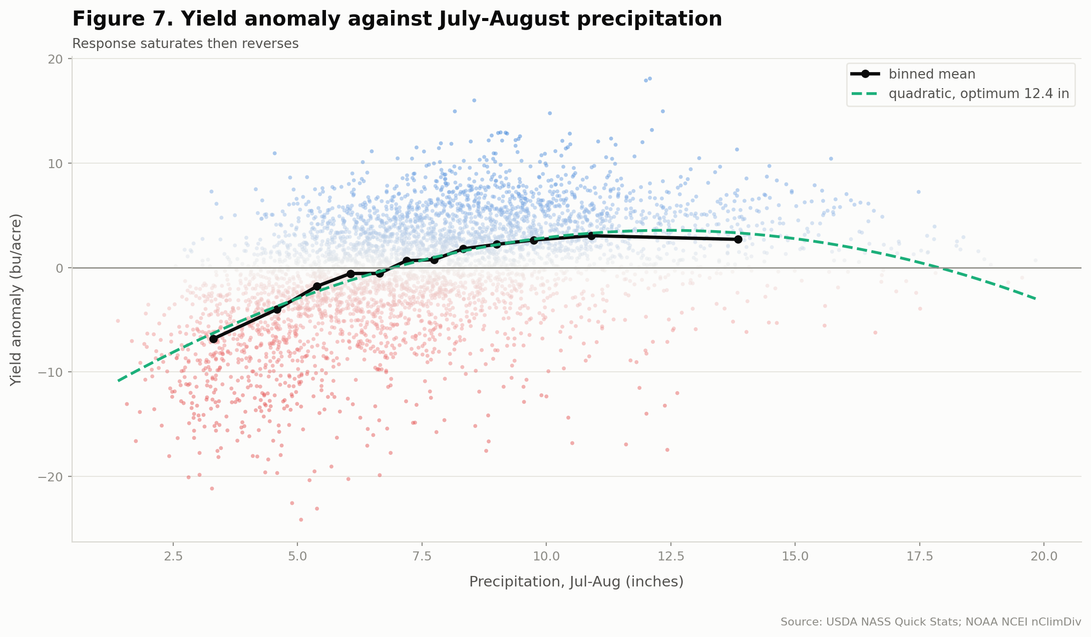
Repository figure 7. Yield anomaly against July–August precipitation, 4,459 county-years. The binned mean shows the response saturating near 16 inches and reversing beyond it.

3.4 Vulnerability concentrates where the buffer is thinnest
County sensitivity to August moisture varies more than sevenfold, from 0.47 bu/acre per standard deviation in Mercer County to 3.60 in Clay County. The pattern tracks soil water-holding capacity rather than rainfall.
Cross-sectional relationship | r
Mean August max temperature vs moisture sensitivity | +0.606
Recent yield level vs moisture sensitivity | −0.512

Advantage compounds. Higher-yielding counties are also less climate-exposed: the best ground both yields more and varies less. A single pooled climate coefficient averages a county where August moisture explains 48% of the variance with one where it explains 3%.

4 Simulated warming and drying
These are sensitivity experiments, not climate projections. They apply uniform shifts to observed climate, use no CMIP6 or IPCC pattern, carry no probability information, and assume no agronomic adaptation, cultivar change, or planting-date shift.
Scenario | Δ bu/acre | Δ % | Counties down
+1 °C | −0.31 | −0.68 | 89 / 91
−10% precipitation | −0.27 | −0.59 | 88 / 91
+1 °C and −10% | −0.73 | −1.62 | 91 / 91
+2 °C | −0.64 | −1.42 | 91 / 91
+2 °C and −20% | −2.03 | −4.48 | 91 / 91

The combination exceeds the sum of its parts: +1 °C costs 0.31 and −10% precipitation costs 0.27, summing to 0.58, but together they cost 0.73. That excess is the interaction from section 3.1 expressing itself again.
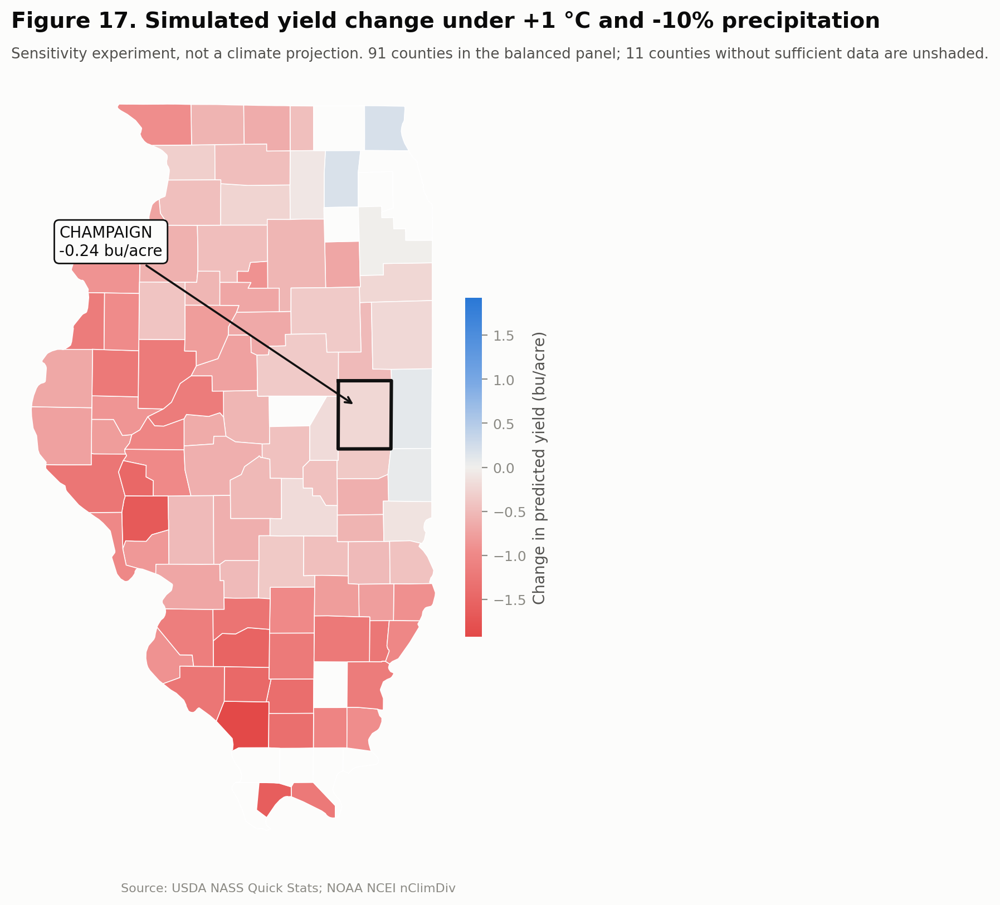
Repository figure 17. Simulated yield change under +1 °C and −10% precipitation. Losses concentrate in the southwest, where baseline yields are already the lowest in the state. The few counties showing small positive responses sit in the cool northeast, below the estimated temperature optimum.

5 Does climate actually predict?
Validation is strictly temporal. No random splits are used anywhere. They fail twice over here: they admit future information, and because counties within a year share weather, they place near-duplicates of test rows into training. Two regimes were run: a fixed 1980–2013 / 2014–2018 / 2019–2025 split, and an expanding-window rolling origin over 2001–2025 with 2,317 test observations.
The comparison that matters is not algorithm versus algorithm. It is a trend-only baseline against models that see climate.
Model | RMSE | MAE | R² | Skill vs baseline
Gradient Boosting | 4.844 | 3.680 | 0.284 | +15.7%
HistGBM | 4.870 | 3.706 | 0.276 | +15.3%
Random Forest | 4.895 | 3.723 | 0.269 | +14.8%
Linear Regression | 5.090 | 3.892 | 0.209 | +11.5%
Ridge | 5.095 | 3.896 | 0.208 | +11.4%
Baseline: trend only | 5.748 | 4.424 | −0.008 | 0.0

Climate wins by 15.7%, which establishes that it carries real predictive content. But gradient boosting beats ridge regression by only 4.9%. Most of the available signal is linear once the quadratic and the interaction are specified. That is the honest headline, stated before a reviewer asks.
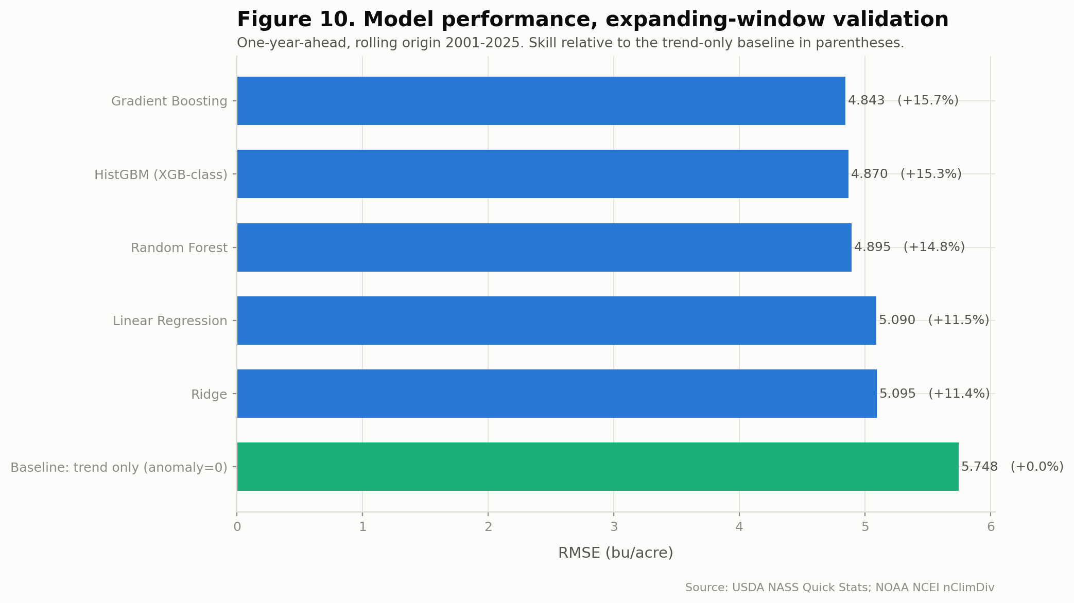
Repository figure 10. Model performance under expanding-window validation, one year ahead, 2001–2025. Skill relative to the trend-only baseline in parentheses.

6 The 2003 anomaly, and a hypothesis that fails its test
One year resists climate explanation entirely. Decomposing model predictions by year, 1988 is explained to 88% and 2012 to 41%, but 2003 to only 15%. At a mean residual of −3.43 bu/acre it is the largest unexplained shortfall in the record, rank 1 of 46 years. Statewide August PDSI was slightly positive and precipitation near normal, yet yield fell 8.5 bu/acre below trend. 2003 contributed 14 of the 39 observations exceeding three standard deviations in the entire panel.

6.1 The candidate explanation
2003 is a documented severe soybean aphid outbreak year in the North Central region, with populations exceeding 1,000 per plant and 40% yield loss recorded at those densities (Ragsdale et al., Journal of Integrated Pest Management, 2012). The soybean aphid overwinters as eggs on common buckthorn, Rhamnus cathartica, which is concentrated north of 41 degrees latitude at densities above 10,000 per acre (Tilmon et al., Journal of Integrated Pest Management, 2011).
Illinois spans 37.2 to 42.5 degrees. It straddles that line, which makes the hypothesis falsifiable against this panel.

6.2 It does not survive
Test | Result | Interpretation
Raw 2003 anomaly vs county latitude | r = −0.775 | Northern, as predicted
Model residual vs latitude, 2003 | r = −0.124 | The gradient is climate
Rank of 2003 by |r(lat, residual)| | 33 of 46 | Unremarkable
North (≥41°N) minus South residual gap | +1.72 | Wrong sign; north did better
Same raw gradient in 1988, pre-aphid | r = −0.655 | Not diagnostic
Aphid-era shift, pre vs post 2000 | t = 0.205, p = 0.84 | No effect

The northern concentration in 2003 is real, but it is fully accounted for by climate: northwestern Illinois recorded a genuine August moisture deficit that year, district mean Palmer Z-index of −2.60. What remains unexplained after the climate model is spatially uniform, which is the opposite of the signature a northern-origin pest would leave.
The three documented outbreak years do not agree with one another either. 2005 shows a northern residual skew of −1.77, in the predicted direction; 2001 shows −0.82; 2003 shows the wrong sign entirely. None ranks among the five most northern-skewed years on record, which are 1996, 2000, 2002, 2007 and 1982.

6.3 What this leaves
2003 is the largest unexplained shortfall in 46 years, and the most plausible candidate explanation does not match its geography. The cause remains open. A definitive test would require county-level aphid scouting records or insecticide application data from the 2003 season, neither of which is in this dataset.
This is also a caution about the class of explanation. A documented event that coincides in time, and appears to match in space, can still fail once the climate signal is removed from that same geography. The raw spatial pattern looked like confirmation. It was not.

7 Limitations

Monthly resolution cannot resolve frost or daily extremes
The coldest monthly mean minimum temperature in the entire record is 32.3 °F in October and 46.4 °F in September. A monthly average never reaches a killing frost even in years when frost occurred. April minimum temperature correlates 0.005 with the yield anomaly, which is an instrument limitation, not evidence that frost does not matter. Degree days above a threshold, dry-spell length, rainfall intensity and vapour pressure deficit are all unavailable. This is the largest methodological gap; gridMET 4 km daily is the upgrade path.

County coverage collapses after 2018
From 102 counties reporting in 2000 to 62 in 2025, with the share of state harvested acreage carrying county attribution falling from 100% to 61%. Survival is not random, so the recent panel is selected toward large producers precisely where out-of-sample validation occurs.

Planting date is missing
2019 shows why. It is the one year where adding climate makes predictions worse, because the rain arrived in spring and delayed planting in a way seasonal aggregates cannot see. NASS Crop Progress would supply this at state level from the same source.

No causal identification
There is no experiment, instrument or discontinuity. County and year fixed effects absorb time-invariant county characteristics and statewide annual shocks, but not county-specific time-varying confounders: drainage tile installation, cultivar turnover, pest and disease pressure, or local land-use change.
The correct statement of the result is therefore: higher July–August temperatures and lower July–August moisture were statistically associated with lower soybean yield after controlling for county and year fixed effects, robustly across thirteen specifications. Not: temperature caused yield to decline.

8 Champaign County
Metric | Champaign | State panel
Mean yield, 2015–2025 (bu/acre) | 64.3 | 58.7
Technology trend (bu/acre/yr) | 0.660 | 0.627
Moisture sensitivity (bu/acre per SD) | 1.740 | 0.47 – 3.60
Sensitivity rank | 53 / 91 | —
Simulated Δ under +1 °C, −10% | −0.24 | −0.73

Champaign is a high-yielding, near-median-sensitivity county that is less exposed than the state average under every perturbation experiment. It has 44 observations, 1980 to 2023; it was suppressed out of the 2024 and 2025 county data under the coverage collapse described in section 7.
Its worst recorded year is 2003 at 13.99 bu/acre below trend, followed by 1988 at 12.25 and 2012 at 11.34. The worst of the three is the one the climate model cannot explain.

9 Conclusions

Is climate variability associated with soybean yield?
Yes, robustly. The two-way fixed-effects model explains 66.8% of detrended yield variance, and the temperature effect is negative and significant at 5% in all thirteen robustness specifications, with a magnitude stable near −0.6 bu/acre per °F.

Which variables matter most?
July–August moisture, best measured by the Palmer Z-index (r = 0.490) rather than raw precipitation (0.464) or PDSI (0.349), followed by August maximum temperature (−0.469). Timing dominates magnitude: June precipitation correlates 0.08 and September 0.02, while August correlates 0.34.

Are relationships nonlinear?
Yes, decisively. Adding quadratic terms and an interaction raises R² from 0.254 to 0.361, the largest single specification gain. Precipitation has an interior optimum near 12.5 inches with the response reversing beyond it, and the drought penalty is roughly three times the wet-year bonus. The temperature effect is conditional on moisture.

Which counties are most vulnerable?
Sensitivity varies more than sevenfold, from 0.47 bu/acre per SD in Mercer County to 3.60 in Clay County, concentrating in the southern and southeastern districts. It correlates negatively with baseline yield (−0.512), so exposure is highest where the buffer is thinnest. Champaign sits at the 42nd percentile.

Does climate improve prediction?
Yes, by 15.7% in RMSE over a trend-only baseline under expanding-window validation. But the increment from algorithm sophistication is small: gradient boosting beats ridge regression by only 4.9%, so most of the signal is linear once the correct nonlinear terms are specified.

Are results robust?
Yes. The sign and significance of the temperature effect survive all thirteen checks, including dropping the balance rule, trimming extreme years, splitting by period, changing the target to logs, levels and growth rates, and substituting alternative climate indicators. Removing 1988, 2003 and 2012 halves the magnitude, which confirms that extreme years carry a disproportionate share of a nonlinear damage function.

What do the scenarios imply?
Under +1 °C with a 10% precipitation reduction, mean simulated yield falls 0.73 bu/acre (1.6%) and all 91 panel counties decline. Under +2 °C with a 20% reduction the loss is 2.03 bu/acre (4.5%). The combination consistently exceeds the sum of the separate perturbations. These are sensitivity experiments and carry no information about the likelihood of any future climate state.

Direct answer to the central question
Between 1980 and 2025, Illinois soybean yield was strongly and negatively associated with July–August heat and moisture deficit, once the county-specific technology trend of roughly 0.65 bu/acre per year was removed. Moisture matters more than heat, and heat matters mainly by amplifying moisture stress. The relationship is nonlinear with an interior precipitation optimum, and it is highly heterogeneous across counties, with sensitivity varying more than sevenfold and concentrating where baseline productivity is lowest. Climate information carries genuine out-of-sample predictive value, improving on a trend-only baseline by roughly 16%. Simulated warming and drying reduce yield in essentially every county, with combined perturbations doing more damage than their separate effects would suggest. All of this is association under a fixed-effects design, not causal identification, and the perturbation experiments are sensitivity analyses rather than climate projections.

References
Ragsdale, D. W., McCornack, B. P., Venette, R. C., et al. (2012). Management recommendations for soybean aphid (Hemiptera: Aphididae) in the United States. Journal of Integrated Pest Management, 3(1), E1.
Tilmon, K. J., Hodgson, E. W., O’Neal, M. E., & Ragsdale, D. W. (2011). Biology of the soybean aphid, Aphis glycines (Hemiptera: Aphididae) in the United States. Journal of Integrated Pest Management, 2(2), A1.
USDA National Agricultural Statistics Service. Quick Stats database. Accessed 31 August 2026.
NOAA National Centers for Environmental Information. nClimDiv county-level monthly climate data, version 1.0.0, released 6 August 2026.

