**Online Student Performance Monitoring System**

**for Tunasan Elementary School**

**Blanca, Jose Israel S.**

Adamson University

222 Capt.E Bocalan st. Amaya Tanza, Cavite

09057910956

jiyayblanca@gmail.com

**Arandia, Darryl E.**

Adamson University

299 Arandia st. Tunasan Muntinlupa City

09264998212

darrylearandia@gmail.com

**Dacanay, Rizza R.**

Adamson University

B5 L22 Amethyst st. Adelina I-A. San Pedro, Laguna

09985463317

rizzadacanay621@yahoo.com

**Narag, Richelle Crizha P.**

Adamson University

F2 12 Fairfax California Garden Square, Libertad st., corner Calbayog st., Mandaluyong City

09077660575

richellecrizhanarag@yahoo.com

**ABSTRACT**

Whenever active parents are interested to know the status of their child’s performance, they’ll meet the teacher and ask for the learning progress. The teachers only present their assessment of student learning through grades and marks as the primary basis of pupil’s strength and weaknesses. The existing grading system in public elementary schools only rates student performance base on summative test, recitation, homework, project, experiments, output and major examinations periodically without specifying the learning area. This clearly shows that the existing system does not fully emphasize or articulate the importance of assessment and the categorical level of assessment about knowledge, process/skills, understanding(s), and product/performance. Thus a performance-based system is a better means to guide pupils in their learning competencies, communicate the progress to parents, and aid teachers to improve their teaching.

In order to aid teachers in assessing pupils holistically and make learners have their self-assessment of personal learning, the researchers come up with the idea of creating an online student performance monitoring system, a system that will support the purpose of assessment and implementation of K to 12 performance-based basic education program curriculum, which shall be used as a quality assistant tool for the employment of a balanced, holistic, standards-based assessment and rating system that tracks the student’s performance in

the attainment of standards, promote self-reflection and personal accountability for one’s learning, and provide a basis for the profiling of student performance that is accessible to the faculty of the school, pupils and parents.

The system will be developed through HTML, CSS, JavaScript, JQuery, and frameworks for front end and open source such as Php and MySQL for backend. The system is a web application to provide an extended access for the users. The user can log on as a student, a teacher, a parent or an admin.

1. **Introduction**

*1.1 Project Context*

As technology has advanced, the concept and the integration of a student performance-based monitoring system will help teachers and learners arrive at evaluation of pupil learning based on assessment result through a technological approach. It will facilitate a more effective way of collecting and documenting information on individual student learning and evaluation. Its features and functionalities will boost the interest of the students in their own progress. It will be an excellent tool that will make students develop their personal responsibility for learning as it lets them be aware of the goals and the criteria of their performance by actively reflecting their progress while they’re still young. In addition, it will let students be introduced to the educational purpose of technology at their young age.

As for teachers, its functionalities will certainly improve add new flavors to their teaching. A system generated assessment will complement their traditional tools and techniques of assessing their students. Assessment process involves the use of a wide array of traditional and authentic assessment of learning tools for a more valid, reliable and realistic assessment of learning. This empowers teachers to use such innovation since traditional and technological approach on assessment should be balanced and are not mutually exclusive. So the integration of the above system endorses the objectives of the K-12 basic education curriculum.

Parents are also responsible of assessing their children to give moral and psychological support to their children. It should be their duty to sustain and affirm the learning acquired by students because learning doesn’t stop at school. Parents need be aware of their child’s academic performance to guide them and ensure that they are performing well. Parents, guidance and teachers have the individual responsibilities in molding the student into a better person. They must be involved in the monitoring the student performance so that the student will also be motivated and they will also contribute in the student’s achievements. Parents, guardian and teachers should work together for the student to be successful in school and in the future.

*1.2 Purpose and Description*

The Online Student Performance Monitoring System for Tunasan Elementary School, is an online electronic assessment and rating generator for a public elementary school designed to cater an advanced and additional approach of assessing student performance and be used by faculties to render evaluation of assessment results.

The main purposes of Online Student Performance Monitoring for Tunasan Elementary School are:

* For teachers, to help them provide a more reliable and realistic method of assessment presented in graphs and charts generated by the system after they encode the offline learning outcome of their students, and also encourage them to support and elevate the performance of student by creating follow up online exercises like homework that will also be assessed. This perfectly suit the goal of performance-based curriculum of K to 12 basic education program and complement the offline and inside-classrooms activities.
* For students, to give them an electronic profile that allows them to monitor their progress and receive feedbacks presented on animated graphs that will spring up their personal responsibility of learning after taking online exercises.
* For the parents, to supply them an online information of their child’s academic interpreted through graphs to understand the need, the type and the nature of their learner aside from consulting teachers.

*1.3 Objectives*

General

* To develop Online Student Performance Monitoring System for Tunasan Elementary School that will support K to 12 Basic Education Program Curriculum

Specific

* To produce a system that will aid teachers in giving feedbacks about student performance.
* To be able to assist the assessment of the 4 levels of assessment categorized by the K to 12 Curriculum with matching percent weight: knowledge (15%), process or skills (25%), understanding(s) (30%), and products/performance (30%), by using the system.
* To be able to show the assessment data through charts and graphs so viewers can easily read and analyze the information and at the same time protecting the sacredness of grades.
* To be able to support the usability of the K to 12 curriculum with a desirable outcome.

*1.4 Scope and Limitation*

Scope

The online student performance monitoring system is intended for Grade 3 section 1 students at Tunasan Elementary School as subject for implementation. Since it is a web application, users must have internet access to be able to use it.

For the Teachers:

* The teachers can encode offline assessment and student average weekly on knowledge, process/skills, understanding, and performance/products to be interpreted by the system using graphs with an equivalent proficiency legend and be monitored by students and parents
* The teachers can construct a follow up assessment tools that can be used as online exercises with the aid of the system based on the 4 levels of assessment:
  + For knowledge
    - Selected-response item like Multiple Choice Test, True or False, and Matching Type
    - Constructed response type like Fill-in-the-blanks
  + For process or skills
    - Organizing, analyzing, interpreting, translating, converting, or expressing information in another format
  + For understanding(s)
    - Explain/justify something based on facts/data, phenomena or evidence
    - Make connections of what was learned within and across learning areas
  + For Products/Performance
    - Observation
  + Other possible online exercises
* The teachers can use the online student attendance monitoring daily or weekly depending on the teachers’ preference. The parents can view the attendance of their learner online. It is an advantage for teachers if they assure parents that their child present in class, and attendance does also affect student performance.
* Occasionally, teachers can use the online guidance notebook to give feedback to students especially to parents about the student performance, behavior, attitudes and others.
* The teachers can edit their profile.
* The teachers can change their password after accessing the initial password given by the admin to secure the encoding of grades of the students in online system.
* The teachers can print their assessment results like ratings and graphs and records about subjects and grades of the students handled.

For the Students:

* The students can perform online exercises in the site and view their charted offline and online monitored performance by entering their account name or student number and password.
* The students can edit their password.

For the Parents:

* The parents will be given a parent account and password to also view their child’s learning progress in graphs and charts online by entering the account number or account name of their child. Once the system detected that the performance is already below the passing line which is 75, it will make an alert to parents that they need to report to teachers.

For the Administrator:

* The administrator has the authority to manage any information with the consent of the teacher.
* The administrator can filter the information of the teachers, students and subjects.
* The administrator can print the summary of performance and remarks of the students, and the records of the teacher.
* The administrator gives an initial password to the users.

Limitation

* The system will be implemented only in Grade 3 section 1 to limit the variable of the experiment, and also they are the most capable of rendering response compared to Grades 1 and 2. The implementation of the new curriculum is only up to Grade 3 only
* The online system cannot be used for conversation since the main purpose of the online website is for viewing of ratings and student performance.
* The functionality of the system relies on an internet connection.
* Students and Parents will not see grades in weekly post of performance but only graphed learning outcomes, rating and proficiency letters. Only teachers can see it as they encode. This is to protect the sacredness of grades
* Supposedly, the system can be used by teachers in laboratory activities weekly so the system can provide an automated assessment right after students take their online activities like quizzes and exercises of students. Unfortunately, our client suggested that the system should provide first online exercises for students to be done in their homes intended for practice and review purposes while at the same time still contributing to the enhancement of student performance
* Online exercises that will be constructed by teachers to give students practice at home will not affect the student’s performance in school but it is intended to sharpen their learning areas of knowledge, process/skills, understanding, and performance/products. The system will automatically monitor through graphs for analysis purposes

**Chapter 2: Review of Related Literature**

***2.1 Local Literature***

According to Prof. Prof. Gerry B. de Cadiz on his paper "Student achievement: a gauge for attaining quality education" Superior student achievement could be accomplished only if there is a genuine government policy of improving the educational system. Each learner must be provided with opportunities to develop holistically in basic skills like conceptual comprehension, technological skills, critical analysis and investigations, and communications and personal or social relations in his/her respective field of discipline. To gauge the value of a process of learning, assessment techniques must be validated and standardized using such criteria as reliability, validity, uniformity and contextually of procedures. Evaluations, technology-enabled and universally-designed, must be intended to acquire higher-order skills, impart more precise opportunities for student progress, and monitor classroom instruction so as to respond to academic needs and social demands. Regarding the sub-standard performance of students during assessment as a basis, the government should commit to raise financial support to the educational sector as well as creating opportunities for greater number of the population to avail of quality education. Therefore, student achievement could be used to appraise organizational and academic functions of educational institutions that will determine the attainment of quality education. [1]

Shifting Philippine basic education to a 12-year cycle highlighted the 10-point education reform agenda that candidate Benigno Aquino III. The full migration to a K to 12 cycle is by no means abrupt. It has four distinct implementation phases. Last year, Phase I began when the DepEd announced that kindergarten will become free and compulsory for 5-year-olds. Secretary Armin Luistro signaled the start of Phase II by announcing that by school year 2012-2013, all public schools will began using the new K to 12 curriculum… [2]

Assessment shall be used primarily as a quality assurance tool to track students’ progress in the attainment of standards, promote self-reflection and personal accountability for one’s learning, and provide a basis for the profiling of student performance. It should be holistic with emphasis on the purpose of quality, assuring students’ learning. The four (4) levels of assessment are: Knowledge (15%) is defined as the substantive content of the curriculum, the facts and information that students acquires. Process (25%) are the kills or cognitive operations that the student performs on facts and information for the purpose of constructing meanings or understandings. Understanding (30%) is enduring big ideas, principles and generalizations inherent to the discipline, which may be assessed using the facets of understanding or other indicators of understanding which may be specific. Product/Performance (30%) are the real-life application of understanding as evidenced by the students’ performance of authentic tasks. Use of feedbacks are the results of the assessment across levels should be fed back immediately to students, consistent with the principle of assessment as learning. Students need to learn from the results of the assessment so they know what to improve further, and then they can plan strategically how they can address any learning deficiency. There are (3) three levels of proficiency: Beginning were the student at this level struggles with his/her understanding: prerequisite and fundamental knowledge and/or skills have not been acquired or developed adequately to aid understanding. Developing were the student at this level possesses the minimum knowledge and skills and core understandings, but needs help throughout the performance of authentic tasks. Approaching Proficiency, at this level learners has developed the fundamental knowledge and skills and core understandings and, with little guidance from the teacher and/or with some assistance from peers, can transfer these understandings through authentic performance tasks. Proficient, at this level learners has developed the fundamental knowledge and skills and core understandings and can transfer them independently through authentic performance tasks. Advanced, at this level learners exceeds the core requirements in terms of knowledge, skills and understandings, and can transfer them automatically and flexibly through authentic performance tasks. These are the grade basis: Beginning - B (74% & below), Developing - D (75-79%), Approaching Proficiency - AP (80-84%), Proficient - P (85-89%) and Advanced - A (90 & above). Promotion and Retention of students shall be by subject. Students whose proficiency level is (B) at the end of the quarter or grading period shall be required to undergo remediation after class hours so that they can immediately catch up as they move to the next grading period. If by the end of the school year, the students are still at the beginning level, then they shall be required to take summer classes. [3]

***2.2 Local Study***

Computer has become a key factor in research and analysis by students and faculty. Educators realize that computer literacy is an important part of student’s education. This study seeks to determine the profile of the teachers and their perception of the respondents in using computers as a teaching strategy; and to test the significant relationship between the respondents’ perception in using computer as a teaching strategy and their profile. The length of years in service has nothing to do with the perception in using computers as a teaching strategy. The educational attainment is not related to the perception in using computers as a teaching strategy. Moreover, the learners’ style has nothing to do with the respondents’ academic performance. It only shows that even the ways of learning of the students do not affects their academic performance. The teacher and the learners’ relationship do not affect the respondents’ academic performance. So, whatever relationship might the students have with their teachers, it will not still affect their academic performance. [4]

Teaching to be effective requires a lot of time, talent and effort who wants to pursue this inspiring and very fulfilling task. Effective teaching is only possible if teachers would consider the understanding of the complexity of classroom teaching and learn to develop strategies that will enable them to continually evaluate and improve the teaching and learning effectiveness. The respondents’ agree that teachers’ strategy in teaching is one of the factors that affects their academic performance. The respondents agree that learners’ style is one of the factors that affects their academic performance. The respondents agree that teachers and learners relationship is one of the factors that affects their academic performance. The respondents agree that the classroom condition is one of the factors that affects their academic performance. The teachers’ strategy is not significant with the respondents’ academic performance. That is why, even the teachers’ use different strategy will not affect the academic performance of the students. [5]

Grading System is an exercise in professional judgment on the part of the teachers. It involves the collection and evaluation of evidence on students’ achievement or performance over a specified period of time. Through this process various types of descriptive information and measures of students’ performance are converted into grades that summarize students’ accomplishments. Online Grading System is a web-based application that can be used to create report cards, class grade list and roll sheet attendance report. It post the grades of the students online. The student has an account to access their report card. Parents can view and be updated on the performance of their children. While teachers work load can be lessen through computing the grades automatically. [6]

Parent-Teacher is something that most of us engage in during our everyday lives, but at the same time hard to describe, and clearly complex and often subtle in its affects. This relationship is essential to the success of the children,; however it requires the person-to-person or person to group contribution. The partnership between the school and the parents would somehow lead to a better understanding of the program that our school initiate. The study is descriptive type of research used to find out the relationship of the Parents-Teachers relationship and the Academic Performance of the pre-school children school year 2008-2009. [7]

The respondents show that even at a young age they were experiencing difficulties in life in terms of social problems, family problems and health problem that maybe the cause of their absenteeism. [8]

***2.3 Foreign Literature***

According to the article made by Nancy Safer and Steve Fleischman, to implement student progress monitoring, the teacher determines a student's current performance level on skills that the student will be learning that school year, identifies achievement goals that the student needs to reach by the end of the year, and establishes the rate of progress the student must make to meet those goals. The teacher then measures the student's academic progress regularly (weekly, biweekly, or monthly) using probes—brief, easily administered measures. Student progress monitoring is a practice that helps teachers use student performance data to continually evaluate the effectiveness of their teaching and make more informed instructional decisions. [9]

According to the article written by Stephen Noonoo dated September 9, 2014, Naiku is adding adaptive learning resources to its cloud-based classroom assessment platform, which teachers can set to send students different resources based on their individual learning. The software is commonly used to measure and track students’ proficiency of standards in any subject area through a variety of meta-cognitive tools, such as justification/journaling and reflection to help teachers gauge understanding and progress. A key part of the upgrade is the ability for teachers to share and remix items from their assessments with each other, as well as create new assessments from the company’s test question bank or via a test generator. Teachers can also have instructional resources sent to each student -- these resources may vary based on students’ individual proficiency, as determined by the software and other factors specified by the teacher. [10]

An article told by Sue Shellenbarger, most educators like the systems if they work smoothly and help students learn, according to teachers and teacher-union representatives. Brian Lewis, chief executive of the International Society for Technology in Education, a Eugene, Ore., professional group, says the systems can "foster a strong home-school connection and allow busy parents to be involved"—and let them step in early if a child is struggling. Bill Erneste, a math teacher for 20 years, says one of the biggest advantages these systems have over paper grade books "is that parents and teachers are communicating without even a phone call." [11]

According to the August 8, 2014 article of Michelle Odgers, many students develop great anticipation for their scores; receiving said scores can take anywhere from a couple of days to a few weeks. Work such as Q&A assignments can be passed out and returned via email. Projects can be sent through attachments of PowerPoints or movie-media programs. Rubrics for oral or performance presentations can be filled out or scanned onto the computer. [12]

According to the article written by Sonali Kohli on August 26, 2014, much of the discussion around affirmative action—the practice of giving preference to underrepresented racial groups in college admissions—centers around the effect the policy has on universities and students after admission. Now a working study from the US National Bureau of Economic Research suggests kids at a disadvantage might achieve better results at a young age if they know there’s a greater chance of a reward for their group. [13]

***2.4 Foreign Study***

The analysis encompassed a broad view of K-12 interactive distance education by focusing on the range of subject areas, grade levels, and applications of distance education in use today. The study design permitted review of a wide sample of research done on academic achievement of students learning with distance education. Consequently, distance education can be expected to result in achievement at least comparable to traditional instruction in most academic circumstances. Educators planning implementations of distance education programs should expect no difference in academic performance as a result of the use of distance education. Distance education programs can be used to complement, enhance, and expand education options for students, at least at intermediate, middle, and upper grades levels. [14]

The researchers offered money to 992 fifth- through eighth-grade students in Utah, depending on their performance in a national math exam. They first split the Utah students into groups—in one, fifth and sixth graders competed against each other, and seventh and eighth graders did as well. The kids who did the best were rewarded with money, regardless of how much math education they’d had. In the second group, the researchers took the educational level into account—all the students took the same test, but were only measured against others in their own grade. Thus, the researchers mimicked the affirmative action system—the kids with the advantage were the sixth and eighth grade students, who had more math education, while the fifth and seventh graders were the students who would benefit from a quota or affirmative action. All the students were given access to a study website, and researchers observed the amount of time that each group spent. Some of the results: -The students in the quota group were 75% more likely to visit the website than the ones in the “color-blind” group, and they spent more time on it, looking at different subjects and trying more questions. -The quota students logged 57% more time on the site and attempted 70% more questions. -The fifth and seventh graders in the quota group also raised their scores by an average of 0.624 points on the test compared to the previous year. (The score is the number of correct answers out of 25). One of the arguments against affirmative action is that increasing incentives for one demographic group might decrease performance for another group. But in the quota group, the fifth and seventh grade students narrowed the median achievement gap to almost zero, without significantly affecting the study habits performance of the sixth and eighth graders. These students did not represent the actual cultural diversity of the US, and a cash prize is a much more immediate incentive for a kid than the possibility of going to college some time in the distant future. But what the study does demonstrate is that to understand the full effects of affirmative action, it’s a good idea to start with improvement that could come before college. [14]

After statistical analysis of data, the researchers concluded that parental socio-economic status; parent’s educational level, parental occupational level; and parental income level affect the academic achievement of secondary school students. Parental socioeconomic status is a vital factor that effect academic achievement of students significantly. It was also come to surface that academic achievement of a student is directly proportional to the parental income, education and occupation. That is why it is right to say that high socioeconomic status of the parents plays a fundamental and crucial role in the enhancement of their children’s academic achievement. [15]

Based on the data analyzed for this research, it was concluded there was a significant correlation between academic performance and socioeconomic status among the two hundred fifty, randomly chosen Missouri school districts in communication arts and math. The higher the percent of students on free and reduced lunch, the lower the percent of students that would score proficient or above proficient on the communication arts and math portions of the MAP test. [16]

This paper examines which student-related factors seem to have a bearing on performance and progress. Five explanatory factors were found to have a bearing on performance and progress: ability, motivation, time spent on studies, time spent on paid work and social background. Some of these factors are interdependent. And we know that motivation might be negatively influenced if a student gets negative feedback in the form of low grades and slow progress. Our findings partly support findings in other studies. Like Goodman et al. (2011) we find that motivation influences performance. ” [17]

A welcoming and supporting environment, coupled with an engaging programme, are all key ingredients for improving retention rates, particularly for students from non-traditional backgrounds. One of the keys, therefore, to retention and success is effective monitoring of student academic performance, to for early identification of changes which may require action. Such timely intervention will not only help improve retention during the year, but can also assist students in fulfilling their potential, thus obtaining better exam results, and avoiding failure. [18]

***2.5 References***

[1] Gerry B. de Cadiz, Faculty of Management and Education. Eastern Visayas State University, Tacloban City 06500 – PHILIPPINES "Student achievement: a gauge for attaining quality education"

[2] Philippine Daily Inquirer, December 17, 2011, P. A15 “K to 12 will define our youth”

[3] “Kto12” Dep. Ed. Order No. 73, s. 2012 Grade 8, Curriculum Guide

[4] Candelario, Lalo, Mallesi, Sitjar, Vicente, Villa “The perception in using computers as a teaching strategy as assessed by the teachers of Pedro T. Mendiola Sr. Memorial National High School”

[5] Balubay, Caleze, Oril, Sarabia, Tingco “Factors affecting the academic performance of TED Freshmen students of Occidental Mindoro State College”

[6] Online Grading System <http://www.oppapers.com/essays/Online-Grading-System/745794>

[7] Colopano, Pineda, Pelaez. October 2009 “Effectiveness of Parents-Teacher relationship and the Academic Performance of Pre-Scgool pupils at Torrijos district”

[8] Rufino, de Tumol - COED Research Journal 2009 “Perceived causes and effects of Absenteeism to the Academic Achievement of pupils in San Roque Elementary School, Gapan City, SY 2009-2010”

[9] Research Matters / How Student Progress Monitoring Improves Instruction

<http://www.ascd.org/publications/educational-leadership/feb05/vol62/num05/How-Student->Progress-Monitoring-Improves-Instruction.aspx

[10] Stephen Noonoo 09/09/14 “Naiku's New Personalized Learning Features Adapt to Student Performance” http://thejournal.com/articles/2014/09/09/naikus-new-personalized-learning-features-adapt-to-student-performance.aspx

[11] Online School Grades

<http://online.wsj.com/news/articles/SB10000872396390443982904578046521163123246>

[12] “Professors strive to keep student grade turnover up to date”

http://thedailycougar.com/2014/08/08/professors-strive-keep-student-grade-turnover-date/

[13] “Affirmative action could help students before they get to college.” By Sonali Kohli August 26, 2014 <http://qz.com/255864/affirmative-action-incentives-can-improve-student-performance-long-before-college/>

[14] Cavanaugh. University of North Florida “The Effectiveness of Interactive Distance Education Technologies in K-12 Learning: A Meta-Analysis”

[15] Qaiser Suleman et. Al., International Journal of Human Resource Studies, 2012, Vol. 2, No. 4 “Effects of Parental Socioeconomic Status on the Academic Achievement of Secondary School Students in Karak District, Pakistan”

[16] "Effects of Socioeconomic Status on Academic Performance in Missouri Public Schools" by Brent M. Blevins. May, 2009

[17] "Student Level Factors Influencing Performance and Study Progress" by Liv Susanne Bugge et. al., The Online Journal of New Horizons in Education Volume 3, Issue 2

[17] “Statistical monitoring of student performance – an early warning system”

<http://journals.heacademy.ac.uk/doi/pdf/10.11120/stem.hea.2012.061>

**CHAPTER 3 METHODOLOGY, RESULTS AND DISCUSSION**

In this chapter the researcher documented how the idea of the system was conceptualized, designed and implemented.

**Requirements Analysis**

The researchers interviewed 2 master teachers of Tunasan Elementary School, a public elementary school, to get necessary information and feedbacks about their proposed system. The researchers discovered that school had already implemented K to 12 performance-based curriculum up to Grade 3 level. After thorough analysis and with the help of 2 teachers and their suggestions, the researchers found out that their topic Online Student Performance Monitoring System can give much impact and is a better complement to the K to 12 curriculum than the previous curriculum since it is really intended to assess and feedback the performance of students and employ a performance-based rating system. The researchers addressed a possible complement system that will post students’ performance assessment to be monitored by students and parents.

The proposed system, a Web Application, provides a visual presentation of student assessment based on 4 levels of assessment (knowledge (15%), process or skills (25%), understanding(s) (30%), and products/performance (30%) weekly.

The system comprised 5 main interfaces with one database. The main interfaces are: a.) *student performance assessment module* for viewing student performance analysis. b.) *online exercises modul*e where teachers construct online exercises for students to be practice at home and monitored. This will not affect student grades at school. c.) *online attendance sheet module* for keeping student attendance record since it is part of student performance. d.) *the teachers’ guidance notebook* *module* where teachers can give narrative report and feedbacks to students and parents. e.) *the teachers’ encoding module* where teachers can encode student ratings.

The system will have students, teachers, parents and admin their personal accounts.

The system lets students login and view their graphed student performance. Teachers can login and encode students’ average grade per level of assessment and then system converts it to graphs. Parents can view their child’s performance online at their own account. The admin has the administrator permissions. The system can perform printing of necessary reports.

*3.1.1 Flowchart of Existing System*

(See Figure 3.1.1 Flowchart of Existing System)

*3.1.2 Flowchart of Proposed System*

(See figure 3.1.2 Flowchart of Proposed System)

*3.1.3 Data Flow Diagram of the Existing System*

(See Figure 3.1.3 DFD of Existing System)

*3.1.4 Data Flow Diagram of the Proposed System*

(See Figure 3.1.4 DFD of Proposed System)

**Requirements Documentation**

*3.2.1 Methods of Research*

The descriptive method of research was used to discover what Tunasan Elementary School teachers are doing to monitor and feedback students’ performance, and to document the challenges of those practices. Mina Roguel (2005) explained that the principal aim in employing this method is to describe the nature of a situation as it exists at the time of study and to explore the causes off particular phenomena. It is the most direct choice to begin to understand how student’s performance is computed by teachers in Tunasan Elementary School and to further develop concepts interrelated with computing and monitoring student’s performance.

*3.2.2 Research Instruments*

The researchers used different methods to acquire more information about the system. The researchers used internet, libraries, observation, interview and questionnaires.

*3.2.2.1 Internet Research*

The researchers used internet to get some sources and the information related to the study. Internet research is the easiest way of collecting information for the researchers.

*3.2.2.2 Library Research*

The researchers visited libraries like National Library of the Philippines to gather some references and citations from different books and authors that are necessary for the study.

*3.2.2.3 Observation*

Observation is used by the researchers to gather more details for the study which are seeable. Additional aspects of the educational system are noticed and considered by the researchers. The best-printed materials from those gathered information was collected to help researchers develop the website

*3.2.2.4 Interview*

The researchers conducted a personal visit to Tunasan Elementary School to ask permission for the system to be developed.

According to Mina Roguel (2005), an interview is more flexible because if respondents misunderstand a question, the interviewer can explain it. The researchers conducted an interview with master teacher I and assistant to the principal (ATP) Ms. Joan Claire De Padua and EPP Coordinator Mr. Jason Manikan.

*3.2.2.5 Questionnaire*

The respondents of the questionnaire were given sufficient time to answer the questions posed on them to avoid inaccuracies in their answers. Mina Roguel (2005) says that a questionnaire should be used if the respondents are literate, easily contacted, and clearly motivated to reply. The researchers assured that all information collected will be treated as confidential.

*3.2.2.6 SDLC*

SDLC stands for System Development Life. It is used to describe functional systems development activity, to gain control of the complexities of systems development, and to ensure the needs of customers.

The SDLC has made a great impact on developing information systems as a general approach. Stages of the SDLC may vary from different references, for instance, “conventional systems analysis”, “traditional systems analysis”, “classical life cycle model”, “linear sequential model” and “waterfall model”.

The stages of SDLC are regularly and necessarily used in investigating activities such as “Do we have sufficient evidence” or “Do we have the required skills” to handle the system. Each stage of the SDLC requires documentation, reporting, and approval.

The researchers used Waterfall Model Design, it is more often focus on the use of technology to enable, store, index, and retrieve. Thus the framework shows the systematically arranged with a part that is cut off or separated from the whole rather portion in a life cycle way with continuous flow.

*Strategy and Planning*

The researchers planned a strategic way for the benefits of Tunasan Elementary School. First, they gathered information and conducted an interview to seek permission for the implementation of the website. They get the history of the institution and existing problem about the process of their grading system.

*Requirement Analysis*

After the researchers gathered all information needed in Tunasan Elementary School, they analyzed the system in developing new model from the existing system of the school. The researchers construct new idea in developing new system based on the gathered data, problems that will find solution on encoding of grades and inquiry of students manually. They reviewed well all the necessary requirements to meet the desired idea for the new system to be developed.

*System Design*

The researchers considered productive Online Student Performance Monitoring by the way it will work. They create the system in accordance to Tunasan Elementary School student performance process. The requirement specifications from first phase are studied in these phase and system design is prepared. The purpose of the system design is to create a technical solution that satisfies the functional requirements for the system of Tunasan Elementary School.

*System Development*

In this phase, they develop the system. It includes the building of website, creating a system and inquiry of grades via Online. They identify all the problems throughout the phase and fix it.

*System Testing*

In this phase, the system was implemented. They also start testing it, explain how to use or operate the system. It also includes the maintaining all solutions that fixed the problems.

*System Implementation and Maintenance*

In this phase, they maintained the system’s availability and performance in executing the work for which it was designed is maintained.

*3.2.2.6.1 SDLC Chart*

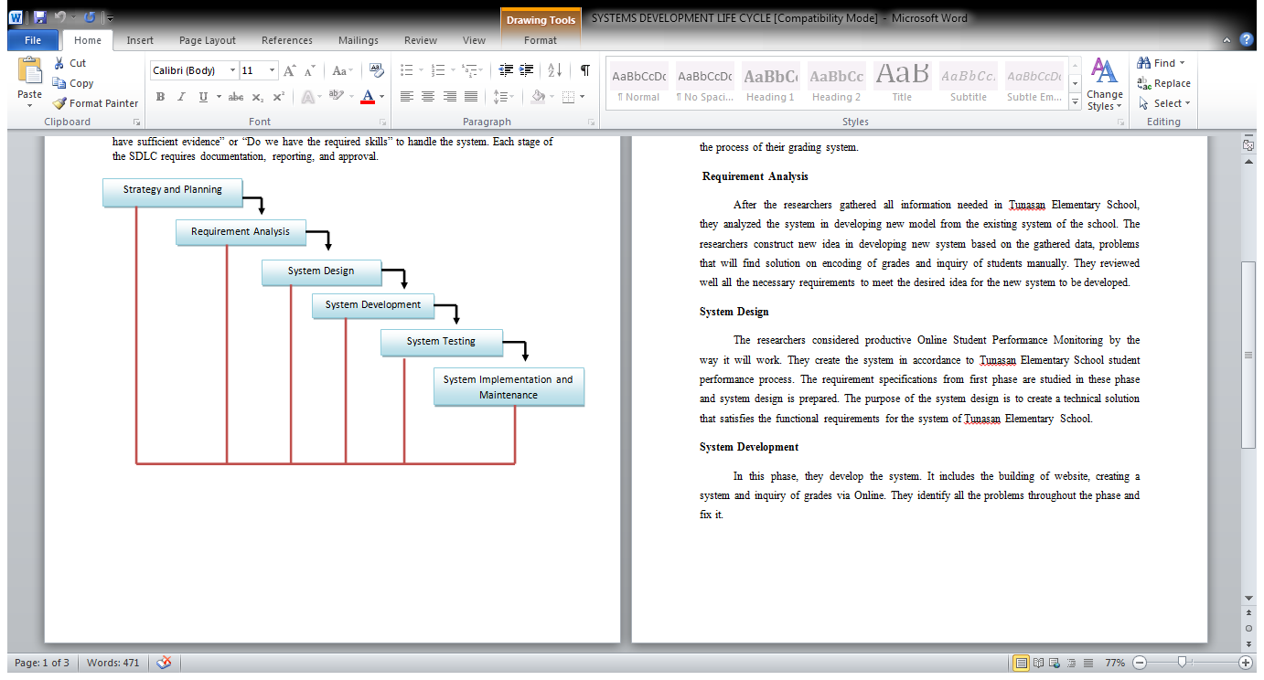

**Technical Background**

*3.3.1 Proposed System Description*

Online Student Performance Monitoring System is a web-based application that generates student performance assessment in graphs and ratings after teachers encodes student grades. It provides student, teacher, and parent web accounts to let them login and create personal accounts. The teacher logs onto website then insert grades, attendance, evaluations and online exercises for students. When data is already stored in the main database, the system will generate reports and notices if needed. Students can setup their profiles accounts and view their assessments. Parents will be given also their own account so they can also view their children’s assessments. Only the admin has all the permission to perform admin tasks.

The system secures login system and avoids both SQL injection and cross-site scripting attacks using PHP.

*3.3.2 Economic Uses of the System*

Tunasan Elementary School reports are fairly computer generated. But the existing system doesn’t have one main database where all important student reports can be saved. The saving of data will be organized and at the same time will be efficient and secured if centralized. The evaluation and the rating of student performance can be computer generated which is more effective. For that reason the researchers proposed the online student performance monitoring management system for Tunasan Elementary School to provide a system that will complement the student-performance assessment curriculum efficiently and effectively.

*3.3.3 Manual Processing*

The existing system has manual processes in daily attendance and in some reports such as creating narrative reports.

*3.3.4 User Requirements*

Main User (Teacher, Student, Parent)

• Fairly computer literate

• Must have an account to be able to access the system

• Must be capable in using the system

Administrator

• Computer literate

• Must have an account to be able to access the system

• Must be knowledgeable in using the system

*3.3.5 System Requirements*

These are the following system requirements for the system.

Software Specification:

• Database: MySQL 5.6

• Platform: Windows 7 or Higher

Hardware Specification:

• Processor: Intel Pentium or Higher

• Hard Disk: 5GB or higher

• Memory: 512MB RAM or higher

3.1.1 Flowchart of Existing System

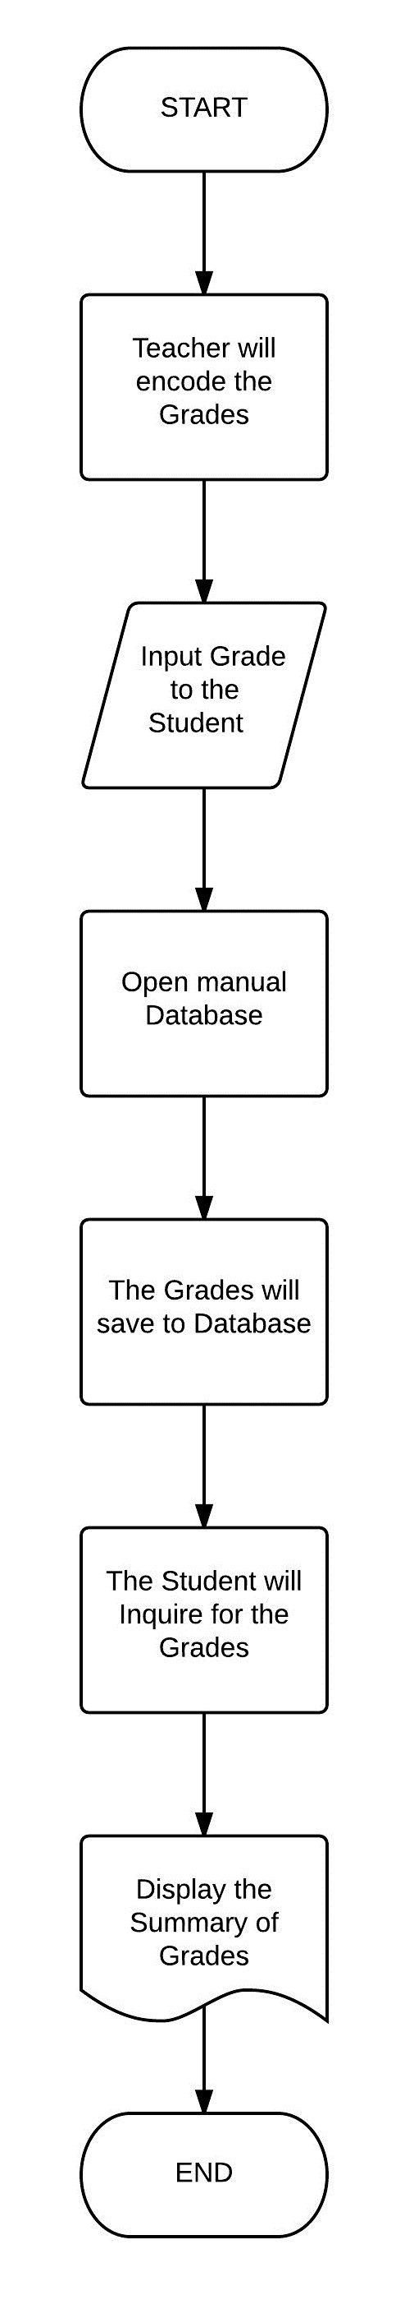

3.1.2 Flowchart of Proposed System

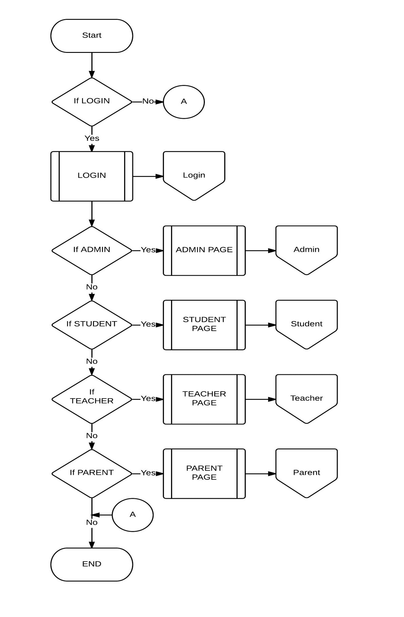

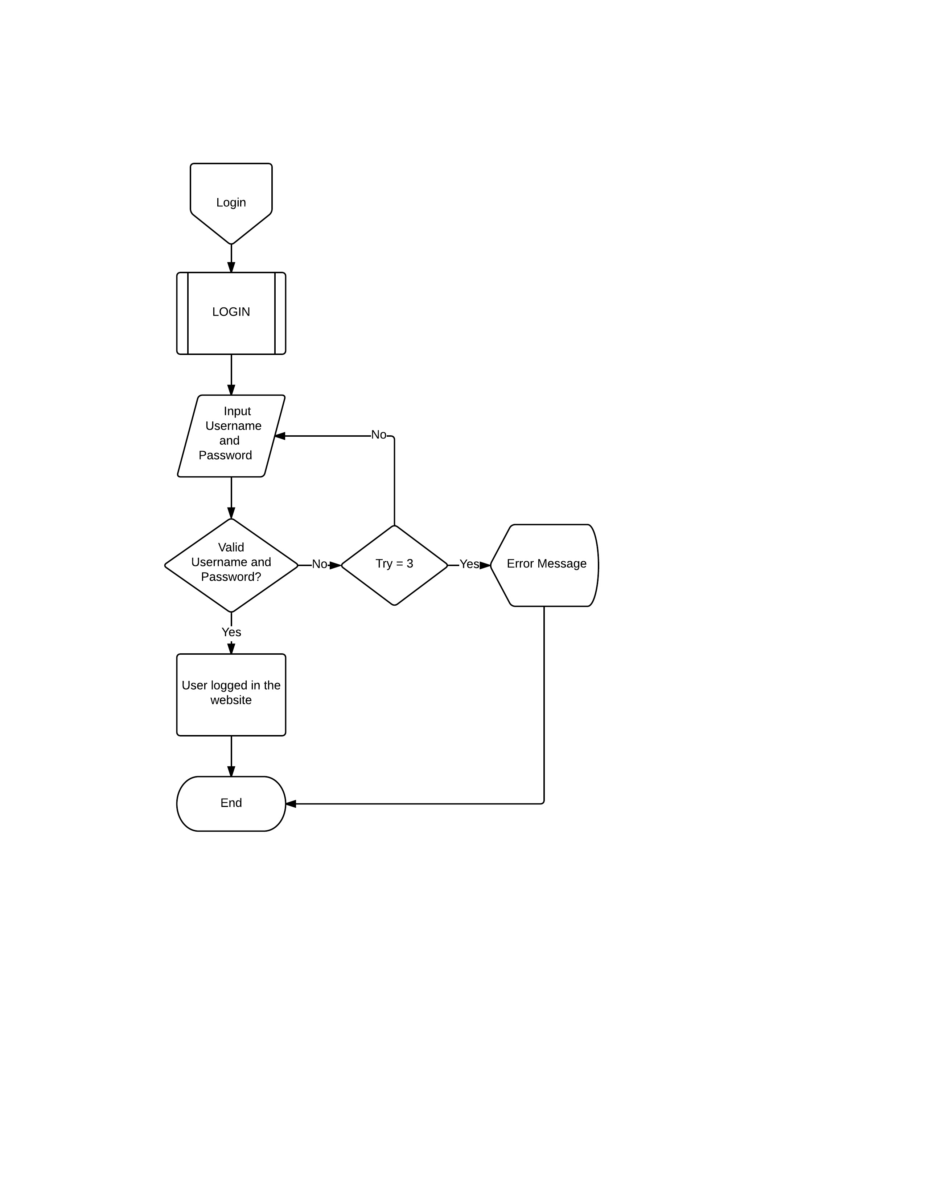

‘

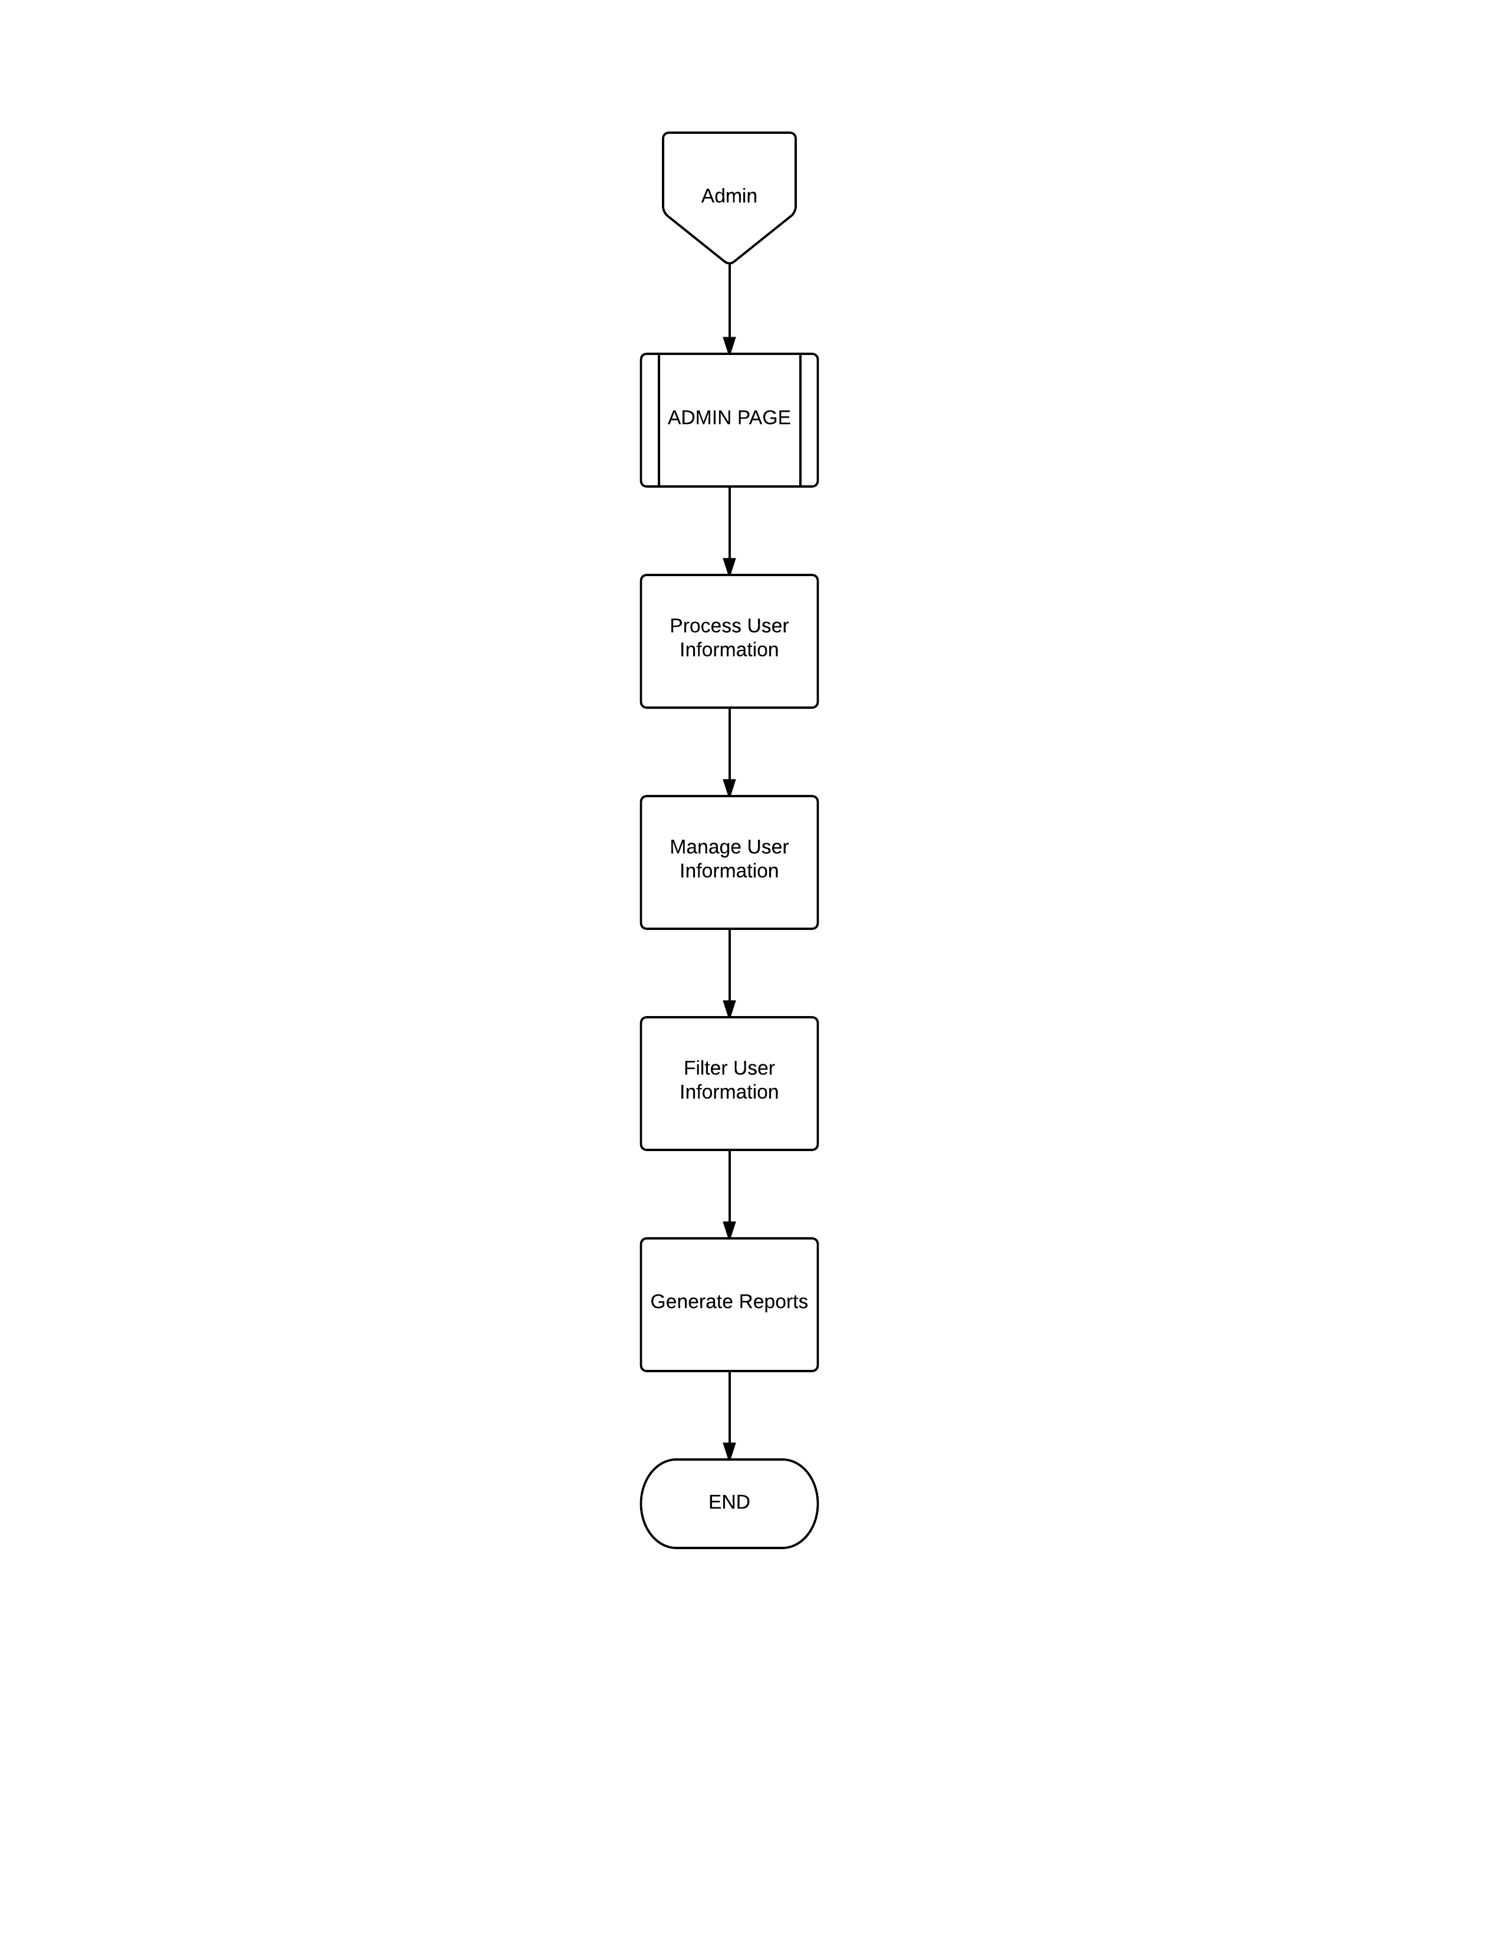

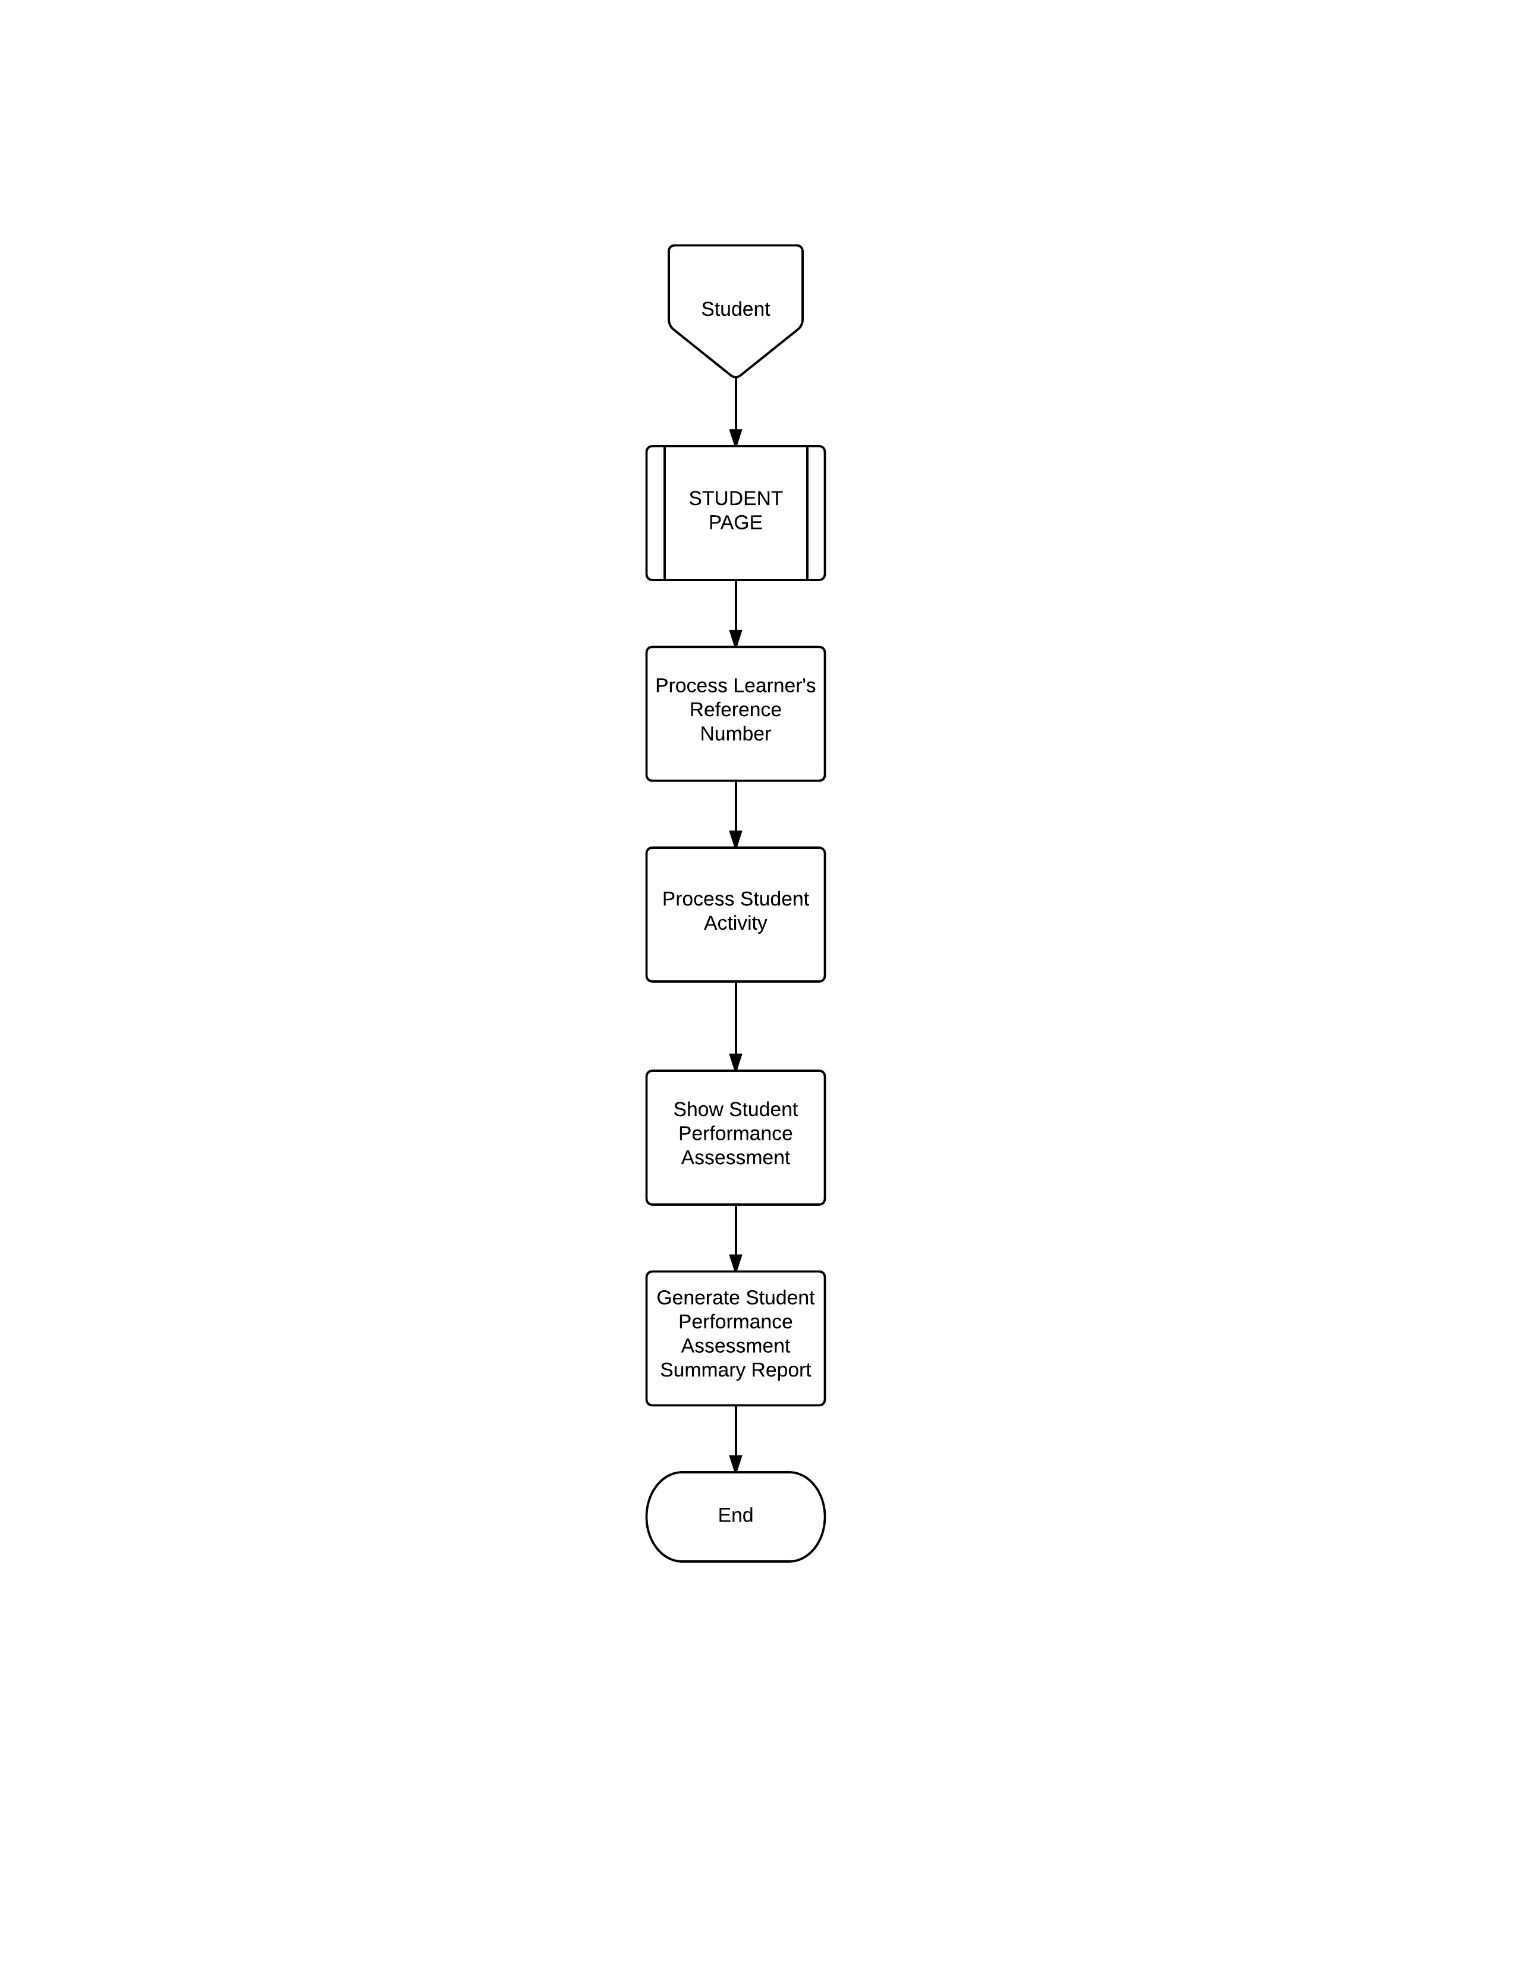

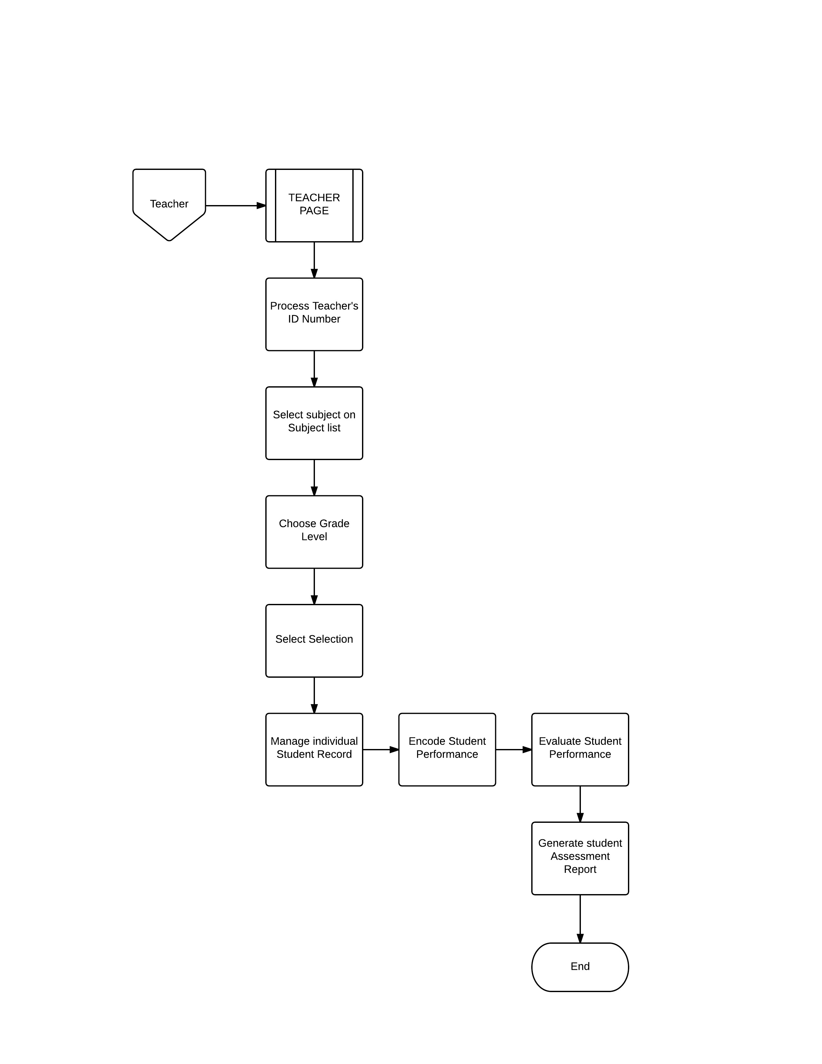

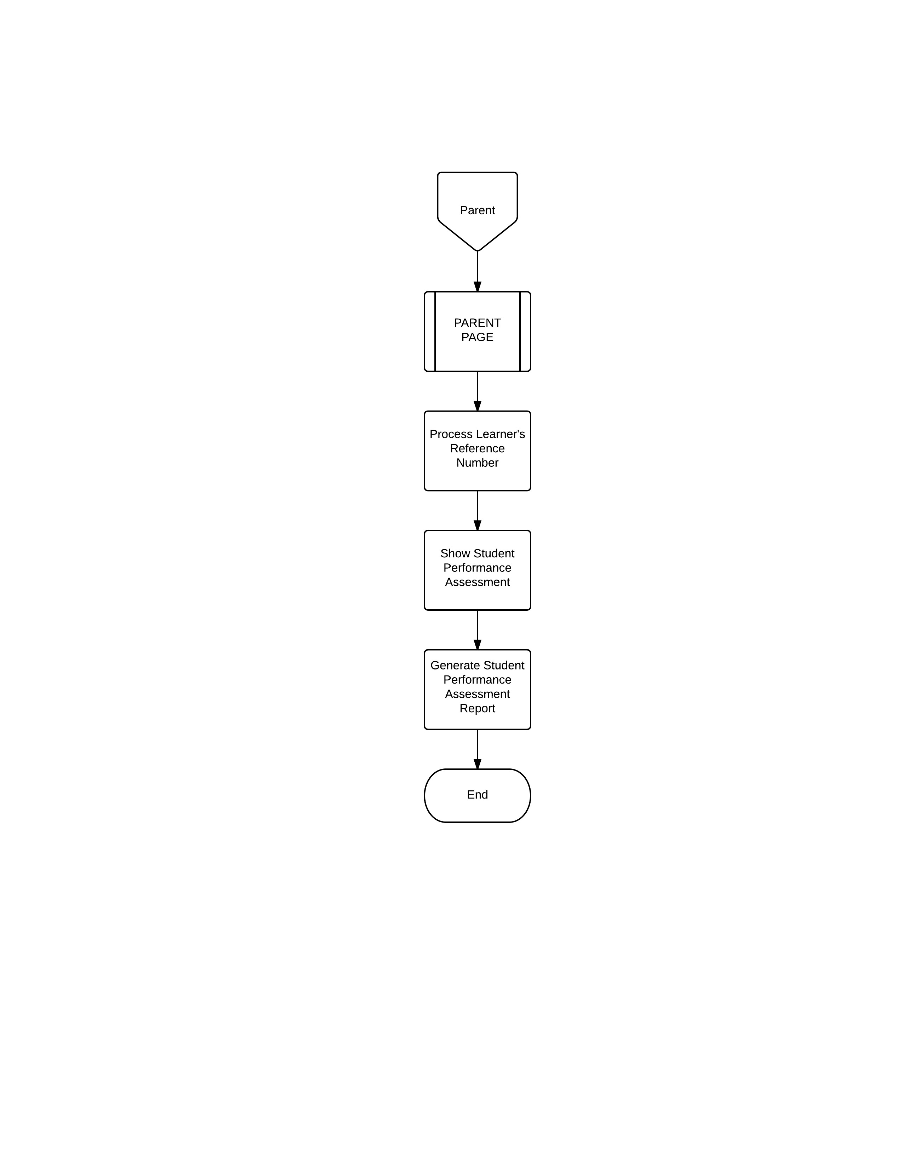

3.1.3 DFD of Existing System

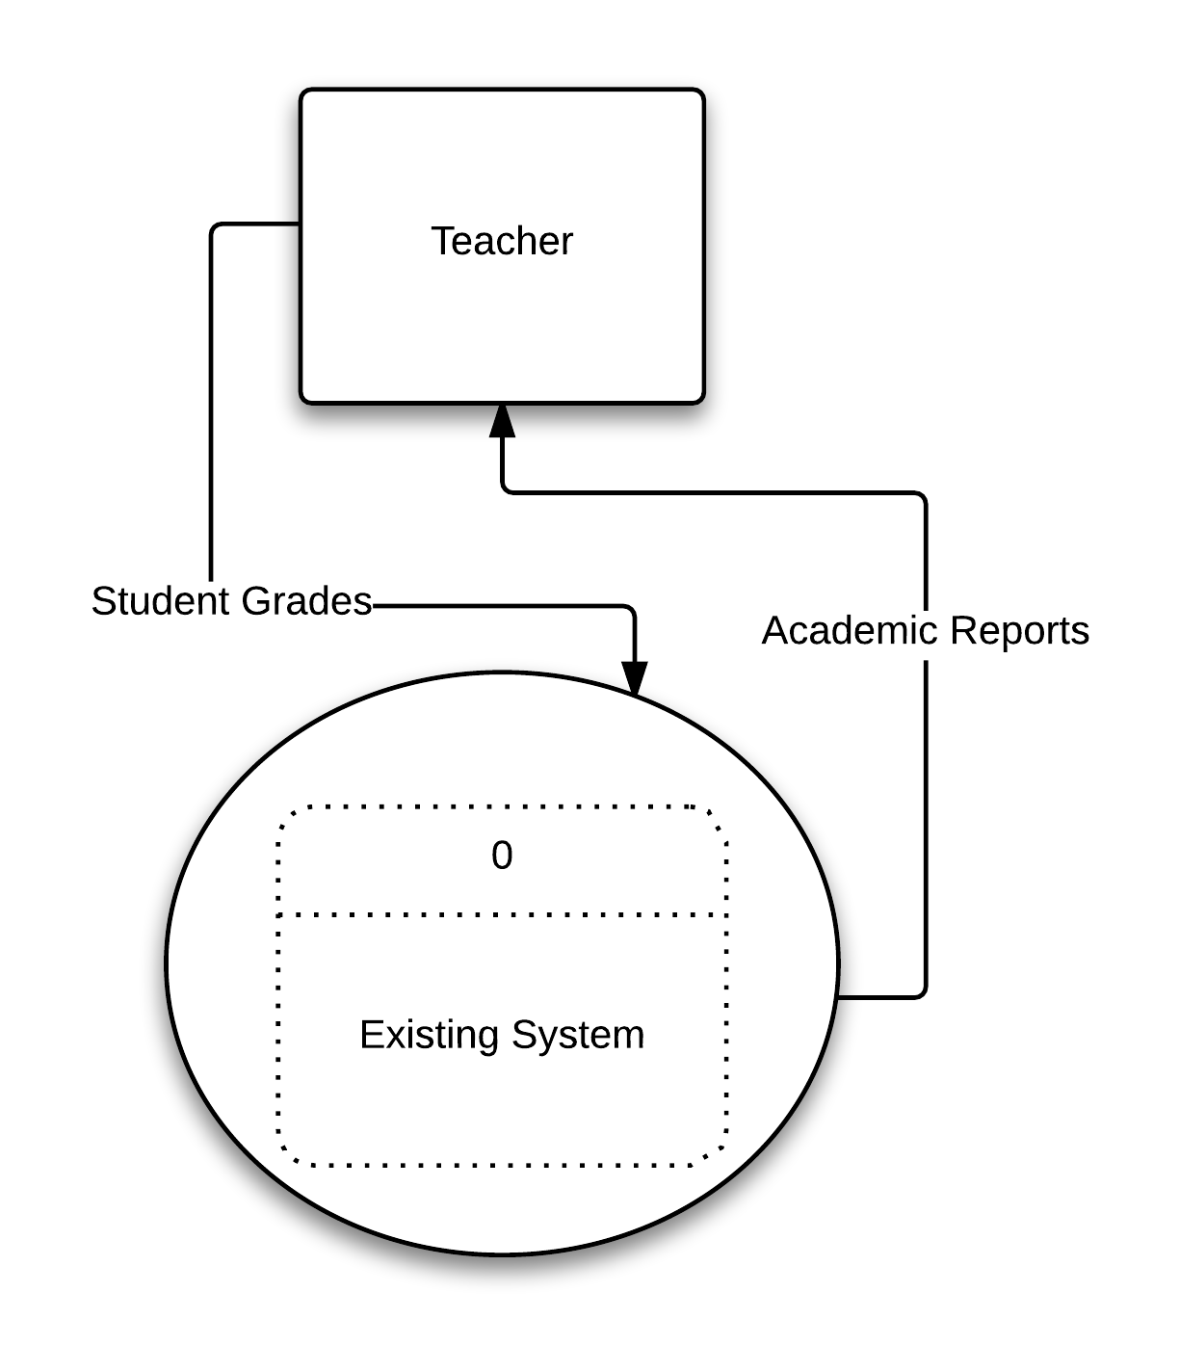

3.1.4 DFD of Proposed System

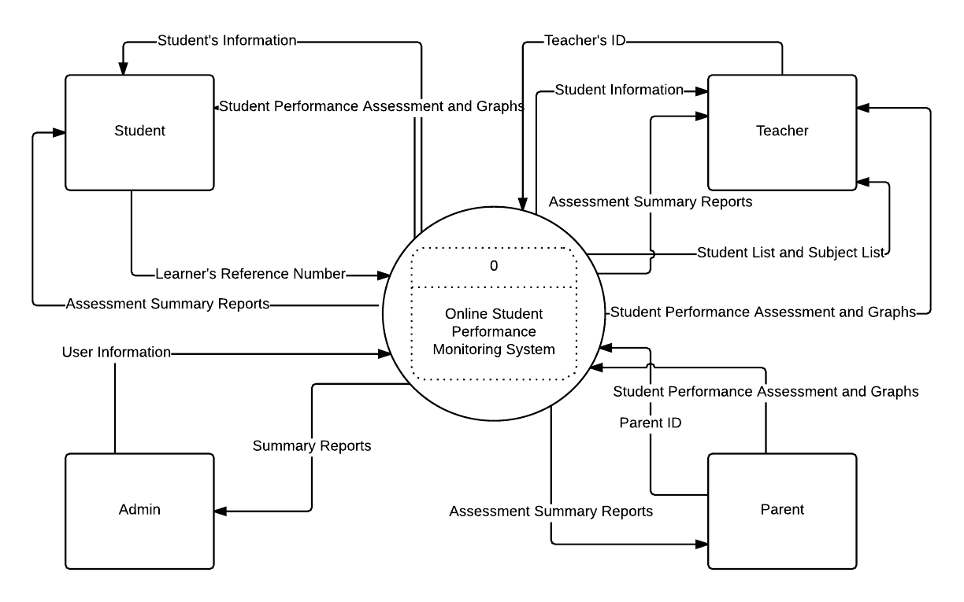

3.4.1 Screenshots of Prototype

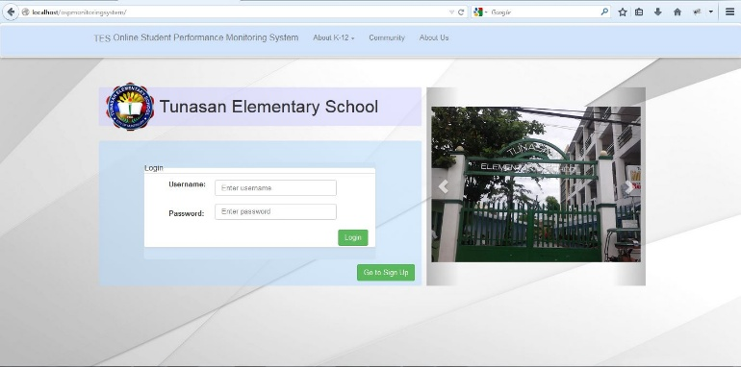

Figure 3.4.1.1- Login Interface

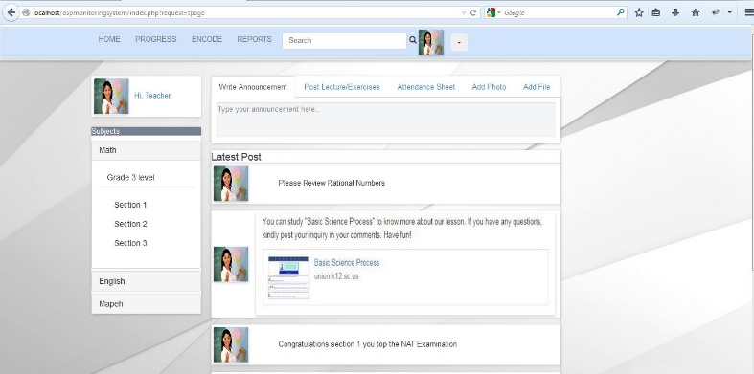

Figure 3.4.1.2-Teachers Page

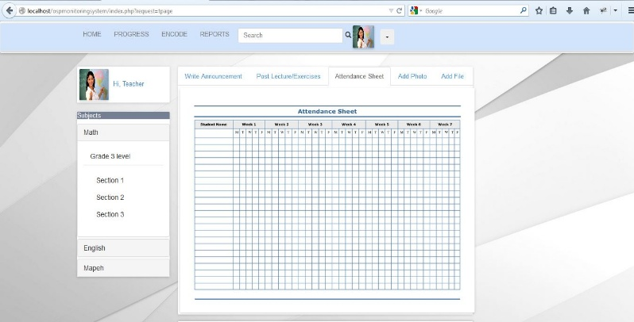

Figure 3.4.1.3-Attendance Sheet Interface

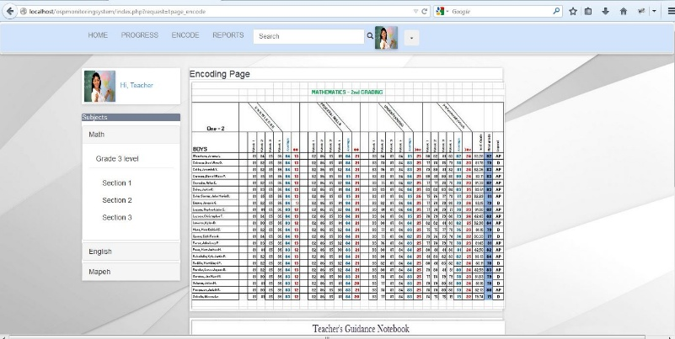

Figure 3.4.1.4-Teachers Assessment Encoding Interface

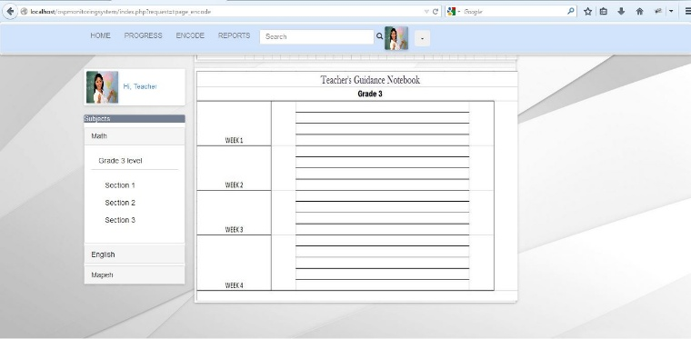

Figure 3.4.1.5-Teachers Guidance Notebook

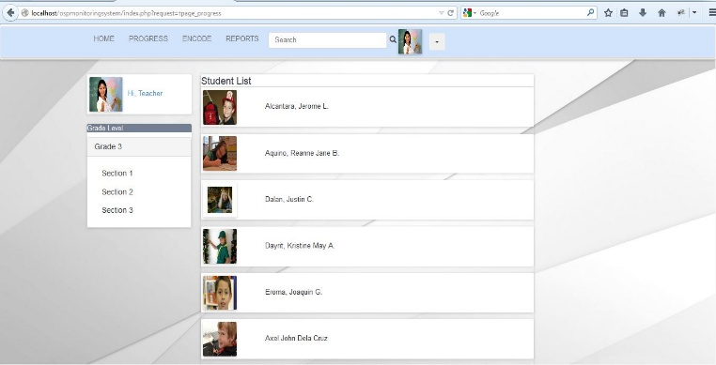

Figure 3.4.1.6-Teachers Student List Interface

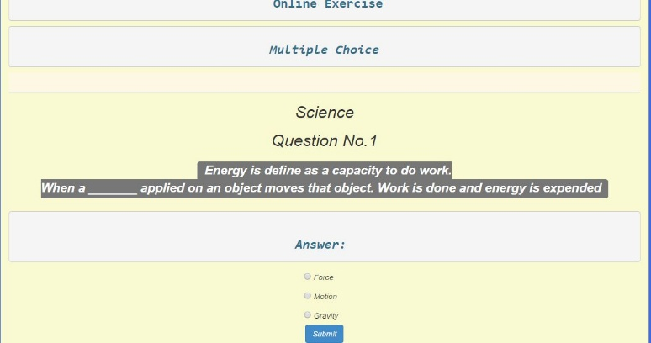

Figure 3.4.1.7-Online Exercise Interface

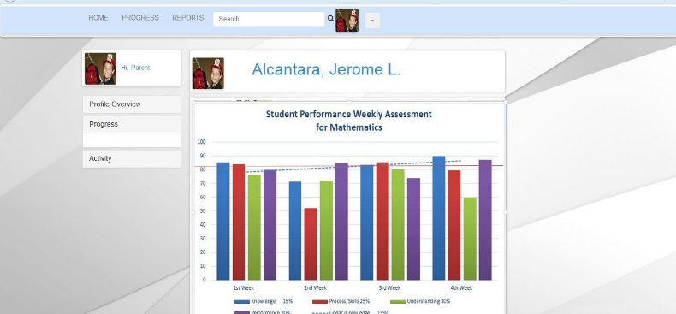

Figure 3.4.1.8-Students Page

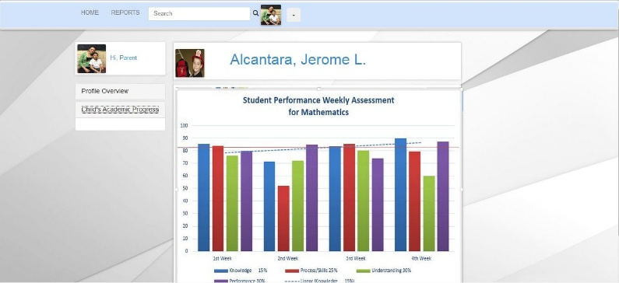

Figure 3.4.1.9-Parents Page