1、必须开通支付，并且有备案的域名 和 配置 https

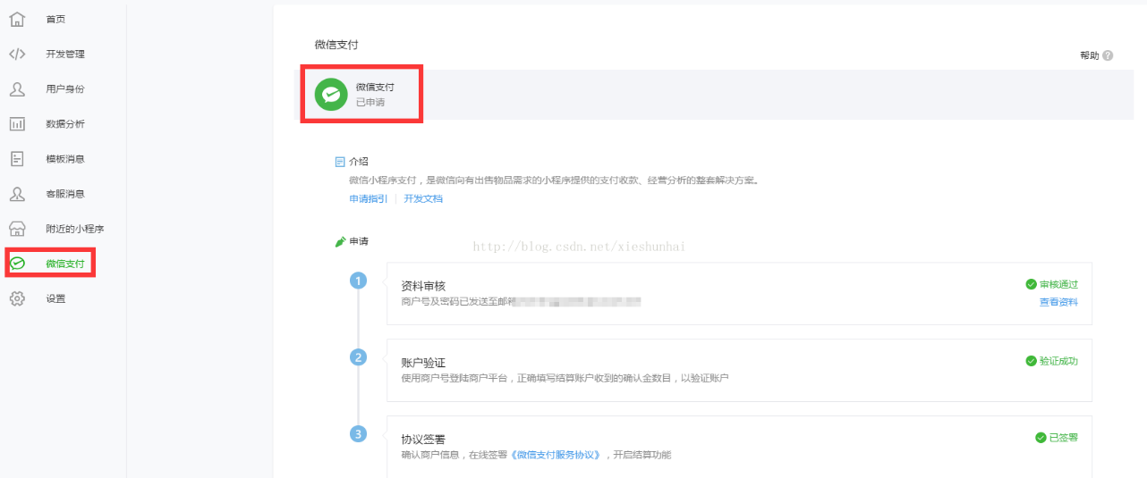

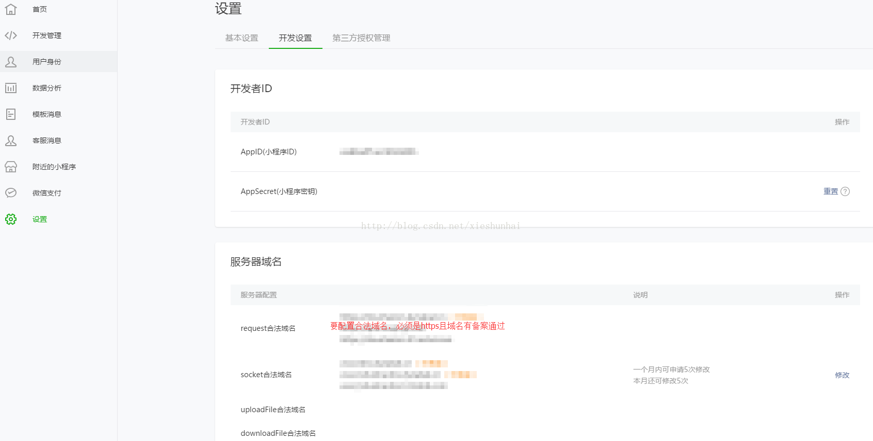

2.微信小程序处理

.wxml

http://img.blog.csdn.net/20170601110357814?watermark/2/text/aHR0cDovL2Jsb2cuY3Nkbi5uZXQveGllc2h1bmhhaQ==/font/5a6L5L2T/fontsize/400/fill/I0JBQkFCMA==/dissolve/70/gravity/Center

.js

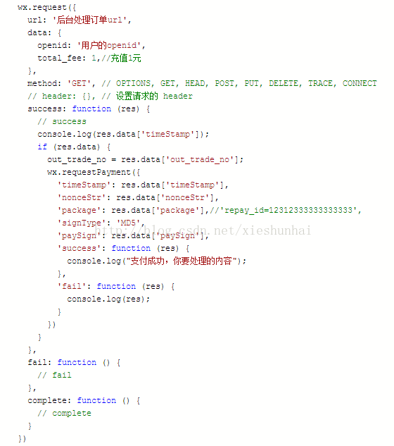

3 后台处理部分（博主使用php为例子）【其他语言参照修改就可以了】

以下参数不懂，可通过这个查看，微信文档查看参数的名称

https://pay.weixin.qq.com/wiki/doc/api/wxa/wxa_api.php?chapter=9_1

下面是实现的代码：

*//微信支付*

**public function** Pay(){

$fee = 0.01;*//举例充值0.01*

$appid = **'微信小程序的appid【自己填写】'**;*//如果是公众号 就是公众号的appid*

$body = **'蜗牛充值【自己填写】'**;

$mch_id = **'你的商户号【自己填写】'**;

$nonce_str = $this->nonce_str();*//随机字符串*

$notify_url = **'回调的url【自己填写】'**;

$openid = **'用户的openid【自己填写】'**;

$out_trade_no = $this->order_number();//商户订单号

$spbill_create_ip = **'服务器的ip【自己填写】'**;

$total_fee = $fee*100;*//因为充值金额最小是1 而且单位为分 如果是充值1元所以这里需要*100*

$trade_type = **'JSAPI'**;*//交易类型 默认*

*//这里是按照顺序的 因为下面的签名是按照顺序 排序错误 肯定出错*

$post[**'appid'**] = $appid;

$post[**'body'**] = $body;

$post[**'mch_id'**] = $mch_id;

$post[**'nonce_str'**] = $nonce_str;*//随机字符串*

$post[**'notify_url'**] = $notify_url;

$post[**'openid'**] = $openid;

$post[**'out_trade_no'**] = $out_trade_no;

$post[**'spbill_create_ip'**] = $spbill_create_ip;*//终端的ip*

$post[**'total_fee'**] = $total_fee;*//总金额 最低为一块钱 必须是整数*

$post[**'trade_type'**] = $trade_type;

$sign = $this->sign($post);*//签名*

$post_xml = **'<xml>**

**<appid>'**.$appid.**'</appid>**

**<body>'**.$body.**'</body>**

**<mch_id>'**.$mch_id.**'</mch_id>**

**<nonce_str>'**.$nonce_str.**'</nonce_str>**

**<notify_url>'**.$notify_url.**'</notify_url>**

**<openid>'**.$openid.**'</openid>**

**<out_trade_no>'**.$out_trade_no.**'</out_trade_no>**

**<spbill_create_ip>'**.$spbill_create_ip.**'</spbill_create_ip>**

**<total_fee>'**.$total_fee.**'</total_fee>**

**<trade_type>'**.$trade_type.**'</trade_type>**

**<sign>'**.$sign.**'</sign>**

**</xml> '**;

*//统一接口prepay_id*

$url = **'https://api.mch.weixin.qq.com/pay/unifiedorder'**;

$xml = $this->http_request($url,$post_xml);

$array = $this->xml($xml);*//全要大写*

**if**($array[**'RETURN_CODE'**] == **'SUCCESS'** && $array[**'RESULT_CODE'**] == **'SUCCESS'**){

$time = *time*();

$tmp=**''**;*//临时数组用于签名*

$tmp[**'appId'**] = $appid;

$tmp[**'nonceStr'**] = $nonce_str;

$tmp[**'package'**] = **'prepay_id='**.$array[**'PREPAY_ID'**];

$tmp[**'signType'**] = **'MD5'**;

$tmp[**'timeStamp'**] = **"**$time**"**;

$data[**'state'**] = 1;

$data[**'timeStamp'**] = **"**$time**"**;*//时间戳*

$data[**'nonceStr'**] = $nonce_str;*//随机字符串*

$data[**'signType'**] = **'MD5'**;*//签名算法，暂支持 MD5*

$data[**'package'**] = **'prepay_id='**.$array[**'PREPAY_ID'**];*//统一下单接口返回的 prepay_id 参数值，提交格式如：prepay_id=\**

$data[**'paySign'**] = $this->sign($tmp);*//签名,具体签名方案参见微信公众号支付帮助文档;*

$data[**'out_trade_no'**] = $out_trade_no;

}**else**{

$data[**'state'**] = 0;

$data[**'text'**] = **"错误"**;

$data[**'RETURN_CODE'**] = $array[**'RETURN_CODE'**];

$data[**'RETURN_MSG'**] = $array[**'RETURN_MSG'**];

}

**echo** *json_encode*($data);

}

*//随机32位字符串*

**private function** nonce_str(){

$result = **''**;

$str = **'QWERTYUIOPASDFGHJKLZXVBNMqwertyuioplkjhgfdsamnbvcxz'**;

**for** ($i=0;$i<32;$i++){

$result .= $str[*rand*(0,48)];

}

**return** $result;

}

*//生成订单号*

**private function** order_number($openid){

*//date('Ymd',time()).time().rand(10,99);//18位*

**return** *md5*($openid.*time*().*rand*(10,99));*//32位*

}

*//签名 $data要先排好顺序*

**private function** sign($data){

$stringA = **''**;

**foreach** ($data **as** $key=>$value){

**if**(!$value) **continue**;

**if**($stringA) $stringA .= **'&'**.$key.**"="**.$value;

**else** $stringA = $key.**"="**.$value;

}

$wx_key = '';//*申请支付后有给予一个商户账号和密码，登陆后自己设置key*

$stringSignTemp = $stringA.**'&key='**.$wx_key;*//申请支付后有给予一个商户账号和密码，登陆后自己设置key* **return** *strtoupper*(*md5*($stringSignTemp));}

*//curl请求啊*

**function** http_request($url,$data = **null**,$headers=**array**())

{

$curl = *curl_init*();

**if**( *count*($headers) >= 1 ){

*curl_setopt*($curl, ***CURLOPT_HTTPHEADER***, $headers);

}

*curl_setopt*($curl, ***CURLOPT_URL***, $url);

*curl_setopt*($curl, ***CURLOPT_SSL_VERIFYPEER***, **FALSE**);

*curl_setopt*($curl, ***CURLOPT_SSL_VERIFYHOST***, **FALSE**);

**if** (!**empty**($data)){

*curl_setopt*($curl, ***CURLOPT_POST***, 1);

*curl_setopt*($curl, ***CURLOPT_POSTFIELDS***, $data);

}

*curl_setopt*($curl, ***CURLOPT_RETURNTRANSFER***, 1);

$output = *curl_exec*($curl);

*curl_close*($curl);

**return** $output;

}

*//获取xml*

**private function** xml($xml){

$p = *xml_parser_create*();

*xml_parse_into_struct*($p, $xml, $vals, $index);

*xml_parser_free*($p);

$data = **""**;

**foreach** ($index **as** $key=>$value) {

**if**($key == **'xml'** || $key == **'XML'**) **continue**;

$tag = $vals[$value[0]][**'tag'**];

$value = $vals[$value[0]][**'value'**];

$data[$tag] = $value;

}

**return** $data;

}

这里就实现微信支付了，看效果，在真机上面测试，才行

