ITM Kepler course

0. Configuration of Gateway account (Garching 03.2013)

1. Installation of NX client
Using X2Go

✔

2. Setting up tutorial environment
create-itm-links NOT WORKING!

Nevertheless, I tried the following and it is working properly:

https://itm.ipp.mpg.de/wiki/ITM/index.php/UserFileSystems

Default links
The following default links should be present in your $HOME directory:
- $HOME/itmwork -> $ITMWORK
  - Points to your work directory
  - Automatically created on login or by the create-itm-links command
- $HOME/itmscratch -> $ITMSCRATCH
  - Points to your scratch directory
  - Automatically created on login or by the create-itm-links command
- $HOME/public/itmdb -> $ITMWORK/itmdb
  - Points to your ITM database
  - Automatically created the first time you run create_user_itm_dir, or
  - Automatically created when you run the copy-old-itmdb command

The create-itm-links command
If any of the above links are missing, they can be restored by running the command

✔
You should execute an ITM initialization script:
source $ITMSCRIPTDIR/ITMv1 kepler test 4.10a > /dev/null NOT WORKING!

Instead of it I tried:
source $ITMSCRIPTDIR/ITMv1.sh kepler test 4.10b

✔

Adding source script into .login
In order to make sure that source script is always started when you log in, add it to ~/.login
echo "\n" >> ~/.login
echo "source $ITMSCRIPTDIR/ITMv1 kepler test 4.10a > /dev/null" >> ~/.login

✔

After this script is executed you will have an access to following tools:
fc2k ✔
hpc2k ✔
kepler ✖
jTraverser ✖
ise ✖

fc2k
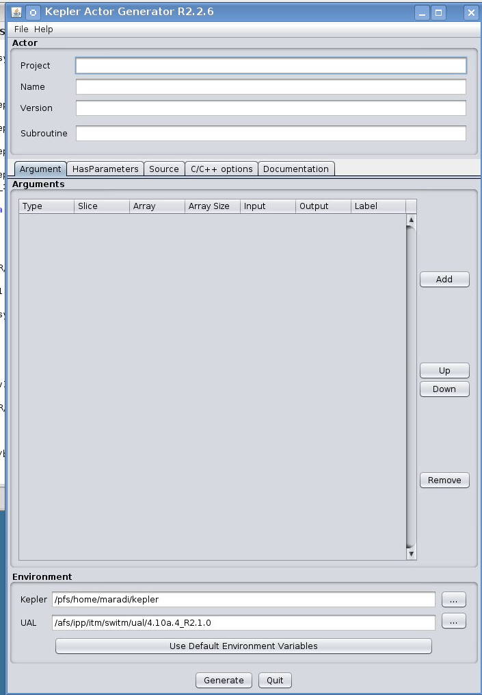

✔

hpc2k
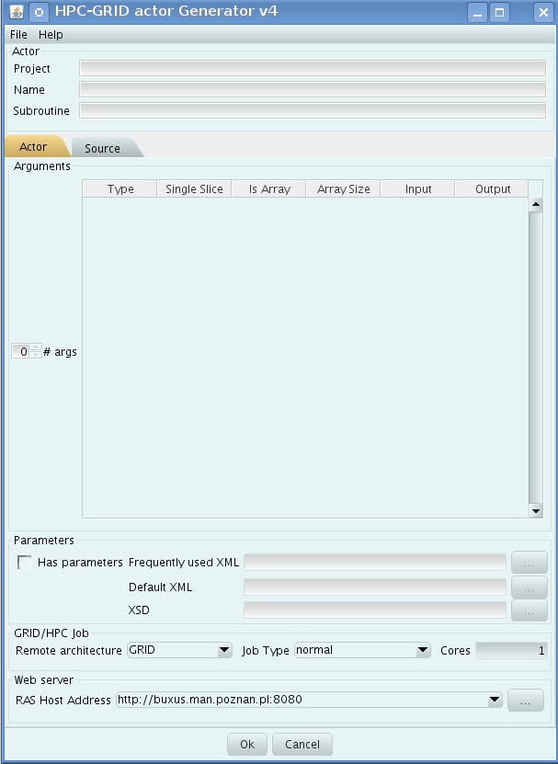

✔

kepler
. $ITMSCRIPTDIR/ITMv1.sh kepler test 4.10b > /dev/null

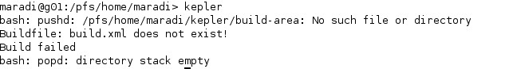

error ✖

jTraverser
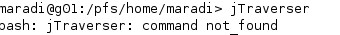

not found ✖

ise
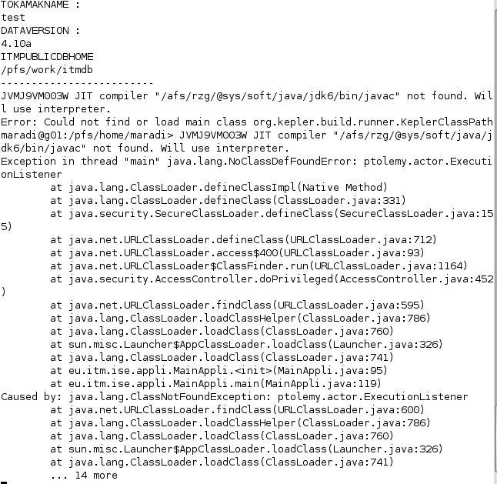

error because of kepler ✖

not working partially! ✖
multikepler.mp4
http://scilla.man.poznan.pl:8080/confluence/display/euforia/Using+multiple+Kepler+installations
Due to the fact of get stuck I was looking for some alternative solutions. I tried /pfs/work/michalo/tutorials/movies/multiplekeplers.mp4, following the instructions of the video.

If it's not working, do Step 4!

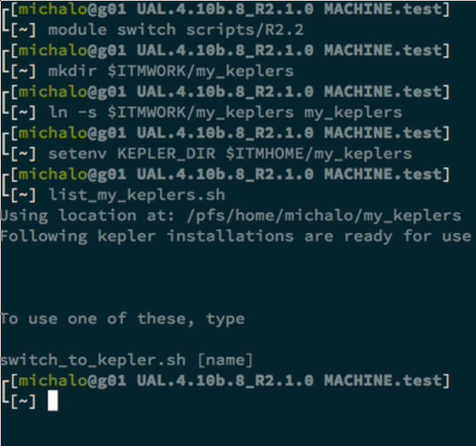

Step 1
module switch scripts/R2.2

✔

Step 2
mkdir $ITMWORK/my_keplers

✔

Step 3
ln -s $ITMWORK/my_keplers my_keplers

✔

Step 4
setenv KEPLER_DIR $ITMHOME/my_keplers NOT WORKING!

Instead of it I tried:
export KEPLER_DIR=$ITMHOME/my_keplers

✔

Step 5
list_my_keplers.sh
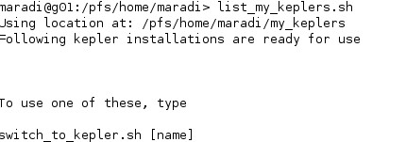

✔

Step 6
list_keplers.sh
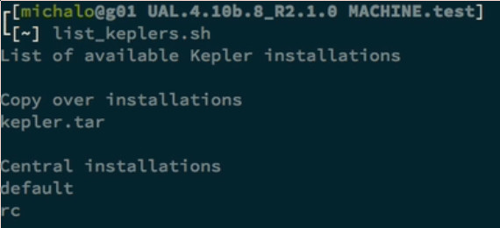
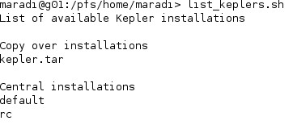

✔

Step 7
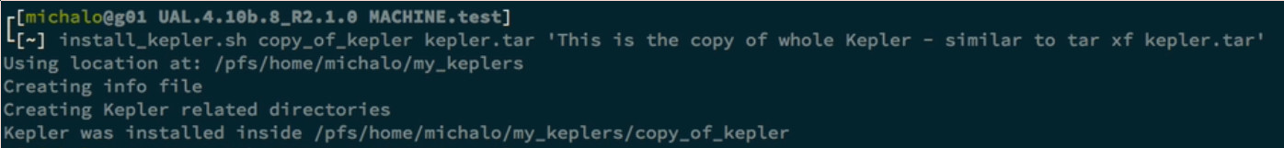
install_kepler.sh copy_of_kepler kepler.tar 'This is the copy of whole Kepler – similar to tar xf kepler.tar'
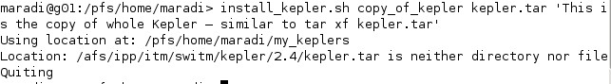

NOT WORKING!
AFTER!:
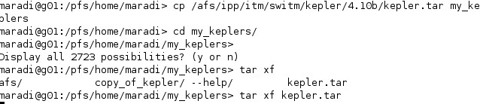

✔

Step 8
list_keplers.sh
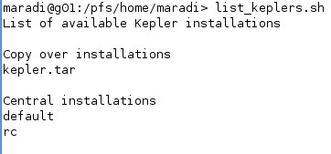

✔

Step 9
install_kepler.sh default_central default 'This is central installation of default Kepler'
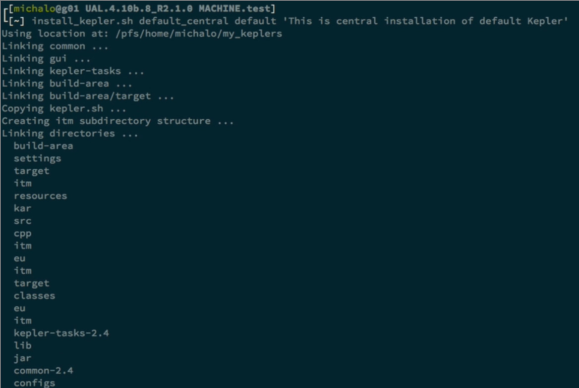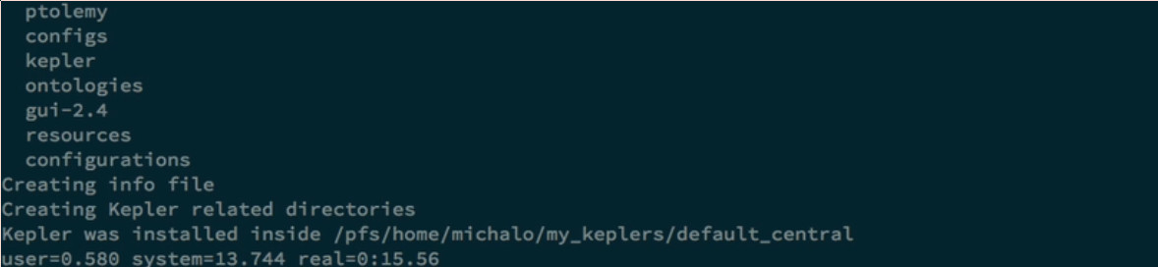

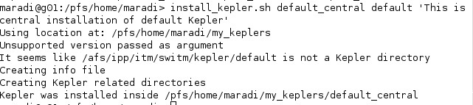

✔

Step 10
list_my_keplers.sh

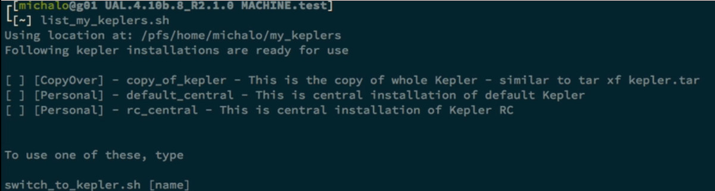
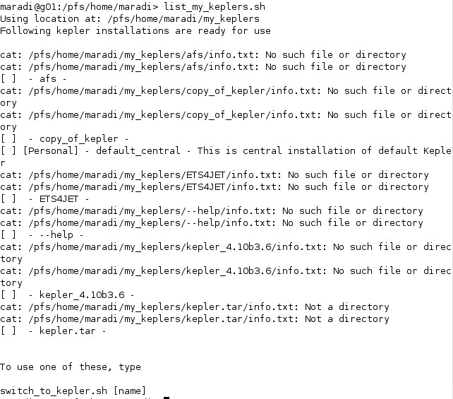
✔

Step 11

rm -r ~/.kepler
rm -r ~/KeplerData
rm -r ~/kepler
switch_to_kepler.sh default_central
list_my_keplers.sh

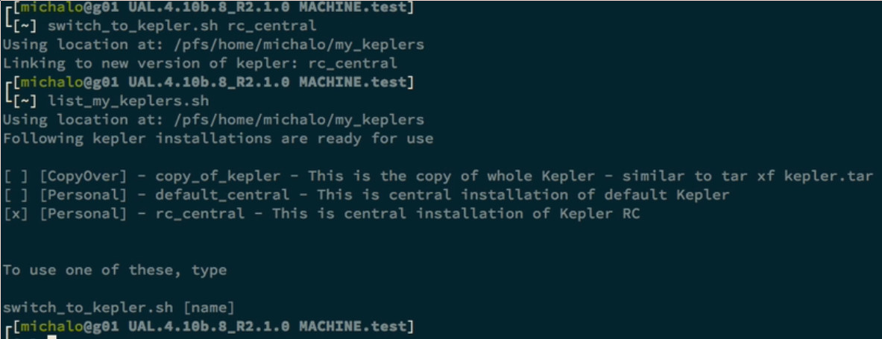

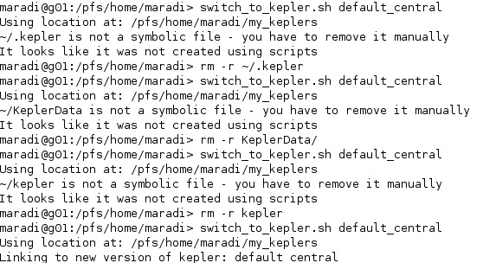
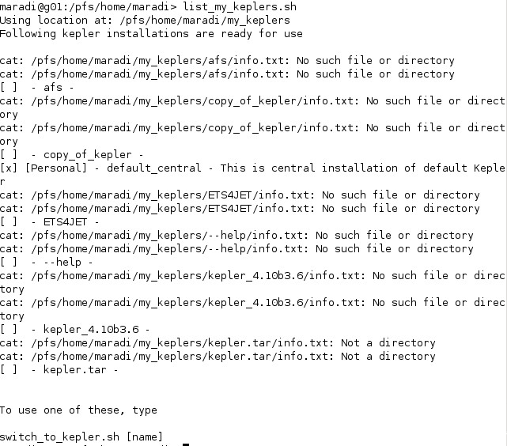
✔

Step 12

✔

ETS4JET

http://portal.efda-itm.eu/twiki/bin/view/Main/CodeCamp2016-01-11_Garching_Merle_Antoine

Step 1
install_kepler.sh ETS4JET _gateway_test R3.8/4.10b.10 "Central installation for testing of ETS4JET"

Step 2

mkdir $ITMWORK/ETS-A
cp ~denka/public/olivier/ETS_WORKFLOW_test_actor_release_JET.xml $ITMWORK/ETS-A/ETS4JET

GO BACK TO 03.2013 Garching codecamp

cd $HOME ✔
mv kepler kepler_03.2013 ✔
mv .kepler .kepler_03.2013 ✔
mv KeplerData KeplerData_03.2013 ✔

✔
After you have backed up your data, install Kepler into your directory (copying could take few minutes)
cd $ITMWORK ✔
tar xf $SWITMDIR/kepler/4.10a/kepler.tar ✔
ln -s $ITMWORK/kepler ~/kepler ✔

✔
Copy tutorial examples. You can install them by issuing following command from Terminal.
mkdir $ITMWORK/tutorials ✔
cp -r /pfs/work/michalo/tutorials/garching-03.2013 $ITMWORK/tutorials ✔

✔

And last thing, but still very important. Copy data files used throughout the tutorial:
# change directory into your database directory
cd $HOME/public/itmdb/itm_trees/test/4.10a/mdsplus/0/ ✔

# copy data files (pay attention to *_dot_* at the end of command line!)
cp ~michalo/public/itmdb/itm_trees/test/4.10a/mdsplus/0/euitm_120002.* . ✔
cp ~michalo/public/itmdb/itm_trees/test/4.10a/mdsplus/0/euitm_130003.* . ✔

✔

