Runaway Fluid testing

26 September 2016

keplerworkflows r795
19 September 2016

IMP5HCD-SA
imp5hcd_sa_runafluid_test.xml

user_in | 'maradi'
machine_in | 'jet'
shot_in | 77922
run_in | 2044
dt_in | 0.1
tbegin_in | 100.0
tend_in | 100.5999

HCD parameters
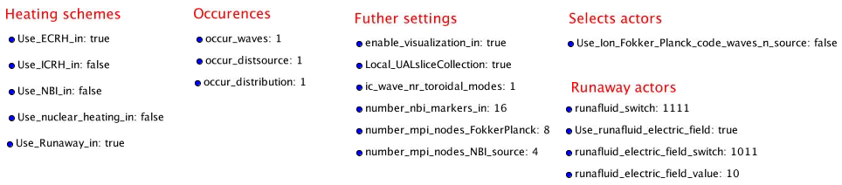

Runaway Fluid parameters
Use_Runaway_in | true
runafluid_switch | 1111
Use_runafluid_electric_switch | true
runafluid_electric_field_switch | 1011
runafluid_electric_field_value | 10

Comment
Running Runafluid in HCD and seeing results on HCD plot and with our own plotter

100.1 s
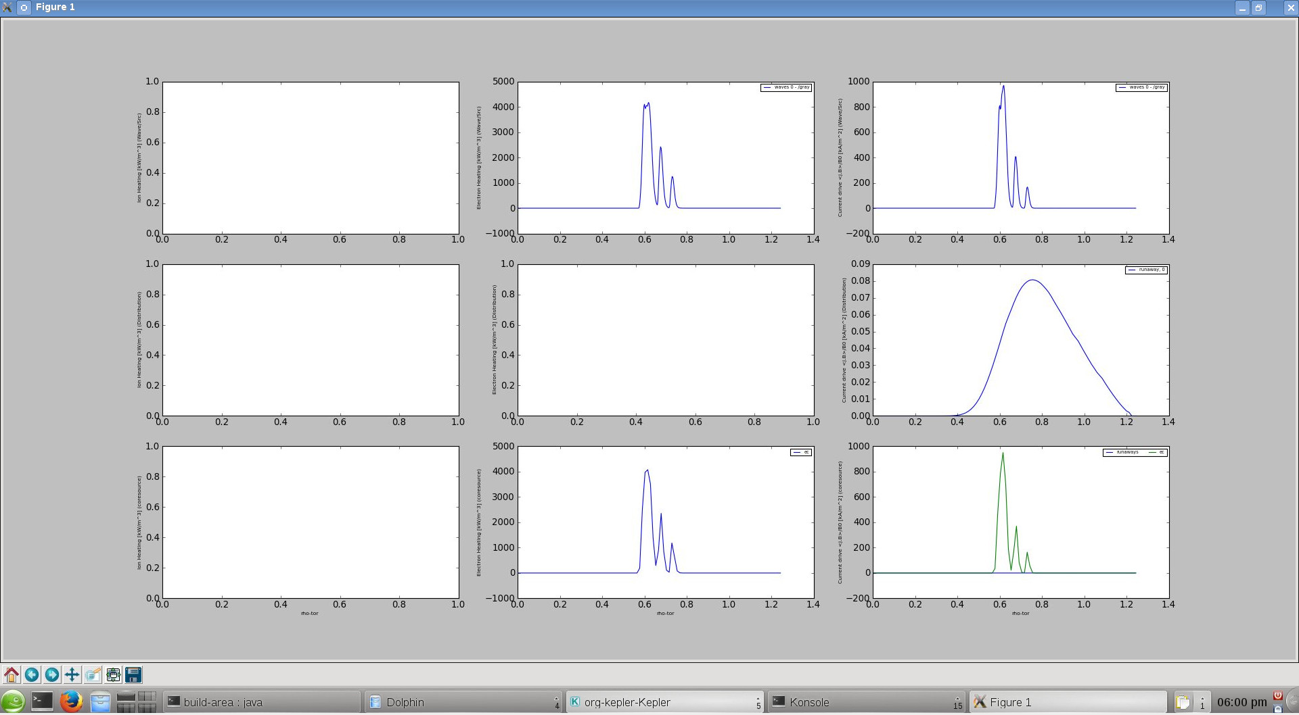

100.2 s
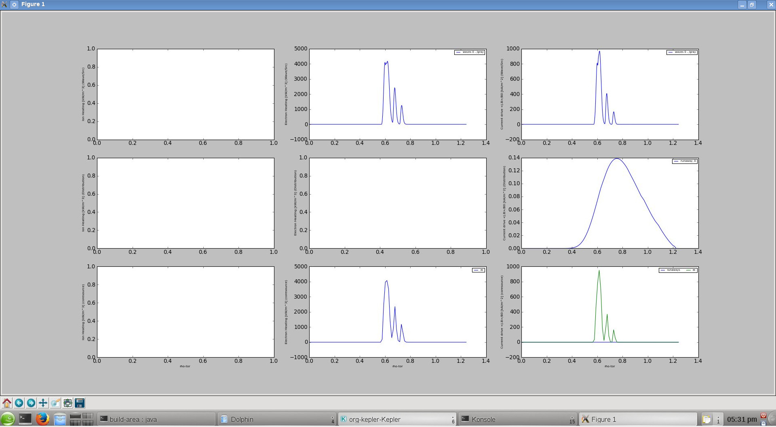

100.3 s
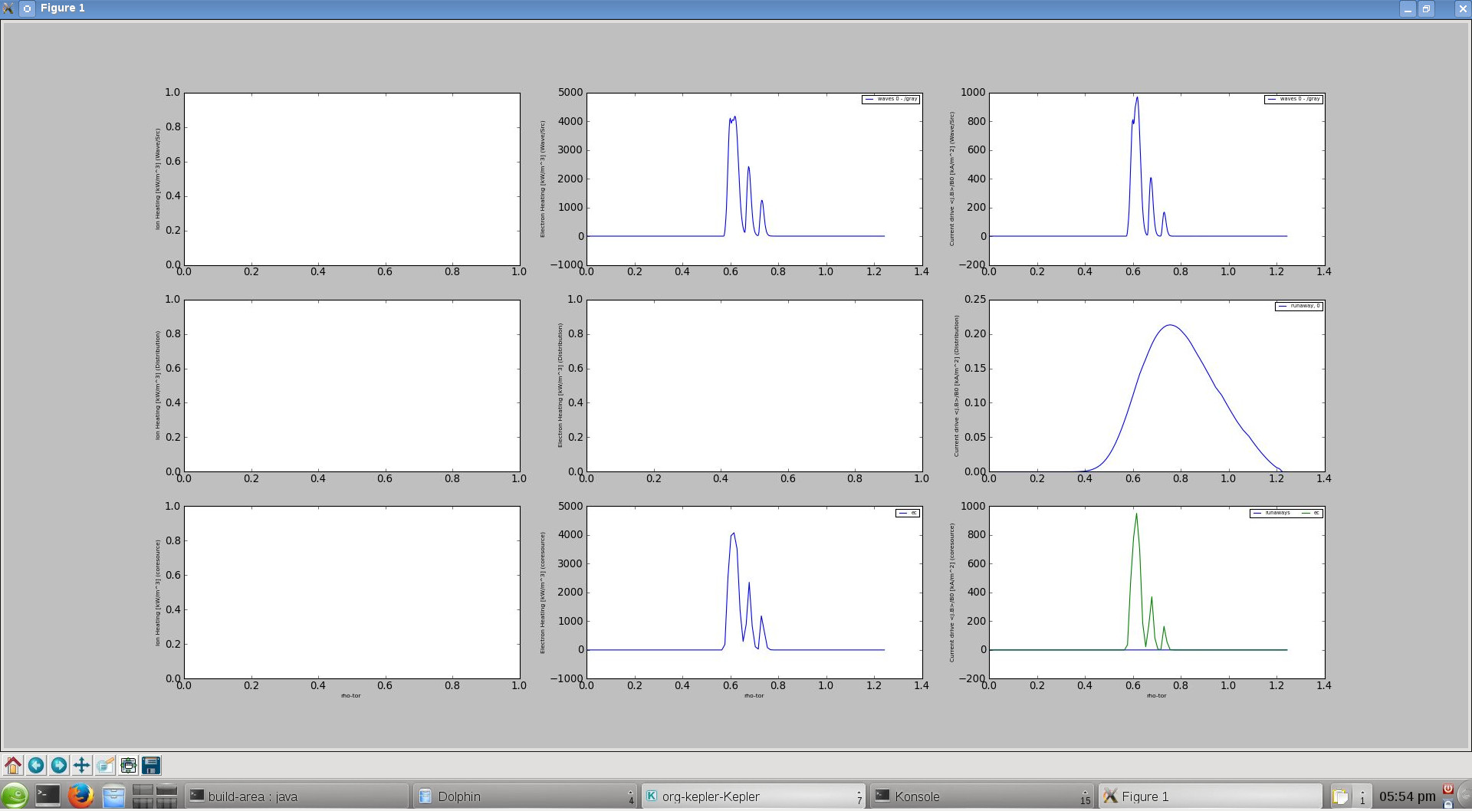

100.4 s
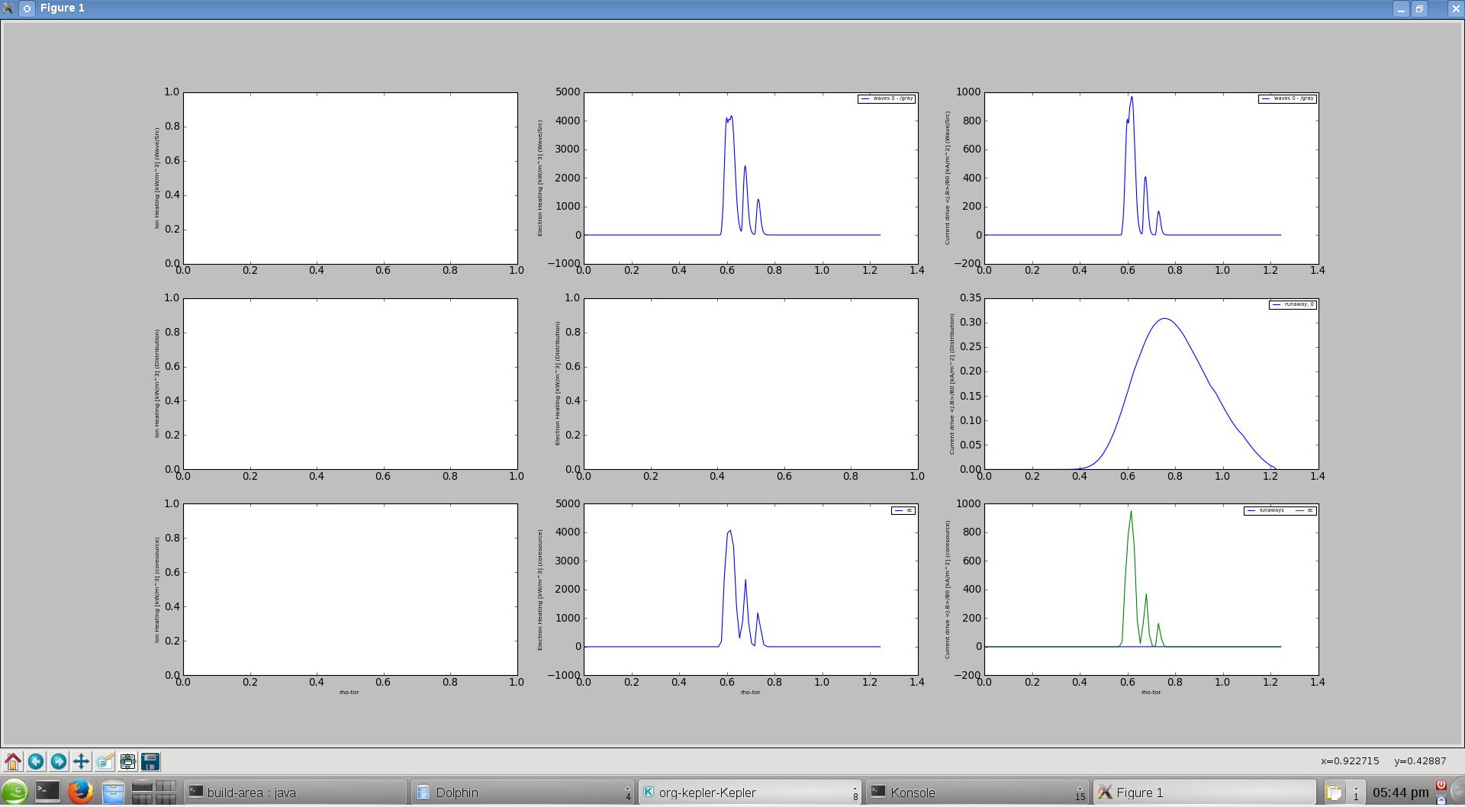

100.5 s
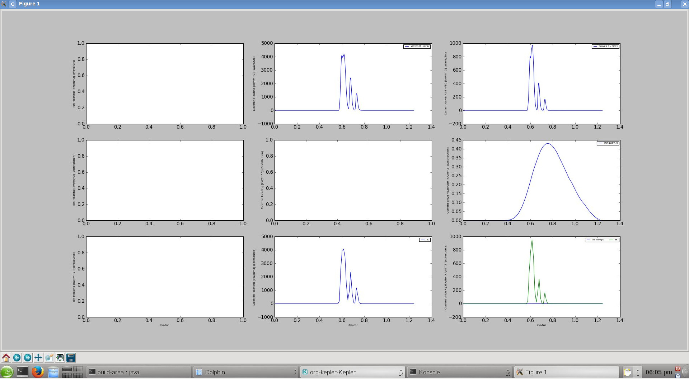

all (100.5 s)

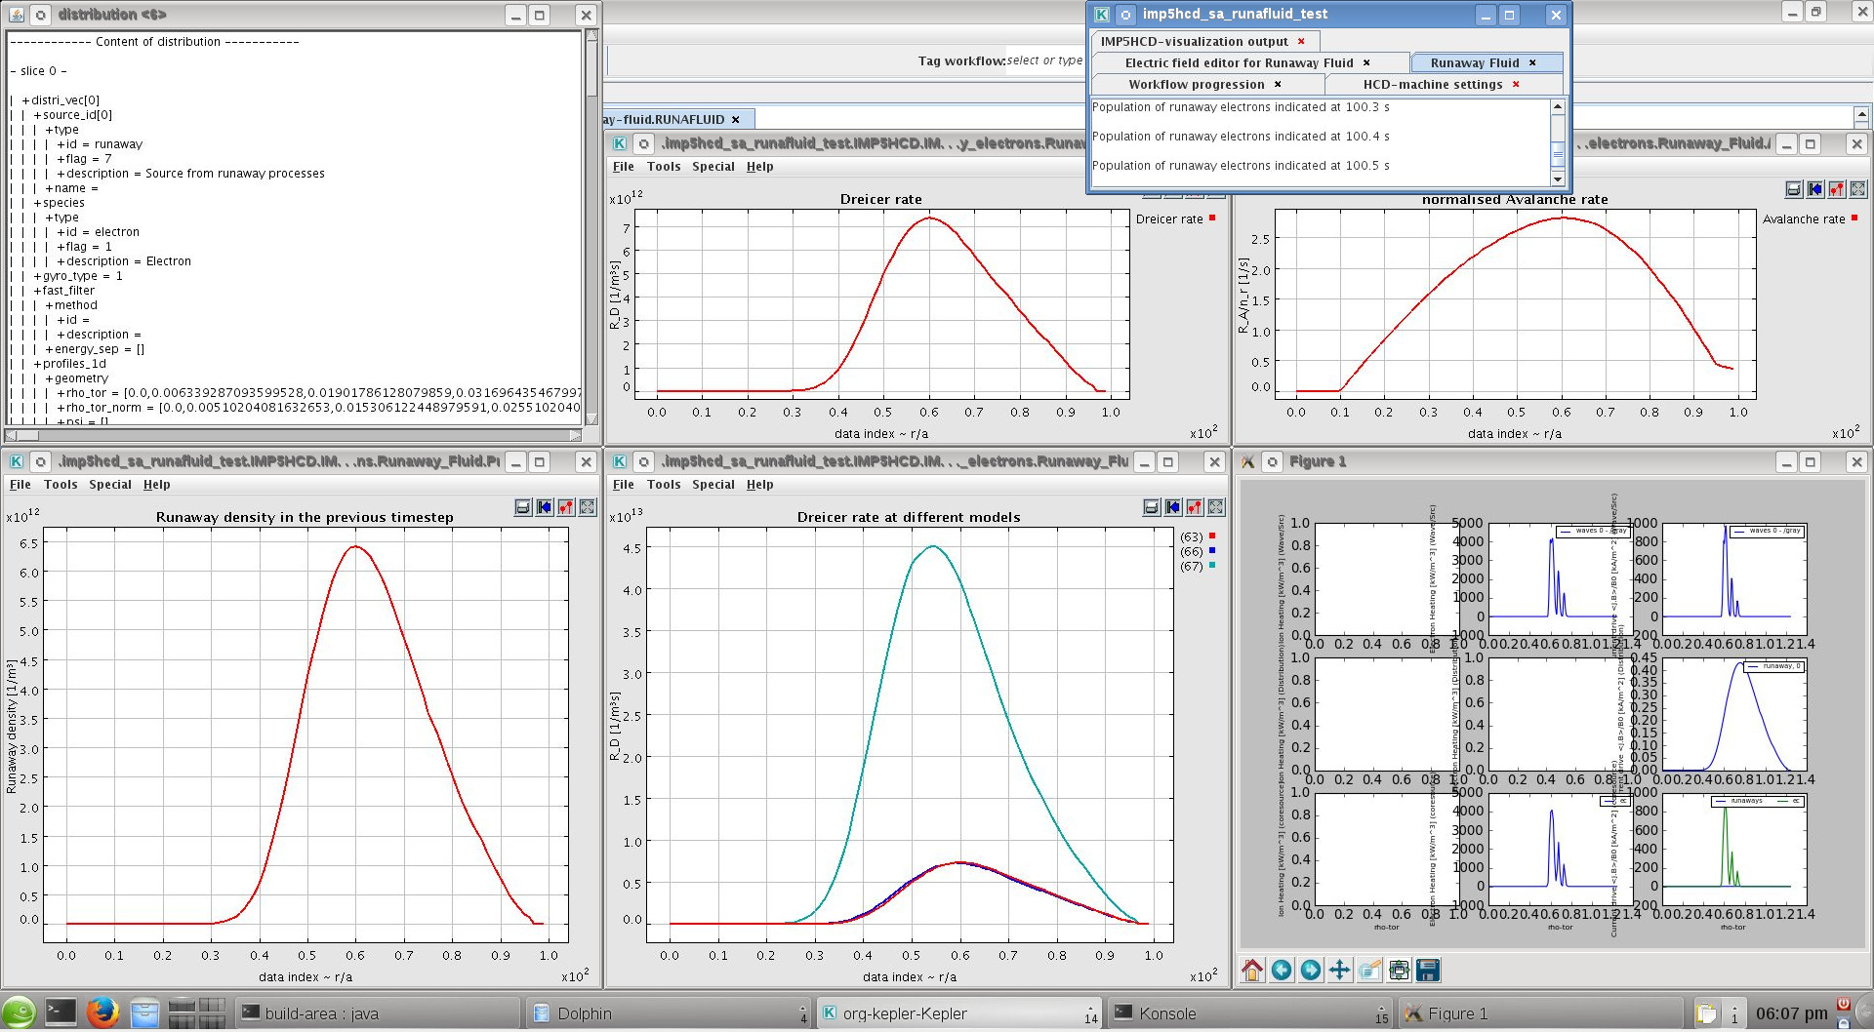

runafluid r1296
26 September 2016

Runaway Fluid
runafluid-test-workflow.xml

user_in | 'maradi'
machine_in | 'jet'
shot_in | 77922
run_in | 2044
dt_in | 0.1
starting_time | 48
stop | 1

Runaway Fluid parameters
runafluid_switch | 1111
Use_runafluid_parameter_editor | true
electric_field_switch | 1011
electric_field_value | 100
Te_switch | 1
Te_value | 1000
ne_switch | 1
ne_value | 1e19

Comment
Testing runafluid and comparing with go. Bug found in Dreicer field!

From GO:
S_67 = 4.1205e+21
S_R66 = 4.0080e+21
S_R63 = 4.0318e+21
S = 0.0206

From Runafluid:
S_67 =1.0089E18
S_R66 = 9.8138E17
S_R63 = 9.8723E17

E_D = 4.1823 V/m → used, but seems incorrect
E_D 2= 5.8478E-9 V/m
E_c = 0.0081847 V/m
ln lambda = 16.051

runafluid r1306
26 September 2016

Runaway Fluid
runafluid-test-workflow.xml

user_in | 'maradi'
machine_in | 'jet'
shot_in | 77922
run_in | 2044
dt_in | 0.1
starting_time | 48
stop | 1

Runaway Fluid parameters
runafluid_switch | 1111
Use_runafluid_parameter_editor | true
electric_field_switch | 1011
electric_field_value | 100
Te_switch | 1
Te_value | 1000
ne_switch | 1
ne_value | 1e19

Comment
Testing runafluid and comparing with go. Bug found in electron collision time!

From GO:
S_67 = 4.1205e+21
S_R66 = 4.0080e+21
S_R63 = 4.0318e+21

From Runafluid:
S_67 =1.0089E18
S_R66 = 9.8138E17
S_R63 = 9.8723E17

E_D = 4.1823 V/m
E_D 2= 4.1823 V/m
E_D 3 = 5.8478E-9 V/m
E_c = 0.0081847 V/m
ln lambda = 16.051

runafluid r1322
26 September 2016

Runaway Fluid
runafluid-test-workflow.xml

user_in | 'maradi'
machine_in | 'jet'
shot_in | 77922
run_in | 2044
dt_in | 0.1
starting_time | 48
stop | 1

Runaway Fluid parameters
runafluid_switch | 1111
Use_runafluid_parameter_editor | true
electric_field_switch | 1011
electric_field_value | 100
Te_switch | 1
Te_value | 1000
ne_switch | 1
ne_value | 1e19

Comment
Dreicer rate test with runafluid and comparing with go. Electron collision time FIXED!

From GO:
S_67 = 4.1205e+21
S_R66 = 4.0080e+21
S_R63 = 4.0318e+21

From Runafluid:
S_67 = 4.1205E21 1/m3s
S_R66 = 4.0080 E21 1/m3s
S_R63 = 4.0318E21 1/m3s

E_D = 4.1823 V/m
E_c = 0.0081847 V/m
ln lambda = 16.051
tau = 1.3740e21 s

runafluid r1322
26 September 2016

Runaway Fluid
runafluid-test-workflow.xml

user_in | 'maradi'
machine_in | 'jet'
shot_in | 77922
run_in | 2044
dt_in | 0.1
starting_time | 48
stop | 1

Runaway Fluid parameters
runafluid_switch | 1111
Use_runafluid_parameter_editor | true
electric_field_switch | 1011
electric_field_value | 100
Te_switch | 1
Te_value | 100
ne_switch | 1
ne_value | 1e19

Comment
Dreicer rate test with runafluid and comparing with go.

From GO:
S_67 = 2.6751e+15
S_R66 = 2.3460e+15
S_R63 = 2.3789e+15

From Runafluid:
S_67 = 2.6751e+15
S_R66 = 2.3460e+15
S_R63 = 2.3789e+15

runafluid r1322
26 September 2016

Runaway Fluid
runafluid-test-workflow.xml

user_in | 'maradi'
machine_in | 'jet'
shot_in | 77922
run_in | 2044
dt_in | 0.1
starting_time | 48
stop | 1

Runaway Fluid parameters
runafluid_switch | 1111
Use_runafluid_parameter_editor | true
electric_field_switch | 1011
electric_field_value | 10
Te_switch | 1
Te_value | 1000
ne_switch | 1
ne_value | 1e19

Comment
Dreicer rate test with runafluid and comparing with go.

From GO:
S_67 = 9.8763e+13
S_R66 = 2.6576e+13
S_R63 = 2.8068e+13

From Runafluid:
S_67 = 9.8763e+13
S_R66 = 2.6576e+13
S_R63 = 2.8068e+13

runafluid r1322
26 September 2016

Runaway Fluid
runafluid-test-workflow.xml

user_in | 'maradi'
machine_in | 'jet'
shot_in | 77922
run_in | 2044
dt_in | 0.1
starting_time | 48
stop | 1

Runaway Fluid parameters
runafluid_switch | 1111
Use_runafluid_parameter_editor | true
electric_field_switch | 1011
electric_field_value | 16
Te_switch | 1
Te_value | 400
ne_switch | 1
ne_value | 1e18

Comment
Avalanche rate test

ln lambda = 16.051
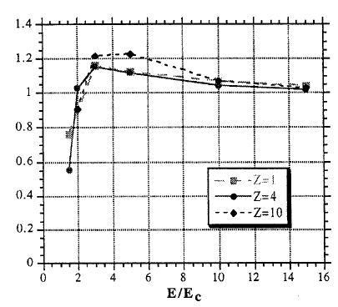
Rosenbluth et al, NF 37 (10) 1997, Fig 1.

