ETS runs for GO and more

9 December 2016

euitm_289060666
keplerworkflows/tags/ets_cc_split r814
ETS_WORKFLOW.xml
9 December 2016

USER | maradi | (General parameters in root)
machine | aug | (General parameters in root)
shot_in | 28906 | (General parameters in root)
run_in | 7 | (General parameters in root)
run_out | 666 | (General parameters in root)
tau | 0.01 | TAU | TAU_OUTPUT (BEFORE THE TIME EVOLUTION composite actor)  min_tau: Minimum time step [s] | max_tau: Maximum time step [s] (Numerics in root)
tbegin | 0 | (Times in root)
tend | 0.1 | (Times in root)

gausiansources parameters
CONVERGENCE LOOP. / Update SOURCE and IMPURITY / Gausian Sources / GaussianSourcesON. / gausiansources
Edit code parameters
currents
  JNITOT
  0.0E6RCURR | 0.0
  FWCURR | 2.0
  heating_el
  WTOT_el | 1.5E6
  RHEAT_el | 0.0
  FWHEAT_el | 0.2
  composition
  AMN | 2.0
  ZN | 1.0
  ZION | 1.0
  heating
  WTOT | 1.5E6
  RHEAT | 0.0
  FWHEAT | 0.2
  particles_el
  STOT_el | 2.0E22
  RPART_el | 0.0
  FWPART_el | 1.0
  particles
  STOT | 0.0E21
  RPART | 0.0
  FWPART | 1.0
momentum
UTOT | 0.0
RMOM | 0.0
FWMOM | 1.0

Runaway Fluid parameters
CONVERGENCE LOOP. / Update SOURCE and IMPURITY
Configure
Use_Runaway_in | false
runafluid_switch | 1111

CONVERGENCE LOOP. / Update SOURCE and IMPURITY / HCDSources / HCDSourcesON. / HCD_COREWithout internal params, i.e. all settings come as globalparameters set on an upper level / Distribution(one time slice distributionfuctionevaluation) / Elektron Fokker–Planckone time slice / Runaway electronsone time slice Runaway_Fluid_package
Configure
Use_runafluid_electric_switch | false
runafluid_electric_field_switch | 1011
runafluid_electric_field_value | 10

Steady state ETS run with default parameters
t = 0.01 s
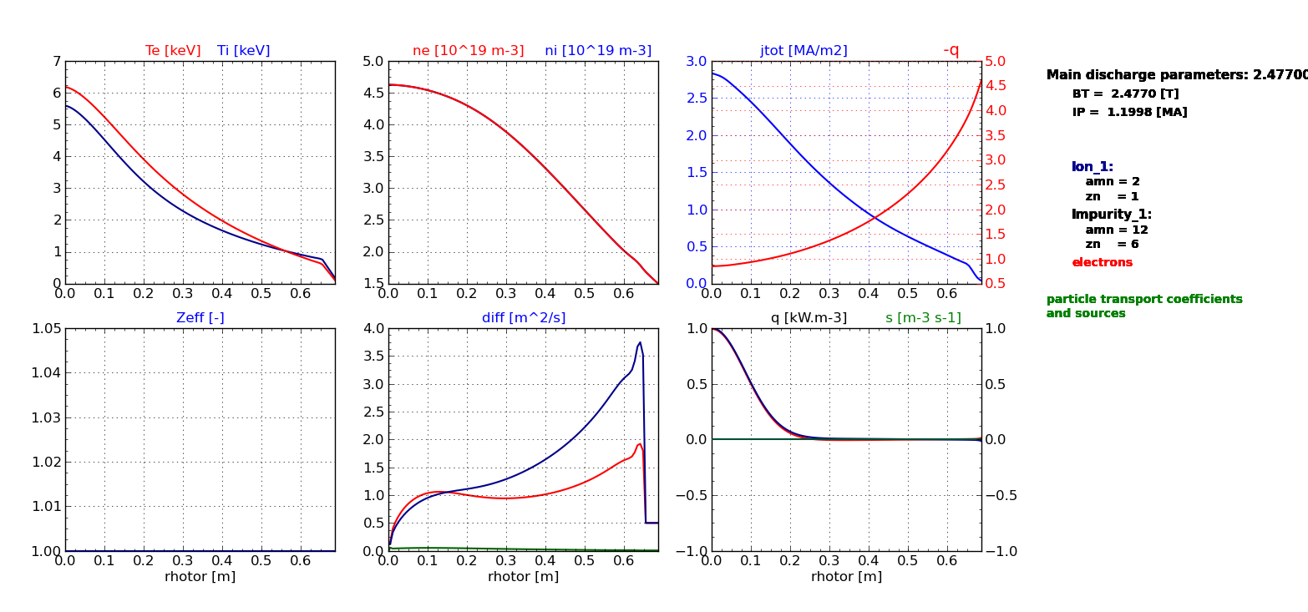

t = 0.1 s
