Bug Report

Bug ID: 001

Description:
No error message is displayed when username and password text box remain empty.

Steps to Reproduce:
- Open the application.
- Empty username and password click on submit.
- Enter username and empty password, click on submit.

Actual Result:
On step 2 and 3, user do not receive any error message prompting the issue.

Expected Result:
User should be prompted that values are missing from the respective fields.

Screenshot:

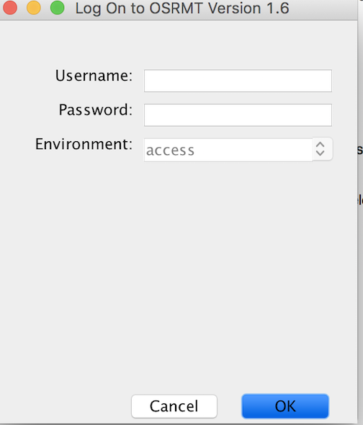

Bug ID: 002

Description:
Error message should be generic in nature rather than specific.

Steps to Reproduce:
- Open the application.
- Empty username and enter correct password, click on submit.
- Enter correct username and incorrect password, click on submit.

Actual Result:
On step 2, user received “invalid username” error message.
On step 3, user received “invalid password” error message.

Expected Result:
Error message should be generic in nature. In either case it should be “Invalid username or password” which can protect user from unauthorized login.

Screenshot:

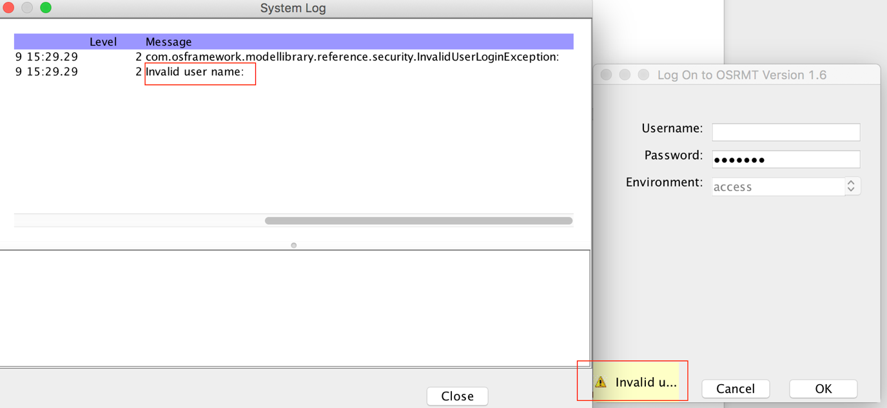
Bug ID: 003

Description:
There is an artifact but when I try to delete it from the parent folder it shows ‘0’ artifacts found.

Steps to Reproduce:
- Open the application and login.
- Create ‘New Product’
- Right click on “Feature” > “New” > “Feature”
- Enter the value in respective fields and click on “Apply”
- Under “Feature”, one artifact should be created.
- Now click on “Feature” and click on “Delete” icon present on the bar.

Actual Result:
After user click on “Delete” icon it shows a pop up with the message “Delete 0 artifacts found”. Also, clicking on “Yes” do not delete the child artifact.

Expected Result:
User should be able to delete all artifacts present under the parent using the above steps.

Screenshot:

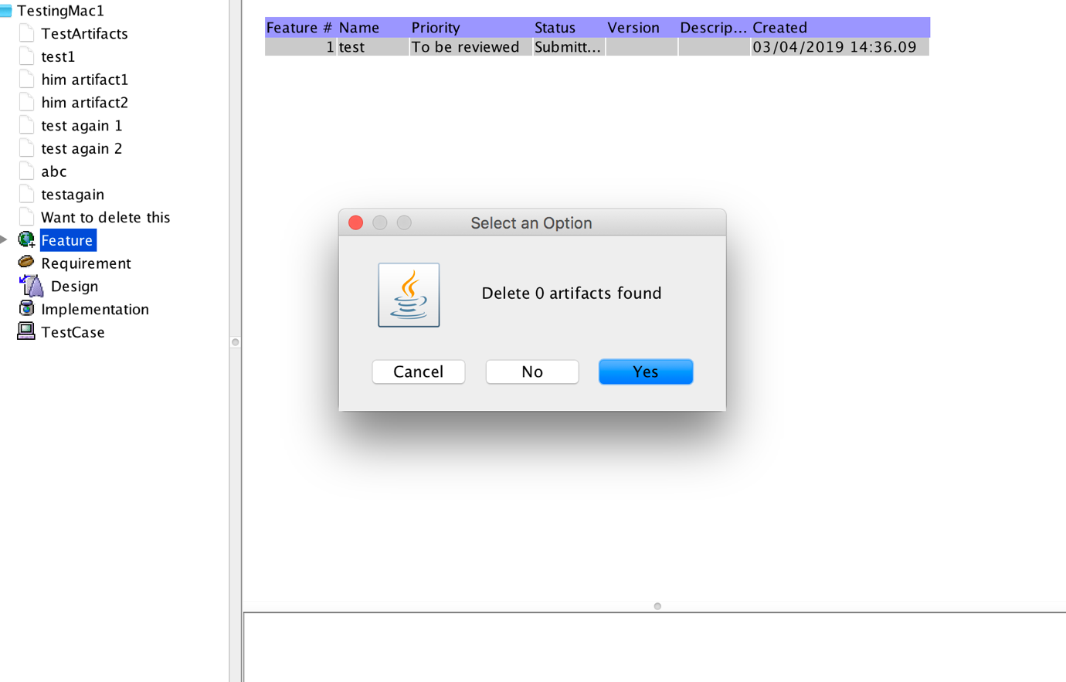
Bug ID: 004

Description:
Blank artifact shows irrelevant screen.

Steps to Reproduce:
- Open the application and login.
- Create ‘New Product’
- Observe that artifacts are present. (Feature, Requirement, etc.)
- Double click on any artifact.

Actual Result:
Irrelevant screen is shown to user as there is no artifact is added under it.

Expected Result:
Some useful information should be provided to user so that user can proceed with adding information to it.

Screenshot:

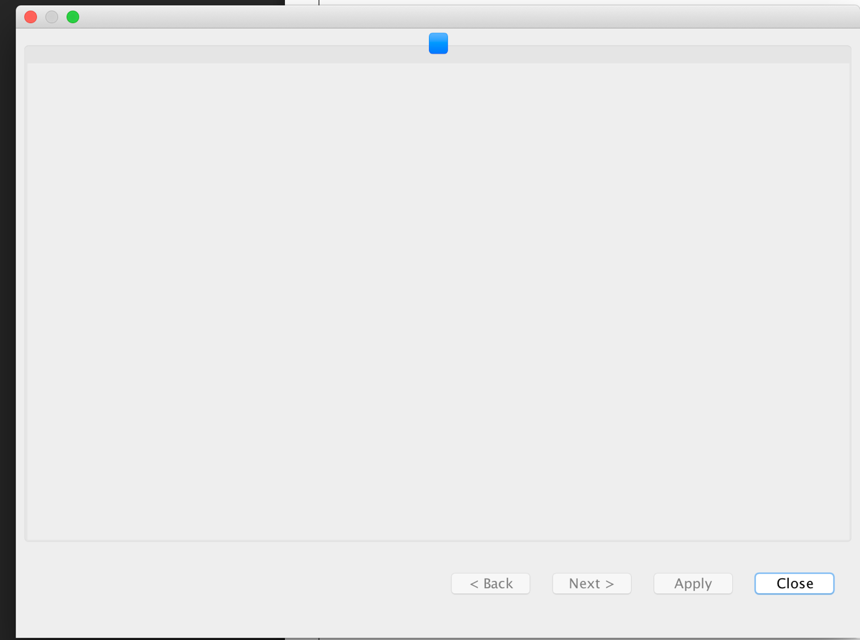
Bug ID: 005

Description:
Under Test cases, clicking on “Apply” present under Steps section gives non user friendly error

Steps to Reproduce:
- Open the application and login.
- Create ‘New Product’
- Right click on “TestCase” > “New” > “TestCase”
- Enter values in all the fields including “Steps” and click on “Apply”.
- Click on “Ok” on the pop up and observe the error.

Actual Result:
Some error like “UCAExc:::4.0.4 integrity constraint violation: foreign key no parent; REQUIREMENT_TREE_ARTIFACTREQUIREMENT_TREE1 table……” is displayed.

Expected Result:
Some useful error message should be provided to the user so that user can rectify the mistake.

Screenshot:

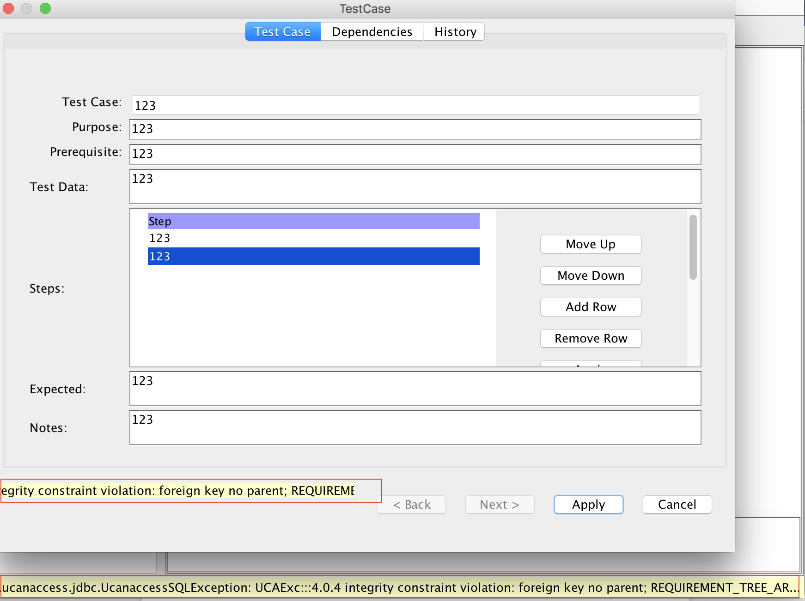
Bug ID: 006

Description:
Under Test cases, not able to proceed after putting steps in test cases.

Steps to Reproduce:
- Open the application and login.
- Create ‘New Product’
- Right click on “TestCase” > “New” > “TestCase”
- Enter values in all the fields including “Steps” and click on “Apply”.
- Click on “Ok” on the pop up.

Actual Result:
Some error message is shown, and user is not able to proceed further.

Expected Result:
User should be able to proceed without any error.

Screenshot:

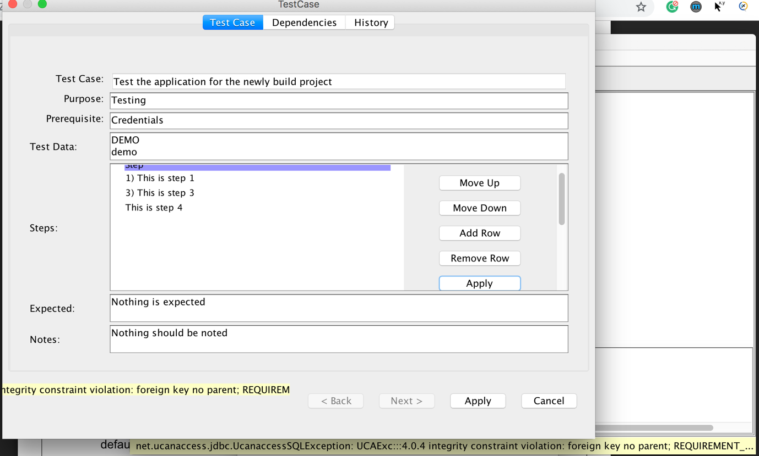

Bug ID: 007

Description:
Improper screen to configure forms.

Steps to Reproduce:
- Open the application and login.
- Under System > Form, select any form.
- Observe the form configuration.

Actual Result:
Width of the configuration section is too less. User can’t see the values and it is bit difficult to play around it.

Expected Result:
Section should be properly visible to give good user experience.

Screenshot:

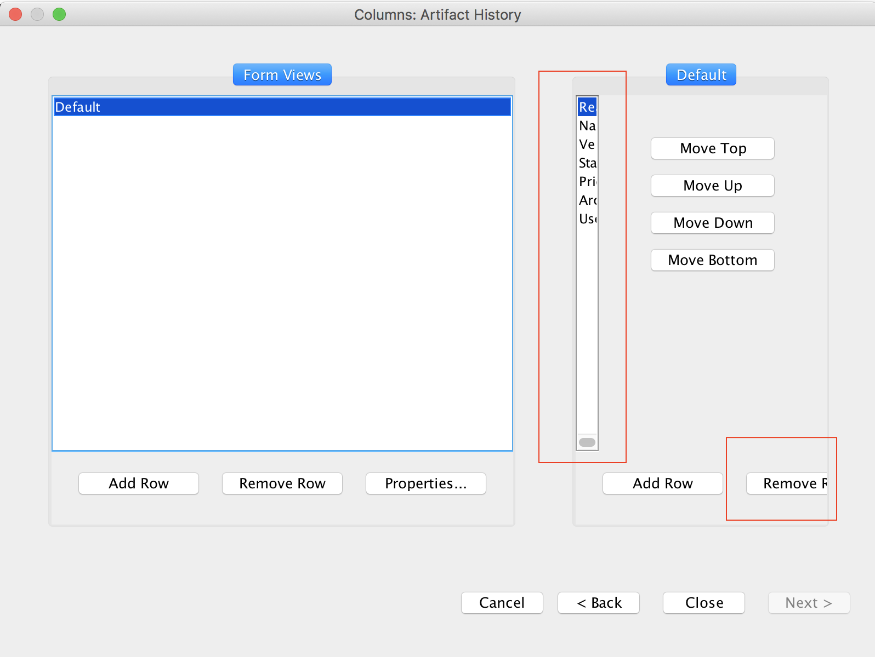
Bug ID: 008

Description:
Export reference not working.

Steps to Reproduce:
- Open the application and login.
- Under “System,” click on “Export reference”

Actual Result:
After clicking, screen get freeze for few seconds and no operation takes place.

Expected Result:
It should download reference.

Screenshot:

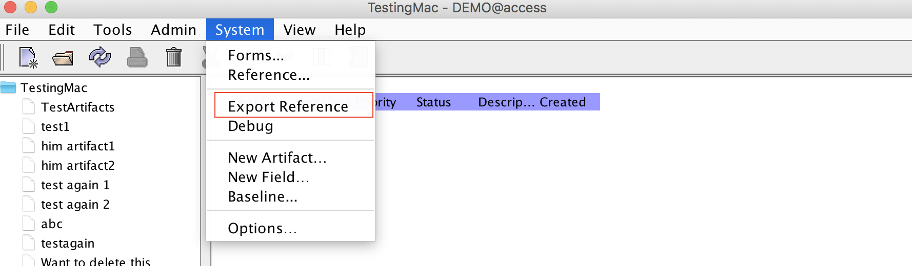
Bug ID: 009

Description:
If artifact is not present, ‘Edit’ option should be greyed out.

Steps to Reproduce:
- Open the application and login.
- Create “New Product”
- Right click on “Requirements”.

Actual Result:
Observe that “Edit” option is visible and clickable. Although after clicking on “Edit” nothing happens.

Expected Result:
“Edit” option should be greyed out if no artifact is added.
Screenshot:
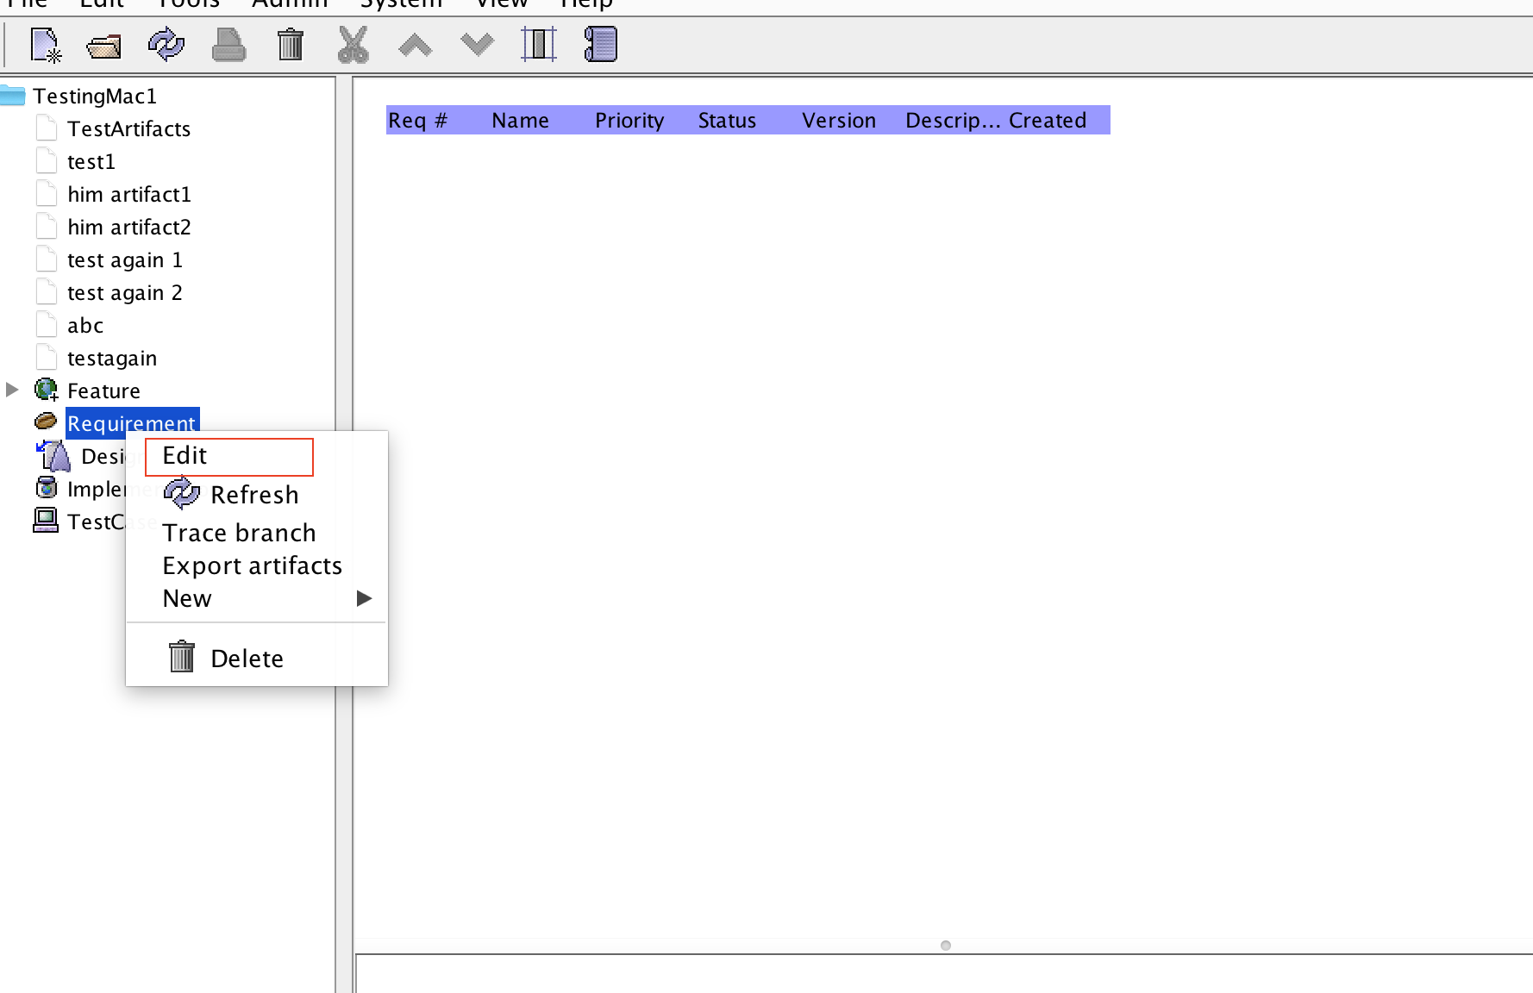
Bug ID: 010

Description:
No option to delete new added artifact.

Steps to Reproduce:
- Open the application and login.
- Create “New Product”
- Go to “Systems” > “New Artifact” > Enter Name > Select to copy fields

Actual Result:
- Once added, user is not able to delete it.
- By default, it remains the part of all the new products.

Expected Result:
- User should be authorized to delete the newly created artifacts.
- User should be able to configure it as per the product.

Screenshot:
