Bug Report

Bug ID: 011

Description:
Not able to upload attachments.

Steps to Reproduce:
- Open the application and login.
- Create ‘New Product’
- Right click on “Feature” > “New” > “Feature”
- Fill in the details and try to attach a file in “attachments”.

Actual Result:
Not getting any option to upload attachment.

Expected Result:
User should get some option to upload the attachment.

Screenshot:

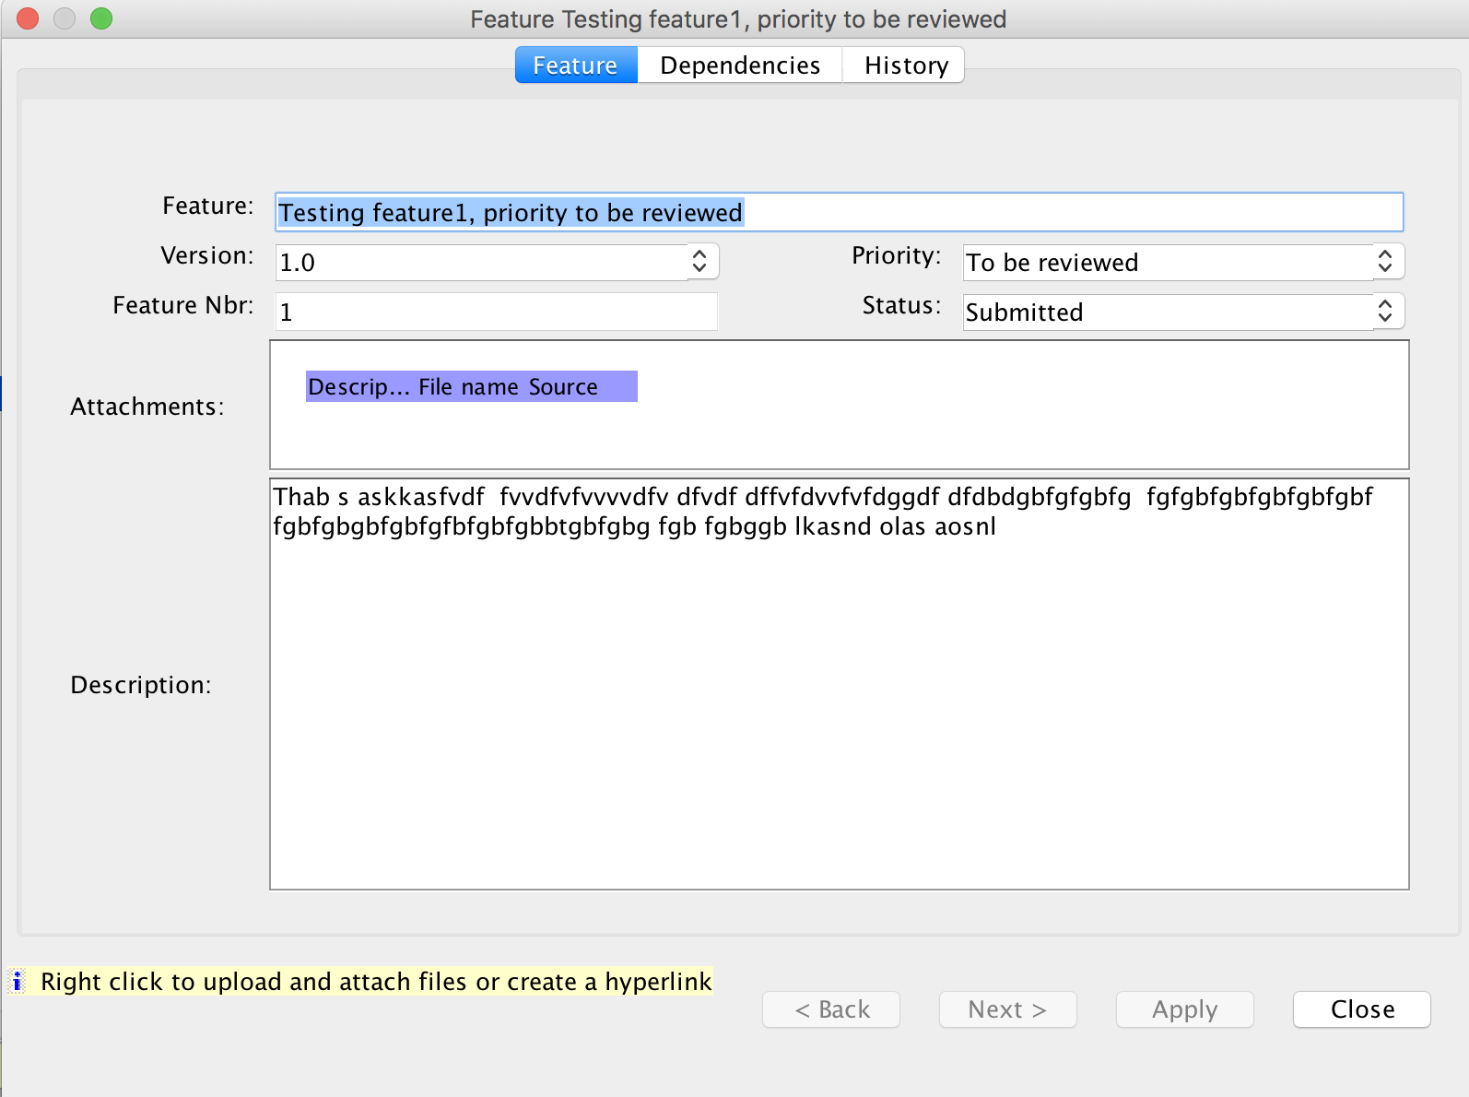

Bug ID: 012

Description:
Not able to download report. (Neither PDF not HTML)

Steps to Reproduce:
- Open the application and login.
- Open the project created > Click on “Tools” > Click on “Report”
- Select the Report > Click “Next” > Select “PDF”/”HTML”

Actual Result:
Error message displayed.

Expected Result:
It should download PDF/HTML.

Screenshot:

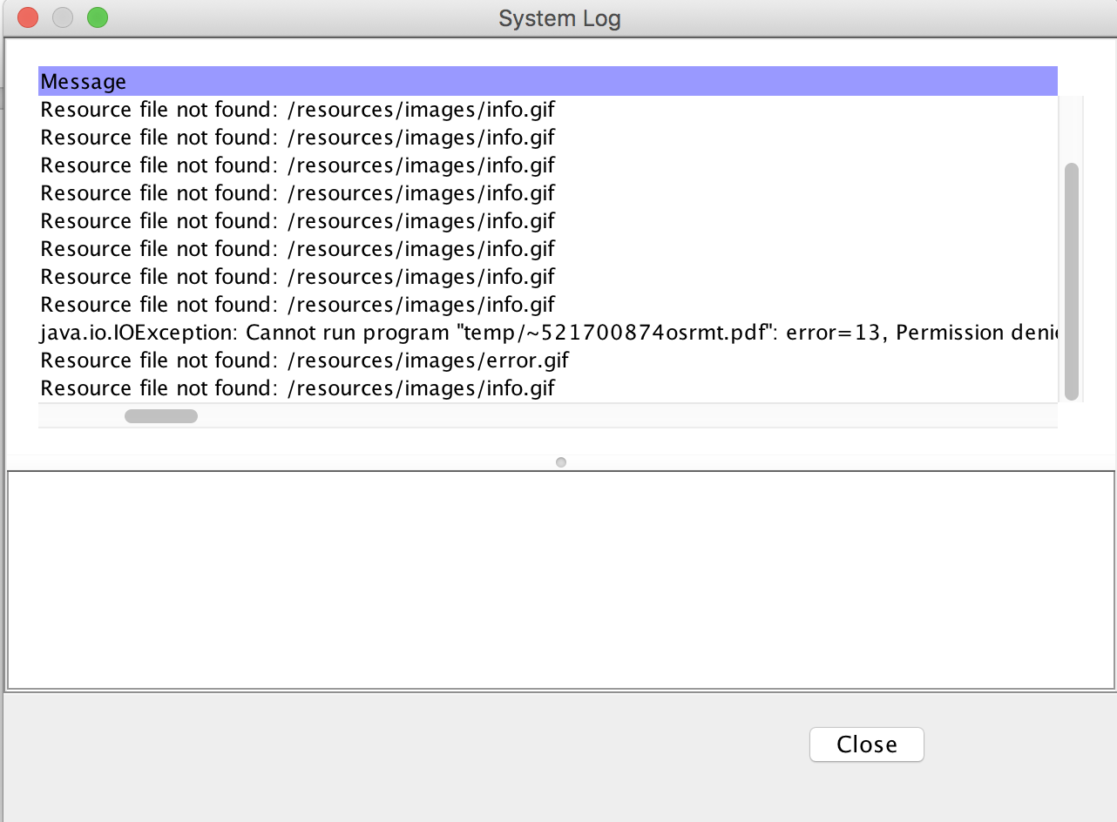

Bug ID: 013

Description:
No option to provide location to export the product.

Steps to Reproduce:
- Open the application and login.
- Open the project created.
- Click on “File” > “Export”

Actual Result:
Observe that “Export to” do not have any browse button.

Expected Result:
User should have an option to export the product.

Screenshot:

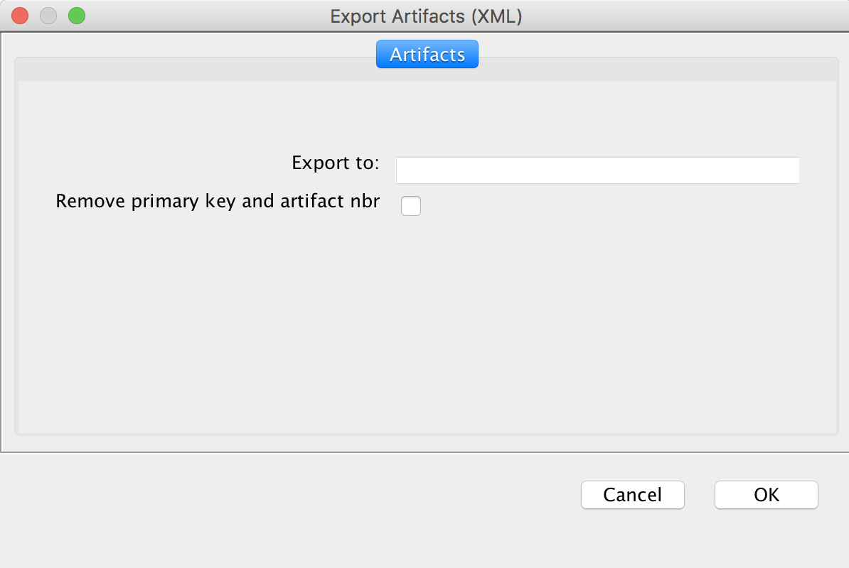

Bug ID: 014

Description:
No option to provide location to import the product.

Steps to Reproduce:
- Open the application and login.
- Open the project created.
- Click on “File” > “Import”

Actual Result:
Observe that “Import file” do not have any browse button.

Expected Result:
User should have an option to import the product.

Screenshot:

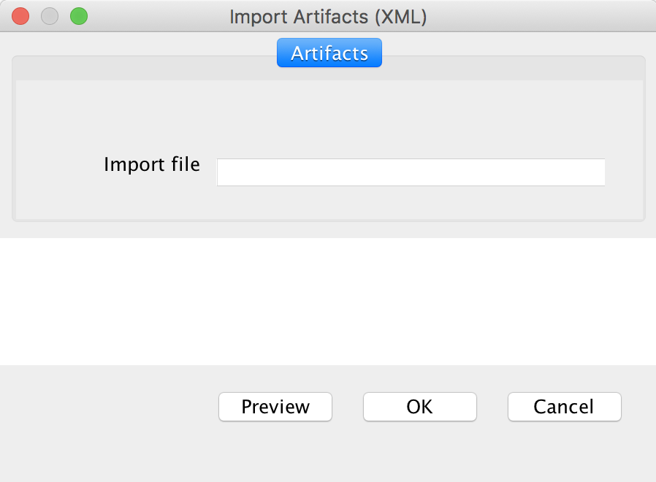

Bug ID: 015

Description:
Traceability not getting deleted.

Steps to Reproduce:
- Open the application and login.
- Open the project created.
- Create ‘feature’
- Create ‘requirement’
- Click on traceability > Under traceability, open different project > Trace feature for requirement.
- Now try to delete this trace.

Actual Result:
Not able to delete it.

Expected Result:
User should able to delete it.

Screenshot:
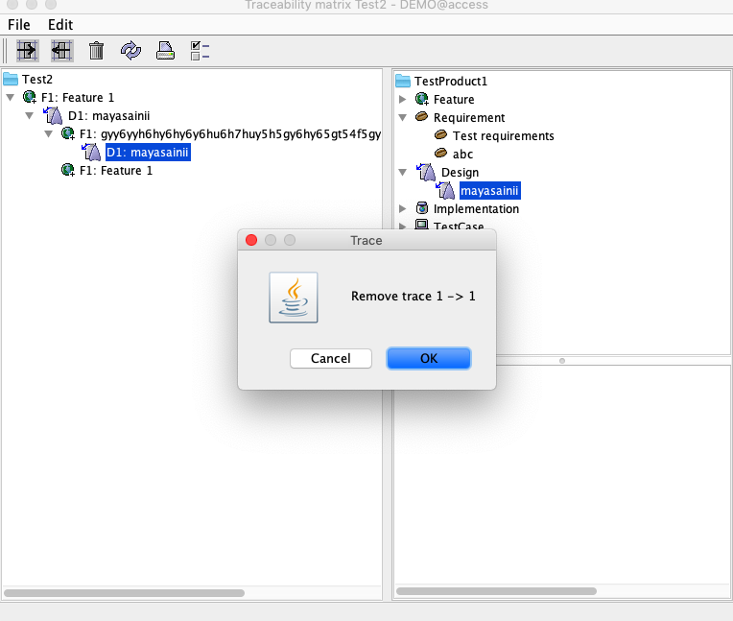
Bug ID: 016

Description:
Print icon on the bar is has similar functionality as Report. Is it acceptable?

Steps to Reproduce:
- Open the application and login.
- Open the project created.
- Click on print icon.

Actual Result:
Print icon on the bar opens the report section

Expected Result:
Not sure if the actual results is the expected one

Screenshot:
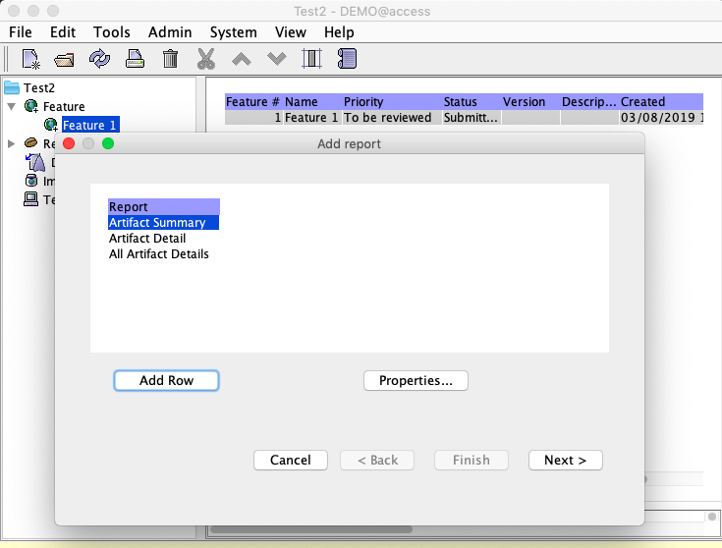
Bug ID: 017

Description:
Not able to Trace from same product.

Steps to Reproduce:
- Open the application and login.
- Open the project created.
- Create ‘feature’
- Create ‘requirement’
- Click on traceability > Under traceability, open same project > Trace feature for requirement.

Actual Result:
Not able to trace with in the same project.

Expected Result:
If option is present then user should be able to trace it.

Screenshot:

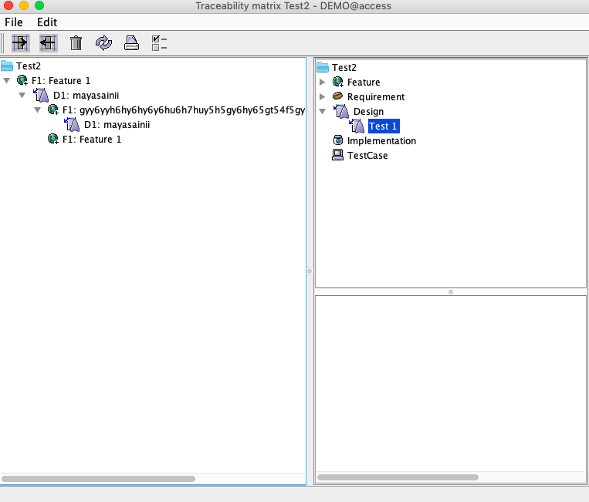
Bug ID: 018

Description:
Not sure why cut icon is there as icon. Not able to use it.

Steps to Reproduce:
- Open the application and login.
- Open the project created.
- Try to click on cut icon.

Actual Result:
Cut icon always remain disabled.

Expected Result:
There should be option when this icon can be used.

Screenshot:

