# Technical Paper Format for the Hamlyn Workshop “Open-Source Software in Surgical, Biomedical and AI Technologies”

## A.N. Author1, A Co-author1, B Co-author2

### 1Institute for xxx, University XXX,

### 2Institute for xxx, University Hospital XXX a.n.author@abc.edu

#### Introduction

The Hamlyn Workshop on “Open-Source Software in Surgical, Biomedical and AI Technologies” is held at the Royal Geographical Society. Conveniently located in the heart of central London, the symposium venue is within a close proximity to the landmarks, museums and Royal parks of London.

#### MATERIALS AND Methods

Topics to be addressed by the workshop include, but are not limited to: (1) Open-source software/hardware libraries and frameworks for surgical and biomedical sciences (2) Open-source AI solutions for surgical and biomedical sciences (3) Open-source software/hardware regulations in clinical sciences (4) Maintaining and supporting surgical and biomedical software/hardware (5) Incorporating open-source software/hardware in clinical trials (6) Open-source software/hardware solutions for low to middle-income countries (7) Case studies showcasing novel applications and combinations of existing open-source software and hardware, and (8) Project summaries, methodological approaches, research findings, and initiatives related to Open-Source Software for Surgical Technologies.

#### Results

Your submission should be no more than 2 pages to include the following sections: INTRODUCTION, MATERIALS AND METHODS, RESULTS, DISCUSSION and REFERENCES.

* **Length:** Maximum of A4 2 pages;
* **Paper size:** DIN A4 Size (210 mm x 297 mm);
* **Rand:** Leave a 25mm margin at top and bottom of the page, and a 20mm margin at left and right sides;
* **Page-Layout:** Set the text in two columns of 80 mm width, with a central separation of 10mm;
* **Font properties and size:** Title: 14 pt, bold; Authors: 14 pt, normal; Institute + E-mail address: 12 pt, italics; Section headings: 10 pt, Capitals, bold; Text: 10 pt, normal; Figure captions and references: 9pt, normal.

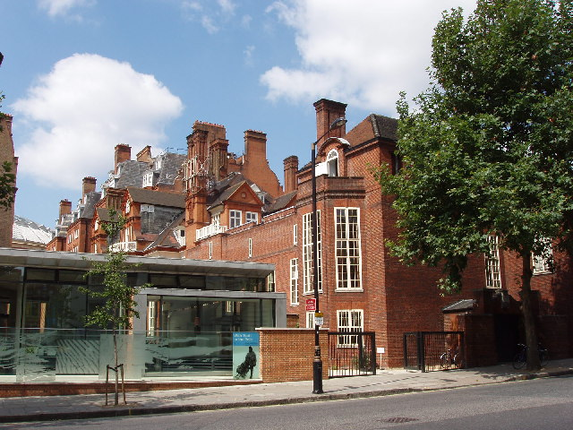

**Fig. 1 Founded in 1830, the Royal Geographical Society is a world centre for geography: supporting research, education, expeditions and fieldwork, and promoting public engagement and informed enjoyment of the world.**

#### Discussion

Completed papers should be submitted as a pdf-file via the online submission at: <https://openreview.net/group?id=hamlynsymposium.org/Hamlyn_Symposium/2025/Workshop/OSS_in_SurgTech#tab-recent-activity>

Please contact the following e-mail address with any questions: s.chopra@ucl.ac.uk

#### REFERENCES

[1] Author AN, Co-Author B. The Transformation of Open Source Software. MIS Quarterly, Vol. 30, No. 3 (Sep., 2006).

[2] Co-author B. Open source licensing and business models. THE ICFAI JOURNAL OF KNOWLEDGE MANAGEMENT 7 (2009): 68-94.