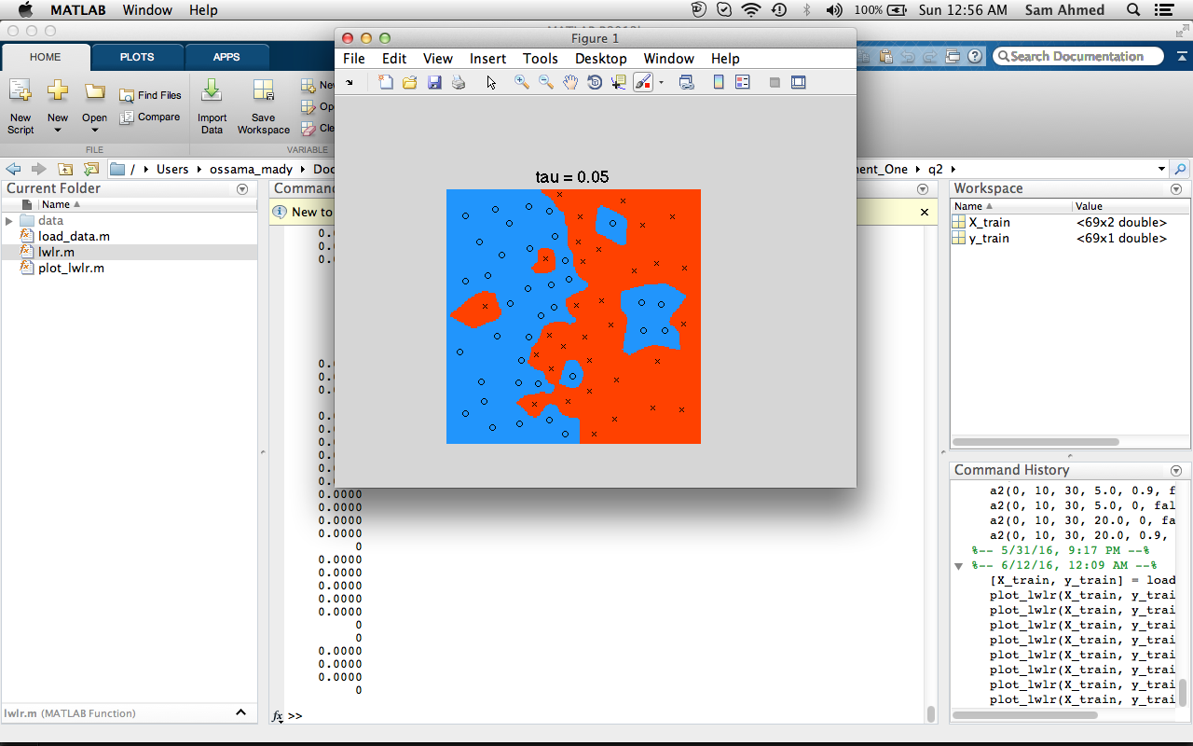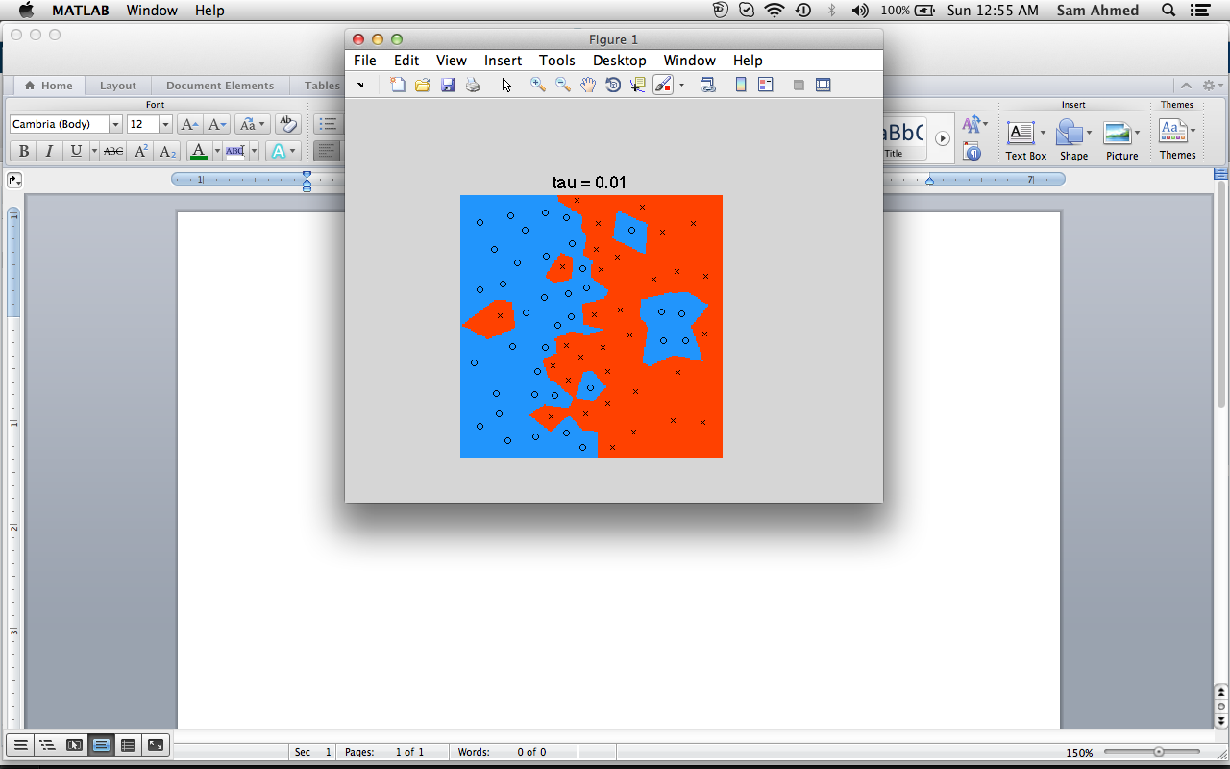

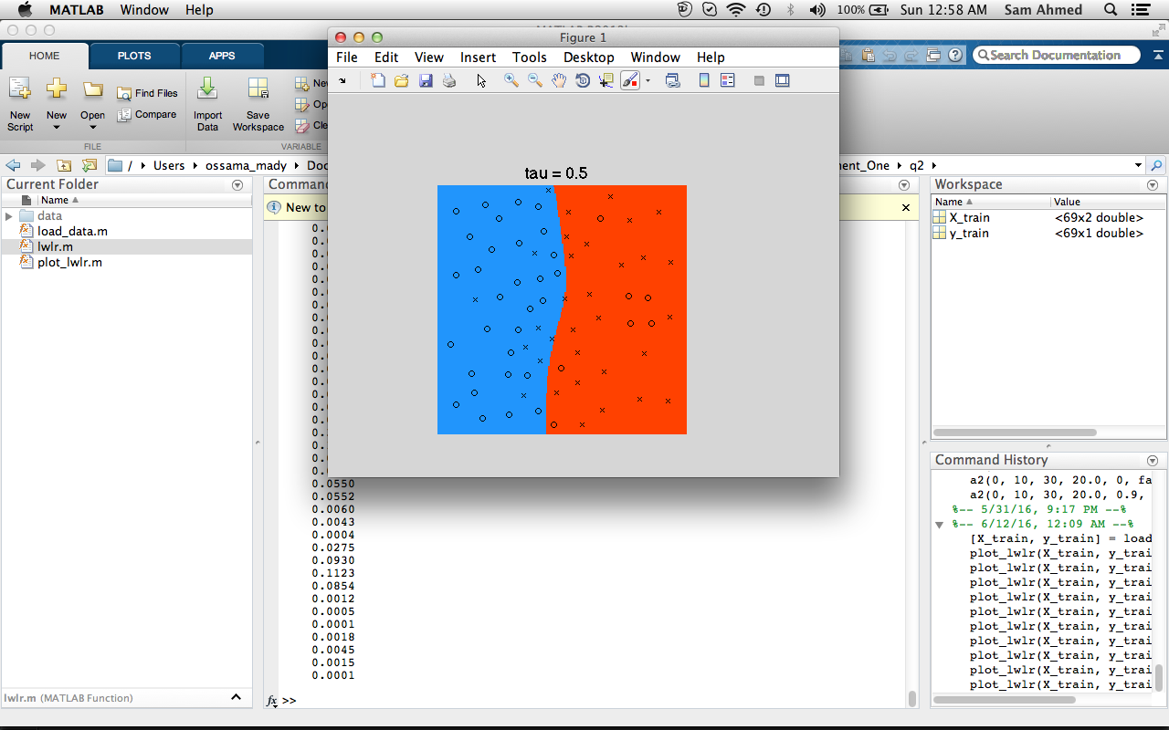

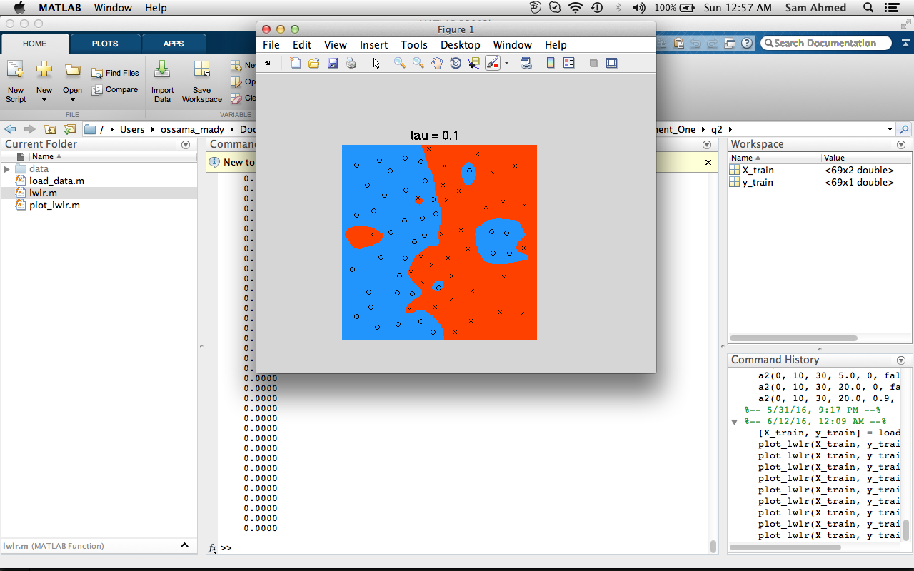

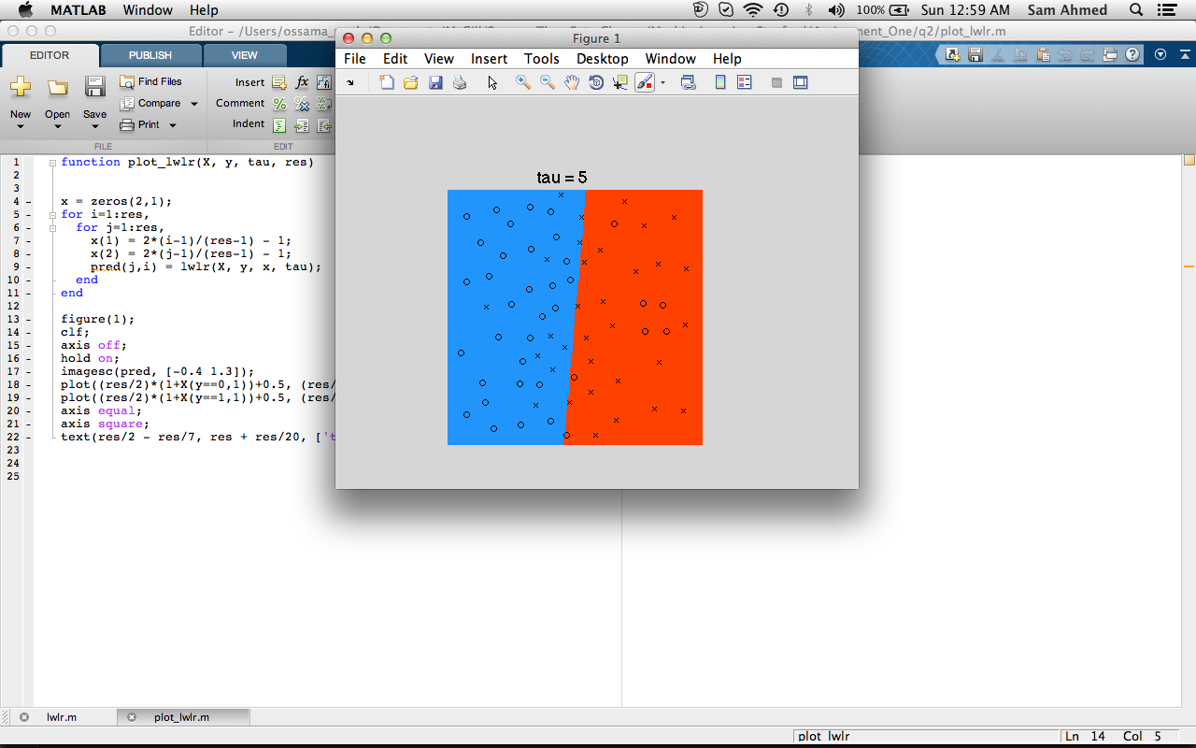

The parameter Tau is responsible for the over fitting of our model, with small Tau’s the model appears to over fit the data. When Tau grows, the decision boundary becomes smoother, eventually converging to the unweighted linear regression solution.