Revision History
Version | Author | Reviewer | Description of change | Release date
4.1 | MJR |  | * Revision + Evolution of the CISO role + Style updates. | 31/05/2023
4.2 | MJR |  | * Removal of all references to the internal auditor.  * Rewording of the chapter “Management by the audit manager of the audit-related directory.” | 27/06/2023
4.3 | MJR |  | * Minor corrections. | 06/07/2023
4.4 | MJR |  | * Added SAS operating procedure.  * Added reverse-shell operating procedure | 27/07/2023
4.5 | MJR |  | * Added control of the penetration testing tools list. | 09/08/2023
4.6 | MJR |  | * Evolution of the control of the penetration testing tools list. | 22/08/2023
4.7 | MJR |  | * Update of PTAUD-M03. | 07/09/2023
4.8 | MJR |  | * Changes following the discontinuation of the exception (waiver) practice. | 19/09/2023
4.9 | MJR |  | * Added the “Use of ZEDPRO” paragraph.  * Added the “Use of Flipper0” paragraph. | 06/08/2024
4.10 | MJR |  | * Modified the “SAS key” chapter to indicate the operating instructions for the SAS.  * Modified the “Summary of secrets held by an auditor” chapter to add that an auditor may hold an access account to the decontamination SAS.  * Added a note at the end of “Password customization” regarding the decontamination SAS.  * Minor correction to the “Sequencing of actions at the end of the audit” diagram | 07/10/2024
4.11 | MJR |  | * Added an instruction that pentesters must enable the launch of the audit trace collection batch via the exec bash command. | 11/10/2024
4.12 | MJR |  | An auditor does not have a personal access account to the decontamination SAS. They use the admin access account, which is therefore a shared account. | 14/10/2024
4.13 | MJR |  | * Zero has been replaced by Windows Eraser (2.4). | 31/10/2024
4.14 | MJR |  | * Removed the paragraph about activating the script from the terminal when performing a penetration test. This paragraph has been moved to the penetration testing methodology. | 25/02/2025
4.15 | MJR |  | * Updated following the move to ON-X and the update of the risk analysis. | 07/10/2025
4.16 | MJR |  | * Externalization of the procedure for privatizing the OPS3 room in the PASSI zone (premises). | 24/11/2025
4.17 | MJR |  | * Following the addition of the administrator workstation. | 02/02/2026
V5 | MJR |  | * Adaptation following the evolution of the 2026 PASSI IS. | 29/04/2026
V5.1 | MJR |  | * A few omissions corrected following the adaptation.

Table of Contents
1 Introduction 3
2 PASSI IS Usage Rules 4
2.1 Physical Security of the PASSI IS 4
2.1.1 Premises 4
2.1.2 Location and Protection of Equipment 4
2.1.3 Use of the Safe 5
2.1.4 Use of the Shredder 5
2.2 Types of Connections 5
2.3 Connection of Unlisted Equipment 5
2.4 Use of Workstations 5
2.4.1 Auditor Workstations 5
2.4.1.1 Principles 5
2.4.1.2 Pentester Workstations 6
2.4.1.3 Writer Workstations 7
2.4.2 Use of ZEDPRO 7
2.4.2.1 Creation of a Container Associated with the Assignment 7
2.4.2.2 Naming Convention for the Container Associated with the Assignment 7
2.4.3 Use of a Writer Workstation by the CISO 8
2.5 Final Check by the CISO 8
2.6 Use of Keys 9
2.6.1 Auditor Key 9
2.6.2 SAS Key 10
2.1 Use of Flipper0 10
2.2 Virus Protection 10
2.2.1 Overall Protection of the PASSI IS 10
2.2.2 Protection Specific to Auditor Workstations 11
2.1 Backups 12
2.1.1 Backups by Auditors During an Audit 12
2.1.2 Backups by the CISO at the End of an Audit 12
2.2 Use of the Printer 12
2.3 Secrets Management 12
2.3.1 Summary of Secrets Held by an Auditor 12
2.3.2 Associated Rules 13
2.3.3 Password Customization 13
2.4 Secure Deletion of Documents and Information 13
2.5 Document Transfers via Email 14
2.6 Updating the List of Penetration Testing Tools 14

Introduction
All On-X employees are required to comply with the internal regulations as well as the IS usage charter annexed to them. This IS usage charter in turn requires employees to consult the CoESSI P&N (Policies & Standards) documents made available to them, and to comply with the rules it sets out. Failure to comply with these rules constitutes misconduct on the part of employees that may result in disciplinary sanctions.
UTI-M03 : Failure by an employee to comply with a rule set out in the CoESSI P&N repository constitutes misconduct that may result in disciplinary sanctions.
This document, part of the CoESSI P&N, specifically describes the rules to follow and the behaviors to be respected by users of the PASSI IS, namely:
- PASSI auditors.
- The CISO of the PASSI IS, in their capacity as the party responsible for PASSI qualification.
- The PASSI IS administrator.
It references, identically, part of the measures listed in the PASSI IS risk analysis, and any update must be made consistently.
It is supplemented by quick-reference guides also made available in the CoESSI P&N repository.
UTI-M04 : Provision to users of quick-reference guides summarizing the rules to follow for the proper use of the PASSI IS.

PASSI IS Usage Rules

Physical Security of the PASSI IS

Premises
The management of the premises is covered by a specific procedure:
Document to consult:
CoESSI_P&N_Interactions with the On-X Group Security Office.docx
OPS3-M01 : Access control to the OPS3 room, a room privatized for conducting a PASSI audit.

Location and Protection of Equipment
The PASSI IS machines are dedicated to this IS and must not be used for other activities. They may only be located:
- In the PASSI zone, under the responsibility of an auditor when an audit is underway, or of the administrator when they are being administered.
- Outside ON-X premises, under the responsibility of an auditor.
- In the safe, in room LT-A, when not in use.
PASSI computers must not be separated from their privacy filter. Laptop PCs must not be separated from their security cable. These PCs must always be secured, except when being transported.
LOC-M03 : PASSI machines dedicated to the PASSI IS.
ORD-M03 : Use of privacy filters on screens.
PTAUD-M03 : Use of security cables to secure auditor workstations; a PC without a security cable must not be left unattended, even momentarily.
PTAUD-M02 : Return to the safe, by the administrator, of auditor workstations no longer used for any audit; the workstations must be accompanied by their security cable and their privacy filter.

Use of the Safe
In room LT-A there is a safe, the access mechanism of which is held by the Cybersecurity Sales Director. The following are kept locked inside:
- Unused equipment (at the request of the IS administrator):
  - Auditor workstations with their security cable.
  - Auditor keys.
- Paper documents containing confidential information, and in particular confidential information related to audits performed (at the request of audit managers).
- The backup envelope containing all the secrets needed for the operational maintenance (MCO) of the PASSI IS.
- The external media used for backups.
LTA-M04 : Storage of unused equipment and secrets in the safe.
RSSI-M11 : Backup envelope in the safe, containing the ADM backup keepass and the CISO backup keepass, with their emergency sheets.
Document to consult: CoESSI_P&N_Backup Envelope PASSI IS_V2 (2026)

Use of the Shredder
A shredder is located in the OPS3 room; it must be used to dispose of all paper documents containing confidential information.
DOC-M04 : Presence of a document shredder within the PASSI zone.

Types of Connections
The PASSI IS does not have Wi-Fi access, and only wired connections are possible. Remote access is neither available nor authorized.
RES-M10 : No Wi-Fi access to the PASSI network, only wired connections are possible.

Connection of Unlisted Equipment
Auditors are prohibited from connecting any equipment to the PASSI network, other than the pentester workstation assigned to them (if they are a pentester); they are prohibited from connecting to an auditor workstation any key other than the auditor key assigned to them.
SYS-M03 : Auditors are prohibited from connecting to the PASSI network any equipment other than that listed within the PASSI IS.

Use of Workstations

Auditor Workstations

Principles
Auditor workstations are uniform, not personalized, and the same workstation may be used successively by different auditors.
Auditor workstations are provided by the PASSI IS administrator at the start of the audit, at the request of the audit manager. Two types are distinguished:
- Pentester Workstations : Reserved for pentesting activities (one workstation per pentester). These workstations may be sent to client sites and connected to a client IS. They are not DR (Disaster Recovery).
- Writer Workstations : Reserved for the office activities of auditors and the CISO. Writer workstations may potentially be shared by several auditors. They may be sent to client sites to progress the drafting of deliverables, but must under no circumstances be connected to any IS.

Pentester Workstations
Pentester workstations run DEBIAN. They contain a pentest template VM, copied there by the administrator.
An auditor assigned to a pentest must create their own pentest system. To do this, they create a clone of the pentest template VM, then customize it:
- Customization of the password for the root and pentester accounts.
- Modification of the operating system name (osName) following this naming convention: <idMission>_<auditorName>, so that it is unique on the network.
PTPEN-M01 : Provision by the administrator to auditors, on the auditor workstations, of a pentest template VM.
The host system of pentester workstations serves no purpose other than to host the pentest systems. It also makes it possible to locate the residue of pentesting activities in a single location (the VM), which will be destroyed at the end of the audit, thereby ensuring that no trace related to the client IS remains on the workstation.
Pentesters are administrators of the host system of the pentester workstation. However, they are prohibited from modifying its standard configuration, and in particular from installing software on it (downloaded from the Internet or developed personally or by a third party) or copies of commercial software. Security tools (antivirus, firewall, etc.) must not be disabled.
Pentesters, on the other hand, are completely autonomous in managing their pentest systems, and may change their configuration as needed for the pentest.
When the audit is complete, pentesters must securely delete their pentest system using the tool installed on their workstation. Beforehand, they must have transferred the audit evidence and trace logs to a writer workstation.
PTPEN-M03 : At the end of the audit, secure destruction by auditors of their pentest VM, using the tool made available on their machine.

Writer Workstations
Writer workstations run Windows. At the start of the audit, following the audit manager's instructions, the administrator creates user accounts on them for each auditor participating in the audit.
At the Courbevoie site, auditor workstations in use during an audit are physically located in the PASSI room.
Writer workstations may be used by PASSI auditors while teleworking. The workstation then remains completely isolated.
The LAN network card is disabled on writer workstations.
PTRED-M06 : Disabling of the network card on writer workstations.
Auditors are only users of the writer workstation assigned to them for the audit. They are prohibited from modifying its standard configuration, and in particular from installing software on it (downloaded from the Internet or developed personally or by a third party) or copies of commercial software. Security tools (antivirus, firewall, etc.) must not be disabled.
PTRED-M05 : Auditors are not administrators of their writer workstation.
An auditor creates a directory dedicated to the audit within their session. At the end of the audit, they transfer all deliverables under their responsibility, including audit evidence and trace logs, to the audit manager. After obtaining validation from the audit manager, they securely delete the contents of the directory, using the tool made available on their machine. They then return their workstation to the PASSI IS administrator.

PTRED-M04 : At the end of the audit, secure deletion, by auditors, of audit-related information in their session, using the tool made available to them on the writer workstation.
The CoESSI By On-X fonts, to be used in particular for presentations, are referenced in the CoESSI P&N repository and must be installed on their system by auditors if needed.

Use of ZEDPRO

Creation of a Container Associated with the Assignment
A ZEDPRO license is acquired by On-X and made available to users of the FCN* writer workstation.
The audit manager must therefore be one of the users of this workstation. Their session is created for them by the administrator at the start of the audit.
Once their session is created, the audit manager creates their ZEDPRO access, keeps their username/password in their keepass, then creates the container associated with the assignment, which typically contains 3 entries:
- Their entry with their personal ZEDPRO key.
- A <Client_Name> entry with the client password specific to the assignment.
- A “CoESSI By On-X” entry with the CoESSI By On-X password specific to the assignment.
They communicate the last two passwords to the relevant parties.
ZEDPRO-M01 : Creation of a ZEDPRO container at the start of the audit by the audit manager.

Naming Convention for the Container Associated with the Assignment
Containers associated with the assignment follow this naming convention:
AU_<Audit_type_code>_<Proposal reference>
The proposal reference is written on the proposal.
Audit_type_code is a 5-character code built as follows:
Position | Value
1 | 1 if penetration testing, 0 otherwise
2 | 1 if configuration audit, 0 otherwise
3 | 1 if architecture audit, 0 otherwise
4 | 1 if organizational audit, 0 otherwise
5 | 1 if physical audit, 0 otherwise

Use of a Writer Workstation by the CISO
A CISO account is created on the writer workstations so that the CISO can use it:
- On an ongoing basis, to update the REFSSI-ADM and REFSSI-CISO documents.
- At the end of each assignment, to check the content of the container associated with the assignment, and attach it to the content of REFPREST-P.

Final Check by the CISO
As the party responsible for PASSI qualification, the CISO must ensure:
- That all deliverables to be retained for an engagement have indeed been produced.
- That all deliverables to be deleted have indeed been deleted.
Once these checks have been performed, they centralize all the elements corresponding to the audit in a REFPREST directory, giving the directory the same name as the container associated with the assignment.
To do this, at the end of the audit, the audit manager sends them the container associated with the assignment (the ZEDPRO).
To facilitate the check by the CISO, the assignment container must be structured using the following subdirectories:
- PRE-SALES (directory intended to contain, in particular, the audit proposal).
- TO BE RETAINED AT THE END OF THE AUDIT (directory intended to contain documents that are always retained after the audit, such as the audit agreement, the delivery report, any signed authorization forms and liability statements, destruction reports, etc.)
- TO BE DELETED AT THE END OF THE AUDIT (directory intended to contain all documents that must, by default, be deleted at the end of the audit, such as audit reports, meeting minutes, etc.). This directory is therefore typically empty at the end of the audit, at the time of transfer to the CISO.
Two cases may arise:
- If everything is compliant, the CISO creates a new directory in REFPREST-P, bearing the name of the container associated with the assignment, and stores the ZEDPRO content in this directory. The audit is then considered complete, and the CISO notifies the audit manager by email, who closes the audit engagement.
- If a non-conformity is identified, the CISO sends an email to the audit manager so that it can be corrected. The check is repeated until everything is compliant.
Once the document check is complete, the audit manager notifies the auditors, who securely delete, on their workstations and their auditor keys, all information related to the audit (possibly after creating anonymized copies of the documents). They then return their workstations to the administrator.
The CISO updates the audit register in REFSSI, adding the audit that has just been completed.
SYS-M20 : Maintenance of the audit register by the CISO.
Similarly, paper documents related to the audit must be shredded and disposed of.
DOC-M02 : At the end of the audit, shredding of paper documents related to the audit.
PTRED-M08 : At the end of the audit, secure deletion of audit-related documents, except those of a contractual or legal nature.
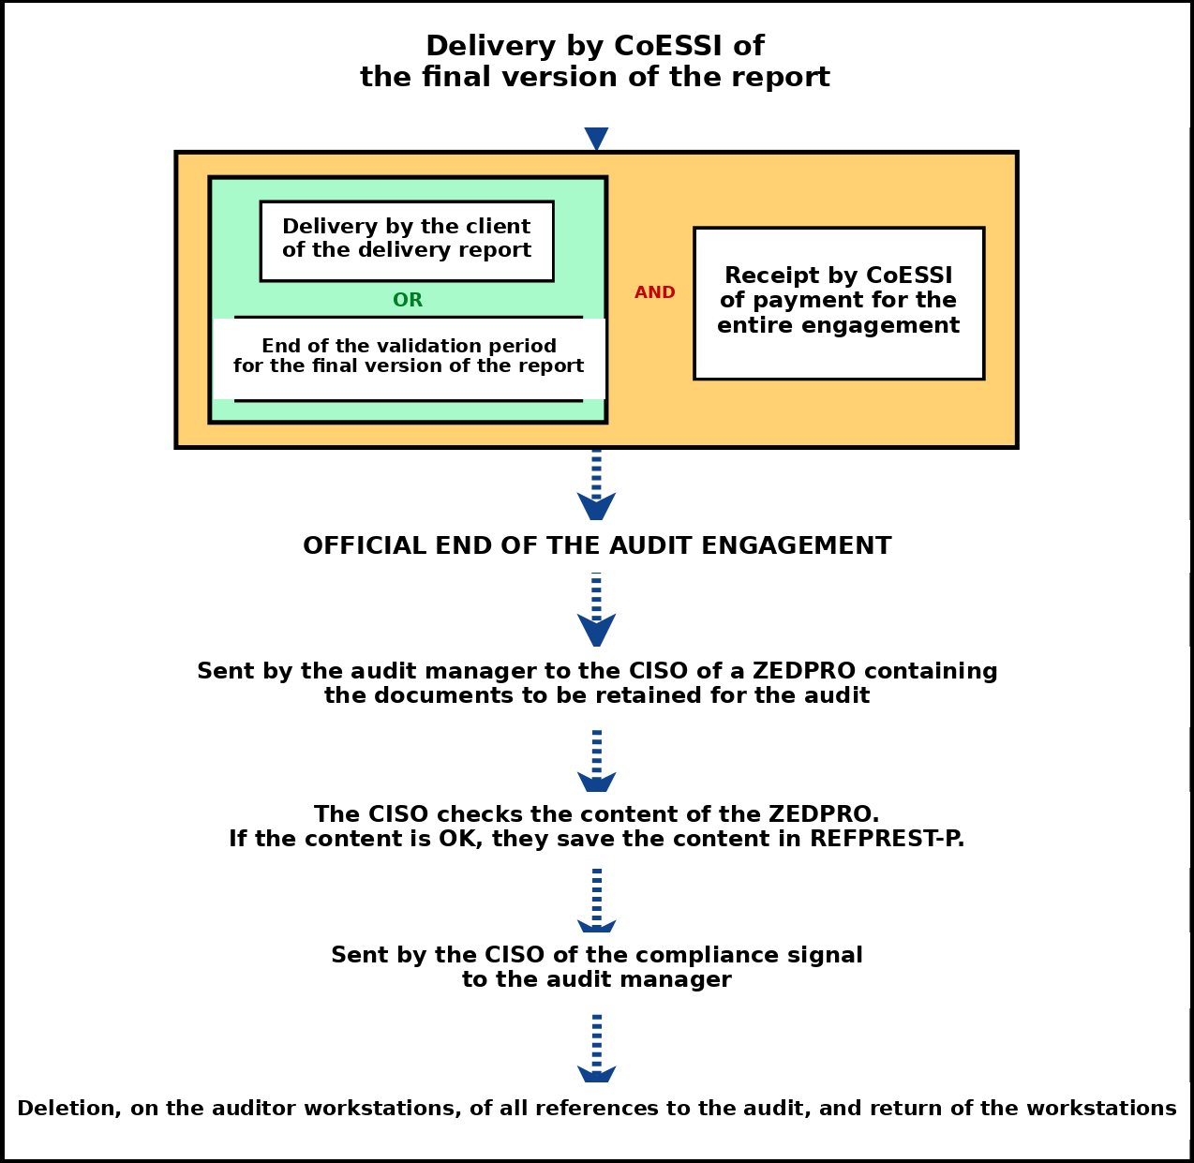
Figure 1 : Sequencing of actions at the end of the audit

Use of Keys

Auditor Key
Each PASSI auditor is given a key by the administrator. This key is used for several purposes:
- Storing information associated with the audit, for transfer to another workstation or via email, or for backup purposes.
- Storing a copy of their password manager.
- Storing a copy of the P&N.
The key (other than DATASHUR keys) is not encrypted. The user must create and use encrypted containers to store information on it. No audit-related information may be stored outside a container. It is the user's responsibility to keep the encryption keys for their containers in their password manager.
CUSB-M01 : Systematic use of encrypted containers to store information on USB keys; no unencrypted confidential information may be present on these keys.
CUSB-M04 : At the end of the audit, deletion by the auditor of all audit-related information found on their key, using the tool made available to them on their workstation.
The key is kept by the auditor for as long as they are under contract with On-X, and is used for all PASSI audits they perform on behalf of CoESSI By On-X. At the end of their contract, or if they are no longer PASSI-qualified, the auditor must return their key to the administrator, who resets it before returning it to the safe.
CUSB-M05 : When an auditor leaves, or when they are no longer a PASSI auditor, return of their auditor key to the administrator, who resets it before returning it to the safe.
CUSB-M03 : Maintenance by the CISO of the backup key register.
CUSB-M06 : Auditors are prohibited from using their auditor key for purposes other than backing up their workstation while traveling, and transferring files between the PASSI IS and the CoESSI IS.

SAS Key
The SAS key is a specific key, inseparable from the decontamination SAS. It may be used, for example, if a client at an audited site provides auditors with audit-related documents held on an external key. This external key must not be connected to a PASSI workstation. Auditors must then use the decontamination SAS.
To use the decontamination SAS, first plug in its power connector, then connect its keyboard into the keyboard port, and its mouse into the mouse port. The SAS screen turns on. You then need to log in with the username and password provided by the administrator.
N.B. At the start of the audit, the administrator provides the username and password for the SAS to auditors who may need to use the decontamination SAS.
The SAS has two USB ports on its interface. Either of these ports may be used to connect the client's potentially contaminated key. The decontamination script performs a virus scan, loads the information into memory, then pauses to allow the client's key to be removed and replaced with the SAS key. The information is then copied onto the SAS key. The SAS key may then be connected to a PASSI workstation.
N.B. The SAS detects viruses that exist under both Windows and Linux.
N.B. When the SAS key is connected to a PASSI workstation, a new antivirus check must be performed on the contents of the SAS key. Indeed, there is a (slight) possibility that the SAS itself is contaminated. The new antivirus check makes it possible to rule out this possibility.
Documents related to the audit, provided by the audited party, are DR (Disaster Recovery) documents, and as such must immediately be saved on the auditor workstation and/or within an encrypted container; the documents must then be deleted from the SAS key using a secure deletion tool.
CUSB-M11 : Upon receipt, on the SAS key during an audit, of documents related to the audited IS, immediate copying of these documents to an auditor workstation or into an encrypted container, and secure deletion of the unprotected content on the SAS key.

CISO Key
CUSB-M07 : Provision to the CISO of a USB key; creation, using the tool present on their workstation, and use by the CISO of encrypted containers for storing confidential documents on their key.

Use of Flipper0
Flipper0 is a tool to be used as part of physical audits. Outside of audit periods, it is kept in the safe.

Virus Protection
All auditor workstations must have antivirus protection.
Auditor workstations, as well as the host system of pentester workstations, are equipped with antivirus software. This antivirus software must under no circumstances be disabled.
The pentest VM, on the other hand, is not equipped with one: the presence of active antivirus software on the machine would indeed prevent pentesting activities from being carried out properly.
It is the auditor's responsibility to perform a virus scan of files before importing them from their pentest system to a writer workstation via their key.
Likewise, when an auditor key is used to transfer documents between the On-X IS and the PASSI IS, an antivirus scan must be performed when the key is connected to the auditor workstation.
PTAUD-M02 : Auditors are prohibited from disabling the antivirus software installed on their work machines.
CUSB-M09 : When connecting to the PASSI IS, any USB key previously connected to the On-X IS must undergo a virus scan; the content of containers of external origin must also be scanned upon first opening.
When, as part of an on-site audit, a client USB key is used to transfer documents held by the audited party onto a PASSI auditor workstation, the decontamination SAS must be used, together with the SAS key.
SASD-M01 : Passage of any external key through the decontamination SAS before connection to the PASSI IS.

Backups

Backups by Auditors During an Audit
During an audit, each auditor is responsible for backing up the information and documents related to an audit that are under their responsibility. To do this, they must use their auditor key. Backups must be performed daily.
CUSB-M02 : Daily backup by auditors of information related to an ongoing audit.

Backups by the CISO at the End of an Audit
At the end of the audit, once the CISO has validated the content of the assignment container sent to them by the audit manager, and has added the document directory corresponding to the current audit to the REFPREST-P audit engagement repository, they must perform a backup to the external disk of this repository.

Use of the Printer
Auditors may use the printer connected to the USERS VLAN, in local mode, provided they turn it off immediately after each use.
IMP-M01 : Use of the printer in local mode and switching it off immediately after use.
Paper documents associated with an audit may only leave the PASSI room to be placed in the safe. They must not be taken off-site for teleworking.
DOC-M01 : Placing in the safe of paper documents related to an audit that must be kept for the duration of the audit, when they are not in the PASSI room under the responsibility of an auditor.

Secrets Management

Summary of Secrets Held by an Auditor
Access Accounts | Passwords
- User access account to a writer workstation  - Pentester access account to a pentester workstation (if pentester)  - Pentester access accounts to their pentest VMs (if pentester)  - Access account to the decontamination SAS (if applicable) | - Decryption password for containers on their auditor key  - Decryption password for the writer workstation  - Decryption password for the pentester workstation (if pentester)  - Access password to their password vault  - Password for the assignment ZED for the CoESSI by On-X entry.

Associated Rules
Auditors must use a password vault to secure their PASSI IS access passwords. They are prohibited from automating system authentication procedures; in particular, they are prohibited from allowing a password to be saved by the system.
SYS-M15 : Secure management by each auditor of all the secrets they hold (use of a password manager).

Password Customization
The purpose of the decryption password for the hard drive of an auditor workstation is to protect the information on the drive in the event of theft or loss. Once initialized, it can no longer be changed. Its distribution is restricted to all PASSI IS users (customization not possible).
When an auditor receives an auditor workstation from the administrator, this workstation is associated with a set of passwords that are communicated to them along with the machine:
Pentester Workstation | Writer Workstation
- Decryption password for the pentester workstation.  - Pentester access account to the workstation.  - Pentester access account to the pentest VM.  - Root access account to the pentest VM. | - Decryption password for the writer workstation.  - Personal user access account for the workstation.

Other than the workstation decryption passwords, all secrets must be customized by the auditor upon receipt.
The pentest template VM, meanwhile, is associated with a generic, public password.
PTPEN-M02 : After installing their pentest VM, the auditor must customize the access password for the pentester and root accounts.
PTRED-M01 : Changing the access password for their user account when a writer workstation is taken over by a group of auditors.
Note: Regarding the decontamination SAS: At the start of the audit, the audit manager designates to the administrator the auditor(s) who will hold access to the decontamination SAS (username and password).

Secure Deletion of Documents and Information
No information from the PASSI IS, whether in digital or paper format, may be taken outside, except onto the backup media listed within the PASSI IS.
Since the hard drives of auditor workstations are encrypted, the user of a writer workstation may save unencrypted confidential information on them. Before returning the workstation, they must securely delete all traces of the information they have stored, using the specific tools made available on the workstation:

Files concerned | System | Commands and tools to use
Office documents | Windows | Windows Eraser software.
Pentest VMs. | Linux | - “Shred” command: Deletion of files with no possibility of recovery.  - “Wipe” command: Deletion of directories with no possibility of recovery.  Both of these commands are available on the host system of the auditor workstation.

Document Transfers via Email
Exchanges with external parties involved in an audit take place via corporate email.
Documents exchanged must be protected in accordance with the rules set out during the kick-off meeting, the audit agreement, and the audit plan.
An encrypted PASSI document received from an external party involved in an audit must under no circumstances be decrypted on an IS other than the PASSI IS. Before any decryption, it must be transferred within the PASSI IS, into the REFPREST-P directory dedicated to the audit.
Conversely, a document to be sent to an external party involved in an audit must be encrypted before leaving the PASSI IS.
PTRED-M07 : Securing of confidential documents sent via email.

Updating the List of Penetration Testing Tools
Following an update of the pentest template VM, the list of penetration testing tools included in the CoESSI P&N must be checked. This check is the responsibility of the CISO, based on the list of tools found in the updated KALI Linux, which is provided to them by the administrator.
The CISO then brings together the pentesters and asks them to compare the two lists:
- Tools present in the P&N, which are not present in Kali, and which are not used by the pentesters, must be removed from the list.
- Tools present in KALI, not present in the P&N list, and used by the pentesters must be added to the list.
- Tools used by the pentesters, which are present neither in KALI nor in the P&N list, must be added to the list. These tools must be highlighted in the list.
N.B. If any of the tools added to the list require precautions for use, these precautions must be detailed in the “Framework for the Use of PT Tools” document of the same P&N.
Documents to update:
CoESSI_P&N_List of penetration testing tools
CoESSI_P&N_Framework for the use of PT tools

Audit trace logs, as referred to here, are the pentester's actions on the audited IS, automatically recorded by a script each time a command prompt is opened, and stored in a LOGAUDIT directory within the pentest VM. These audit trace logs make it possible to reconstruct the audit and must be kept until the end of the audit. The penetration testing methodology may be consulted. Veracrypt not being installed in the pentest VM, pentesters must transfer their audit trace logs to the host system before placing them in a secure container. They use this feature for this transfer: VirtualBox -> Devices -> Shared folders -> Shared folders settings.

