Revision History
Version | Author | Reviewer | Description of change | Release date
1 | MJR |  | Initialization from the corresponding document of the non-simplified version of the PASSI IS. | 22/04
Table of Contents
1 PASSI IS Network Diagram 2
2 Pentester Workstation 3
3 Writer / CISO Workstation 5
4 RASPBERRY PI 5
5 Flipper0 6
6 Printer 6

PASSI IS Diagram
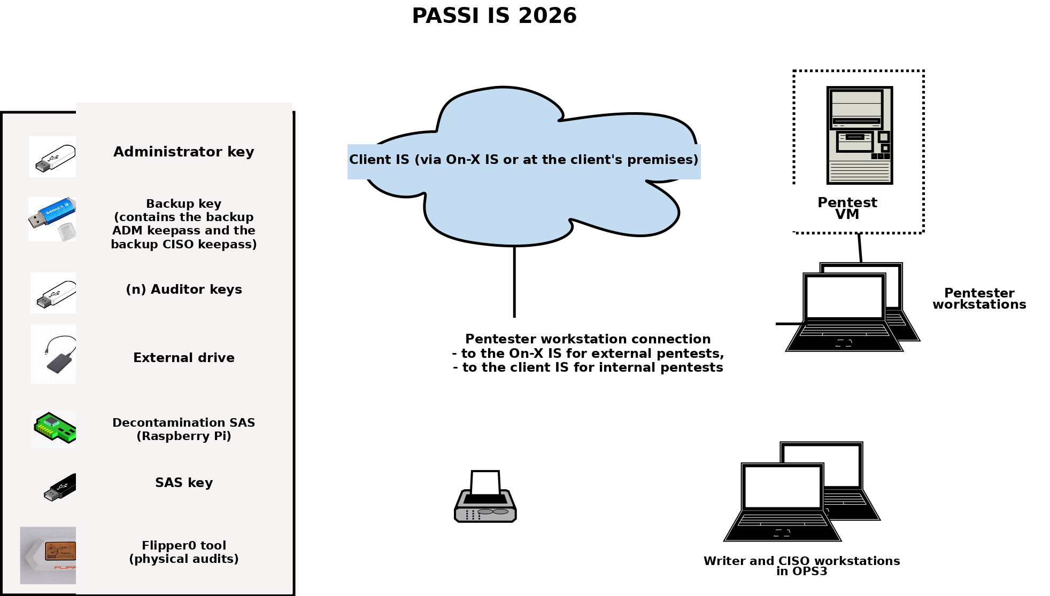

Pentester Workstation

Configurations

Host system
HARDWARE CONFIGURATION
HARD DRIVE | 500GB
RAM | 16 GB (2x8GB) (ASUS) – 6GB (TOSHIBA)
NETWORK | 1 Ethernet card
SOFTWARE CONFIGURATION
OPERATING SYSTEM | DEBIAN 11
VIRTUAL MACHINES | Pentest VM (VMPEN)
INSTALLED SOFTWARE | Oracle VirtualBox 7.1.12  RSYSLOG 8.2408  ClamAV 1.4.3  Veracrypt 1.26.24 (Container management and disk encryption)  Keepass XC 2.7.10  Wipe 0.23 (secure file deletion command).
ACCESS ACCOUNT
root | Root access.
admin | Administrator access (permanent).
Secours | Backup administrator envelope access (permanent).
auditeur | Auditor administrator access (temporary, during the audit).
NETWORK
VLAN 100 – PENTEST AUDITOR | 192.168.100.11 (ASUS) – 192.168.100.13 (TOSHIBA)

Pentest VM (VMPEN)
HARDWARE CONFIGURATION
HARD DRIVE | 100 GB
RAM | 8 GB
NETWORK | 1 Ethernet card
SOFTWARE CONFIGURATION
OPERATING SYSTEM | Kali Linux 2023.3
SOFTWARE | RSYSLOG 8.2306.0-2  Wipe 0.23 (secure file deletion command).
ACCESS ACCOUNT
root | Kali access (root).
NETWORK
1 virtual card in “NAT Network” mode
VLAN 100 – PENTEST AUDITOR | 192.168.100.X

For the pentester workstations, a change must be made at the “Network” level.
These workstations now connect:
- During an internal pentest, to the client's network.
- During an external pentest, to On-X's network.
Pentesters carry out their pentest from the pentest VM, which is deleted at the end of the pentest.
As a reminder, these workstations are not DR (Disaster Recovery).

Writer / CISO Workstation

Configurations

Host system
HARDWARE CONFIGURATION
HARD DRIVE | 1 x 1 TB
RAM | 8 GB
NETWORK | 1 Ethernet card
SOFTWARE CONFIGURATION
OPERATING SYSTEM | Windows 10 22H2
INSTALLED SOFTWARE | Windows Defender.  Microsoft Office Home and Student 2019  DIA 0.97.2-2 (Drawing software)  Adobe Acrobat Reader DC 2025.001.20643  Keepass 2.59 (X) (Password manager)  Veracrypt 1.26.24 (X) (Container management and disk encryption)  Nxlog-CE 3.2.2329 (Log reformatting before sending)  ERASER 6.2.0.2996 (X) (Secure file deletion)  ZED 2024.4 (Container management)  ZEDPRO 2024.1
ACCESS ACCOUNT
admin | Administrator access (permanent).
secours | Backup administrator envelope access (permanent).
XXX | Writer user access (1 per writer) (temporary, during the audit).
rssi | CISO user access (permanent).
NETWORK
VLAN 30 – USERS (CISO + writer auditor) | 192.168.30.X

The writer workstations no longer connect to ANY network. A change must therefore be made: the workstations must no longer be able to connect.
Note: ZEDPRO is installed on only one of the writer workstations (the one labeled FCN*).

RASPBERRY PI
HARDWARE CONFIGURATION
HARD DRIVE | MicroSD 32GB
RAM | 4GB LPDDR4 (3GB+ is the minimum required for ClamAV).
NETWORK | 1 Et1.0.5hernet card
SOFTWARE CONFIGURATION
OPERATING SYSTEM | Linux Raspberrypi 6.6.31+rpt-rpiv8
INSTALLED SOFTWARE | ClamAV 1.0.7  Decontamination script
ACCESS ACCOUNT
root | Root access.
admin | Administrator access.
Secours | Backup administrator envelope access.

Flipper0
HARDWARE CONFIGURATION
External memory | 16GB
SOFTWARE CONFIGURATION
FIRMWARE | 1.1.2

Printer
HARDWARE CONFIGURATION
Brand | BROTHER
Model | HL-3150CDW
Serial number | E71793L4J529452
SOFTWARE CONFIGURATION
FIRMWARE | Ver.1.06 (14.07.10)

The printer may be kept. It must only be usable locally.

