
Design Optimization Proposal for Enhanced
Robotic Arm Responsiveness

1. Problem Statement
Identified Issues:
- Actuator Strain:
  - Description: The shoulder, elbow and wrist actuators carry the load of the whole extended arm, so they run close to their limits at full reach. In the control diagnostics, rotate_joint was the slowest command at 0.15 seconds, and move_arm was slightly over its expected time (0.102 against 0.10 seconds).
  - Impact: Slower, less consistent responses and faster wear. The design simulation starts from a 0.20 second response time and a durability score of 75 out of 100, which leaves clear room to improve both. In surgery, lag reduces responsiveness and precision.
- Sensor Misalignment:
  - Description: The joint sensors tell the controller where each arm segment is. If a sensor sits slightly off-axis, or its mount shifts over time, the position it reports is slightly wrong.
  - Impact: The controller makes extra corrections based on inaccurate readings, which adds delay and small unwanted movements and reduces positioning precision. A loose mount can drift further over time, which also affects reliability.

2. Proposed Modifications
Modification 1:
- Proposal: Replace the shoulder, elbow and wrist actuators with higher-efficiency units (design target: a 15% efficiency improvement). Size them with torque headroom above the peak load at full extension, and add temperature monitoring so overload is detected early.
- Justification: Responsiveness: the simulated 15% efficiency factor cuts the response time from 0.20 to 0.17 seconds. Applied to the diagnostic results, all three commands meet their expected times (move_arm 0.102 to 0.087 against 0.10, rotate_joint 0.15 to 0.128 against 0.18, adjust_grip 0.051 to 0.043 against 0.09). Torque headroom also reduces wear, which supports durability.
Modification 2:
- Proposal: Realign the joint sensors, fit reinforced and more rigid sensor mounts (design target: a 10% reinforcement improvement), and add a start-up calibration check that compares each sensor with a known home position and flags any offset beyond a set tolerance.
- Justification: Precision and durability: accurate feedback lets the controller move the arm without repeated corrections, and sturdier mounts keep the sensors in place. In the simulation, the 10% reinforcement factor raises the durability score from 75 to 82.5.

3. Simulation Results
- Initial Metrics:
  - Actuator Response Time: 0.20 seconds
  - Sensor Feedback Delay: Not modelled. The simulation reports one overall response time, so there is no separate sensor figure. Recommended as a follow-up measurement.
  - Durability Score: 75 out of 100
  - Commands Within Expected Time: 2 of 3 (move_arm at 0.102 seconds is over its 0.10 second limit)
- Post-Optimization Metrics:
  - Actuator Response Time: 0.17 seconds (15% faster, efficiency factor 0.15)
  - Sensor Feedback Delay: Not modelled (see above).
  - Durability Score: 82.5 out of 100 (+10%, reinforcement factor 0.10)
  - Commands Within Expected Time: 3 of 3 (move_arm 0.087, rotate_joint 0.128, adjust_grip 0.043 seconds)
- Key Insights:
  - Efficiency factor: a 15% improvement cuts the response time by 0.03 seconds, from 0.20 to 0.17. The simulation applies the factor directly, so the time falls by exactly the percentage entered.
  - Reinforcement factor: a 10% reinforcement raises the durability score by 7.5 points, from 75 to 82.5.
  - Iterative testing (Python and NumPy, in the Control System Diagnostic and Design Simulation notebooks): three trials were run. Trial 1 (efficiency 0.05, reinforcement 0.05) and Trial 2 (0.10, 0.10) left move_arm with only a 3% and 8% margin under its expected time, so the design was refined. Trial 3 (0.15, 0.10) gave a 13% margin on every command and a 10% durability gain. The acceptance criteria (at least a 10% margin and a 10% durability gain) were chosen for this proposal.
  - Trade-offs: the simulation treats the two factors as independent, so no trade-off appears. In a real arm, extra reinforcement adds mass and can slow movement, so both changes should be tested together on the hardware.
  - Limits: the simulation uses simple formulas and example base values, so it shows the expected direction and size of the gains, not proven real-world performance. It has no sensor-specific input, so the reinforcement factor stands in for the sturdier sensor mounts.

4. Annotated Visual Examples
Visual Example 1: Current Sensor Misalignment vs. Proposed Realignment
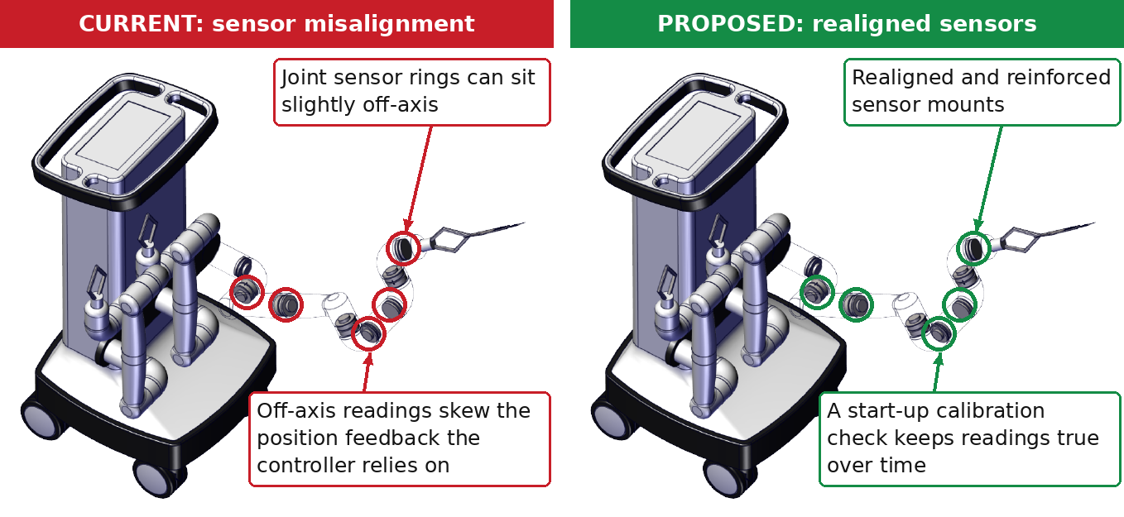
- Brief Description: Left: the joint sensor rings in the exploded view of the arm, circled in red where small off-axis errors would distort the position feedback. Right: the proposed fix in green, realigned and reinforced mounts plus a start-up calibration check. This is a conceptual annotation of the program's CAD image, not a measured fault.
Visual Example 2: Actuator Upgrade Impact
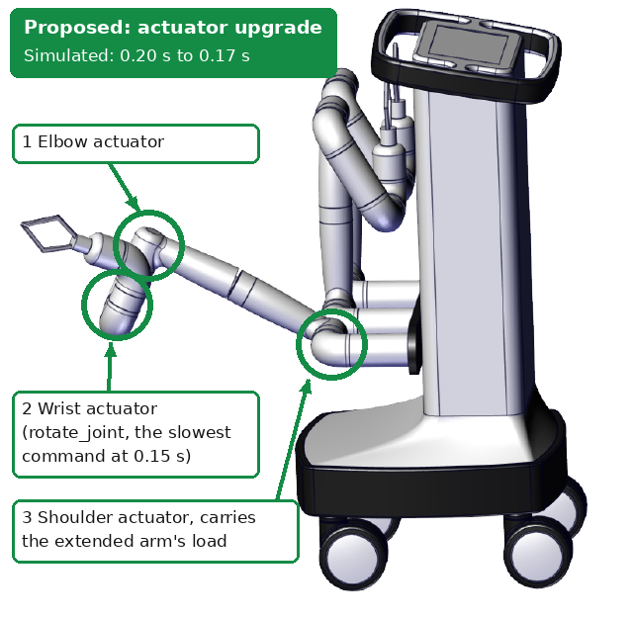
- Brief Description: Side view of the extended arm with the three actuators proposed for upgrade circled in green: the elbow, the wrist (rotate_joint, the slowest command in the diagnostics) and the shoulder, which carries the extended arm's load. The simulated gain is a response time falling from 0.20 to 0.17 seconds.

5. Expected Outcomes
- Improved Responsiveness: The simulated response time falls 15%, from 0.20 to 0.17 seconds, and all three commands run within their expected times, so the arm follows the surgeon's input more closely.
- Enhanced Reliability: Commands meeting their expected response time rise from 2 of 3 to 3 of 3, and the start-up calibration check keeps sensor readings accurate, so movements should be steadier and more repeatable. The calibration benefit is expected from the design and is not measured by the simulation.
- Increased Durability: Reinforced mounts and actuators that no longer run near their limits should wear more slowly. The simulated durability score rises 10%, from 75 to 82.5.

6. Conclusion
Impact of the proposed modifications:
- Two critical issues are addressed: actuator strain (responsiveness) and sensor misalignment (precision and durability).
- Measured in simulation: response time down 15% (0.20 to 0.17 seconds), durability up 10% (75 to 82.5), and commands within their expected time up from 2 of 3 to 3 of 3.
- Next steps: test on real hardware, measure the sensor feedback delay, and confirm that the added reinforcement does not slow the arm.

