Customer Churn Analysis Report
This report presents the exploratory data analysis and data preparation steps undertaken to predict customer churn using various data sets. It includes data collection, visualisation, and cleaning processes, providing a foundation for developing a predictive model.

Data Identification and Collection
The following data sets were identified as relevant for predicting customer churn:
- Customer Demographics
- Transaction History
- Customer Service Interactions
- Online Activity
- Churn Status
These data sets provide comprehensive insights into customer behaviour and engagement.

Exploratory Data Analysis
Exploratory data analysis was conducted to uncover patterns and insights that could inform predictive modelling. Key findings include demographic trends, spending patterns, and the impact of customer service interactions on churn.
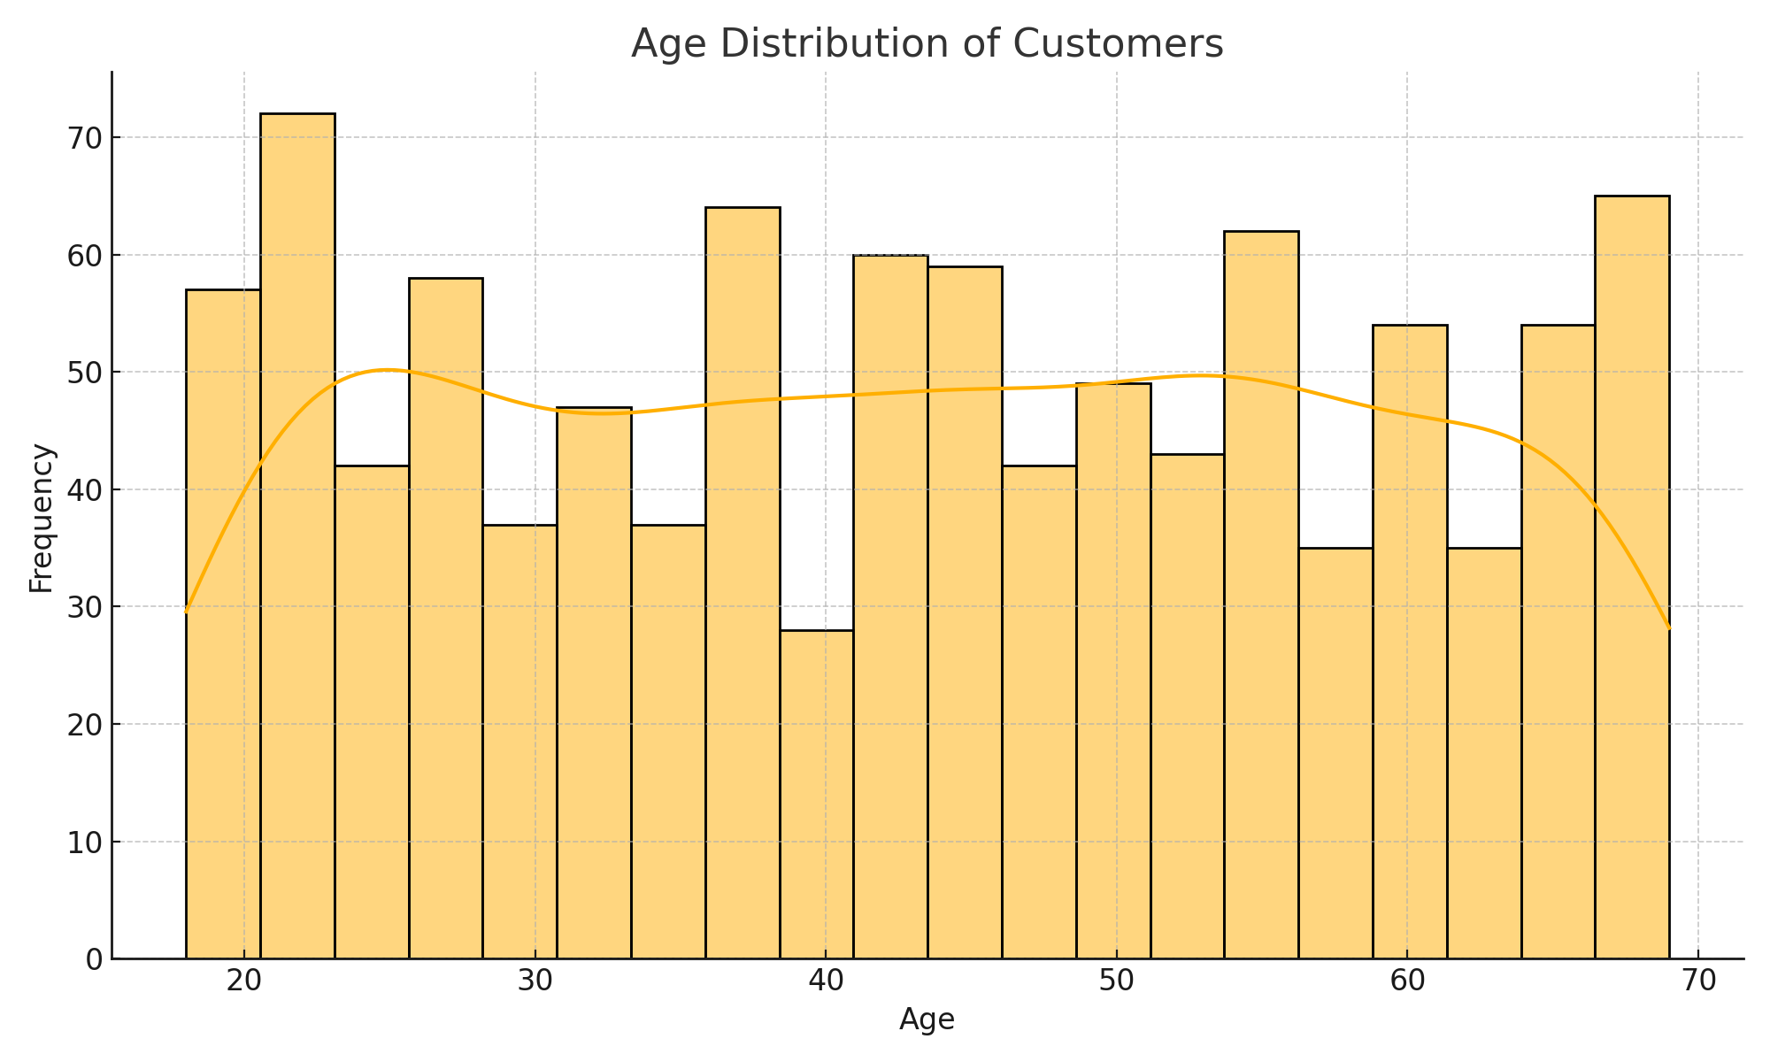

Figure 1: Age Distribution of Customers

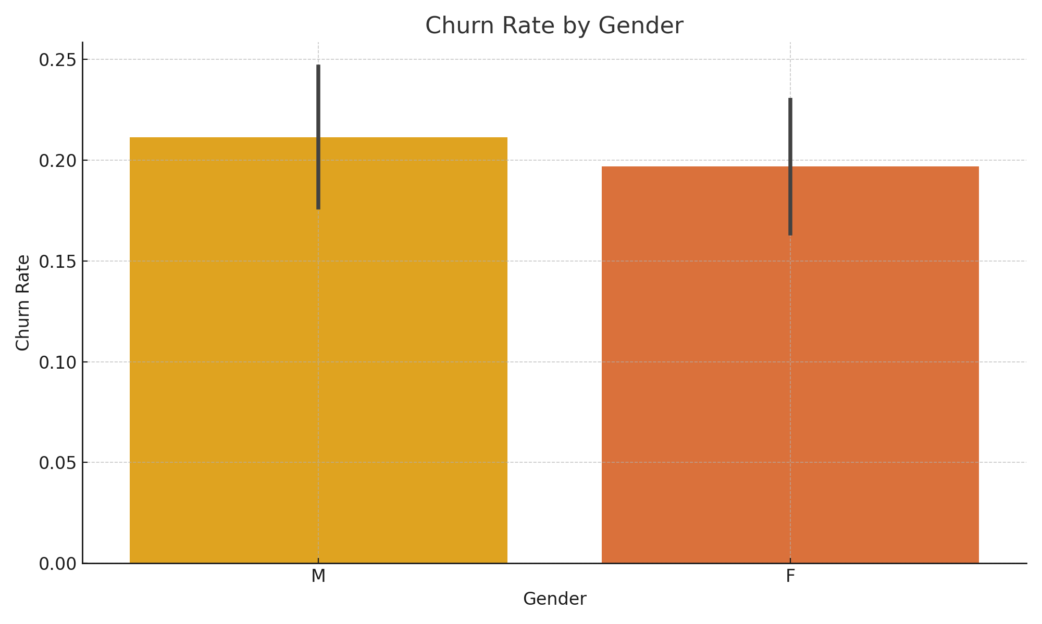

Figure 2: Churn Rate by Gender

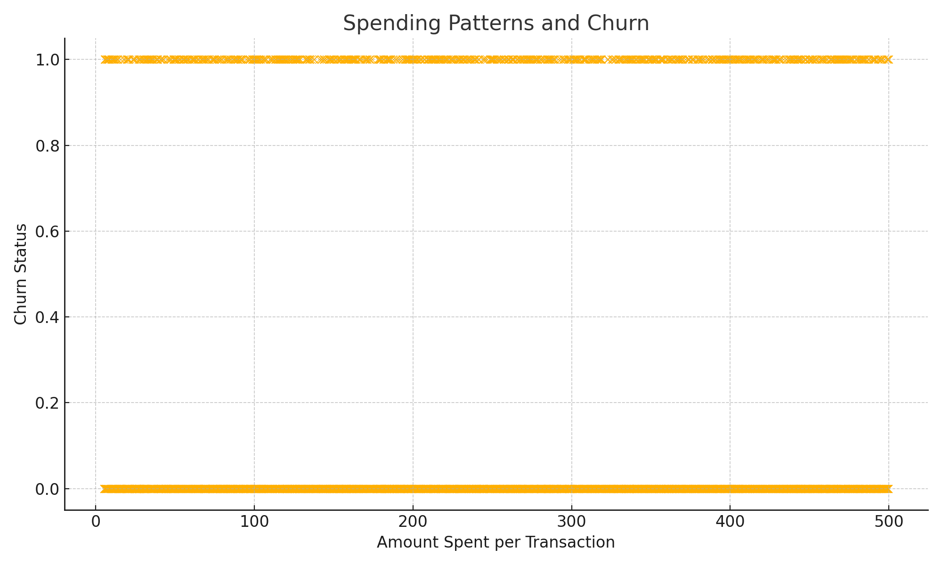

Figure 3: Spending Patterns and Churn

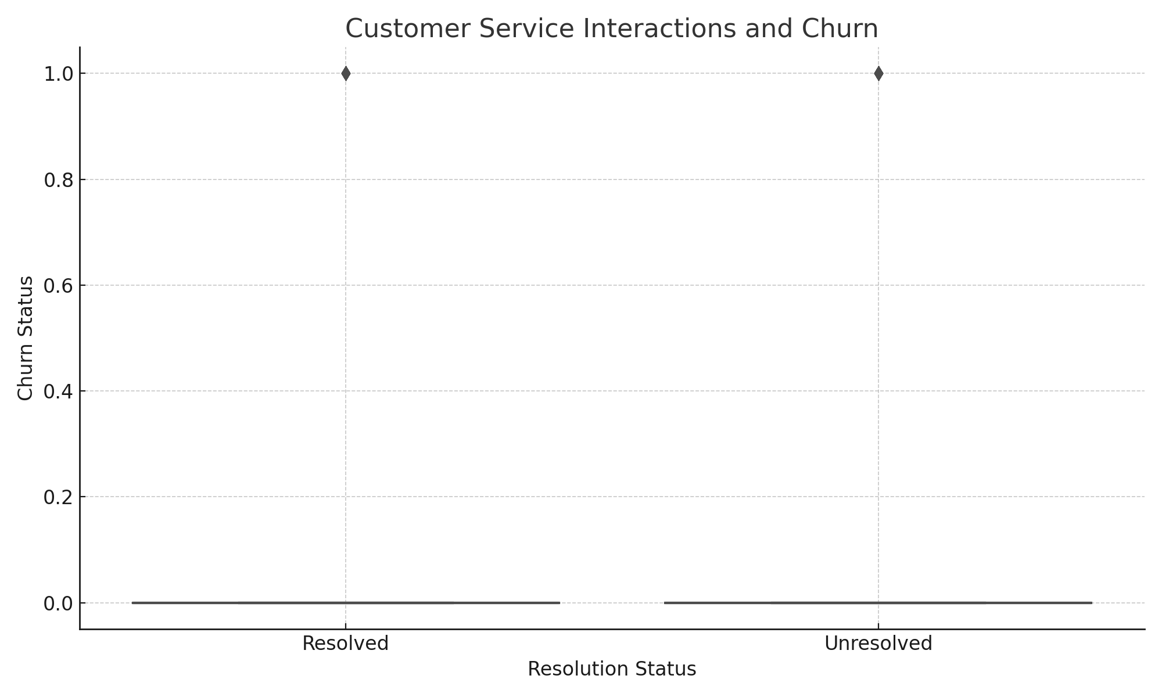

Figure 4: Customer Service Interactions and Churn

Data Cleaning and Preparation
Data cleaning involved handling missing values, detecting and addressing outliers, and normalising/standardising numerical features. Categorical features were encoded using one-hot encoding to prepare the data for machine learning algorithms.

