Exercise Set 2: Estimation theory

1. LS and ML estimators

Ossi Koski

I tested samples, noise and error parameters by hand

1. 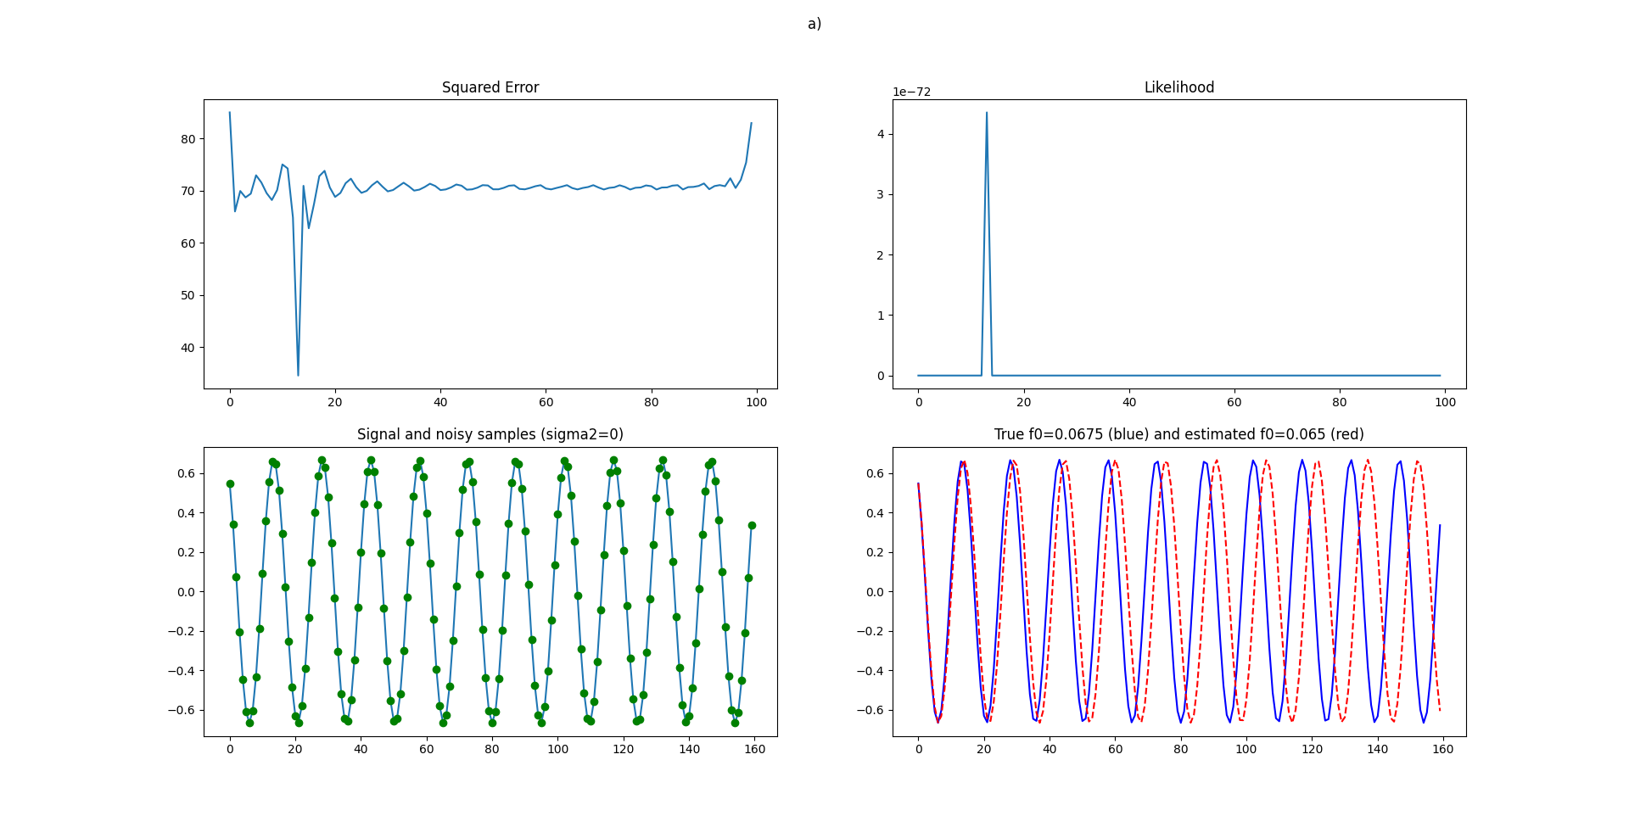100 samples, no noise and no error:
2. 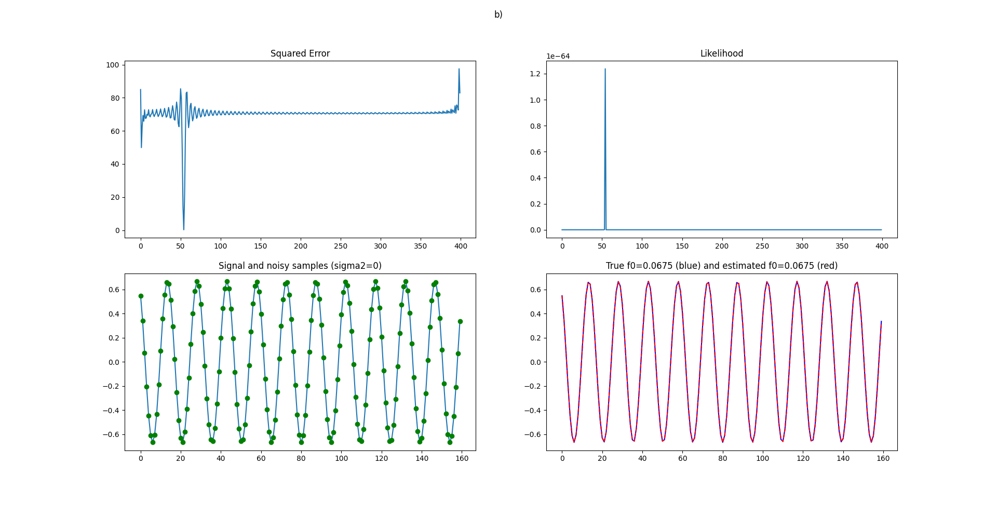400 samples, no noise and no error:
3. 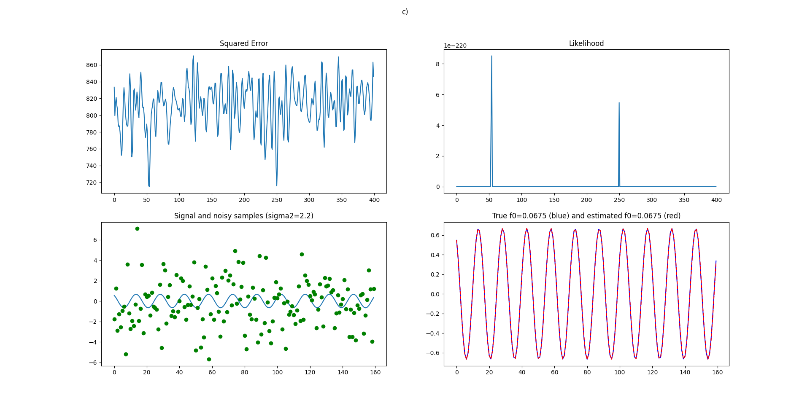400 samples, noise=2.2, no error:  
   With noise=2.3, estimated frequency was wrong.
4. 400 samples, noise=1.3, error=1.1:  
   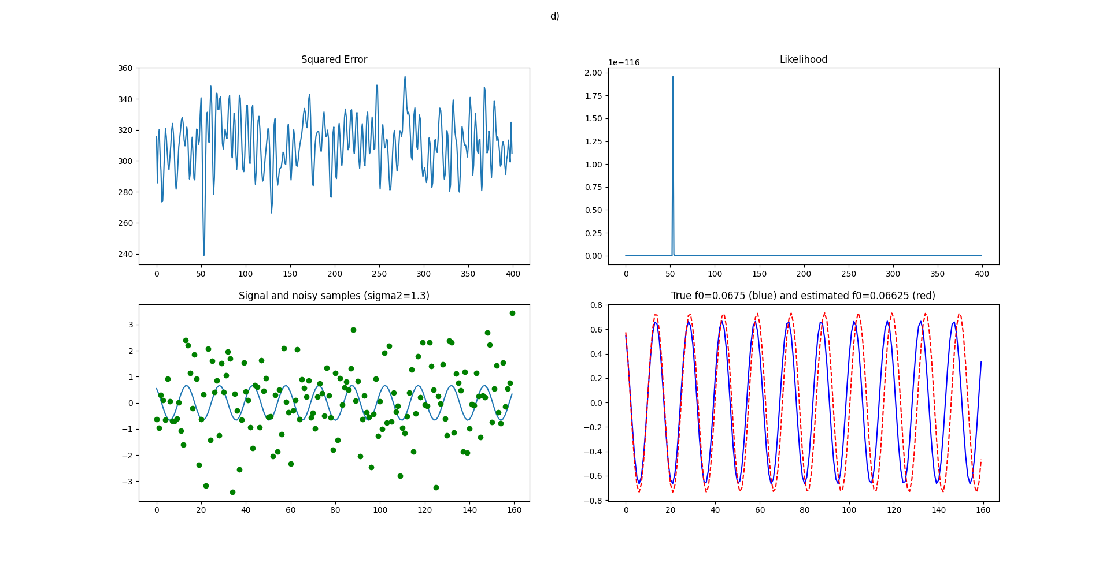With noise=1.4, estimated frequency was wrong.