<https://medium.com/@Sara_Mednick/why-having-more-sex-can-save-your-life-23a02397e0e5>

Get unlimited access to the best of Medium for less than $1/week.

[Become a member](https://medium.com/plans?source=upgrade_membership---post_top_nav_upsell----------------------------------)

# Why having more sex can save your life.

[[](https://medium.com/@Sara_Mednick?source=post_page-----23a02397e0e5--------------------------------)](https://medium.com/@Sara_Mednick?source=post_page-----23a02397e0e5--------------------------------)

[Sara\_Mednick](https://medium.com/@Sara_Mednick?source=post_page-----23a02397e0e5--------------------------------)

·

Follow

9 min read

·

Sep 21, 2022

2.6K

37

Health relies on the autonomic nervous system, and a great way to stay autonomically healthy is SEX. I’ll teach you about the science of sex. In short, more is better!



After reading my most recent book, my friend said that she could tell I was getting a lot of sex while I was writing it. And she was right! I wrote it during the pandemic, so my usual bi-coastal marriage problem was solved by moving to upstate New York for 15 months. My wife and I could finally sleep in the same bed every night and that meant MORE SEX, which was great for our relationship, sure, but it was also great for our sleep, our autonomic balance, our ability to deal with stress, and our emotional, cognitive, and psychological health. Stay with me here as I explain a little about how your health is determined by your autonomic nervous system, and that a great way to stay autonomically healthy is, you guessed it, SEX.



Your health is determined by a lot of factors, and one very important bedrock factor is how well your [autonomic nervous system](https://en.wikipedia.org/wiki/Autonomic_nervous_system) is functioning. The autonomic system has two branches. One controls your get up and go by speeding up your heart rate, your respiration, your access to energy and shutting down any slow maintenance functions like digestion. The scientific label for this branch is the sympathetic nervous system, but I call it REV because its REVs you up and ensures you are ready for any go-time moment. Given that that taut state of REV is energy-depleting and stressful on your health, the function of other autonomic branch is to maintain basic functioning of your restorative systems and specifically calm down REV in the moment and also across the whole day.

RESTORE’s job is to inhibit and reverse your stress response and help you recover precious physiological resources such as glycogen, body fluids, and blood flow. But RESTORE does so much more than take over the nonessential mind-body functions put on hold during REV’s domineering act (e.g., digestion, urination, sexual arousal, heart rate relaxation, and general lubrication of the eyes, mouth, and erogenous zones). While crusading and conquering occur courtesy of REV, our restorative, creative processes flourish via RESTORE, including the transformation of recent experiences into long-term memories, engagement in complex thinking, creativity, and regulation of emotions. It provides a safe space for your mind to wander, dream, and create. In a nutshell, when you elevate RESTORE, you enter the [Downstate](https://www.saramednick.com/), the time and space where you recover from life’s stressors, replenish your resources, and get ready for the next challenge.

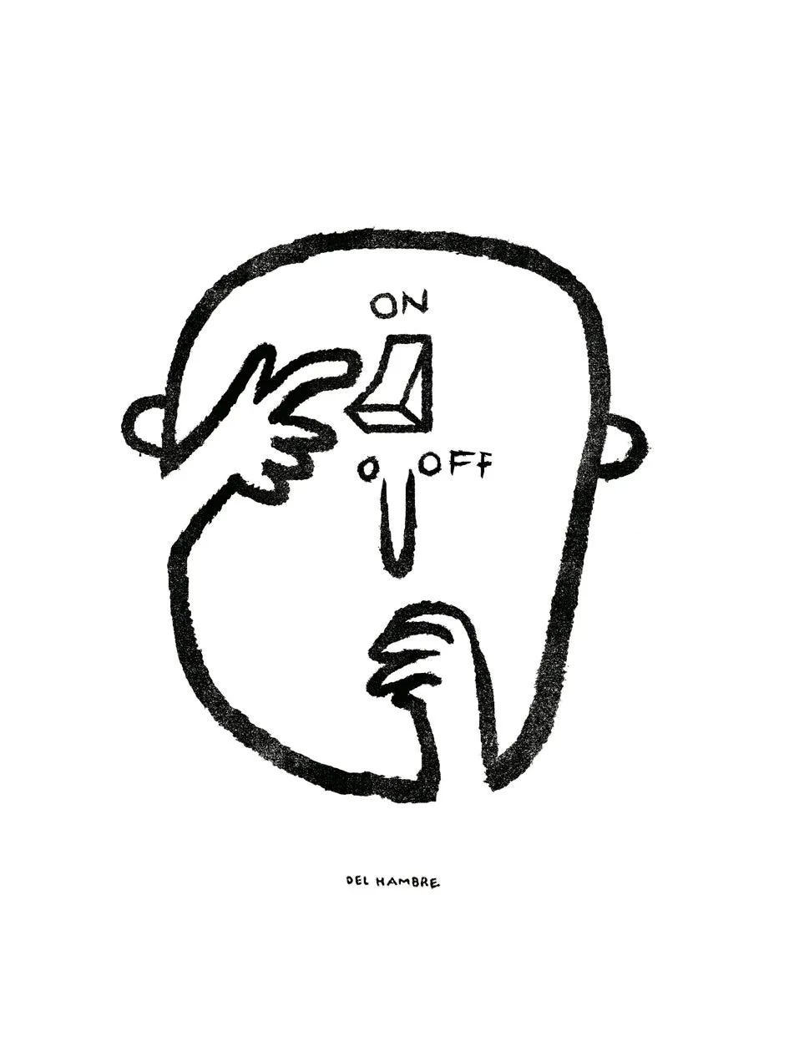

With prolonged states of REV and not enough RESTORE, however, you can end up in a state of autonomic imbalance that debilitates the entire system, causing the stress response to essentially become stuck in the On position. Autonomic imbalance, characterized by high blood pressure, high fasting glucose, high lipids, and elevated resting heart rate, has been associated with chronic diseases like [cardiovascular disease](https://pubmed.ncbi.nlm.nih.gov/19910061/), [type 2 diabetes](https://pubmed.ncbi.nlm.nih.gov/29277456/), and [cancer](https://pubmed.ncbi.nlm.nih.gov/34640409/). When your body is stressed, tired, and unfit, the heart is forced to work harder to keep blood circulating. As a result, resting heart rate increases. Study after study has linked elevations in resting heart rate not only with a heightened risk of all the aforementioned diseases, but also with the chance of [dying early](https://www.thelancet.com/journals/lancet/article/PIIS0140-6736(14)61682-2/fulltext). One study found that every ten beats-per-minute increase in resting heart rate increased people’s risk for death by about [20 percent](https://www.sciencedirect.com/science/article/abs/pii/S0033062009000322?via%3Dihub=).

This mountain of medical data draws a straight line from autonomic imbalance to an elevated, inflexible heart rate to chronic disease. BUT this is actually great news because both a healthy autonomic ratio and a strong, resilient heart rate are two things that you can control. In the [Power of the Downstate](https://www.amazon.com/Power-Downstate-Recharge-Restorative-Systems/dp/0306925796), I explain all the many ways that you can actively achieve a great REV/RESTORE ratio through your breathe, sleep, exercise, and eating. But here I’m just going to focus on SEX.



Sex is a major regulator of your REV/RESTORE ratio in the moment of that actual act and in the post-orgasm afterglow. First, during the initial stages of getting turned on, the RESTORE system warms up the body and mind for sex, as any fight or flight–type thoughts or feelings can be a real buzzkill. But while RESTORE is critical for arousal mechanisms like erections and clitoral engorgement, REV takes over as things heat up, increasing heart rate, blood pressure, sweat production, and pupil [dilation](https://pubmed.ncbi.nlm.nih.gov/31568703/) . . . this last sign being a universal signal for “Come and get it.” REV also handles the swelling of breasts, vaginal walls, and testicles; tightens the scrotum; and lubricates the tip of the penis. These actions all continue through REV’s final push toward the Big O.



The massive RESTORE rebound following all that exertion makes orgasms your gateway drug to deep Downstate bliss. Post-YES!, RESTORE covers your entire body in [calm](https://www.businessinsider.com/what-happens-to-your-brain-during-orgasm-2019-1). Your thinking brain, which made a big push during the lead-up to the fireworks show, takes five, as it soaks in a warm bath of attachment-facilitating oxytocin and feel-good serotonin. And to all you insomniacs out there, to the anxiety-prone people who spend hours ruminating, to anyone who feels exhausted all the time, whether or not they get good [sleep](https://www.sleepfoundation.org/physical-health/sex-sleep#:~:text=How%20Does%20Sex%20Affect%20Sleep,which%20is%20associated%20with%20stress.): sex is the answer.



I like to think of orgasms as blow darts, whisking you off on a nightly voyage to deep sleep. Whether you’re with a partner or Lone Ranger style, that great big romp in the hay activates all brain areas as REV rides that pony all the way to the finish line. Every cell in your brain and body is running at max capacity, like a one-person orchestra performing Ride of the Valkyries. After the fireworks finale, RESTORE shuttles in the deep comedown and it’s lights out in the theater, bring on the sleep show.

The reason orgasms are such potent Downstate instigators is because your [vagus nerve](https://en.wikipedia.org/wiki/Vagus_nerve" \t "_blank), the primary information highway of RESTORE activity, is directly connected to your [genitals](https://pubmed.ncbi.nlm.nih.gov/22082262/), bypassing most of the spinal cord. (In fact, many people with spinal cord injuries can still have orgasms for just this reason.) If you’re wondering how scientists know so much about brain activity patterns during orgasms, it’s because people volunteer in pairs or on their own to get down in a brain scanner while a bunch of scientists sit in a control room making small talk. Awkwaaaaard!

And the reverse relationship is also true; having robust Downstate sleep that thoroughly switches off REV is good for maintaining healthy plumbing in the sex department. About four or five times a night, proerectile RESTORE pathways predominate, producing nocturnal erections and labial, vaginal, and clitoral engorgement. Sex experts sound like Downstate aficionados when they refer to these events as a “battery-recharging” mechanism for the sex organs because they increase energy-rich, oxygenated blood flow to those areas.



Curiously, vaginal orgasms may beat clitoral ones when it comes to RESTORative gains, due to stronger connections between the vagus nerve and the [vagina](https://pubmed.ncbi.nlm.nih.gov/22082262/)(as opposed to the clitoris). Less is known about whether anal sex might lead to the same RESTORE perks, but intriguingly, vagal connections do reach the anus, suggesting that it’s possible. Along with improved REV/ RESTORE ratios, orgasms give your cardiovascular system a run for its money; help combat restless sleep; and just make you happy. And happy mood is associated with higher heart rate variability (HRV), a signature of strong RESTORE functioning.



Sexercise class combines yoga, fitness, and sex. From <https://www.xonecole.com/sex-and-ftiness-sexercise/>

Good sex and HRV are a two-way street because a healthy REV/RESTORE ratio is crucial for a good sex life. Becoming aroused requires just the right amount of REV; too little or too much and you’ll experience trouble becoming and staying aroused. High HRV is associated with better overall sexual function, and people with higher HRV tend to be the ones having more sex. Having a rich and plentiful sex life well into your eighth and ninth decades has secondary benefits for your brain, as studies have shown that executive function is higher in people who are more sexually [active](https://pubmed.ncbi.nlm.nih.gov/28645192/) later in life.



In fact, restorative practices that increase HRV, such as Autogenic training, can help people increase sexual arousal. Check out instructions for Autogenic training and other HRV practices in my book, [The Power of the Downstate](https://www.audible.com/pd/The-Power-of-the-Downstate-Audiobook/B09S29736G?qid=1663736987&sr=1-1&ref=a_search_c3_lProduct_1_1&pf_rd_p=83218cca-c308-412f-bfcf-90198b687a2f&pf_rd_r=JRC2N0TJB3CA7S9NYQ67). The audio version of my book might be especially helpful as I lead listeners through an actual Autogenic training session.

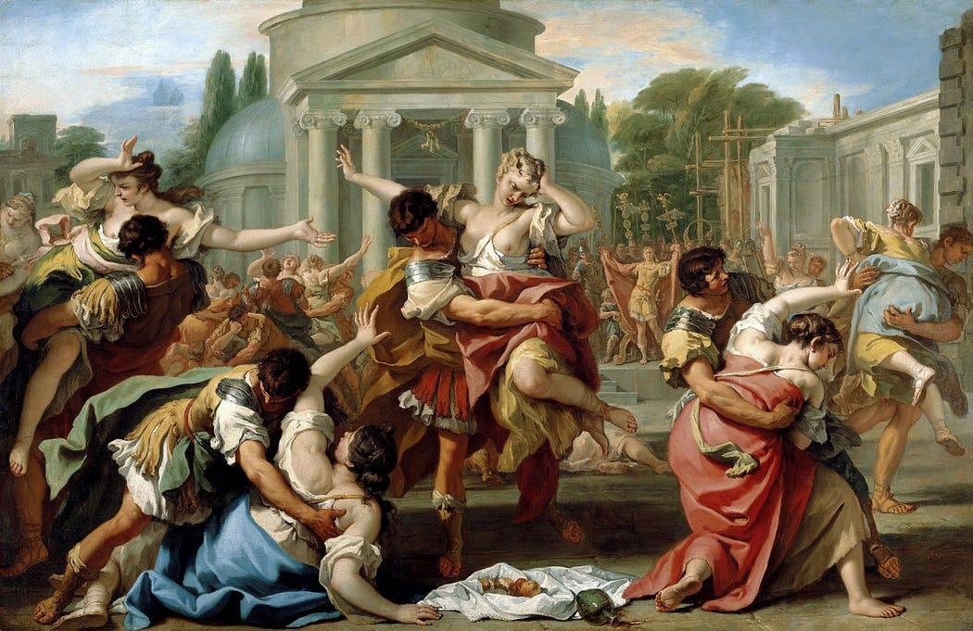

Rape of the Sabine Women by Sebastiano Ricci

On the other hand, sex or touch that doesn’t feel right is the exact opposite of Downstate comfort, making you feel unsafe, on your guard, and everything BUT relaxed. Even slight touches, such as a stranger placing a hand on your back, or a colleague or boss giving you a too-often pat, can make you feel vulnerable and can even send you into a full-blown stress response due to the casualness with which they cross your physical boundary without consent. It’s up to you to decide the whos, whens, hows, and wheres of physical touch and intimacy. Understanding and training yourself to embody the rules of consent can be helpful for self-empowerment.

Here are some good rules of thumb for sexual interactions that keep the Downstate on the rise:

Say yes only when it is a real yes.

Say no when it is a maybe or no.

Change your mind at any time; that is, you might be a yes, and then start feeling weird and switch to a no.

When you take responsibility for setting the boundaries in a clear and honest way, physical touch can be a pleasurable way to welcome the Downstate.



In sum, sex is good for you. I know that shaking the sheets can sometimes be the furthest thing from your mind after a busy day that has sucked up your very last ounce of energy, but think about it as medicinal, like taking your vitamins, and have fun! With some creative planning you can even win the trifecta of the Downstate Derby by following these steps:

First, start your day with an intensive cardio training session to boost REV early in the day.

Second, make a date with yourself (and a partner, if available) to get down tonight.

Third, take a small dose of melatonin an hour before your Estimated Time of Orgasm (ETO).

# PAYOUT!

**Dr. Sara C. Mednick is a cognitive neuroscientist at the**[**University of California, Irvine**](https://www.cogsci.uci.edu/index.php)**and author of**[**The Power of the Downstate: Recharge Your Life Using Your Body’s Own Restorative Systems**](https://bookshop.org/books/the-power-of-the-downstate-recharge-your-life-using-your-body-s-own-restorative-systems/9780306925795)**(HachetteGO) and**[**Take a Nap! Change Your Life**](https://www.amazon.com/Take-Nap-Change-Your-Life/dp/0761142908/ref=sr_1_2?qid=1663723769&refinements=p_27%3ASara+C.+Mednick+PhD&s=books&sr=1-2&text=Sara+C.+Mednick+PhD)**(Workman)**