e
e
Project Number: 11

TalkToRepair



TalkToRepair

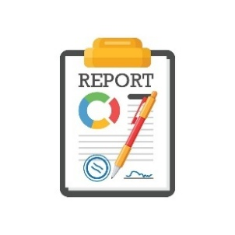

Student ID | Student Name | Section | No
0225715 | Mohammed Arqan | 5 | 18
0227350 | Othman Qwakneh | 5 | 25
Supervised By: Prof. Amjad Hudaib
Second Semester 2024/2025

PROJECT NAME 1
TABLE OF CONTENTS
SUMMARY 7
Chapter 1: PROJECT INTRODUCTION 8
  - Project Idea (Overview) 8
  - Main Objectives 9
  - Main Motivations 10
  - Constraints 11
  - Similar Projects 12
  - Project Organization 13
Chapter 2: FEASIBILITY STUDY 14
  - Technical Feasibility 14
  - Operational Feasibility 15
  - Economic Feasibility 16
  - Schedule Feasibility 18
  - Legal Feasibility 20
  - Software Process Model 21
Chapter 3: SYSTEM SPECIFICATIONS 23
  - Stakeholders 23
  - Data Gathering Techniques 24
  - Functional Requirements 25
  - Nonfunctional Requirements 29
  - Domain Requirements 30
  - Requirements Analysis 31
  - Architectural Design 32
Chapter 4: SYSTEM DESIGN 34
  - Class Diagram 34

  - Use Case Diagrams 35
  - Use Case Descriptions and Sequence Diagrams 40
Chapter 5: PROJECT IMPLEMENTATION AND TESTING 65
  - Project Implementation 65
  - Project Testing 89
APPENDIX 90
Appendix A: Survey Questions and Results 90
REFERENCES 98

Table of Figures

Figure 1: Pert Diagram 19
Figure 2: Software Process Model 22
Figure 3: Architectural Design 32
Figure 4: Class-Diagram 33
Figure 5: Account Management System 35
Figure 6:Issue Reporting & Assignment system 36
Figure 7:Issue tracking & notification System 37
Figure 8: Administration and Analytics system 38
Figure 9: Help and support system 39
Figure 10: user registration system 40
Figure 11: Issue Reprting 41
Figure 12: Issue Tracking dashboard 42
Figure 13:Issue Management 43
Figure 14: Notification system 44
Figure 15: Search and Filter 45
Figure 16: Analytics dashboard 46

Figure 17:Feedback System 47
Figure 18: Request Additional Information 48
Figure 19: language support system 49
Figure 20: Mobile responsivness UI system 50
Figure 21: Visualization of Issue on map 51
Figure 22: Offline reporting tool 52
Figure 23: Account management 53
Figure 24: Duplicate Issue detector 54
Figure 25: Help and FAQ system 55
Figure 26: In-Progress Issue counter 56
Figure 27:User Activity Logger 57
Figure 28:Logging system 58
Figure 29:Security System 59
Figure 30: Logout 60
Figure 31: Categorization 61
Figure 32: Annoucment System 62
Figure 33: Login Page 63
Figure 34: Sign up Page 64
Figure 35: OTP page 65
Figure 36:Forget Password Page 66
Figure 37:Reset Password Page 67
Figure 38: Account Profile Page 68
Figure 39:Home Page 69
Figure 40:Report Issue Page 70
Figure 41: List Of Issue Page Citizen 71
Figure 42: Issue Detail Page 72
Figure 43: Issue confirmation Page 73

Figure 44: Notification Page 74
Figure 45: Profile Page admin 75
Figure 46: Home Page Admin 76
Figure 47: Analytics Page 77
Figure 48: Manage Issue Page 78
Figure 49:Issue Detail Page 79
Figure 50:Help Page 80

Table of Tables

Table 1: Hardware, Software and Employee Requirements 16
Table 2: Tasks, Durations and Dependencies 18
Table 3: Stakeholders 23
Table 4: Functional Requirements 25
Table 5: Nonfunctional Requirements 29
Table 6: Domain Requirements 30
Table 7: Components 33

SUMMARY

TalkToRepair is a platform designed to improve the connection between citizens and government services. This user-friendly mobile app makes the process of reporting community issues easier, from broken streetlights to repairing the holes in the street, through a simple interface that allows uploads photos and location of the issue . Citizens can track the status of their submissions, receive notifications about progress updates, and see a timeline from the start of the repair to the end of it.
TalkToRepair also provides a dashboard that displays reports statistics and recent announcements, achieving transparency and accountability.

CHAPTER 1: PROJECT INTRODUCTION

Project Idea (Overview)

TalkToRepair system connecting citizens directly with government maintenance services. The platform consists of a mobile application with interfaces for both residents and workers and administrators. The system provides an easy issue reporting workflow, assignment protocols, and a database that tracks all community maintenance requests. Main functionalities include providing location and photos to the report, status tracking mechanisms, and a notification system that keeps all stakeholders informed.
TalkToRepair addresses the fundamental challenges of traditional reporting methods by eliminating paperwork, reducing response delays, and providing transparency throughout the entire maintenance process.

Main Objectives

    - Simplified Issue Reporting: Enable citizens to quickly and easily report community issues through a user-friendly mobile interface with photo uploads and location, eliminating traditional paperwork and phone calls.
    - Real-Time Status Tracking: Provide transparent monitoring of reported issues from submission to resolution, with timestamped updates and notifications that keep citizens informed throughout the repair process.
    - Citizen Engagement Analytics: Generate comprehensive data on community issues, resolution rates, and department performance to help administrators identify patterns, allocate resources more effectively, and improve service delivery.
    - Increase Trust Between Citizen and Government: being able to see the progress of the reports will make the people trust the government because they are not lacking in the work.

Main Motivations

    - Increase Citizen Engagement: TalkToRepair makes the relation between citizens and government better, encouraging residents to participate in improvements. This direct engagement gives a sense of ownership while building trust in government services.
    - Improved Service Delivery: By simplify issue reporting and work order management, TalkToRepair significantly reduces the time from problem identification to fix. Real-time tracking removes communication difficulties and ensures faster response.
    - Increased Transparency: ability to see issue status and fixing progress builds public confidence in government operations. Citizens can see exactly how their taxes are being used.
    - Reduced Administrative difficulties: decrease paperwork and administrative overhead. Government staff can focus more on addressing issues rather than managing complaint procedures, improving overall operational efficiency.

Constraints

    - Technical Limitations: Ensuring integration with existing government systems may be challenging.
    - Data Security and Privacy: The application must comply with data protection laws and secure sensitive citizen information.
    - Government Adoption: Ensuring government actively use and respond to citizen reports.
    - Funding and Resources: Limited budget and resources for development and maintenance.
    - User Adoption: Encouraging citizens to use the app instead of traditional complaint methods.

Similar Projects

    - SeeClickFix - A citizen reporting tool that enables users to report non-emergency issues to local governments(https://seeclickfix.com/).
    - FixMyStreet - A platform for reporting and tracking local issues such as potholes and broken streetlights(https://www.fixmystreet.com/).
    - UReport (UNICEF) - A platform for youth engagement and government feedback(https://ureport.in/).
    - GAM APP – An android app includes e-services like vehicle tickets, real state, vocational license, complain(https://play.google.com/store/apps/details?id=com.gam_municipality&pcampaignid=web_share).

Project Organization

The software documentation will go as follows (including the ones above):
    - Chapter Two: Feasibility Study
Analysis of resources, technologies, budgets, and regulatory compliance.

    - Chapter Three: System Specifications

Stakeholder roles, technical and performance requirements, software needs, and system architecture.
    - Chapter Four: System Design

System architecture and interface design, including UML models, use case, and sequence diagrams.
    - Chapter Five: Project Implementation and Testing

Programming languages used, documentation of testing procedures and test cases.

CHAPTER 2: FEASIBILITY STUDY

Technical Feasibility

    - Technological Capabilities: The development of TalkToRepair is technically feasible with the use of modern mobile development technologies such as flutter for the frontend and the backend, and FireBase for the database. These technologies are well-suited for building scalable, high-performance web applications and offer extensive community support.
    - System Integration: Integrating TalkToRepair with existing government management systems and third-party services (such as GPS tracking services) is feasible. Modern APIs and middleware solutions can simplify integration, ensuring that TalkToRepair can operate efficiently within the existing technological system.
    - User Interface: Developing a user-friendly interface for TalkToRepair is highly feasible given the advanced tools and libraries available for UI/UX design. Sites like Figma can be employed to create intuitive and responsive designs that enhance user engagement and satisfaction.

Operational Feasibility

    - User Adoption: The intuitive design and comprehensive features of TalkToRepair are expected to attract high user adoption rates. By simplifying the issue reporting process and enhancing user experience.
    - Business Process Integration: TalkToRepair is well-aligned with existing government workflows, by simplifying citizen engagement processes. Its real-time issue reporting, status tracking, and feedback features support more efficient communication between citizens and government , reducing manual workload and improving response.
    - Resource Availability: TalkToRepair can be developed using widely available tools like Flutter and cloud services. using cloud hosting reduces the need for physical infrastructure, making the project more practical to run.

Economic Feasibility

Table 1: Hardware, Software and Employee Requirements

Category | Description | Quantity | Unit Price (JD) | Total Price (JD) | Notes
Hardware Requirements
Developer Workstations (8GB RAM, Core i5/i7) | Laptops with sufficient performance for mobile app development and testing | 2 | 600 | 1200 | For development and design tasks
Mobile Testing Devices (Android & iOS smartphones) | Physical devices used for app testing across multiple platforms | 2 | 100 | 200
Cloud Server Hosting (for backend and database) | Cloud infrastructure to host backend services and APIs | 1 | 370 (per month) | 4440 (per year)
Backup Storage (cloud-based or external drives) | Cloud or external storage to maintain backups of app data and code | 1 | Included with the server
Software Requirements
Flutter IDE | Code editor and tools for Flutter app development | 2 | 0 | 0 | For coding, debugging, and version control
UI/UX Design Tools (Figma) | UX/UI design software subscription | 2 | 50 (per user/month) | 1200 (per year) | For interface design and prototyping
 | Cloud-based database service subscription | 1 | 500 (per month) | 6000 (per year) | For storing, managing, and querying rental and user data
  Firebase or Cloud Database Service
Services and APIs
GPS Mapping API | Enables location-based issue reporting | 1 | 500 (per month) | 6000 (per year)
Notification Services | Service to send real-time updates | 1 | Included in firebase

Employee Costs and Salaries
Mobile App Developers (Flutter Frontend & Backend) | Built the cross-platform mobile app | 2 | 500 (per month)  Contracted | 12000 (per year)
UI/UX Designer | Designs user interfaces and improves user experience | 2 | 500 (per month) | 12000 (per year) | For creating a user- friendly design
Quality Assurance (QA) Tester | Ensures the application is bug- free and performs well | 1 | 800 (per month) | 9600 (per year) | For testing and quality assurance
Total one-time Costs (JD) | 1400
Total Yearly Costs (JD) | 46440

Schedule Feasibility

Table 2: Tasks, Durations and Dependencies

Task ID | Task Description | Duration (Workdays) | Dependencies | Responsible Staff | Resources
T1 | Requirements of Gathering and Specifications | 5 | None | Mohammed Arqan  Othman Qwakneh
T2 | Architecture Design | 5 | T1 (M1) | Mohammed Arqan  Othman Qwakneh | Lucidchart
T3 | Detailed System Design | 7 | T2 (M2) | Mohammed Arqan  Othman Qwakneh | Lucidchart
T4 | User Interface Design | 6 | T3 (M3) | Othman Qwakneh | Figma
T5 | Frontend Development | 8 | T2, T4 (M4) | Mohammed Arqan  Othman Qwakneh | Flutter (dart)
T6 | Backend Development (APIs & Database) | 10 | T5 (M5) | Mohammed Arqan  Othman Qwakneh | Flutter (dart),FireBase
T7 | System Testing and Quality Assurance | 4 | T6 (M6) | Othman Qwakneh | JUnit
T8 | User Acceptance Testing | 3 | T7, T8 (M7) | Othman Qwakneh | Test Cases
T9 | System Deployment and Mentoring | 3 | T9 (M8) | Mohammed Arqan  Othman Qwakneh | Hosting Dashboard, Documentation

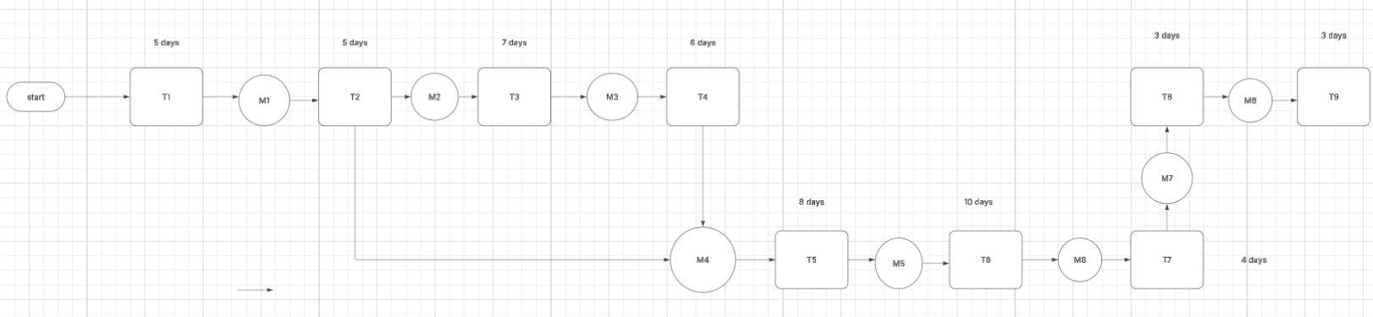

Figure 1: Pert Diagram

Critical Path = T1 + T2 + T3 + T4 + T5 + T6 + T7 + T9 + T10 = 51 days

Legal Feasibility

    - Compliance with Laws: The app will follow all national e-government, data protection, and cybersecurity laws in Jordan.

    - Data Privacy and Security: Personal data will be protected using encryption and secure storage and following data privacy laws.

    - Government Approvals and Ownership: All necessary permissions will be obtained from government, and intellectual property rights.

Software Process Model

In the TalkToRepair project, we will use the Agile Development Model due to its flexibility and effectiveness in managing complex projects with iterative requirements and frequent stakeholder interactions. Here are the reasons for choosing the Agile model:
- Adaptive Planning and Development: The Agile model allows for continuous planning and development, enabling the TalkToRepair project team to adapt to changes more efficiently. This is important as customer feedback and technological advancements could affect system enhancements and iterations.
- Incremental Delivery: By delivering the project in increments, stakeholders can see progress in real-time and provide feedback that can be quickly incorporated into subsequent iterations. This approach ensures that the final product is more aligned with user needs and expectations.
- Improved Collaboration: Agile emphasizes regular collaboration between project developers and business stakeholders. For TalkToRepair, this means frequent communication and decision-making sessions with the project team and client to ensure clarity and alignment on project goals.

- Customer-Based Approach: This model prioritizes customer involvement and satisfaction by ensuring that the project deliverables reflect the client’s desires and adjustments are made based on direct feedback from actual system users.

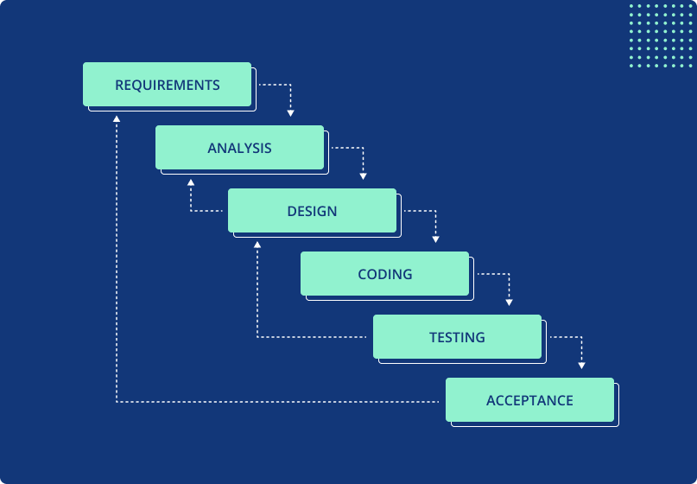

Figure 2: Software Process Model

CHAPTER 3: SYSTEM SPECIFICATIONS

Stakeholders

Table 3: Stakeholders

ID | Name | Notes
St1 | Users | Use the app to report issues, submit feedback, and communicate with government entities.
St2 | Government Agencies | Receive and manage reports from citizens, aiming to improve service delivery and respond efficiently to public concerns.
St3 | Regulatory and Legal Authorities | Ensure the app complies with data protection laws, e-government policies, and cybersecurity standards.
St4 | Developers | system integration, infrastructure, and data protection within the government framework.
St5 | Customer Support Staff | Assist citizens with issues, contributing to user satisfaction.

Data Gathering Techniques

- Interviews: One-on-one discussions with key stakeholders such as government agencies, frequent customers, and IT team members. These interviews aim to gather information about the requirements and expectations of the TalkToRepair app.
- User Stories and Use Cases: Descriptions from the perspective of different types of users that describe the tasks they wish to perform using the app. This includes report issues, tracking status of the issues, including location and photos of the issue.

Functional Requirements

Table 4: Functional Requirements

ID | Functional Requirement | Description | Stakeholders | Priority | Increment | Notes
FR1 | User Registration | Allow citizens to create accounts | St1, St2,St4 | 5 | 1
FR2 | Issue Reporting | Enable users to submit municipal issues with descriptions, categories, photos, and location data | St1,St4 | 5 | 1
FR3 | Issue Tracking | Allow users to monitor the status of reported issues through a dashboard and notification system | St1, St2,St4 | 4 | 1
FR4 | Issue assignment (Admin) | Assigning the issue to an available team | St2,St4 | 4 | 1
FR5 | Notification System | Send automated updates to users regarding status changes and comments on their reported issues | St1, St2, St4 | 3 | 2
FR6 | Search & Filter Functionality | Allow users to search for specific issues and filter by status, category, or location | St1, St2,St4 | 3 | 2
FR7 | Analytics Dashboard | Provide statistical overview of issues by status, type, and location for administrators | St2, St4 | 3 | 2
FR8 | Feedback System | Allow users to rate their experience after issue resolution | St1, St2, St4,St5 | 2 | 3
FR9 | Log out | Allow users to log out of their account to change the account | St2, St4 | 5 | 1
FR10 | Request Additional Information | Allow government staff to provide updates and request additional information from citizens | St1, St2,St4, St5 | 3 | 2
FR11 | Authentication & Authorization | Implement secure login and role-based access controls for different user types | St1, St2, St4, St6 | 5 | 1
FR12 | Reset Password | Reset the password when you forget it | St1, St2,St4 | 4 | 1
FR13 | Multi-language Support | Provide interface in multiple languages | St1, St2,St4 | 3 | 3
FR14 | Announcement System | Allow administrators to publish city-wide announcements visible to all users | St2,St4,St5 | 2 | 2
FR15 | Mobile Responsiveness | Ensure application functions properly on various devices and screen sizes | St3,St4 | 5 | 1
FR16 | Geolocation Services | Automatically detect and suggest a user’s current location when reporting issues | St1,St4 | 3 | 2
FR17 | Issue Categorization System | Implement comprehensive taxonomy of issue types with subcategories | St2, St4 | 3 | 2
FR18 | Two-Factor Authentication | Provide an additional layer of security through two factors  authentication. | St1, St3,St4 | 4 | 1
FR19 | Offline Functionality | Allow users to create reports without internet connection that synchronize when connection is restored | St1,St2,St4 | 2 | 3
FR20 | Account Deactivation | Allow customers to deactivate their account. | St1,St2,St4 | 4 | 1
FR21 | Profile management | Allow customers to update their personal information and  preferences. | St1,St2,S4 | 4 | 1
FR22 | Issue completion | Change the status of the issue to complete and remove it from the list of current issue | St2,St4 | 2 | 2
FR23 | Duplicate Issue Detection | Check if the location and the type of the issue is the same and if true do not add it | St4 | 4 | 2
FR24 | Public Issue Map | Provide map visualization of reported issues viewable by all citizens | St2,St4 | 2 | 3
FR25 | Help and support | Offer searchable FAQ and self-help resources for common issues | St1,St2,St4, St5 | 2 | 2
FR26 | Upload photos | Allow users to attach photos about the reported issue to provide more information | St1, St4 | 2 | 2
FR27 | Push Notifications | Send mobile device notifications for issue updates and announcements | St1,St2,St4 | 3 | 2
FR28 | Display the number of in-progress issue | Allow the user to see the number of in-progress issue | St1,St2, St4 | 1 | 3
FR29 | User Activity Logging | Track and store user actions for audit purposes | St4, St6 | 5 | 1
FR30 | User Login functionality | Allow customers to log in using their credentials | St1, St2,St4 | 5 | 1

Nonfunctional Requirements

Table 5: Nonfunctional Requirements

NFR ID | Description | Priority | Note
NFR1 | Availability: Ensure the system remains operational 24/7. | 5 | Essential for user satisfaction and operational continuity.
NFR2 | Performance: Guarantee that page response times do not exceed 3 seconds under typical load conditions. | 4 | Critical for user retention and reducing bounce rates.
NFR3 | Security: Secure all data exchanges and storage with encryption standards. | 4 | Complies with the best security practices, crucial for user trust.
NFR4 | Data Integrity: maintain the reliability of business transactions. | 5 | Prevents data corruption and loss, essential for operations.
NFR5 | User Experience: Deliver an easy-to- navigate interface, requiring minimal to no training for new users. | 4
NFR6 | Compliance: stick to relevant laws and regulations. | 5 | Protects the company from legal risks.
NFR7 | Maintainability: Keep the code clean with frequent refactoring to ensure minimal documentation and high clarity. | 4 | Simplifies system upkeep and evolution over time.

Domain Requirements

Table 6: Domain Requirements

DFR ID | Description | Note
DR1 | The system must implement categorization system aligned with government department structures. | Must support proper routing across departments and accommodate differences between departments.
DR2 | The application must comply with government transparency, data protection, and accessibility standards.
DR3 | The system must differentiate between standard service requests and emergency situations requiring immediate attention. | Can be specified through the type of the report
DR4 | The issue management workflow must align with established government processes.

Requirements Analysis

    - G1: Account Management System (FR1,FR9, FR11, FR12, FR18, FR20, FR21, FR30).
    - G2: Issue Reporting & Assignment System (FR2, FR4, FR10, FR16, FR17, FR22, FR23, FR26).
    - G3: Issue Tracking & Notification System (FR3, FR5, FR6, FR24, FR27, FR28).

    - G4: Administration & Analytics System (FR7, FR13,FR14, FR15, FR19, FR29).

    - G5: Help & Support System (FR8,FR25).

Architectural Design

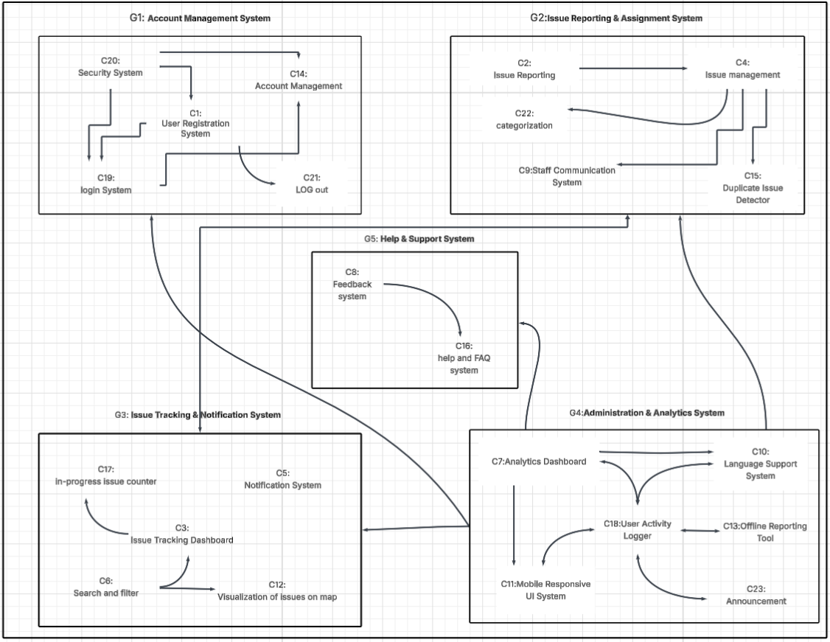
Figure 3: Architectural Design
This image represents the architecture diagram of TalkToRepair app. It is organized into five grouped systems (G1–G5), each containing related components form(C1–C23). Arrows between components indicate data flow or functional dependency.

Table 7: Components

Component ID | Component Name | Mapped Functional Requirement
C1 | User Registration System | FR1
C2 | Issue Reporting | FR2,FR16,FR26
C3 | Issue Tracking Dashboard | FR3
C4 | Issue management | FR4,FR22
C5 | Notification System | FR5 ,FR27
C6 | Search and filter | FR6
C7 | Analytics Dashboard | FR7
C8 | Feedback System | FR8
C9 | Staff Communication System | FR10
C10 | Language Support System | FR13
C11 | Mobile Responsive UI System | FR15
C12 | Visualization of issues on map | FR24
C13 | Offline Reporting Tool | FR19
C14 | Account Management | FR20,FR21
C15 | Duplicate Issue Detector | FR23
C16 | Help & FAQ System | FR25
C17 | In-Progress Issue Counter | FR28
C18 | User Activity Logger | FR29
C19 | Login System | FR12,FR30
C20 | Security system | FR11,FR18
C21 | Log out | FR9
C22 | categorization | FR17
C23 | Announcement | FR14

CHAPTER 4: SYSTEM DESIGN

Class Diagram

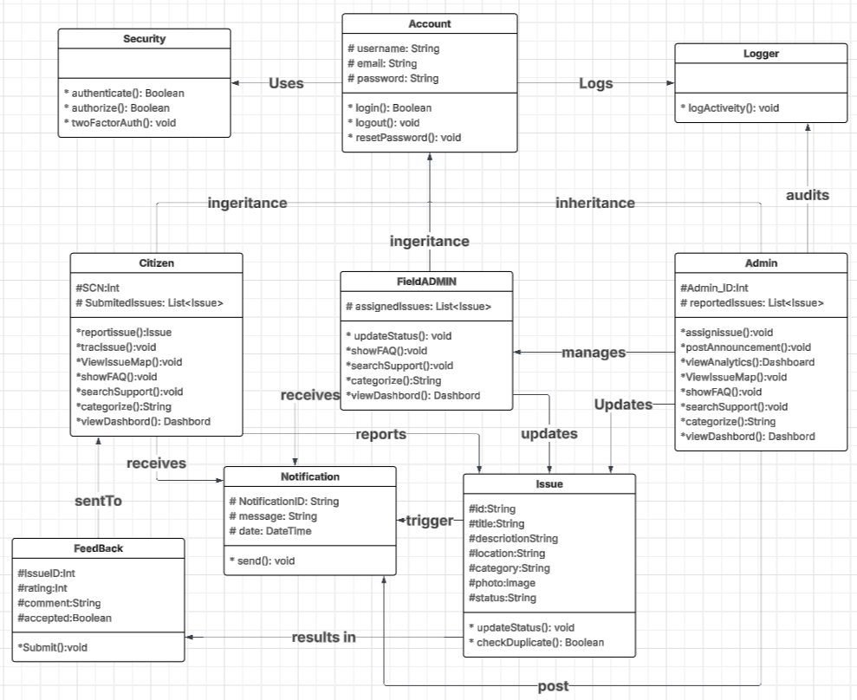

Figure 4: Class-Diagram

Use Case Diagrams

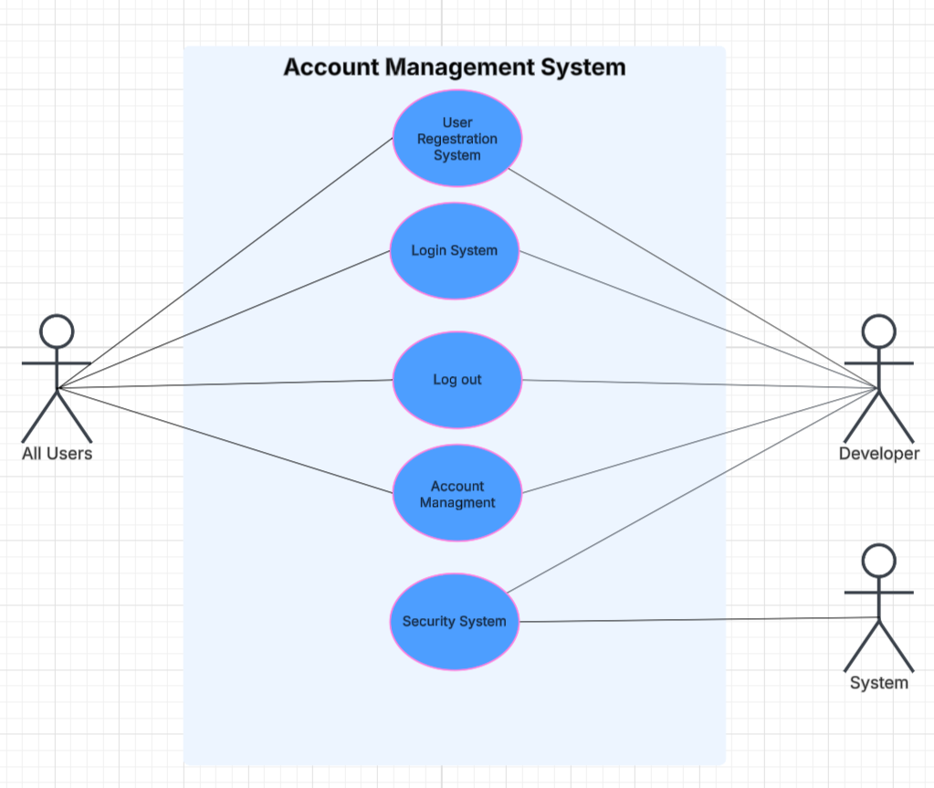

Figure 5: Account Management System

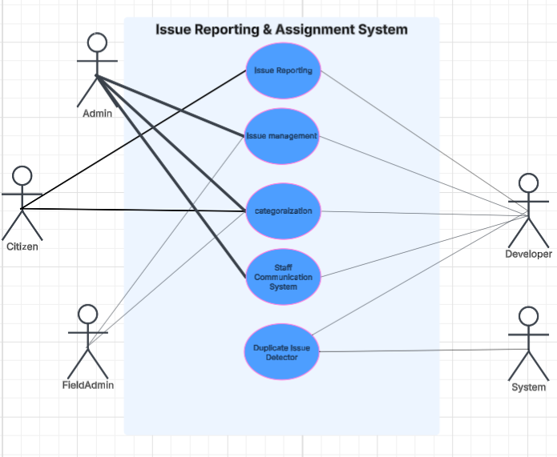

Figure 6: Issue Reporting & Assignment System

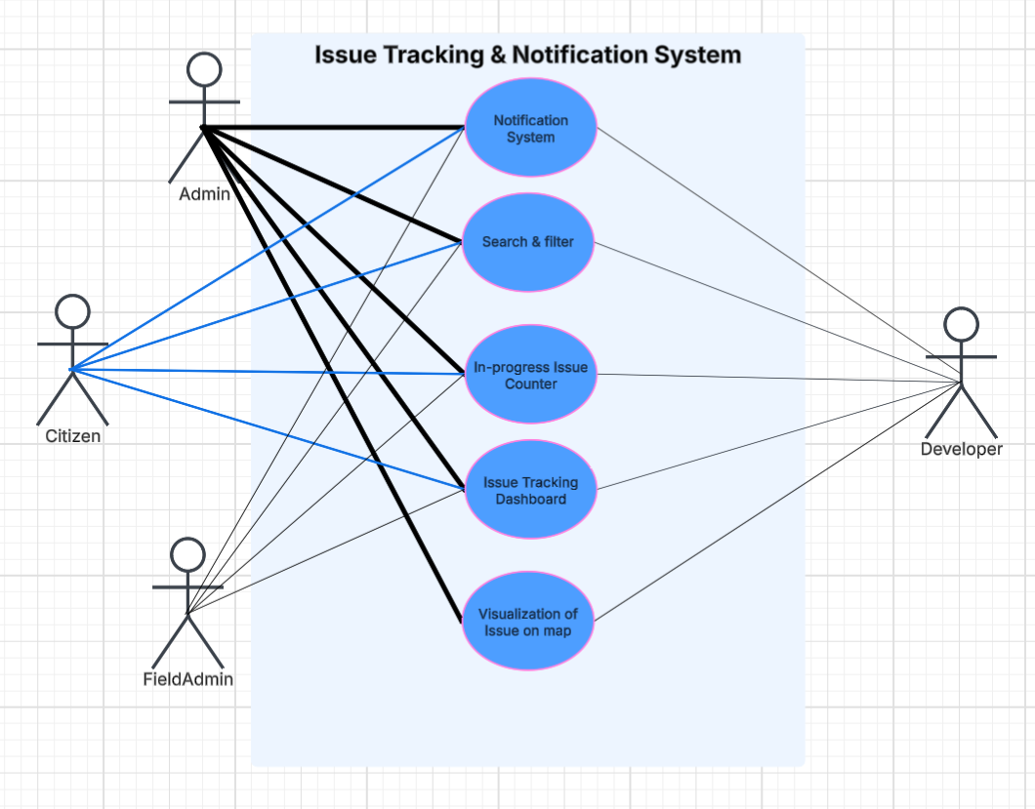

Figure 7: Issue Tracking & Notification System

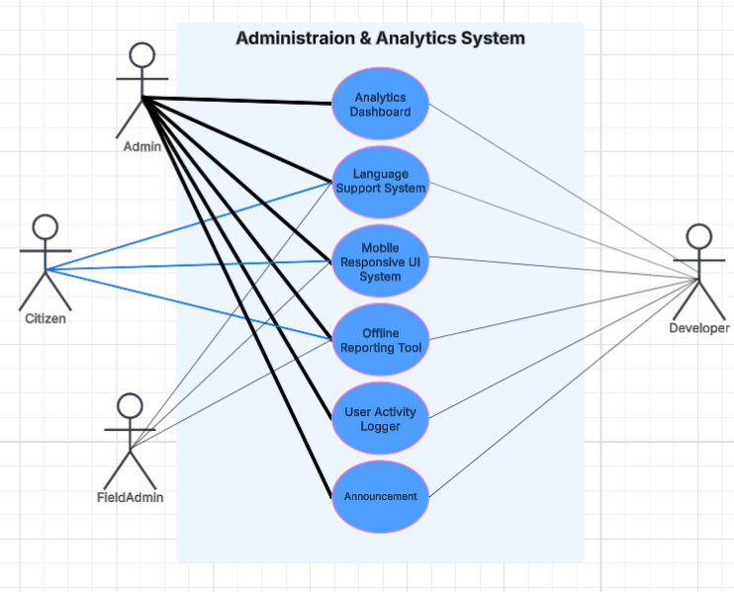

Figure 8: Administration & Analytics System

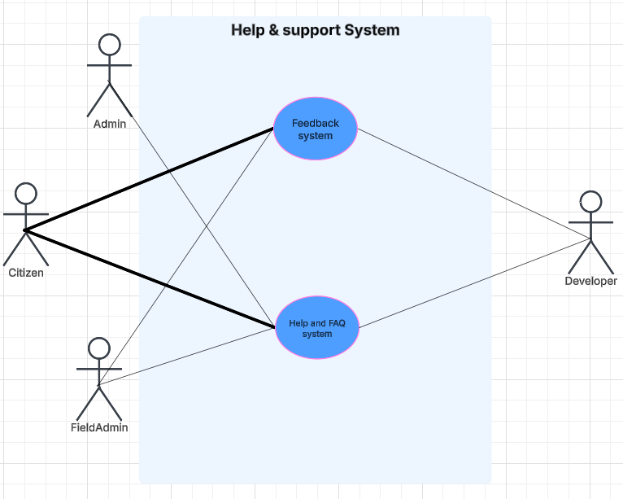

Figure 9: Help & support System

Use Case Descriptions and Sequence Diagrams

User Registration System (C1 – FR1)
Actors | All Users, System
Description | Users create new accounts to access system features. Developer ensures secure form handling and storage of user data.
Data | Full Name, Email, Password
Stimulus | User submits registration form.
Response | A new account is created and stored securely.
Comments | Must include privacy controls and data validation for accuracy and integrity.

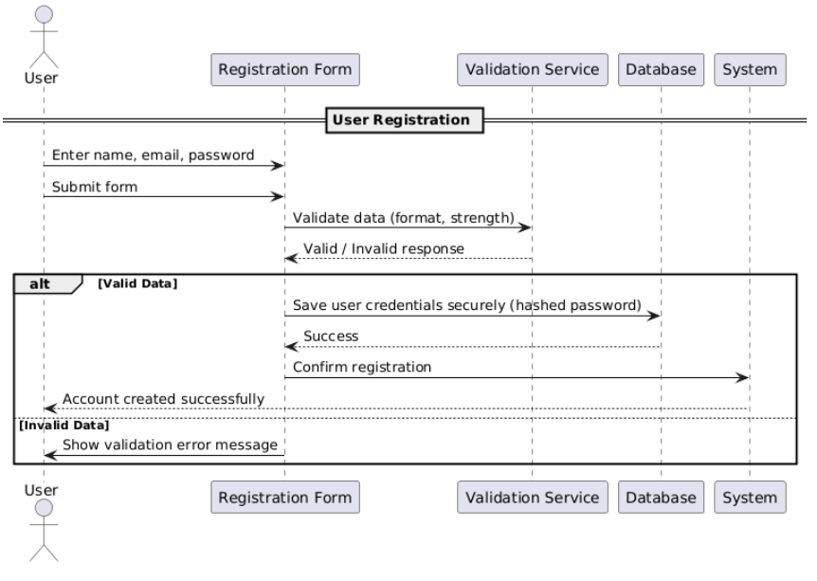

Figure 10: User Registration System

Issue Reporting (C2 – FR2, FR16, FR26)
Actors | Citizen, System
Description | Citizens submit municipal issues with optional photos and geolocation. Developer ensures accurate recording and categorization.
Data | Title, Description, Category, Location, Photo
Stimulus | Customer fills out and submits the login form.
Response | Issue is saved with location and photo; system may suggest current location.
Comments | Validate location and image size. Ensure duplicates are avoided.

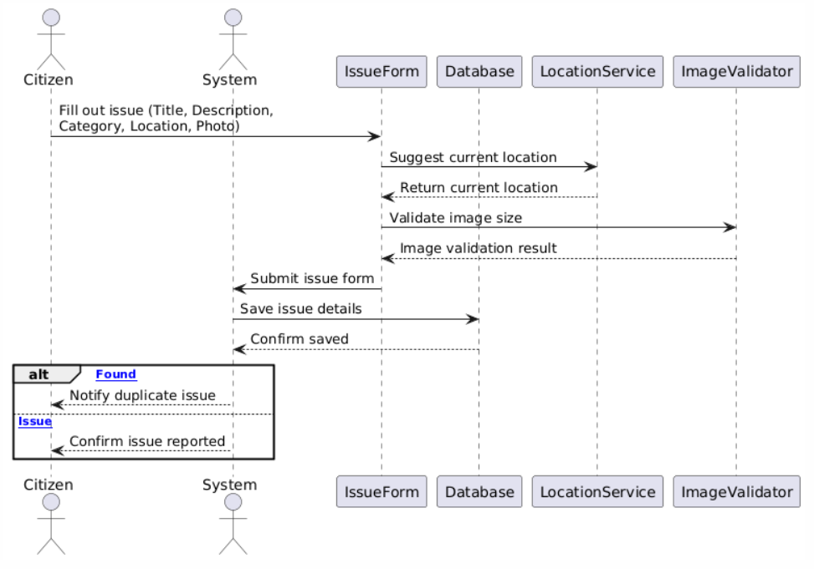

Figure 11: Issue Reporting

Issue Tracking Dashboard (C3 – FR3)
Actors | All Users, System
Description | Users can view and track the status of their reported issues in a dashboard interface.
Data | Issue ID, Status, Updates
Stimulus | User opens the dashboard.
Response | List of issues with statuses and filters is shown.
Comments | Include status change notifications for engagement.

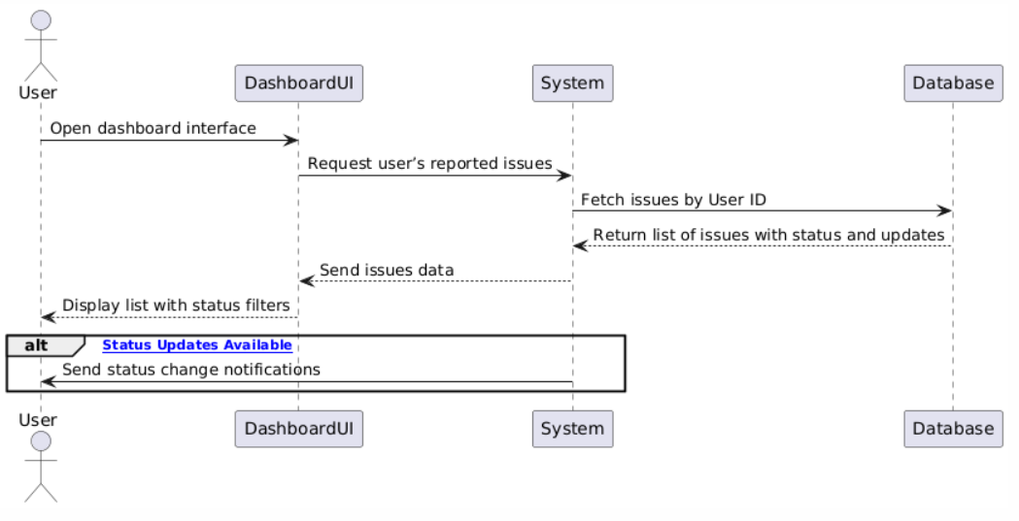

Figure 12: Issue Tracking Dashboard

Issue Management (C4 – FR4, FR22)
Actors | Admin, Field Admin, System
Description | Admins assign reported issues to teams; Field Admins mark them as completed.
Data | Issue ID, Assignee ID, Completion Status
Stimulus | Admin assigns or Field Admin completes an issue.
Response | Issue status updated in system.
Comments | Provide logs for assignment and completion.

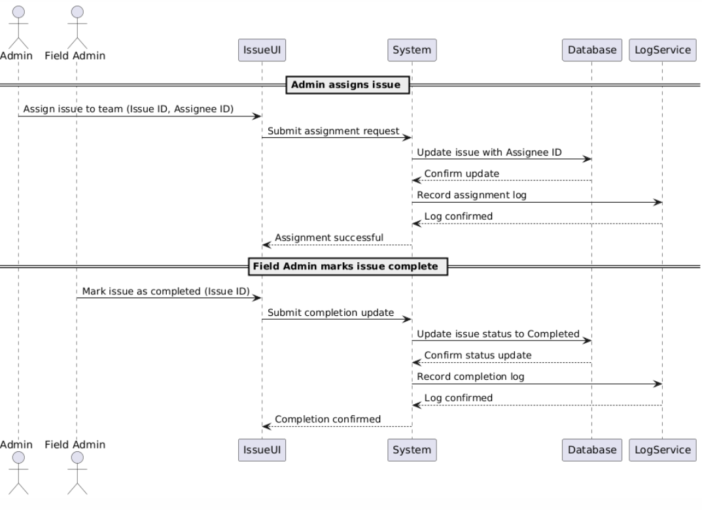

Figure 13: Issue Management

Notification System (C5 – FR5, FR27)
Actors | All Users, System
Description | Sends automatic notifications and mobile push alerts for updates and announcements.
Data | Notification Type, User ID, Message
Stimulus | Issue of status changes or announcement is published.
Response | Notification is delivered to user.
Comments | Must go through mobile notification.
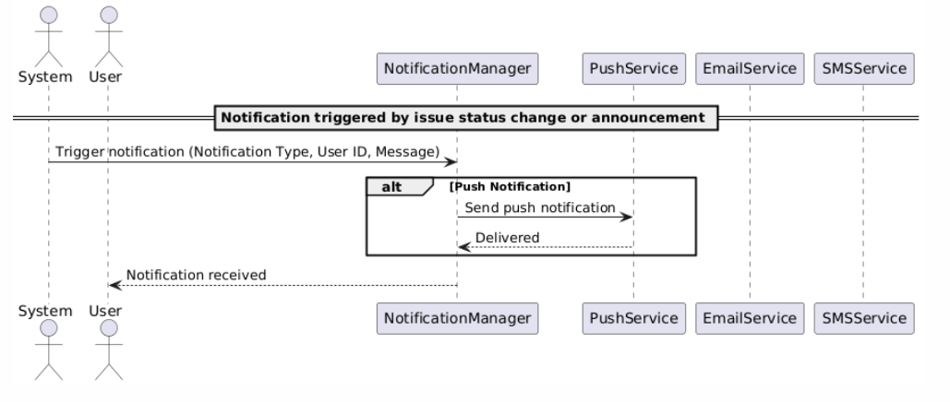

Figure 14: Notification System

Search and Filter (C6 – FR6)
Actors | All Users
Description | Users can search and filter issues based on various criteria such as status and category.
Data | Status, Category, Keywords
Stimulus | User enters a search query or filter.
Response | Matching issues are displayed.
Comments | Support dynamic filters and fuzzy search.

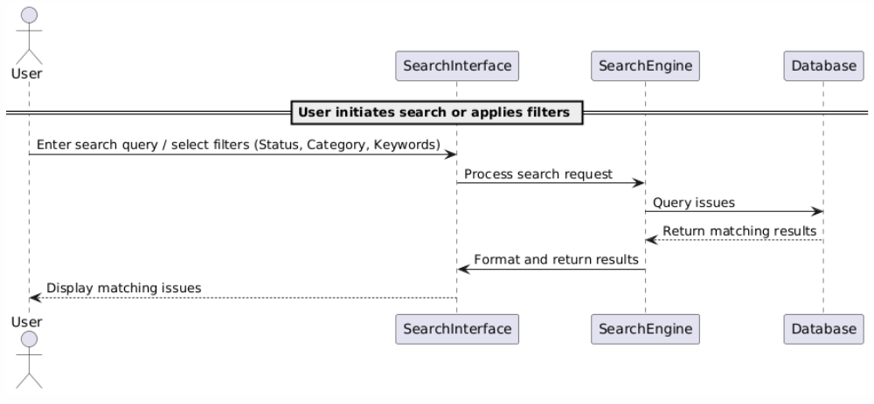
Figure 15: Search and Filter

Analytics Dashboard (C7 – FR7)
Actors | Admin
Description | Admins view analytics and statistics of issues by type, status, and location.
Data | Issue Status, Locations
Stimulus | Admin opens analytics page.
Response | Graphs and stats are rendered.
Comments | Include time filters and export option.

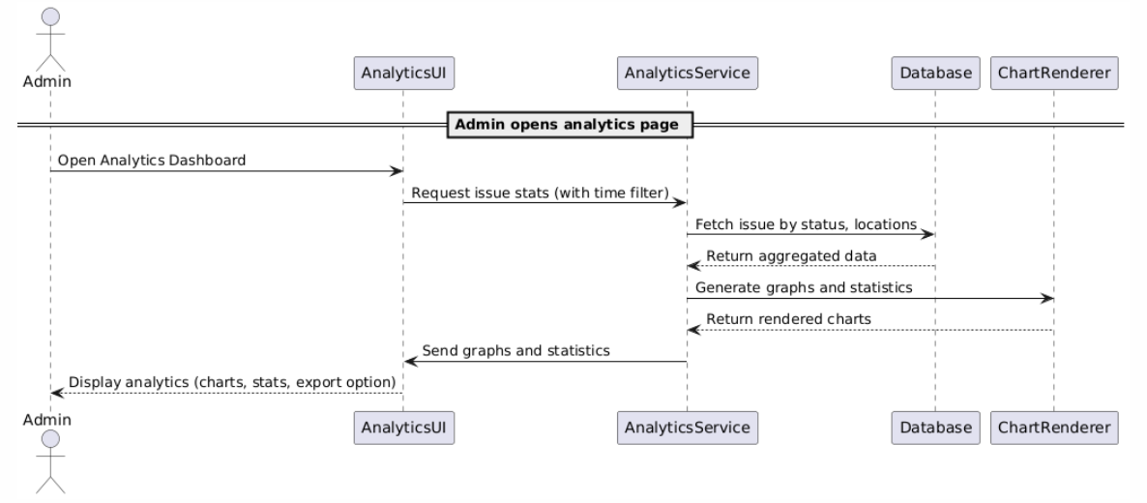

Figure 16: Analytics Dashboard

Feedback System (C8 – FR8)
Actors | Citizen, System
Description | Allows users to provide ratings and feedback after an issue is resolved.
Data | Rating, Comments, Issue ID
Stimulus | Issue is marked resolved.
Response | Feedback form is shown and stored.
Comments | Encourage user feedback for quality improvement.

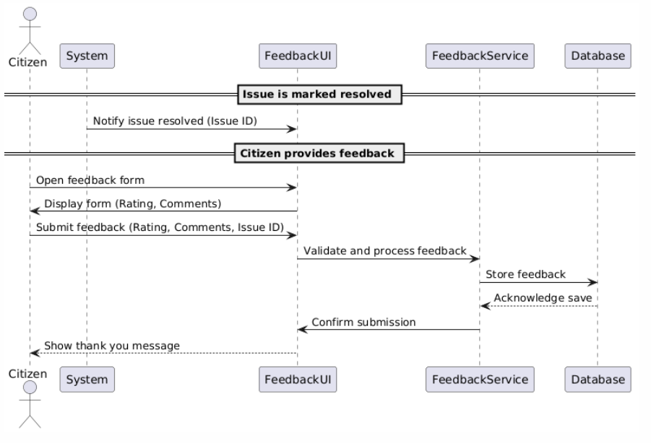
Figure 17: Feedback System

Request Additional Information (C9 – FR10)
Actors | Admin, Citizen, System
Description | Rejecting the report for the user and asking for more information
Data | Messages.
Stimulus | Citizen report and the admin reject the request with the cause of need more information.
Response | Notification sent to the user
Comments | Maintain logs for request.

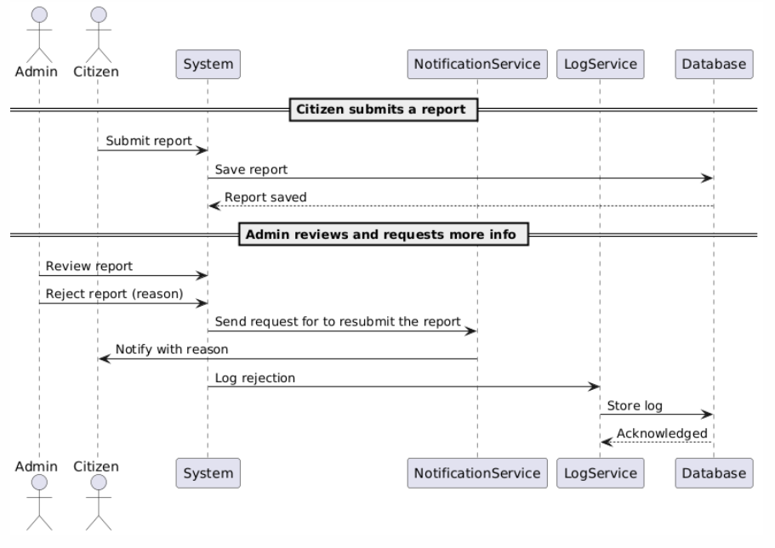

Figure 18: Request Additional Information

Language Support System (C10 – FR13)
Actors | All Users, System
Description | Interface is available in multiple languages to ensure accessibility.
Data | Language preference
Stimulus | User selects or system detects preferred language.
Response | Interface language is updated.
Comments | Include RTL support and translations for all content.

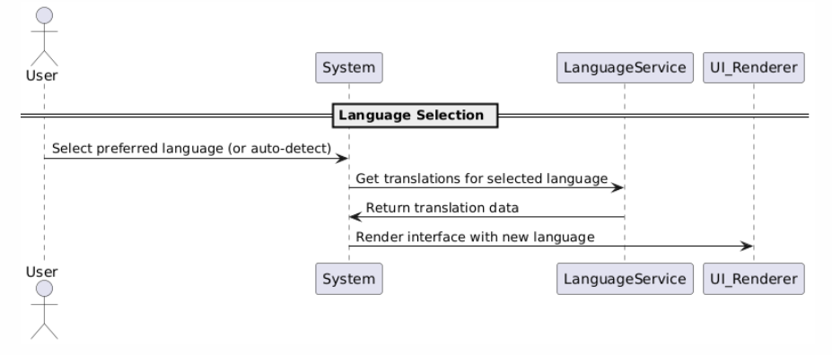
Figure 19: Language Support System

Mobile Responsive UI System (C11) — (FR15)
Actors | All Users, System
Description | Ensures the application interface adjusts properly across different screen sizes and devices.
Data | Device screen resolution, browser information
Stimulus | Users access the system from a mobile or tablet device.
Response | Responsive layout is rendered automatically.
Comments | Improves accessibility and usability across platforms.

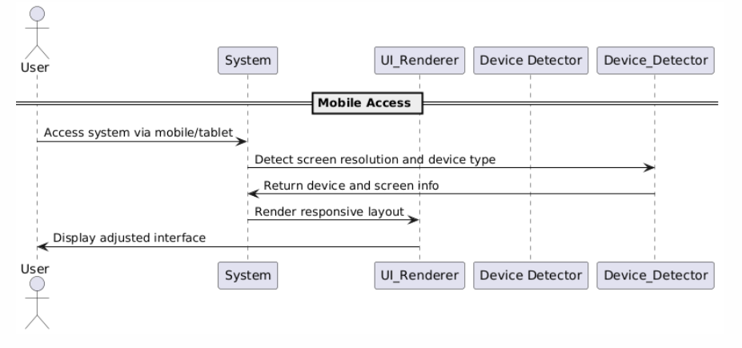
Figure 20: Mobile Responsive UI System

Visualization of Issues on Map (C12) — (FR24)
Actors | Admin, System
Description | Displays reported issues visually on a map to enhance geographic context and transparency.
Data | Issue location (coordinates), issue status, type
Stimulus | Admin requests to view reported issues on the map interface.
Response | An interactive map with issue markers is displayed.
Comments | Helps in spatial analysis and management of municipal services.

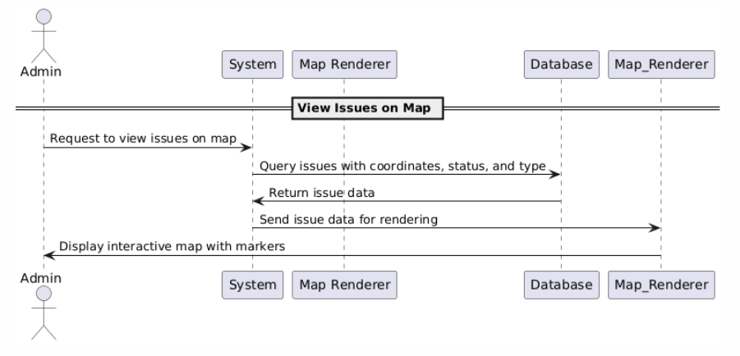
Figure 21: Visualization of Issues on Map

Offline Reporting Tool (C13) — (FR19)
Actors | All Users, System
Description | Allows users to report issues without an active internet connection, synchronizing data when online.
Data | Issue description, category, location, photos
Stimulus | User opens the app in offline mode and reports an issue.
Response | Data is stored locally and synchronized once connectivity is restored.
Comments | Crucial for areas with limited internet access.
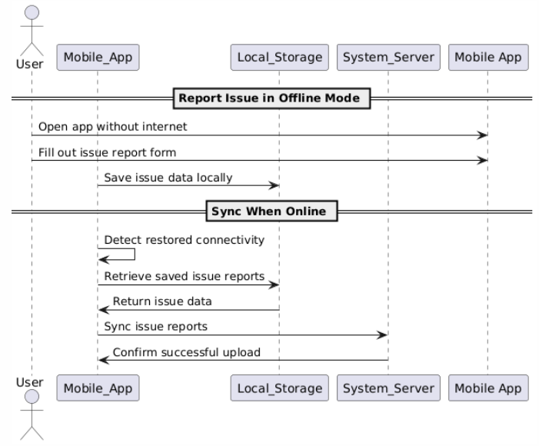
Figure 22: Offline Reporting Tool

Account Management (C14) — (FR20, FR21)
Actors | All Users
Description | Enable users to manage their account including profile updates and deactivation.
Data | Name, phone, email, password, preferences
Stimulus | User selects profile management or account deactivation.
Response | Account details are updated or marked as deactivated.
Comments | Includes confirmation for deactivation and an option for reactivation.

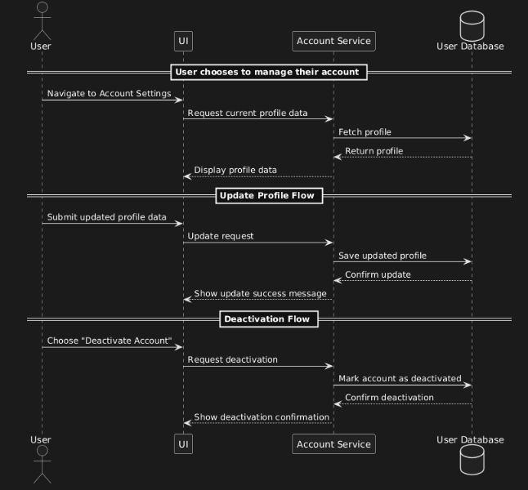
Figure 23: Account Management

Duplicate Issue Detector (C15) — (FR23)
Actors | All User
Description | Automatically detects duplicate issues based on location and issue type.
Data | Location, issue category, timestamp
Stimulus | New issue report is submitted.
Response | If a duplicate is found, the user is notified; otherwise, issue is submitted.
Comments | Improves data integrity and prevents redundancy.

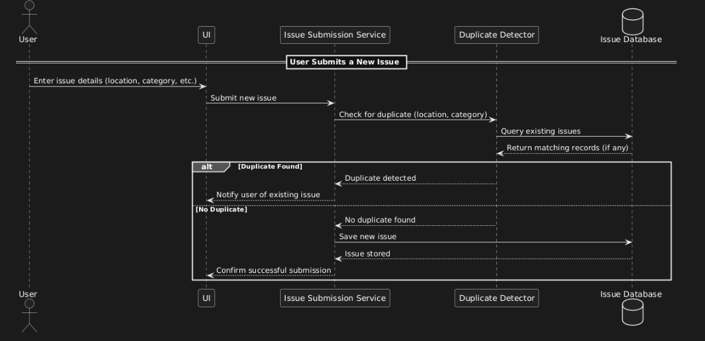

Figure 24: Duplicate Issue Detector

Help & FAQ System (C16) — (FR25)
Actors | All Users
Description | Provides self-help resources and frequently asked questions.
Data | FAQ entries, user queries
Stimulus | User clicks Help or FAQ section.
Response | Relevant help content is displayed.
Comments | Reduces support requests and enhances user knowledge.

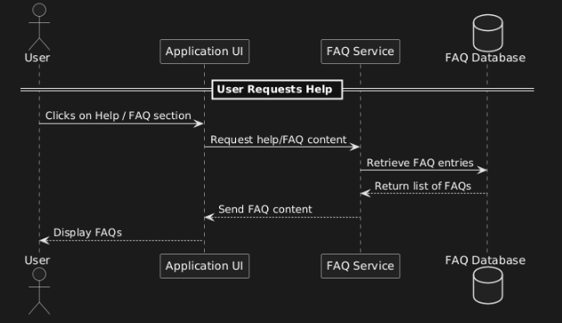
Figure 25: Help & FAQ System

In-Progress Issue Counter (C17) — (FR28)
Actors | All Users
Description | Displays the number of issues currently being worked on.
Data | Issue status, timestamps
Stimulus | User opens dashboard or issue overview.
Response | The number of in-progress issues is shown.
Comments | Help users track workload and progress.

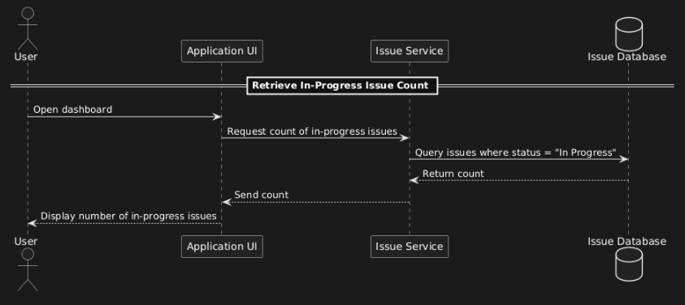

Figure 26: In-Progress Issue Counter

User Activity Logger (C18) — (FR29)
Actors | All Users, Developer
Description | Logs user actions for auditing and monitoring purposes.
Data | User ID, actions performed, timestamps
Stimulus | User performs an action within the system.
Response | Action is logged securely.
Comments | Useful for tracking changes and ensuring accountability.

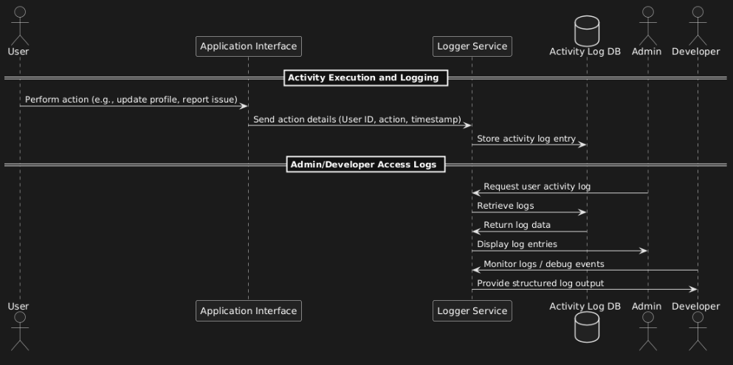
Figure 27: User Activity Logger

Login System (C19) — (FR12, FR30)
Actors | All Users, System
Description | Manages secure login and password reset.
Data | Username, password, reset credentials
Stimulus | User attempts to log in or reset password.
Response | Access is granted or password reset instructions sent.
Comments | Ensures secure access and user-friendly recovery.

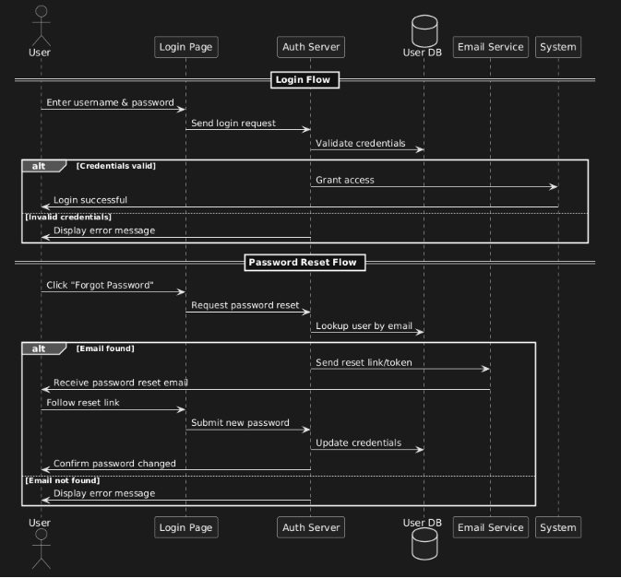

Figure 28: Login System

Security System (C20) — (FR11, FR18)
Actors | All Users, System
Description | Implement authentication and two-factor security controls.
Data | Login credentials, device ID, OTP
Stimulus | User attempts to login or change sensitive settings.
Response | User is authenticated with password and OTP.
Comments | Enhance protection against unauthorized access.

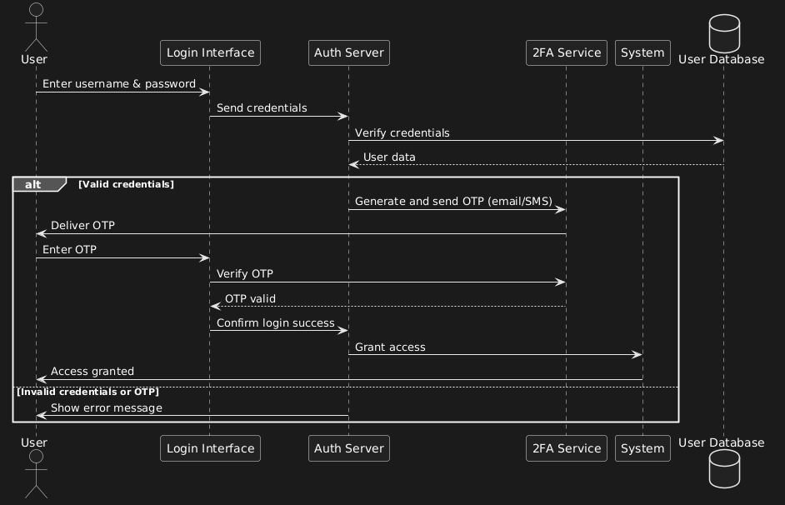

Figure 29: Security System

Log Out (C21) — (FR9)
Actors | All Users, System
Description | Allow users to safely log out of their accounts.
Data | Session token
Stimulus | User selects the log-out option.
Response | Session is terminated securely.
Comments | Prevents unauthorized access on shared devices.

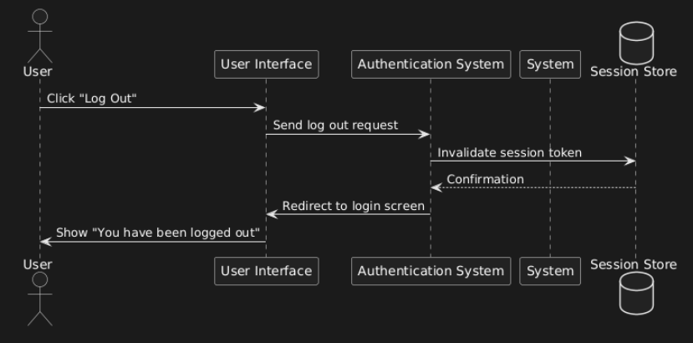

Figure 30: Log Out

Categorization (C22) — (FR17)
Actors | All Users, System
Description | Provides an overview of system metrics and issue statuses.
Data | Issue type, subcategories, metadata
Stimulus | User reports a new issue.
Response | User selects from predefined categories.
Comments | Facilitates accurate assignment and analysis.

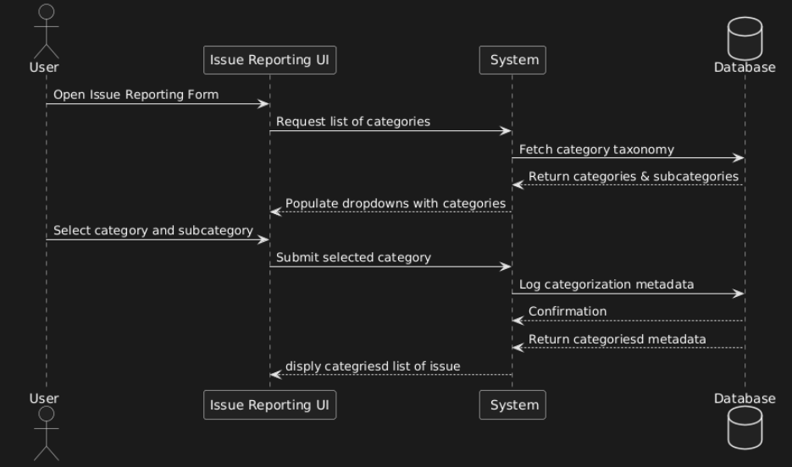

Figure 31: Categorization

Announcement System (C23) — (FR14)
Actors | All User, System
Description | Allow administrators to broadcast announcements to all users.
Data | Announcement title, content, date
Stimulus | Admin creates a new announcement.
Response | Announcement is displayed to all users.
Comments | Useful for community updates and emergency alerts.

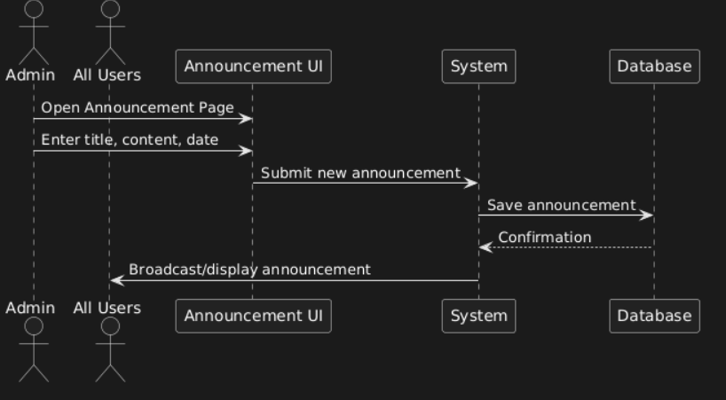

Figure 32: Announcement System

CHAPTER 5: PROJECT IMPLEMENTATION AND TESTING

Project Implementation

We prefer to use flutter for the Frontend and Backend and firebase as database .

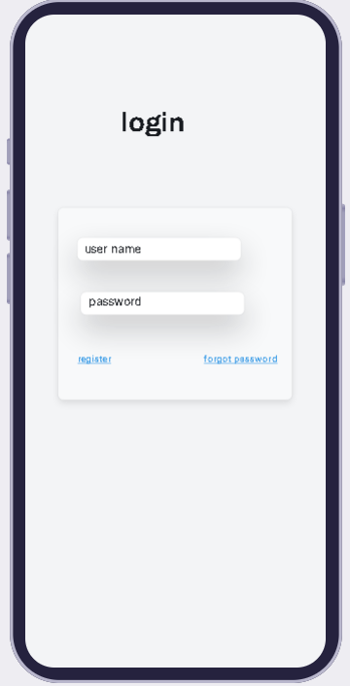

Figure 33: Login Page

Enter the username and the password of your account. If you do not have an account click on the register and if you forgot the password click on forgot password.

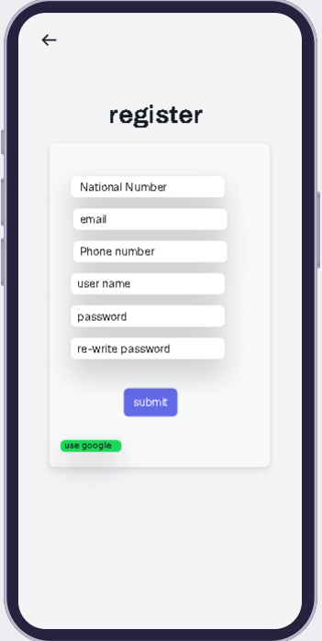

Figure 34: Sign Up Page with National ID and Name

Enter the information shown in the picture and press submit to create an account or click google if you want to sign up with google.

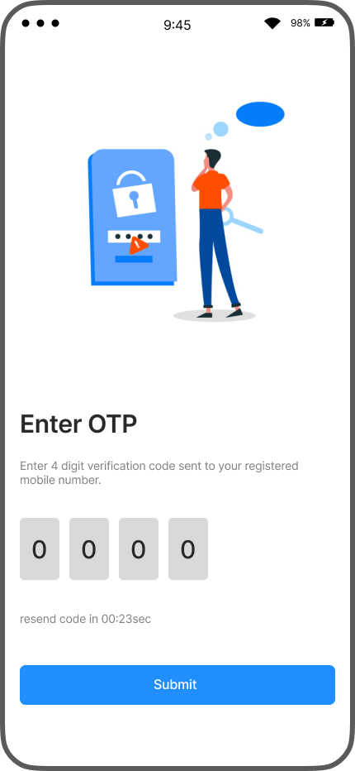

Figure 35: OTP Page

When you log in a password consists of 4 digits will be sent to you write it so you can continue login .

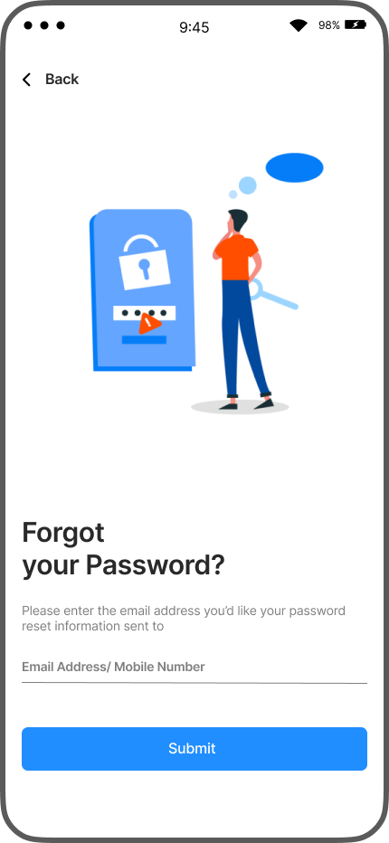
Figure 36: Forget Password Page

Enter the email address of the account you forgot its password to send you the verification link on it

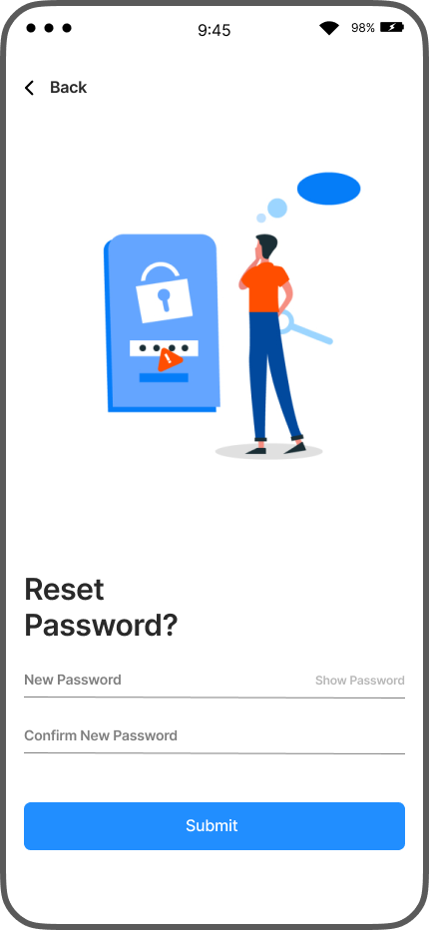

Figure 37: Reset Password Page

When you click on the verification link in your email you will be redirected to this page and can enter a new password.

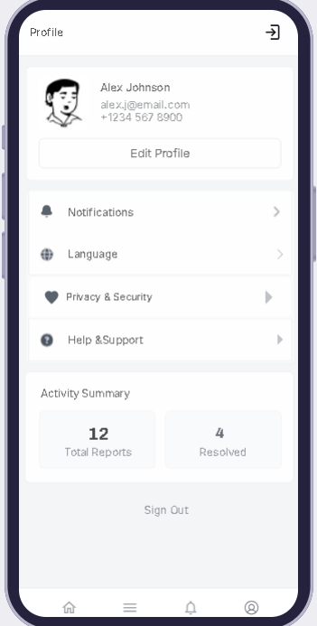

Figure 38: Account Profile Page

  - You can edit the profile information(name, email, phone number, photo) by clicking on the edit profile button.
  - You can enable or turn off the notification by clicking on the “notification.”
  - You can change the language by clicking on Language a drop-down list will show, and you can select the language you want.
  - You can edit the security and privacy(allow to use information about you for feedback or disable two factor authentication) settings by clicking on “privacy & security.”
  - You can get help on the FAQ from the “Help & support”>
  - If you want to sign out of your account click on “Sign Out”
  - You can use the bottom navigation to move between different pages in the app
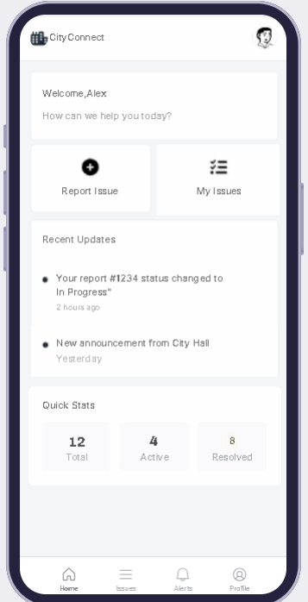

Figure 39: Home Page

  - If you want to report a new issue press “Report Issue”
  - If you want to see the list of issue reported press “My Issues”
  - You can press the icon in the top right corner to open the profile page
  - You can see the latest notification in the Recent Updates.
  - You can see the total number of the problems you have reported and the active ones and the resolved ones.

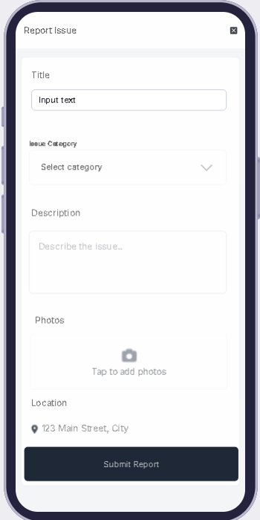
Figure 40: Report Issue Page Citizen

You need to put the title of the report and the type of it and the description of the problem you want to report and photo of it and the location of the problem

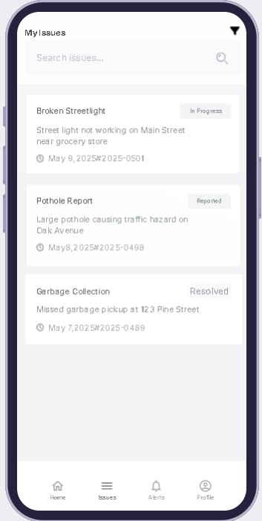
Figure 41: List of Issue Page Citizen

  - You can see the list of issues and if you want to see the details of any issue click on it

  - You can search the issue by name or filter the results by pressing the icon in the top-right corner.

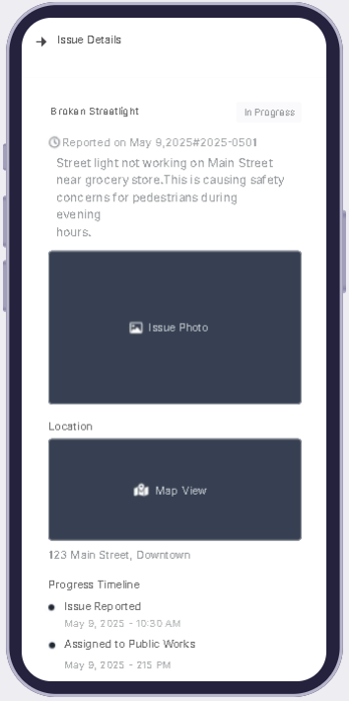

Figure 42: Issue Detail Page Citizen

This page will show you the details of the issue. You can return to the previous page by clicking on the arrow in the top-left corner.
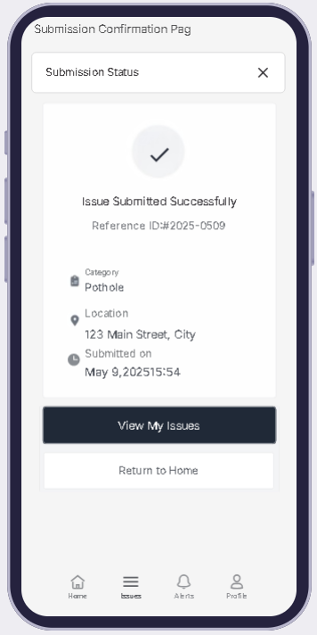
Figure 43: Issue Confirmation Page

You will see this page after submitting a report it just tells you that you report has been sent, and you can view all the issue ”View My Issues” or return home page “Return to Home.”
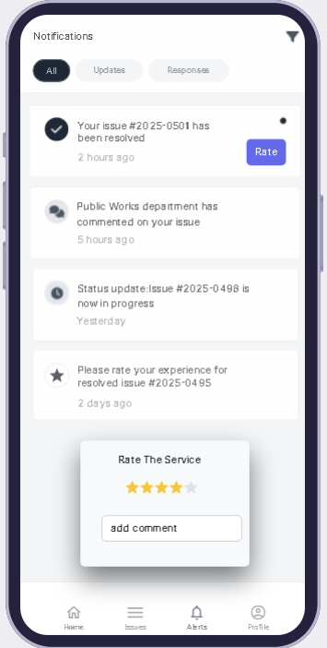

Figure 44: Notification Page

- You will see the notification and can filter them from the options above “All” or “Updates” or “Responses” or the icon top-right corner.
- You can rate the resolved issue by clicking on the rate button a box will appear telling you to rate the service and add a comment.

Admin

Figure 45:Profile Page Admin

This page is like the profile page of the citizen.

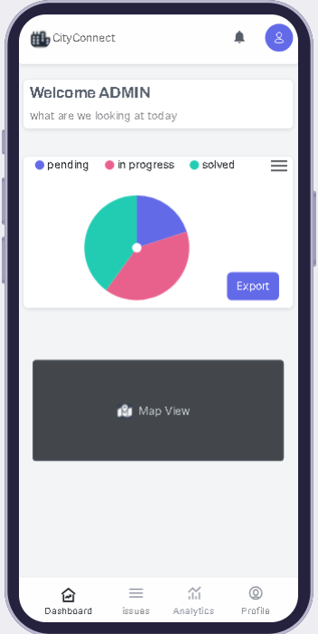

Figure 46: Home Page Admin

You have two main functions here you can export the data to use in analytics report, and you can press on “Map View” and this will open a map with markers on the problems location.
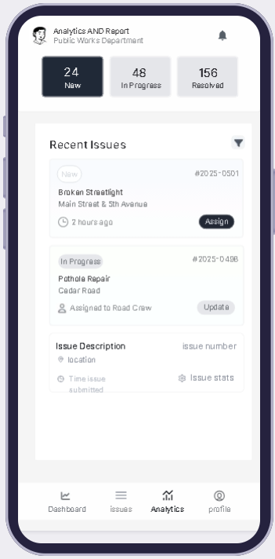

Figure 47: Analytics page

You can see the problem in numbers and the recent Issues that has been received.
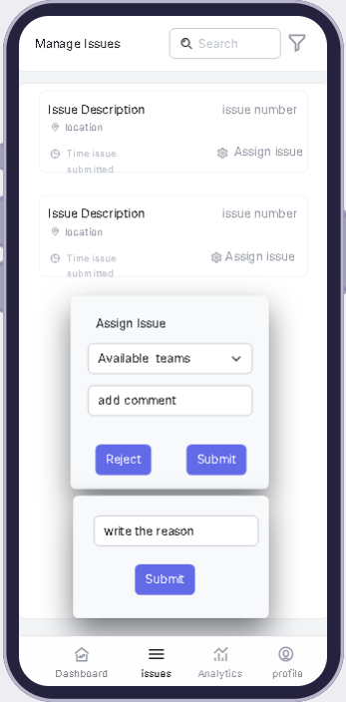
Figure 48: Manage Issue Page

  - You can search for issues from the search box and filter the results from the icon beside it.
  - You can manage the issue by clicking on the Assign issue button and a box will appear. You can assign the problem to the team and submit or reject the problem which will make another box appear with a text box to write the reason .
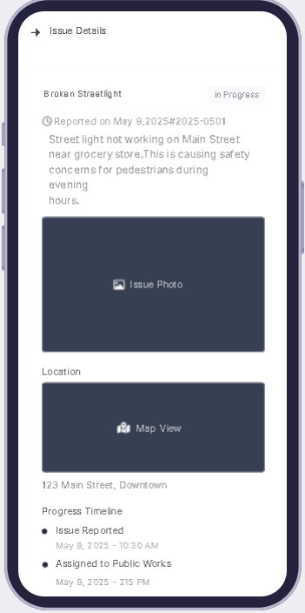
Figure 49: Issue Detail Page Admin

This page is like the Issue Detail Page of the Citizen.
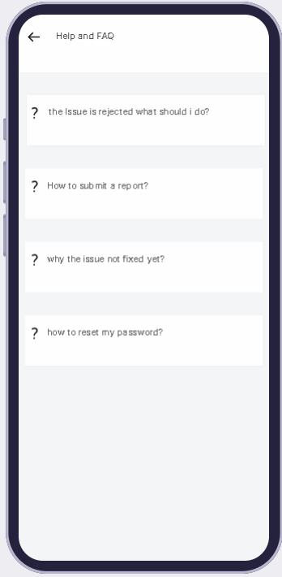

Figure 50: Help Page

This is the page of the FAQ you can click on the question you want and will expand to give you the answer

Project Testing

TalkToRepair app underwent extensive testing to ensure functionality across various mobile devices and compatibility with essential services. Key focus areas include performance in diverse network conditions, user interface responsiveness, and integration with external APIs. Security and privacy tests were conducted to comply with data protection standards. Usability testing with different user groups ensured an accessible and intuitive user experience, making the app ready for real-world deployment.

APPENDIX

Appendix A: The questioned asked in the interview:

- What information would you like to provide when reporting an issue?
- How would you like to track your reported issues after submission?
- Do you want to rate your experience or give feedback after your issue is resolved?
- Would you prefer to be notified about updates or announcements?
- What features would you need to search, or filter reported issues easily?
- What account-related actions would you expect?
- Should the system be accessible in multiple languages or work on all devices?
- If you're not connected to the internet, should you still be able to report an issue?
- From an admin's perspective, what should happen after an issue is reported?
- What type of security or control do you expect over your account and data?

REFERENCES

- Lucidchart. PlantUML User Guide, version 4.0. www.plantuml.com.

- Sommerville, Ian. Software Engineering. 10th ed., Addison-Wesley, 2015.
- Amjad, Prof. "Software Engineering" Template.
- "Figma." Figma Inc., Figma, www.figma.com.
- "Lucidchart." Lucid Software Inc., Lucidchart, www.lucidchart.com.
- SeeClickFix - A citizen reporting tool that enables users to report non-emergency issues to local governments(https://seeclickfix.com/).
- FixMyStreet - A platform for reporting and tracking local issues such as potholes and broken streetlights(https://www.fixmystreet.com/).
- UReport (UNICEF) - A platform for youth engagement and government feedback(https://ureport.in/).
- GAM APP – An android app includes e-services like vehicle tickets, real state, vocational license,complain(https://play.google.com/store/apps/details?id=com.gam_municipality&pcampaignid=web_share).

