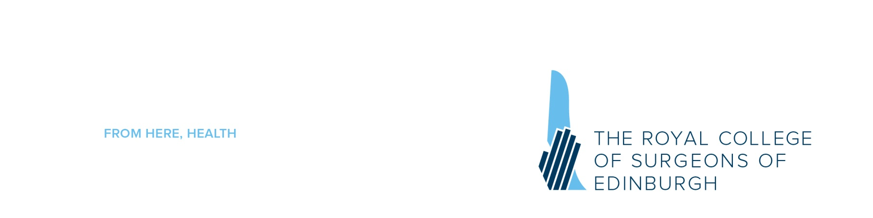

Neurosurgical Approaches to the Cranial Compartments
(Co-organised by the Edinburgh Department of Clinical Neurosciences and the Glasgow Institute of Neurological Sciences)

19, 20 & 21 November 2013
Venue: Stewarts Skills Laboratory, RCSEd

DAY 1 – Tuesday 19th November 2013 |  | Faculty /Lead
08.00-08.25 | Registration and Coffee
08:25 – 08:30 | Welcome and Introduction | Mr I Fouyas
08.30-09.00 | Pterional craniotomy/orbitozygomatic osteotomy | Mr I Fouyas
09.00-11.00 | Dissection
11.00-11.15 | Coffee Break
11.15-11.45 | Anterior clinoidectomy/approaches to the optic canal | Mr P Statham
11.45-13.15 | Dissection
13.15-14.30 | Lunch
14.30-15.00 | Subtemporal approach to the middle fossa | Mr M Kamel
15.00-16.30 | Dissection
16.30-17.00 | Discussion of the approaches and quiz | Mr M Lee
17:15 – 18:30 | Museum Tour and drink reception

DAY 2 – Wednesday 20th November 2012 |  | Faculty/Lead
08.30-09.00 | Anterior interhemispheric approach | Mr M Lee
09.00-11.00 | Dissection
11.00-11.15 | Coffee break
11.15-11.45 | Transcallosal approaches to the third ventricle | Mr C Mathieson
11.45-13.15 | Dissection
13.15-14.30 | Lunch
14.30-15.00 | Retrosigmoid craniotomy | Mr W Taylor
15.00-16.30 | Dissection
16.30-17.00 | Discussion of the approaches and quiz | Mr M Lee

** 7:30pm Dinner: Blondes Restaurant, St Leonard Street, Edinburgh **

DAY 3 – Thursday 21st November 2012 |  | Faculty/Lead
08.30-09.00 | Approaches to the fourth ventricle | Mr I Fouyas
09.00-11.00 | Dissection
11.00-11.15 | Coffee break
11.15-11.45 | Approaches to the pineal region | Mr J St George
11.45-13.15 | Dissection
13.15-14.30 | Lunch
14.30-15.00 | Far lateral approach /C1 – C2 exposure | Mr L Alakandy
15.00-16.30 | Dissection
16.30-17.00 | Discussion of the approaches and quiz | Mr M Lee

Confirmed Faculty

Mr Ioannis Fouyas, Consultant Surgeon, Department of Clinical Neurosciences, Western General Hospital, Edinburgh

Mr Likhith Alakandy, Consultant Neurosurgeon, Institute of Neurological Sciences, Southern General Hospital, Glasgow
Mr Syed Al Haddad Consultant Neurosurgeon, Aberdeen Royal Infirmary
Mr Mahmoud Kamel, Consultant Neurosurgeon, Aberdeen Royal Infirmary
Mr Marco Lee, Attending Neurosurgeon, Stanford Medical School, US
Mr Calan Mathieson, Consultant Neurosurgeon, Institute of Neurological Sciences, Southern General Hospital, Glasgow
Mr Patrick Statham, Consultant Neurosurgeon, Department of Clinical Neurosciences, Western General Hospital, Edinburgh
Mr Jerome St George, Consultant Neurosurgeon, Institute of Neurological Sciences, Southern General Hospital, Glasgow

Professor George Stranjalis, Department of Neurosurgery, Athens Medical School
Mr William Taylor, Consultant Neurosurgeon, Institute of Neurological Sciences, Southern General Hospital, Glasgow
This course has been generously supported by:



