1. Public site: The drop down to jump from month to month

We are not working on a public website. What do you mean: ‘The drop down to jump from month to month’? Give more information. It would be great to have screenshot/picture.

2.NEW-In the profile creation we need to add Mecomed members

Do you mean, we need to create new users- Mecomed members. Now we have administrator (eucomed, Middle east, sAdmin) and users that create profile. If yes, what function this users will have? Or maybe we need to add new function on the step ‘register on site’

3.The distinction between Europe and Middle East has to take place before <http://emtcdev.morris-chapman.net/conferences/termsPa> as Eucomed and Mecomed Codes are different, terms and conditions should refer each to the different Codes.

* + Mecomed Code of Business Practice: <http://www.mecomed.org/media/PDFs/code.pdf>.

What do you mean? Should we replace this links, pdf file on another links, pdf file? If yes, please, give us another links and pdf file for replacing. And how we will understand on this first step of creation conference, that this is Europe or Middle East? (picture attached).

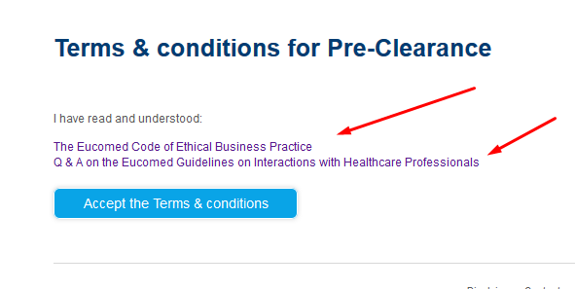

4. Once the region chosen and terms accepted.

What do you mean? Please give us more details. It would be great to have screenshot/picture.

5. Drop down with selection boxes

What do you mean? Please give us more details. It would be great to have screenshot/picture.

6. Replace show message with doc vault button and access

Are doc vault button and access two different button? Or this is name of one button? If this is two different button, what function has ‘access’ button?

7. Country selection first step – prefills the country field in the conference information field.

What do you mean? Please give us more details. It would be great to have screenshot/picture. (picture attached).

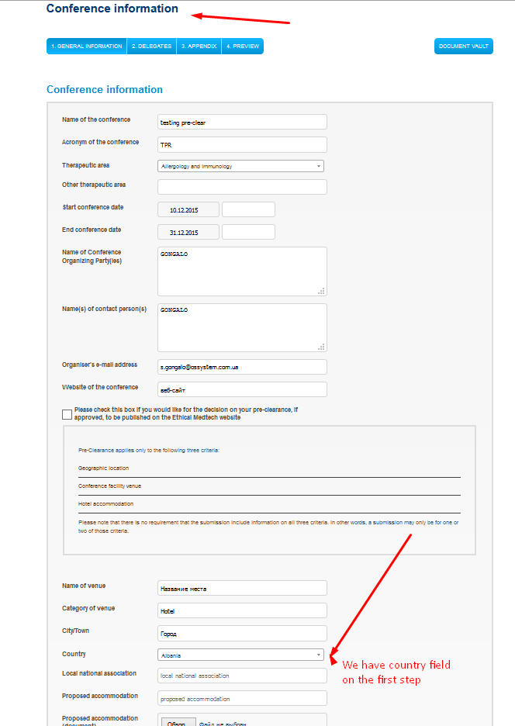

8. The calendar should have the possibility to choose the month and year from a dropdown

Now you can choose month and year in calendar. Maybe you want another type of chosen month and year in calendar. If yes, please give us more details what you want or maybe some examples. (picture attached).

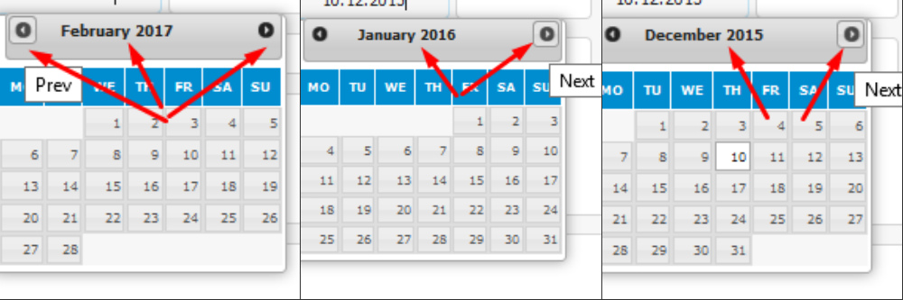

9. The Pre Clearance message should be on top not on the middle of the page

What do you mean? Сan you specify which messages? Please give us more details. It would be great to have screenshot/picture.

10. In the profile of the organizer they can choose to be updated by a newsletter. That should feed a Campaign Monitor list. What do you need from us to make the bridge?

What do you mean? What is Campaign Monitor list? What is a newsletter? And who is organizer? Please give us more details.

11. We need to keep conference numbering

What do you mean? Please give us more details. Now all conferences have their unique numbers. (picture attached).

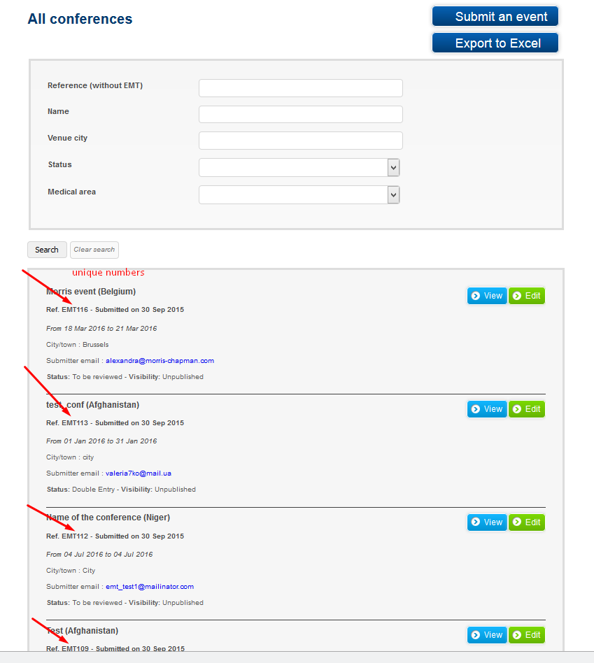

12. After migration of all the content, is it possible to continue with the numbering of the conferences as it was in the old system?

What do you mean? Please give us more details. What numbering of the conferences was in old system?