* ~~Submit an event - Delete 'Edit' function~~
* ~~Conference information instead of General Details~~
* 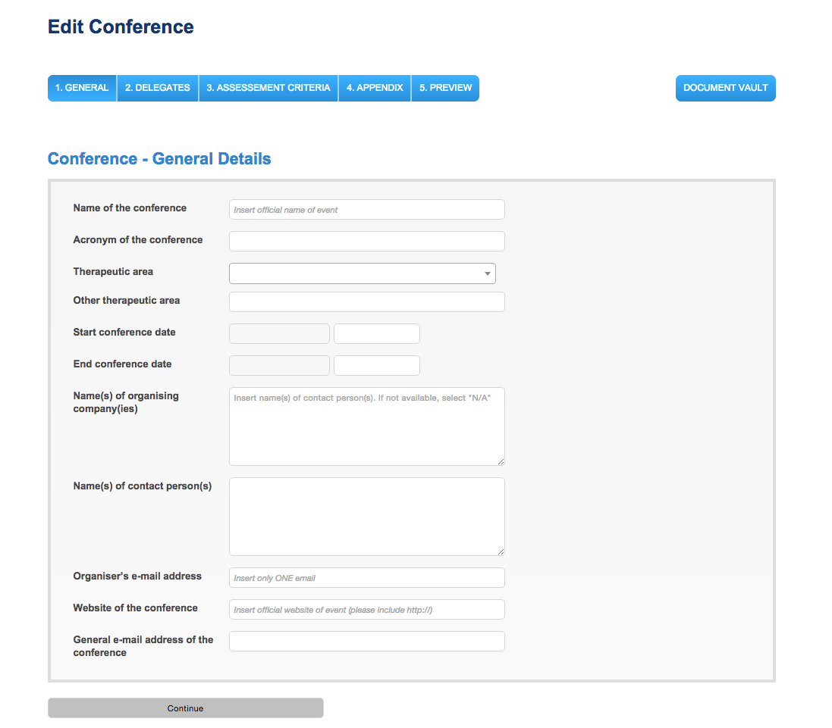
* ~~For Regular Submission - it should be 75 NOT 180~~
* 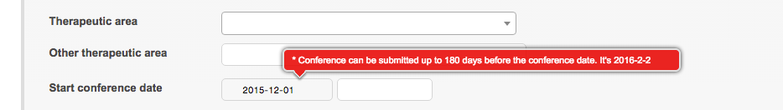
* ~~Dates - EU format not American style~~
* E-mail address - pls no Russian tests-????
* **Change titles for e-mails + message for Appeal and Double Entry (received)**
* ~~Vault message: ' A new document has been added to your document vault'~~
* ~~Content of the new message on board - It should the new message in the e-mail~~
* ~~Languages: FR + Farsi~~
* ~~Merge section 1 + 3 = title > General Information~~
* 
* ~~List of countries - Checbox for multiple~~
* 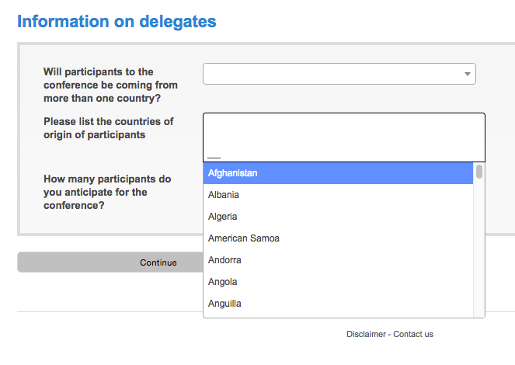
* ~~Name of Organizing = Name of Conference Organizing Party(ies)~~
* 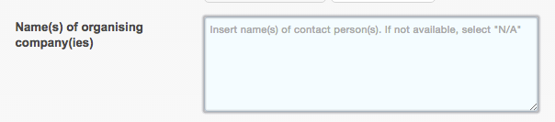
* ~~General e-mail address - cut field~~
* ~~Add Range of participants - <50 participants; 51 – 200, 201 – 500, 501 – 1000; ≥ 1000 participants~~
* ~~Pre-Clearance - send for review -> error (Ex 6April 2016)~~
* 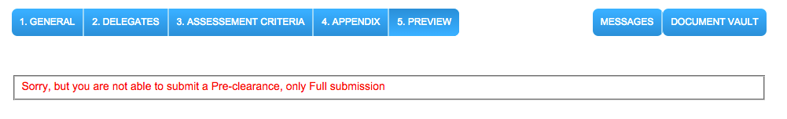
* ~~Use boxes to display the information before sending for review~~
* 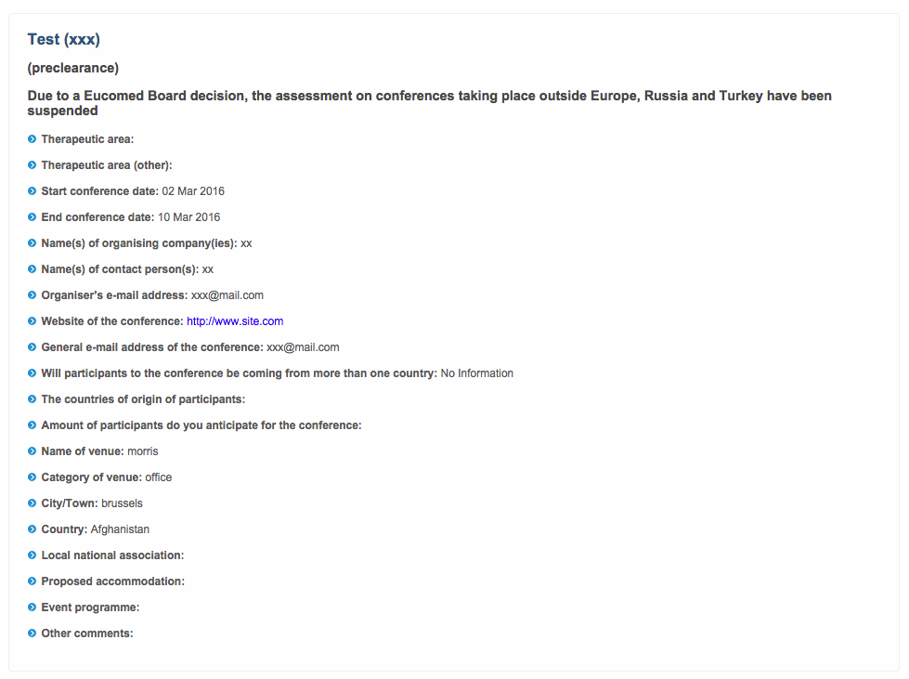
* 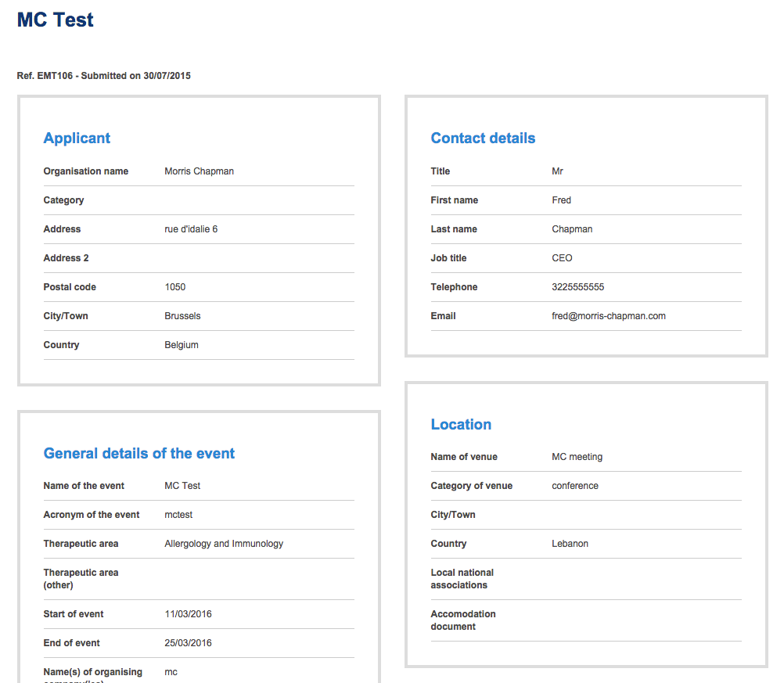
* ~~Remove the bar at the bottom after submitting~~
* 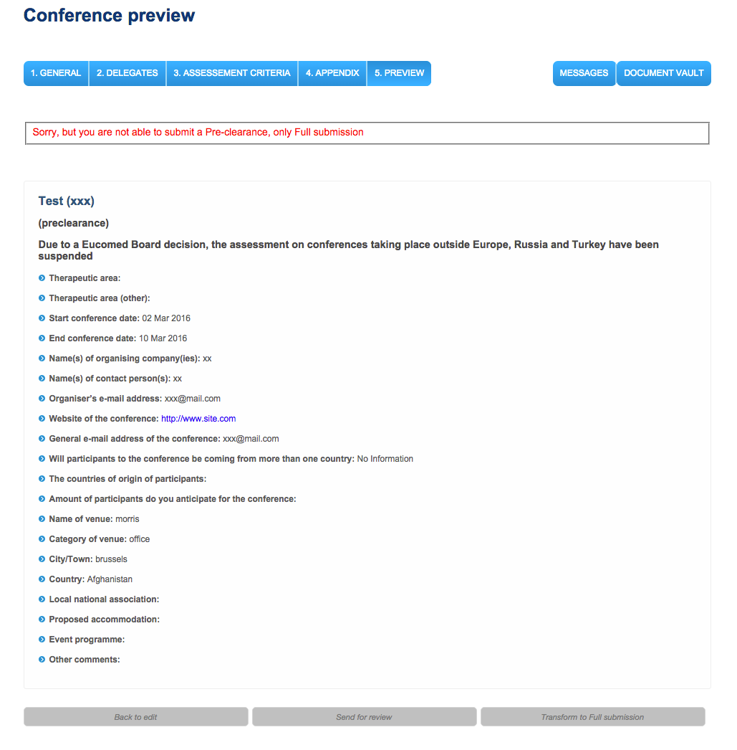
* ~~Acknowledgement of receipt - the message is missing (it is in the old system) – имеется в виду получения письма на почту о создании конферннции?~~
* Messages - export to PDF format with EMT letterhead (with possibility of selecting which message)
* ~~Messages - Back to Button - Back to conference + Back to conference list (Cut Edit conference)~~
* 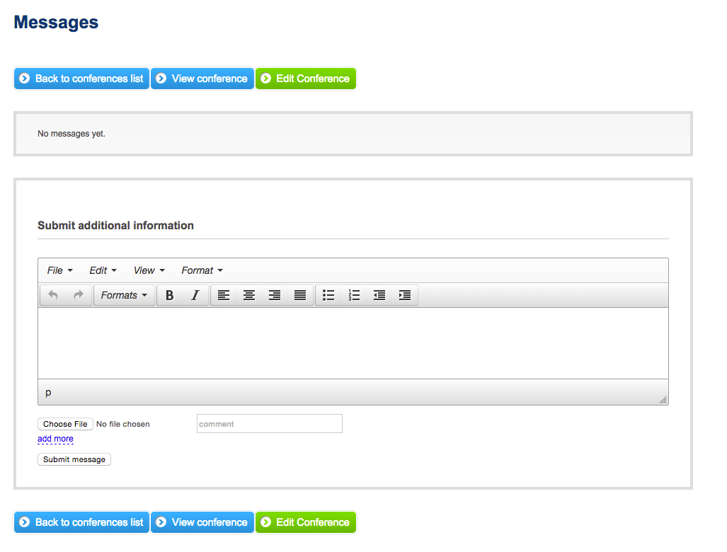
* ~~Non-compliant criteria = correction notice - no message~~
* ~~Add Clean-up button when copying from word cf old editor in old system~~
* ~~Change the status of the event = remove Rejected~~
* 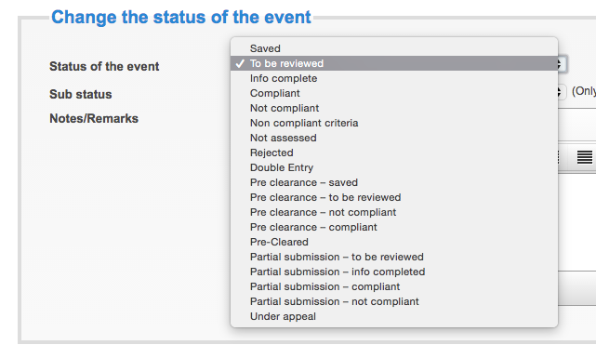
* ~~Status of the event (Display Sub-status' only when 'Not Assessed' is selected~~
* ~~Outside of Eu -> Outside of the Scope (Change message to)~~
* Assessment = Possibility to add documents to different Criteria
* ~~The document vault Disappears. It should stay everywhere in the admin part~~

~~Appendix not Appendices - что это значит (когда нажимаем на message то он пропадает)~~

* ~~???(как его проверять)~~Calendar - Display the Comments of the Assessment - Remove NB (frontend)
* ~~Status - Pre-Clearance Saved (Delete) and any messages linked to it~~
* ~~There are different fonts in Edit conference - these should be uniformed~~
* ~~Edit Conference - Update + Update and Back to conference view~~
* ~~Declare as double entry - The feature to link it to the other (main) conference is missing~~ + we need to link it to the message of the 'master one!!!!!!!!!!!!!!!1. The current system has this feature.
* Export options -Receive necessary fields……о чем это
* **For the Automated messages - MSG - Complete and not-compliant we have a text where we need to remove the text of <> ?????????????**
* 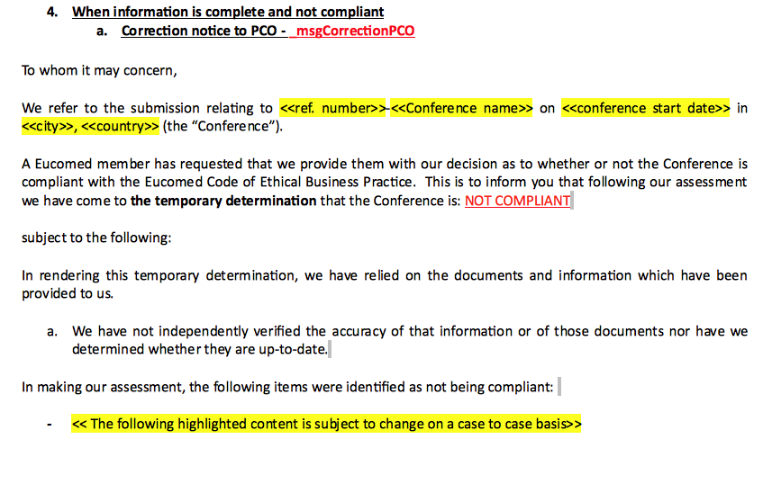
* ~~Check for middle east and world prompt~~
* Change the titles of the e-mails – see other doc