* Submit an event – Title: Change from ‘Edit Conference’ to ‘Conference information’

What page you are referring to? Please describe more detailed. It would be great to get screenshot

Sorry my mistake. Reread the yellow part

* E-mail address - pls no Russian tests----------------------------------------------------

Not sure what do you mean. What should we do? – Tests have been sent from your address.

Can we not use your addresses anymore? Can we have our web address?

web@morris-chapman.com

* Content of the new message on board - It should the new message in the e-mail

Do you mean we have to notify conference author by email each time he got a new message in the board?

YES

* Languages: FR + Farsi

Please, describe more detailed this thesis. What should we do?

IGNORE

* Merge section 1 + 3 = title > General Information

I suppose we should move all the functionality of step 3 into step 1 (append) and remove step 3, moving step 4,5 one step back (3 and 4). Am i right?

YES

* General e-mail address - cut field

Should we delete field “General e-mail address of the conference” on step 1 and all the data it contains?

YES

* Use boxes to display the information before sending for review

Do you mean we have to make step “Preview” like admin–mode preview page? Like this

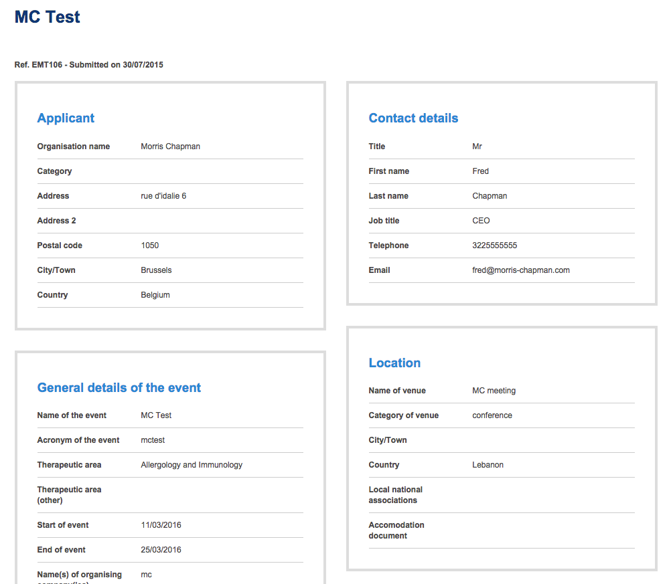

YES

* Messages - export to PDF format with EMT letterhead (with possibility of selecting which message)

Do you mean we should add functionality to select messages from Messages of conference and export selected to PDF? Can you describe what is “EMT letterhead”?

It will have the logo and maybe some contact details. I still need to receive this.

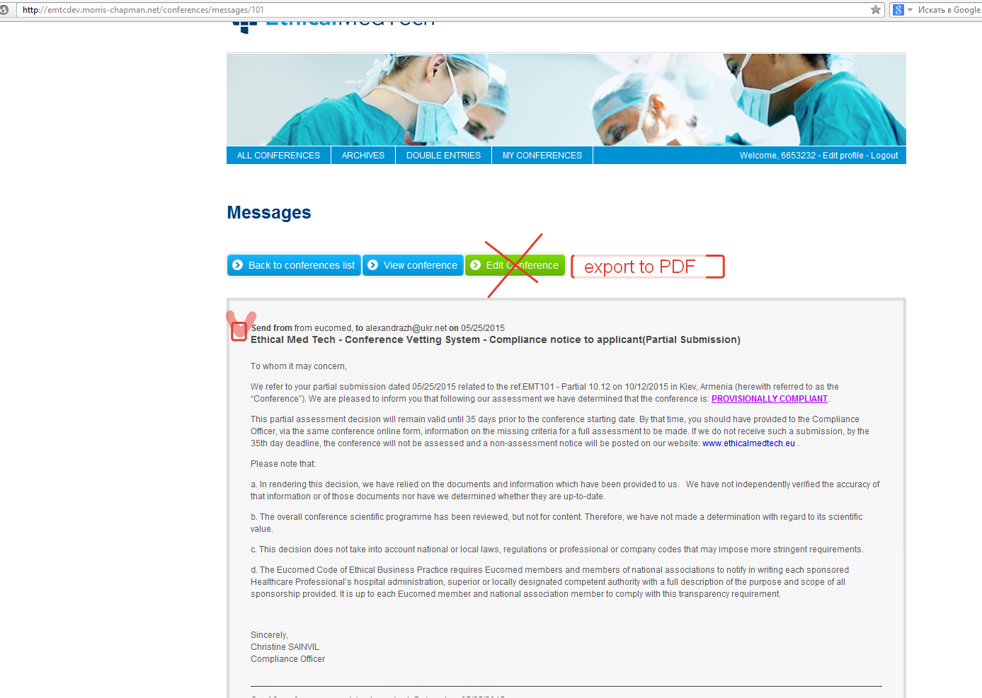

* Assessment = Possibility to add documents to different Criteria

Not sure what do you mean. Please, describe in details this thesis.

These need to be able to add docs to. (Admin part)

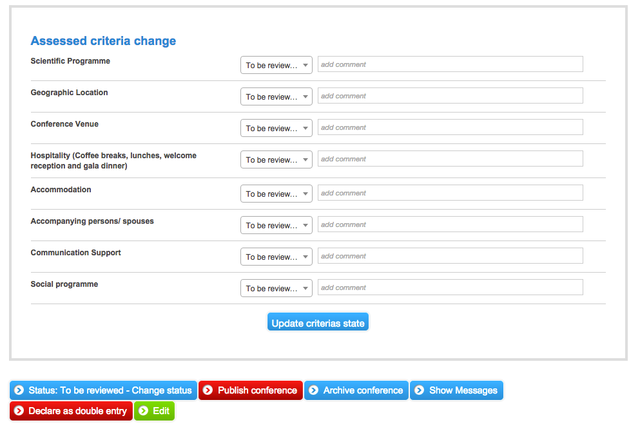

* Export options -Receive necessary fields.-------------------------------------

Not sure what do you mean. Please, describe in details this thesis.

Well the client doesn’t want all the data exported so she will send me the fields that we need to export.

* Check for middle east and world prompt------------------------------------

What we have to do?

When you click on a country for Middle East you should be directed to that section. When you select a country belonging to the rest of the world (not Middle East nor Europe) you should receive a message. It was outlined in the technical details that Simon sent you.

# Geographic Reach

The system will accept conferences organised in any country in the world. Depending on a geographic criterion, both front and back end will change however. The geographic criterion is the country where the event will take place.

* The event takes places in Europe: Eucomed will review the conference (countries: Austria, Belgium, Bulgaria, Croatia, Cyprus, Czech Republic, Denmark, Estonia, Finland, France, Germany, Greece, Hungary, Ireland, Iceland, Italy, Latvia, Liechtenstein, Lithuania, Luxembourg, Malta, Netherlands, Norway, Poland, Portugal, Romania, Russia, Slovakia, Slovenia, Spain, Sweden, Switzerland, Turkey and United Kingdom.)
* The event takes placed in the Middle East: the local association will review the conference (countries: Egypt, Iran, Iraq, Jordan, Bahrain, Saudi Arabia, Kuwait, Lebanon, Morocco, Pakistan, Palestine, Qatar, Oman, United Arab Emirates, Yemen, Syria and Libya.)
* The event takes place outside Europe and the Middle East: Eucomed will review the conference but only publish a recommendation, not a full assessment. If the conference takes place outside Europe or the Middle East, the messages sent to users will also be different and the terms used for ‘compliant ‘ and ‘non compliant’ will be different but the exact wording is yet to be determined

NB: the submission part of the site will always be in English. Only the public facing back end will be Arabic