# Ethical MedTech System Description

Introduction  
EthicalMedTech is a platform, supported by Eucomed, dedicated to ethics and compliance projects in the European MedTech industry.

The Ethical MedTech platform hosts the Conference Vetting System (CVS), a unique initiative in the healthcare industry. This independently managed system reviews the compliance of third-party educational conferences with the Eucomed Code of Ethical Business Practice (the “Code”) to determine the appropriateness for companies which are members of Eucomed and members of the national associations affiliated with Eucomed to sponsor Healthcare Professionals to participate in such conferences.

CVS aims to simplify and centralise decision-making for Eucomed members by establishing a single assessment procedure based on a set of criteria provisioned in the Eucomed Code of Ethical Business Practice. It also aims to harmonise the interpretation of the Code across the European medical technology industry with the goals of greater consistency and transparency in industry behaviour.

Scope  
The project is composed of several parts

* Rebuild the submission and vetting system in Symfony 2 with a new logic
* Add the international conference dimension
* Build the parallel Middle East System including an Arabic Front end
* Integrate several new features such as the admin overview, message board to keep track of the messages exchanged, a document upload system per application and an admin overview to replace the excel file currently being used
* Integrate the new features in the front end

# User Categories

* **PCOs**  
  PCOs are conference organisers or associations that organise conferences
* **Companies**  
  Companies organise conferences, sponsors or attend conferences

In terms of rights, both user types are very similar except for the fact that PCOs can submit a pre-clearance whilst companies can only submit a full submission.

# Geographic Reach

The system will accept conferences organised in any country in the world. Depending on a geographic criterion, both front and back end will change however. The geographic criterion is the country where the event will take place.

* The event takes places in Europe: Eucomed will review the conference (countries: Austria, Belgium, Bulgaria, Croatia, Cyprus, Czech Republic, Denmark, Estonia, Finland, France, Germany, Greece, Hungary, Ireland, Iceland, Italy, Latvia, Liechtenstein, Lithuania, Luxembourg, Malta, Netherlands, Norway, Poland, Portugal, Romania, Russia, Slovakia, Slovenia, Spain, Sweden, Switzerland, Turkey and United Kingdom.)
* The event takes placed in the Middle East: the local association will review the conference (countries: Egypt, Iran, Iraq, Jordan, Bahrain, Saudi Arabia, Kuwait, Lebanon, Morocco, Pakistan, Palestine, Qatar, Oman, United Arab Emirates, Yemen, Syria and Libya.)
* The event takes place outside Europe and the Middle East: Eucomed will review the conference but only publish a recommendation, not a full assessment. If the conference takes place outside Europe or the Middle East, the messages sent to users will also be different and the terms used for ‘compliant ‘ and ‘non compliant’ will be different but the exact wording is yet to be determined

NB: the submission part of the site will always be in English. Only the public facing back end will be Arabic

# Process

## Profile Set up

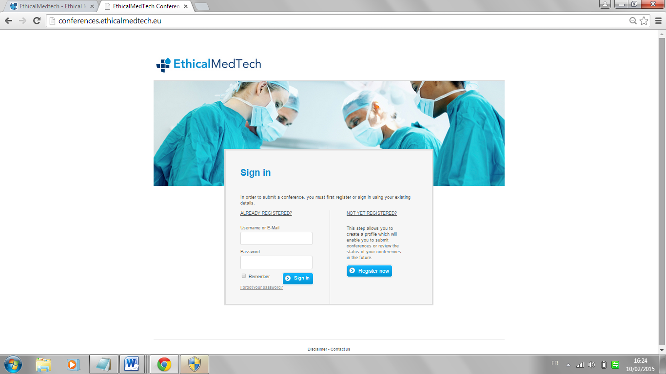

Users can either set up a profile or use their existing profile

Before submitting a conference, all users need to create a profile in the system. The profile contains the following fields (* is mandatory)

**MADATORY FIELDS**

For both users:

* email confirmation when creating username
* Accept terms and conditions/Conference general info
* Applicant details (except for address2)
* Assessment Criteria (all except local national association and proposed accommodation)

***Applicant***

* Organisation Name
* Category
  + Congress organiser
  + Eucomed corporate member
  + National industry association
  + Scientific society
* Address
* Address 2
* Postal Code
* City/Town
* Country

***Contact Details***

* Title
* First name
* Last name
* Job Title
* Telephone
* E-mail

And Opt in ‘I want to receive updates on the Conference Vetting System’

All fields need to have sample data pre-filled as per example below

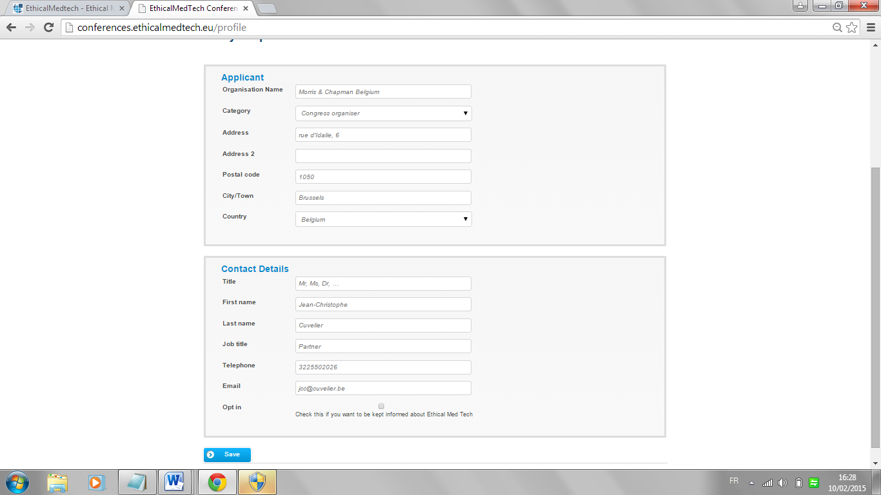

Once the profile is created:

* An e-mail is sent to the user asking the user to confirm their registration
* A message is displayed on screen ‘An e-mail has been sent to INSERT EMAIL’ please confirm your registration by clicking on the link provided in the e-mail. If you have not received the e-mail within 6 hours, please double check your spam folder or contact us
* The user profile is stored in the database

Once the user has confirmed the registration

* The user will have access to the reset password
* The user will have access to the control panel to add conferences

## Conference Management

NB: When submitting a conference outside Europe or the Middle East the user will be prompted to read an import message stating that only a recommendation will be published and not a full opinion?

Pre-Clearance  
A pre-clearance can be submitted by PCOs only when not all data to submit a conference is available. A pre-clearance can be submitted up to 180 days before the conference date and maximum 6 years before.

**The pre-clearance submission**

The PCO can submit a pre-clearance at any time up to 180 days before the data of the event.

Before submitting a pre-clearance, the user has to confirm as per below

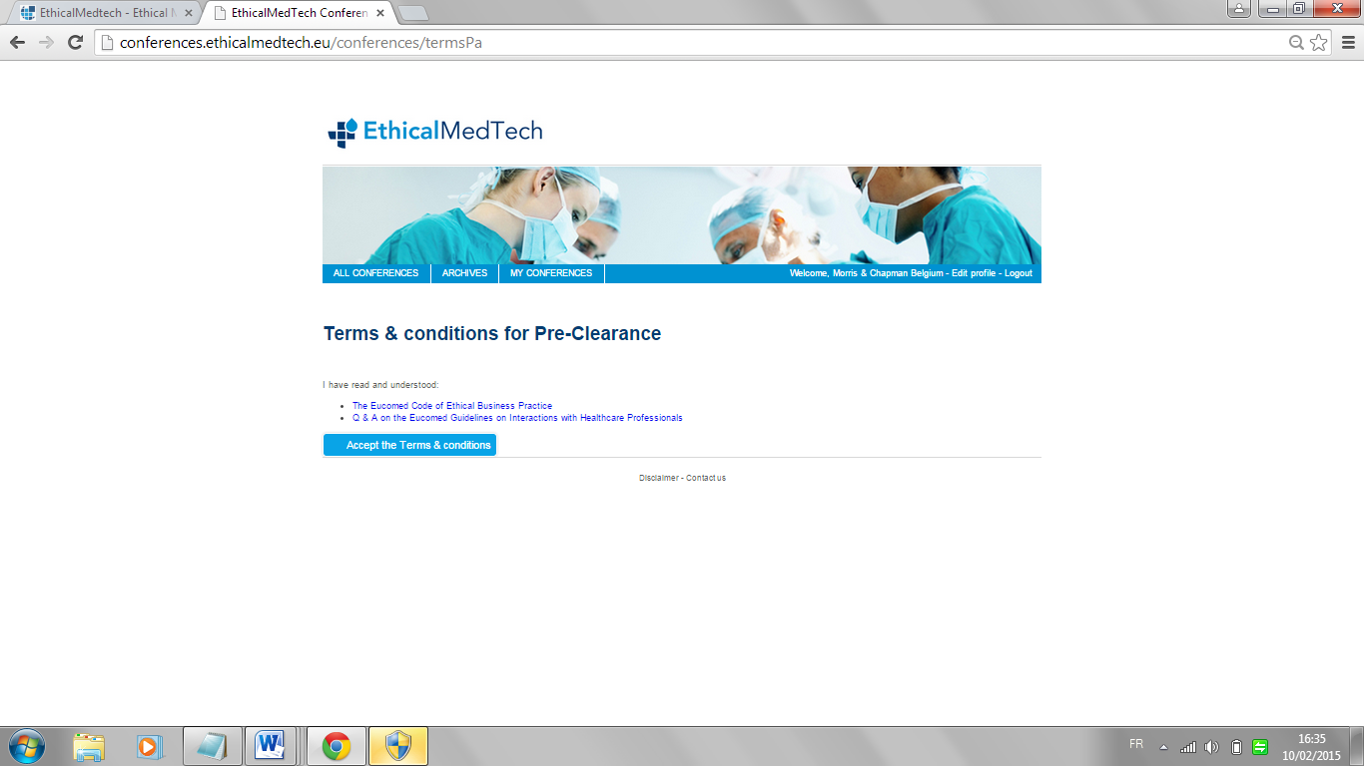

Once agreed, the user can start completing the pre-clearance submission

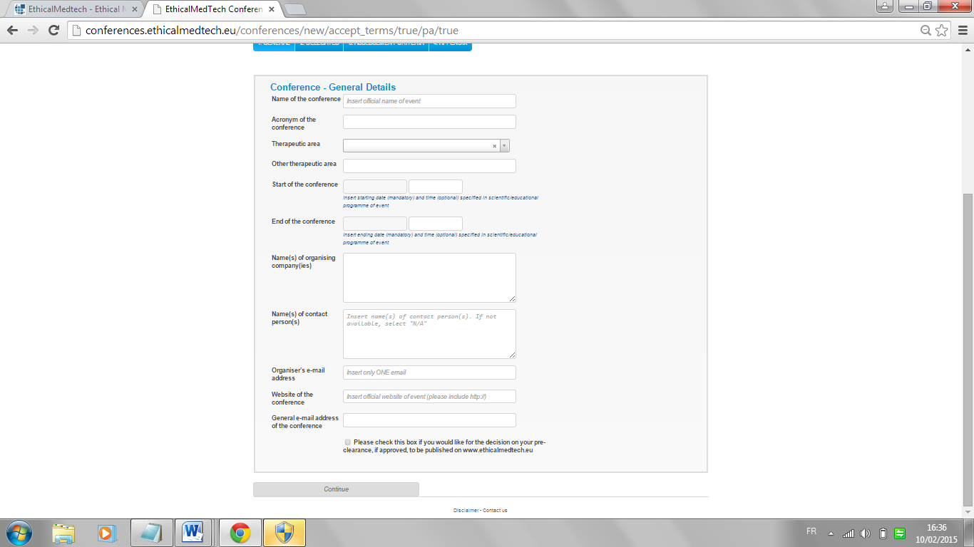

The pre-clearance is composed of the first sections of a full clearance including the following fields

**GENERAL**

* Name of the conference
* Acronym of the conference
* Therapeutic Area (single select)
  + Allergology and Immunology
  + Anaesthesiology
  + Cardiology/Cardiovascular
  + Dermatology
  + Emergency Medicine
  + Endocrinology
  + Gastroenterology
  + Gynaecology"
  + Hematology and Hemotherapy"
  + Hepatology
  + Infectiology/Infectious Diseases
  + Intensive Care>
  + Neurology
  + Oncology
  + Ophthalmology
  + Orthopaedics
  + Paediatrics
  + Pharmacology
  + Physical Medicine
  + Radiology
  + Reproductive Medicine
  + Rheumatology
  + Sports Medicine/Trauma
  + Stomatology
  + General Surgery
  + Other (please specify)
* Start of the Conference
  + Date
  + Time
* End of the Conference
  + Date
  + Time
* Name(s) of organising company or companies
* Names(s) of contact person(s)
* Organiser e-mail address
* Website of the conference
* General e-mail address of the conference

+ tick box Please check this box if you would like for the decision on your pre-clearance, if approved, to be published on the Ethical Medtech website. If not ticked the conference will not appear in the front end

* If the conference is less than 180 days, an error message appears before submission (as per current site but, now it is after submission)
* This version should also use European date formatting

**INFORMATION ON DELEGATES**

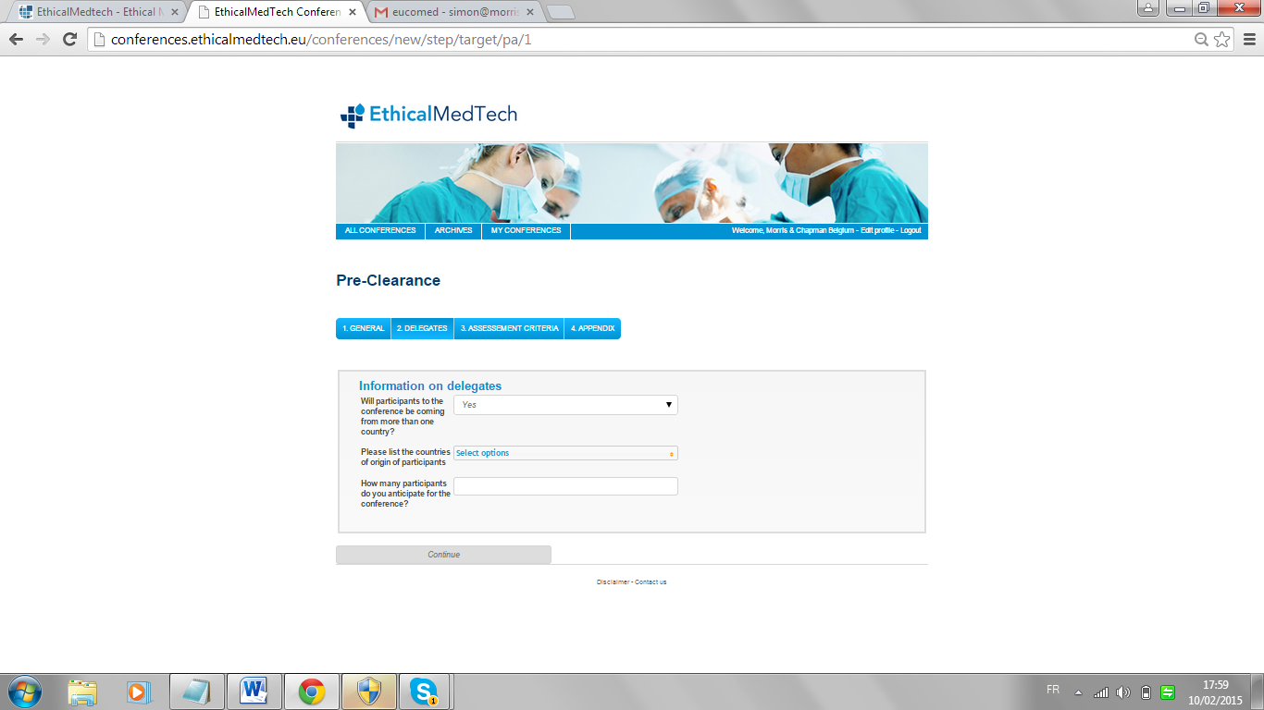

* Will participants to the conference be coming from more than one country?
  + Yes
  + No
  + No information available at this time
* Please list the countries of origin of participants (MULTISELECT)
* How many participants do you anticipate for the conference?

**ASSESMENT CRITERIA**

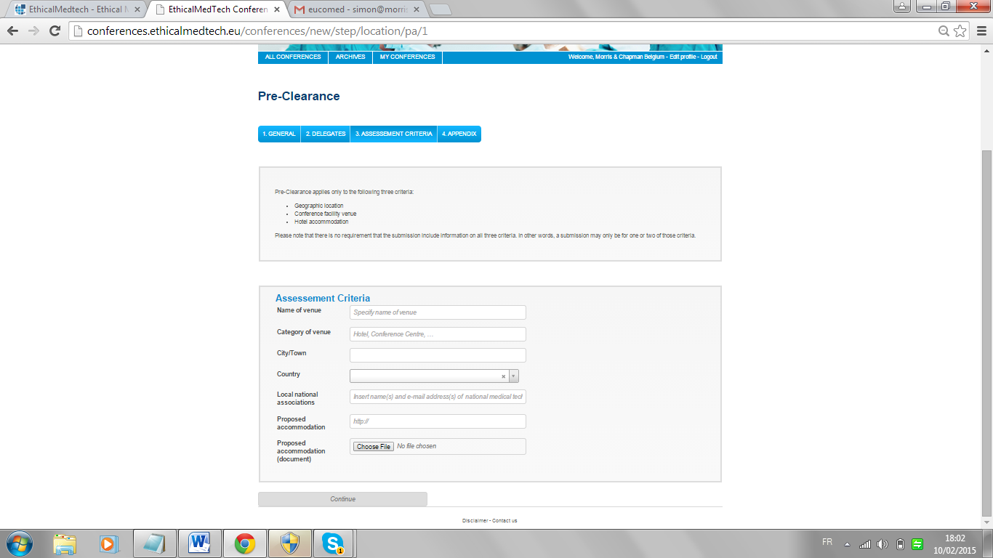

* Name of venue
* Category of venue
* City/Town
* Country
* Local national associations
* Proposed accommodation
* Proposed accommodation (document)

**DOCUMENTS / LINKS**

Possibility of adding documents with a ‘add more’ function as not to limit the number of documents added. All document types except for .exe are accepted

* The PCO can submit a non-complete submission but the submission should include at least the fields in the GENERAL and DELEGATES stage
* At any stage the PCO can save the submission before submitted. Only when the PCO thinks the submission is ready will he/she hit the ‘Submit for Review’ button.
* Before submitting the user would see a review page and provide the user the possibility to go back and edit or submit (NEW FEATURE)
* Once submitted, the fields that have been completed and submitted are blocked and will be for ever. The user can complete fields that were left empty. But by doing do, the conference goes back into ‘under review’

## Full Submission

A normal submission can be submitted by all user types and includes the same fields of the pre-clearance but would only by submitted if

* The event is less than 180 day from the submission date
* More information is available

The same options to save or submit.

# The Review Process

## Who reviews what?

* The event takes places in Europe (exact list of countries to be submitted): Eucomed will review the conference
* The event takes placed in the Middle East: the local association will review the conference
* The event takes place outside Europe and the Middle East: Eucomed will review the conference but only publish a recommendation, not a full assessment.

The Process  
The process is similar for pre-clearance and full submissions

1. The user submits a conference and from that moment the completed fields are blocked in the user admin panel
2. The user receives an e-mail that the conference has been added for review
3. The compliance officer receives and e-mail that a new conference has been added
4. The conference is added to the control panel of the compliance officer
5. The compliance officer reviews the submission and can decide to mark the conference as  
   - Non-compliant  
   - Compliant  
   - Not applicable  
   - No information available  
   - Under correction notice
6. A conference can also be archived by the administrator, this will mean that
   1. The archivec conferences will no appear in the list of conferenced to be reiewed and will only be accessible in by clicking on an ‘archived’ tab
7. This status is based on 8 individual sub criteria
   1. Scientific Programme
   2. Geographic Location
   3. Conference Venue
   4. Hospitality (coffee breaks, lunches, welcome reception and gala dinner)
   5. Accommodation
   6. Accompanying persons / spouses
   7. Communication Support
   8. Social Programme  
      Each decision can be commented by the compliance officer  
      If not all criteria were submitted, the conference should be marked as ‘partial submission in the control panel and back end
8. Once the compliance officer has published an opinion  
   - The opinion is published on the website including the detail per criterion  
   - For the pre-clearance procedure, the opinion is not published online unless the user ticked the box during the submission stage  
   - The user gets an e-mail with the opinion  
   - The opinion is visible in the user control panel  
   - For international conferences, the review should be clearly marked as ‘recommendation’ in the front end
9. Following the publishing of the opinion, the user has several options  
   - Do nothing  
   - Edit the submission, which is now editable. Once the submission is altered in any way, the status changes to ‘To be reviewed’  
   -In the case of pre-clearance, click to ‘Submit complete submission’ button and transform the pre-clearance into a full submission (NEW FEATURE) this will also lead to a status changes to ‘To be reviewed’
10. If the user appeals against a decision the status changes to ‘under appeal’ and the user can complete a free field with attached documents and links. An e-mail is sent to three people of the appeal board and the compliance officer. The appeal board renders a decision offline and informs the compliance officer who communicates with the user via the messaging system until a decision is reached. Following the decision, the compliance officer can  
    - Mark the conference as non-compliant  
    - Mark the conference as compliant  
    This is done per criteria. If the status has changed, a field with title ‘Corrections Notice’ will appear in the front end with a message posted by the compliance office  
    - The decision will be sent by e-mail and published online

**NEW FEATURES**

* The user can edit submissions at any time, this will change to the status to ‘to be reviewed’ and trigger and e-mail to both the compliance officer and user
* Appeal procedure
* Admin control panel with general overview and EXCEL EXPORT

# The double entry process

Some conferences are entered in the system several times by different users. The compliance officer has to decide which one to review. For the others, they will be marked as ‘double entry’

* An e-mail will be submitted to the applicant saying the conference has already been submitted
* The conference will no longer appear in the compliance officer review dashboard but accessible via a ‘double entries’ tab’

# The Message Board

The message board is a new feature in the system that will centralise all communications between the compliance officer and the user to avoid e-mails. Both parties can add messages that will appear in the message board system. A notification will also be sent by e-mail when the other party posts a message. Documents can be attached to messages and will be stored in the document vault.

The Document Vault  
The document vault is a new feature that would

* Store all documents added during a submission in one place
* Store all documents subsequently added (e.g. during the process and appeal)
* Provide the user the possibility of adding ad hoc documents (for example when adding additional information)

When a new document is posted, an e-mail will be sent to the other party

# The Compliance Officer Tools

The compliance officer has access to several tools

## The Review Panel

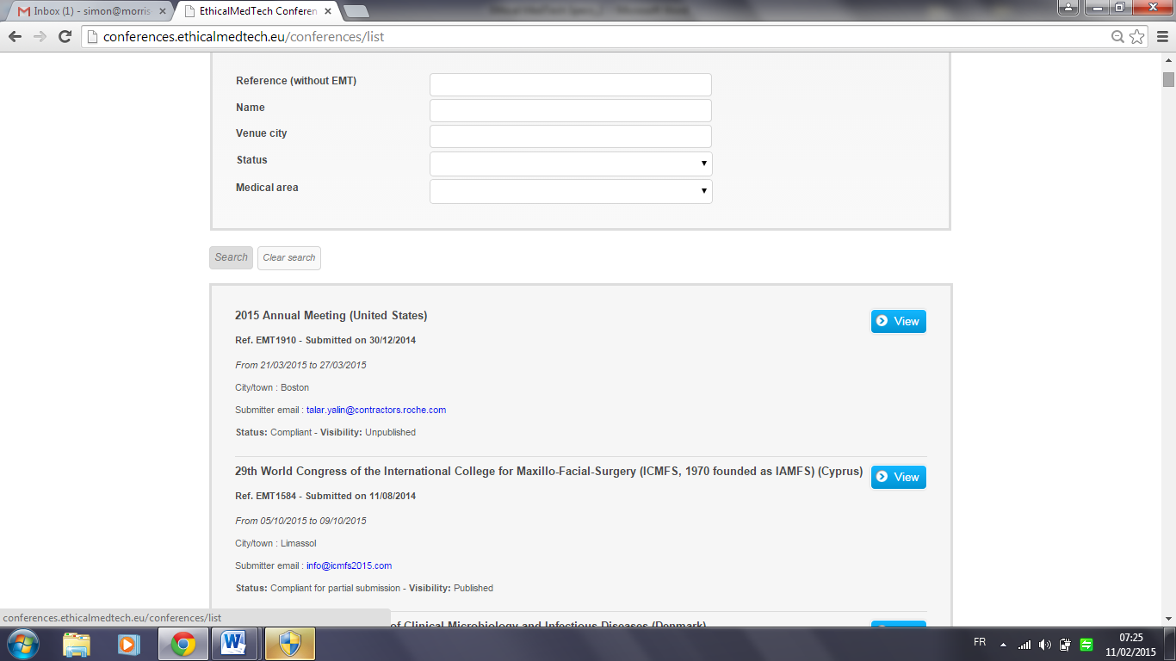

The panels will enable the compliance officer to evaluate the conference and enter a status for each of the 8 criteria. The panel will enable the compliance officer to search and filter submissions.

* For pre-clearances at least 3 criteria have to be compliant and the rest to be ‘no information available’ for the event to be ‘pre-clearance compliant’
* For complete submission all of criteria have to be entered or not applicable and all to be compliant, otherwise the conference will be marked as ‘Under Review’

Before an opinion is published the compliance officer has to click on the ‘publish conference’ button.

At all times, the compliance officer can edit data in any field or change the status of criteria.

## The overview panel

The overview panel gives the compliance officer a bird’s eye view of all submission. Please see excel for available data. The panel will enable the compliance officer to search and filter submissions. The panels should also include an excel export

## The user panel

Users can login in (and have access to rest password fuction) at any stage and

* View the status of their conferences
* Edit their profile
* Edit their conferences if the fields are not blocked for review
* Send a message to the compliance officer
* Upload a document to the document vault
* Apeal a decision

# The Front End

Once decisions on either a pre-clearance or a full submission has been taken and published by the compliance officer, they will be published on the website in a format similar to today.

Please note that the Middle Eastern conference will be displayed on a separate site which is carbon copy of the site but in Arabic. However, the calendar is shared and will display all conferences.

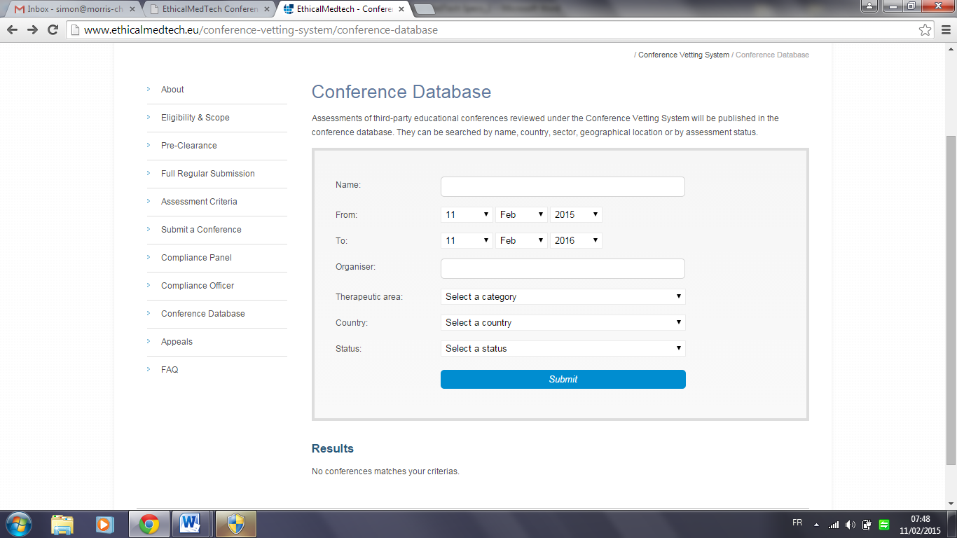

Users can search conferences and view details. This is currently implanted using JSON in CMSMS and can keep this technology or be displayed directly from Symfony (preferred option)

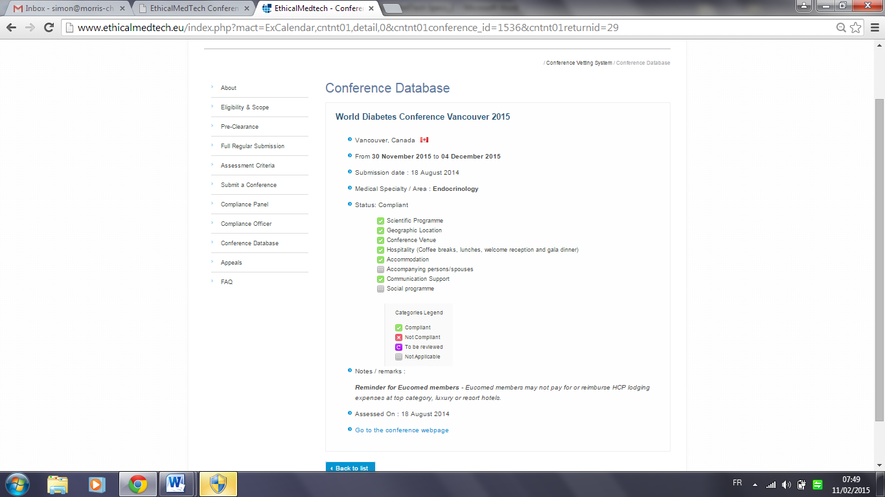

Users an can also view the detail of each conference.

Calendar Display changes

Today when I receive a submission in CVS for a partial assessment and have completed the initial review, I post the conference in the online calendar with a blue colour coding with the status label “partially compliant”. Anyone interested in the conference can open up the link from the calendar and will find a breakdown of the 8 criteria with the review status of each one as well as the following note that I adapt depending on which criteria I am still missing information upon:

“*Please note that this is a****partial submission****therefore the actual decision is a****temporary****one. The overall appropriateness of the conference is subject to the assessment of further information on the conference scientific programme (under the format of a timetable, highlighting for each hour the session title and faculty name), registration packages benefits, planned entertainment and social activities (if any) that must be provided to EthicalMedTech Compliance Officer up to 35 days prior to the conference starting date.”*

Another situation is when I determine that a criteria is not compliant and send a correction notice. During that period of time (10 or more days), the conference associated colour coding is purple (just like for an initial conference to be reviewed).

So today the colour coding we use is as follows:

Under review – purple

Partially compliant - blue

Correction notice – purple

Compliant – green

Not compliant – red

I think this may be confusing for the members who do not totally understand the colour coding and i) inquire a lot via email on what is to be done from their part in both cases of a partial submission or a correction notice ii) forget that they need to feed me with information in order for me to complete the assessment.

So as suggested we already changed in all communications (that obviously people don’t read) the words “partially compliant “to “provisional”. So I thought we could do the same for the online calendar and merge under a single status: “provisional” for both partial and correction notices. Indeed whether we are in the partial submission option or an issued a correction notice awaiting for a response from the PCO, both status are provisional.

We would therefore only have 4 colour coding:

Under review – purple

~~Partially compliant - blue~~

~~Correction notice – purple~~

Provisional – blue (with a new comment box which would read “action required by PCO/Medical Society or Eucomed members for example) and a date for completion.

Compliant – green

Not compliant – red

## System Messages

System message will be sent at several stages in the process. See separate document for tiling and text. It is important that these messages differ based on where the conference takes place. The message will be standardised and sent by the system. All custom messages will be sent using the message board.

**Main changes**

* Mark International conferences in a different way and indicate ‘recommendation only’
* Add ‘under appeal’ when appropriate
* Add autocomplete to search function
* Add corrections notice when applicable
* Message board and document vault
* Possibility for the compliance officer to edit conference
* Overview panel