* Submit an event - Delete 'Edit' function

What page you are referring to? Please describe more detailed. It would be great to get screenshot

* E-mail address - pls no Russian tests

Not sure what do you mean. What should we do?

* Content of the new message on board - It should should the new message in the e-mail

Do you mean we have to notify conference author by email each time he got a new message in the board?

* Languages: FR + Farsi

Please, describe more detailed this thesis. What should we do?

* Merge section 1 + 3 = title > General Information

I suppose we should move all the functionality of step 3 into step 1 (append) and remove step 3, moving step 4,5 one step back (3 and 4). Am i right?

* General e-mail address - cut field

Should we delete field “General e-mail address of the conference” on step 1 and all the data it contains?

* Use boxes to display the information before sending for review

Do you mean we have to make step “Preview” like admin–mode preview page? Like this

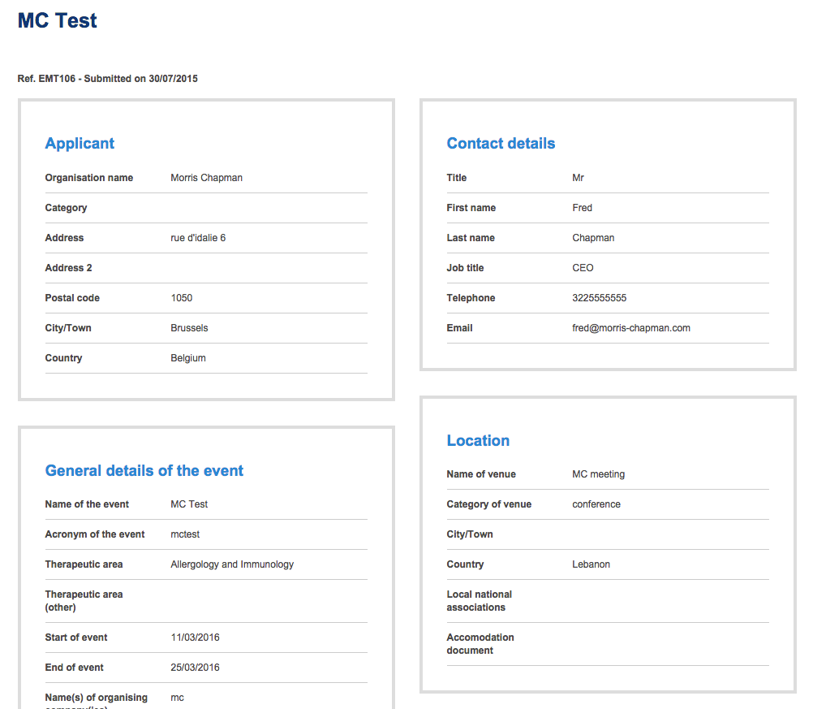

* Messages - export to PDF format with EMT letterhead (with possibility of selecting which message)

Do you mean we should add functionality to select messages from Messages of conference and export selected to PDF? Can you describe what is “EMT letterhead”?

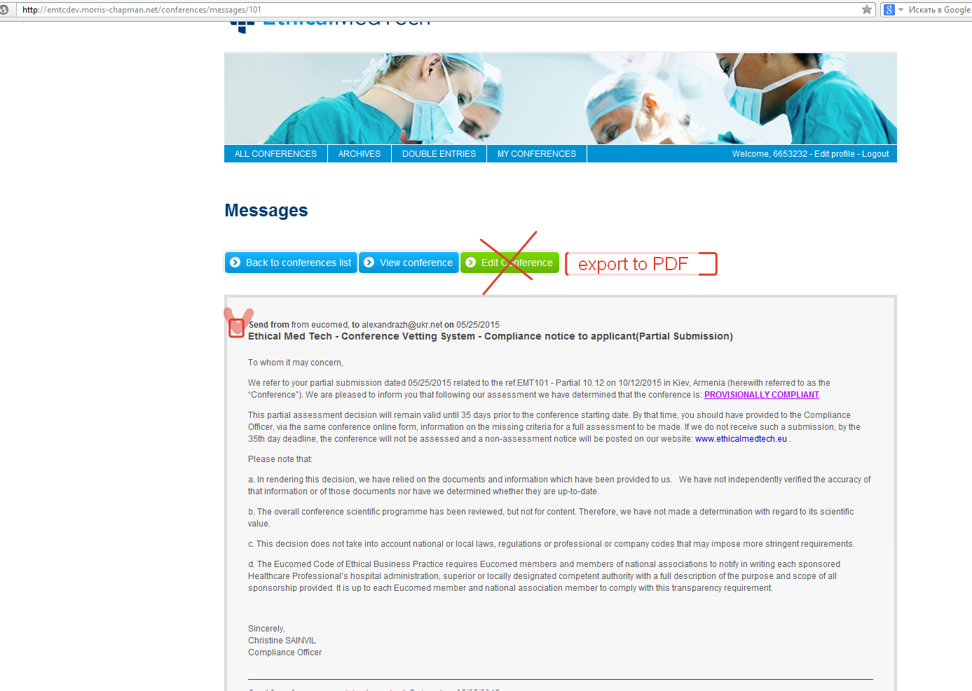

* Assessment = Possibility to add documents to different Criteria

Not sure what do you mean. Please, describe in details this thesis.

* Export options -Receive necessary fields.

Not sure what do you mean. Please, describe in details this thesis.

* Check for middle east and world prompt

What we have to do?