

Course program

AOTrauma Course—Advances in Operative Fracture Management

Online preparations: November 1–December 9, 2012

Course: December 9–14, 2012 Davos, Switzerland

Online follow-up: December 14, 2012–January 15, 2013

Lecture hall: Davos

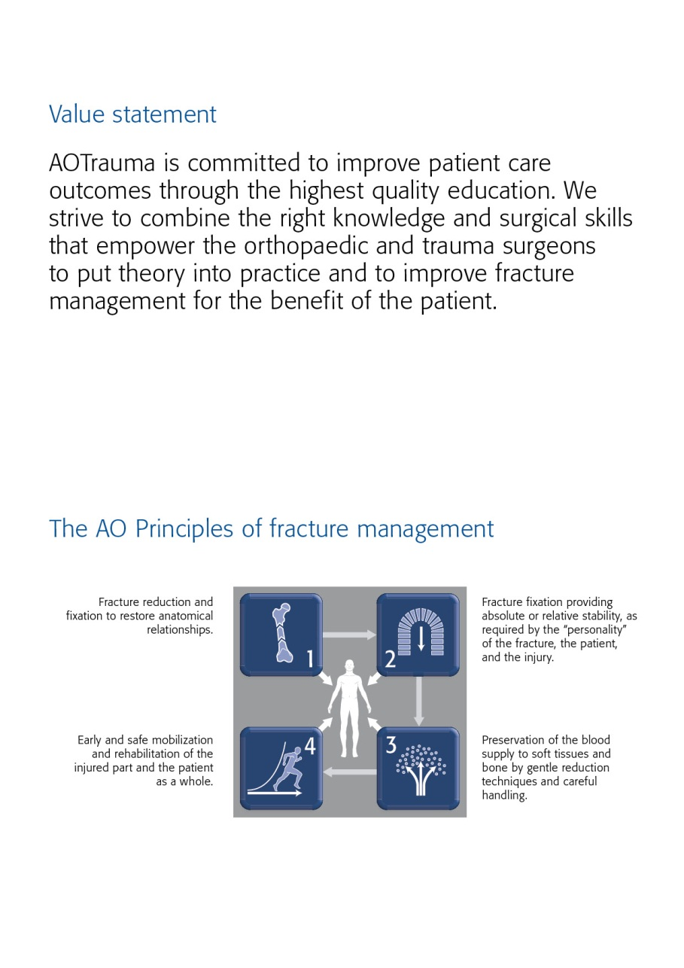

Dear AOTrauma course participant

We have the honour to welcome you to the AOTrauma Course—Principles in Operative Fracture Management run by the AOTrauma Specialty! We hope you will enjoy your course and the entire experience.

What is AOTrauma? We are the "clinical division"—a community for Trauma and Orthopaedics within the AO Foundation. As an AO Specialty we aim to integrate and align applied and clinical research, education, and community development functions into one direction—AOTrauma for the benefit of our members, stakeholders, and patients.

How AOTrauma benefits you? By working as a single team we will focus and better leverage our resources, expertise, and skills to create and deliver new and greater value to our members.

What does this mean in education? AOTrauma is committed to providing you the best possible educational experience by continuously embracing and introducing new educational techniques to help you learn and more effectively implement your knowledge for the benefit of your patients.

Why join AOTrauma? Joining AOTrauma means you are part of the “Trauma & Orthopaedic” community within the AO. AOTrauma will help you develop lifelong friendships and relationships; we will help you access our “knowledge network” and get involved in new opportunities that advance trauma care.

Yours sincerely,

*Photo Photo*

Kodi Kojima Nikolaus Renner

Chairperson AOTrauma Chairperson AOTrauma

Education Commission International Board

PS: Your experiences with us, over the next few days, will result in the realization of new and meaningful knowledge, skills, and understanding that we hope will translate into improved patient care.

The first AO Course was held in Davos in 1960—these early courses pioneered psychomotor techniques by teaching practical skills of AO Techniques. Since those early days over 250,000 surgeons and 135,000 ORP staff from over 110 countries have attended AO Courses—we now launch AOTrauma to move our education to the next level.

Content

Value statement

The AO principles

Dear AOTrauma course participant

Goal of the course

Target participants

Course objectives

Course description

Chairpersons

Faculty

Online activities

Sunday, December 9, 2012

Monday, December 10, 2012

Tuesday, December 11, 2012

Wednesday, December 12, 2012

Thursday, December 13, 2012

Friday, December 14, 2012

Course organization

Course logistics

Course information

Course venue

Business center

Wireless network

Exhibitions

AO Research Institute Davos (ARI)

Transportation

Sponsors

Upcoming AO Courses–Davos 2013

Goal of the course

The AOTrauma Course—Advances in Operative Fracture Management teaches current concepts and fundamental principles in the treatment of complex injuries. The latest techniques in operative fracture management are incorporated in the course.

Target participants

The AOTrauma Course—Advances in Operative Fracture Management is targeted at surgeons at the threshold of becoming independent surgeons and taking over decision-making responsibility for the treatment of complex injuries.

It builds upon the AO Principles and techniques of the Principles course, making it necessary for participants to have completed the AOTrauma Course—Principles in Operative Fracture Management previously. They also must be actively involved in trauma management.

Course objectives

At the end of this course, participants will be able to:

* Apply reduction techniques in fracture management with attention to soft-tissues
* Assess and treat complex fractures using advanced application techniques
* Demonstrate strategies for assessing and treating open fractures and soft-tissue injuries, as well as managing polytrauma patients
* Evaluate, classify, and formulate a treatment plan for pelvic injuries and acetabular fractures
* Recognize complications and manage accordingly

Course description

Online precourse self-assessment prepares participants for the course and allows the faculty to tailor the course to the participants' needs. Before attending the course, participants are expected to complete an online module on reduction techniques.

The course will be taught in a modular format. Each module consists of evidence-based lectures, which will cover the key information required. Discussing cases in small groups will help participants to understand decision-making and management skills. Debates and interactive sessions will promote interactivity between faculty and course participants. In practical exercises participants will be trained in the application of various techniques.

Optional sessions on patient positioning are offered over lunch and in the evening. Participants may also bring their own cases for discussion with the faculty.

After the course an online postcourse self-assessment will provide participants with important feedback on what they have learned.

Chairpersons

*Photo Photo*

**Emilio Fantin Matthew Porteous**

Cordoba, Argentina Bury St Edmunds, United Kingdom

Faculty

|  |  |  |
| --- | --- | --- |
| Abela | Massimo | Malta |
| Bajammal | Sohail | Saudi Arabia |
| Barbosa | Paulo Roberto | Brazil |
| Berry | Greg | Canada |
| Brown | Daniel | United Kingdom |
| Cohen | Nir | Israel |
| Crist | Brett | USA |
| Du Plessis | Frederick P | South Africa |
| Ekman | Anna | Sweden |
| Elliott | David | United Kingdom |
| Fantin | Emilio | Argentina |
| Ferguson | Tania | USA |
| Fernandes | Hélio | Brazil |
| Finkemeier | Christopher | USA |
| Fogagnolo | Fabricio | Brazil |
| Gerich | Torsten | Luxembourg |
| Hanson | Beate | Switzerland |
| Hartsock | Langdon | USA |
| Jones | Clifford | USA |
| Karges | David | USA |
| Khaled | Sherif | Egypt |
| Kloub | Martin | Czech Republic |
| Lafee | Caricia | Venezuela |
| Lee | Mark | USA |
| Lee | Keun-Bae | Korea South |
| Lu | Yi | China |
| Marques Lopez | Fernando | Spain |
| McFadyen | Iain | United Kingdom |
| McMurtry | Ian | United Kingdom |
| Mukhopadhaya | John | India |
| Murphy | Diarmuid | Singapore |
| Patel | Amratlal | United Kingdom |
| Pesantez-Hoyos | Rodrigo | Colombia |
| Phornphutkul | Chanakarn | Thailand |
| Pintsaar | Aivar | Estonia |
| Pirpiris | Marinis | Australia |
| Porteous | Matthew J | United Kingdom |
| Reed | Lori | USA |
| Reynders | Piet | Belgium |
| Rossiter | Nigel | United Kingdom |
| Roukoz | Sami | Lebanon |
| San Juan | Jose Antonio | Philippines |
| Sato | Toru | Japan |
| Segura | Florencio Pablo | Argentina |
| Stampfl | Paul | Austria |
| Suhm | Norbert | Switzerland |
| Szabó | Zsolt | Hungary |
| Taha | Wa'el | Saudi Arabia |
| Taitsman | Lisa | USA |
| Triana | Miguel | Colombia |
| Wong | Kam Yiu | Hong Kong |
| Zublin | Carlos Miguel | Argentina |
| Zuluaga | Mauricio | Colombia |

Precourse online activities, November 1—

December 9, 2012

DATE ACTIVITIES

Task 1

**November 1‒15, 2012** Online precourse self-assessment (30 min)

The online precourse self-assessment consists of multiple choice questions and a survey and provides you an overview of the important topics from the course.

Task 2:

**November 15‒ eLearning activity on** [**"Fracture reduction. An introduction"**](http://www.aovideo.ch/~aoelearn/AOT_launch/fr.htm) **(15 min)   
December 9, 2012**

After the precourse self-assessment, please complete the eLearning activity on "Fracture reduction" before the course as faculty will build on your newly acquired knowledge.

Monday, December 10, 2012  
**Main lecture hall: Davos**

|  |  |  |
| --- | --- | --- |
| Time | AGENDA ITEM | WHO |
| **Module Nr. 1** | **Review of the principles and new techniques**  At the end of this module, participants will be able to:   * Discuss the indications for relative and absolutely stable fixation * Apply reduction techniques with attention to the soft tissues * Recognize the importance of a preoperative plan * Identify clinical indications for locked plating * Be aware of advantages and problems of minimally invasive plate osteosynthesis (MIPO) | Moderator:  E Fantin |
| 08:00–08:20 | Welcome and introduction to the course (including ARS) | M Porteous, E Fantin |
| 08:20–08:35 | A review of the principles of fracture fixation | D Elliott |
| 08:35–08:50 | Modern implants—new techniques | E Fantin |
| 08:50–09:05 | Treatment planning | R Pesantez |
| 09:05–09:15 | LOCATION CHANGE TO PRACTICAL EXERCISES |  |
| 09:15–10:15 | **RED TEAM**  **Practical exercise 1**  **Fixing a periprosthetic fracture  Location:** "Davos II" interleading from Davos main lecture hall | M Porteous, A Ekman |
| 09:15–10:15 | **GREEN TEAM**  **Discussion Group 1**  **Modern application of principles**  Group 1 **Location**:"Landwasser" see floor plan (**go to group 13**)  Group 2 **Location**:"Landwasser" see floor plan (**go to group 14**)  Group 3 **Location**:"Landwasser" see floor plan (**go to group 15**)  Group 4 **Location**:"Landwasser" see floor plan (**go to group 16**)  Group 5  **Location**:"Landwasser" see floor plan (**go to group 17**)  Group 6 **Location**:"Davos" (remain in your main lecture hall)  Group 7 **Location**:"Davos" (remain in your main lecture hall)  Group 8 **Location**:"Davos" (remain in your main lecture hall) | T Ferguson, A Pintsaar, B Crist, N Suhm  D Brown, S Roukoz, C Lafee G Berry, KB Lee, N Cohen W Taha, H Fernandes, F Du Plessis  I McMurtry, M Kloub, CM Zublin S Bajammal, M Abela, P Stampfl A Patel, M Triana, FP Segura D Elliott, M Zuluaga, JA San Juan |
| 10:15–11:00 | COFFEE BREAK |  |
| 11:00-12:00 | **RED TEAM**  **Discussion Group 1**  **Modern application of principles**  Group 9  **Location**: "Landwasser" see floor plan  Group 10 **Location**: "Landwasser" see floor plan  Group 11 **Location**: "Landwasser" see floor plan  Group 12 **Location**: "Landwasser" see floor plan  Group 13 **Location**: "Landwasser" see floor plan  Group 30 **Location: "Davos" (a booth in the main lecture hall)**  Group 31 **Location: "Davos" (a booth in the main lecture hall)**  Group 32 **Location: "Davos" (a booth in the main lecture hall)** | N Rossiter, T Sato, D Karges  M Lee, F Fogagnolo, L Hartsock PR Barbosa, L Reed, KY Wong R Pesantez-Hoyos,Y Lu, M Pirpiris T Gerich, L Taitsman, J Mukhopadhaya Z Szabo, K Sherif,C Jones  I McFadyen, F Marques Lopez, C Phornphutkul P Reynders, C Finkemeier, D Murphy |
| 11:00-12:00 | **GREEN TEAM**  **Practical exercise 1**  **Fixing a periprosthetic fracture  Location: "Davos II" interleading from Davos main lecture hall** | M Porteous, A Ekman |
| 12:00-12:05 | Location change to lecture hall |  |
| 12:05–12:20 | Periprosthetic fractures | M Porteous |
| 12:20-12:25 | Reflections |  |
| 12:25–13:15 | LUNCH BREAK |  |
| 13:15–16:00 | Daily educational offering on modern and advanced technologies and surgical implants for individual choice of Continued Medical Education  - TIP Workshop: Multi LOC  - TIP Meet the Experts |  |
| **Module Nr. 2** | Upper limb injuries At the end of this module, participants will be able to:   * Identify the expected outcomes and appropriate treatment options for clavicular fractures * Evaluate evidence for fixation of proximal humeral fractures vs replacement * Plan fixation of a distal humeral fracture * Explain the key issues in the debate about distal radial fractures | Moderator:  Z Szabo |
| 16:00–16:10 | Fractures of the clavicle | M Zuluaga |
| 16:10–16:50 | Management of proximal humeral fractures | Moderator to chair session  Conservative: I McFaddian  Nail: M Kloub  Plate: Y Lu  Arthroplasty:A Patel  Summary: B Hanson |
| 16:50–17:05 | Humeral shaft fractures | T Ferguson |
| 17:05–17:20 | Distal humeral fractures | E Fernandez |
| 17:20–17:25 | LOCATION CHANGE TO PRACTICAL EXERCISES |  |
| 17:25–18:55 | **Practical exercise 2**  **Fixation of a 4-fragment fracture in the proximal humerus using a PHILOS plate**  **Location: "Davos II" interleading from Davos main lecture hall** | R Persantez  P Segura |
| 18:55–19:00 | Reflections on humeral fractures (at end of practical) |  |
| 19:00–19:30 | FACULTY MEETING |  |

Tuesday, December 11, 2012  
**Main lecture hall: Davos**

|  |  |  |
| --- | --- | --- |
| Time | AGENDA ITEM | WHO |
| **Module Nr. 2** | **Upper limb injuries (continued)** | Moderator: T Ferguson |
| 08:00–09:25 | **RED TEAM**  **Discussion Group 2**  **Upper limb injuries**  Group 9  **Location**: "Landwasser" see floor plan  Group 10 **Location**: "Landwasser" see floor plan  Group 11 **Location**: "Landwasser" see floor plan  Group 12 **Location**: "Landwasser" see floor plan  Group 13 **Location**: "Landwasser" see floor plan  Group 30 **Location: "Davos" (a booth in the main lecture hall)**  Group 31 **Location: "Davos" (a booth in the main lecture hall)**  Group 32 **Location: "Davos" (a booth in the main lecture hall)** | N Rossiter, T Sato, D Karges M Lee, F Fogagnolo, L Hartsock  PR Barbosa, L Reed, KY Wong R Pesantez-Hoyos,Y Lu, M Pirpiris T Gerich, L Taitsman, J Mukhopadhaya  Z Szabo, K Sherif,C Jones I McFadyen, F Marques Lopez, C Phornphutkul  P Reynders, C Finkemeier, D Murphy |
| 09:25–09:30 | **RED TEAM: Reflections on upper limb injuries** (in discussion rooms) |  |
| 08:00–9:30 | **GREEN TEAM**  **Playground workshop (8 stations)**  1 Torque measurement of bone screws (10 –12 min)  2 Soft-tissue penetration during drilling (10 –12 min)  3 Heat generation during drilling (10 –12 min)  4 Mechanics of bone fractures (10 –12 min)  5 Fracture healing *or* Techniques of reduction (10 –12 min)  6 Mechanics of plate fixation Part 1 (10 –12 min)  7 Mechanics of plate fixation Part 2 (10 –12 min)  8 Difficult implant removal (10 –12 min)  **Location**: next to "Sanada" see floor plan | T Ferguson, A Pintsaar, B Crist, N Suhm  D Brown, S Roukoz, C Lafee G Berry, KB Lee, N Cohen W Taha, H Fernandes, F Du Plessis  I McMurtry, M Kloub, CM Zublin S Bajammal, M Abela, P Stampfl A Patel, M Triana, FP Segura D Elliott, M Zuluaga, JA San Juan |
| 09:30–09:50 | coffee break |  |
| 09:50–11:20 | **RED TEAM**  **Playground workshop (8 stations)**  1 Torque measurement of bone screws (10 –12 min)  2 Soft-tissue penetration during drilling (10 –12 min)  3 Heat generation during drilling (10 –12 min)  4 Mechanics of bone fractures (10 –12 min)  5 Fracture healing *or* Techniques of reduction (10 –12 min)  6 Mechanics of plate fixation Part 1 (10 –12 min)  7 Mechanics of plate fixation Part 2 (10 –12 min)  8 Difficult implant removal (10 –12 min)  **Location**: next to "Sanada" see floor plan | N Rossiter, T Sato, D Karges  M Lee, F Fogagnolo, L Hartsock  PR Barbosa, L Reed, KY Wong  R Pesantez-Hoyos,Y Lu, M Pirpiris  T Gerich, L Taitsman, J Mukhopadhaya  Z Szabo, K Sherif,C Jones  I McFadyen, F Marques Lopez, C Phornphutkul  P Reynders, C Finkemeier, D Murphy |
| 09:50–11:15 | **GREEN TEAM**  **Discussion Group 2**  **Upper limb injuries**  Group 1 **Location**: "Landwasser" see floor plan  Group 2  **Location**: "Landwasser" see floor plan  Group 3 **Location**: "Landwasser" see floor plan  Group 4 **Location**: "Landwasser" see floor plan  Group 5 **Location**: "Landwasser" see floor plan  Group 6 **Location**: "Landwasser" see floor plan  Group 7 **Location**: "Landwasser" see floor plan  Group 8 **Location**: "Landwasser" see floor plan | N Suhm, A Pintsaar, B Crist  D Brown, S Roukoz, C Lafee G Berry, KB Lee, N Cohen W Taha, H Fernandes, F Du Plessis I McMurtry, M Kloub, CM Zublin S Bajammal, M Abela, P Stampfl A Patel, M Triana, FP Segura D Elliott, M Zuluaga, JA San Juan |
| 11:15–11:20 | **GREEN TEAM: Reflections on upper limb injuries** (in discussion rooms) |  |
| 11:20–11:25 | Location Change to lecture hall |  |
| 11:25–12:10 | Management of distal radial fractures (debate) | Chair: T Ferguson  Conservative: W Taha  Kwires:Mc Murtry  Locking plate: N Cohen  Summary: B Hanson |
| 12:10–13:10 | Optional Session  Patient positioning | D Elliot, R Pesantez |
| 12:10–13:00 | Lunch Break |  |
| 13:00–16:00 | Daily educational offering on modern and advanced technologies and surgical implants for individual choice of Continued Medical Education  - TIP Meet the Experts  - Siemens Workshop |  |
| 16:00–17:30 | **Practical exercise 3, part I**  **Fixation of a type 13-C1 fracture in the distal humerus using a locking compression plate (LCP)**  **Location: "Davos II" interleading from Davos main lecture hall** | N Rossiter, M Kloub |
| 17:30–17:40 | **Practical exercise 3, part II**  Review of upper limb fractures (at practical tables) **Location: "Davos II" interleading from Davos main lecture hall** |  |
| 17:40–17:45 | **Practical exercise 3, part III**  Reflections (at practical tables)  **Location: "Davos II" interleading from Davos main lecture hall** |  |
| 17:45–18:05 | Coffee Break |  |
| **Module Nr. 3** | **Polytrauma**  At the end of this module, participants will be able to:   * Describe the systemic impact of injury * Debate the place of Early Total Care v Damage Control * Assess pelvic ring damage in patients with pelvic injuries * Define a lowest risk protocol for spinal clearance | Moderator: T Gerich |
| 18:05–18:20 | Systemic inflammatory response syndrome (SIRS) | W Taha |
| 18:20–18:35 | Damage control surgery | C Jones |
| 18:35–18:50 | Spine clearance in trauma | S Bajammal |
| 18:50–19:05 | Assessment of pelvic ring injury | N Rossiter |

Wednesday, December 12, 2012

|  |  |  |
| --- | --- | --- |
| Time | AGENDA ITEM | WHO |
| 07:30–07:55 | FACULTY MEETING: REVIEW OF PRACTICALS 4-6 | ALL FACULTY |
| **Module Nr. 3** | **Polytrauma (continuation)** | Moderator: G Berry |
| 08:00–08:30 | Interactive session 1: Decision making-timing of surgery | Greg Berry (chair)  Piet Reynders  Marinis Piripiris |
| 08:30–08:35 | LOCATION CHANGE TO DISCUSSION GROUP |  |
| 08:35–09:55 | **Discussion Group 3**  **Polytrauma and damage control**  Group 1 **Location**: "Landwasser" see floor plan  Group 2 **Location**: "Landwasser" see floor plan  Group 3 **Location**: "Landwasser" see floor plan  Group 4 **Location**: "Landwasser" see floor plan  Group 5 **Location**: "Landwasser" see floor plan  Group 6 **Location**: "Landwasser" see floor plan  Group 7 **Location**: "Landwasser" see floor plan  Group 8 **Location**: "Landwasser" see floor plan  Group 9 **Location**: "Landwasser" see floor plan  Group 10 **Location**: "Landwasser" see floor plan  Group 11 **Location**: "Landwasser" see floor plan  Group 12 **Location**: "Landwasser" see floor plan  Group 13 **Location**: "Landwasser" see floor plan  Group 30 **Location: "Davos" (a booth in the main lecture hall)**  Group 31 **Location: "Davos" (a booth in the main lecture hall)**  Group 32 **Location: "Davos" (a booth in the main lecture hall)** | T Ferguson, A Pintsaar, B Crist, N Suhm  D Brown, S Roukoz, C Lafee San Juan, KB Lee, N Cohen W Taha, H Fernandes, F Du Plessis I McMurtry, M Kloub, CM Zublin S Bajammal, M Abela, P Stampfl A Patel, M Triana, FP Segura D Elliott, M Zuluaga, A Ekman  N Rossiter, T Sato, D Karges M Lee, F Fogagnolo, L Hartsock PR Barbosa, L Reed, KY Wong R Pesantez-Hoyos,Y Lu, M Pirpiris T Gerich, L Taitsman, J Mukhopadhaya Z Szabo, K Sherif,C Jones I McFadyen, F Marques Lopez, C Phornphutkul P Reynders, C Finkemeier, D Murphy |
| 09:55–10:00 | **Reflections on the management of polytrauma patients**  (in discussion rooms) |  |
| 10:00–10:20 | Coffee Break |  |
| **Module Nr. 4** | **Femoral injuries**  At the end of this module, participants will be able to:   * Outline the management of femoral neck fractures * Identify the expected outcomes and appropriate treatment option   for subtrochanteric fractures   * List indications for plating of femoral shaft fractures * Plan the management of distal femoral fractures | Moderator: G Berry |
| 10:20–10:35 | Distal femoral fractures | A Ekman |
| 10:35–10:40 | LOCATION CHANGE TO PRACTICAL EXERCISE |  |
| 10:40–12:05 | **Practical exercise 4**  **Distal femur: fixation of an intraarticular type 33-C2.1 fracture using an LCP distal femoral plate**  **Location: "Davos II" interleading from Davos main lecture hall** | S Bajammal, KY Wong |
| 12:05–13:00 | Lunch Break |  |
| 13:00–16:00 | Daily educational offering on modern and advanced technologies and surgical implants for individual choice of Continued Medical Education  - TIP Workshop: osteotomy around the knee  - TIP Meet the Experts  - Storz Workshop  - AO Center visit (bus leaves at 12:30) |  |
| **Module Nr. 4** | **Femoral injuries (continuation)** | Moderator: R Persantez |
| 16:00–17:30 | **Discussion Group 4**  **Lower limb injuries; injuries of the femur**  Group 1 **Location**: "Landwasser" see floor plan  Group 2 **Location**: "Landwasser" see floor plan  Group 3 **Location**: "Landwasser" see floor plan  Group 4 **Location**: "Landwasser" see floor plan  Group 5 **Location**: "Landwasser" see floor plan  Group 6 **Location**: "Landwasser" see floor plan  Group 7 **Location**: "Landwasser" see floor plan  Group 8 **Location**: "Landwasser" see floor plan  Group 9 **Location**: "Landwasser" see floor plan  Group 10 **Location**: "Landwasser" see floor plan  Group 11 **Location**: "Landwasser" see floor plan  Group 12 **Location**: "Landwasser" see floor plan  Group 13 **Location**: "Landwasser" see floor plan  Group 30 **Location: "Davos" (a booth in the main lecture hall)**  Group 31 **Location: "Davos" (a booth in the main lecture hall)**  Group 32 **Location: "Davos" (a booth in the main lecture hall)** | T Ferguson, A Pintsaar, B Crist,  D Brown, S Roukoz, C Lafee G Berry, KB Lee, N Cohen W Taha, H Fernandes, F Du Plessis I McMurtry, M Kloub, CM Zublin S Bajammal, M Abela, P Stampfl A Patel, M Triana, FP Segura D Elliott, M Zuluaga, A Ekman, JA San Juan  N Rossiter, T Sato, D Karges M Lee, F Fogagnolo, L Hartsock PR Barbosa, L Reed, KY Wong N Suhm,Y Lu, M Pirpiris  T Gerich, L Taitsman, J Mukhopadhaya Z Szabo, K Sherif,C Jones I McFadyen, F Marques Lopez, C Phornphutkul P Reynders, C Finkemeier, D Murphy |
| 17:30–17:50 | Coffee Break |  |
| 17:50–18:05 | Subtrochanteric fractures | T Gerich |
| 18:05–18:15 | Femoral shaft fractures | F Du Plessis |
| 18:15–18:55 | Case-based discussion: Proximal femoral fractures in the elderly | Danny Brown (chair)  F Fogagnolo, S Kahled  L Taitsman, Z Szabo |
| 18:55–19:05 | Intracapsular femoral neck fractures in young patients | S Bajammal |
| 19:05–19:10 | Reflections on fractures of the femur |  |

Thursday, December 13, 2012

|  |  |  |
| --- | --- | --- |
| Time | AGENDA ITEM | WHO |
| **Module Nr. 5** | **Injuries of the tibia, foot, and ankle**  At the end of this module, participants will be able to:   * Describe the decision-making process for the management of articular tibial fractures * Evaluate surgical options and techniques for ORIF of tibial   plateau and pilon fractures   * Plan and manage the fixation of a bicondylar tibial plateau   fracture with plating- Assess hind and mid foot injuries and plan appropriate treatment | Moderator:  Piet Reynders |
| 08:00–08:05 | Questions |  |
| 08:05–08:20 | Tibial shaft fractures | I McMurtry |
| 08:20–08:35 | Proximal tibial fractures | M Piripiris |
| 08:35–08:50 | Pilon fractures | P Barbosa |
| 08:50-08:55 | Location change to practical room |  |
| 08:55‒10:25 | **Practical exercise 5**  **Management of a type 41-C3 bicondylar tibial plateau fracture with 4.5 mm & 3.5 mm LCP**  **Location: "Davos II" interleading from Davos main lecture hall** | G Berry, A Pintsaar |
| 10:25‒10:45 | COFFEE BREAK |  |
| 10:45-11:00 | Calcaneal Fractures | D Karges |
| 11:00–11:15 | Talar neck fractures | C Lafee |
| 11:15–11:25 | Midfoot injuries | L Reed |
| 11:25–11:55 | Case-based discussion: Foot injuries (on calcaneal and foot injuries) | D Karges (chair), C Lafee, D Murphy |
| 11:55–12:00 | Reflections on fractures of the tibia foot and ankle |  |
| 12:00–13:00 | Lunch Break |  |
| 12:00–13:00 | Faculty lunch time meeting |  |
| 13:00–16:00 | Daily educational offering on modern and advanced technologies and surgical implants for individual choice of Continued Medical Education  - TIP Meet the Experts  - Siemens Workshop  - AO Center visit (bus leaves at 12:30) |  |
| **Module Nr. 6** | **Special situations**  At the end of this module, participants will be able to:   * **Analyse current evidence associated with management of soft tissue injuries and open fractures** * **Evaluate the roles of limb reconstruction and limb preservation in severe injury** * **Assess/classify a bone defect and discuss options for management** * **Discuss the indications for amputation in severe limb injuires** | Moderator: D Elliott |
| 16:00–16:15 | Open fractures | N Rossiter |
| 16:15–16:25 | Management of bone defects | M Lee |
| 16:25–17:00 | Interactive session 2: When to amputate | N Rossiter (chair)  P Barbosa  T Gerich  M Lee |
| 17:00-17:05 | Reflections on special situations |  |
| 17:05–17:25 | Coffee Break |  |
| 17:25–18:55 | **Discussion Group 5**  **Lower limb injuries; injuries of the tibia, foot and ankle**  Group 1 **Location**: "Landwasser" see floor plan  Group 2 **Location**: "Landwasser" see floor plan  Group 3 **Location**: "Landwasser" see floor plan  Group 4 **Location**: "Landwasser" see floor plan  Group 5 **Location**: "Landwasser" see floor plan  Group 6 **Location**: "Landwasser" see floor plan  Group 7 **Location**: "Landwasser" see floor plan  Group 8 **Location**: "Landwasser" see floor plan  Group 9 **Location**: "Landwasser" see floor plan  Group 10 **Location**: "Landwasser" see floor plan  Group 11 **Location**: "Landwasser" see floor plan  Group 12 **Location**: "Landwasser" see floor plan  Group 13 **Location**: "Landwasser" see floor plan  Group 30 **Location: "Davos" (a booth in the main lecture hall)**  Group 31 **Location: "Davos" (a booth in the main lecture hall)**  Group 32 **Location: "Davos" (a booth in the main lecture hall)** | T Ferguson, A Pintsaar, B Crist, N Suhm  D Brown, S Roukoz, C Lafee G Berry, KB Lee, N Cohen W Taha, H Fernandes, F Du Plessis I McMurtry, M Kloub, CM Zublin S Bajammal, M Abela, P Stampfl A Patel, M Triana, FP Segura M Zuluaga, A Ekman, JA San Juan  N Rossiter, T Sato, D Karges M Lee, F Fogagnolo, L Hartsock PR Barbosa, L Reed, KY Wong R Pesantez-Hoyos,Y Lu, M Pirpiris T Gerich, L Taitsman, J Mukhopadhaya Z Szabo, K Sherif,C Jones I McFadyen, F Marques Lopez, C Phornphutkul P Reynders, C Finkemeier, D Murphy |
| 18:55–Late!! | **AO WORLD NIGHT** |  |

Friday, December 14, 2012

|  |  |  |
| --- | --- | --- |
| **Module Nr. 6** | **Special situations (continuation)** | Moderator: A Patal |
| Time | AGENDA ITEM | WHO |
| 08:00–09:30 | **Practical exercise 6: Mystery practical Management of a type 43-C3.2 pilon tibial fracture using an LCP distal tibia plate**  **Location: "Davos II" interleading from Davos main lecture hall** | W Taha, M Triana |
| 09:30–09:50 | Coffee Break |  |
| 09:50–10:05 | Management of acute infection | B Crist |
| 10:05–10:20 | Nonunion | D Elliott |
| 10:20–10:35 | Osteoporosis | T Ferguson |
| 10:35–10:40 | Coffee Break |  |
| 10:40–12:10 | **Discussion Group 6**  **Management of complications**  Group 1 **Location**: "Landwasser" see floor plan  Group 2 **Location**: "Landwasser" see floor plan  Group 3 **Location**: "Landwasser" see floor plan  Group 4 **Location**: "Landwasser" see floor plan  Group 5 **Location**: "Landwasser" see floor plan  Group 6 **Location**: "Landwasser" see floor plan  Group 7 **Location**: "Landwasser" see floor plan  Group 8 **Location**: "Landwasser" see floor plan  Group 9 **Location**: "Landwasser" see floor plan  Group 10 **Location**: "Landwasser" see floor plan  Group 11 **Location**: "Landwasser" see floor plan  Group 12 **Location**: "Landwasser" see floor plan  Group 13 **Location**: "Landwasser" see floor plan  Group 30 **Location: "Davos" (a booth in the main lecture hall)**  Group 31 **Location: "Davos" (a booth in the main lecture hall)**  Group 32 **Location: "Davos" (a booth in the main lecture hall)** | T Ferguson, A Pintsaar, B Crist, N Suhm  D Brown, S Roukoz, C Lafee G Berry, KB Lee, N Cohen W Taha, H Fernandes, F Du Plessis I McMurtry, M Kloub, CM Zublin S Bajammal, M Abela, P Stampfl  M Triana, FP Segura  D Elliott, M Zuluaga, A Ekman, JA San Juan  N Rossiter, T Sato, D Karges M Lee, F Fogagnolo, L Hartsock PR Barbosa, L Reed, KY Wong R Pesantez-Hoyos,Y Lu, M Pirpiris T Gerich, L Taitsman, J Mukhopadhaya Z Szabo, K Sherif,C Jones I McFadyen, F Marques Lopez, C Phornphutkul P Reynders, C Finkemeier, D Murphy |
| 12:10–12:15 | location change to lecture hall |  |
| 12:15–12:45 | Interactive session 5: Complications | Elliot chair  Phornphukul  A Patal |
| 12:45–13:20 | LUNCH BREAK (lunch will be provided at the Congress Center) |  |
| **Module Nr. 6** | **Special situations (continuation)** | Moderator: B Crist |
| 13:20–14:30 | AO Court: Polytrauma | P Barbosa (organizer) |
| 14:30–15:00 | Summary of the course and closing remarks | M Porteous |

Postcourse online activities

December 14, 2012—January 15, 2013

DATE ACTIVITIES

Task 1

December 14 , 2012— **Online postcouse self-assessment (30 min)**

January 15, 2013

After the course please complete the postcouse self-assessment (30 min),which will provide you an opportunity to review the important topics from the course and helps us to improve future courses.

Course organization

**AOTrauma**

George Clay

Clavadelerstrasse 8

7270 Davos, Switzerland

Phone +41 81 414 27 25

Fax +41 81 414 22 84

Email gclay@aotrauma.org

Course logistics

**Industrial Partner**

DePuy Synthes

Luzernstrasse 21

4528 Zuchwil, Switzerland

Tel +41 32 720 40 60

Fax + 41 32 720 46 89

Website [www.depuysynthes.com](http://www.depuysynthes.com)

Course information

**Course fee**

AOTrauma Course—Advances in Operative Fracture Management CHF 2’800.

Included in course fee are conference bag with documentation, coffee breaks, course certificate.

**Accreditation**

AOTrauma Courses are accredited for continuing medical education (CME) programs. The number of credit points or hours varies from country to country. The final information and number of credit points will be distributed with the course certificate.

**Evaluation guidelines**

All AOTrauma courses apply the same evaluation process, either audience response system (ARS) or paper and pencil questionnaires. This will help AOTrauma to ensure that we continue to meet your training needs. In some regions, CME accreditation is dependent on the participant’s evaluation results.

**Intellectual property**

Course materials, presentations, and case studies are the intellectual property of the course faculty. All rights are reserved. Check hazards and legal restrictions on www.aotrauma.org/legal.

🡪 **Recording, photographing, or copying of lectures, practical exercises, case discussions, or any course materials is strictly forbidden. Participants violating intellectual property will be dismissed.**

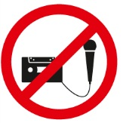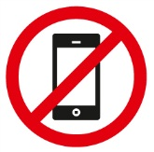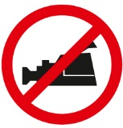

The AO Foundation reserves the right to film, photograph, and audio record during their events. Participants must understand that in this context they may appear in these recorded materials. The AO Foundation assumes participants agree that these recorded materials may be used for AO marketing and other purposes, and made available to the public.

**Security**

Security checks will be conducted at the entrance of the building. Wearing of a name tag is compulsory during lectures, workshops, and group discussions.

**No insurance**

The course organization does not take out insurance to cover any individual against accidents, thefts or other risks.

**Use of mobile phone**

Use of mobile phone is not allowed in the lecture halls and in other rooms during educational activities. Please be considerate of others by turning off your mobile phone.

**Dress code**

Course: casual or sportswear

Davos is a mountain resort. Warm clothes and suitable shoes are advisable.

**Hotels**

Participants who have not booked a package including hotel should settle their hotel bill directly when checking out.

**HRG travel office**

The HRG travel office will support you with flight confirmation or re-booking.

Course venue

**Congress Center Davos**

Talstrasse 49A

7270 Davos, Switzerland

Phone +41 81 414 62 00

Fax +41 81 414 62 29

**Welcome desk–opening hours**

General information/registration for special events

Sunday 15:00–17:00

Monday to Thursday 07:45–19:00

Friday 07:45–16:00

**Information/Faculty desk–opening hours**

Course information for faculty and participants

Sunday 15:00–17:00

Monday to Thursday 07:45–19:00

Friday 07:45–16:00

Business center

There are business center facilities in the Congress Center which are accessible to everybody.

**Services**

• Internet and e-mail access

• Printer access

• www.aotrauma.org

AO Course website offering course-related information.

**Location**

The business centers are available in different locations in the Congress Center.

**Opening hours**

30 minutes before the first course of the day starts until

30 minutes after the last course ends

**Disclaimer**

The use of your own computer in the business center network is inherently not secure. We strongly recommend that you take appropriate actions to protect your computer against unauthorized use or theft (eg, Firewall, VPN-Connection, VirusScanner, etc). AO cannot be held responsible for any data loss or theft.

For further information or support please contact:

AO Foundation

Phone +41 81 414 28 70

E-mail [it.support@aofoundation.org](mailto:it.support@aofoundation.org)

Wireless network

A special wireless network "AOBusiness" is accessible and free for everybody.

**Services**

• Internet and e-mail access

• www.aotrauma.org

AO Course website offering course-related information.

**Locations**

At public places in the Congress Center.

**How to connect**

• Open the wireless network connection window

• Choose the "AOBusiness" network as shown in the picture below and click on the connect button



• Open your internet browser

• Enter user name and password on the wireless connection site

Username: aowireless

Password: aowireless

• Press the OK button

Exhibitions

Visit the AO World in the main foyer, home of the new world of the AO Specialties: AOTrauma, AOSpine, AOCMF, and AOVET. At the specialty exhibits you can explore membership opportunities and the award winning Surgery Reference, examine our print and electronic publications, learn about the ground-breaking activities occurring within AO, and discover the research, development, fellowship, and other opportunities available to you. You can also visit with the Clinical Investigation and Documentation (CID), the AO Research Institute Davos, the TK Office and AO GCTM.

**Industry exhibitions**

Visit our industry partner DePuy Synthes

as well as a number of industry providers who will demonstrate the latest advances in their technologies:

BrainLab, Mathys Orthopädie, Siemens, Storz, Synbone.

AO Research Institute Davos (ARI)

**Mission**

Excellence in research and concept development within trauma and disorders of the musculoskeletal system and translation of this knowledge to achieve more effective patient care worldwide.

**Goals within the Mission**

* Contribute **high quality research and concept development**
* Investigate and **improve the performance** of surgical procedures, devices and substances
* Foster a **close relationship** with the AO medical community, academic societies, universities, and industry
* Provide research environment/support for AO clinicians

At the AO world booths, meet with our team including our ARI Medical Research Fellows, establish contacts, freely discuss your clinical problems, ideas, and learn about the latest results from the AO Research Institute Davos (ARI). On the tours of the AO Center, see our infrastructure under one roof and meet some of our research team.

Areas:

**Exploratory Collaborative Research Programs**

* Large Bone Defect Healing
* Annulus Fibrosus Rupture
* Acute Cartilage Injury

**CMF**

* Imaging and planning of surgery, computer aided preoperative planning
* Preclinical model development for Bisphosphonate-Related Osteonecrosis of the Jaw

**Spine**

* Degeneration and Regeneration of the Intervertebral Disc
* Fracture Fixation in Osteoporotic Bone

**Trauma**

* Bone Infection, including minimizing infection risk through implant design, diagnostics of infection through novel imaging techniques
* Fracture Fixation in Osteoporotic Bone including Intra-operative assessment of bone quality, augmentation techniques and prophylaxis
* Evaluation of the cortical and trabecular bone remodeling (with special regards to the porosity) in the proximal humerus and its impact on the fracture zones

**Veterinary**

* External fixation implant for large animals
* Development of new implants for small animals

**Multidisciplinary**

* Analysis of implant-specific functional anchorage with CT-technology
* Ex-vivo testing using advanced biomechanical models
* In-vivo studies using established or newly developed preclinical models
* Gene Transfer- non viral and viral
* Implant design using the Finite Element Methods
* Implant positioning assistance, C Arm guided implant placement
* Telemetric monitoring of bone healing
* In vivo and in vitro quantification of bone turnover and scaffold degradation
* Longitudinal analysis within in-vivo studies using CT technology
* Medical image processing and analysis
* Polymers to deliver cells and biological factors, create potential space for tissue development, and guide the process of tissue regeneration
* Prototype development and production
* Stem cell therapies for the treatment of bone, intervertebral disc and cartilage defects
* Bioreactor Culture systems and mechanobiology
* Surface modification of PEEK to improve tissue integration
* Thermosresponsive Gel for delivery of antibiotics, stem cells, growth factors, transfected cells etc.

For the 2012 AO Research Institute Davos, activity report and recent publications go to http://www.aofoundation.org/ari/publications

Transportation

**Special bus for course participants**

Wednesday and Thursday

**12:15** Congress Center–AO Center

**13:30** AO Center–Congress Center

Local buses run every 10 minutes during the day.

Sponsors

We would like to thank our partner **DePuy Synthes** for their support without which this event would not be possible.

A special thanks to our main sponsors:

**Audi**

**Siemens**

We also extend our thanks to the following co-sponsors:

**BrainLab**

**Credit Suisse**

**Synbone**

**Storz**

Upcoming AO Courses—Davos 2013

**AO Course–November 30–December 5, 2013**

* AOTrauma Swiss Residents Course—Principles in Operative Fracture Management
* AOTrauma Fortgeschrittenen-Kurs für operative Frakturbehandlung
* AOTrauma Masters Course—Current Concepts
* AOTrauma Course—Hand and Wrist
* AOCMF Course—Principles in Craniomaxillofacial Fracture Management
* AOVET Courses

**AO Course–December 8–13, 2013**

* AOTrauma Course—Principles in Operative Fracture Management
* AOTrauma Course—Advances in Operative Fracture Management
* AOTrauma Masters Course—Lower Extremity
* AOTrauma Masters Course—Upper Extremity
* AOTrauma Masters Course—Complications and Complex fractures
* AOSpine Courses

List subject to changes. The final Davos courses list as well as worldwide courses lists will be available on [www.aotrauma.org](http://www.aotrauma.org) in January 2013.

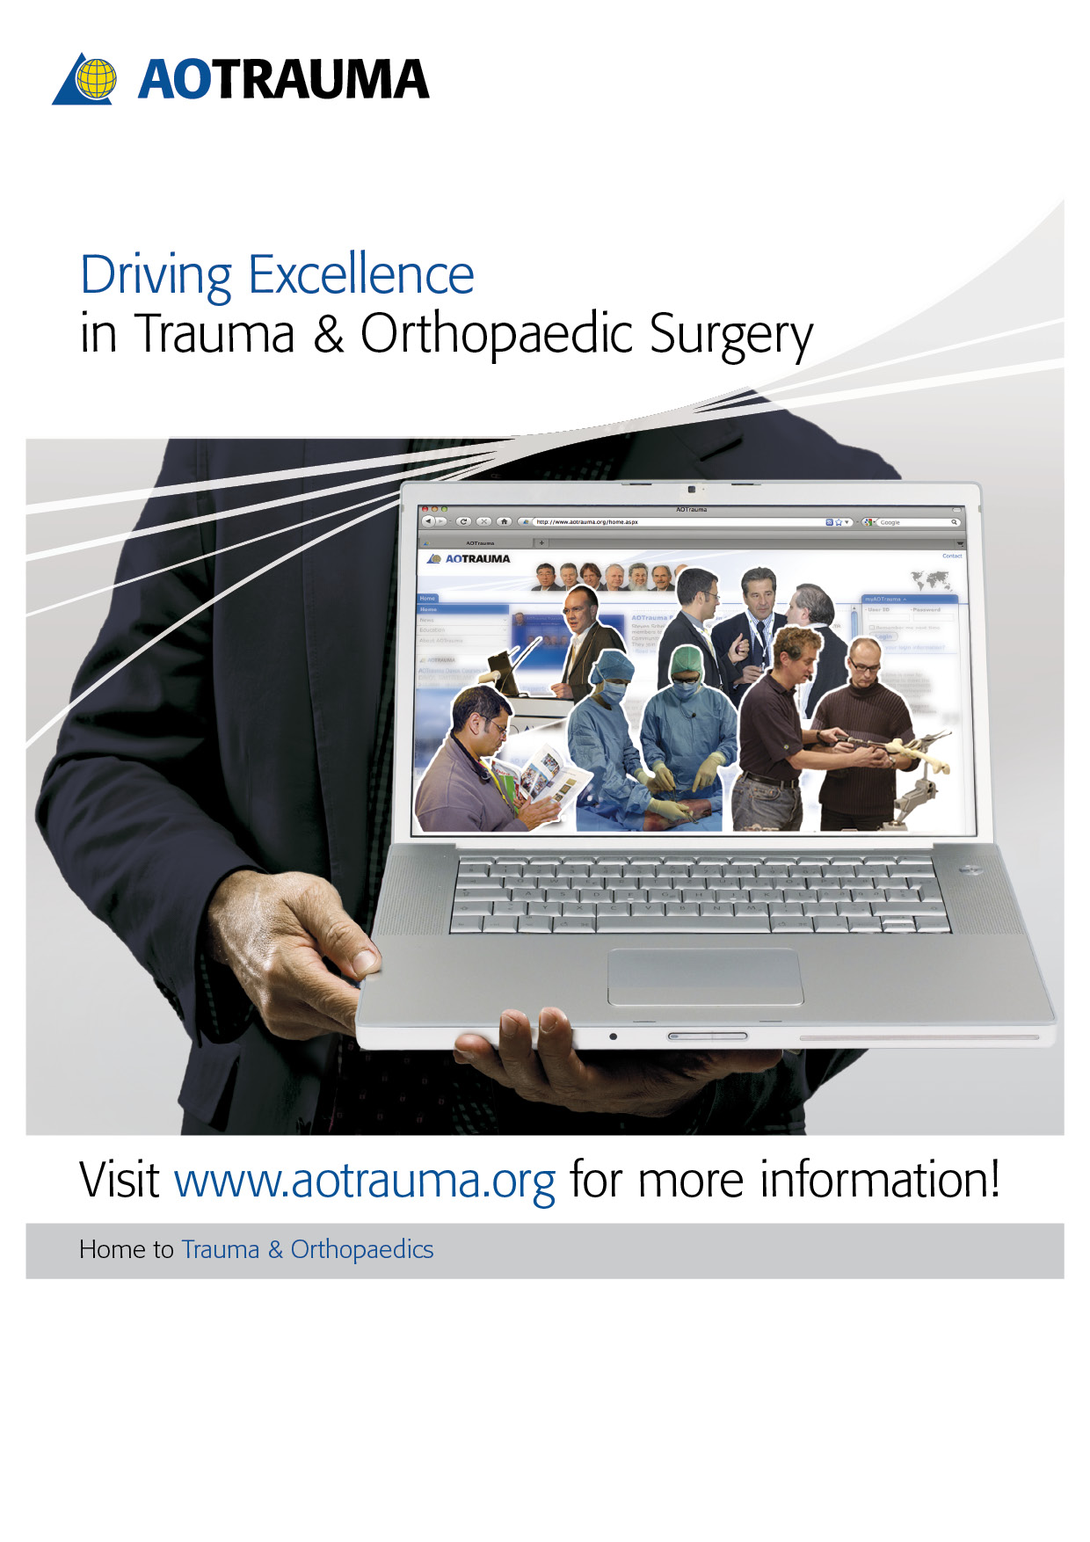

AOTrauma Clavadelerstrasse 8, 7270 Davos Platz, Switzerland

Phone +41 81 414 27 20, F +41 81 414 22 84, courses@aotrauma.org

Logistics and support provided by an educational grant from Synthes.