

Course program

AOTrauma Course—Principles in Operative Fracture Management

Online preparations: November 1–December 9, 2012

Course: December 9–14, 2012 Davos, Switzerland

Online follow-up: December 14, 2012–January 15, 2013

Lecture hall: Aspen

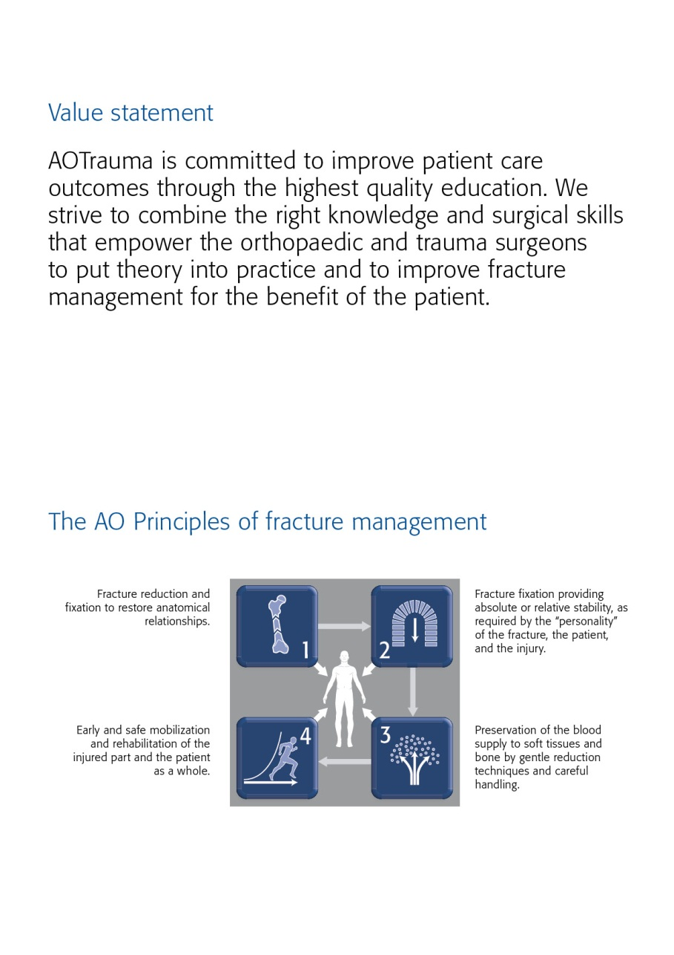

Dear AOTrauma course participant

We have the honour to welcome you to the AOTrauma Course—Principles in Operative Fracture Management run by the AOTrauma Specialty! We hope you will enjoy your course and the entire experience.

What is AOTrauma? We are the "clinical division"—a community for Trauma and Orthopaedics within the AO Foundation. As an AO Specialty we aim to integrate and align applied and clinical research, education, and community development functions into one direction—AOTrauma for the benefit of our members, stakeholders, and patients.

How AOTrauma benefits you? By working as a single team we will focus and better leverage our resources, expertise, and skills to create and deliver new and greater value to our members.

What does this mean in education? AOTrauma is committed to providing you the best possible educational experience by continuously embracing and introducing new educational techniques to help you learn and more effectively implement your knowledge for the benefit of your patients.

Why join AOTrauma? Joining AOTrauma means you are part of the “Trauma & Orthopaedic” community within the AO. AOTrauma will help you develop lifelong friendships and relationships; we will help you access our “knowledge network” and get involved in new opportunities that advance trauma care.

Yours sincerely,

*Photo Photo*

Kodi Kojima Nikolaus Renner

Chairperson AOTrauma Chairperson AOTrauma

Education Commission International Board

PS: Your experiences with us, over the next few days, will result in the realization of new and meaningful knowledge, skills, and understanding that we hope will translate into improved patient care.

The first AO Course was held in Davos in 1960—these early courses pioneered psychomotor techniques by teaching practical skills of AO Techniques. Since those early days over 250,000 surgeons and 135,000 ORP staff from over 110 countries have attended AO Courses—we now launch AOTrauma to move our education to the next level.

Content

Value statement

The AO principles

Dear AOTrauma course participant

Goal of the course

Target participants

Course objectives

Course description

Chairpersons

Faculty

Online activities

Sunday, December 9, 2012

Monday, December 10, 2012

Tuesday, December 11, 2012

Wednesday, December 12, 2012

Thursday, December 13, 2012

Friday, December 14, 2012

Course organization

Course logistics

Course information

Course venue

Business center

Wireless network

Exhibitions

AO Research Institute Davos (ARI)

Transportation

Sponsors

Upcoming AO Courses–Davos 2013

Goal of the course

The AOTrauma Course—Principles in Operative Fracture Management emphasizes basic principles in operative treatment of the most common human fractures based on application of the AO Principles. This course is the initial step along the path of lifelong learning in the area of operative fracture management.

Target participants

The AOTrauma Course—Principles in Operative Fracture Management is targeted to doctors in surgical training who are interested in furthering their knowledge and skills in operative fracture care.

Course objectives

At the end of this course participants will be able to:

* Understand the concepts of stability, their influence on bone healing, and how to apply implants to achieve appropriate stability
* Plan a treatment based on assessment, imaging, classification, and decision making
* Apply reduction techniques in fracture management with attention to the importance of the soft-tissue
* Treat fractures using different application technique
* Evaluate and recognize the special problems related to; fractures in the immature skeleton, pelvic injuries, osteoporotic fractures, postoperative infection and delayed union and/or nonunion

Course description

Online precourse self-assessment prepares participants for the course and allows the Faculty to tailor the course to the participants' needs.

Before attending the course, participants are also expected to complete two online modules on bone healing and fracture classification.

The face-to-face course is built in a modular system. Evidence-based lectures will cover the key information required. Discussing cases in small groups will reinforce the principles and help participants to understand decision-making and management skills. In practical exercises participants will acquire the required skills for the application of various techniques. In the playground you will able to see and test most of the principles of fractures and fracture management options.

After the course an online postcourse self-assessment will provide participants with important feedback on how much they have learned.

Chairpersons

*Photo Photo*

**Mahmoud Odat Paul Szypryt**

Amman, Jordan Nottingham, United Kingdom

Faculty

|  |  |  |
| --- | --- | --- |
| Al-Qdhah | Hashem | Jordan |
| Al-Thani | Saeed | United Arab Emirates |
| Azeem | Hazem | Egypt |
| Baumgaertel | Friedrich | Germany |
| Bernstein | Brian | South Africa |
| Besselaar | Arnold | Netherlands |
| Blachut | Piotr | Canada |
| Castro | Cristhian | Costa Rica |
| Cimerman | Matej | Slovenia |
| Collado Torres | Francisco | Spain |
| Colton | Christopher | United Kingdom |
| Frosch | Karl-Heinz | Germany |
| Goodspeed | David | USA |
| Gunther | Tibor | Hungary |
| Gutierrez | Ricardo | Panama |
| Hadisoebroto Dilogo | Ismail | Indonesia |
| Hatton | Mark | United Kingdom |
| Herngren | Bengt | Sweden |
| Hoigné | Dominik | Switzerland |
| Hövekamp | Tobias | Switzerland |
| Kholeif | Ahmed | Egypt |
| König | Michael | Austria |
| Kremli | Mamoun | Saudi Arabia |
| Kritsaneephaiboon | Apipop | Thailand |
| Krivohlavek | Martin | Czech Republic |
| Malani | Sunil | Oman |
| McClelland | Damian | United Kingdom |
| Monk | Jonathan | United Kingdom |
| Odat | Mahmoud | Jordan |
| Reindl | Rudolf | Canada |
| Richards | R | Switzerland |
| Seitz | Helmut | Austria |
| Smith | Malcolm | USA |
| Stamatis | Emmanouil | Greece |
| Summers | Hobie | USA |
| Szypryt | Paul | United Kingdom |
| Tahami | Seyed Mohammad | Iran |
| tang | xin | China |
| Tsuchida | Yoshihiko | Japan |
| Tyllianakis | Minos | Greece |
| Wixted | John | Switzerland |

Precourse online activities, November 1—

December 9, 2012

DATE ACTIVITIES

Task 1

**November 1‒15, 2012** Online precourse self-assessment (30 min)

The online precourse self-assessment consists of multiple choice questions and a survey and provides you an overview of the important topics from the course. The precourse self-assessment also helps the course chairpersons and faculty to focus on your needs.

Task 2:

**November 15‒ eLearning activity on "**[**Biology of bone healing**](http://www.aovideo.ch/~aoelearn/aot_launch/bh.htm)**" (30 min)  
December 9, 2012 eLearning activity on "**[**Classification**](http://www.aovideo.ch/~aoelearn/aot_launch/clas.htm)**" (30 min)**

After the precourse self-assessment, please complete the two eLearning activities on "Biology of bone healing" and "Classification" before you arrive for the course as faculty will build on your newly acquired knowledge.

Monday, December 10, 2012  
**Main lecture hall: Aspen**

|  |  |  |
| --- | --- | --- |
| Time | AGENDA ITEM | WHO |
| 08:00–08:15 | Welcome and introduction to the course (including ARS) | P Szypryt, M Odat |
| **Module 1** | **Injury pattern (soft and hard tissue), biology of bone**  At the end of this module, participants will be able to:   * Outline the AO principles of fracture management * Explain the biology of fracture healing and how it is affected by fracture treatment * Describe the importance of soft tissues in fracture healing * Use the AO classification to describe a fracture * Define absolute and relative stability and describe their effect onfracture healing | Moderator: Prof Colton, B Bernstein |
| 08:15–08:25 | AO history and philosophy | C Colton |
| 08:25–08:40 | Influence of patient factors and the mechanism of injury on fracture management | M Cimmerman |
| 08:40–08:55 | The soft-tissue injury—a high priority consideration | H Azeem |
| 08:55–09:05 | Biology of bone healing—review of eLearning activity | P Szypryt |
| 09:05–09:15 | AO Classification of fractures long bones—review of eLearning activity | P Szypryt |
| 09:15 -09:30 | What have we learned so far? | C Colton, B Bernstein |
| 09:30 – 9.45 | COFFEE BREAK |  |
| 9:45 – 10.40 | **Discussion group 1**  **Discussion on general principles and classification—developing a thought process to help manage fractures**  Group 1 **Location**: "Landwasser" see floor plan  Group 2 **Location**: "Landwasser" see floor plan  Group 3 **Location**: "Landwasser" see floor plan  Group 4 **Location**: "Landwasser" see floor plan  Group 5 **Location**: "Landwasser" see floor plan  Group 6 **Location**: "Landwasser" see floor plan  Group 7 **Location**: "Landwasser" see floor plan  Group 8 **Location**: "Landwasser" see floor plan  Group 9 **Location**: "Landwasser" see floor plan  Group 10 **Location**: "Landwasser" see floor plan  Group 11 **Location**: "Landwasser" see floor plan  Group 12 **Location**: "Landwasser" see floor plan | P Blachut, H Al Qdhah  M Smith, S Al Thani  A Besselaar, X Tang  H Seitz, C Castro  F Collado Torres, M Tahami  R Reindl, T Gunther  Y Tsuchda, R Gutierrez  J Monk, I Hadisoebroto Dilogo  B Herngren, E Stamatis  H Summers, AKholeif, M Krivohlavk  D McClelland, A Kritsaneephaiboon  J Wixted, S Malani |
| 10:40 – 10.45 | LOCATION CHANGE TO LECTURE HALL |  |
| **Module 2** | **Stability and biomechanics**  At the end of this module, participants will be able to:   * Describe how the measure of stability affects bone healing * Distinguish between absolute and relative stability * Describe the types and purposes of surgical screws and their design considerations * Explain the principles and steps of the lag screw technique * Understand the concept of the locking internal fixator | Moderators: P Szypryt, M Odat |
| 10.45–11:00 | Spectrum of stability—how relative and/or absolute stability affect fracture healing | P Szypryt |
| 11:00–11:15 | Biomechanics—techniques of absolute stability (screws, plates, tension band principles) | C Colton |
| 11:15–11:30 | Biomechanics—techniques of relative stability (intramedullary, extramedullary splinting) | J Monk |
| 11:30–11:45 | LCP (locking compression plate) design and function | M Hatton |
| 11:45–12:00 | What have we learned so far? | P Szypryt, M Odat |
| 12:00–13:00 | LUNCH BREAK |  |
| 13:00–16:00 | Daily educational offering on modern and advanced technologies and surgical implants for individual choice of Continued Medical Education  - TIP Workshop: Multi LOC  - TIP Meet the Experts |  |
| 16:00-17:00 | **Practical exercise 1  Internal fixation with screws and plates—absolute stability**  **Location:** next to "Aspen" see floor plan | J Monk |
| 17:00–17:20 | COFFEE BREAK |  |
| 17:20–18:20 | **RED TEAM**  **Discussion group 2**  **Discuss the concepts of stability, their influence on bone healing, and how to apply implants to achieve the appropriate stability**  Group 1 **Location**: "Landwasser" see floor plan  Group 2 **Location**: "Landwasser" see floor plan  Group 3 **Location**: "Landwasser" see floor plan  Group 4 **Location**: "Landwasser" see floor plan  Group 5 **Location**: "Landwasser" see floor plan  Group 6 **Location**: "Landwasser" see floor plan | P Blachut, H Al Qdhah  M Smith, S Al Thani  A Besselaar, X Tang  H Seitz, C Castro  F Collado Torres, M Tahami  R Reindl, T Gunther |
| 17:20–18:20 | **GREEN TEAM**  **Playground workshop**  1 Mechanics of bone fractures (10 min)  2 Techniques of reduction (10 min)  3 Mechanics of intramedullary fixation (10 min)  4 Mechanics of plate fixation (part 1) (10 min)  5 Mechanics of plate fixation (part 2) (10 min)  6 Fracture healing (10 min)  **Location**: next to "Sanada" see floor plan | Y Tsuchda, R Gutierrez  J Monk, I Hadisoebroto Dilogo  B Herngren, E Stamatis  H Summers, A Kholeif  D McClelland, A Kritsaneephaiboon  J Wixted, S Malani |
| 18:20–18:25 | RED AND GREEN TEAMS SWITCH LOCATIONS |  |
| 18:25–19:25 | **GREEN TEAM**  **Discussion group 2**  **Discuss the concepts of stability, their influence on bone healing, and how to apply implants to achieve the appropriate stability**  Group 7 **Location**: "Landwasser" see floor plan  Group 8 **Location**: "Landwasser" see floor plan  Group 9 **Location**: "Landwasser" see floor plan  Group 10 **Location**: "Landwasser" see floor plan  Group 11 **Location**: "Landwasser" see floor plan  Group 12 **Location**: "Landwasser" see floor plan | Y Tsuchda, R Gutierrez  J Monk, I Hadisoebroto Dilogo  B Herngren, E Stamatis  H Summers, A Kholeif, M Krivohlavk,  D McClelland, A Kritsaneephaiboon  J Wixted, S Malani |
| 18:35–19:25 | **RED TEAM**  **Playground workshop**  1 Mechanics of bone fractures (10 min)  2 Techniques of reduction (10 min)  3 Mechanics of intramedullary fixation (10 min)  4 Mechanics of plate fixation (part 1) (10 min)  5 Mechanics of plate fixation (part 2) (10 min)  6 Fracture healing (10 min)  **Location**: next to "Sanada" see floor plan | P Blachut, H Al Qdhah  M Smith, S Al Thani  A Besselaar, X Tang  H Seitz, M Cimerman  F Collado Torres, M Tahami R Reindl, T Gunther |

Tuesday, December 11, 2012  
**Main lecture hall: Aspen**

|  |  |  |
| --- | --- | --- |
| Time | AGENDA ITEM | WHO |
| 07:30–08:25 | Faculty meeting |  |
| **Module 3** | **Surgical treatment of diaphyseal fractures**  At the end of this module, participants will be able to:   * Describe the treatment goals for diaphyseal fractures * Determine the type of reduction and stability needed for diaphyseal fractures * Prioritize the soft-tissue injury in relation to the “personality of the fracture” | Moderators: M Tyllianakos, P Blachut |
| 08:30–08:45 | Principles of diaphyseal fracture management—what is important in treating these fractures? | H Seitz |
| 08:45–09:00 | Reduction techniques of diaphyseal fractures—principles and methods | F Baumgaertel |
| 09:00–09:15 | Principles of intramedullary nailing | M Smith |
| 09:15–09:30 | Fractures of the humeral diaphysis | M Tyllianakis |
| 09:30–09:45 | Fractures of the femoral diaphysis (including subtrochanteric fractures) | C Castro |
| 09:45–10:00 | Fractures of the tibial diaphysis | K Frosch |
| 10:00–10:15 | What have we learned so far? | M Tyllianakis, P Blachut |
| 10:15–10:35 | COFFEE BREAK |  |
| 10:35–12:00 | **Practical exercise 2  Principle of the internal fixator using the locking compression plate (LCP)**  **Location:** next to "Aspen" see floorplan | M Hatton |
| 12:00–13:00 | LUNCH BREAK |  |
| 12:05–12:55 | Optional skill training for participants  7 Soft-tissue penetration during drilling (10 min)  8 Heat generation during drilling (10 min)  9 Difficult implant removal (10 min)  10 Torque measurement (10 min) | Faculty |
| 13:00–16:00 | Daily educational offering on modern and advanced technologies and surgical implants for individual choice of Continued Medical Education  - TIP Meet the Experts  - Siemens Workshop |  |
| 16:00–17:10 | **Practical exercise 3**  **Tibial fractures—intramedullary nailing with the expert tibia nail (ETN) (with reaming)**  **Location:** next to "Aspen" see floor plan | K Frosch |
| 17:10–17:15 | LOCATION CHANGE TO DISCUSSION GROUP |  |
| 17:15–18:15 | **Discussion group 3**  **Management principles for the treatment of diaphyseal fractures**  Group 1 **Location**: "Landwasser" see floor plan  Group 2 **Location**: "Landwasser" see floor plan  Group 3 **Location**: "Landwasser" see floor plan  Group 4 **Location**: "Landwasser" see floor plan  Group 5 **Location**: "Landwasser" see floor plan  Group 6 **Location**: "Landwasser" see floor plan  Group 7 **Location**: "Landwasser" see floor plan  Group 8 **Location**: "Landwasser" see floor plan  Group 9 **Location**: "Landwasser" see floor plan  Group 10 **Location**: "Landwasser" see floor plan  Group 11 **Location**: "Landwasser" see floor plan  Group 12 **Location**: "Landwasser" see floor plan | P Blachut, H Al Qdhah  M Smith, S Al Thani  A Besselaar, X Tang  H Seitz, C Castro  F Collado Torres, M Tahami  R Reindl, T Gunther  Y Tsuchda, R Gutierrez  J Monk, I Hadisoebroto Dilogo  B Herngren, E Stamatis  H Summers, AKholeif, M Krivohlavk  D McClelland, A Kritsaneephaiboon  J Wixted, S Malani |
| 18:15–18:35 | COFFEE BREAK |  |
| 18:35–19:35 | **Practical exercise 4**  **Tibial fractures treated with different external fixator frame constructs—assessment of stability**   * Material according to video 00118 * Bone model: 1111 * Bone model: PR0536 (for demonstration)   **Location:** next to "Aspen" see floorplan | M König |

Wednesday, December 12, 2012

|  |  |  |
| --- | --- | --- |
| Time | AGENDA ITEM | WHO |
| **Module 4** | **Preoperative planning and forearm fractures**  At the end of this module, participants will be able to:   * Explain the rationale of preoperative planning * Recognize the emphasis of careful decision making with regard to reduction technique, implant requirements, and fixation techniques * Describe a logical sequence of planning steps * Understand the special relationship of radius and ulna | Moderator: M Cimerman, X Tang |
| 08:00–08:15 | Forearm fractures—not just another shaft fracture | R Reindl |
| 08:15–08:30 | Preoperative planning—rationale and how to do it | D McClelland |
|  | LOCATION CHANGE TO PRACTICAL EXERCISE ROOM |  |
| 08:30–09:30 | **Practical exercise 5, part I**  **Preoperative planning—plan your forearm operation  Location:** "Aspen" see floor plan | D McClelland |
| 09:30–09:45 | COFFEE BREAK |  |
| 09:45–11:00 | **Practical exercise 5, part II**  **Operate your plan—fixation of a type 22-C1 forearm fracture using the LCP 3.5 (8 and 11 holes)**  **Location:** next to "Aspen" see floor plan | R Reindl |
| 11:00–11:05 | LOCATION CHANGE TO LECTURE HALL |  |
| **Module 5** | **Articular fractures: management of articular fractures of the upper extremities**  At the end of this module, participants will be able to:   * Describe the treatment goals for articular fractures * Determine the type of reduction and stability needed for articular fractures * Outline the function and clinical indications for the tension band technique * Apply key surgical principles to the management of articular fractures | Moderators: M Kremli, D Hoigne |
| 11:05–11:20 | Management principles for articular fractures—how do they differ from diaphyseal fractures? | M Odat |
| 11:20–11:35 | Reduction techniques for articular fractures—principles and methods | F Baumgaertel |
| 11:35–11:50 | Proximal humeral fractures—an update on treatment protocols | F Collado Torres |
| 11:50–12:00 | Fractures of the olecranon and patella | D Godspeed |
| 12:00–13:00 | LUNCH BREAK |  |
| 13:00–16:00 | Daily educational offering on modern and advanced technologies and surgical implants for individual choice of Continued Medical Education  - TIP Workshop: osteotomy around the knee  - TIP Meet the Experts  - Storz Workshop  - AO Center visit (bus leaves at 12:30) |  |
| 16:00–17:00 | **Practical exercise 6**  **Tension band wiring of the olecranon**  **Location:** next to "Aspen" see floorplan | D Godspeed |
| 17:00–17:05 | LOCATION CHANGE TO LECTURE ROOM |  |
| 17:05–17:20 | Distal radial fractures—which to fix? How to fix? | D Hoigne |
| 17:20–17:35 | What have we learned so far? | M Kremli, D Hoigne |
| 17:35–17:55 | COFFEE BREAK |  |
| 17:55–19:05 | **Discussion group 4**  **Preoperative planning—developing a thought and action process**  Group 1 **Location**: "Landwasser" see floor plan  Group 2 **Location**: "Landwasser" see floor plan  Group 3 **Location**: "Landwasser" see floor plan  Group 4 **Location**: "Landwasser" see floor plan  Group 5 **Location**: "Landwasser" see floor plan  Group 6 **Location**: "Landwasser" see floor plan  Group 7 **Location**: "Landwasser" see floor plan  Group 8 **Location**: "Landwasser" see floor plan  Group 9 **Location**: "Landwasser" see floor plan  Group 10 **Location**: "Landwasser" see floor plan  Group 11 **Location**: "Landwasser" see floor plan  Group 12 **Location**: "Landwasser" see floor plan | Y Tsuchda, R Gutierrez  J Monk, I Hadisoebroto Dilogo  B Herngren, E Stamatis  H Summers, A Kholeif, M Krivohlavk  D McClelland, A Kritsaneephaiboon  J Wixted, S Malani  P Blachut, H Al Qdhah  M Smith, S Al Thani  A Besselaar, X Tang  H Seitz, C Castro  F Torres, M Tahami  R Reindl, T Gunther |

Thursday, December 13, 2012

| Time | AGENDA ITEM | WHO |
| --- | --- | --- |
| **Module 6** | **Surgical management of articular fractures of the lower extremities**  At the end of this module, participants will be able to:   * Describe the anatomy, physiology, and response to injury of the articular segments * Recognize the need for anatomical reduction of the joint * Name the reduction techniques and explain, when direct and indirect methods are used | Moderators: H Azeem, K Frosch |
| 08:00–08:15 | Femoral neck fractures | M Hatton |
| 08:15–08:30 | Trochanteric fractures | H Azeem |
| 08:30–08:45 | Distal femoral fractures—management principles | M Smith |
| 08:45–09:00 | Tibial plateau fractures | B Bernstein |
| 09:00–09:15 | Distal tibial fractures | M König |
| 09:15–09:30 | Ankle fractures—a logical approach for their fixation | M Odat |
| 09:30–09:40 | What have we learned so far ? | H Azeem, K Frosch |
| 09:40–10:00 | COFFEE BREAK |  |
| 10:00–11:00 | **Practical exercise 7**  **Management of a malleolar type 44-C fracture**  **Location:** next to "Aspen" see floor plan | M Odat |
| 11:00–11:05 | LOCATION CHANGE TO DISCUSSION GROUP |  |
| 11:05–12:05 | **Discussion group 5**  **Articular fractures—principles and synopsis**  Group 1 **Location**: "Landwasser" see floor plan  Group 2 **Location**: "Landwasser" see floor plan  Group 3 **Location**: "Landwasser" see floor plan  Group 4 **Location**: "Landwasser" see floor plan  Group 5 **Location**: "Landwasser" see floor plan  Group 6 **Location**: "Landwasser" see floor plan  Group 7 **Location**: "Landwasser" see floor plan  Group 8 **Location**: "Landwasser" see floor plan  Group 9 **Location**: "Landwasser" see floor plan  Group 10 **Location**: "Landwasser" see floor plan  Group 11 **Location**: "Landwasser" see floor plan  Group 12 **Location**: "Landwasser" see floor plan | Y Tsuchda, R Gutierrez  J Monk, I Hadisoebroto Dilogo  B Herngren, E Stamatis  H Summers, A Kholeif, M Krivohlavk  D McClelland, A Kritsaneephaiboon  J Wixted, S Malani  P Blachut, H Al Qdhah  M Smith, S Al Thani  A Besselaar, X Tang  H Seitz, C Castro  F Torres, M Tahami  R Reindl, T Gunther |
| 12:05–13:00 | LUNCH BREAK |  |
| 13:00–16:00 | Daily educational offering on modern and advanced technologies and surgical implants for individual choice of Continued Medical Education  - TIP Meet the Experts  - Siemens Workshop  - AO Center visit (bus leaves at 12:30) |  |
| 16:00–16:50 | **Practical exercise 8**  **Management of a femoral neck fracture using 7.3 mm cannulated screws**  **Location:** next to "Aspen" see floor plan | M Kremli |
| 16:50–16:55 | LOCATION CHANGE TO LECTURE HALL |  |
| **Module 7** | **Emergency management and MIO**  At the end of this module, participants will be able to:   * Outline the algorithm for polytrauma management * Discuss roles of the team members * Recognize the pathology of severe pelvic trauma and identify the reasoning behind emergency pelvic stabilization * Outline the treatment plan and priorities for open fractures * Describe different techniques of minimally invasive surgery (MIO) | Moderators: D Mc Clelland, B Herngren |
| 16:55–17:10 | Treatment algorithms for the polytrauma patient | X Tang |
| 17:10–17:25 | Emergency management of pelvic fractures—a critical skill that can save lives | F Baumgaertel |
| 17:25–17:40 | Management of open fractures | B Bernstein |
| 17:40–17:55 | Minimally invasive osteosynthesis (MIO)—when to use it? | S Al Thani |
| 17:55–18:00 | LOCATION CHANGE TO PRACTICAL EXERCISE |  |
| 18:00–19:00 | **Practical exercise 9**  **Stabilization of the pelvic ring using a large external fixator and a pelvis binder**   * Video: 00122 * Bone model: 4083   **Location:** next to "Aspen" see floor plan | F Baumgaertel |
| 19:00 | AO WORLD |  |

Friday, December 14, 2012

| Time | AGENDA ITEM | WHO |
| --- | --- | --- |
| 08:00–09:05 | **Practical exercise 10**  **Management of a trochanteric fracture using a dynamic hip screw (DHS)**  **Location:** next to "Aspen" see floor plan | A Kholeif |
| 09:05–09:10 | LOCATION CHANGE TO LECTURE HALL |  |
| **Module 8** | **Special Issues and problems**  At the end of this module, participants will be able to:   * Recognize the special problems related to fractures in the immature skeleton * Describe the changes in osteoporotic bone and identify special techniques to deal with them * Describe and understand the dangers of radiation and how to avoid them * List the causes and factors that lead to postoperative infection * Name factors leading to delayed union and/or malunion | Moderators: P Szypryt, M Odat |
| 09:10–09:25 | Fractures in the growing skeleton—how are they different? | A Besselaar |
| 09:25–09:40 | Fixation principles in osteoporotic bone—the geriatric patient | J Wixted |
| 09:40–09:50 | Implant removal—why, when, and how? | M Odat |
| 09:50–10:05 | Radiation hazards | M Kremli |
| 10:05–10:20 | AO Foundation Research Institute | G Richards |
| 10:20–11:10 | Infection after osteosynthesis—how to diagnose and manage?  Delayed healing—causes and treatment principles  ( Case discussions / ARS) | M Smith, P Szypryt, M Hatton, J Monk, P Blachut |
| 11:10–11:25 | COFFEE BREAK |  |
| 11:10–11:35 | What have we learned so far ? | M Odat, P Szypryt |
| 11:35–11:50 | The future of fracture treatment | T Reudi |
| 11:50–12:05 | Introduction to AO Surgery Reference | T Hövekamp |
| 12.05–12:35 | Take-home message from the course participants | All Participants |
| 12:35–12:50 | Closing remarks | M Odat, P Szypryt |

Postcourse online activities

December 14, 2012—January 15, 2013

DATE ACTIVITIES

Task 1

December 14 , 2012— **Online postcouse self-assessment (30 min)**

January 15, 2013

After the course please complete the postcouse self-assessment (30 min),which will provide you an opportunity to review the important topics from the course and helps us to improve future courses.

Course organization

**AOTrauma**

George Clay

Clavadelerstrasse 8

7270 Davos, Switzerland

Phone +41 81 414 27 25

Fax +41 81 414 22 84

Email gclay@aotrauma.org

Course logistics

**Industrial Partner**

DePuy Synthes

Luzernstrasse 21

4528 Zuchwil, Switzerland

Tel +41 32 720 40 60

Fax + 41 32 720 46 89

Website [www.depuysynthes.com](http://www.depuysynthes.com)

Course information

**Course fee**

AOTrauma Course—Principles in Operative Fracture Management CHF 2’250.

Included in course fee are conference bag with documentation, coffee breaks, course certificate.

**Accreditation**

AOTrauma Courses are accredited for continuing medical education (CME) programs. The number of credit points or hours varies from country to country. The final information and number of credit points will be distributed with the course certificate.

**Evaluation guidelines**

All AOTrauma courses apply the same evaluation process, either audience response system (ARS) or paper and pencil questionnaires. This will help AOTrauma to ensure that we continue to meet your training needs. In some regions, CME accreditation is dependent on the participant’s evaluation results.

**Intellectual property**

Course materials, presentations, and case studies are the intellectual property of the course faculty. All rights are reserved. Check hazards and legal restrictions on www.aotrauma.org/legal.

🡪 **Recording, photographing, or copying of lectures, practical exercises, case discussions, or any course materials is strictly forbidden. Participants violating intellectual property will be dismissed.**

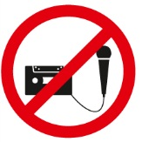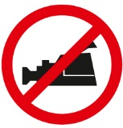

The AO Foundation reserves the right to film, photograph, and audio record during their events. Participants must understand that in this context they may appear in these recorded materials. The AO Foundation assumes participants agree that these recorded materials may be used for AO marketing and other purposes, and made available to the public.

**Security**

Security checks will be conducted at the entrance of the building. Wearing of a name tag is compulsory during lectures, workshops, and group discussions.

**No insurance**

The course organization does not take out insurance to cover any individual against accidents, thefts or other risks.

**Use of mobile phone**

Use of mobile phone is not allowed in the lecture halls and in other rooms during educational activities. Please be considerate of others by turning off your mobile phone.

**Dress code**

Course: casual or sportswear

Davos is a mountain resort. Warm clothes and suitable shoes are advisable.

**Hotels**

Participants who have not booked a package including hotel should settle their hotel bill directly when checking out.

**HRG travel office**

The HRG travel office will support you with flight confirmation or re-booking.

Course venue

**Congress Center Davos**

Talstrasse 49A

7270 Davos, Switzerland

Phone +41 81 414 62 00

Fax +41 81 414 62 29

**Welcome desk–opening hours**

General information/registration for special events

Sunday 15:00–17:00

Monday to Thursday 07:45–19:00

Friday 07:45–16:00

**Information/Faculty desk–opening hours**

Course information for faculty and participants

Sunday 15:00–17:00

Monday to Thursday 07:45–19:00

Friday 07:45–16:00

Business center

There are business center facilities in the Congress Center which are accessible to everybody.

**Services**

• Internet and e-mail access

• Printer access

• www.aotrauma.org

AO Course website offering course-related information.

**Location**

The business centers are available in different locations in the Congress Center.

**Opening hours**

30 minutes before the first course of the day starts until

30 minutes after the last course ends

**Disclaimer**

The use of your own computer in the business center network is inherently not secure. We strongly recommend that you take appropriate actions to protect your computer against unauthorized use or theft (eg, Firewall, VPN-Connection, VirusScanner, etc). AO cannot be held responsible for any data loss or theft.

For further information or support please contact:

AO Foundation

Phone +41 81 414 28 70

E-mail [it.support@aofoundation.org](mailto:it.support@aofoundation.org)

Wireless network

A special wireless network "AOBusiness" is accessible and free for everybody.

**Services**

• Internet and e-mail access

• www.aotrauma.org

AO Course website offering course-related information.

**Locations**

At public places in the Congress Center.

**How to connect**

• Open the wireless network connection window

• Choose the "AOBusiness" network as shown in the picture below and click on the connect button



• Open your internet browser

• Enter user name and password on the wireless connection site

Username: aowireless

Password: aowireless

• Press the OK button

Exhibitions

Visit the AO World in the main foyer, home of the new world of the AO Specialties: AOTrauma, AOSpine, AOCMF, and AOVET. At the specialty exhibits you can explore membership opportunities and the award winning Surgery Reference, examine our print and electronic publications, learn about the ground-breaking activities occurring within AO, and discover the research, development, fellowship, and other opportunities available to you. You can also visit with the Clinical Investigation and Documentation (CID), the AO Research Institute Davos, the TK Office and AO GCTM.

**Industry exhibitions**

Visit our industry partner DePuy Synthes

as well as a number of industry providers who will demonstrate the latest advances in their technologies:

BrainLab, Mathys Orthopädie, Siemens, Storz, Synbone.

AO Research Institute Davos (ARI)

**Mission**

Excellence in research and concept development within trauma and disorders of the musculoskeletal system and translation of this knowledge to achieve more effective patient care worldwide.

**Goals within the Mission**

* Contribute **high quality research and concept development**
* Investigate and **improve the performance** of surgical procedures, devices and substances
* Foster a **close relationship** with the AO medical community, academic societies, universities, and industry
* Provide research environment/support for AO clinicians

At the AO world booths, meet with our team including our ARI Medical Research Fellows, establish contacts, freely discuss your clinical problems, ideas, and learn about the latest results from the AO Research Institute Davos (ARI). On the tours of the AO Center, see our infrastructure under one roof and meet some of our research team.

Areas:

**Exploratory Collaborative Research Programs**

* Large Bone Defect Healing
* Annulus Fibrosus Rupture
* Acute Cartilage Injury

**CMF**

* Imaging and planning of surgery, computer aided preoperative planning
* Preclinical model development for Bisphosphonate-Related Osteonecrosis of the Jaw

**Spine**

* Degeneration and Regeneration of the Intervertebral Disc
* Fracture Fixation in Osteoporotic Bone

**Trauma**

* Bone Infection, including minimizing infection risk through implant design, diagnostics of infection through novel imaging techniques
* Fracture Fixation in Osteoporotic Bone including Intra-operative assessment of bone quality, augmentation techniques and prophylaxis
* Evaluation of the cortical and trabecular bone remodeling (with special regards to the porosity) in the proximal humerus and its impact on the fracture zones

**Veterinary**

* External fixation implant for large animals
* Development of new implants for small animals

**Multidisciplinary**

* Analysis of implant-specific functional anchorage with CT-technology
* Ex-vivo testing using advanced biomechanical models
* In-vivo studies using established or newly developed preclinical models
* Gene Transfer- non viral and viral
* Implant design using the Finite Element Methods
* Implant positioning assistance, C Arm guided implant placement
* Telemetric monitoring of bone healing
* In vivo and in vitro quantification of bone turnover and scaffold degradation
* Longitudinal analysis within in-vivo studies using CT technology
* Medical image processing and analysis
* Polymers to deliver cells and biological factors, create potential space for tissue development, and guide the process of tissue regeneration
* Prototype development and production
* Stem cell therapies for the treatment of bone, intervertebral disc and cartilage defects
* Bioreactor Culture systems and mechanobiology
* Surface modification of PEEK to improve tissue integration
* Thermosresponsive Gel for delivery of antibiotics, stem cells, growth factors, transfected cells etc.

For the 2012 AO Research Institute Davos, activity report and recent publications go to http://www.aofoundation.org/ari/publications

Transportation

**Special bus for course participants**

Wednesday and Thursday

**12:15** Congress Center–AO Center

**13:30** AO Center–Congress Center

Local buses run every 10 minutes during the day.

Sponsors

We would like to thank our partner **DePuy Synthes** for their support without which this event would not be possible.

A special thanks to our main sponsors:

**Audi**

**Siemens**

We also extend our thanks to the following co-sponsors:

**BrainLab**

**Credit Suisse**

**Synbone**

**Storz**

Upcoming AO Courses—Davos 2013

**AO Course–November 30–December 5, 2013**

* AOTrauma Swiss Residents Course—Principles in Operative Fracture Management
* AOTrauma Fortgeschrittenen-Kurs für operative Frakturbehandlung
* AOTrauma Masters Course—Current Concepts
* AOTrauma Course—Hand and Wrist
* AOCMF Course—Principles in Craniomaxillofacial Fracture Management
* AOVET Courses

**AO Course–December 8–13, 2013**

* AOTrauma Course—Principles in Operative Fracture Management
* AOTrauma Course—Advances in Operative Fracture Management
* AOTrauma Masters Course—Lower Extremity
* AOTrauma Masters Course—Upper Extremity
* AOTrauma Masters Course—Complications and Complex fractures
* AOSpine Courses

List subject to changes. The final Davos courses list as well as worldwide courses lists will be available on [www.aotrauma.org](http://www.aotrauma.org) in January 2013.

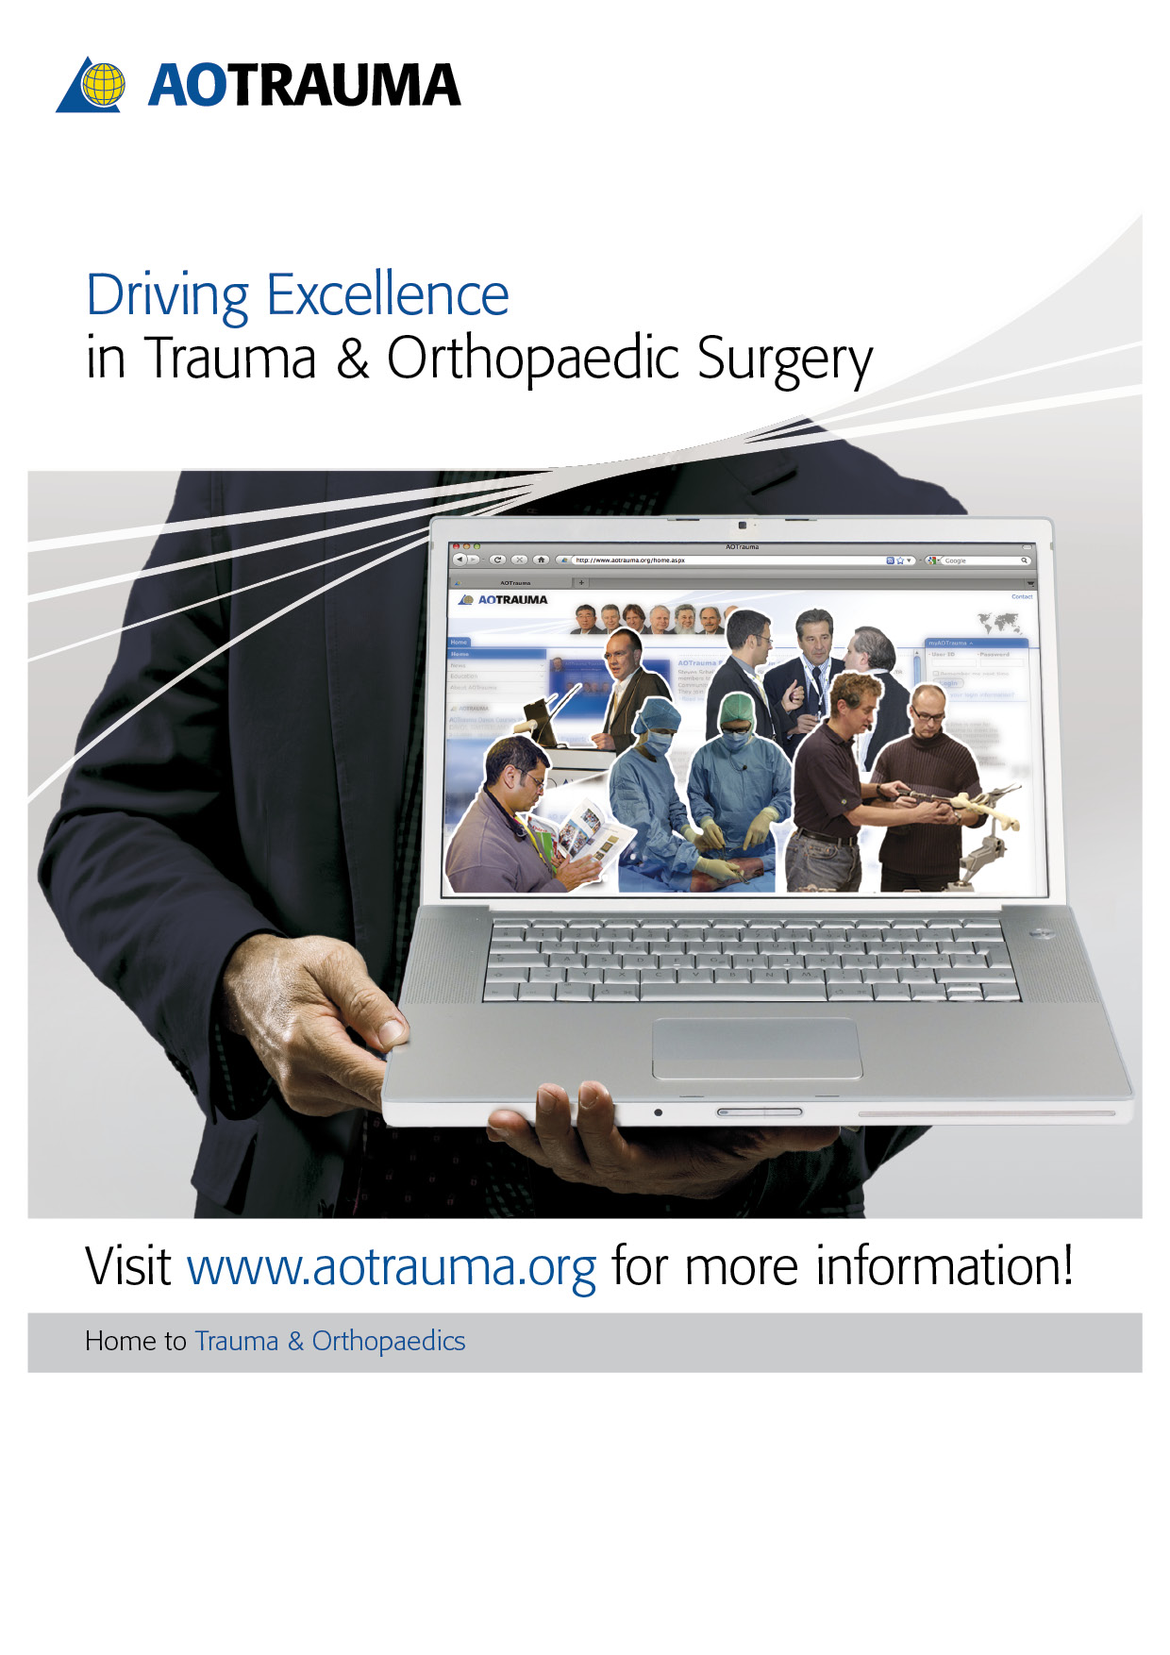

AOTrauma Clavadelerstrasse 8, 7270 Davos Platz, Switzerland

Phone +41 81 414 27 20, F +41 81 414 22 84, courses@aotrauma.org

Logistics and support provided by an educational grant from Synthes.