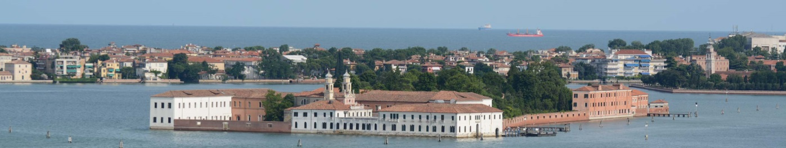

Dear colleague,

we would kindly like to invite you as a presenter / chair  or participant to our  6th  “**Cardiac  Regeneration and Vascular Biology**” conference in San Servolo, Venice from  June  17th to  19th. The intention of our so called “ISLAND-Meetings” is to bring together cardiologists, cardiac surgeons and basic scientists focussing on regeneration in cardiovascular medicine.  This is a joint meeting of the working groups on "Genetics and Molecular Biology of Cardiovascular Diseases" and "Vascular Biology" of the German society for cardiology (DGK).

The scope of this meeting comprises novel scientific developments in key areas of vascular mechanisms of growth and inflammation (atherosclerosis) and frontier molecular therapy of cardiac diseases. In addition, complementary sessions will address tissue engineering, trans-aortic valve implantation (TAVI) and clinical trials.

The attached program will be flanked by poster presentations. Please submit your abstract by March 29th.

Please let us know if you are willing to accept our invitation and serve as speaker/chairman for this meeting (preliminary programm attached).

Just one more thing: in order to be able to fulfil our teaching mission (which is essential for the International University of Venice, our host) and in order to encourage networking of the next generation, as a rule we expect every speaker/chair to be accompanied by two junior researchers of his/her group. Experience tells that this formula is working out nicely, to the benefit of each contributing group. Our tradition is to reimburse speaker travel fees up to 300€, accommodation and registration are included. Accompanying persons are subject to registration fees of 400€ (including accommodation and 2x dinner).

Looking forward to hearing from you,

With cordial regards

**Please register by sending the attached form to** [**sekretariat.cardiac-regeneration@med.uni-muenchen.de**](mailto:sekretariat.cardiac-regeneration@med.uni-muenchen.de)

**We are looking forward to welcome you in San Servolo.**

**Cordially yours**

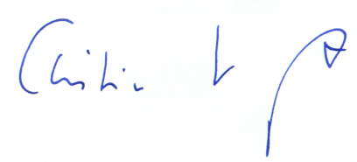

Christian Kupatt Christian Weber

*AG 8 Genetik und AG 4 Vask. Biologie*

*Mol. Kardiologie*