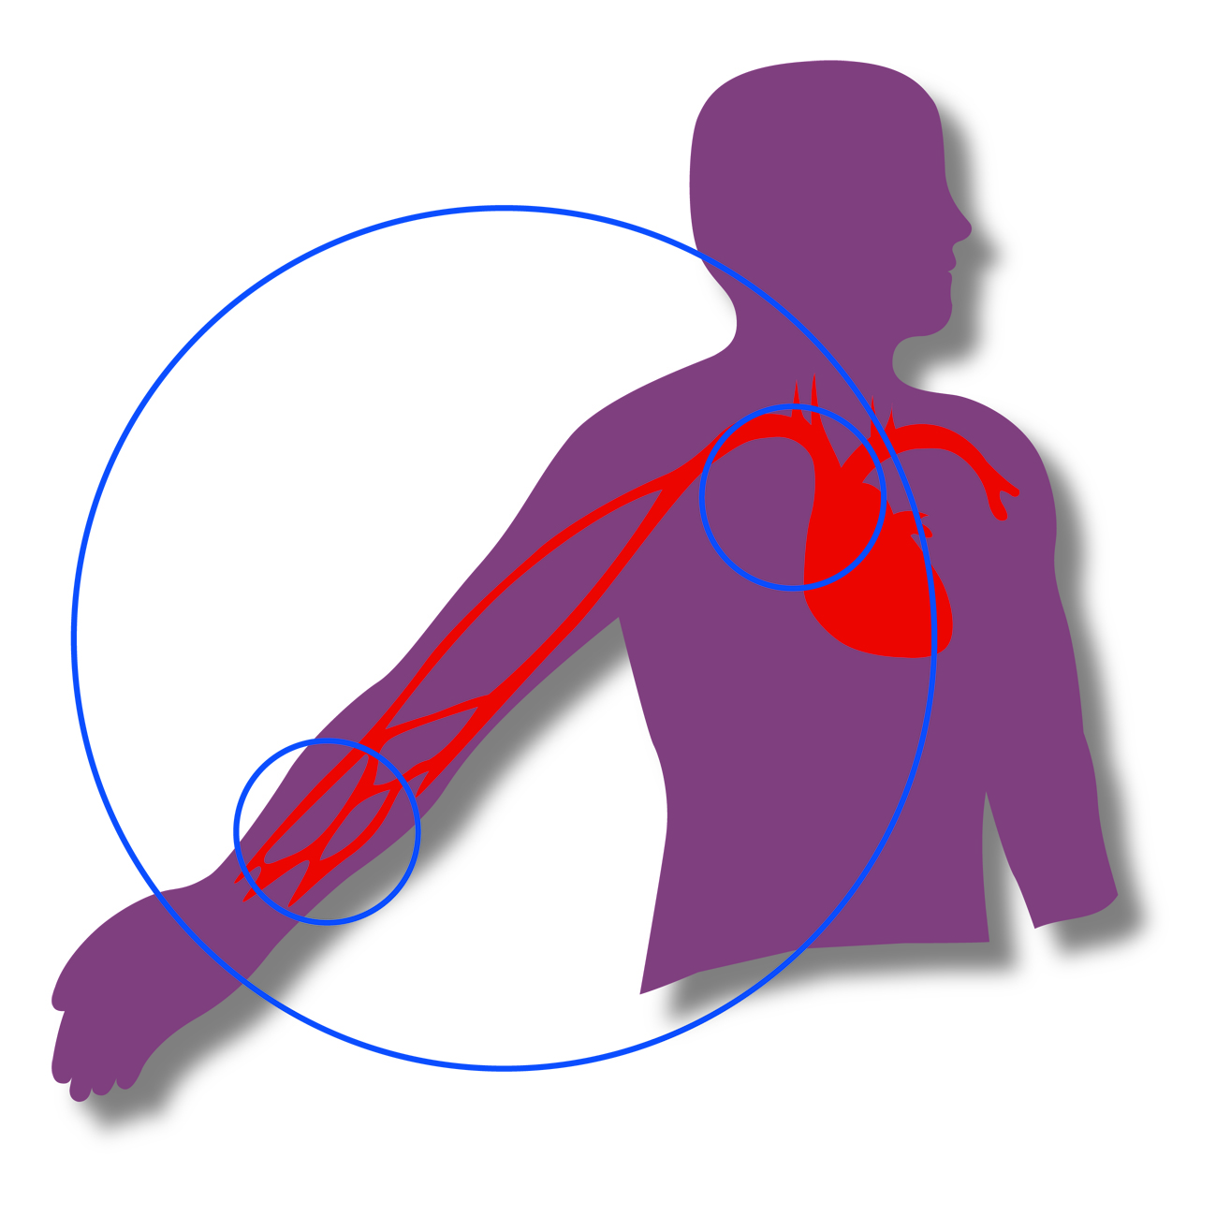

**TRANSRADIAL MASTERCLASS**

**Crewe Hall**

**20th – 21st November 2014**

**PROGRAMME COMMITTEE**

Dr Jim Nolan University Hospital of North Staffordshire

Dr Doug Fraser Manchester Royal Infirmary

Dr Helen Routledge Worcestershire Royal Hospital

Dr Beth Freestone Birmingham Heartlands Hospital

Dr Sanjay Sastry Royal Bolton Hospital

Dr Mamas Mamas Manchester Royal Infirmary



**TRANSRADIAL MASTERCLASS**

**DAY ONE - THURSDAY 20th NOVEMBER**

09:50Welcome and Introduction Jim Nolan

|  |
| --- |
| **SESSION ONE – What can the UK tell us**  Chairman – Jim Nolan |

10:00 Insights from the BCIS database Mamas Mamas

**10:40 LIVE CASE ONE – FMC Adelaide**

**11:30 COFFEE**

|  |
| --- |
| **SESSION TWO – What’s new in the last 12 months**  Chairman – Helen Routledge |

11:45Review of the years literature Jon Byrne

**12:15 LIVE CASE TWO – OLVG Amsterdam**

**13:00 LUNCH**

|  |
| --- |
| **SESSION THREE – Slender Club Europe**  Chairman- Ferdinand Kiemeneij and Doug Fraser |

14:00 Why bother: equipment calibre and radial injury Alun Harcombe

14:20 Slender TRI: Overview and classification Ferdinand Kiemeneij

14:40 The European approach - what we do in daily practice Giovanni Amoroso

15:00 The Japanese approach - what we do in daily practice Takashi Matsukage

15:25 Technical innovations 1 Doug Fraser

15.30 Technical innovations 2 Ferdinand Kiemeneij

**15:40 COFFEE**



**TRANSRADIAL MASTERCLASS**

**DAY ONE - THURSDAY 20th NOVEMBER**

|  |
| --- |
| **SESSION FOUR – Radiation issues**  Chair – Jacques Monsegu |

16:00 Literature overview Olivier Bertrand

16:15 What does it mean Jim Nolan

**16:30 LIVE CASE THREE – OLVG Amsterdam**

|  |
| --- |
| **SESSION FIVE – Small Group Angio Review** |

17:15 **Group 1 – Chairs: Rod Stables and Helen Routledge**

Case 1 Mark Appleby

Case 2 Nalyaka Sambu

Case 3 Yogesh Raja

17:15 **Group 2 – Chairs: Jim Nolan and Beth Freestone**

Case 1 Simon Eccleshall

Case 2 Cara Hendry

Case 3 Clare Appleby

17:15 **Group 3 – Chair: David Foley**

Case 1

Case 2

Case 3

**TRANSRADIAL MASTERCLASS**

**DAY TWO – FRIDAY 21st NOVEMBER**

|  |
| --- |
| **SESSION SIX – Beyond the acess site: The PPCI drugs debate**  Chairman – Olivier Bertrand |

09:00 Just Heparin for all Rod Stables

09:15Bivalirudin is best tbc

09:30 GPI for most PPCI Sagar Doshi

**10:00 LIVE CASE 4: AH UNIVERSITY HOSPITAL OF NORTH STAFFORDSHIRE**

**10:45 Coffee**

|  |
| --- |
| **SESSION SEVEN – Triumphs and Disasters**  Chairman – David Foley |

11:00 My most memorable radial case Jacques Monsegu

11:15 My most memorable radial case Ivo Bernat

**11:30 LIVE CASE 5: AH CYPRUS**

**12:15 COFFEE**

|  |
| --- |
| **SESSION EIGHT – Why are results better for radial operators**  Chairman – Doug Fraser |

12:30 It’s all related to the access site Scot Garg

12:45 There are other factors Tim Kinnaird

**12:30 LIVE CASE 6: AH CYPRUS**

|  |
| --- |
| **13:15 MEETING CLOSE** |