Hello, Penguins!

Jan Freihardt

## Data

For this analysis we’ll use the penguins dataset from the palmerpenguins R package.

Hello…

library(tidyverse)  
library(ggthemes)  
library(palmerpenguins)  
library(gt)

## Species

The figure below is a scatterplot of species of penguins.

ggplot(data = penguins,  
 mapping = aes(x = bill_length_mm,   
 y = bill_depth_mm,  
 color = species,  
 shape = species)) +  
 geom_point() +  
 scale_color_colorblind() +  
 labs(x = "Bill length (mm)", y = "Bill depth (mm)") +  
 theme_minimal()

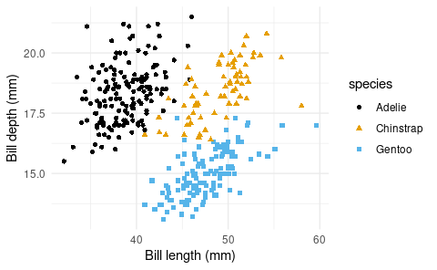

## Penguins

The table below shows the first 10 penguins from the dataset.

penguins |>  
 slice_head(n = 10) |>  
 select(species, island, bill_length_mm, bill_depth_mm) |>  
 gt()

| species | island | bill_length_mm | bill_depth_mm |
| --- | --- | --- | --- |
| Adelie | Torgersen | 39.1 | 18.7 |
| Adelie | Torgersen | 39.5 | 17.4 |
| Adelie | Torgersen | 40.3 | 18.0 |
| Adelie | Torgersen | NA | NA |
| Adelie | Torgersen | 36.7 | 19.3 |
| Adelie | Torgersen | 39.3 | 20.6 |
| Adelie | Torgersen | 38.9 | 17.8 |
| Adelie | Torgersen | 39.2 | 19.6 |
| Adelie | Torgersen | 34.1 | 18.1 |
| Adelie | Torgersen | 42.0 | 20.2 |