Report Orange3: Breast Cancer Wisconsin Dataset (Diagnostic)
Course: UE 5BM753 – Supervised and Unsupervised Learning for Biology

Summary
1. Biological context and dataset 2
1.1 Biological context 2
1.2 Dataset preparation 2
2. Supervised analytical strategy 2
2.1 Objective 2
2.2 Validation procedure 3
3. Supervised results 4
3.1 Model comparison 4
3.2 Confusion Matrix of the SVM model 4

1. Biological context and dataset

1.1 Biological context
Breast cancer diagnosis relies partly on the identification of morphological abnormalities in cell nuclei. Malignant cells frequently exhibit changes in nuclear size, shape, texture, contour regularity and spatial organization. Quantitative analysis of these morphological characteristics can therefore provide discriminative information for distinguishing malignant from benign breast masses.

1.2 Dataset preparation
The dataset contained 569 observations:
- 357 benign tumors, corresponding to 62.7% of the dataset.
- 212 malignant tumors, corresponding to 37.3%.
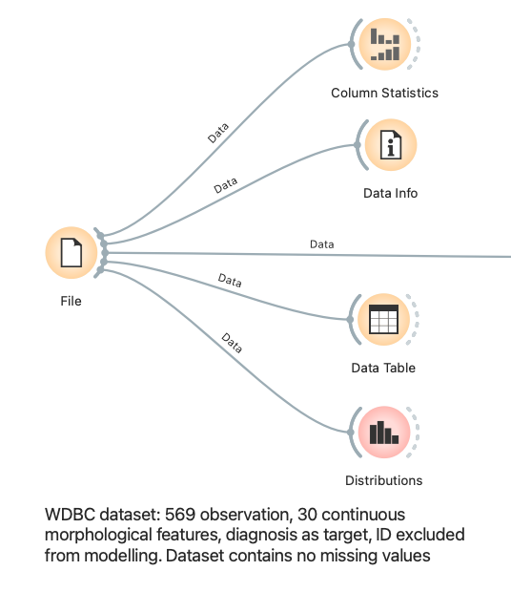
The variable “diagnosis” as defined as the categorical target, with ‘B’ representing benign tumors and ‘M’ representing malignant tumors. The identifier variable “id” was retained as metadata and excluded from modelling because it does not contain biological information. The 30 morphological variables were retained as continuous input features.
No missing values were detected. Nevertheless, an explicit imputation step was included in the preprocessing pipeline to make the analytical procedure reproductible and robust to potential missing values. Continuous variables were standardized by centering them around their mean and scaling them by their standard deviation.
Figure 1: initial Orange3 workflow used to import, inspect and configure the dataset.

2. Supervised analytical strategy

2.1 Objective
The first question was: Can we reliably predict the diagnosis (benign/malignant) from the 30 morphological features? Which standard classifier performs best as a baseline?
Seven classification algorithms were compared in this step:

Model | Reason for inclusion
Constant | Naïve reference model that always predicts the majority class
Logistic Regression | Simple and relatively interpretable linear baseline
SVM | Effective classifier for continuous, potentially complex decision boundary
Random Forst | Ensemble model able to represent nonlinear effects and feature interactions
kNN | Distance-based method suitable for testing local separation between observations
Naive Bayes | Probabilistic baseline based on conditional independence assumptions
Classification Tree | Interpretable nonlinear decision model
Table 1: the seven classifiers used and the reason for inclusion

2.2 Validation procedure
Performance was estimated using stratified 10-fold cross validation. The data were divides into ten folds while preserving approximately the same benign/malignant distributions in each fold. For each iteration, nine-fold were used for training, and the remaining fold was used for testing. This was repeated until every observation had been used once for testing.
The preprocessing pipeline was connected directly to the “Test & Score” widget. Consequently, imputation and standardization were fitted separately within each training fold and then applied to the corresponding test fold. This prevented information from the test observation from influencing model training. Orange explicitly recommends applying preprocessing within “Test & Score” for cross validation (https://orangedatamining.com/widget-catalog/evaluate/testandscore/)
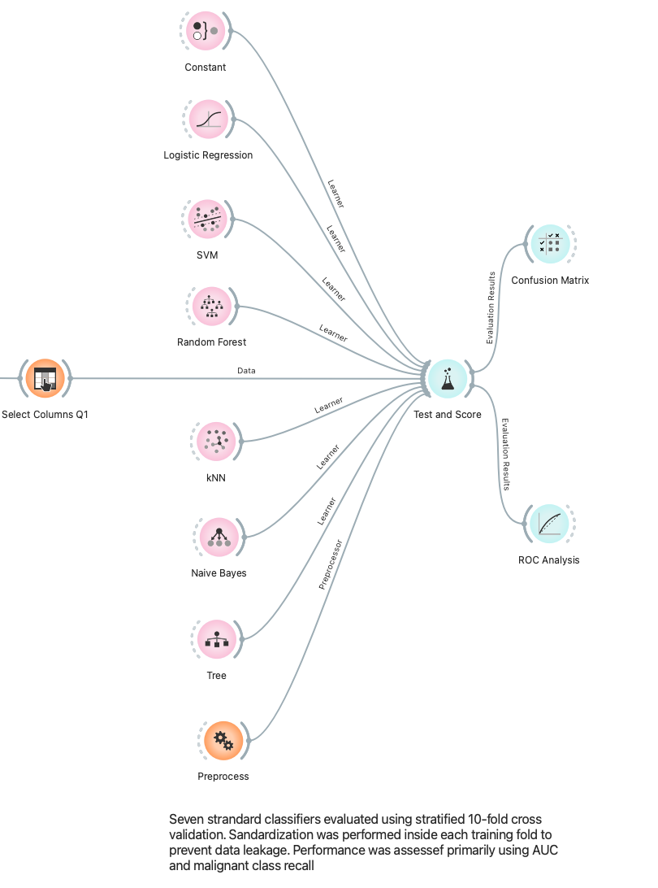
The malignant class ‘M’ was selected as the positive class. Models were compared using:
- Area under the ROC curve, or AUC
- Classification accuracy, or CA
- Precision for the malignant class
- Specificity
- F1 score
- Matthews correlation coefficient, or MCC
- The number and type of errors in the confusion matrix
Recall was considered particularly important because a false negative corresponds to a malignant tumor incorrectly predicted as benign.
Figure 2: Supervised Orange3 workflow. Seven learning algorithms were evaluated using the same stratified 10-fold cross validation procedure. Preprocessing was performed independently within each training fold

3. Supervised results

3.1 Model comparison
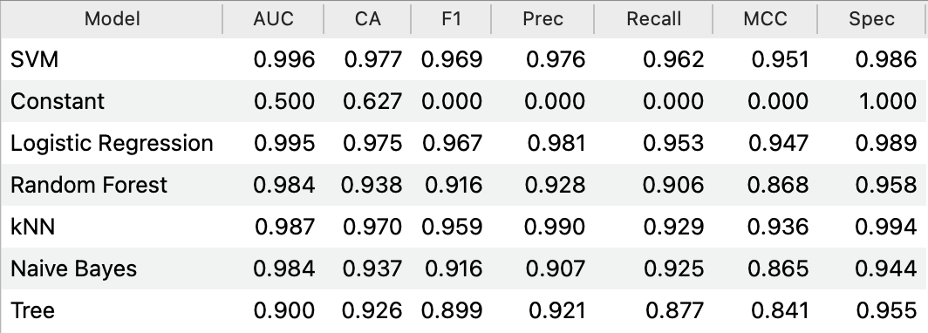
Table 2: The performance of the seven baseline classifiers for malignant diagnosis under stratified 10-fold cross validation.
SVM achieved the highest AUC, accuracy, malignant class recall and MCC. Logistic regression performed almost identically, with an AUC difference of only 0.001 and an accuracy difference of 0.002.
The pairwise comparison indicated a probability of 0.683 that SVM had a higher AUC than logistic regression. This does not constitute strong evidence of a meaningful difference between the two classifiers. SVM can therefore be described as the best numerical baseline, while logistic regression remains a practically equivalent and simpler alternative.
Th constant model obtained an apparent accuracy of 0.627 because it always predicted the majority benign class, this demonstrates why the accuracy alone would have been misleading for this dataset.

3.2 Confusion Matrix of the SVM model
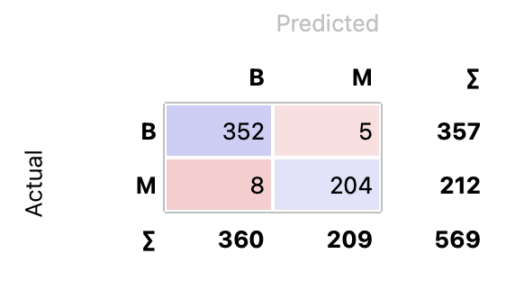
SVM correctly classified 556 of the 569 observation and made 13 errors. It correctly identified 204 of the 212 malignant tumors, corresponding to a sensitivity of 96.2%. It also correctly identified 352 of the 357 benign tumors, corresponding to a specificity of 98.6%.
Figure 4: Cross validated confusion matrix for SVM

