Ostap Voynarovskiy
Pset 7

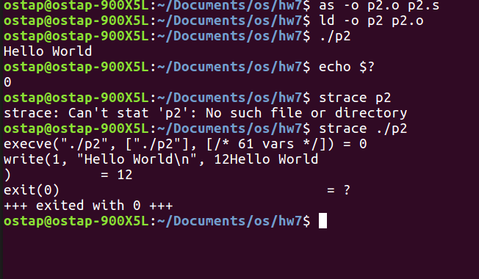
P3:
If you only have a write sys call you get a segmentation fault. You get this because you never exit and you keep reading and then you end up in memory you arent supposed to be in.
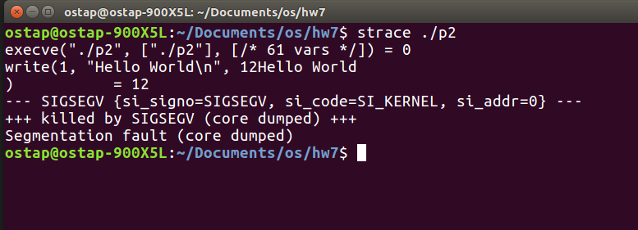

P3 Cont.
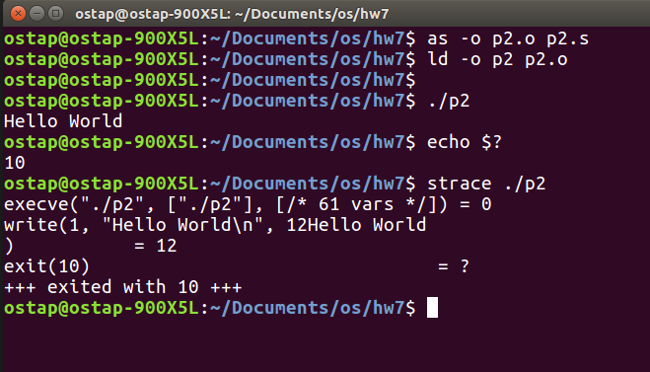
P4:
