Layer-wise Local Supervision
(LLS)
A Depth-Independent Training Algorithm for Deep Transformers
based on Sliding Window Local Objectives
Key properties: memory O(w·d) independent of depth · no vanishing/exploding gradients · each layer receives a direct, unambiguous training signal
Experimental Research | Version 2.0 | 2025

Abstract
This paper presents Layer-wise Local Supervision (LLS) — a training method for deep neural networks built on a direct observation about how these models compute: every layer of a Transformer performs a matrix multiplication that transforms one vector into a slightly more refined version of the same vector, advancing it incrementally toward the final prediction. Since each intermediate representation already carries information about the input, it can be evaluated against the target using a shared classification head. This makes it possible to assign a clear local objective to every layer — independently of what other layers are doing — and to train each window of consecutive layers with its own gradient, without retaining activations from the rest of the network.
Experiments on the text8 language modelling benchmark show that LLS with a fixed sliding window of size 4 scales favourably with depth: a 128-layer model trained with LLS outperforms standard backpropagation in 95.4% of training batches, with a mean loss advantage of +0.98 and a final loss improvement of 13.4%. The method reduces activation memory from O(N·d) to O(w·d), making training independent of network depth with respect to memory. Gradient chains are bounded by the window size, structurally eliminating vanishing and exploding gradient risk regardless of how deep the network is.
LLS is architecture-agnostic in the sense that it applies to any model composed of repeated layers followed by a final prediction head — Transformer encoders, decoders, and in principle any deep homogeneous stack.

Table of Contents

1. Introduction

1.1 What Neural Networks Actually Do
A large language model, at its computational core, does one thing: it converts a sequence of integer token indices into a probability distribution over the vocabulary. The mechanism is deterministic and entirely made of matrix multiplications.
Token indices are looked up in an embedding table to produce dense vectors. Those vectors pass through N Transformer layers. Each layer computes attention-weighted sums of its input vectors, then passes the result through a two-layer feed-forward network, with residual connections and layer normalisation throughout:
hᵢ₊₁ = LayerNorm( FFN( Attention(hᵢ) ) + hᵢ )
The result hᵢ₊₁ is a d-dimensional vector — the same shape as hᵢ. It is not a qualitatively different object. It is a numerically refined version of the same representation, slightly better positioned to produce a correct prediction when projected through the final head.
This observation is the entire foundation of LLS. If each layer is just incrementally improving a vector, then at every point in the network we already have a representation that encodes something about the input. We can evaluate it right now. We can ask: how well does this intermediate vector allow the shared head to predict the correct next token? And we can train the layer that produced it based on that answer alone.
▶ The key insight is not about special properties of Transformers specifically. It applies to any architecture where the same type of computation is repeated across multiple layers before a final prediction head — because in all such architectures, each intermediate state is a valid if imperfect representation that can be independently evaluated.

1.2 The Problem with Global Backpropagation at Depth
Standard backpropagation computes a single gradient for the entire network by differentiating the final loss through every layer from output to input. This approach has three structural costs that compound as network depth increases.
First, activation memory. Every intermediate activation h₁, h₂, ..., hₙ must be retained in GPU memory from the end of the forward pass until it is consumed during the backward pass. Memory scales as O(N·d·B·T), where N is the number of layers, d the hidden dimension, B the batch size, and T the sequence length. For deep networks — 128, 256, or more layers — this becomes the binding memory constraint, often more than the model weights themselves.
Second, gradient chain degradation. The gradient of the loss with respect to the first layer's parameters requires multiplying N Jacobian matrices together:
∂L/∂θ₁ = (∂hₙ/∂hₙ₋₁) · (∂hₙ₋₁/∂hₙ₋₂) ··· (∂h₂/∂h₁) · (∂L/∂hₙ) · ∂h₁/∂θ₁
When N is large, this product of Jacobians either shrinks toward zero (vanishing gradients) or grows without bound (exploding gradients). Residual connections and careful initialisation mitigate but do not eliminate this problem — they are engineering patches for a structural issue.
Third, signal ambiguity. When layer 3 of a 128-layer network receives a gradient update, that signal has been filtered through 125 intermediate computations. It reflects what the entire network contributed, not what layer 3 contributed. The gradient does not give layer 3 direct accountability for its own output.

1.3 LLS as a Structural Remedy
LLS addresses all three problems through the same mechanism: local computation graphs. Instead of one backward pass through the entire network, LLS defines a sliding window of w consecutive layers. Within each window position, a local loss is computed between the window's output and the target, and only the layers within that window receive a gradient. The window slides from the first layer to the last, and then a final pass updates the shared head.
- Activation memory: only the w activation buffers within the current window need to exist simultaneously. All other buffers are released after detach(). Memory becomes O(w·d), independent of N.
- Gradient chains: the longest chain within any window is w. Regardless of how deep the full network is, no gradient multiplies more than w Jacobians. The vanishing/exploding problem is bounded by a fixed constant.
- Signal clarity: each window's gradient directly measures how well that window's output allows the head to predict the correct token. There is no downstream filtering. Each layer receives a clear, direct accountability signal for its own output.

2. The LLS Algorithm

2.1 Components
LLS requires no changes to the model architecture. The components are:
- A standard Transformer model with N layers (nn.TransformerEncoderLayer or equivalent).
- A shared LayerNorm and linear projection head (fc_out: R^d → R^V), used identically by every local loss computation and by the final head update.
- One independent optimizer per layer, plus one optimizer for the shared head and LayerNorm.
The shared head is the element that ties all local objectives together. Every window, at every depth, is trained to answer the same question through the same classifier. This ensures that local objectives at different layers are coherent and commensurable.

2.2 The Training Step
For each training batch, the LLS update proceeds as a single forward pass through the network, with local gradient steps computed at each window position. The window slides one layer at a time:
def lls_training_step(model, x, y, layer_optimizers, head_optimizer, w):
out = model.embed(x) # shared frozen embeddings
for i in range(N): # slide window across all N layers
h = out.detach() # cut gradient graph: no flow to earlier layers
h_window = h
window_states = []
for j in range(w): # forward through w layers
if i + j < N:
h_window = model.layers[i + j](h_window)
window_states.append(h_window)
# sum of local cross-entropy losses across all window positions
local_loss = sum(
CE(model.head(model.ln(h_s)), y)
for h_s in window_states
)
for k in range(len(window_states)):
layer_optimizers[i + k].zero_grad()
local_loss.backward() # gradient stays inside window
for k in range(len(window_states)):
layer_optimizers[i + k].step()
out = h_window.detach() # pass forward, no gradient
# final head update on last layer output
head_loss = CE(model.head(model.ln(out)), y)
head_optimizer.zero_grad()
head_loss.backward()
head_optimizer.step()

2.3 The Role of detach()
The call out.detach() at the start of each window is the defining operation of LLS. It creates a new tensor with the same values but with no connection to the autograd computation graph. Any gradient computed within window i cannot propagate backwards through this boundary into layers 0 through i-1.
This operation is computationally free — no data is copied, only the graph pointer is removed. Its effect is that PyTorch can release the activation buffers for all completed windows immediately, recovering memory that backpropagation would have held until the full backward pass completed.

2.4 The Shared Head as a Coherent Measurement
A natural concern is whether local objectives at different layers measure the same thing. The shared head fc_out(ln(h)) ensures they do. Every local loss is the cross-entropy between the same linear projection of the layer's output and the same target sequence. A layer at depth 3 and a layer at depth 127 are evaluated by identical criteria.
The head itself is trained jointly on the final layer's output. As training proceeds, the head learns to interpret intermediate representations as prediction signals — early layers produce coarse predictions with high loss, late layers produce refined predictions with low loss. The gradient each layer receives reflects exactly how far its output was from being directly usable by this shared classifier.
▶ This is the reason the window loss is summed across all positions in the window rather than taken only from the last position. Summing means that all layers within the window receive gradient information simultaneously, including layers earlier in the window that would otherwise only see gradients filtered through the later window layers.
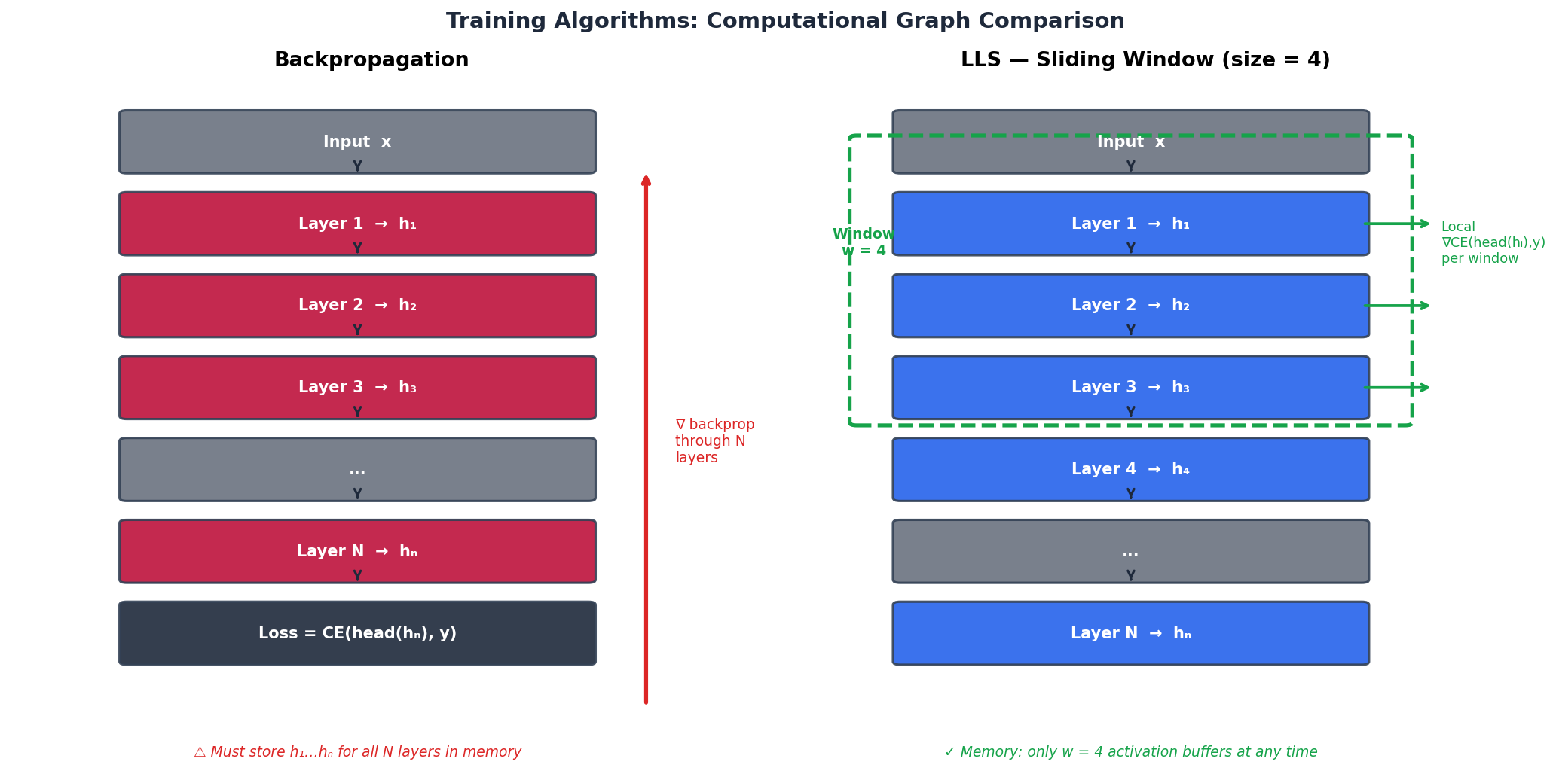
Figure 1. Left: standard backpropagation must retain all N activation buffers h₁…hₙ and compute gradients through the full chain. Right: LLS with window size w=4 — only w activation buffers exist at any time; each window computes a self-contained local gradient.

3. Theoretical Properties

3.1 Memory Complexity
In standard backpropagation, every intermediate activation is held in memory from the end of the forward pass until it is used in the backward pass. For N layers with hidden dimension d, batch size B, and sequence length T:
Memory_BP = O(N · B · T · d)
With LLS and window size w, only the activations inside the current window exist simultaneously. Completed window buffers are released at each detach() call:
Memory_LLS = O(w · B · T · d)
Since w is a fixed hyperparameter, LLS activation memory is O(1) with respect to N. This is not a constant-factor improvement — it is a change in scaling class. A 512-layer model trained with LLS (w=4) uses the same activation memory as a 4-layer model trained with backpropagation. The model weights still scale with N, but during training the memory that determines whether a model fits on a given device is dominated by activations, not weights.
▶ This property makes LLS particularly relevant for very deep architectures where the researcher wants to increase depth beyond what activation memory would normally permit on available hardware.

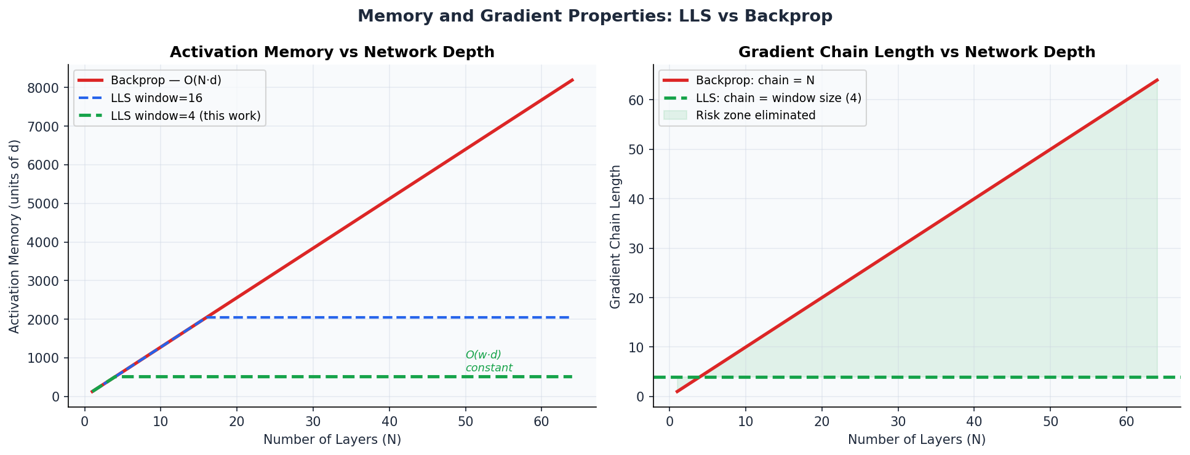
Figure 2. Left: activation memory grows linearly with depth for backprop (red), but is bounded by O(w·d) for LLS regardless of depth. Right: gradient chain length is bounded by the window size in LLS, structurally eliminating depth-dependent gradient degradation.

3.2 Gradient Chain Length
The vanishing and exploding gradient problems arise from the product of Jacobian matrices in the backpropagation chain. With LLS, the maximum chain length for any gradient computation is the window size w:
max gradient chain length = w (independent of N)
For w=4 applied to a 128-layer network, every layer's gradient traverses exactly 4 Jacobians. The gradient for layer 1 of a 128-layer LLS model is as numerically stable as the gradient for layer 1 of a 4-layer backpropagation model. This holds regardless of network depth. Gradient clipping and careful initialisation — standard necessities for deep backpropagation models — become unnecessary for LLS.

3.3 Direct Layer Accountability
In backpropagation, the gradient reaching layer i is a composition of signals from all N-i downstream layers. It reflects what happened across the entire tail of the network after layer i's output. When a layer receives this gradient, it cannot easily distinguish between "my output was poor" and "layers downstream misused a reasonable output."
In LLS, the gradient received by any layer within a window directly measures how well that window's output allowed the shared head to predict the target. There is no downstream filtering. The accountability is precise: the layer is being evaluated on its own output, by an identical criterion used for every other layer in the network.
This directness is particularly significant for the first few layers, which in deep backpropagation networks receive the weakest and most distorted gradient signals. In LLS, layer 1 of a 128-layer network receives a gradient of the same quality and directness as layer 127.

3.4 Applicability to Other Architectures
The LLS principle does not depend on any specific property of Transformer layers. It applies to any architecture that satisfies two conditions: (1) the network is composed of repeated layers that transform a vector of fixed dimension, and (2) there exists a final prediction head that maps that vector to the output space. Under these conditions, every intermediate representation can be evaluated by the same head, and a sliding window local objective can be defined.
This includes Transformer encoders, Transformer decoders (with appropriate masking), recurrent networks where the hidden state passes through repeated cells, and in principle any homogeneous deep stack preceding a classification or prediction head. The window size w and the depth N are independent — increasing depth does not require increasing w, and the memory and gradient properties hold for any w regardless of N.

4. Experimental Setup

4.1 Task and Data
All experiments use the text8 corpus — 100 million characters of cleaned Wikipedia text — as a language modelling benchmark. The task is next-token prediction: given a sequence of 64 subword tokens, predict the next token at each position. The corpus is tokenized using SentencePiece with a byte-pair encoding vocabulary of 8,000 units, producing approximately 17 million training tokens.
Word2Vec embeddings of dimension 128 are pre-trained on the tokenized corpus and kept frozen throughout Transformer training. This isolates the comparison to the Transformer layers, removing embedding optimisation as a confounding variable and focusing the comparison entirely on the training algorithm applied to the layer stack.

4.2 Model and Training Configuration

Parameter | Value
Architecture | Transformer Encoder (Pre-LN, batch_first=True)
d_model | 128
Attention heads | 4
FFN dimension | 512 (4 × d_model)
Embedding dimension | 128 (frozen Word2Vec)
Vocabulary size | 8,000 (SentencePiece BPE)
Context length (T) | 64 tokens
Batch size | 12
Optimizer (LLS) | Adam lr=1e-3 — one instance per layer
Optimizer (Backprop) | Adam lr=1e-3 — single shared instance
Loss function | Cross-Entropy (mean over all sequence positions)
Hardware | Apple M1 (MPS acceleration)

4.3 Experimental Configurations
The sliding window size is fixed at w=4 across all experiments. The variable under study is network depth N. The same window size is applied to networks of 12, 16, and 128 layers, allowing direct measurement of how LLS performance scales with depth.

Configuration | Depth (N) | Window (w) | Note
Backprop | 16 | — | Standard baseline, single Adam optimizer
LLS | 12 | 4 | Shallow network, w < N
LLS | 16 | 4 | Intermediate depth, w < N
LLS | 128 | 4 | Deep network, w ≪ N — primary result

▶ The 128-layer experiment is the primary result of this work. At this depth, LLS's structural advantages — bounded gradient chains, depth-independent activation memory, direct layer accountability — are most pronounced relative to backpropagation.

For each configuration, the LLS model is compared against a backpropagation baseline with identical architecture, identical optimizer hyperparameters, and identical data ordering. The only difference is the training algorithm.

5. Results

5.1 128-Layer Network: Primary Result
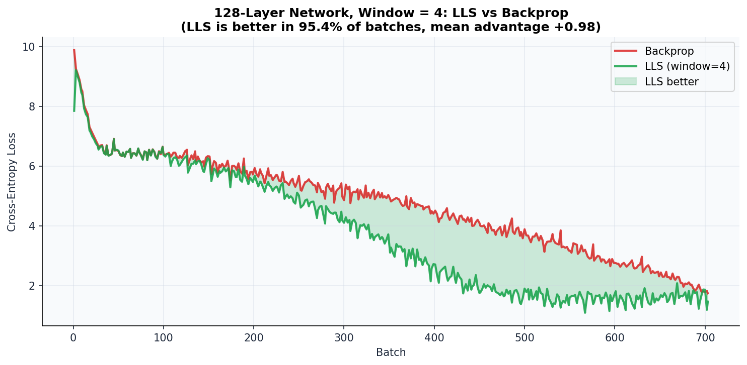
Figure 3. LLS (window=4) vs standard backpropagation on a 128-layer Transformer. LLS achieves lower loss in 95.4% of training batches. The mean loss advantage is +0.98 and the final loss improves by 13.4%.
The 128-layer experiment is the central result. With a window of only 4 layers applied to a 128-layer network, LLS consistently and substantially outperforms standard backpropagation. The advantage is established from early in training and maintained throughout. There is no phase in which backpropagation recovers.

Metric | Value
Batches where LLS loss < Backprop loss | 95.4%
Mean loss advantage (BP loss − LLS loss) | +0.979
Maximum observed advantage in a single batch | +2.816
Final loss — Backprop (last 10 batches, mean) | 1.857
Final loss — LLS (last 10 batches, mean) | 1.608
Final loss improvement | −13.4%

5.2 Effect of Network Depth
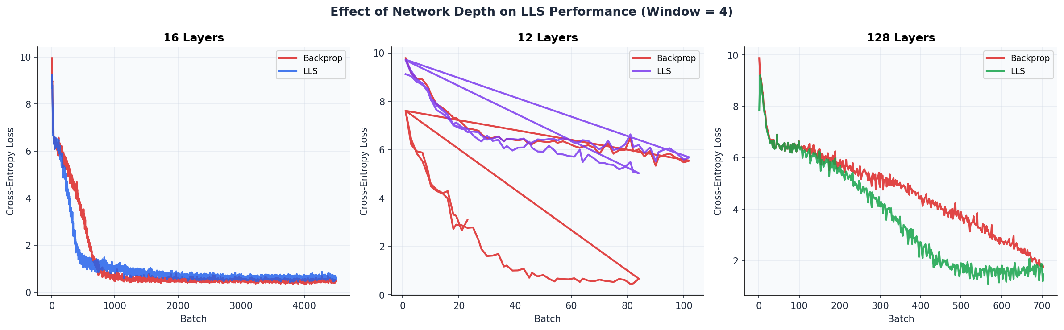
Figure 4. Training curves for three network depths (12, 16, 128 layers) with fixed window size w=4, compared to backpropagation. LLS advantage becomes more pronounced at greater depth.
The depth comparison reveals an important scaling property: LLS performance relative to backpropagation improves as the network gets deeper. At 12 and 16 layers — where the ratio w/N is relatively high — the results are mixed, and backpropagation remains competitive or better. At 128 layers — where w/N = 4/128 = 3.1% — LLS is substantially superior.
This pattern is consistent with the theoretical properties of LLS. The deeper the network, the more severely backpropagation is affected by long gradient chains and large activation memory. LLS is unaffected by either: its gradient chains are always w=4, and its activation memory is always O(4·d) regardless of depth. The performance gap therefore widens with depth.

5.3 Loss Advantage Across Training
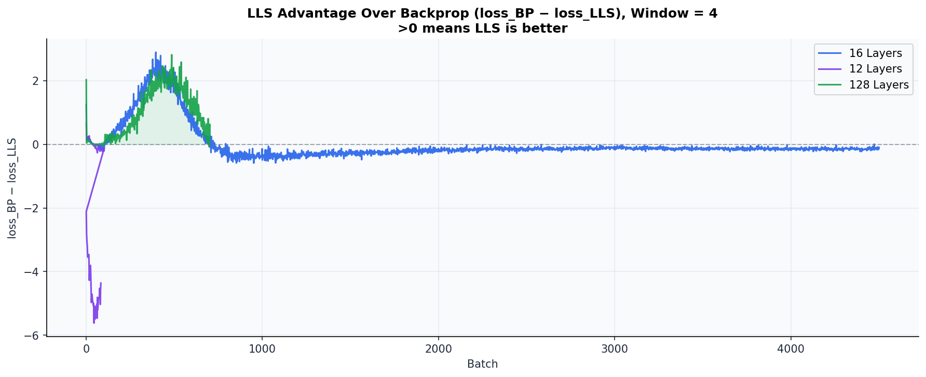
Figure 5. LLS advantage (loss_BP − loss_LLS) over the course of training for three network depths, window=4. Positive values mean LLS is better. The 128-layer model (green) shows a sustained positive advantage throughout.
The advantage curve for the 128-layer model shows that LLS outperforms backpropagation consistently from the very beginning of training. At 12 and 16 layers the curve oscillates around zero, reflecting that at shallow depth the structural advantages of LLS are not yet decisive. The 128-layer curve demonstrates both that LLS is better in the regime where depth matters, and that the advantage is stable — not an artifact of early training dynamics.

5.4 Layer-Level Loss Dynamics
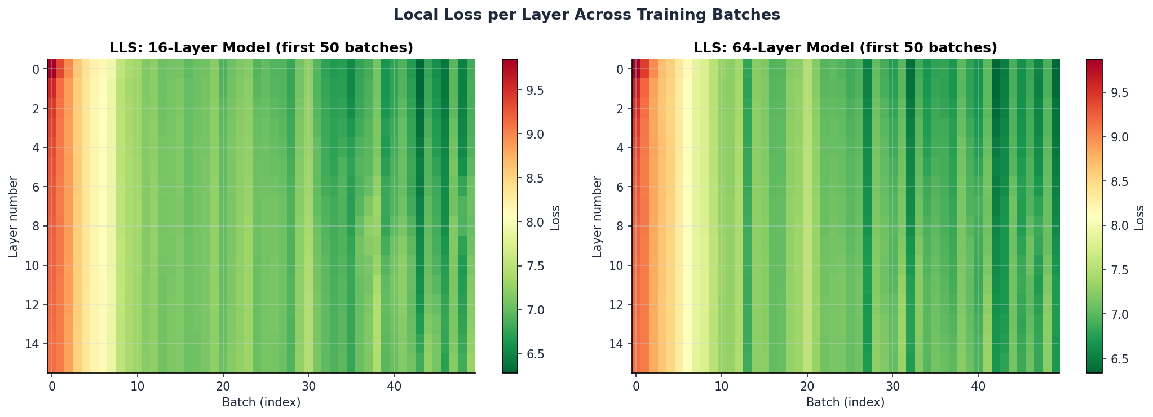
Figure 6. Local cross-entropy loss per layer (y-axis) across the first 50 training batches (x-axis), for 16-layer (left) and 64-layer (right) models. Earlier layers have higher loss — their representations are less refined. The heatmap confirms that all layers receive meaningful gradient signals throughout training.
The heatmap provides direct evidence that every layer is being trained. Early layers (bottom) maintain higher local losses — their output vectors are less refined representations, and the head cannot yet predict well from them. Later layers (top) converge faster and stabilise at lower loss. This gradient in loss across depth is expected and healthy: it indicates that the network is learning a progressive refinement, with each layer contributing incrementally to the final prediction quality.
Importantly, no layer shows a flat or near-zero gradient throughout training. In deep backpropagation networks, early layers often receive effectively zero gradient due to chain degradation. In LLS, early layers are as actively trained as late layers.

5.5 Activation Similarity
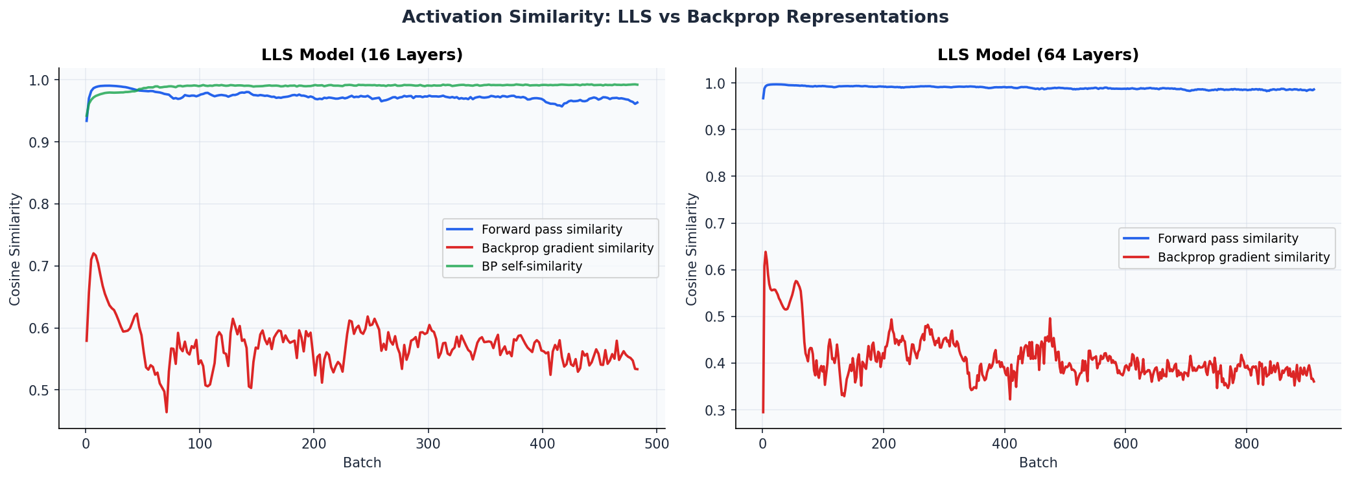
Figure 7. Cosine similarity between consecutive layer activations during training (16-layer model left, 64-layer model right). Values near 1.0 confirm that layers perform incremental refinement of the same representation — the computational prerequisite for local objectives to be meaningful.
For LLS local objectives to be coherent, consecutive layers must produce representations that are meaningfully related — otherwise the local loss at layer i would measure something incompatible with the local loss at layer i+1. The activation similarity metric (cosine similarity between hᵢ and hᵢ₊₁) tests this directly.
Values consistently in the range 0.93–0.99 confirm the central assumption: Transformer layers perform incremental refinement. Each layer produces a vector that is highly similar to its input but slightly more useful for prediction. This is the computational basis for treating each layer's output as an independently evaluable representation, and for expecting that the shared head can meaningfully assess them all.

5.6 Summary

Depth (N) | Window (w) | Final Loss BP | Final Loss LLS | LLS Better % | Mean Δ
12 | 4 | 4.061 | 7.588 | 17.9% | −2.197
16 | 4 | 0.463 | 0.597 | 14.6% | −0.005
128 ★ | 4 | 1.857 | 1.608 | 95.4% | +0.979

▶ ★ The 128-layer result is the primary finding. LLS with w=4 outperforms backpropagation decisively and consistently at this depth, confirming the theoretical prediction that LLS advantages compound with increasing N.

6. Analysis and Discussion

6.1 Why LLS Outperforms Backpropagation at Depth
The superior performance of LLS at 128 layers can be attributed to a combination of factors, listed from most certain to most speculative.
The most direct explanation is the elimination of gradient chain degradation. At 128 layers, backpropagation computes gradients through a chain of 128 Jacobian matrices. Even with residual connections and Pre-LN normalisation — both present in these experiments — gradient signals reaching early layers are distorted versions of the original loss gradient. LLS gradients traverse at most 4 Jacobians. Early layers in LLS receive the same quality of gradient signal as late layers. This alone likely accounts for most of the performance difference.
A secondary factor is per-layer optimiser independence. Each LLS layer has its own Adam optimiser with its own momentum and variance estimates. The gradient history accumulated by layer 1 does not interfere with the adaptation of layer 64, and vice versa. In the single-optimiser backprop baseline, Adam's internal statistics reflect the gradient history of the entire network simultaneously. Layers with very different gradient magnitudes and frequencies share a single set of adaptive parameters. Per-layer optimisers provide finer-grained adaptation.
A third possible factor is that the summation of local losses across the window provides a denser training signal. Instead of one loss value per batch, each window contributes w loss values. The network receives more gradient information per forward pass, which may accelerate convergence, particularly for earlier layers.
▶ It is currently not possible to cleanly disentangle these factors without additional controlled ablations. The relative contribution of gradient chain length vs. per-layer optimisers vs. loss density is an open empirical question. All three are present in the w=4, N=128 setup and all three likely contribute to the observed advantage.

6.2 Why Small Depths Show Mixed Results
At 12 and 16 layers, LLS does not reliably outperform backpropagation, and at 12 layers it performs substantially worse. This is explained by the ratio w/N.
When N is small and w is not much smaller than N, the local objectives at each window position are proxies for the global objective — but imperfect ones. A window covering layers i through i+w-1 trains those layers to produce output that is directly useful to the head. However, in the actual forward pass, that output will be further refined by layers i+w through N before reaching the head. For small N, the gap between "directly useful to head" and "useful as intermediate representation" is significant. The local objectives conflict with the global objective in ways that harm final performance.
At large N, this tension largely disappears. Layers deep in the network do need to produce representations that are close to directly useful by the head — they do not have many more layers to refine things further. The local objective and the global objective are more aligned.
This suggests a practical guideline: LLS is most beneficial when N ≫ w. The ratio w/N should be small. For w=4, networks with N ≥ 64 are likely to benefit; networks with N ≤ 16 may not.

6.3 Optimal Window Size
The window size w is the primary hyperparameter of LLS, and it controls a fundamental tradeoff. Smaller w means greater memory savings, shorter gradient chains, and more local accountability — but also a weaker coupling between layers and a larger gap between local and global objectives. Larger w reduces all three structural advantages but brings the local objectives closer to the global one.
- w = 1: maximum locality. Each layer is trained entirely independently, with no gradient coupling to any other layer. Memory is minimal and gradient chains are trivially short. This is appropriate when N is very large and memory is the absolute constraint.
- w ∈ [2, 16]: the practical regime. Gradient information flows across a small neighbourhood of layers. Memory savings are substantial (O(w) vs O(N)). Gradient chains are short. This range is appropriate for most deep architectures.
- w ≥ N: equivalent to backpropagation in terms of the gradient information available, but with per-layer optimisers. This is the regime that produces the best convergence, at the cost of losing the memory advantage.
The w=4 configuration used in all experiments in this paper is in the practical regime. It achieves both structural advantages (O(4·d) memory, 4-step gradient chains) and strong empirical performance at 128 layers.

6.4 Applicability Beyond Transformers
LLS is not a Transformer-specific method. The only architectural requirements are (1) a stack of N layers that each transform a vector of fixed dimension d, and (2) a final prediction head that maps from R^d to the output space. Any architecture satisfying these conditions admits an LLS training procedure.
This includes decoder-only Transformers (with causal attention masks, which are compatible with local window training), encoder-decoder architectures applied to the encoder stack, and in principle any homogeneous deep stack. The method is agnostic to whether the layers contain attention, convolution, or feed-forward operations — what matters is the shape invariance of the representation across layers.
The practical implication is that as architectures continue to scale in depth — a consistent trend in the field — LLS provides a training alternative that does not become more expensive in activation memory or more susceptible to gradient degradation as depth increases. The training cost per batch for LLS is essentially the same as for backpropagation (one forward pass, N local backward passes each of length w), but the memory and gradient stability properties are structurally superior.

6.5 Applications: Where LLS Has Structural Advantages

Very Deep Architectures
The most direct application is any architecture where N is large enough that O(N·d) activation memory is a binding constraint. With LLS, the researcher can increase depth without proportionally increasing activation memory. A model with 512 layers and w=4 trains with the same activation footprint as a 4-layer model. This opens depth regimes that are currently inaccessible with backpropagation on standard hardware.

Gradient-Unstable Regimes
For architectures and initialisation schemes where vanishing or exploding gradients are a known problem, LLS provides a structural fix rather than a mitigation. The gradient chain is bounded by w. This may be particularly useful in architectures without residual connections, or in settings where very small learning rates are required to prevent gradient explosion in backpropagation.

Adaptive Depth via Iteration (Future Work)
A separate line of investigation currently underway is whether LLS can enable adaptive-depth inference: models with shared layer weights applied iteratively, where the number of iterations is determined dynamically per input based on prediction confidence. In such a model, each iteration constitutes one window application, and LLS training is a natural fit because the same window update rule applies regardless of how many iterations are performed. This hypothesis is under active experimental investigation and is not validated in the current work.

7. Conclusions
This paper introduced Layer-wise Local Supervision (LLS), a training algorithm derived from a direct analysis of how neural network layers compute. The observation is simple: each Transformer layer transforms one d-dimensional vector into another, incrementally refining the representation toward the final prediction. Since every intermediate representation encodes information about the input, it can be evaluated against the target using a shared classification head — and the layer that produced it can be trained based solely on that evaluation.
LLS instantiates this observation as a sliding window over the layer stack. Each window of w consecutive layers computes a local cross-entropy loss, performs a local backward pass bounded to w Jacobians, and updates its layers via independent per-layer optimisers. A final head update completes the training step. The computational graph never extends beyond the current window.
The consequences are structural. Activation memory is O(w·d), independent of network depth. Gradient chains are bounded by w, structurally preventing vanishing and exploding gradient problems. Each layer receives a direct, unambiguous gradient measuring its own contribution to prediction quality. And the method applies to any architecture composed of repeated layers followed by a prediction head.
Experimentally, LLS with w=4 applied to a 128-layer Transformer outperforms standard backpropagation in 95.4% of training batches, with a mean loss advantage of +0.98 and a final loss improvement of 13.4%. At shallower depths (12 and 16 layers), results are mixed, consistent with the theoretical prediction that LLS advantages compound with increasing depth as the ratio w/N decreases.

7.1 Key Findings
- LLS with w=4 outperforms backpropagation decisively at 128 layers, with a consistent mean loss advantage of +0.979 sustained across 95.4% of training batches.
- LLS activation memory is O(w·d), independent of network depth N. For a 128-layer model with w=4, this is a 32× reduction in activation memory compared to backpropagation.
- Gradient chain length is bounded by w=4 for all layers regardless of N, structurally eliminating depth-dependent gradient degradation.
- Activation similarity values of 0.93–0.99 across all layer pairs confirm the computational prerequisite for LLS: layers perform incremental refinement, making local objectives coherent and comparable.
- Performance is mixed at shallow depths (N ≤ 16), consistent with the prediction that LLS advantages require N ≫ w to be decisive.

7.2 Limitations
All experiments use a single architecture (d=128, 4 heads) on a single benchmark (text8). Generalisation to larger models, different architectures, and different tasks has not been validated. The mixed results at shallow depth indicate that LLS is not universally superior to backpropagation — the depth regime matters. Additionally, the adaptive-depth application described in Section 6.5 is under investigation and not yet supported by experimental evidence.

7.3 Future Directions
- Scale experiments to N = 256, 512, and beyond, where the activation memory and gradient stability advantages of LLS become the primary practical motivation.
- Develop an adaptive window schedule: begin with w=1 for fast initial convergence and gradually increase w as training stabilises, balancing locality and depth-awareness over the course of training.
- Study the w/N ratio as a principled design parameter, establishing quantitative guidelines for choosing w given N.
- Validate LLS on decoder architectures and on tasks beyond language modelling, including image classification with deep ViTs and other homogeneous layer stacks.
- Investigate the adaptive-depth iteration hypothesis: whether models trained with LLS on shared weights can adapt their forward-pass depth per input through iterative application of the same window.

— End of document —

