Basic tool kit for PCB assembly and rework

|  |  |  |
| --- | --- | --- |
| PRODUCT |  | PRICE |
| 8 Pc Watch Repair Kit | [8 Pc Watch Repair Kit](http://www.harborfreight.com/8-piece-watch-repair-kit-91622.html)  Pittsburgh  Item #: 91622 | Only:  $8.99 |
| 1500 Watt Dual Temperature Heat Gun 572°/1112° | [1500 Watt Dual Temperature Heat Gun 572°/1112°](http://www.harborfreight.com/1500-watt-dual-temperature-heat-gun-572-1112-96289.html)  1500 Watt Dual Temperature Heat Gun (572°/1112°)  Drill Master  Item #: 96289 | $14.99 |
| 30 Watt Lightweight Soldering Iron | [30 Watt Lightweight Soldering Iron](http://www.harborfreight.com/30-watt-lightweight-soldering-iron-69060.html)  30 Watt Lightweight Soldering Iron  Chicago Electric Welding  Item #: 69060 | $3.99 |
| 7 in. Wire Stripper with Cutter | [7 in. Wire Stripper with Cutter](http://www.harborfreight.com/7-in-wire-stripper-with-cutter-61586.html)  7 in. Wire Stripper with Cutter  Pittsburgh  Item #: 61586 | $4.99 |
| 7 Function Digital Multimeter | [7 Function Digital Multimeter](http://www.harborfreight.com/7-function-digital-multimeter-90899.html)  Cen-Tech  Item #: 90899 | $5.99 |
| 6 Pc Precision Pliers Set | [6 Pc Precision Pliers Set](http://www.harborfreight.com/6-piece-precision-pliers-set-31675.html)  Pittsburgh  Item #: 31675 | $7.99 |
| Heavy Duty Variable Speed Rotary Tool Kit 31 Pc | [Heavy Duty Variable Speed Rotary Tool Kit 31 Pc](http://www.harborfreight.com/heavy-duty-variable-speed-rotary-tool-kit-31-pc-60713.html)  Variable Speed Rotary Tool Kit  Chicago Electric Power Tools  Item #: 60713 | $24.99 |
|  | http://www.ebay.com/itm/Kester-951-flux-pen-Great-for-cell-tabbing-and-other-soldering-operations-/201392071719?hash=item2ee3e72427:g:mNoAAOSwQJhUcmRi | $5.56 |
|  | **http://www.all-spec.com/Catalog/Soldering-Rework/Solder/Solder-Wire/163240-1998** | $35.10 |
|  | **Kester EP256 Lead Solder Paste 63/37 Syringe Dispenser** | US $15.41  Total: $128 |

This basic kit can easily be upgraded but contains all of the basic necessities to produce electronics. The following is a list of upgrades and additional tools that can be purchased to enhance the kit and quality of PCB’s produced. In order of benefit:

High Quality Exacto Knife

This is the a workhorse tool that will make you like so much better, they can get expensive but it’s not worth having a cheap one. Get a good solid metal handle and a big pack of fine tip blades. I personally use my exacto more than any other tool on this list.

METCAL SP200 Soldering Iron

This is a fantastic soldering iron used by a very large number of contract manufacturers and engineers, It uses smart heat technology to set the tip temperature which really speed up soldering. 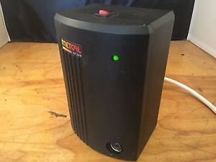

These can usually be found in broken in bulk on ebay for very cheap. The repair for these is nearly always the same problem and replacing the power regulation FET will generally revive these awesome irons.

Microscope

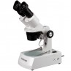

You don’t need anything fancy and this Amscope student microscope is generally all you will truly need. If you plan to work on very large boards or wish to record your work you may want something nicer but a student scope for $115 is more than ample for most projects.

Fluids Dispenser

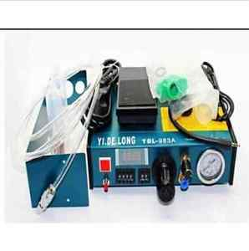

A paste dispenser can be found on ebay between $50-100 they are all about the same quality and you will replace them about every 2-3years under full time daily use. These are amazing for speeding up solder paste dispensing and accuracy when working with SMT components. Also can be used with 3621 Henkle/loctite chipbonder which is an awesome epoxy for electronics use.

Beyond this is basically all consumables such as solder wick, different types of solder, etc.

These are the exact tools I have used for the last several years as a full time RF engineer. Believe me when I say they are battle tested.